 | INTERNATIONAL TELECOMMUNICATION UNION |  |  |  |  |  | COM 15 – LS 272 – E
TELECOMMUNICATION
STANDARDIZATION SECTOR
STUDY PERIOD 2013-2016
English only
Original: English
Question(s): |  | 9/15
Ref.: TD 381 (PLEN/15) Annex R
Source: |  | ITU-T Study Group 15
Title: |  | LS on request for clarification on IEEE STD 802.1AX (2014)
LIAISON STATEMENT
For action to: |  |  | IEEE 802.1
For comment to: |  |  | -
For information to: |  |  | -
Approval: |  |  | ITU-T SG15 meeting (22 June – 3 July 2015)
Deadline: |  |  | 12 October 2015
Contact: |  | Tom Huber  Rapporteur Q9/15 |  |  |  | Tel: +1.630.798.6625  Email: tom.huber@coriant.com
Contact: |  | Han Li  Associate Rapporteur Q9/15 |  |  |  | Tel: +86.13501093385  Email: lihan@chinamobile.com
ITU-T Q9/15 thanks IEEE 802.1 for past liaisons and clarifications about P802.1AX-REV (now published as IEEE Std 802.1AX-2014) Distributed Resilient Network Interconnect (DRNI).
ITU-T Q9/15 is exploring the applicability of DRNI in the context of our work on Multi Domain Segment network Protection (MDSP). During our investigation, we have found some failure scenarios for which we would appreciate your clarification.
We would appreciate IEEE 802.1 continuing to share clarifications about IEEE Std 802.1AX-2014, and we look forward to further interaction between our organizations.
ITU-T Q9/15 will be meeting next during the week of 19 October 2015.
- Introduction
Figure 1 shows a Dual Node Interconnection (DNI) architecture where DRNI is used between two Protected Subnetworks.

Protected Subnetwork 2

DRNI
I1
IPL 1
Aggregation Link 1
I2
I3
I4
Aggregation Link 2
Portal 1
Portal 2
IPL 2
W1
P1
W2
P2
V1
V2
Gateway 1
Gateway 3

Interconnected Domain
Gateway 2
Gateway 4
Protected Subnetwork 1

Wj: Working path in Protected Subnetwork j (j=1, 2)
Pj: Protection path in Protected Subnetwork j (j=1, 2)
Vj: Vertical path in Protected Subnetwork j (j=1, 2)
Ix: Portal System (x=1,2,3,4)
Portal 1: I1 and I3
Portal 2: I2 and I4
Figure 1 ‒ DNI Architecture with DRNI in the Interconnected Domain
We understand that connectivity through both Gateways within a Portal can be enabled by the operations of the network control protocol at the same time and DRNI will take care to activate only one Gateway (GW) at a given time. We assume this is the default behaviour when there are no failures in the Protected Subnetwork.
- Failure Scenario #1
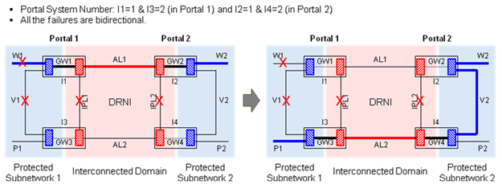Figure 2 ‒ Scenario 1 (I1 isolated in the Protected Subnetwork and all IPLs fail)
In this case, we understand that only Aggregation Link 1 (AL1) is used and Gateway 1 (GW1) and Gateway 2 (GW2) are activated, assuming that I1 and I2 have lower Portal System Numbers than I3 and I4, respectively. We understand that the intention is to avoid a super-loop involving AL1 and Aggregation Link 2 (AL2).
However, assuming that the network control protocols running in the two Protected Subnetworks can avoid the super-loop, traffic cannot be recovered with this failure scenario.
Question 1-1: Is it possible to solve this problem by allowing the network control protocol in I3 to request DRNI to change the traffic path to that shown in Figure 2 (red-coloured lines in the right figure) so that Gateway 3(GW3) and Gateway 4 (GW4) become active instead of GW1 and GW2, regardless of the Portal System Number configuration?
Question 1-2: If it is possible, then which variable(s) in the DRNI process in I3 should be controlled by the network control protocol in I3?
- Failure Scenario #2
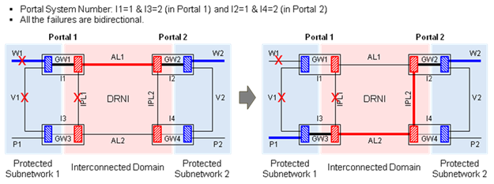Figure 3 ‒ Scenario 2 (I1 isolated in the Protected Subnetwork and IPL1 fails)
In this case, GW1 is disabled by the operations of the network control protocol in I1 and we understand that AL2 is used and both GW3 and GW2 are active in spite of I1 having a lower Portal System Number than I3.
Question 2-1: Is our understanding correct?
- Failure Scenario #3
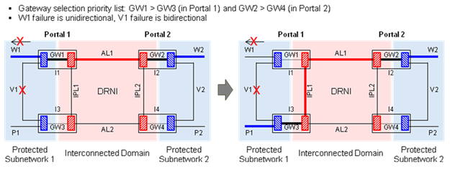
Figure 4 ‒ Scenario 3 (I1 isolated in the Protected Subnetwork)
In this case, we understand that the DRNI requires that the network control protocol running in I1shall be capable to detect I1 isolation within the Protected Subnetwork and disable GW1.
However, assuming that the network control protocol running in I1 does not know that I1 has been isolated in the Protected Subnetwork, GW1 cannot be disabled by the network control protocol running in I1. Under this assumption, the network control protocol running in I3 is aware of I1 isolation and selects P1 for traffic delivery.
Question 3-1: Is it possible to solve this problem by allowing the network control protocol in I3 to request DRNI to change the traffic path to that shown in Figure 4 (red-coloured lines in the right figure) so that GW3 becomes active instead of GW1, regardless of the Gateway selection priority list configuration?
Question 3-2: If it is possible, then which variable(s) in the DRNI process in I3 should be controlled by the network control protocol in I3?
- Failure Scenario #4
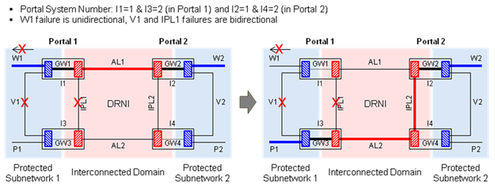
Figure 5 ‒ Scenario 4 (Scenario 3 + IPL1 fails)
As described for failure scenario 3, assuming that the network control protocol running in I1 does not know that I1 has been isolated in the Protected Subnetwork, GW1 cannot be disabled by the network control protocol running in I1.
We understand that GW1 is selected based on the Portal System Number configuration.
Question 4-1: Is it possible to solve this problem by allowing the network control protocol in I3 to request DRNI to change the traffic path to that shown in Figure 5 (red-coloured lines in the right figure) so that GW3 becomes active instead of GW1, regardless of the Portal System Number configuration?
Question 4-2: If it is possible, then which variable(s) in the DRNI process in I3 should be controlled by the network control protocol in I3?

_______________________

