Project | IEEE 802.16 Broadband Wireless Access Working Group <http://ieee802.org/16>
Title | Adaptive Frequency Reuse for Interference Management in IEEE 802.16m System
Date Submitted | 2008-01-22
Source(s) | I-Kang Fu, Kelvin Chou, Yih-Shen Chen and Paul Cheng  MediaTek Inc.  No.1, Dusing Rd. 1, HsinChu Science-Based Industrial Park, HsinChu, Taiwan 300, R.O.C. | IK.Fu@mediatek.com  Paul.Cheng@mediatek.com
Re: | IEEE 802.16m-07/047, “Call for Contributions on Project 802.16m System Description Document”. In response to the following topics:  • Proposed IEEE 802.16m Reference Model and potential System Architectures  • Proposed 802.16m Protocol Architecture and main functionalities per protocol layer
Abstract | This contribution introduces the adaptive frequency reuse technique and discusses its benefit to IEEE 802.16m system
Purpose | For discussion on the adaptive frequency reuse and the interference management issues by TGm
Notice | This document does not represent the agreed views of the IEEE 802.16 Working Group or any of its subgroups. It represents only the views of the participants listed in the “Source(s)” field above. It is offered as a basis for discussion. It is not binding on the contributor(s), who reserve(s) the right to add, amend or withdraw material contained herein.
Release | The contributor grants a free, irrevocable license to the IEEE to incorporate material contained in this contribution, and any modifications thereof, in the creation of an IEEE Standards publication; to copyright in the IEEE’s name any IEEE Standards publication even though it may include portions of this contribution; and at the IEEE’s sole discretion to permit others to reproduce in whole or in part the resulting IEEE Standards publication. The contributor also acknowledges and accepts that this contribution may be made public by IEEE 802.16.
Patent Policy | The contributor is familiar with the IEEE-SA Patent Policy and Procedures:  <http://standards.ieee.org/guides/bylaws/sect6-7.html#6> and <http://standards.ieee.org/guides/opman/sect6.html#6.3>.  Further information is located at <http://standards.ieee.org/board/pat/pat-material.html> and <http://standards.ieee.org/board/pat>.
Adaptive Frequency Reuse for Interference Management in IEEE 802.16m System
I-Kang Fu, Kelvin Chou, Yih-Shen Chen and Paul Cheng
MediaTek Inc.

Motivation
In order to achieve much higher spectrum efficiency than IEEE 802.16e and meet the requirement of IMT-Advanced, more flexible frequency (i.e. radio resource) reuse/control techniques will be very critical to achieve this objective. However, more aggressive frequency reuse may result in worse interfering situation and the unacceptable signal quality. Interference management will be very important at improving the spectrum efficiency in IEEE 802.16m system. In this contribution, the concept of adaptive frequency reuse is introduced; where different frequency reuse patterns can be applied in the same cell to serve the MSs suffering different level of interferences. According to this technique, IEEE 802.16m system can achieve higher spectrum efficiency by more aggressive frequency reuse without significant increment on interference level.

Introduction

The radio spectrum is a very scarce resource and managed by the government in each country. The privilege to provide mobile communication services via a specific radio spectrum (i.e. licensed-spectrum) is very expensive and the available bandwidth for system operation is very limited. In order to provide complete service coverage in the system and to serve more users (i.e. higher system capacity), reusing the same frequency band in different geographical area (i.e. reused by different BSs) is a common technique in mobile communication systems today. The cellular structure, as shown in Fig.1, is a popular tool for preliminary network planning to determine the frequency band used by each cell (i.e. the frequency reuse pattern of the system).

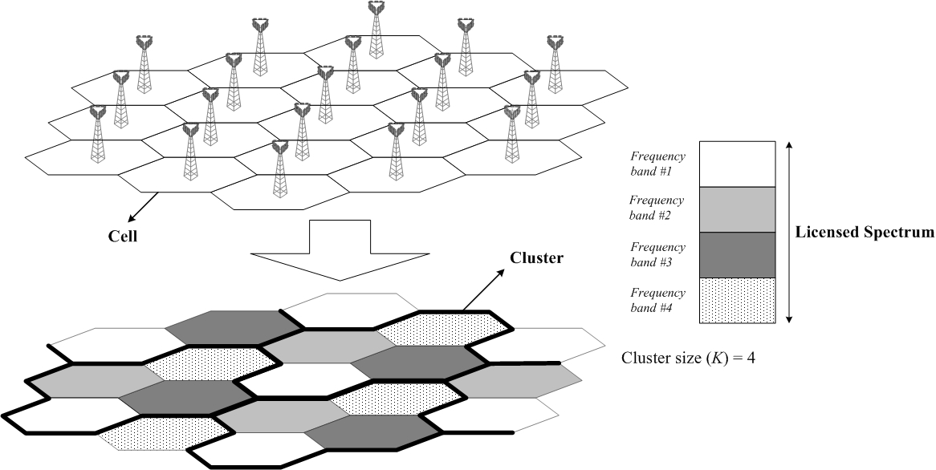

Fig.1 Cellular structure with cluster size (K) = 4
In Fig.1, the available bandwidth is divided into four frequency bands so that the same frequency band will be reused in every four cells. A simple rule (as shown in Fig.2) can be derived under ideal cellular structure: 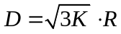 [1], where D is the distance between adjacent interfering cells and R is the cell radius. This simple rule can help people realize a tradeoff between system capacity and interference level. For higher K, the distance between adjacent interfering cells will be enlarged and lead to lower inter-cell interference; but it will also result in lower capacity due to less frequency bandwidth available for each cell (see Fig.1). On the other hand, lower K can increase the capacity by more bandwidth for each cell, but the interference will be increased due to the closer interfering sources.

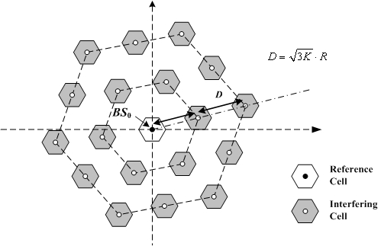
Fig.2 The distance (D) between adjacent interfering cells is function of cluster size (K)

In addition, the available frequency bandwidth for each cell can be further divided into frequency segments for the use by sectors. In Fig.3, there are three segments for each cell and each sector can exclusively use one of the segments or use all the segments. The same tradeoff also exists in reusing the segments in different sectors or not. For the case with reusing, the sector throughput (i.e. spectrum efficiency) can be increased by having more sub-channels, but additional interference will exist and degrade the received signal quality. On the other hand, there will be no intra-cell interference if each sector uses different segment. Note that the frequency reuse pattern (K,J,X) in Fig.3 is defined for easy presentation, where K is the cluster size, J=3 is the number of sectors in each cell, X= 1 or 1/J in following example is the ratio of available frequency bandwidth for each sector over the one for each cell.

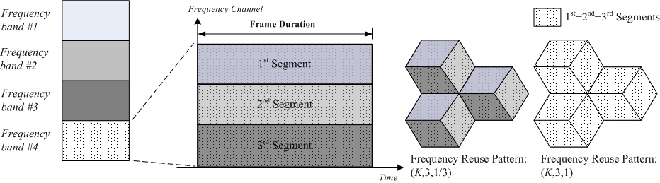
Fig.3 The definition of frequency reuse pattern

However, the MS locations in each cell are usually different and they may experience different level of interference (i.e. lead to different MCS). Using the same frequency reuse pattern to serve entire cell may not lead to optimal performance all the time. In Fig.4, the MS located at outer cell is closer to interfering cells and farer away from serving BS. Higher K may be required to reduce the inter-cell interference so as to maintain the required signal quality. On the other hand, MS located at inner cell is relative farer away from interfering cells and the lower K can be chosen for more bandwidth in each cell and maintain the required signal quality at the same time.

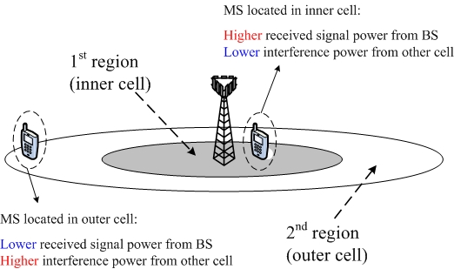
Fig.4 The MSs located at inner cell and outer cell may experience different level of interference

In order to achieve better tradeoff, adaptive (or fractional) frequency reuse is a popular technique to apply different cluster sizes to serve the MSs at different location [2]. Fig.5(a) gives an example to apply K₁=4 to serve the MS at inner cell (i.e. 1st geographical region) and K₂=7 for the MSs at outer cell (i.e. 2nd geographical region) by the 1st frame zone and 2nd frame zone respectively. Compare to the worst case design (i.e. use K=7 to serve entire cell), each cell can have more radio resource from the 1st zone and achieve higher system capacity.

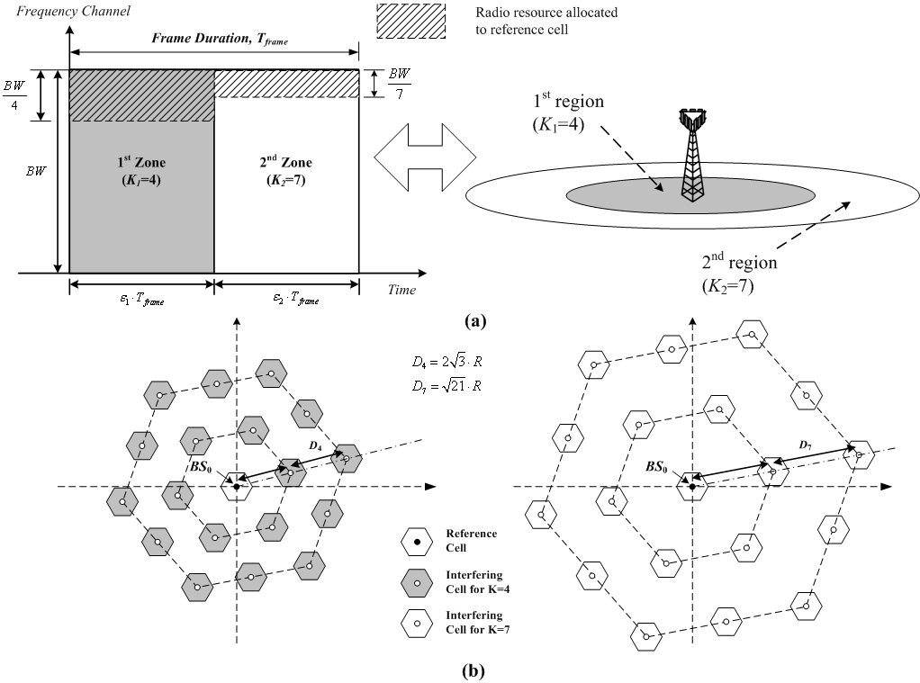
Fig.5 (a) An example of adaptive frequency reuse by applying different frequency reuse patterns to serve the MSs at inner and outer cell; (b) Higher K can enlarge the distance between adjacent interfering cells and reduce the inter-cell interference.

Along this line, the coverage of each cell may be partitioned into multiple regions served by the corresponding frame zones and cluster sizes (as shown in Fig.6). The regions may be classified by the received interference level, MS location, geographical characteristics (e.g. open area or crowded buildings), and etc. The radio resource reserved for each frame zone may base on the cluster size for each zone, number of users (i.e. traffic load) to be served by each region, and etc.
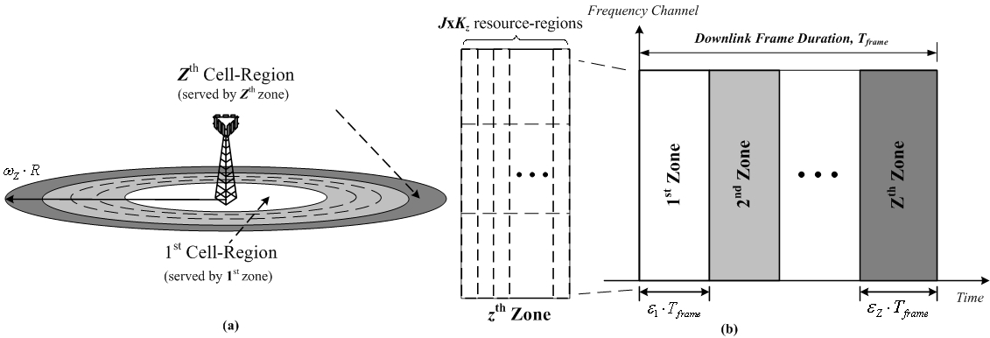
Fig.6 (a) An example to partition the cell coverage into Z regions, which are served by (b) Z frame zones with corresponding frequency reuse factor K_{z}

In mobile communication system such as IEEE 802.16m, the MS location and the channel condition from MS to each interfering source are time variant. In order to best tradeoff between allowable interference level (or received signal quality) and the system capacity, the frequency reuse pattern, the radio resource reserved for each frame zone (e.g. parameter ε_{z} in Fig.6), and the threshold to schedule each MS served by specific frame zone (e.g. parameter ω_{z} in Fig.6) may need to be adapted from time to time. Based on the configuration decision, a network coordinator can be used to send the radio parameters to each BS to reconfigure its frame zones. Then each BS can schedule its subordinate MSs to be served by appropriate zones to manage the received interference.

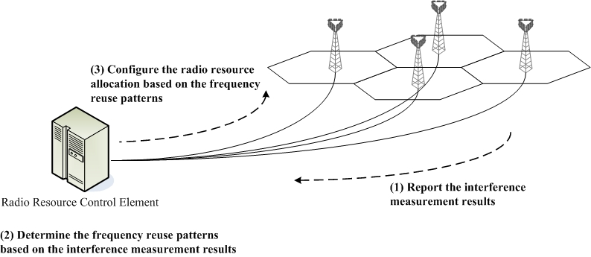
Fig.7 An example to realize the adaptive frequency reuse

In Fig.7, an example is illustrated to explain how the IEEE 802.16m system may realize the adaptive frequency reuse. The first step is to measure the received interference level from BSs or MSs and then report to a radio resource control element. Then, this control element can determine whether the frequency reuse pattern or the relative radio parameters need to be adapted or not. Finally, the decision will be sent to each BS to reconfigure its radio parameters in response to the frequency reuse pattern for each zone.

- Summary

In this contribution, the concept of adaptive frequency reuse is introduced and discussed. Its flexibility to apply different frequency reuse patterns to serve different MSs in each cell can increase the spectrum efficiency while keeping the interference level at an acceptable level. In order to realize this mechanism in IEEE 802.16m system, new channelization format, measurement/reporting mechanism, messaging procedure, and inter-cell coordination methods are needed and should be further developed in the 802.16m SDD.

- Text Proposal

-----------------------------------------------------------Start of Text--------------------------------------------------------------

[Add the following text into the 16m SDD document [3]]

XX Support for Interference Management
XX.1 Adaptive frequency reuse
------------------------------------------------------------End of Text--------------------------------------------------------------

Reference
[1] G. L. Stuber, Principle of Mobile Communication, ISBN: 978-0-7923-7998-0, Kluwer Academic Publisher, 2001.
[2] IEEE 802.16m-07/002r4, “TGm System Requirements Document,” Oct. 2007.
[3] IEEE C802.16m-07/320r1, “Draft Table of Content for the IEEE 802.16m System Description Document”.

