Project | IEEE 802.16 Broadband Wireless Access Working Group <http://ieee802.org/16>
Title | SDD Text Proposal for Multi-carrier operation
Date Submitted | 2009-01-14
Source(s) | Jaehee Cho, Hyunjeong Kang  Samsung Electronics  Kamran Etemad  Intel | jaehee1.cho@samsung.com  Kamran.etemad@intel.com
Re: | TGm SDD: Others
Abstract | Modification on SDD MC text: Mainly for changing the definition of partially configured carrier and some editorial changes
Purpose | For review and adoption into P802.16m System Description Document
Notice | This document does not represent the agreed views of the IEEE 802.16 Working Group or any of its subgroups. It represents only the views of the participants listed in the “Source(s)” field above. It is offered as a basis for discussion. It is not binding on the contributor(s), who reserve(s) the right to add, amend or withdraw material contained herein.
Release | The contributor grants a free, irrevocable license to the IEEE to incorporate material contained in this contribution, and any modifications thereof, in the creation of an IEEE Standards publication; to copyright in the IEEE’s name any IEEE Standards publication even though it may include portions of this contribution; and at the IEEE’s sole discretion to permit others to reproduce in whole or in part the resulting IEEE Standards publication. The contributor also acknowledges and accepts that this contribution may be made public by IEEE 802.16.
Patent Policy | The contributor is familiar with the IEEE-SA Patent Policy and Procedures:  <http://standards.ieee.org/guides/bylaws/sect6-7.html#6> and <http://standards.ieee.org/guides/opman/sect6.html#6.3>.  Further information is located at <http://standards.ieee.org/board/pat/pat-material.html> and <http://standards.ieee.org/board/pat>.
Modified text proposal for SDD MC
Jaehee Cho, Hyunjeong Kang, Kamran Etemad
Samsung Electronics, Intel

Introduction
Partially configured carrier is assumed that some control channels can be omitted to reduce system overhead. But it will bring different carrier configuration from single carrier case. We analyze as follows:
- Overhead reduction (10MHz BW is assumed)
  - Reduced overhead: 1% (2 symbols in every 20ms)
    - No P-BCH in every 20 ms: 1 symbol
      - 4 symbols * 0.5 (1/2 of 5MHz) * 0.5 (5MHz from 10MHz)
    - No P-SCH in every 20 ms: 1 OFDMA symbol
- Different carrier configurations
  - Two types of initial L1 access procedures per carriers
    - Fully configured carrier: P-SCH, S-SCH, P-BCH, S-BCH
    - Partially configured carrier: S-SCH, S-BCH
  - No stand alone operation of broadcast only carrier

In this contribution, we propose to change the definition of partially configured carrier to be a carrier with only DL. In addition, we propose to provide all control channels in the partially configured carrier including P/S-SCH and P/S-BCH.

- Re-define partially configured carrier
  - A carrier with only DL
  - Allow DL control channels for partially configured carrier
    - Except those related with UL like UL HARQ feedback, PC
    - Allow P/S SCH, P/S BCH, system information and USCCH
- Some editorial changes
  - Move MC stuff from section 11 to section 19
    - MC frame structures, Primary and secondary carrier
  - Change terminologies according to recent SDD change
    - LDRU ➔ DRU
    - LLRU ➔ CUR

Text Proposal

---------------------------------------------------------Start of the Text----------------------------------------------------------
[Modify the text and figure in 11.4.3 as follows and move the modified text to 19.3.1]

119.43.31.2 Frame Structure Supporting Legacy Frames in IEEE 802.16m Systems with Wider Channel Bandwidths

Figure 24 shows an example for the IEEE 802.16m frame structure supporting legacy frame in a wider channel. A number of narrow bandwidth carriers of the IEEE 802.16m can be aggregated to support wide bandwidth operation AMSs. One or multiple of the carriers can be designated as the legacy carrier(s). When the center carrier spacing between two adjacent carriers is an integer multiple of subcarrier spacing, it is not necessary to reserve guard subcarriers for the IEEE 802.16m carriers. Different number of usable guard sub-carriers can be allocated on both sides of the carrier.

For UL transmissions both TDM and FDM approaches should be supported for multiplexing of legacy and AMSs in the legacy and IEEE 802.16m mixed carrier. The TDM in the figure is only for example.

In the case when the edge carrier is a legacy carrier, the impact of the small guard bandwidth on the edge of the wider channel on the filter requirements is FFS.

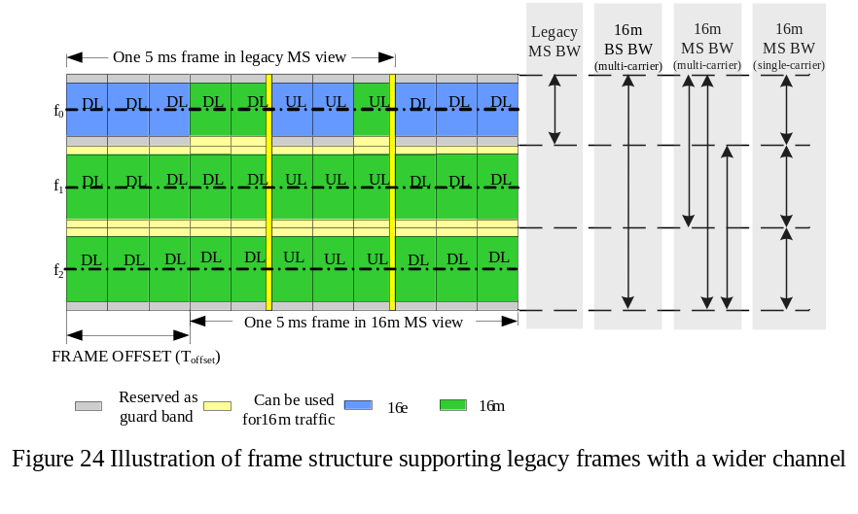

[Modify the text in 11.4.6 as follows and move the modified text to 19.3.1]

119.43.61.1 Frame Structure to support multi-carrier operation
The support for multiple RF carriers can be accommodated with the same frame structure used for single carrier support, however, some considerations in the design of protocol and channel structure may be needed to efficiently support this feature.
In general, each MS operating under IEEE 802.16m standard is controlled by one RF carrier, herein referred to as the primary RF carrier. When multi-carrier operation feature is supported, the system may define and utilize additional RF carriers to improve the user experience and QoS, or provide services through additional RF carriers configured or optimized for specific services.

Figure 37 shows that the same frame structure would be applicable to both single carrier and multicarrier mode of operation. A number of narrow BW carriers can be aggregated to support effectively wider BW operation. Each carrier may have its own synchronization channel and superframe header. Further, some carriers may have only part of superframe header. A multi-carrier IEEE 802.16m MS is an MS which can utilize radio resources across multiple RF carriers under the management of a common MAC. Depending on MS's capabilities, such utilization may include aggregation or switching of traffic across multiple RF carriers controlled by a single MAC instantiation.

The multiple carriers involved in multi-carrier operation may be in a contiguous or non-contiguous spectrum. When carriers are in the same spectrum and adjacent and when the separation of center frequency between two adjacent carriers is multiples of subcarrier spacing, no guard subcarriers are necessary between adjacent carriers.

[Modify the text in 11.7.4 as follows and move the modified text to the start of 19.1 ]
11.7.4 Multi-carrier Control Structure
<Editors’ Notes:This section is a placeholders for text to be developed based on SDD text that will be added to Section 19 of the SDD (Support for Multi-carrier Operation). >

The carriers involved in a multi-carrier system, from one AMS point of view, can be divided into two types:

• A Primary carrier is the carrier used by the ABS and the AMS to exchange traffic and PHY/MAC control information defined in IEEE 802.16m specification. Further, the primary carrier is used for control functions for proper AMS operation, such as network entry. Each AMS shall have only one carrier it considers to be its primary carrier in a cell.
• A Secondary carrier is an additional carrier which the AMS may use for traffic, only per ABS’s specific allocation commands and rules typically received on the primary carrier. The secondary carrier may also include control signaling to support multi-carrier operation.

Based on the primary and/or secondary usage, the carriers of a multi-carriers system may be configured differently as follows:

• Fully configured carrier: A carrier for which all control channels including synchronization, broadcast, multicast and unicast control signaling are configured. Further, information and parameters regarding multi-carrier operation and the other carriers can also be included in the control channels. Fully configured carrier shall support both single carrier AMS and multicarrier AMS.
• Partially configured carrier: A carrier with only essential control channel configuration to support traffic exchanges during multi-carrier operation. A carrier with only downlink transmission in TDD or a downlink carrier without paired UL carrier in FDD mode and configured with all control channels to support downlink transmission.

A primary carrier shall be fully configured while a secondary carrier may be fully or partially configured depending on usage and deployment model.

19 Support for Multi-carrier Operation
19.1 Multi-carrier operation Principles
The following is common in all modes of multi-carrier operation:
- The system defines N standalone fully configured RF carriers as defined in section 11.7.4, each fully configured with all synchronization, broadcast, multicast and unicast control signaling channels. Each AMS in the cell is connected to and its state being controlled through only one of the fully configured carriers as its primary carrier.
- They system defines M (M >= 0) partially configured RF carriers as defined in section 11.6.4, each configured with all the essential control channels configuration needed to support downlink transmissions traffic exchanges during multi-carrier operation.
- In the multicarrier operation a common MAC can utilize radio resources in one or more of the secondary carriers, while maintaining full control of AMS mobility, state and context through the primary carrier.
- Some information about the secondary carriers including their presence and location shall be made available to the user through the primary carriers. The primary carrier may also provide user the information about the configuration of the secondary carriers.
- The resource allocation can span across a primary and multiple secondary RF carriers. Link adaptation feedback mechanisms should incorporate measurements relevant to both primary and secondary carriers.
- A multi-carrier system may assign secondary carriers to an AMS in the downlink and/or uplink asymmetrically based on system load (i.e., for static/dynamic load balancing), peak data rate, or QoS demand.
- In addition to its primary RF carrier data transfer between a ABS and an AMS may dynamically utilize resources across multiple secondary RF carriers. Multiple AMS, each with a different primary RF carrier may also share the same secondary carrier.
- The multiple carriers may be in different parts of the same spectrum block or in non-contiguous spectrum blocks. The use of non-contiguous spectrum blocks may require additional control information on the secondary carriers.
- Each AMS will consider only one fully configured RF carrier to be its primary carrier. A secondary carrier for a AMS, if fully configured, may serve as primary carrier for other AMS’s.

There are two scenarios to multicarrier deployment.
Scenario 1: All carriers in the system are fully configured to operate standalone and may support some users as their primary carrier and others as their secondary carrier.
Scenario 2: In addition to fully configured and standalone RF carriers the system also utilizes additional partially configured supplementary radio carriers optimized as downlink transmission only service like multicast and broadcast services data pipes for certain services or traffic types using limited control signaling capability. Such supplementary carriers may be used only in conjunction with a primary carrier and cannot operate standalone to offer IEEE 802.16m services for a AMS.
In multi-carrier operation, an AMS can access multiple carriers. The following multi-carrier operations are identified:
- Carrier aggregation
  - AMS shall always maintain its physical layer connection and monitor the control information on the primary carrier.
- Carrier switching
  - AMS can switch its physical layer connection from the primary to the secondary carrier per ABS’ instruction. When the AMS is connected to the secondary carrier, the AMS doesn’t need to maintain its physical layer connection to the primary carrier.
  - This mode may be is used for primary carrier switching or switching to partially configured carriers for downlink only transmissions the cases of single radio AMS.

19.2 Subcarrier Alignment for Utilization of Guard Subcarriers of Adjacent Frequency Channels
When multiple contiguous frequency channels are available, the guard sub-carriers between contiguous frequency channels can be utilized for data transmission only if the sub-carriers from adjacent frequency channels are well aligned. In order to align those sub-carriers from adjacent frequency channel, a frequency offset (Δf’) can be applied to its FA. The basic idea is shown by the example in Figure 59.
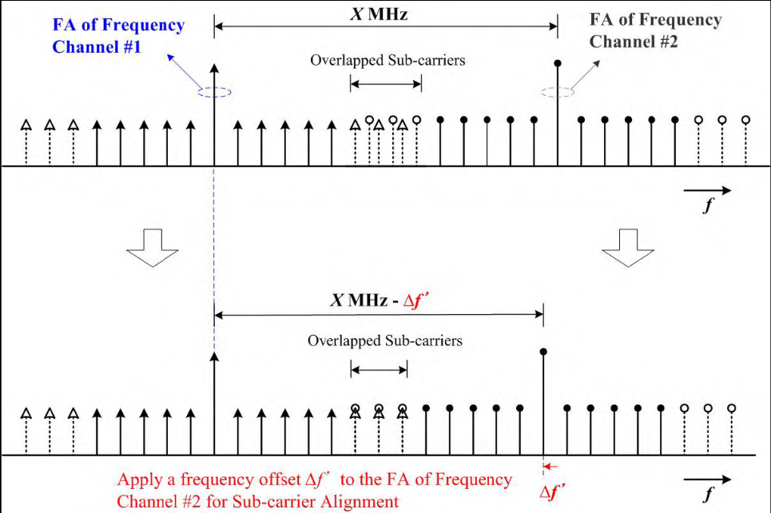
Figure 59 Sub-carrier alignment by applying a fraction of sub-carrier spacing to the FA of adjacent frequency channel
In order to utilize the guard sub-carrier for data transmission, the information of the available guard sub-carriers eligible for data transmission shall be sent to AMS. This information shall include the numbers of available sub-carriers in upper side and in lower side with respect to the DC sub-carrier of carrier.
[Modify the text as follows]
19.3 PHY Aspects of OFDMA Multi-carrier Operation

Physical layer to support OFDMA multi-carrier operation is shown in Figure 1. A single MAC PDU or a concatenated MAC PDUs is received through the PHY SAP and they can form a FEC block called PHY PDU. The figure shows that the physical layer performs channel encoding, modulation and MIMO encoding for a PHY PDU and generates a single modulated symbol sequence. Any one of the multiple carriers (primary or secondary carriers) can deliver a modulated symbol sequence. Or, in case of allocation on LDRU, a single modulated symbol sequence may be segmented into multiple segments where each segment can be transmitted on a different carrier. The same MCS level and MIMO scheme are used for all segments of a PHY PDU. However, different PHY PDUs transmitted on the same or different carriers may have different MCS and MIMO schemes. The physical layer performs subcarrier mapping for a modulated symbol sequence or a segment of the sequence relevant to the given carrier.
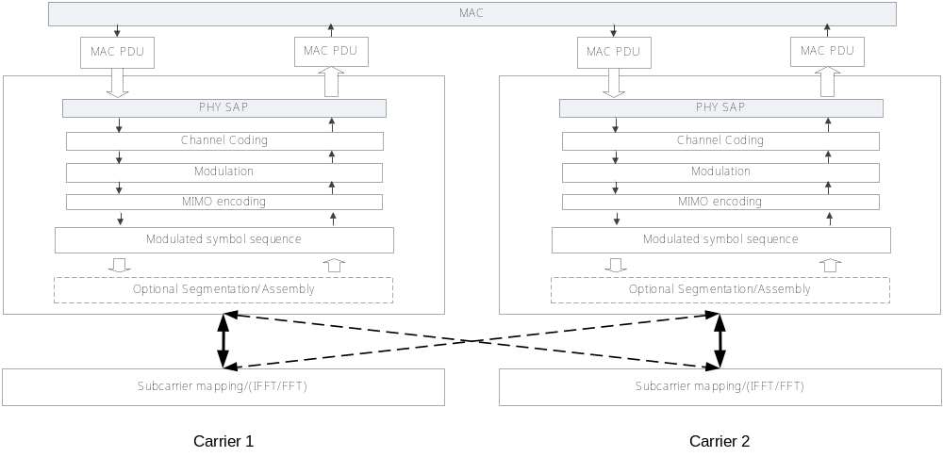
Figure 1. An example of physical layer structure to support multi-carrier operation

The following describes the details of the PHY PDU transmission operation:
- For a PHY PDU, the PHY delivers a single modulated symbol sequence. This modulated symbol sequence, is regarded as a single HARQ packet the same as in a single carrier system.
- A modulated symbol sequence of a PHY PDU can be transmitted as follows:
  - Transmitting the modulated symbol sequence on a single RF carrier. Note that in the same time, different PHY bursts may be transmitted to an AMS from different RF carriers.
  - Transmitting the modulated symbol sequence on LDRUs across several RF carriers at the same sub-frame, via PHY burst segmentation and mapping to different RF carriers, by using the same MCS and MIMO scheme.
- In the multi-carrier system, an LRU is defined independently per carrier. The RF carrier specific physical layer performs subcarrier mapping based on the LRU per carrier. It must be noted that the radio resource utilization on each RF carrier may be different.
PHY segmentation, i.e. transmitting one PDU across multiple carriers is FFS.

19.3.1 Frame Structure
The frame structures to support multi-carrier can be found in 11.4.3 and 11.4.6.

19.3.2 Channel Coding, Modulation and HARQ
For a PHY PDU, channel encoding, modulation and MIMO encoding are performed as in a single carrier operation to generate a single modulated symbol sequence. The modulated symbol sequence can be segmented and transmitted over LDRUs in multiple carriers as shown in Figure 1.

The modulated symbol sequence is regarded as a single HARQ packet. HARQ feedback for PHY PDU sent across primary and secondary carriers can be carried in the primary carrier. HARQ feedback for PHY PDU sent only in the secondary carrier can be carried in the secondary carrier.

19.3.3 Data Transmission over Guard Resource

The guard sub-carriers between contiguous RF carriers in the new zone can be utilized for data transmission if the sub-carriers on contiguous RF carriers are well aligned. The serving ABS and the AMS need to negotiate their capability to support guard sub-carrier data transmission. The set of guard sub-carriers utilized for data transmission is defined as guard resource.

19.3.3.1 PHY Structure Support
Each carrier can exploit subcarriers at band edges as its additional data subcarriers. The guard resource forms integer multiples of PRUs. The resulting data subcarriers (including guard resource) form PRUs. The PRU structure used for guard resource is the same as the structure of the ordinary PRU in 11.5 and 11.6. For the carrier, LLRUCRUs may be constructed from the PRUs including PRUs from guard resource. Support of LDRU is FFS.

The ABS provides information regarding the use of guard resource for data channels. Guard resource is not used for control channels transmission.

Figure xxx illustrates example of exploiting guard subcarriers for data transmission.

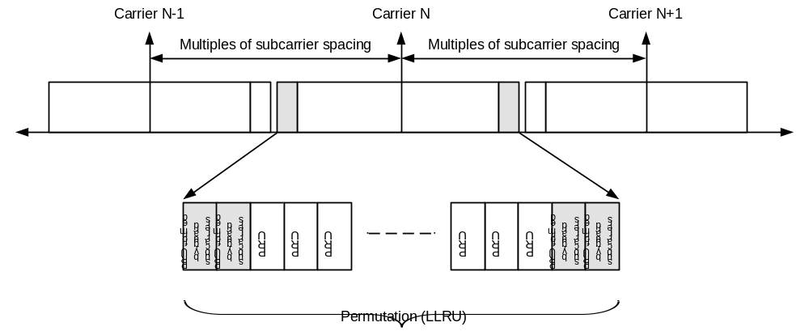s
Figure xxx Example of data transmission using the guard subcarriers

19.3.4 Allocation Scheme for OFDMA Multi-carrier
Allocation signaling is made to indicate the allocation of OFDMA data regions which is defined as a set of LRUs. A modulated symbol sequence of a PHY PDU can be sent through a single carrier (primary or secondary). In this case, there is only one data region for the modulated symbol sequence in a carrier. Additionally, a modulated symbol sequence of a PHY PDU can be segmented for the allocation in LDRU and multiple carriers can deliver the segments through each carrier. In this case, there are multiple data regions for the modulated symbol sequence across multiple carriers. The segmentation is only allowed for the allocation in LDRU. Allocation information indicates a data region or multiple data regions with other parameters like MCS level. When multiple PHY PDUs are transmitted over multiple carriers in a sub-frame, the delivery order is FFS.

For each AMS the allocation information for both its Primary and secondary carriers is sent through the primary carrier, or the allocation information for each carrier is sent through the carrier itself.

19.3.5 Data Regions and Sub-carrier Mapping for OFDMA Multi-carrier Operation
When a modulated symbol sequence is transmitted through one carrier, the sequence is mapped using the same mapping rule of the single carrier mode. When a modulated symbol sequence is segmented, each segment can be mapped to OFDMA data regions over multiple carriers using the algorithms defined below, where logical carrier index is defined as FFS.
- Segment the modulated symbol sequence into blocks sized to fit into a single LRU.
- Map each segmented block onto one LRU from the lowest LRU index in the OFDMA data region of the carrier with the lowest logical carrier index.
- Continue the mapping so that the LRU index increases. When the edge of the data region is reached, continue the mapping from the lowest LRU index in the OFDMA data region of the carrier with the next available logical carrier index.
- Continue the mapping until the all modulated data symbols are mapped.

An example is shown in Figure 2. Within the LRU, subcarrier mapping follows the mapping rule for a single carrier case.
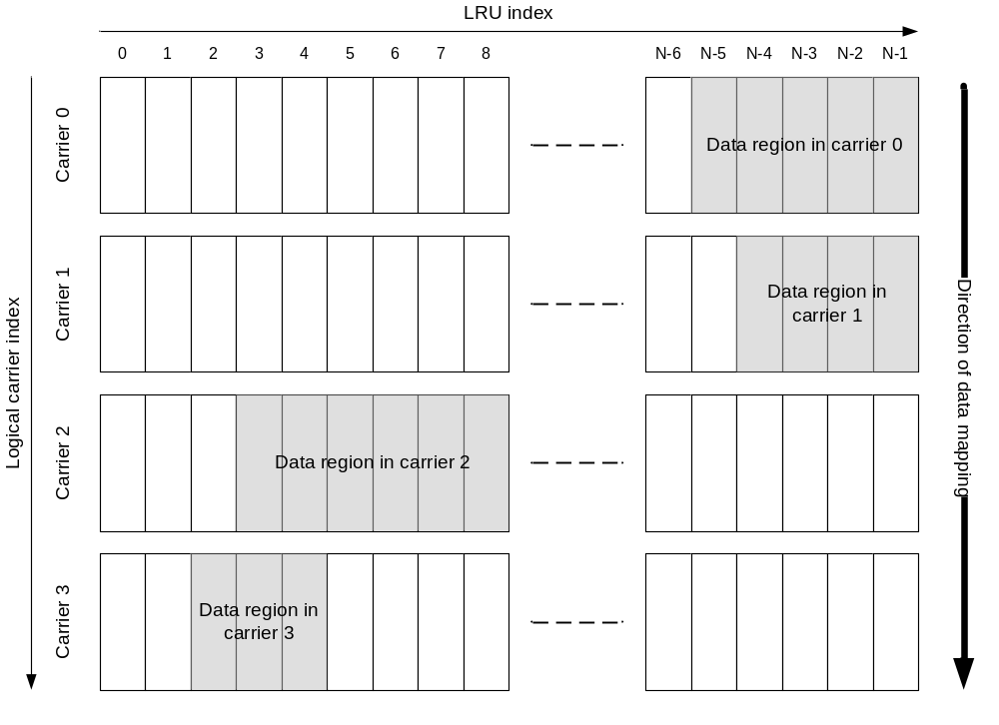

Figure 2 Example of modulated symbol sequence mapping in OFDMA multi-carrier operation

19.3.6 DL Control Structure
All DL controls channel needed for single carrier operation are needed for the fully configured carrier. For partially configured carrier, the BCH, additional broadcast information, USCCH and SCH may have different configuration from those of the fully configured carrier. DL control channels necessary for UL transmission are not present.

Obtaining System Information of Secondary Carriers
• For the case where the AMS can simultaneously decode multiple carriers, the AMS can decode the broadcast channels of its secondary carriers. ABS may instruct the AMS, through control signaling on the primary carrier, to decode broadcast channels of specific set of secondary carriers.
• When the AMS cannot simultaneously decode multiple carriers, the ABS can convey the system information of secondary carriers to AMS, through control signaling on the primary carrier.

19.3.6.1 SCH
Primary and Secondary SCHs are present in a fully configured and partially configured carrier. In a fully configured and partially configured carrier, the location and transmission format of SCH is the same as that of the single carrier described in 11.7.2.1. SCH configuration in the partially configured carrier is FFS.

19.3.6.2 BCH
BCH is present in a fully configured and partially configured carrier. In a fully configured and partially configured carrier, the location and transmission format of PBCH/SBCH is the same as that of single carrier described in section 11.7.2.2. Configuration of BCH in a partially configured carrier is FFS.

19.3.6.3 USCCH
USCCH is present in a fully configured carrier. The location and transmission format of USCCH on the fully configured carrier is the same as that defined in 11.7.2.3.
The presence and use of USCCH on the partially configured carrier is FFS.

19.3.6.4 Additional Broadcast Information
All additional broadcast information related to multicarrier operation is carried with the fully configured carrier. which can be provided on the fully configured carrier should not be transmitted on the partially configured carrier Except uplink information, all additional broadcast information related to operation of partially configured carrier can be carried by the partially configured carrier.

19.3.7 UL Control Structure
All UL controls channel needed for single carrier operation are supported for the fully configured carrier. A partially configured carrier may not does not have any uplink capability as such carrier is, e.g. a secondary carrier configured to be optimized for downlink only transmissions such as multicast and broadcast services.
19.3.7.1 UL Fast Feedback Channel
The ABS configures the set of carriers for which the AMS reports fast feedback information. The ABS may only allocate resource to the AMS on a subset of those configured carriers. Fast feedback information for link adaptation for SIMO and information for MIMO operation can be sent through the primary carrier. The fast feedback information related to the assigned secondary carriers can be carried in those carriers if supported by their configuration.

19.3.7.2 UL HARQ Feedback Channel
HARQ feedback for PHY PDU sent across primary and secondary carriers can be carried in the primary carrier. HARQ feedback for PHY PDU sent in secondary is carried in the secondary if supported by the secondary carrier configuration

19.3.7.3 UL Ranging Channel

UL initial ranging for non-synchronized AMS is conducted on a fully configured carrier. UL periodic ranging for synchronized AMS is conducted on the primary carrier but may also be performed in a secondary carrier if supported by the secondary carrier. The issue of periodic ranging on the secondary carrier, autonomously performed by the AMS or directed by the ABS, is FFS. The serving ABS transmits the ranging response on the same carrier that the UL ranging is received.

19.3.7.4 UL sounding channel
UL sounding is conducted on the primary and secondary carrier.

19.3.7.5 Bandwidth Request Channel
BW request channel is transmitted only on the primary carrier.

19.3.8 UL Power Control
Depending on the correlation between RF carriers, separate controls of UL power for different RF carriers are necessary. Thus, one or multiple power control commands for multiple carriers are supported. Although multiple power control commands are allowed, the power control commands or messages can be sent to AMS through the primary carrier. When a AMS switches to a secondary carrier in carrier switching mode, the secondary carrier can carry power control commands or messages if supported by its configuration.

19.4 MAC Aspect of OFDMA Multi-carrier Operation
The MAC layer in OFDMA multi-carrier mode will operate in the same way as single carrier MAC.

19.4.1 Addressing
There is no difference between a single carrier and OFDMA multi-carrier operation from an addressing perspective as described in sub-clause 10.1.

19.4.2 Security
All the security procedures (Section 10.65) between AMS and ABS are performed using only the AMS’s primary carrier. The security context created and maintained by the procedures is managed per ABS through the primary carrier.

19.4.3 Initial Entry
The AMS attempts initial ranging and network entry only with a fully configured carrier. An AMS needs to know which carrier(s) of the ABS are fully configured carriers. The use of SCH or BCH to indicate whether a carrier is fully or partially configured is FFS.
The following options can be used to help AMS with determining whether it can use a carrier for network entry:
1) A carrier which does not have a SCH can not be used as primary carrier by a AMS. So when an AMS detects a carrier without a SCH the AMS skips the carrier and proceed with scanning and network entry procedure with another carrier.
2) When partially configured carrier includes the SCH, tThe ABS may use a preamble sequence selected from a predefined set of sequences reserved for partially configured carriers. By detecting a preamble sequence designated for partially configured carrier the AMS skips that carrier and proceed with scanning and selection of alternative carrier.
Once the AMS detects the SCH on a fully configured carrier, the AMS may proceed with reading BCH or Extended system parameters and system configuration information where the ABS indicates its configuration, its support for multicarrier feature, as well as other carriers configuration information, which are FFS. The AMS can decide on proceeding with network entry with the current carrier or going to alternative carriers based on this information.
Once a candidate primary carrier is determined the initial network entry procedures are the same as in single carrier mode. The carrier on which the AMS successfully performs initial network entry becomes the primary carrier of the AMS. After successful ranging, the AMS follows the capability negotiation procedure in which it provides ABS with its OFDMA multi-carrier capabilities, such as carrier aggregation or carrier switching. The ABS may provide configuration parameters of other carriers to the AMS. The ABS may assign secondary carriers to the AMS, through negotiation with the AMS.
The AMS may omit UL ranging (for time/frequency synchronization and power adjustment purpose) with secondary carrier. In this case, AMS uses the same timing, frequency and power adjustment information for the secondary carrier as in the primary carrier. The AMS may perform fine timing/frequency/power adjustment on the secondary carrier through measuring the sync channel and/or pilot on the secondary carrier. The AMS may perform UL ranging with secondary carrier. In this case, power adjustment results in the primary carrier may be used as initial transmission power for UL ranging over the secondary carrier. The use of dedicated ranging resource received from the primary carrier to enhance the ranging in the secondary carrier is FFS.
----------------------------------------------------------End of the Text----------------------------------------------------------

