Project | IEEE 802.16 Broadband Wireless Access Working Group <http://ieee802.org/16>
Title | Proposed Changes on the Transmission of AAI_E-MBS-CFG in IEEE P802.16m (16.9.3.1 & 16.3.6.2.3)
Date Submitted | 2010-04-30
Source(s) | Eunkyung Kim, Soojung Jung, Jaesun Cha, Sungcheol Chang, Hyun Lee, Chulsik Yoon  ETRI  138 Gajeongno, Yusong-gu, Daejeon, 305-700, KOREA | Voice: +82-42-860-5415  E-mail: ekkim@etri.re.kr
Re: | “P802.16m/D5,” in response to the IEEE 802.16 Working Group Letter Ballot Recirc #31a: Announcement, IEEE 802.16-10/0032
Abstract | Transmission of AAI_E-MBS-CFG message supporting E-MBS on IEEE 802.16m Amendment Draft Standard
Purpose | To discuss and adopt the proposed text in the next revision of 802.16m draft
Notice | This document does not represent the agreed views of the IEEE 802.16 Working Group or any of its subgroups. It represents only the views of the participants listed in the “Source(s)” field above. It is offered as a basis for discussion. It is not binding on the contributor(s), who reserve(s) the right to add, amend or withdraw material contained herein.
Release | The contributor grants a free, irrevocable license to the IEEE to incorporate material contained in this contribution, and any modifications thereof, in the creation of an IEEE Standards publication; to copyright in the IEEE’s name any IEEE Standards publication even though it may include portions of this contribution; and at the IEEE’s sole discretion to permit others to reproduce in whole or in part the resulting IEEE Standards publication. The contributor also acknowledges and accepts that this contribution may be made public by IEEE 802.16.
Patent Policy | The contributor is familiar with the IEEE-SA Patent Policy and Procedures:  <http://standards.ieee.org/guides/bylaws/sect6-7.html#6> and <http://standards.ieee.org/guides/opman/sect6.html#6.3>.  Further information is located at <http://standards.ieee.org/board/pat/pat-material.html> and <http://standards.ieee.org/board/pat>.

Proposed Changes on the Transmission of AAI_E-MBS-CFG in IEEE P802.16m (16.9.3.1 & 16.3.6.2.3)
Eunkyung Kim, Soojung Jung, Jaesun Cha, Sungcheol Chang, Hyun Lee, Chulsik Yoon
ETRI

Instructions
IEEE 802.16m Amendment Draft Standard [1] describes the Enhanced Multicast Broadcast Service (E-MBS).
According to the IEEE 802.16m Amendment Draft Standard [1], AAI_E-MBS-CFG shall be advertised in the superframe before the beginning of the largest MSI (16superframes).
However, it is a little bit inefficient because the AMS in idle mode or sleep mode should receive all frame of the superframe before the beginning of the largest MSI.
Therefore, in order to enhance the power saving for the AMS, the location should be predefined some specific location. Figure 1 shows the proposed location of the AAI_E-MBS-CFG which is transmitted at the first frame of the start MSI. In order to support the proposed contribution, the multicast RUs should exclude those of the unicast region and the E-MBS MAP is transmitting the subsequent frame of the unicast region in unit of frame.

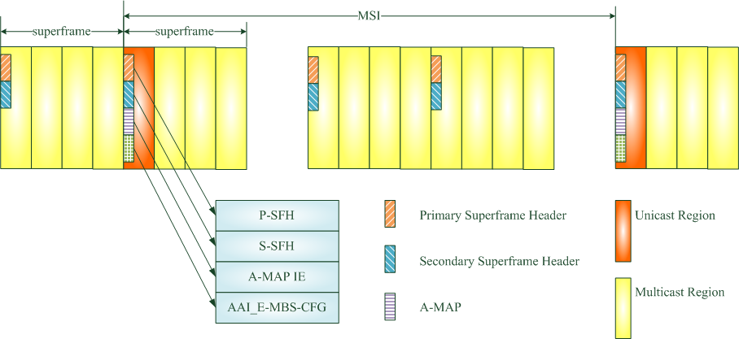
Figure 1 – Transmission of the AAI_E-MBS-CFG

Text Proposal for the 802.16m Amendment Draft Standard
Note:
The text in BLACK color: the existing text in the 802.16m Amendment Draft Standard
The text in RED color: the removal of existing 802.16m Amendment Draft Standard Text
The text in BLUE color: the new text added to the 802.16m Amendment Draft Standard Text

[-------------------------------------------------Start of Text Proposal---------------------------------------------------]

[Remedy1: Modify the following text in 16.9.3.1 of 802.16m/D5]
16.9.3.1 E-MBS Configuration Indicators
The information regarding E-MBS configuration is transmitted periodically to the AMSs interested in E-MBS using a MAC control message called the AAI-E-MBS_CFG message. The E-MBS configuration indicators specify the resources reserved for E-MBS traffic in the downlink physical resources and additional information necessary for E-MBS operation.
The E-MBS configuration information necessary for E-MBS operation include E-MBS-Zone_IDs of serving and neighboring ABSs, E-MBS MAP time offset (frequency offset), E-MBS MAP resource allocation, E-MBS MAP I_{size-offset}, E-MBS MAP MIMO Mode and E-MBS ID and FID mappings between serving E-MBS Zone and neighboring E-MBS Zone for the same content. AAI_E-MBS-CFG shall be advertised in the superframe before 1st frame at the beginning of the largest MSI (16 superframes) as shown in Figure XXX.

Figure XXX – Transmission of AAI_E-MBS-CFG message
Table 974—AAI_E-MBS-CFG message Format
Syntax | Size (bits) | Notes
AAI-E-MBS-CFG_Message_Format() {
MAC Control Message Type | 8 | AAI_E-MBS-CFG
E-MBS_CFG_LIFETIME (m) | 4 | Indicates the duration of E-MBS_CFG_LIFETIME for which the E-MBS configuration information of the zone do not change.  Duration of E-MBS_CFG_LIFETIME:  16×(m+1) superframes
for (i = 0; i< Num_E-MBS_Zones; i++) {
E-MBS_Zone_ID | 7 | The EMBS_Zone_ID to which this EMBS MAP applies.
E-MBS MAP Resource Index | 11 | Resource index includes location and allocation size.
E-MBS MAP ISizeOffsetI_{SizeOffset} | 5 | Offset used to compute burst size index
E-MBS ID and FID Mappings List inclusion | 1 | Indicates whether E-MBS ID and FID Mapping list is included or not  0b0: No Zone boundary or Zone boundary but no inter-zone service continuity in neighbor ABS  0b1: Zone boundary and inter-zone service continuity
if (E-MBS ID and FID Mappings List inclusion ==1) {
E-MBS ID and FID Mappings List | Variable | E-MBS ID and FID Mappings List between serving and neighbor E-MBS Zones
}
Extension Flag | 1 | Used to indicate the remaining part of the AAI_E-MBS-CFG message exists  0b0: there is no remaining part of the AAI_E-MBS-CFG in the subsequent subframe of the frame  0b1: the remaining part of the AAI_E-MBS-CFG message will be transmitted in the subsequent subframe of the frame
}
}

[Remedy2: Modify the following text in 16.3.6.2.3 of 802.16m/D5]
16.3.6.2.3 Enhanced Multicast Broadcast Service MAP (E-MBS MAP)
The E-MBS MAP carries configuration information for enhanced multicast broadcast service for one E-MBS Zone. The E-MBS MAP is transmitted in the first several RUs of the E-MBS region in subsequent frame of the superframe where AAI_E-MBS-CFG MAC control message described in 16.9.3.1 is transmitted at the beginning of the MSI. The parameters of the E-MBS region and the burst size of the E-MBS MAP is transmitted in the AAI_E-MBS-CFG MAC control message described in 16.9.3.1. AAI_E-MBS-CFG Change Indication indicates any change in the parameters of AAI_E-MBS-CFG MAC Control Message at its next transmission instance.

[-------------------------------------------------End of Text Proposal----------------------------------------------------]

References
- IEEE P802.16m/D5, “DRAFT Amendment to IEEE Standard for Local and metropolitan area networks; Part 16: Air Interface for Broadband Wireless Access systems; Advanced Air Interface,” April 2010

