Project | IEEE 15.4a
Title | Coexistence assurance information for the CSS part of 15.4a
Date Submitted | 26 April 2006
Source | [Rainer Hach]  [Nanotron Technologies GmbH  Alt-Moabit 61, 10555 Berlin, Germany]  [Kyung-Kuk Lee ]  [Orthotron Co., Ltd.  709 Kranz Techno, 5442-1 Sangdaewon-dong, Jungwon-gu, Sungnam-si, Kyungki-do, Korea 462-120] | Voice : [+49 30 399 954 0]  Fax : [+49 30 399 954 288]  E-mail : [r.hach@nanotron.com]  Voice : [+82 31 777 8198]  Fax : [+82 31 777 8199]  E-mail : [kyunglee@orthotron.com]
Re: | []
Abstract | This document shows results of coexistence calculations
Purpose | Provide information on on Coexistence performance of CSS at 2450 MHz
Notice | This document has been prepared to assist the IEEE P802.15. It is offered as a basis for discussion and is not binding on the contributing individual(s) or organization(s). The material in this document is subject to change in form and content after further study. The contributor(s) reserve(s) the right to add, amend or withdraw material contained herein.
Release | The contributor acknowledges and accepts that this contribution becomes the property of IEEE and may be made publicly available by P802.15.

This doument is the Coexistence assurence document for the CSS part of D2 of 802.15.4a. It is meant to provide information which was missing in annex E of D1 of 15.4 and as a baseline for an coexistence annex of future revisions of 15.4a.

Annex E (informative) Coexistence with other IEEE standards and proposed standards

While not required by the specification, IEEE 802.15.4 devices can be reasonably expected to “coexist,” that is, to operate in proximity to other wireless devices. Sections E.1 to E.4 of this annex consider issues regarding coexistence between IEEE 802.15.4 devices and other wireless IEEE-compliant devices. These sections also consider issues regarding coexistence between IEEE P802.15.4a CSS devices and other wireless IEEE-compliant devices.

Insert the following text in the introduction
With more and more radio services using the spectrum, coexistence is becoming a key issue. The IEEE 802.19 TAG established some new procedures in 2005 which include the requirement for a Coexistence Assurance document from any IEEE 802 WG or TG drafting a new standard. Added sections in the present Annex address (sections E5 to E10) the coexistence between UWB 802.15.4a devices and other wireless IEEE-compliant devices.

E.1 Standards and proposed standards characterized for coexistence with IEEE 802.15.4 and 802.15.4a CSS devices
Add the following text at the end of E.1:

This clause also enumerates IEEE-compliant devices that are characterized and the devices that are not characterized for operation in proximity to IEEE P802.15.4a CSS devices.

IEEE P802.15.4a CSS PHYs for the 2400 MHz ISM Band are specified for operation in 14 channels. Channel 0 through channel 13 reside in frequencies from 2412 MHz to 2484 MHz bands and, therefore, may interact with other IEEE compliant devices operating in those frequencies.

Standards and proposed standards characterized in this annex for coexistence are:
IEEE Std 802.11b-1999 (2400 MHz DSSS)
IEEE Std 802.15.1-2002 [2400 MHz frequency hopping spread spectrum (FHSS)]
IEEE Std 802.15.3-2003 (2400 MHz DSSS)
IEEE Std 802.15.4-2003 (2400 MHz DSSS)
IEEE P802.15.4a (2400 MHz CSS)

Standards not characterized in this annex for coexistence are:
IEEE Std 802.11, 1999 Edition, frequency hopping (FH) (2400 MHz FHSS)
IEEE Std 802.11, 1999 Edition, infrared (IR) (333GHz AM)
IEEE Std 802.16-2001 (2400 MHz OFDM)
IEEE Std 802.11a-1999 (5.2GHz DSSS)

Replace

E.2 General coexistence issues
with

E.2 General coexistence issues for IEEE 802.15.4 and 802.15.4a CSS devices

Add the following section after E.2.6:

E.2.6a Channel alignment
The alignment between IEEE 802.11b (nonoverlapping sets) and IEEE P802.15.4a CSS channels (overlapping sets) are shown in Figure E.2.6.1. There are 14 IEEE P802.15.4a CSS channels (n = 0, 2, … , 13). Operating an IEEE P802.15.4a network on one of these channels will minimize interference between systems.

When performing dynamic channel selection, either at network initialization or in response to an outage, an IEEE P802.15.4a CSS device will scan a set of channels specified by the ChannelList parameter. For IEEE P802.15.4a networks that are installed in areas known to have high IEEE 802.11b activity, the ChannelList parameter can be defined from the above set in order to enhance the coexistence of the networks.

2412 2417 2422 2427 2432 2437 2442 2447 2452 2457 2462 2467 2472 2484
Figure E.2.6.1— IEEE P802.15.4a CSS channel selection

Replace

E.3 Coexistence performance
wth

E.3 Coexistence performance for IEEE 802.15.4 and 802.15.4a CSS devices

Add the following sentence :
Subclauses E.3.2 and E.3.3 also describe the assumptions made for individual standards and quantify their predicted performance when coexisting with IEEE P802.15.4a CSS devices.

E.3.1.2 Receiver sensitivity
Add the following text to E.3.1.2:
The receiver sensitivity assumed is the reference sensitivity specified in each standard as follows:
-76 dBm for IEEE 802.11b 11 Mb/s CCK
-70 dBm for IEEE 802.15.1
-75 dBm for IEEE P802.15.3 22 Mb/s DQPSK
-85 dBm for IEEE 802.15.4
-85 dBm for IEEE 802.15.4a 1 Mb/s CSS
-91 dBm for IEEE 802.15.4a 250 kb/s CSS

E.3.1.3 Transmit power
Add the following text to E.3.1.3:
The transmitter power for each coexisting standard has been specified as follows:
14 dBm for IEEE 802.11b
0 dBm for IEEE 802.15.1
8 dBm for IEEE 802.15.3
0 dBm for IEEE 802.15.4
0 dBm for IEEE P802.15.4a (both 1Mb/s and optional 250 kb/s)

E.3.1.4 Receiver bandwidth
The receiver bandwidth is as required by each standard as follows:
a) 22 MHz for IEEE 802.11b
b) 1 MHz for IEEE 802.15.1
c) 15 MHz for IEEE P802.15.3
d) 2 MHz for IEEE 802.15.4
Add the following bullet to the list :
e) 22 MHz for IEEE P802.15.4a

E.3.1.5 Transmit spectral masks
Add the following Table :

Table E.3.1.5.1—Transmit mask for IEEE P802.15.4a CSS
Frequency | Relative limit
fc – 22 MHz < f < fc – 11 MHz and  fc + 11 MHz < f < fc + 22 MHz | –30 dBr
f < fc – 22 MHz and  f > fc + 22 MHz | –50 dBr

E.3.1.8 Bit error rate (BER) calculations
Add the following bullet :
8) BER for IEEE 802.15.4a CSS =
$$\begin{aligned} \\ \left[\left(M−2\right)×Q\left(\sqrt{{\text{SNR}}_{0}×{\text{log}}_{2}M}\right)+Q\left(\sqrt{{\text{SNR}}_{0}×2{\text{log}}_{2}M}\right)\right]/2 \\ \text{where}{\text{ SNR}}_{0}=\text{SNR}×\text{14}×\text{ 1}\text{.}\text{6667, M}=\text{8 for 1 Mb/s,} \\ {\text{ SNR}}_{0}=\text{SNR}×\text{14}×\text{ 1}\text{.}\text{6667}×\text{4, M}=\text{64 for 250 Kb/s}\end{aligned}$$

E.3.1.9 PER
Add the following bullet :
- Average frame length for IEEE P802.15.4a CSS = 32 bytes
- Unless states otherwise the average frame length of all other standards interfered by CSS is assumed to be 32 bytes
- Unless states otherwise the transmit duty cycle of all other standards intering with CSS is assumed to be 100%

E.3.2.1 BER model for IEEE802.15.4a
Modify the numbering of Figure E.2 mentioned above to Figure E.3.2.1, and add the following text :
Figure E.3.2.2 illustrates also the relationship between BER and SNR for IEEE 802.11b, IEEE 802.15.3 base rate, IEEE 802.15.1, IEEE 802.15.4, and IEEE P802.15.4a CSS.

Note: Since 11b and 11g use the same frequency channel plan, the coexistence performance between CSS and 11g is comparable with the coexistence performance between CSS and 11b.
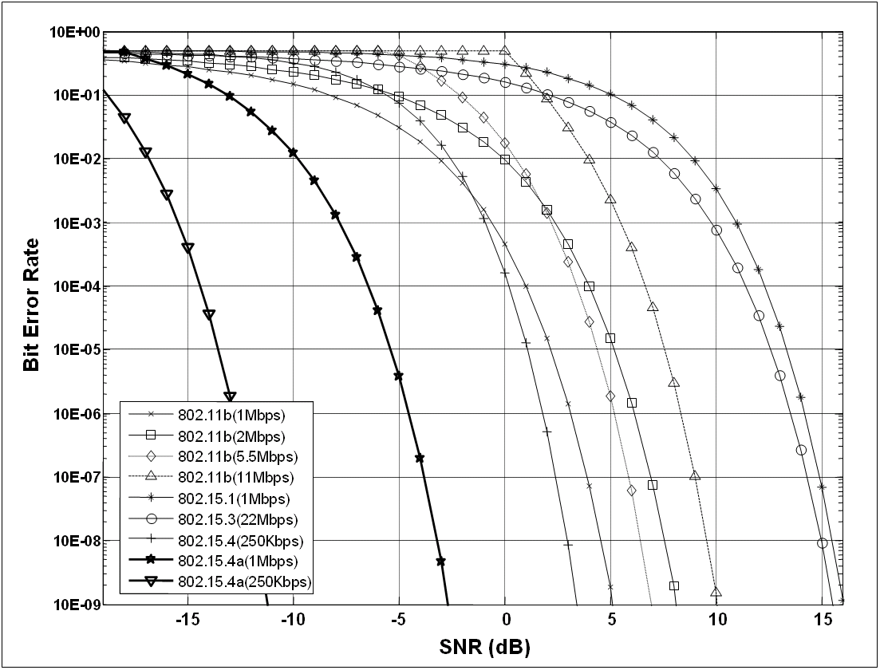
Figure E.3.2.2—BER Results of IEEE 802.11b, IEEE 802.15.1, IEEE 802.15.3, IEEE 802.15.4 (2400 MHz PHY) and IEEE P802.15.4a CSS

E.3.3 Coexistence simulation results
Modify "E.3.3.1 Transmit and receive masks" as follows :
The transmit and receive masks used are defined in Table E.3.3.1

Table E.3.3.1 – Transmit and receive masks

IEEE802 | Transmit |  | Receive
IEEE802 | Frequency offset (MHz) | Attenuation  (dB) | Frequency offset  (MHz) | Attenuation  (dB)
15.1 | 0 | 0 | 0 | 0
15.1 | 0.25 | 0 | 0.25 | 0
15.1 | 0.75 | 38 | 0.75 | 38
15.1 | 1 | 40 | 1 | 40
15.1 | 1.5 | 55 | 1.5 | 55
11b | 0 | 0 | 0 | 0
11b | 4 | 0 | 4 | 0
11b | 6 | 10 | 6 | 10
11b | 8 | 30 | 8 | 30
11b | 9 | 55 | 9 | 55
15.4 | 0 | 0 | 0 | 0
15.4 | 0.5 | 0 | 0.5 | 0
15.4 | 1 | 10 | 1 | 10
15.4 | 1.5 | 20 | 1.5 | 20
15.4 | 2 | 25 | 2 | 25
15.4 | 2.5 | 30 | 2.5 | 30
15.4 | 3 | 31 | 3 | 31
15.4 | 3.5 | 33 | 3.5 | 33
15.4 | 4 | 34 | 4 | 34
15.4 | 5 | 40 | 5 | 40
15.4 | 6 | 55 | 6 | 55
15.4a - CSS | 0 | 0 | 0 | 0
15.4a - CSS | 6 | 0 | 6 | 0
15.4a - CSS | 12 | 32 | 12 | 32
15.4a - CSS | 15 | 55 | 15 | 55

Note on duty cycle assumptions:
The assumption of 1 % duty cycle for 15.4a devices was introduced in 15-05-0632-00-004b-coexistence-assurance-802-15-4b.doc, page 5. Under the assumption that 4a devices aare battery powered and have a life time of at least one year, the 1 % assumption can be hardened by taking into account state of the art numbers: A typical AA battery has a capacity of 1.8 Ah. A typical 15.4 device operating at 2.4 GHz has a Tx current of 30 mA. If the device only transmits during its entire life time the result would be 30/1800=60h of operation. Over a life time of one year =365*24h=8760h the duty cycle would be 0.0068 which is clearly below 1%. In reality traffic generated by several nodes will accumulate. On the other hand a significant part of the battery power will be spent in receive mode (which requires more current than the transmit mode for many implementations). Thus the 1% duty cycle also is valid for networks of 4a devices.

Add the following graphs :
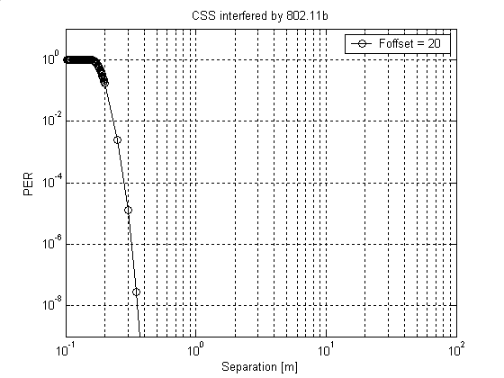
Figure E.3.3.1 —IEEE P802.15.4a CSS receiver (1Mbps), IEEE 802.11b interferer

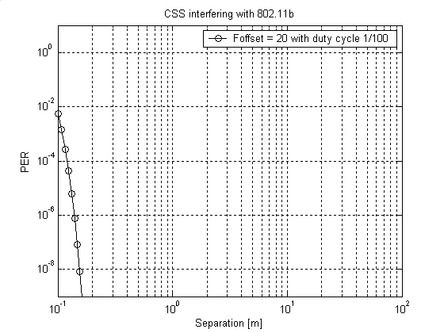
Figure E.3.3.2 —IEEE 802.11b receiver, IEEE P802.15.4a CSS interferer

Note: If CSS and 802.11b/11g are operated at the same location and at the same center frequency the coexistence performance will mainly be determined by the duty cycle parameters of the two systems. It is expected though that such situations will be avoided by the frequency selection techniques which are implemented in state of the art wireless protocol layers.

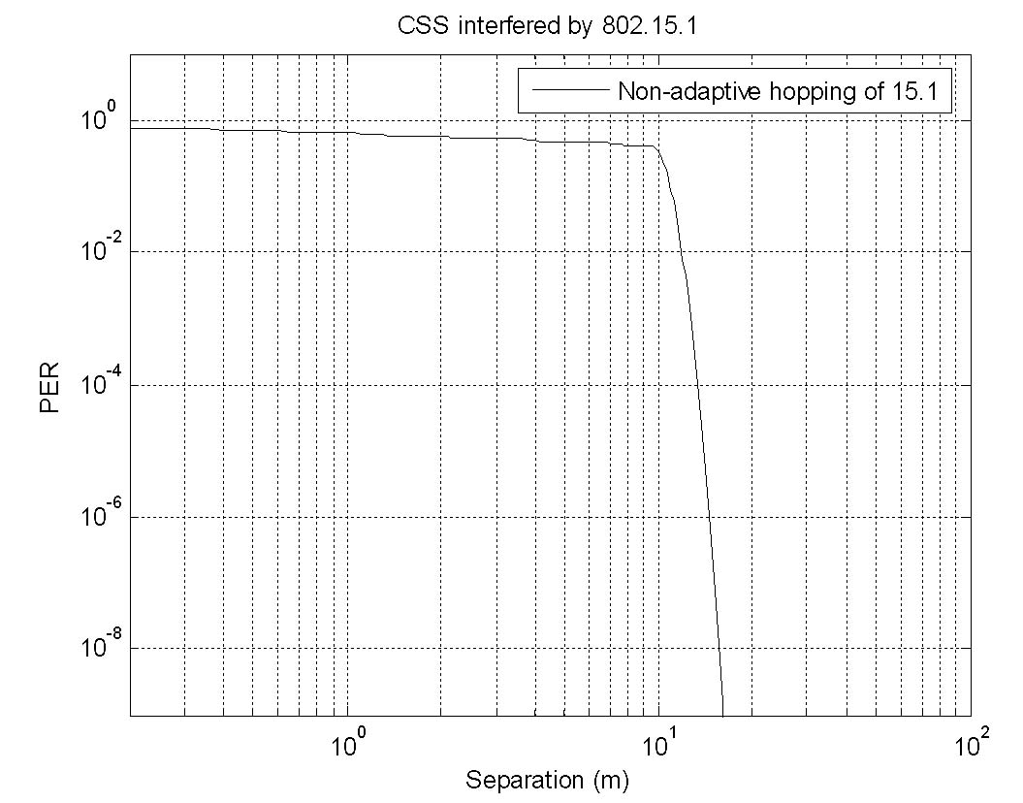

Figure E.3.3.3 —IEEE P802.15.4a CSS receiver (1Mbps), IEEE 802.15.1 interferer

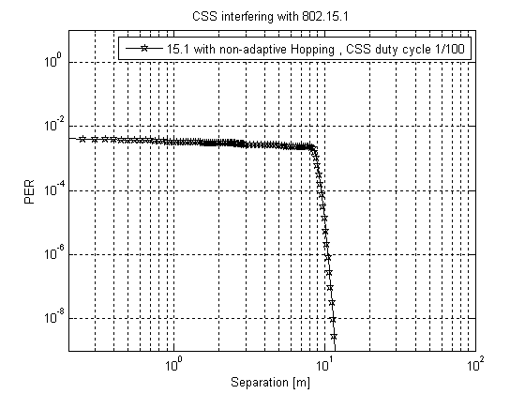
Figure E.3.3.4 —IEEE 802.15.1 receiver, IEEE P802.15.4a CSS interferer

Figure E.3.3.5 —IEEE P802.15.4a CSS receiver (1Mbps), IEEE 802.15.3 interferer

Figure E.3.3.6 —IEEE 802.15.3 receiver, IEEE P802.15.4a CSS interferer
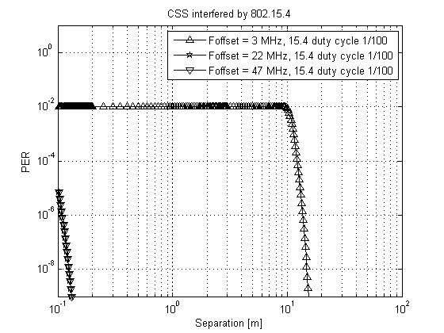
Figure E.3.3.7 —IEEE P802.15.4a CSS receiver (1Mbps), IEEE 802.15.4 interferer

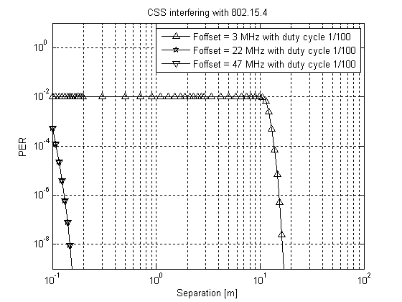
Figure E.3.3.8 —IEEE 802.15.4 receiver, IEEE P802.15.4a CSS interferer
Coexistence with 11g
Three modes of 11g are considered:
1) OFDM, 6 MBits/s, BPSK, 5.7dB Coding Gain

2) OFDM, 24 MBits/s, M-ary QAM, M=16, Coding Gain: Cg=5.7dB
3) OFDM, 54 MBits/s, M-ary QAM, M=64, Coding Gain: Cg=3.8dB

For mode 1) the BER is assumed as:
$$\text{BER}(M=2)=Q\left(\sqrt{2⋅\frac{E_{b}}{N_{0}}⋅{\text{10}}^{\frac{5\text{.}7}{\text{10}}}}\right)$$
while from equations for M-ary QAM given by [Proakis: Digital Communications, Third Edition, McGraw-Hill, 1995] the BER for 2) and 3) is assumed as:
$$\text{BER}(M,\text{Cg})=1−{\left[1−2⋅\left(1−\frac{1}{\sqrt{M}}\right)⋅Q\left(\sqrt{\frac{3}{M−1}⋅\frac{{\text{log}}_{2}(M)⋅E_{b}}{N_{0}}⋅{\text{10}}^{\frac{\text{Cg}}{\text{10}}}}\right)\right]}^{2⋅\frac{1}{{\text{log}}_{2}(M)}}$$
Eb/N0 is calculated from the subcarrier spacing F_{S} = 0.3125 MHz and the OFDM symbol rate R_{S}=0.25 MHz as:
$$\text{SNR}=\frac{E_{b}}{N_{0}}⋅\frac{F_{S}}{R_{S}}$$

The size of 11g packets is assumed as 1500 bytes. In this analysis this number has some impact on the PER performance of CSS interfering with 11g, since the PER is computed from the BER.

The duty cycle of 11g is assumed as 50 %. Since this analysis is restricted to PER calculations instead of throuphput calculations this number has some impact only on the PER performance of CSS interfering with 11g.
