Project | IEEE 802.21 MIHS  <http://www.ieee802.org/21/>
Title | Events generated by MIH Users
DCN | 21-07-xxxx-00-0000-MIH_User_generated_events.doc
Date Submitted | 3rd January 2007
Source(s) | Albert Vidal (albert.vidal@netlab.nec.de)  Telemaco Melia (telemaco.melia@netlab.nec.de)  Albert Banchs (banchs@it.uc3m.es)  Antonio de la Oliva (aoliva@it.uc3m.es)
Re: | IEEE 802.21 Session #NN in January 2007
Abstract | This document presents a proposal for supporting MIH users events generation
Purpose | Discussion and modification of the current text.
Notice | This document has been prepared to assist the IEEE 802.21 Working Group. It is offered as a basis for discussion and is not binding on the contributing individual(s) or organization(s). The material in this document is subject to change in form and content after further study. The contributor(s) reserve(s) the right to add, amend or withdraw material contained herein.
Release | The contributor grants a free, irrevocable license to the IEEE to incorporate material contained in this contribution, and any modifications thereof, in the creation of an IEEE Standards publication; to copyright in the IEEE’s name any IEEE Standards publication even though it may include portions of this contribution; and at the IEEE’s sole discretion to permit others to reproduce in whole or in part the resulting IEEE Standards publication. The contributor also acknowledges and accepts that IEEE 802.2 may make this contribution public.
Patent Policy | The contributor is familiar with IEEE patent policy, as outlined in Section 6.3 of the IEEE-SA Standards Board Operations Manual <http://standards.ieee.org/guides/opman/sect6.html#6.3> and in Understanding Patent Issues During IEEE Standards Development <http://standards.ieee.org/board/pat/guide.html>.

Introduction

In this document we propose to extend the Event Service of 802.21 to support also events generated by MIH Users. The current specification explicitly defines the Event Service as a communication exclusively originated from Link Layers to MIHF or from MIHF to MIH users.

Motivation for MIH User generated events

Let us illustrate the necessity of MIH User generated events with the following two examples.

Mobility-aware applications

A mobility aware transport protocol, such as a variant of TCP, could freeze the congestion window until the L3 handover is complete. Also, a VoIP application may change the codec adapting its transfer rate to the new conditions.

The current specification notifies applications (defined as MIH Users) that a connection is re-established after a handover, by means of a link event. However, link events can only inform about L2 connectivity, which does not mean that applications can really transmit packets end-to-end. Although L2 connectivity might be already established, this does not mean that applications established the L3 connectivity.

In order to provide applications with L3 connectivity information, events need to be generated by MIH Users, since this type of information is available at the upper layers (e.g. layer 3). Such event generated by the upper layers may provide valuable information to mobility aware applications, like e.g. to transport protocols which could adapt to the imminent handover.

Other applications that may benefit from this information can be VoIP or video, which may react upon the lack of layer 3 connectivity.

Triggers received by decision engines

The decision engine may benefit from higher layers events. Mobility management protocols may notify the decision engine of the current status of the layer 3 (and upper) connection.

Also, the operating system may notify the decision engine of the battery status computed by an MIH User. The decision engine may not perform a handover to specific technologies (more power demanding than the current one) if the battery reaches certain threshold.

Decision engines at the mobile terminal (defined as MIH Users), responsible for taking handover decisions, may also benefit from any other information from other MIH users that may provide the decision engine with the necessary information in order to take handover decisions. For instance, the decision engine might initiate a handover to another access technology in case the user has initiated a new application that requires more bandwidth than the offered by the current access technology.

Amendments to the current draft

In page 18:

5.3.1 Media Independent Event Service

Events may indicate changes in state and transmission behavior of the physical, data link, logical link layers and upper layers, or predict state changes of these layers. The Event Service may also be used to indicate management actions or command status on part of network or some management entity.

5.3.1.1 Event Origination

Events may originate from the MIHF (MIH Events), any lower layer (Link Events) or any upper layer (MIH User Events) within the protocol stack of a client device.

5.3.1.2 Event Destination

The destination of an event may be the MIHF or any upper layer entity. The recipient of the event may be located within the stack that originated the event or within a remote stack. The destination of an event is established dynamically with a subscription mechanism that enables an endpoint to subscribe its interest in particular event types.

5.3.1.3 Event Service Flow

In case of local events, messages often propagate from the lower layers (PHY, MAC, GMM...) to the MIHF and from MIHF to any upper layer. In case of remote events, messages propagate from the MIHF in one stack to the MIHF in the peer stack. Events may then be further propagated to any upper layer. Events may also be originated in a MIH user (upper layer) and be propagated to another local or remote MIH user. One of the stacks may be present in a client or mobile node while the other may be present in a fixed network entity. This network entity may be a point of attachment or any node not directly connected to the other stack.

In page 38:

6.2 Media Independent Event Service

6.2.1 Introduction

In general handovers may be initiated either by the mobile node or by the network. Events that may be relevant to handover may originate from MAC, PHY, MIHF or MIH Users either at the mobile node or at the network point of attachment. Thus, the source of these events may be either local or remote. A transport protocol is needed for supporting remote events. Security is another important consideration in such transport protocols.

Multiple higher layer entities may be interested in these events at the same time. Thus these events may need to have multiple destinations. Higher layer entities may subscribe to receive event notifications from a particular event source. The MIHF may help in dispatching these events to multiple destinations.

These events are treated as discrete events. As such there is no general event state machine. However, in certain cases a particular event may have state information associated with it, such as the Link_Going_Down event discussed below. In such cases the event may be assigned an identifier and other related events may be associated with the corresponding event using this identifier.

From the recipient’s perspective these events are mostly “advisory” in nature and not “mandatory”. In other words, the recipient is not obligated to act on these events. Layer 3 and above entities may also need to deal with reliability and robustness issues associated with these events. Higher layer protocols and other entities may prefer to take a more cautious approach when events originate remotely as opposed to when they originate locally. These events may also be used for homogeneous handovers.

The Event Service may be broadly divided into two categories, Link Events and MIH Events. Link Events may transverse from a lower to a higher layer, MIH Events may transverse either from a lower to higher layer or from a higher layer to another higher layer. Link Events are defined as events that originate from event source entities below the MIHF and may terminate at the MIHF. Entities generating Link Events include but are not restricted to various IEEE 802-defined, 3GPP-defined and 3GPP2-defined interfaces. Within the MIHF, Link Events may be further propagated, with or without additional processing, to upper layer entities that have subscribed for the specific event. Events that are propagated by the MIHF to the MIH users are defined as MIH Events. This relationship is shown in Figure 15.

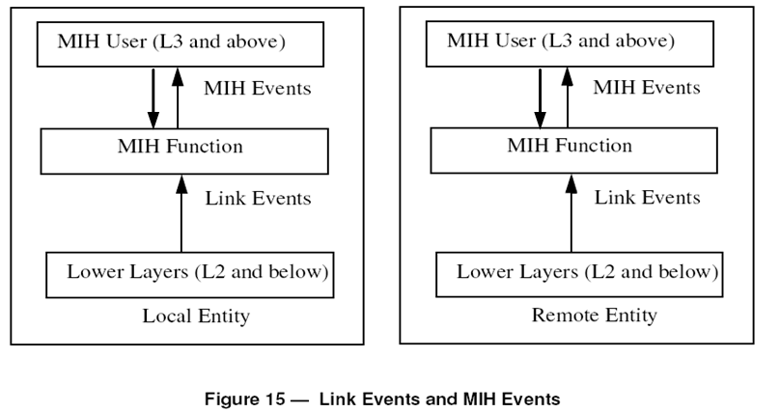

6.2.2 Event Categories

The Media Independent Event Service supports several categories of events:

1) MAC and PHY State Change events: These events correspond to changes in MAC and PHY state. These events correspond to definite changes in state. For example Link_Up event is an example of a state change event.

2) Link Parameter events: These events are due to change in link layer parameters. These events are triggered either synchronously (i.e. on a regular basis) or asynchronously (i.e. when the value of a given link layer parameter crosses a specified threshold). For example, the primitive Link_Parameters_Report is a Link Parameter event.

3) Predictive events: Predictive events express the likelihood of change in the link properties in the future based on past and present conditions. For example, decay in signal strength of WLAN network may indicate loss of link connectivity in near future. Since they attempt to predict the future, they may be incorrect and hence there is a need to retract predictive events. Predictive events may carry predictive information including a time bound, specifying the time interval in which the event is expected to occur and a level of confidence that the event shall occur in the specified time bound.

4) Link Synchronous events: These events give indications to MIH users about link layer activities (not related to any MAC/PHY state change) that are relevant in upper layer mobility management decision making. These events give indications of precise timing of L2 handover events that are useful to upper layer mobility management protocols. Link Synchronous events differ from Link State Change events in that they do not necessarily report a link state change that has occurred in the past. These events also differ from Predictive events in that they are deterministic and do not predict any future link state change that is only a possibility. An example of Link Synchronous event is the native link layer L2 handover/switching event that exists in many media types (e.g., Cellular, 802.16e). Native link layer handover/switching decision is deterministic and is made and executed autonomously at link layer, independent of the upper layer mobility management function. Indicating the occurrence of these link layer handover/ switching events to MIH users facilitates upper layer mobility management decision making.

5) Link Transmission events: These events indicate the transmission status (e.g., success or failure) of higher layer PDUs by the link layer. This information may be used by upper layer to improve buffer management for achieving low-loss or no loss handovers. For example, the occurrence of a handover of a mobile node, from one access network to another will result in the reestablishment of a link layer connection to the target access network. When this occurs the upper layer may still have data that had been transmitted over the old link but has not been received by the receiver (e.g. the contents of the outstanding transmit and retransmit MAC ARQ queues in the old access network as well as the mobile node that need to be flushed out during the handover). This data will be lost because of the handover. If low-loss or no loss handover is desired, then MIH users will attempt to retransmit any lost data over the new link. But, before the retransmission may occur, the upper layer needs to first identify the lost data and then re-tag them in their internal buffers, including updating (if necessary) the source/destination IP addresses and re-fragmentation if the MTU of the new link demands so. The upper layer normally has to rely on the use of retransmission timer and end-to-end feedback (such as the ACK in the application or transport layer) to identify lost packets. The latency of this lost data detection based on retransmission time-out and end-to-end feedback often becomes a limiting factor to the handover performance as well as the overall data throughput, especially for timesensitive applications operating over wireless links with long round-trip delay times. Link Transmission events may significantly facilitate this process in the upper layer by providing a fast local indication on whether a particular PDU has been successfully transmitted over the link or not. This helps the upper layer to quickly identify lost packets and prepare for selective retransmission of the lost data if needed, without waiting for a retransmission timer expiration or end-to-end feedback.

6) MIH User Event: These events are generated from the MIH users and their destination usually is another MIH User. After a handover, L2 connectivity is re-established after some time, and L3 connectivity is also re-established after some additional time. The instant of time after which stations have an end-to-end connectivity corresponds to the latter. Therefore, this kind of events generated by the upper layers can help to improve handover performance e.g. by sending an event to mobility aware applications or to TCP entities when connectivity is re-established after a handover.

6.2.3 Local and Remote Events

Local events are propagated across different layers within the local stack of a device. All link events are local in nature. Remote events are indications that traverse across the network medium from one MIHF to a peer MIHF. MIH events may be local or remote. Remote MIH events originate at remote MIHF. They traverse the medium to the local MIH Function and are then dispatched to MIH Users that have subscribed to these events within the local stack as shown in Figure 16. This is with the assumption that the local upper layer entities have subscribed for the remote event. Link events that are received by MIHF may also be sent to a remote entity as MIH event.

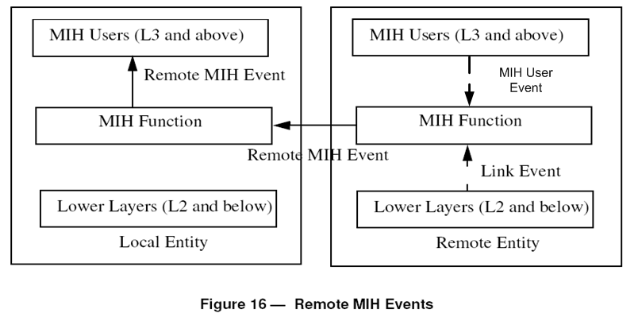

Acknowledgments

The presented contribution has been studied in the framework of the IST collaborative project Daidalos (www.ist-daidalos.org), founded by the European commission.

