33.2.7.x PSE PI Pair-to-Pair Resistance/Current Unbalance

Background (Not part of the Baseline text)
- We need to define the following parameters in Table 33-11.
  - PSE Vdiff – Done. See D0.2.
  - Imax=maximum pair current due to E2ERunb. Now we have the numbers. Please see below.
  - PSE PI Rmax, Rmin that meets Rmax ≤ U*Rmin + Cpse.
  - Rmax and Rmin will be measured by test setup TBD per Annex 33B.
  - U and Kpse are constants representing worst case conditions per the curves showed for Type 3 and 4 on the positive pairs for E2ERunb.
  - This will ensure that the PSE will not exceed Imax and E2ERunb for any channel and any PD.

PSE PI Pair to Pair effective Runb [PSE_P2PRunb] contribution to the whole Effective System End to End Resistance/Current Unbalance, E2ERunb is specified by PSE Rpair_max and Rpair_min values.
See details for Rpair_max and Rpair_min Annex 33B.

The PSE_P2PRunb contribution ensures that with any other parts of the system i.e. channel (cables and connectors) and the PD, the maximum pair current due to E2ERunb, shall not exceed Icont_2P_unb as defined in Table Table 33.2.7.x item 2. Icont_2P_unb is the pair current above Icont_2P that is the result of E2ERunb. See drawing 33.2.7.x.

Rpair_min and Rpair_max are specified and measured under maximum Pclass sourcing conditions.
Testing methods of Rpair_min and Rpair_max are described in Annex 33-B.
Conformance shall be determined with equation 33-9 that sets Rpair_max and Rpair_min ;

(33-9)

[Note: All constants are temporary numbers (TBDs) to illustrate the concept and will be updated later]

Where:
Rpair_max and Rpair_min are maximum and minimum PSE common mode effective resistances in the powered pairs of the same polarity. The values of Rpair_max and Rpair_min are implementation specific and need to satisfy eq. 33-9.

Note: Information regarding equation 33-9 constants can be found in Annex ANNEX 33B

Table 33-11
Item | Parameter | Symbol | Unit | Min | Max | PSE Type | Additional Information
TBD | Pair current due to E2ERunb within E2ERunb range | Icont_2P_unb | A |  | 0.668  (TBD) | 4 | See clause 33.2.7.x.1
 |  |  |  |  | 0.931  (TBD) | 4 | See clause 33.2.7.x.1

33.2.7.x.1 PSE PI Pair to Pair Resistance/Current Unbalance Requirements

Icont_2P_unb_max is the average Icon_2P current value with the additional current added to the pair due the presence of E2EP2PRunb in the system. The total sum of the current of pairs with the same polarity shall not exceed Pclass/Vpse.

Icont_2P_unb_max was specified for total channel common mode pair resistance from 0.1Ω to 12.5Ω. For channels with common mode pair resistance lower than 0.1Ω, see guidelines in Annex 33B in clause TBD.

For using the PSE PI Rpair_min and Rpair_max for achieving current lower than Icont_2P_unb_max for any compliant unbalanced channel and PD, see guidelines in Annex 33B in clause TBD.

Drawing 33.2.7.x (may be part of informative or normative section, TBD)

α =System P2P_Iunb effect=E2ERunb. β = Current ripple contribution

ANNEX 33B PSE PI Pair-to-Pair Resistance/Current Unbalance
Pair-to-pair current unbalance refers to current differences in powered pairs of the same polarity. Current unbalance can occur in positive powered pairs, negative powered pairs, or both during 4-pair powering.
Current unbalance must be met with any compliant unbalanced load, and is ultimately determined by the End-to-End Pair-to-Pair Resistance Unbalance (E2EP2PRunb).
A compliant unbalanced load consists of the channel (cables and connectors) and the PD.
Equation 33-8, specified for the PSE, assures that E2EP2PRunb will be met in a compliant 4-pair powered system. Fig. 33B-1 illustrates the relationship between PSE PI equation 33-8 and E2EP2PRunb.
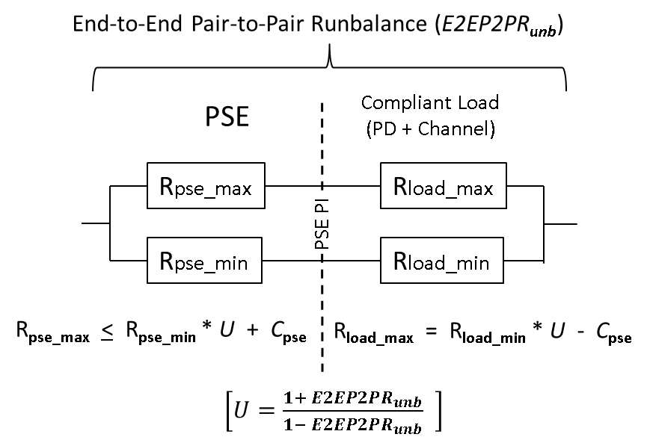
Fig. 33B-1 PSE PI Unbalance specification and E2EP2PRunb
Equation 33-8 specifies the PSE effective resistances required to meet E2EP2PRunb in the presence of all compliant, unbalanced loads attached to the PSE PI. A corresponding equation is shown for the worst case compliant pair-to-pair load. The pair-to-pair load equation is essentially the conjugate of the PSE equation.
There are 3 alternate test methods for Rpse_max and Rpse_min and determining conformance to equation 33-8:
33B.1 direct measurements of Rpse_max and Rpse_min
If there is access to internal circuits, effective resistance may be determined by sourcing current in each path corresponding to maximum Pclass operation, and measuring the voltage across all components that contribute to the effective resistance, including circuit board traces and all components passing current to the PSE PI output connection. The effective resistance is the measured voltage divided by the current through the path (R=V/I. See Fig. 33B-1 .(Yair to updated Figure 33B-1 and add Vmax, Vmin labels across Rpse_max and Rpse_min).
The two sections that follow illustrate two other possible measurements if the internal circuits are not accessible.33B.2: Measurement of PSE effective resistances for Rpse_max and Rpse_min equation 33-8 verification.
33B.2 Measurement of current unbalance under worst case pair-to-pair load conditions
33B.2 Effective Resistance Measurement Method:
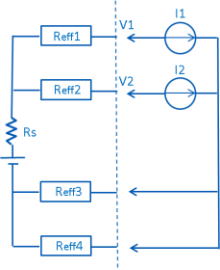
Figure 33B-2 shows a possible test circuit for effective resistance measurements on a PSE port for evaluating conformance to Equation 33-8.
The Effective Resistance Test Procedure is described below:
- With the PSE powered on, set the following current values
  - 10mA < I₂ < 50mA
  - I₁ = 0.5*(Pclass_{max}/Vport) - I₂.
- Measure V₁, V₂.
- Reduce I₁ by 20% (=I₁’). Ensure I₂ remains unchanged.
- Measure V₁’, V₂’.
- Calculate R_{eff1}:
  - R_{eff1} = |[(V₂-V₁) – (V₂’-V₁’)]/ (I₁ – I₁’)|
- Repeat procedure for R_{eff2}, with I₁, I₂ values swapped.
Fig. 33B-2 Effective resistance Test Circuit
- Repeat procedure for R_{eff3}, R_{eff4}.
- Evaluate compliance with Equation 33-8.

The Effective resistance test method applies to the general case; if pair-to-pair balance is actively controlled in a manner that changes effective resistance to achieve balance, then the Current Unbalance Measurement Method described below should be used.
33B.3 Current Unbalance Measurement Method
The pair-to-pair load resistance equation from Fig. 33B-1 is shown below for reference.
R_{load_max} = R_{load_min} * U - C_{pse} (33B-3)
Unbalanced load resistances conforming to equation in figure 33B-3 must be selected. Note that the equation only provides relative resistance values; if the selected resistances are too low, the results may be influenced by losses in the connecting hardware, and if the selected values are too high, the current unbalance will be dominated by the load and may mask the PSE unbalance. Current unbalance must be met for any pair-to-pair resistances meeting the equation; selected resistance values which provide adequate verification are dependent upon PSE circuit implementation and as such are left to the designer.
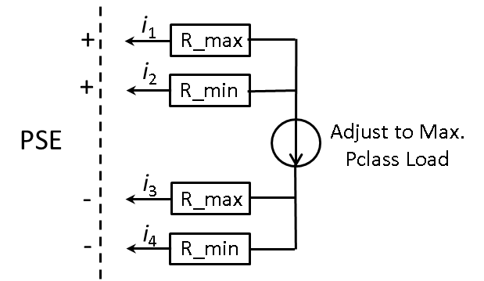
Fig. 33B-4 shows a test circuit for the current unbalance measurement.
The current unbalance test method is described below:
- Select suitable R_max and R_min values which conform to equation 33B-3
- With the PSE powered on, adjust the load for Max. Pclass power at the PSE
- Measure i₁, i₂
- Swap R_max, R_min, repeat steps 1 and 2.
- Repeat for i₃, i₄
- Verify that the current unbalance in each case does not exceed I_{unb_ptp} limit
in table 33-11.
Fig. 33B-4 Current Unbalance Test Circuit

Verification of I_{unb_ptp} in step 6 confirms PSE conformance to Equation 33-8.

