33.2.8.5 Continuous output current capability in the POWER_ON state
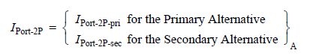
For Type 1 and Type 2 PSEs, IPort-2P is defined in 33.1.3. For Type 3 and Type 4 PSEs, IPort-2P and IPort-2P-other are the currents on the pairs with the same polarity of the two pairsets and are defined in Equation (33–5) and in Equation (33–6).

(33–5)
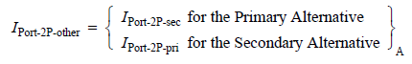
(33–6)

where
IPort-2P-pri is the output current sourced by the Primary Alternative, defined in 33.2.5.9
IPort-2P-sec is the output current sourced by the Secondary Alternative, defined in 33.2.5.9
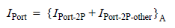
IPort is the total current on both pairs with the same polarity and is defined in Equation (33–7).
(33–7)

PSEs shall be able to source ICon-2P, the current the PSE supports on each powered pairset, as specified in Equation (33–8).
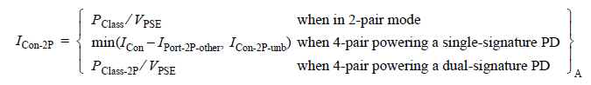
(33–8)

where
PClass is PClass as defined in Equation (33-2)
PClass-2P is PClass-2P as defined in Equation (33-3)
VPSE is the voltage at the PSE PI as defined in 33.1.3
ICon is the total current a PSE is able to source as defined in Equation (33–9)
ICon-2P-unb is the current a PSE is able to source on a pairset due to unbalance as defined in
Table 33–18
IPort-2P-other is the output current on the other pairset as defined in Equation (33–6).

When powering a single-signature PD over 4 pairs, a Type 3 or Type 4 PSE supports:
- A total current of Icon, defined in Equation (33–9), over both pairs with the same polarity
- A minimum current of Icon-2P-unb over one of the pairs of the same polarity under maximum unbalance condition (see 33.2.8.5.1) in the POWER_ON state.

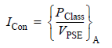
(33–9)

The PSE shall support the AC current waveform parameter IPeak-2P, defined in Equation (33–10), on each powered pairset while within the operating voltage range of VPort_PSE-2P, for a minimum of TCUT-2P and a duty cycle of at least 5%.

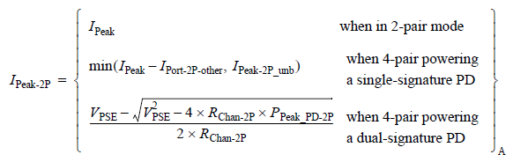

(33–10)

where
IPeak is the total peak current a PSE supports per Equation (33–11)
IPort-2P-other is the output current on the other pairset as defined in Equation (33–6).
IPeak-2P-unb is the minimum current due to unbalance effects a PSE must support on a pairset as defined in Equation (33–12).
VPSE is the voltage at the PSE PI as defined in 33.1.3
RChan-2P is the pairset loop resistance; this parameter has a worst-case value of RCh defined in 33.1.3. RCh is defined in Table 33–1.
PPeak_PD-2P is the total peak power a dual-signature PD may draw per its Class on a pairset; see Table 33–30

IPeak, defined in Equation (33– 11), is the total current of the powered pairs with the same polarity that a PSE supports, when powering a PD over 2 pairs or powering a single-signature PD over 4 pairs.

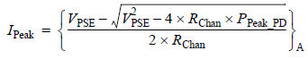
(33–11)

where
VPSE is the voltage at the PSE PI as defined in 33.1.3
RChan is the channel loop resistance as defined in 33.1.3
PPeak_PD is the total peak power a PD may draw for its Class; see Table 33–30

IPeak-2P-unb, defined in Equation (33–12), is the minimum current due to unbalance effects that a PSE supports on a pairset when powering a single-signature PD over 4-pair.

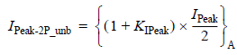
(33–12)

where
KIPeak The value of KIPeak, defined in Equation (33–13), is based on a curve fit and is dimensionless
IPeak is the total peak current a PSE supports per Equation (33–11)

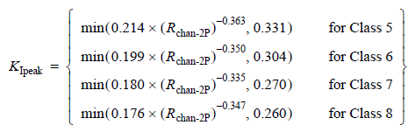

(33–13)

Yair: Ipeak-2P_unb does not exists for class 0-4 as class 0-4 do not have unbalance requirements (Class 0-4 currents may flow over 2-pairs or 4-pairs without effect on magnetic components or any other aspect of the system since 2-pairs class 0-4 is legacy and 4-pairs PSE has to support legacy without new requirements. As a result, the above editing instructions are not necessary and also incorrect.
Editing Instruction: Add new top row to KIpeak Equation with values:
1 Classes 0-4
It is better just to add text as follows:
“There are no unbalance requirements for class 0-4.”

where
RChan-2P is the channel DC loop resistance per pairset, as defined in 33.1.3. RChan-2P has a minimum value of 0.2 Ω when used in Equation (33–13).

Alternatively, an over-margined value of IPeak-2P-unb, IPeak-2P-unb_max which is defined by Equation (33–14), may be used.
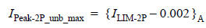
(33–14)

where
ILIM-2P is the ILIM-2P min value per pairset for the PSE, as defined in Table 33–18

