1-. Introduction

The OAM (Operations, Administration and Management) channel has arisen as a requirement from Original Equipment Manufacturers (OEM) in the automobile industry. The purpose of this document is to define a mechanism to reliably exchange OAM messages between OAM peers sharing a link. OAM message definition is not covered by this document and it is something up to the management entities implementer. As we will see, OAM messages exchange is going to occur only in the Physical Coding Sublayer (PCS), since OAM messages are transmitted as part of the Physical Header Data (PHD).

The rest of this document is organized as follows. A detailed description of the OAM channel implementation is provided in Section 2.

2-. OAM channel

2.1 OAM Transmission (Tx) Registers description

The local PHY provides the local Management Entity (ME) with a set of 16-bit width registers, which shall be accessed through the PHY management interface. These registers shall be used by the local ME to transmit a message to its peer at the other end of the link and also to check the status of previous message transmissions. The content of the different OAM Tx registers is illustrated in Table 1.

Bit(s) | Name | Description | R/W
TxTBD0.15 | TXREQ | Transmission ReQuest. It is raised by the ME to request the transmission of a new message. It is set to 0 by the local PHY to indicate that it has started the transmission of the message. | R/W
TxTBD0.14 | PHYT | PHY Toggle bit. Corresponds to the toggle bit of the last message received by the remote PHY. | RO
TxTBD0.13 | MERT | Management Entity Read Toggle bit. Toggle bit of the last message read by the Management Entity attached to the remote PHY. | RO
TxTBD0.12 | MSGT | Message Toggle Bit. Toggles with each successive transmitted message and is used for message identification. | RO
TxTBD0.11:0 | OAM_CTRL | OAM message control information. Intended to be used by the ME to indicate the type or some information relevant about the content of OAM_DATA0..7 message for the proper processing of the OAM message by the remote ME. This information is not manipulated by the PHY and is transparently transmitted to the link partner together with the OAM message contained in OAM_DATA0..7 registers. | R/W
TxTBD1.15:0 | OAM_DATA0 | OAM message 16-bit data word 0. | R/W
TxTBD2.15:0 | OAM_DATA1 | OAM message 16-bit data word 1. | R/W
TxTBD3.15:0 | OAM_DATA2 | OAM message 16-bit data word 2. | R/W
TxTBD4.15:0 | OAM_DATA3 | OAM message 16-bit data word 3. | R/W
TxTBD5.15:0 | OAM_DATA4 | OAM message 16-bit data word 4. | R/W
TxTBD6.15:0 | OAM_DATA5 | OAM message 16-bit data word 5. | R/W
TxTBD7.15:0 | OAM_DATA6 | OAM message 16-bit data word 6. | R/W
TxTBD8.15:0 | OAM_DATA7 | OAM message 16-bit data word 7. | R/W

Table 1 : OAM Tx Registers content

The registers labelled “OAM_DATAx” (x = 0,1,..,7) together with the set of bits of register TxTBD0 labelled “OAM_CTRL” are used to store the OAM message itself, which consists of 128 user data bits (OAM_DATA) and 12 user control bits (OAM_CTRL). On the other hand, bit 15 of register TxTBD0 (labelled “TXREQ”) is intended for OAM message transmission handshake. In particular, this control bit is to be raised by the local ME to request the transmission of a new OAM message, whereas it shall be set to 0 by the local PHY to indicate that the transmission of the last requested message has started and it is ready to accept a new request for transmission.

Additionally, bits 14, 13 and 12 of register TxTBD0 (labelled “PHYT”, “MERT” and “MSGT”, respectively) are used by the local PHY to inform the local ME of the OAM channel status. The information encoded by these control bits, which are read-only (RO) from the point of view of the local ME, is defined as follows:

- “MSGT”: Message Toggle Bit. It is used for OAM message identification. It is toggled by the local PHY whenever a new message is accepted for transmission.
- “PHYT”: PHY Toggle Bit. It corresponds to the toggle bit associated to the last message received by the remote PHY.
- “MERT”: Management Entity Read Toggle Bit. It corresponds to the toggle bit associated to the last message read by the ME attached to the remote PHY.

2.1.1 Transmission handshake mechanism

There is a handshake mechanism that ensures the integrity of the OAM message to be transmitted. It also implements a flow control mechanism, since the resources are locked until they are free for transmission of a new message.

Whenever the Management Entity attached to the local PHY wishes to transmit a new message, it shall proceed as follows:

Step 1: Wait until bit 15 of register TxTBD0 (“TXREQ”) is low, which indicates that the OAM Tx registers are free and a new OAM message can be accepted by the local PHY for transmission.

Step 2: Write the 128 user data bits of OAM message into registers TxTBD1 to TxTBD8.

Step 3: Write the 12 control data bits of OAM message into the corresponding section of register TxTBD0 (TxTBD0.11:0, also referred to as “OAM_CTRL”) and simultaneously set bit 15 of register TxTBD0 (“TXREQ”) to 1 to indicate to the local PHY that a new OAM message is ready to be transmitted.

As soon as the local PHY accepts the new message for transmission, it will be set the bit “TXREQ” to 0. Simultaneously, the local PHY will toggle bit “MSGT” to notify the local Management Entity the toggle bit associated with the message that is currently being transmitted to the remote PHY by using the fields of the PHD reserved for this purpose. From then on, the OAM Tx registers are free. Bits “PHYT” and “MERT” indicate the toggle bit associated the last message acknowledged by the remote PHY and the remote ME, respectively.

2.1.2 OAM channel status

The complete status of the OAM channel can be inferred from the value taken by the 4 control bits that are part of the OAM Tx registers (“TXREQ”, “PHYT”, “MERT” and “MSGT”). Let us note that up to three OAM messages can live simultaneously in the system per direction by using three different memory locations, namely, the OAM Tx registers, the transmitted PHD and the OAM Rx registers.

Table 2 specifies all the possible status of the OAM channel as a function of the values taken by the above mentioned control bits. The value of the variable a can be either 0 or 1, whereas the symbol ~ denotes logical not operator. Message K refers to the OAM message that is currently being transmitted from the local PHY to the remote PHY by using the fields of the PHD reserved for this purpose. Its associated toggle bit takes value a (as indicated by the bit “MSGT” of the OAM Tx registers, see 4th column of Table 2). Correspondingly, message K-1 denotes the previous message transmitted from the local PHY to the remote PHY. Its associated toggle bit takes value ~a. Finally, message K+1 corresponds to the last OAM message that the local ME has written into the OAM Tx registers.

TXREQ | PHYT | MERT | MSGT | Message K+1 Status | Message K Status | Message K-1 Status
0 | a | a | a | Not set | Sent  ACK by remote PHY  ACK by remote ME | Sent  ACK by remote PHY  ACK by remote ME
0 | ~a | ~a | a | Not set | Sent  No ACK by remote PHY  No ACK by remote ME | Sent  ACK by remote PHY  ACK by remote ME
0 | a | ~a | a | Not set | Sent  ACK by remote PHY  No ACK by remote ME | Sent  ACK by remote PHY  ACK by remote ME
0 | ~a | a | a | Not set | Sent  No ACK by remote PHY  No ACK by remote ME | Sent  ACK by remote PHY  No ACK by remote ME
1 | a | a | a | Written by local ME  Pending transmission by local PHY | Sent  ACK by remote PHY  ACK by remote ME | Sent  ACK by remote PHY  ACK by remote ME
1 | ~a | ~a | a | Written by local ME  Pending transmission by local PHY | Sent  No ACK by remote PHY  No ACK by remote ME | Sent  ACK by remote PHY  ACK by remote ME
1 | a | ~a | a | Written by local ME  Pending transmission by local PHY | Sent  ACK by remote PHY  No ACK by remote ME | Sent  ACK by remote PHY  ACK by remote ME
1 | ~a | a | a | Written by local ME  Pending transmission by local PHY | Sent  No ACK by remote PHY  No ACK by remote ME | Sent  ACK by remote PHY  No ACK by remote ME

Table 2 : List of all possible OAM channel status

2.2 OAM Receive (Rx) Registers description

The local PHY provides the local ME with another set of 16-bit width registers, where each newly received OAM message from the remote PHY is made available to the local ME. These registers are read-only from the point of view of the local ME and shall be accessed through the PHY management interface. The content of the different OAM Rx registers is illustrated in Table 3.

The registers labelled “OAM_DATAx” (x = 0,1,..,7) together with the set of bits of register RxTBD0 labelled “OAM_CTRL” are used to store the OAM message itself. On the other hand, bit 15 of register RxTBD0 (labelled “RXVAL”) is intended for OAM message receive handshake. In particular, this control bit is to be raised by the local PHY to signal that a new message is ready to be processed by the local ME. It will be set to 0 by the local PHY as soon as the message has been completely read by the local ME. Additionally, bit 12 of register RxTBD0 (labelled “MSGT”) indicates the toggle bit associated with the received message.

Bit(s) | Name | Description | R/W
RxTBD0.15 | RXVAL | Reception Valid. It is raised by the PHY to indicate to the Management Entity that a new message has arrived and is ready for processing. The message will be locked in the Rx Registers until the Management Entity access register RxTBD8, at which point the PHY will clear bit RXVAL and will also acknowledge the message processing to the link partner (see 2.4) | RO
RxTBD0.14:13 | Reserved
RxTBD0.12 | MSGT | Message Toggle bit. Indicates the toggle bit associated with the received message, and serves as message identification. It will toggle with every new received message. | RO
RxTBD0.11:0 | OAM_CTRL | OAM message control information. Intended to be used by the ME to indicate the type or some information relevant about the content of OAM_DATA0..7 message. | RO
RxTBD1.15:0 | OAM_DATA0 | OAM message 16-bit data word 0. | RO
RxTBD2.15:0 | OAM_DATA1 | OAM message 16-bit data word 1. | RO
RxTBD3.15:0 | OAM_DATA2 | OAM message 16-bit data word 2. | RO
RxTBD4.15:0 | OAM_DATA3 | OAM message 16-bit data word 3. | RO
RxTBD5.15:0 | OAM_DATA4 | OAM message 16-bit data word 4. | RO
RxTBD6.15:0 | OAM_DATA5 | OAM message 16-bit data word 5. | RO
RxTBD7.15:0 | OAM_DATA6 | OAM message 16-bit data word 6. | RO
RxTBD8.15:0 | OAM_DATA7 | OAM message 16-bit data word 7. | RO

Table 3 : OAM Rx Registers content

2.2.1 Receive handshake mechanism

There is a handshake mechanism that ensures the integrity of the each received OAM message. It also serves to lock the OAM Rx registers until the message has been completely read by the local ME.

Whenever the Management Entity attached to the local PHY wishes to process a new received message, it shall proceed as follows:

Step 1: Read the content of register RxTBD0. If the bit 15 (“RXVAL”) is high, which indicates that a new OAM message has been received from the remote PHY and is ready to be processed by the local ME, go to Step 2. Otherwise, repeat Step 1.

Step 2: Read the 128 user data bits of OAM message from registers RxTBD1 to RxTBD8. It is critical that the local ME reads the registers in order starting by RxTBD1 and ending by RxTBD8, since as soon as the reading of the content of register RxTBD8 finishes, the local PHY will set the bit “RXVAL” to 0. Moreover, the local PHY shall acknowledge to the remote PHY the reception of the message by the local ME (see 2.4 for state diagrams). Let us note that the 12 user control bits have been already read in Step 1.

2.3 OAM PHY to PHY message description

Each OAM message written by the local ME into the corresponding OAM Tx registers is transmitted by the local PHY by using a set of fields of the PHD reserved for this purpose (see [1]). More specifically, the field PHD.OAM.CTRL contains the 12 user control bits, whereas the fields PHD.OAM.DATAx (x=0,1,..,7) are used to transport the 128 user data bits. The value of the toggle bit (field “MSGT” of TxTBD0 register), which the local PHY associates to the message before its transmission for its identification, is transmitted by using the field PHD.OAM.MSGT.

The fields PHD.OAM.PHYT and PHD.OAM.MERT are used by the local PHY to notify the remote ME of the status of the receive link. In particular, the field PHD.OAM.PHYT contains the value of the toggle bit associated to the last message received by the local PHY, whereas the field PHD.OAM.MERT contains the value of the toggle bit associated to the last message acknowledged by the local ME.

After PHY reset, all bits of the PHD fields reserved for OAM channel implementation are set to 0 until the first OAM message is transmitted by the local PHY. From then on, as long as no new OAM message has to be transmitted by the local PHY, this keeps transmitting the information associated to the last OAM message accepted for transmission within the PHD. Thus, it is ensured that remote partner receives the message even in the case of a corruption in the PHD transmission.

2.4 OAM channel state machines description

2.4.1 OAM Tx control state machine

The state machine that governs PHY OAM transmission is illustrated in Figure 1.

Upon reset, disconnection of the PMA from the PMD or unreliable PHD communication link, OAM Tx registers are reset (OAMTX_RESET state). Moreover, the transmitted PHD shall have all the fields reserved for OAM messages transmission set to 0.

Once the transmission and reception of PHD blocks is reliable (rcvr_hdr_lock = OK), the local PHY waits for a new OAM message transmission request from the local ME. Meanwhile, whenever a new PHD block is correctly received from the remote PHY, the local PHY shall update the value of bits 14 (“PHYT”) and 13 (“MERT”) of register TxTBD0 with that of the fields PHD.OAM.PHYT and PHD.OAM.MERT of the received PHD. By doing so, the local PHY notifies the attached ME of the status of current and previous transmissions. This corresponds to OAMTX_NEWMSG_WAIT state.

As soon as the first OAM message transmission is requested by the local ME (txr_txreq = 1), the local PHY will accept it (OAMTX_TRANSMIT state). This implies that the content of OAM Tx registers labelled “OAM_DATAx” (x=0,1,…,7) and “ OAM_CTRL” in Table 1 is transmitted within the fields PHD.OAM.DATAx (x=0,1,...,7) and PHD.OAM.CTRL of the transmitted PHD, respectively. Additionally, the bit transmitted within the field PHD.OAM.MSGT shall be toggled as the transmission of a new OAM message within the PHD begins. Once the OAM message has been accepted for transmission, the local PHY shall toggle the bit “MSGT” and set the bit “TXREQ” to 0. Thus, the local PHY indicates to the attached ME that the OAM Tx registers are free to accept a new message.

From then on, the local PHY shall keep transmitting the same OAM PHY to PHY message within the PHD until the remote PHY acknowledges its reception (OAMTX_PHYT_WAIT state). Simultaneously, whenever a new PHD block is correctly received from the remote PHY, the local PHY shall update the value of bits 14 (“PHYT”) and 13 (“MERT”) of register TxTBD0 with that of the fields PHD.OAM.PHYT and PHD.OAM.MERT of the received PHD. As soon as the OAM message that is being currently transmitted by using the PHD is acknowledged by the remote PHY, the local PHY can accept a new OAM message for transmission. The transition from state OAMTX_PHYT_WAIT to state OAMTX_NEWMSG_WAIT occurs at the moment that the field PHD.OAM.PHYT of the received PHD takes the same value as that of the field PHD.OAM.MSGT of the transmitted PHD (rxphd_phyt = txphd_msgt).

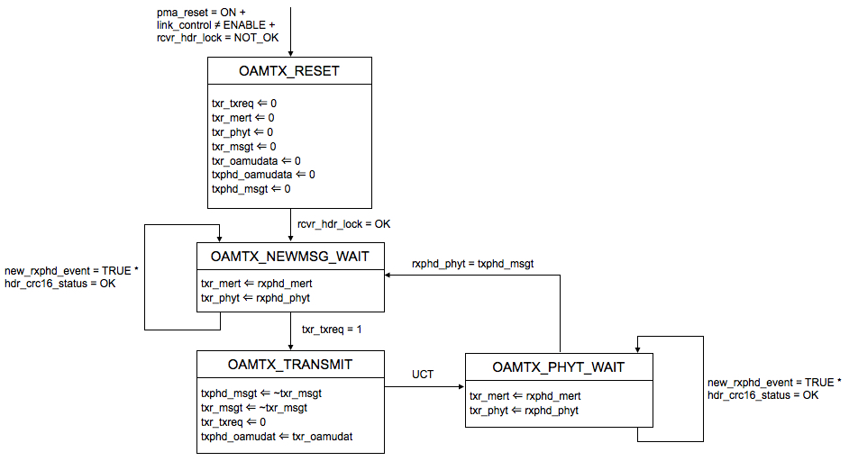

Figure 1 : PHY OAM Tx control FSM

All the variables used in the state diagram of Figure 1 are defined in the following.

  - pma_reset
Allows reset of all the PMA functions. It is set by the PMA reset. PMA reset function is intended to be executed whenever one of power on or reset from management entity conditions occurs. All state diagrams take the open-ended pma_reset branch upon execution of PMA Reset.
Values:
ON: reset is asserted
OFF: reset is de-asserted

  - link_control
Controls the connection of the PMA to the PMD. This control variable is foreseen for an eventual coexistence of the PHY with an autonegotiation sub-system.
Values:
  - DISABLE: isolates the PMA from the PMD
  - ENABLE: connects the PMA to the PMD (both transmitter and receiver)

  - txr_txreq
    - Value of bit TxTBD0.15. This bit indicates whether the local ME is requesting the transmission of a new OAM message.
    - Values:
    - 0: there is no message transmission request from the local ME
    - 1: the local ME has written a new message into the OAM Tx registers and is requesting the local PHY to transmit it

  - txr_msgt
  - Value of bit TxTBD0.12. This bit is written by the OAM Tx state machine to reflect the identifier of the message being sent by the local PHY.
  - Values:
  - It alternates between values 0 and 1

  - txr_phyt
  - Value of bit TxTBD0.14. This bit is written by the OAM Tx state machine to reflect the identifier of the last message that has been acknowledged by the remote PHY.
  - Values:
  - It alternates between values 0 and 1

  - txr_mert
  - Value of bit TxTBD0.13. This bit is written by the OAM Tx state machine to reflect the identifier of the last message that has been acknowledged by the remote ME.
  - Values:
  - It alternates between values 0 and 1

  - txr_oamudat
  - OAM message to be transmitted. It corresponds to the content of registers TxTBD0.11:0 and TxTBD1.15:0 to TxTBD8.15:0.
  - Values:
    - Any value

  - txphd_msgt
  - Identifier of the message being transmitted by the local PHY. It corresponds to the content of PHD field PHD.OAM.MSGT.
  - Values:
  - It alternates between values 0 and 1

  - txphd_oamudat
  - Content of the PHD fields PHD.OAM.CTRL and PHD.OAM.DATAx (x=0,1,...,7) being transmitted by the local PHY.
  - Values:
    - Any value

  - rxphd_phyt
  - Content of the field PHD.OAM.PHYT of the last PHD that has been correctly received by the local PHY.
  - Values:
  - It alternates between values 0 and 1

  - rxphd_mert
  - Content of the field PHD.OAM.MERT of the last PHD that has been correctly received by the local PHY.
  - Values:
  - It alternates between values 0 and 1

  - new_rxphd_event
Variable set by the PCS Receive function to indicate the arrival of a new PHD block from the link partner
Values:
TRUE: indicates the event of a new PHD received from link partner. The value TRUE extends one receive symbol period
FALSE: indicates no new PHD was received

  - rcvr_hdr_lock
Variable set by the PMA Receive function to indicate whether reliable transmission (i.e. reliable reception by the link partner) and reception of PHD are detected
Values:
OK: PHD transmission and reception are reliable
NOT_OK: PHD transmission or reception is unreliable

  - hdr_crc16_status
  - Result of the CRC16 evaluation for a received PHD from the link partner; this variable is assigned for each received PHD block.
  - Values:
    - OK: the received PHD block is correct by CRC16 verification
    - NOT_OK: the received PHD block is not correct determined by CRC16 verification

2.4.2 OAM Rx control state machine

The state machine that governs PHY OAM reception is illustrated in Figure 2.

Upon reset, disconnection of the PMA from the PMD or unreliable PHD communication link, OAM Rx registers are reset (OAMRX_RESET state). Moreover, the transmitted PHD shall have all the fields reserved for OAM channel status report set to 0.

Once the transmission and reception of PHD blocks is reliable (rcvr_hdr_lock = OK), the local PHY waits until the field PHD.OAM.MSGT of a correctly received PHD block takes a value that is different from that of the bit “MSGT” of register RxTBD0. This would indicate that a new OAM message is being received from the remote PHY. As soon as this event occurs, transition from state OAMRX_NEWMSG_WAIT to state OAMRX_RXR_UPDT takes place.

At this moment, the content of the fields PHD.OAM.DATAx (x=0,1,..,7) and PHD.OAM.CTRL of the received PHD are written into OAM Rx registers labelled “OAM_DATAx” (x=0,1,..,7) and “OAM_CTRL” in Table 2, respectively. The bit “MSGT” of register RxTBD0 is assigned the value of the received PHD field PHD.OAM.MSGT, which is used for message identification. The local PHY also set the bit “RXVAL” of register RxTBD0 to 1 in order to indicate to the attached ME that a new OAM message from the remote ME is available. Additionally, the local PHY shall notify the remote PHY of the reception of the message by assigning the field PHD.OAM.PHYT of the transmitted PHD the identifier of the acknowledged message (txphd_phyt ⇐ rxphd_msgt).

As soon as the local ME reads the content of register RxTBD0 and becomes aware that a new message is available in the OAM Rx registers (read_RxTBD0_event = TRUE), the local PHY locks these registers (OAMRX_RXR_LOCK state) until register RxTBD8 is accessed by the local ME through the PHY management interface.

As this event occurs (read_RxTBD8_event = TRUE), the local PHY assumes that the message has been successfully processed by the attached ME. Thus, it sets the bit “RXVAL” of register RxTBD0 to 0 indicating that no valid message is stored in the OAM Rx registers. Moreover, the local PHY shall notify of the precessing of the message by the local ME by assigning the field PHD.OAM.MERT of the transmitted PHD the identifier of the acknowledged message (txphd_mert ⇐ rxr_msgt). This corresponds to state OAMRX_MERT_UPDT. From then on, the local PHY waits for a new message to be received (OAMRX_NEWMSG_WAIT) and the described process repeats.

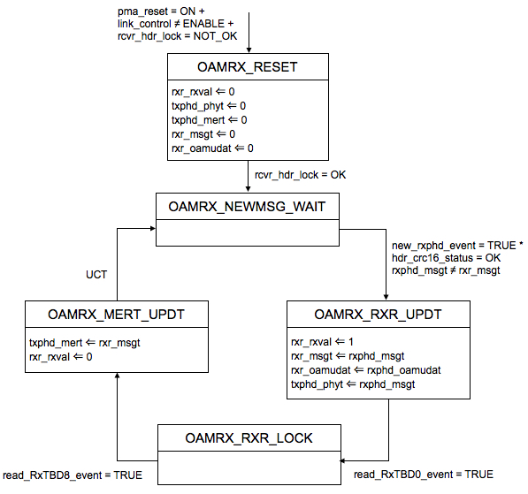

Figure 2 : PHY OAM Rx control FSM

All the variables used in the state diagram of Figure 2 that have not been previously introduced are defined in the following.

  - rxr_rxval
Value of bit RxTBD0.15. This bits indicates the presence of a valid message in the OAM Rx registers.
Values:
1: there is a valid message in the Rx registers, which is pending for processing from the local ME
0: there is no valid message in the Rx registers

  - rxr_msgt
Value of bit RxTBD0.12. This bit is the identifier of the message that is contained in the Rx registers.
Values:
  - It alternates between values 0 and 1

  - rxr_oamudat
    - Content of registers RxTBD0.11:0 and RxTBD1.15:0 to RxTBD8.15:0.
    - Values:
    - Any value

  - txphd_phyt
  - Content of the PHD field PHD.OAM.PHYT being transmitted by the local PHY. It indicates to the remote PHY which is the last message that has been written to the Rx registers to be processed by the local ME.
  - Values:
  - It alternates between values 0 and 1

  - txphd_mert
  - Content of the PHD field PHD.OAM.MERT being transmitted by the local PHY. It informs to the remote PHY which is the last message that has been processed by the local ME.
  - Values:
  - It alternates between values 0 and 1

  - rxphd_msgt
  - Content of the field PHD.OAM.MSGT of the last PHD that has been correctly received by the local PHY. It contains the message identifier of the OAM message carried in that PHD.
  - Values:
  - It alternates between values 0 and 1

  - rxphd_oamudat
  - Content of fields PHD.OAM.CTRL and PHD.OAM.DATAx (x=0,1,..,7) of the last PHD that has been correctly received by the local PHY. It carries the payload of the OAM message.
  - Values:
    - Any value

  - read_RxTBD0_event
  - Event to indicate that the content of register RxTBD0.15:0 has been read.
  - Values:
    - TRUE: register RxTBD0 has been read
FALSE: register RxTBD0 has not been read

  - read_RxTBD8_event
  - Event to indicate that the content of register RxTBD8.15:0 has been read.
  - Values:
    - TRUE: register RxTBD8 has been read
FALSE: register RxTBD8 has not been read

3-. References

[1] Dunia Prieto. “PMA control state machines for GEPOF. Proposed text for standard”

