EAP and Access Control

Introduction

A revised EAP draft has been submitted to the ietf repository. The renewed interest in EAP is largely because of work being done with 802.11 and 802.1x authentication.

EAP is used as mechanism to allow “supplicant” (e.g. workstation) to authenticate with an Authentication Server (AS – e.g. RADIUS server) through an Authenticator (e.g. Access Point)

Supplicant Authenticator Authentication Server
(STA) (AP) (AS)

EAP is defined to work over several protocols. A definition of how it is carried in RADIUS is included in the RADIUS extensions RFC. The use of EAP is defined in at least the following places:

EAP/PPP
EAPOL
EAP/RADIUS
EAP/Diameter
COPS Access PIB

This note attempts to outline some issues with EAP that might be addressed while reviewing the changes from the EAP rfc suggested in the new EAP draft. Some of these changes will need to be reflected in the EAP/RADIUS and perhaps in 802.1x.

Overview of EAP
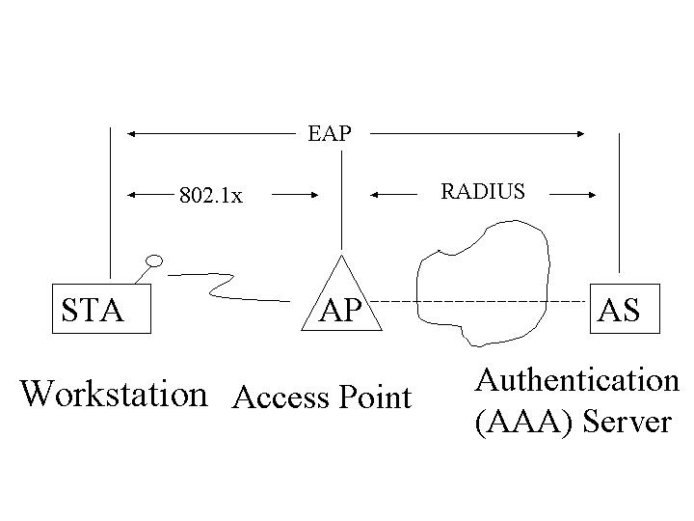
An Access Point, when determining whether to allow access to the net, will create an EAP path between the STA and AS so a dialog can take place between the STA and AAA server. The STA and AAA server each use the EAP dialog path to authenticate the other. Either side could decide not to allow the connection based on the results of the authentication dialog. Each side agrees on the dialog required to support authentication of the other.

As described above the primary value of EAP is to provide a “transparent” path for an authentication dialog between a client attempting to connect to a network, and an authentication server that is on the network. The access device maps the EAP messages from one protocol to another to provide the communication path for the authentication dialog. The access device generally does not interpret or modify the EAP messages used in the authentication dialog.

EAP Issues

Most of the issues that have come up with EAP have to do with interactions between EAP and the protocols on which it is carried.

For example, 802.1x uses an EAP success to indicate to the station that the connection to the network can now be established. In this case the access device is not just forwarding the EAP message from the authentication server, but is using EAP to signal the STA directly.

The AP and the AS use RADIUS to communicate with each other. RADIUS is also used to transport or “piggyback” EAP messages between the AS and STA. A well documented issue with this in that the AS tells the AP to accept the call with a RADIUS Access Accept message. The Access Accept also typically carries an EAP success message which can be forwarded to the STA. However, the Access Accept could have an EAP failure message, and it is then unclear whether the EAP failure should be forwarded to the STA or dropped and then have the AP create an EAP success to forward.

Note that 802.1 does specify that an AP will create an EAP success/failure based on RADIUS Access Accept /Reject. It does not specify whether to forward an EAP success in a RADIUS Accept Reject. Nor does it specify what to do with an EAP failure in an Access Challenge.

Another problem with EAP as specified is that EAP requires that a single authentication method be selected. The intent was that one could not negotiate a different method if the first one failed. In practice it seems that it would be useful to allow a sequence of methods to be deployed in EAP. For example, authentication of user might use one protocol, authentication of AS might use another, and negotiation of capabilities might use yet another. It would be good to be able to string these together as desired.

Suggestions for change

Conceptually separate the parts of the EAP exchange between the STA and AP from the part between the STA and AS.

In particular, make the initial EAP identity request and the final EAP success message exchanges be between the AP and STA. All other EAP exchanges would be between the STA and AS. The following picture illustrates this.

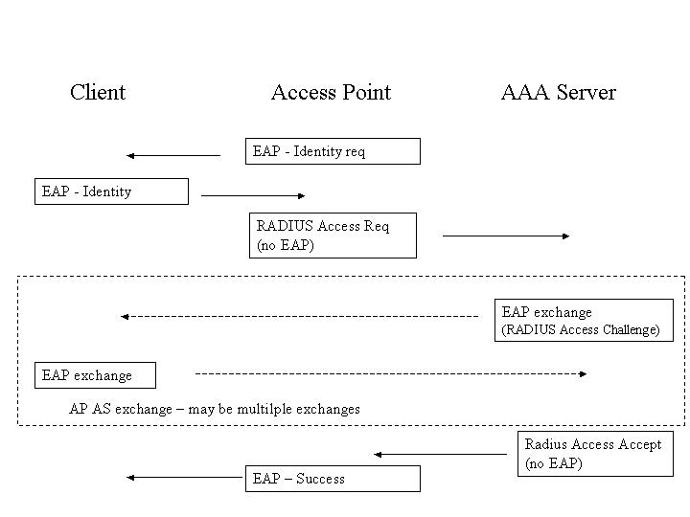

This picture illustrates the initial identity request as being from the AP to the Client. The response is handled by the AP, which takes the identity and creates a RADIUS Access Request for that identity and sends it to the AAA server. Note that Access Request does not have an EAP message.

On receiving the Access Request the AAA server sends an Access Challenge with an EAP request message. The AP forwards all EAP messages in RADIUS Access Challenge to the Client. The Client returns an EAP reply which is forwarded to the AAA Server. This exchange may happen several times.

When the Client/AAA dialog is complete, the AAA sends an Access Accept or Reject to the AP. This does not include any EAP message. The AP then creates an EAP success or failure message and sends it to the Client.

Most of the changes to support this are in the AP and in documentation. I am curious about how hard it would be to make this work in existing implementations.

Create an easy way to sequence EAP dialogs

EAP method sequences. The dialog between STA and AS needs to have an authentication method specified. It should be possible to terminate one method (after the party making a decsion is satisfied with the results of that method) and start another. For example, one might want to use a public key based method to authenticate the AAA server to the Client, but use an id/password method to authenticate the Client to the AAA server. After mutual authentication one might want to do some additional dialog to determine how the Access point is to be provisioned for this client.

Example: STA authenticates itself to AS via MD5 challenge response
AS accepts, says it is ok
AS authenticates itself to STA via TLS
STA accepts, say it is ok
AS initiates dialog to determine what parameters STA wants and is allowed
AS offers and STA accepts parameters

AS sends Access Accept to AP.
AP sends EAP Success to STA

A method for allowing these transitions is necessary. One way might be to send EAP success messages as a transition, but that runs into the problem that the success message may be misinterpreted by the STA.

This needs additional discussion. In this case the changes seem to be mostly in the EAP implementations in client and server.

