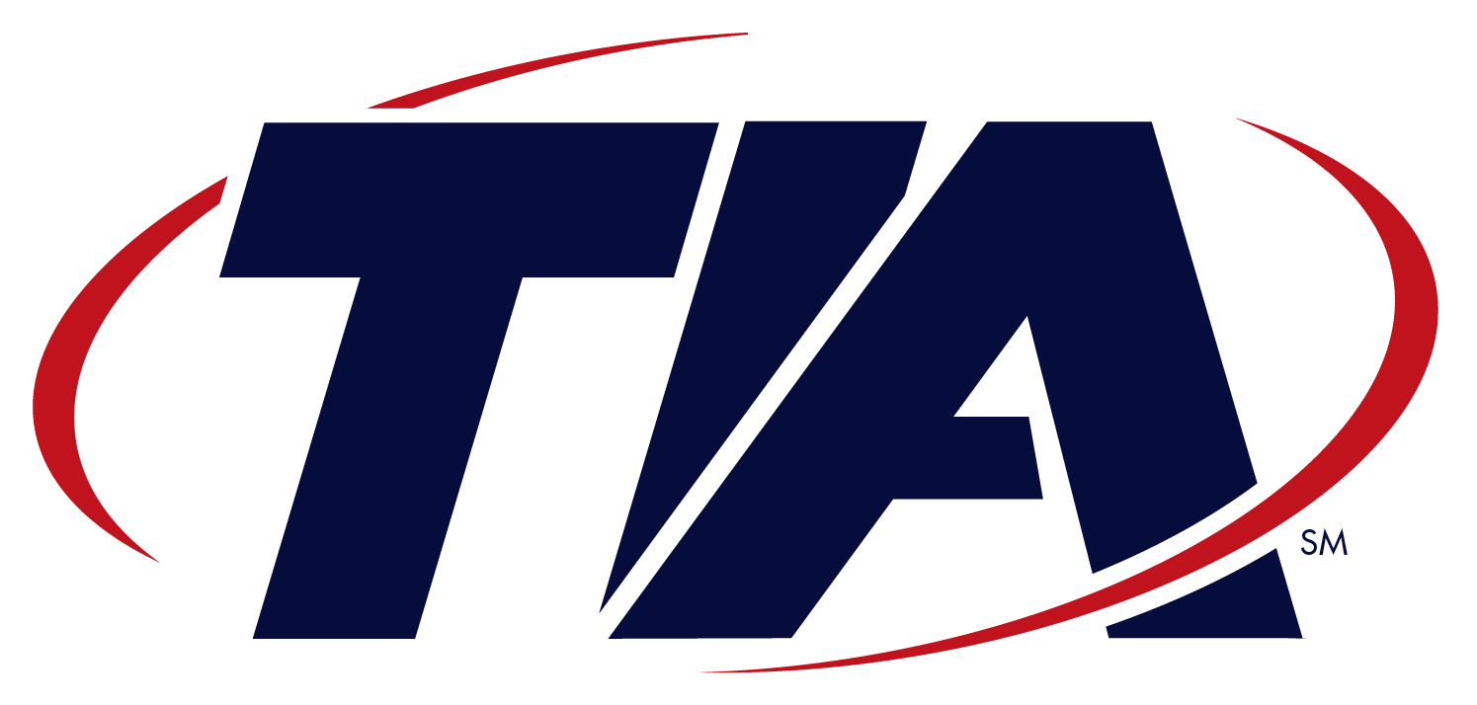
B U I L D I N G G L O B A L C O M M U N I C A T I O N S

Committee Correspondence

Engineering Subcommittee TR-41.4
VoIP Systems – IP Telephony Infrastructure and Endpoints

May 07, 2004
Tony Jeffree, Chairman IEEE 802.1
tony@jeffree.co.uk

As you might be aware, TR-41.4 is the VoIP Systems – IP Telephony Infrastructure and Endpoints Subcommittee within Committee TR-41 User Premises Telecommunications Equipment Requirements of the Telecommunications Industry Association. We create standards to assist in the development and deployment of IP Telephony Systems. The standards developed within TR-41.4 promote call quality, reliability, security, and the interoperability of IP Telephony infrastructure components and external network components.
TR-41.4 is about to undertake the development of a new standard tentatively titled “Media Endpoint Discovery Based on IEEE 802.1AB™ (LLDP) Extensions”. This new TR-41.4 standard will utilize the IEEE 802.1AB™ standard as its foundation. The scope of this new development effort is to define an international open set of standard Type Length Value (TLV) extensions for 802.1AB™ as well as necessary management elements, for the purpose of improving multi-vendor interoperability between IP Telephony Devices and Local Area Networking Equipment. This standard will also enable E-9-1-1 Emergency Calling Services and assist in the management of IP telephony networking policies involving Virtual LANs and Priority.
Given the fact that TR-41.4’s effort will rely heavily on the standards already developed within IEEE, we would like to form a liaison with IEEE 802.1 to facilitate the creation of our new standards and the adoption of IEEE developed technology.
We envision this liaison as an avenue for information exchange between our respective organizations as well as a vehicle that will facilitate collaborative efforts to define and refine multiple IEEE 802.1 projects as they apply to IP telephony and other Media endpoint devices. With this liaison in place, we would anticipate future collaborations leading to the development of new TR-41.4 standards that build upon other IEEE 802.1 standards. As an example, future TR-41.4 standards may attempt to enhance IP Telephony Security through network level access control and link security.
I look forward to hearing from you at your earliest convenience.

Sincerely,
Bob Bell
Chair, TR41.4, (rtbell@cisco.com)

