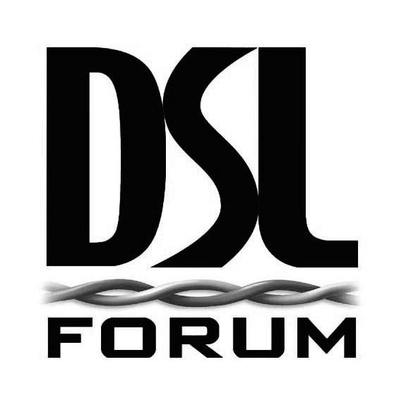

DSL Forum Liaison to:

IEEE 802.1ag
Mick Seaman, Interworking and Security Task Groups Chair
mick_seaman@ieee.org

cc: Tony Jeffree, 802.1 Working Group Chair
tony@jeffree.co.uk

cc: Gilles Joncour, Rapporteur SG13/Q5
gilles.joncour@francetelecom.com

cc: Ghassem Koleyni, Rapporteur SG13/Q7
ghassem@nortelnetworks.com

From:
Gavin Young, DSL Forum Technical Committee Chair
gyoung@dslforum.org

Date: September 21st, 2006

Subject: DSL Forum Liaison w.r.t. Ethernet CFM management object model

The DSL Forum has concluded work on specifying the requirements for an Ethernet Access Node (AN) in TR-101. Included in the specification are requirements for the Access Node to support Connectivity Fault Management (CFM), as outlined in draft IEEE 802.1ag and Y.1731.
Currently, the DSL Forum is working on the Element Management System’s (EMS) interpretation of requirements included in TR-101 that are applicable for managing the AN. WT-141 contains the managed objects derived from TR-101 in a protocol-independent fashion. In this context, the DSL Forum is also looking at appropriately managing the CFM related entities specified in TR-101.
We would like to understand the level of activity that is ongoing in 802.1ag in terms of modeling the managed entities for CFM. Specifically, we would like to understand if work is ongoing in specifying a protocol-independent object model so that we can reuse those managed entities in WT-141. We would appreciate your guidance in order to ensure full alignment on this matter.

Our next meeting is in Atlanta on December 11th to 14th, 2006

Sincerely,

Gavin Young
DSL Forum Technical Chair

Attachments: TR-101, WT-141v3

