17.3.2.2 Relationship to the IF-MIB

<<Add to the end of this clause>>

The BRIDGE MIB also defines a new interface type called an internal LAN (I-LAN). This interface is identified by an ifIndex and is intended to help manage internal associations between bridging components. The BRIDGE-MIB provides the ability to create and destroy I-LAN interfaces. When an I-LAN interface is created, a corresponding row is created in the ifTable. The ifType of this interface is XXX.

I-LAN interfaces support stacking through the ifStackTable. Through this mechanism, the I-LAN interface can create internal connections between components. For example, an I-LAN interface can connect two C-components in a system. To complete this process, the following steps are required:
- Create C-component 1
- Create C-VLAN port 1 on component 1
- Create a bridge port interface (type 209) identified by ifIndex 1 using a external mechanism
- Associate C-VLAN port 1 on component 1 to bridge port interface 1
- Create an I-LAN interface identified with ifIndex 2
- Stack bridge port interface 1 on the I-LAN interface 2
- Create C-component 2
- Create C-VLAN port 1 on component 2
- Create a bridge port interface (type 209) identified by ifIndex 3 using a external mechanism
- Associate C-VLAN port 1 on component 2 to bridge port interface 3
- Stack bridge port interface 3 on the I-LAN interface 2
The result of the previous configuration steps are displayed in the Figure XXX below.

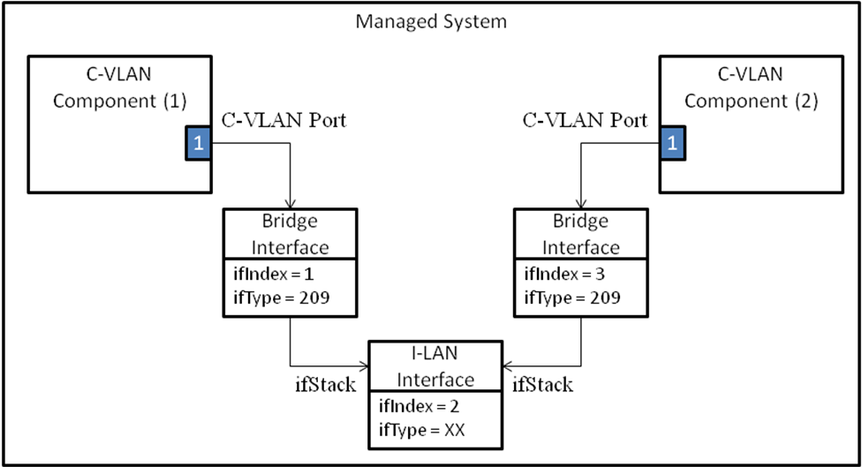
Figure 17-XXX

As a result, traffic can now be forwarded between C-Component 1 and C-Component 2 through the internal LAN.

17.3.8 Relationship of the IEEE8021-PBB MIB to other MIB modules
<<Add to the end second last paragraph>>
Therefore, when a PIP is created, a row is also created in the ifTable identified by the PIP’s ifIndex. The ifType of this interface is XXX.

<<Add to the end of the clause>>

A PIP supports stacking through the ifStackTable. For external PIP interfaces, a PIP can be stacked on an Ethernet interface (type 6). If the PIP is internal, it can be stacked on an I-LAN interface to create a connection between an I-Component and a B-component. An example of how this process is completed is described below:
- Create I-component 1
- Create VIP 1 on component 1
- Create a PIP identified by ifIndex 1
- Associate VIP 1 on component 1 to the PIP
- Create an I-LAN interface identified with ifIndex 2
- Stack PIP 1 on the I-LAN interface 2
- Create B-component 2
- Create CBP 1 on component 2
- Associate CBP 1 on component 2 to I-LAN interface 2
The result of the previous configuration steps are displayed in the Figure XXX below.

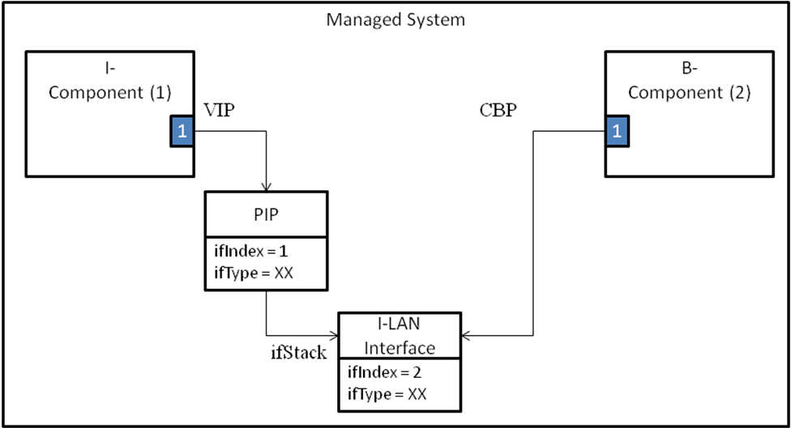
Figure 17-XXX

As a result, traffic can now be forwarded between I-Component 1 and B-Component 2 once a service is provisioned.

