 | INTERNATIONAL TELECOMMUNICATION UNION |  |  |  |  |  | COM 15 – LS 076 – E
TELECOMMUNICATION
STANDARDIZATION SECTOR
STUDY PERIOD 2013-2016
English only
Original: English
Question(s): |  | 9/15
LIAISON STATEMENT
Source: |  | ITU-T Study Group 15
Title: |  | LS/r on Multi Domain Segment network Protection (MDSP) (reply to IEEE-802.1-LS15)
LIAISON STATEMENT
For action to: |  |  | IEEE 802.1
For comment to: |  |  | -
For information to: |  |  | -
Approval: |  |  | ITU-T Study Group 15 management (11 October 2013, by correspondence)
Deadline: |  |  | 20 March 2014
Contact: |  | Tom Huber  Tellabs Oy  Finland |  |  |  | Tel: +1.630.798.6625  Email : tom.huber@tellabs.com
Contact: |  | Han Li  China Mobile Communications Corp.  P.R. China |  |  |  | Tel: +86.13501093385  Email: lihan@chinamobile.com
Mr. Jeffree, Mr. Haddock,
ITU-T Q9/15 thanks IEEE 802.1 for your liaison regarding Multi Domain Segment network Protection (MDSP) as a follow up to our common participation in the July 13th 2013 Joint IEEE-SA and ITU Workshop on Ethernet.
We hereby acknowledge receipt of IEEE P802.1AX-REV draft 3.0 and have made it available on our password-protected file server. Our work on MDSP is still in an early stage and we will certainly liaise our latest draft when it reaches a reasonably mature state.
We understand our work on MDSP appears to have similarities with the work IEEE 802.1 is conducting on Distributed Resilient Network Interconnect (DRNI). These similarities stem from our common interest in meeting our respective objectives for protection switching at UNIs and ENNIs. We believe existing ITU-T Recommendations could be used natively in lieu of DRNI at these interfaces, an example being existing ITU-T Recommendation G.8032 Ethernet Ring Protection Switching (ERPS).
Our objectives also apply to protection switching at INNI interfaces. We are currently also exploring the applicability of ITU-T Recommendation G.8031 Ethernet Linear Protection Switching (ELPS) and of other ITU-T Recommendations for Dual Node Interconnect (DNI) to these interfaces.
To ensure maximal re-use of applicable mechanisms that may support desired functionality, we are not excluding consideration of DRNI in the context of MDSP. Therefore, we are not planning to specify new mechanisms that would overlap with the functionality provided by DRNI.
We would appreciate your clarification on the following items:
- Could DRNI cause segmentation of the networks it is interconnecting under failure conditions? In this context, segmentation means that under certain failure conditions, traffic cannot flow between Protected Domains. Following is the specific example we are considering, where the dashed connectivity is optional:
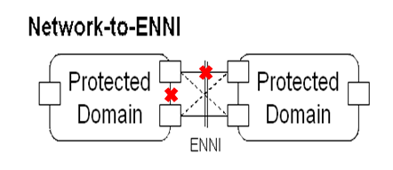
Figure 1
- With respect to Figure 2:
  - Is DRNI’s transfer time (T_{t} – “The time interval after the confirmation that a [Signal Fail] or [Signal Degrade] requires protection switching operations to the completion of the protection switching operations”) 50ms or less? If yes, under which conditions?
  - What is DRNI’s recovery time (T₅ – “Time interval between the completion of protection switching operations and the full restoration of protected traffic”) in the cases where the transfer time is 50ms or less?
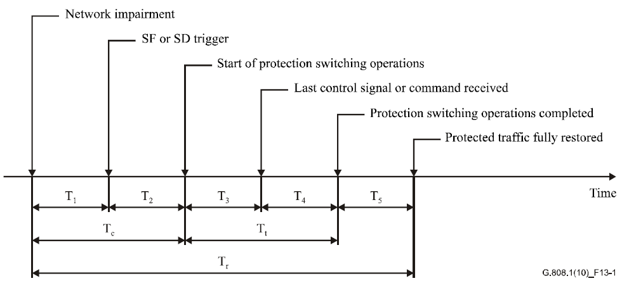
Figure 2
- Could operator commands such as those specified in ITU-T Recommendation G.8031 be supported with DRNI?
- What is DRNI’s expected behavior when the Intra-Portal Link (IPL) fails in a Portal, i.e. when the link between the two Portal Systems fail?
ITU-T Q9/15 experts have been encouraged to review IEEE P802.1AX-REV, which may result in future requests for clarification to IEEE 802.1.
We would appreciate IEEE 802.1 continuing to share upcoming updates to IEEE P802.1AX-REV, and we look forward to further interaction between our organizations.
ITU-T SG15 will be meeting next in Geneva, 24 March-4 April, 2014.

_______________

