Use Cases IEC/IEEE 60802 Vx.x

Use case XX: Transmission of mixed traffic types
There are 9 different industrial automation traffic types as described in Clause 2.4.1. These traffic could be transmitted together on one TSN network. More specifically, streams of different traffic types could share one physical link between two TSN network ports.

Figure X shows an example of mixed traffic type transmission. The red link, which connects routers or bridges or PLCs and carries streams of up to 9 traffic types, locates within the area of production line and/or production cell as shown in Figure 1 (Hierarchical structure of industrial automation). Inside the TSN Machine, there could be such a link that carries streams of multiple traffic types as well, but this scenario is not explicitly shown in Figure X.

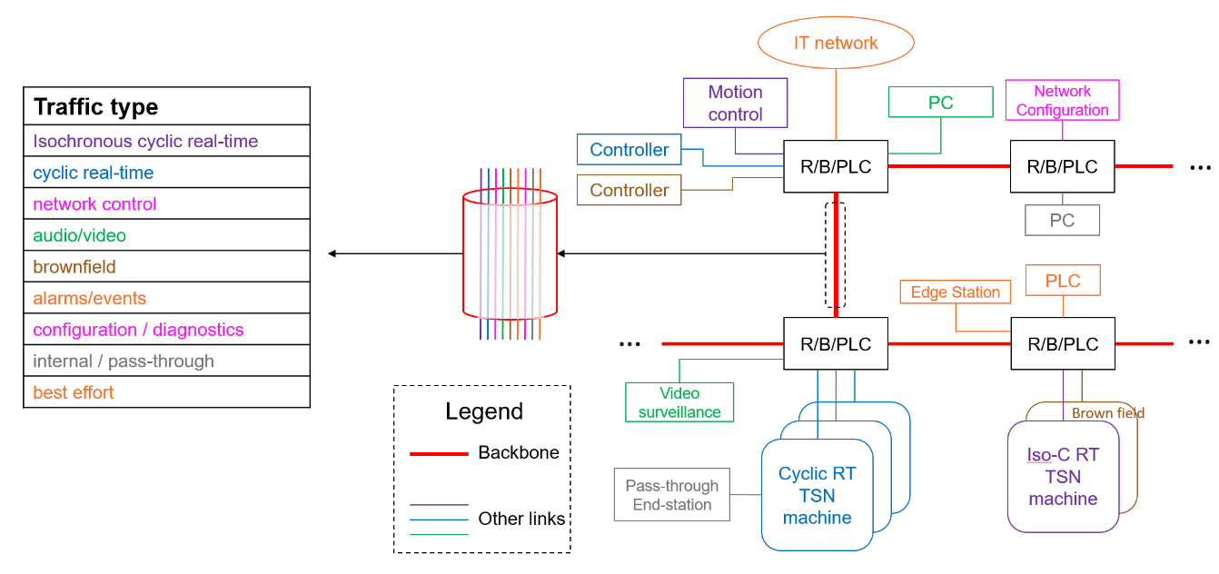
Figure X – An example of mixed traffic type transmission

Requirement:
- Guarantees (deadline, bounded latency, bandwidth) of each different traffic type have to be fulfilled.
- The change of one stream should not cause disturbances to other streams.

Useful 802.1 mechanisms:
- 802.1 Qbv, 802.1Qav, 802.1 Qbu, 802.1 Qci, 802.1 Qch, 802.1 Qcr, 802.1 Qcc, …
- 802.1 AS-Rev
- Whatever helps, e.g., ongoing project such as 802.1 Qdd.

