IEEE P802.15
Wireless Personal Area Networks

Project | IEEE P802.15 Working Group for Wireless Personal Area Networks (WPANs)
Title | Second Call For Proposal Report
Date Submitted | [27, August 1999]
Source | [Ian C. Gifford]  [M/A-COM, Inc.]  [1011 Pawtucket Boulevard Lowell, MA 01853-3295 USA] | Voice: [+1 978 442 4650]  Fax: [+1 978 442 5442]  E-mail: [giffordi@amp.com]
Re: | Submission
Abstract | [This submission is a formal report on the Second Call For Proposal that was conducted from 14 June 1999 to 1 July 1999.]
Purpose | [During the Second Call For Proposals, June 1999 to July 1999, the IEEE received one (1) submission - Bluetooth Special Interest Group. [Authors note: AmeriSys, Inc. provided an "application" proposal however the frequency of interest was 13.56 MHz and did not meet the WPAN Requirements. A WPAN-LR (Low Rate) Study Group is likely to evolve from this and other low rate applications.]
Notice | This document has been prepared to assist the IEEE P802.15. It is offered as a basis for discussion and is not binding on the contributing individual(s) or organization(s). The material in this document is subject to change in form and content after further study. The contributor(s) reserve(s) the right to add, amend or withdraw material contained herein.
Release | The contributor acknowledges and accepts that this contribution becomes the property of IEEE and may be made publicly available by P802.15.

Summary

During the 7Jun99 IEEE P802.15 Ad Hoc Meeting in London the attendees decided to prepare a Second Call For Proposal. An excerpt from the meeting minutes is provided:

'Bob Heile stated that Jim Carlo proposed the need for an aggressive timeline. Jim Carlo suggested that in July 1999 we start with a default proposal with a call for other proposals, in November 1999 an initial draft ready for WG ballot.' [-99/022r0]

The Second Call For Proposal was drafted and approved for release to the IEEE P802.15 Web site on 14Jun99. Additionally, the Leadership called all of the parties with known candidate radio transmission technologies to inform them of our call; there was a summary provided [-99/30] during the Jul99 Plenary. The abstract for this call has been provided:

"The following submission is a final call for participation from the IEEE, Industry, Academia, and past participants to the IEEE P802.15 Working Group. It is anticipated that the past Proposers would submit formal draft specifications to address the WPAN MAC Sub Layer PHY Layer call." [-99/024r1]

On 1Jul99 the call was closed and only one (1) submission was recorded. That being the Bluetooth Special Interest Group (BSIG) Letter Of Intent. The Bluetooth Special Interest Group (SIG) Chair summarized their intention as follows:

"This letter is to inform the IEEE 802.15 working group know that it is the intention of the Bluetooth Special Interest Group (SIG) to submit the "Bluetooth 1.0 Foundation" specification for use by the IEEE as a foundation for developing their 802.15 technology." [-99/028r0]

Project Background

The chain of events leading to the formation of IEEE P802.15 began in June 1997 when the IEEE Ad Hoc "Wearables" Standards Committee was initiated by one of the Authors [RCB] during an IEEE Standards Activities Board (SAB) meeting. According to Braley, the purpose of the Committee was to "encourage development of standards for wearable computing and solicit IEEE support to develop standards." The consensus recommendation to Braley from those that attended the SAB meeting was that he bring his request to encourage such standards development to the IEEE Portable Applications Standards Committee (PASC).

During the PASC Plenary Meeting in July 1997, an IEEE Ad Hoc Committee was assembled (17 attendees) to discuss "Wearables" Standards. The Committee identified several areas that could be considered for standardization, including short range wireless networks or Personal Area Networks (PANs), peripherals, nomadicity, wearable computers, and power management. Of these, the committee determined that the best area of focus was the Wireless PAN because of its broad range of application. The IEEE Ad Hoc "Wearables" Standards Committee met twice more - once in December 1997 and again in January 1998. During the January 1998 meeting it was agreed that the 802 LAN/MAN Standards Committee (LMSC) was probably a more suitable home for the groups activities, especially with a PAN focus. Two delegates were sent to the IEEE P802.11 Interim Meeting, that was taking place that same month, to get reactions and to gain support for the proposal. At that meeting it was agreed to propose the formation of a Study Group under P802.11 at the March Plenary of 802. A WPAN Tutorial was organized to socialize the idea within 802. The result was that in March 1998, the "Wearables" Standards Ad Hoc Committee under PASC became the IEEE P802.11 Wireless Personal Area Network (WPAN) Study Group within LMSC with the goal of developing a Project Authorization Request (PAR) for the development of a WPAN standard.

At the time the Study Group was formed, there had been no other publicized initiatives in the WPAN space other than IrDA, the Infrared Data Association, which, because of its line-of-sight restrictions, did not adequately address the problem. By the time the work of the Study Group concluded, a year later, both the Bluetooth Special Interest Group and HomeRF were active in developing WPAN specifications. By March 1999, when the Study Group and P802.11 submitted the PAR to the 802 Executive Committee for approval, Bluetooth had over 600 adopter companies and HomeRF had over 60. Because of the significance of these groups in the WPAN market space, it was felt that the standards development process would be better served if a new Working Group were formed to address the problem rather than attack it as a Task Group under P802.11. The PAR was approved and the new group was designated as IEEE P802.15 Working Group for Wireless Personal Area Networks.

http://grouper.ieee.org/groups/802/15/index.html

Call For Proposal Background

During the IEEE P802.11 Study Group's (First) Call For Proposals or "WPAN Call For Proposals, straw model proposals for Medium Access Control and Physical Layers", 6May98 to 8Mar99, the IEEE received five (5) submissions:

- May1998:
- GTE Technology Organization
- Intermec Technologies Corporation
- M/A-COM, Inc.
- July 1998:
- Motorola, Inc.
- January 1999
- Eastman Kodak Company

These proposals were based on the following requirements:

"Proposals are solicited from members of the WPAN Study Group, Academia, and Industry to provide a straw model for Medium Access Control and Physical layer solutions that are consistent with the WPAN Functional Requirements. The WPAN Technical Guidelines were discussed in our April 8-9, 1998 meeting in Cambridge, MA USA and appears in the list below:" [-99/199]

WPAN Functional Requirements (Technical Guidelines)

- Mobility: 0-10mph (hand-off not required to another PAN)
- Range: 0-10 meters
- Effective Data Rate at the MAC SAP: (19.2 - 100) kbit/s (actual 1 device to 1 device)
- Should allow coexistence of multiple Wireless PAN's in the same area (20 within 400 square feet)
- Should allow coexistence of multiple Wireless Systems i.e. P802.11 in the same area
- Networking support for a minimum of 16 devices
- Bridge or Gateway connectivity to other data networks

Again, these WPAN Call For Proposals addressed a call for a straw model proposal for Medium Access Control and Physical Layers. The proposal details can be viewed at the following URL:

http://grouper.ieee.org/groups/802/15/pub/Proposals.htm

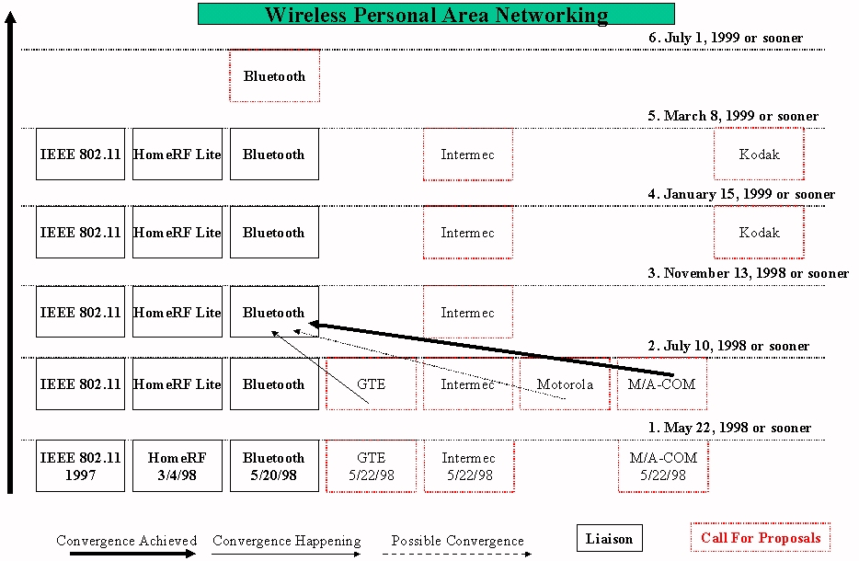
Figure 1 WPAN Roadmap
Figure

Figure 1 describes the WPAN Roadmap of incoming proposals and submissions. The graphic is read from bottom to top. The time progression is based on IEEE events e.g., Meetings, Calls, etc. The top of the graphic indicates the goal of the IEEE Project. Therefore, as of Mar99 the Project was aware of five (5) proposals. The purpose of the Second Call For Proposals was to determine if these five (5) were (or others) a potential source of WPAN technology or if the Project had to create new technology to meet our approved (18Mar99) Project Authorization Request.

Bluetooth Special Interest Group (SIG) Background

This liaison letter was proceeded by five (5) Bluetooth Special Interest Group (SIG) document submissions as well as Bluetooth Special Interest Group (SIG) attendance at four (4) previous IEEE meetings:

- Note: Bluetooth Special Interest Group Formed 20May98 and our first correspondence dates to 15Jun98 from Anders Edlund to Ian Gifford.
- Liaison #1 July 7, 1998 P802.11-98/253
- Liaison #2 September 15, 1998 -98/300
- Liaison #3 October 26, 1998 -98/350 (Minutes only)
- Liaison #4 December 14, 1998 J. Carlo 802 Overview to Bluetooth SIG
- Liaison #5 March 9, 1999 -99/053 Tutorial
- Liaison #6 July 1, 1999 -99/028 Letter Of Intent P802.15-99/028 (this 2nd CFP submission)

The Bluetooth Special Interest Group (SIG) was formed by five (5) Promoters e.g., Ericsson AB, IBM Corporation, Intel Corporation, Nokia Corporation, and Toshiba Corporation. More information can be found at the following URL:

http://www.bluetooth.com/

Conclusion

The Second Call For Proposals was successful and achieved the Sponsor goals as well as our Project/PAR goals. We have formed a Task Group (Task Group 1) to receive the Draft Standard Submission from the Bluetooth Special Interest Group.

The issue of dealing with high low end WPANs has been observed by the IEEE P802.15 Leadership and we have established one of the objectives for the Sep99 Interim Meeting as:

- CONDUCT A CALL FOR INTEREST TO FORM SGs ON HIGH AND LOW END WPANs

During the Jul99 Plenary we observed that one of our Voting Members AmeriSys, Inc. provided an "application" proposal however the frequency of interest was 13.56 MHz and did not meet the Second Call For Proposal WPAN Requirements. Also we have been informed of additional submissions for WPANs e.g., an update to the Kodak WICS PHY Layer and possibly a new MAC Sublayer too, a BreezeCom 2.4 GHz RF Proposal, an IBM Infrared Proposal, etc.

It is presumed that a new classification will need to be introduced to the Projects lexicon e.g., multiple WPANs (Wireless Personal Area Networks). One solution could be that we designate a WPAN-LR (Low Rate) and WPAN-HR (High Rate) terms; once these submissions are received. After the study phase and if a PAR is submitted and approved we think that multiple MACs and PHYs will be best differentiated by this three (3) part approach. WPAN, a derivative of the Bluetooth v1.0A Foundation Specification(s), and WPAN-LR and WPAN-HR for the other applications.

