IEEE P802.11
Wireless LANs
TGe Functional Requirements
Recommendations
Date:
July 13, 2000
Author:
Dave Halasz, Peter Eccelsine, Steve Williams, Jesse Walker
Cisco, Cisco, Intel, Intel
Phone:
Fax:
e-Mail:

Key: Accepted = already accecpted by TGe
Rejected = already rejected by TGe
Yes = recommend accept as is
? = requires discusion
No = recommend reject
Redundant = recommend reject because already covered by other requirement(s)

Summary:

Yes:

3.3. Support for multiple priorities and classes of service.

3.5. Support for multiple simultaneous streams with differing priority and class requirements.

4.2.2. Security framework must be able to prevent unauthorized access by unauthenticated peers over the link. (Yes)

4.2.3. Security framework must allow for mutual authentication of STA and AP. (Yes)

4.3.2. Security framework must allow for authentication of the source of each packet, to prevent link hijacking or undetected insertion of rogue packets into the link. (Yes; Move to 4.2)

4.4.1. Security framework must allow key distribution or derivation of per-link or per-session keys (Yes)

4.4.2. Security framework must strongly protect keys and passwords from recovery by eavesdropper (Yes)

4.5.2.2. The standard should specify one set of algorithms as mandatory when security extensions are implemented. (Yes)

?:
4.6. Security framework must scale to: (?, priority 1)
4.6.1. Simple environments (etc., home, SOHO) (? This needs to be reworded into something feasible)
4.6.2. Ad hoc wireless LANs
4.6.3. Enterprise environments (e.g., office campuses, factories)
4.6.4. Public environments (e.g., hotels, public services)

1.4. Provide a mechanism to mitigate the effects of interface between overlapping BSS’s that are not part of the same ESS, while not compromising security mechanisms. (?)

1.6. Allows for migration and duplication of Distribution Services. (?)

3.7. Support for classes of service where acknowledgement is not mandatory. (?)

4.2.1. Security framework must be able to prevent unauthorized authentication or re-authentication with an AP as those terms are defined within the 802.11 specification. (?)

4.3.1. Security framework must protect network traffic from eavesdropping to a reasonable level compatible with the state of the art. (?)

4.5.1. Negotiation of authentication and privacy algorithms must be incorporated. (?)
4.5.1.1. The following negotiations must be supported: (?)
4.5.1.1.1. authentication algorithm
4.5.1.1.2. privacy algorithm
4.5.1.1.3. data integrity algorithm
4.5.1.1.4. key establishment algorithm
4.5.1.1.5. one way hash function for sub key derivation algorithm
4.5.1.1.6. key expiration
4.5.1.3. Inability to complete negotiations must be able to cause a failure to authenticate. (?)

4.5.2. A flexible mechanism for adding both authentication and privacy algorithms must be incorporated, so that the standard does not need to be revised to use new algorithms in the future. (?)

General Requirements

Any changes to the standard must be optional. This standard can not make a device conformant to the existing 802.11 standard non-conformant. (Accepted)

Any changes to the standard must remain compatible with legacy equipment (both APs and stations, and both DCF and PCF modes). (Accepted)

Association acceptence decisions must remain a policy decision of the AP or station and must not become requirements in the standard. IE, decisions to accept or reject association requests or admit association requests are outside the scope of the standard.

Changes to frame formats must be compatible with existing formats.

Capabilities must fit in remaining bits of CIF

Extensions to existing frames must use the information element data structure or existing reserved bits.

New frame subtypes of existing types should be used in preference to the currently reserved fourth frame type.

New frame formats should be kept to the minimum required to meet the requirements.

(Rejected)

Support for direct STA to STA communication. (No)

(Improperly deleted: not exactly what was voted down)

Provide a mechanism to mitigate the effects of interface between overlapping BSS’s that are not part of the same ESS, while not compromising security mechanisms. (?)

(Rejected)

Transmit Power Control (TPC) per CEPT. (Accepted)

Allows for migration and duplication of Distribution Services. (?)

(Rejected)

External Requirements

Applications

Support for the traffic loads listed in the application scenarios specified in document 00/196. (Accepted)

(Rejected)

Higher Layers

(Rejected)

(Rejected)

(Rejected)

(Rejected)

Do not duplicate functions provided by higher layer standards, except where the nature of the wireless medium breaks an assumption of the higher layer standard. (Accepted)

QoS Requirements

Corrections and enhancements to the PCF that may be required to best meet QoS performance objectives must be incorporated. (Accepted)

(Rejected)

Support for multiple priorities and classes of service. (Yes)

Support for Class of Service three years in the future (No)

Support for QoS Streams and bursty data concurrently. (No)

Support for “toll quality” voice, audio, and video streaming. (No)

Support for multiple simultaneous streams with differing priority and class requirements. (Yes)

Support for interactive data streams. (No)

Support for dynamic bandwidth allocation and/or reservation. (Redundant)

Support for classes of service where acknowledgement is not mandatory. (?)

Bounded delay, prioritized acess, and bounded latency per MDSU (allocatable services), power management bypass mechanisms (which has priority in iBSS and BSS may need a mechanism for separable handsets). (Accepted)

MAC SAP support for 802.1D/802.1q. (Accepted)

To provide the hooks in the MAC to obtain remote channel information. (Accepted)

Security Requirements
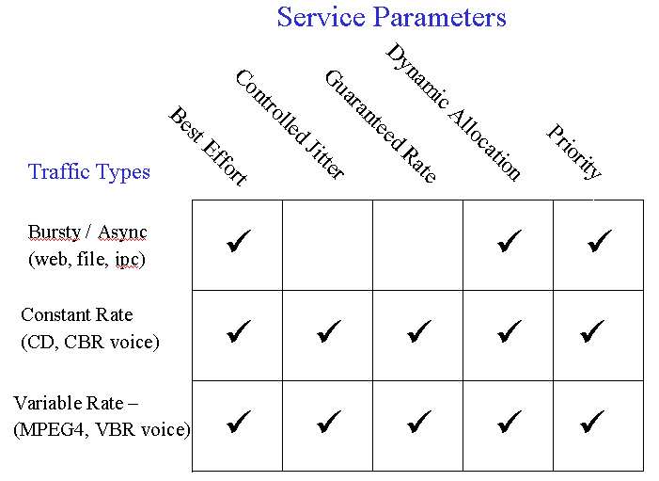
Figure 1 QoS Taxonomy (Controversial)

General

The standard must add at least one extension to the authentication algorithms that provides mutual authentication in both Infrastructure and Independent BSSs. (Accepted)

In the standard, security requirements are independent of QoS requirements. However, implementers should be aware of the potential interactions. (Accepted)

The extensions to the standard should not be constrained by QoS requirements.

It is an implementer decision as to which algorithms are to be used over and above the baseline standard and whether that choice is compatible with QoS requirements.

Authentication

Security framework must be able to prevent unauthorized authentication or re-authentication with an AP as those terms are defined within the 802.11 specification. (?)

Security framework must be able to prevent unauthorized access by unauthenticated peers over the link. (Yes)

Security framework must allow for mutual authentication of STA and AP. (Yes)

Security framework authentication mechanisms must fit within the designated multi-media authentication and re-authentication time budget. {conflict with 4.1.3} (Redundant)

Security framework should make no assumption whether peer authentication is machine or user authentication, as different organizations will establish different policies regarding who or what is authenticated. (No)

Privacy

Security framework must protect network traffic from eavesdropping to a reasonable level compatible with the state of the art. (?)

Security framework must allow for authentication of the source of each packet, to prevent link hijacking or undetected insertion of rogue packets into the link. (Yes; Move to 4.2)

Security framework must preserve the security characteristics of content streams. (No)

The security extensions must not build in support for application layer protections mechanisms, i.e. SDMI, CSS, or other application content protection systems. (No)

Keys

Security framework must allow key distribution or derivation of per-link or per-session keys (Yes)

Security framework must strongly protect keys and passwords from recovery by eavesdropper (Yes)

Extensibility, Compatibility, and Interoperability

Negotiation of authentication and privacy algorithms must be incorporated. (?)

The following negotiations must be supported: (?)

authentication algorithm

privacy algorithm

data integrity algorithm

key establishment algorithm

one way hash function for sub key derivation algorithm

key expiration

Negotiation must take place before authentication is complete. (Redundant)

Inability to complete negotiations must be able to cause a failure to authenticate. (?)

All extensions to the standard must use the current authentication frame format. (Redundant with 1.2.2.2)

No additional fixed fields may be added to the frame format.

All extension to the frame format must be done using one or more information elements.

Modifications to the content or meaning of existing fixed fields must be compatible with legacy equipment.

A flexible mechanism for adding both authentication and privacy algorithms must be incorporated, so that the standard does not need to be revised to use new algorithms in the future. (?)

Existing algorithm identifications from other standards should be used where applicable. (No)

The standard should specify one set of algorithms as mandatory when security extensions are implemented. (Yes)

Security framework must not compromise (i.e., break the security of) existing industry standard network user authentication methods and techniques used within the framework. (No)

Security framework must coexist with existing industry standard network user authentication methods and techniques (e.g., RADIUS-based authentication). (No: out of scope)

Security framework must scale to: (?, priority 1)

Simple environments (etc., home, SOHO) (? This needs to be reworded into something feasible)

Ad hoc wireless LANs

Enterprise environments (e.g., office campuses, factories)

Public environments (e.g., hotels, public services)

Implementation and Complexity (No: evaluation criteria)

Security framework should cause minimal computational expense consistent with meeting other requirements. (No)

Security framework should use public and/or standard algorithms to the greatest extent possible. (No)

Security framework should minimize the number of mandatory cryptographic algorithms. (No)

