IEEE P802.11
Wireless LANs
LB104 DSE reporting CID 1093
Date: 2007-05-12
Author(s):
Name | Company | Address | Phone | email
Peter Ecclesine | Cisco Systems | 170 W. Tasman Dr.  MS SJ-10-5  San Jose, CA 95134-1706 | +1-408-527-0815 | petere@cisco.com
Abstract
This document is aligned with P802.11™-2007, P802.11k/D7.0, P802.11r/D5.0 for baseline, P802.11n/D2.0 and P802.11y/D2.0 and addresses LB104 comment 1093.

Notice: This document has been prepared to assist IEEE 802.11. It is offered as a basis for discussion and is not binding on the contributing individual(s) or organization(s). The material in this document is subject to change in form and content after further study. The contributor(s) reserve(s) the right to add, amend or withdraw material contained herein.

Release: The contributor grants a free, irrevocable license to the IEEE to incorporate material contained in this contribution, and any modifications thereof, in the creation of an IEEE Standards publication; to copyright in the IEEE’s name any IEEE Standards publication even though it may include portions of this contribution; and at the IEEE’s sole discretion to permit others to reproduce in whole or in part the resulting IEEE Standards publication. The contributor also acknowledges and accepts that this contribution may be made public by IEEE 802.11.

Patent Policy and Procedures: The contributor is familiar with the IEEE 802 Patent Policy and Procedures <http:// ieee802.org/guides/bylaws/sb-bylaws.pdf>, including the statement "IEEE standards may include the known use of patent(s), including patent applications, provided the IEEE receives assurance from the patent holder or applicant with respect to patents essential for compliance with both mandatory and optional portions of the standard." Early disclosure to the Working Group of patent information that might be relevant to the standard is essential to reduce the possibility for delays in the development process and increase the likelihood that the draft publication will be approved for publication. Please notify the Chair <stuart@ok-brit.com> as early as possible, in written or electronic form, if patented technology (or technology under patent application) might be incorporated into a draft standard being developed within the IEEE 802.11 Working Group. If you have questions, contact the IEEE Patent Committee Administrator at <patcom@ieee.org>.
- Introduction

Interpretation of a Motion to Adopt
A motion to approve this submission means that the editing instructions and any changed or added material are actioned in the TGy Draft. This introduction, is not part of the adopted material.

Editing instructions formatted like this are intended to be copied into the TGy Draft (i.e. they are instructions to the 802.11 editor on how to merge the TGy amendment with the baseline documents).

TGy Editor: Editing instructions preceded by “TGy Editor” are instructions to the TGy editor to modify existing material in the TGy draft. As a result of adopting the changes, the TGy editor will execute the instructions rather than copy them to the TGy Draft.

Summission Note: Notes to the reader of this submission are not part of the motion to adopt. These notes are there to clarify or provide context.

Clause 7.3.2

CIDs:

Discussion:
In 11y/D2.0:
- Comment 1093 suggests that DSE request and report be added to Spectrum management reports

Proposed Resolution:
Accept: 1093.

Editorial Instructions:
Tgy Editor insert text in 7.3.2, pg 5, after Table 26 D2.0 as follows
EDITORIAL NOTE— last Type entry in 11ma-D9.0 has order 2, 11k/D7.0 adds 7 and Type 255.

Measurement Request element
Measurement Types 0, 1, 2 and 102 are defined for spectrum management and shall only be included in Spectrum Management Measurement Request frames.
Insert new row in Table 29 before “Reserved” and update the “Reserved” range of measurement codes appropriately.
Table 29—Measurement Type definitions for measurement requests

Name | Measurement Type | Measurement Use
DSE request | 10 | Spectrum Management
Reserved | 1110-254 | N/A
EDITORIAL NOTE— last entry in 11ma-D9.0 has order 2, 11k/D7.0 adds 7 and Type 255.
Insert new text before 7.3.2.22:

7.3.2.21.11 DSE request
The Measurement Request field corresponding to a DSE request is shown in Figure 79m.
 | Regulatory Class | Channel Number | Measurement Start Time | Measurement Duration
Octets: | 1 | 1 | 8 | 2
Figure 79m—Measurement Request field format for a DSE request
It is mandatory for a STA in a BSS to generate a DSE report in response to a DSE request if the request is received from the AP with which it is associated, and dot11DSELCIRequired is true. Regulatory Class indicates the channel set for which the measurement request applies. Regulatory Class and Channel Number together specify the channel frequency and channel bandwidth for which the measurement request applies. Valid values of Regulatory Class are shown in Annex J.

The Measurement Start Time field is set to the TSF at the time (± 32 µs) at which the requested DSE request measurement shall start. A value of 0 shall indicate it shall start immediately.

The Measurement Duration field is set to the duration of the requested measurement, expressed in units of TUs.

      - Measurement Report element
Change fourth sentence of first paragraph of 7.3.2.22 as follows:
Measurement Types 0, 1, 2 and 102 are used for spectrum management and shall only be included in
spectrum management Measurement Report frames.

Insert new row in Table 30 before “Reserved” and update the “Reserved” range of measurement codes appropriately.
Table 29—Measurement Type definitions for measurement reports
Name | Measurement Type | Measurement Use
DSE report | 10 | Spectrum Management
Reserved | 1110-255 | N/A
EDITORIAL NOTE— last entry in 11ma-D9.0 has order 2, 11k/D7.0 adds 7.
Insert new text before 7.3.2.23:

7.3.2.22.11 DSE report
A Measurement Type in the Measurement Report element may indicate a DSE report. It is mandatory for a STA to support the generation of this report if dot11DSELCIRequired is true. It is optional for a STA to support the generation of this report. The format of the Measurement Report field corresponding to a DSE report is shown in Figure 85p.

 | Regulatory Class | Channel Number | Actual Measurement Start Time | Measurement Duration | Reported DSE LCIs
Octets: | 1 | 1 | 8 | 2 | variable
Figure 85p—Measurement Report field format for a DSE report
Regulatory Class indicates the channel set for which the measurement report applies. Regulatory Class and
Channel Number together specify the channel frequency and spacing for which the measurement request applies. Valid values of Regulatory Class are shown in Annex J.

The Actual Measurement Start Time field is set to the value of the measuring STA’s TSF timer at the time (± 32 µs) at which the DSE measurement started.

The Measurement Duration field is set to the duration over which the requested measurement was measured, expressed in units of TUs.

The Reported DSE LCI field contains the DSE Location Configuration Information received at the measuring STA. If the Reported DSE LCI elements would cause the Measurement Report element to exceed the maximum information element size, then the Reported DSE LCI elements shall be truncated so that the last reported DSE LCI element shall be complete. The DSE LCI element format is shown in Figure 85q.
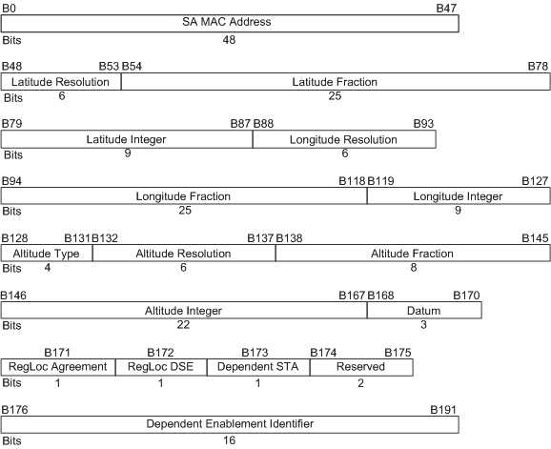
Figure 85q—DSE LCI element format
The SA MAC address field contains the SA MAC address from the Beacon or Spectrum management Action frame containing a DSE registered location element being reported.

The remaining fields are as defined in the DSE registered location element (see 7.3.2.49).

Annex A

Insert new item in SM5 after Receive power indicator (PRI) histogram
Item | Feature | References | Status | Support
SM5 | DSE request | 7.3.2.21.11 | CFy:M | Yes □ No □ N/A □
Insert new item in SM6 after PRI histogram report
Item | Feature | References | Status | Support
SM6 | DSE report | 7.3.2.22.11 | CFy:M | Yes □ No □ N/A □

Annex D

In the Major section of Annex D, delete dot11LCIDSEReportTable object

In the SMT MIB section of Annex D, delete dot11LCIDSEReport Table

