802.11 TG”k” Letter Ballot 85 Instructions

These instructions apply only for the 802.11 Letter Ballot 85 (LB85) on Draft 5.0 of the Task Group “k” amendment to the current IEEE 802.11 standard.

Important: YOU MUST FOLLOW THE INSTRUCTIONS BELOW!

This is a New Process we will be using to vote on letter ballots. It is a web based process similar to the process used for sponsor ballots. Please do not send email to vote.

Failure to follow the instructions may result in your vote being discarded as an invalid vote. Letter ballots are an enormous amount of work for the leadership due to the large size of the group. The only way to have this ballot processed accurately and in a timely manor is for voting members to cooperate and following the instructions.

In case there is an error in the voters list, your name is not in the voters list and you believe you are an 802.11 voting member, you MUST vote to maintain your voter’s status.

This is a Procedural Motion and requires only a Yes, No or Abstain with no comments required for “no” votes. This, being a vote on moving a draft forward, will also require a greater than 75% approval to pass per IEEE 802 Policies and Procedures.

The ballot opens August 10, 2006 at 2359 Eastern Time USA and closes 16 days later on August 26, 2006 at 2359 USA Eastern Time. This ballot has been extended one day due to the draft document links on the instruction document not working the first day.

Motion: Believing that comment responses in 11-06/891R9 (except comment 716 which has been withdrawn by the commenter) and the draft mentioned below satisfy WG 802.11 rules for letter ballot recirculation, authorize a 15-day letter ballot recirculation of P802.11k_Draft 5.0.pdf assuming approval of the current draft by a 15 day procedural letter ballot.

Obtaining the draft:
Draft 5.00 of IEEE 802.11k is available at http://www.ieee802.org/11/private/Draft_Standards/11k/P802.11k_D5.0.pdf

Obtaining the support documentation:

The redlined version of the draft can be found at
http://www.ieee802.org/11/private/Draft_Standards/11k/11-06-1311-00-0000-redlined-document-11k-draft-d5.0.doc

The resolved comments can be found at:
http://www.ieee802.org/11/11-06-0891-18-000k-LB83-may-to-jun-com-merge.xls

The draft is password protected per IEEE 802 Policies and Procedures. To obtain the draft, use the username and the password supplied to voting members for the private area.

To Vote: Open your web browser tohttps://standards.ieee.org/cgi-bin/eballoting?vote:0000085. You will see the following web page.

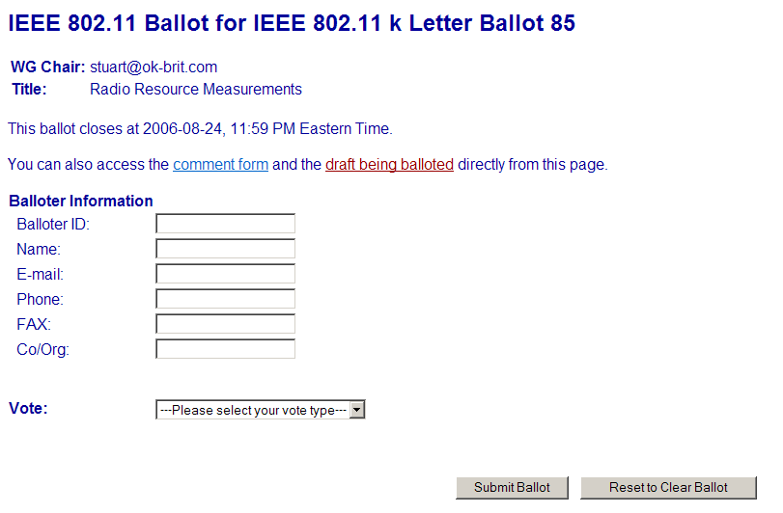
- Please fill out the balloter information that is requested.
  - The Balloter ID can be found on the Voters List at
http://www.ieee802.org/11/Voters-list-LB85.xls
(All fields are required except for the FAX field in order for your vote to be valid)
- Click on the drop down box and select on of the following
  - Approve (no comments)
  - Approve (with comments)
  - Do Not Approve
  - Abstain due to lack of technical expertise
- Once the information above is completed, Click the “Submit Button” to enter your vote.
- You will receive an email confirmation of your vote as below:

(Message sent via IEEE Standards webmail)
-----------------------------------------
Here is a courtesy copy of a ballot for IEEE 802.11 k Letter Ballot 85 just submitted:

# Ballot/Comment Data for 0000001 (IEEE 802.11 k Letter Ballot 85) # Submitted Tue Aug 8 21:47:29 EDT 2006 # Type: ballot # Record Number: 112

ballot_code = 0000001
form_type = ballot
balloter_id = 112
name = Harry Worstell
email = hworstell@research.att.com
phone = 973-236-6915
fax =
org = AT&T
vote = Approve, no comments (Y)
-----------------------------------------
(End of IEEE Standards webmail message)

- You will also receive a confirmation web page for your vote. ALSO on the confirmation page is a “Submit Comment” button.
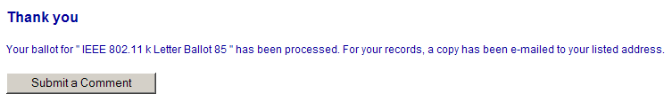
If you have comments, select the “Submit Comments” button.

TO SUBMIT COMMENTS: (Comments are not required for this letter ballot.)

This will take you to the following page:

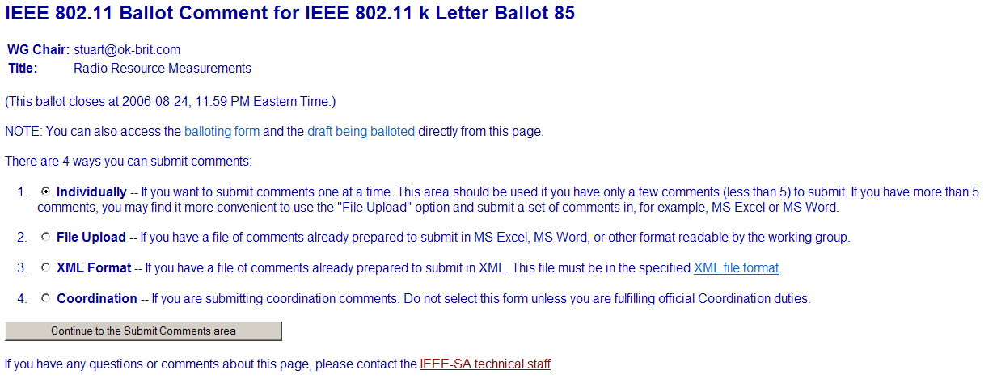

Select ONLY #2 - “File Upload”
Once selected, Click the “Continue to the Submit Comments Area”.
This takes you to the page below:

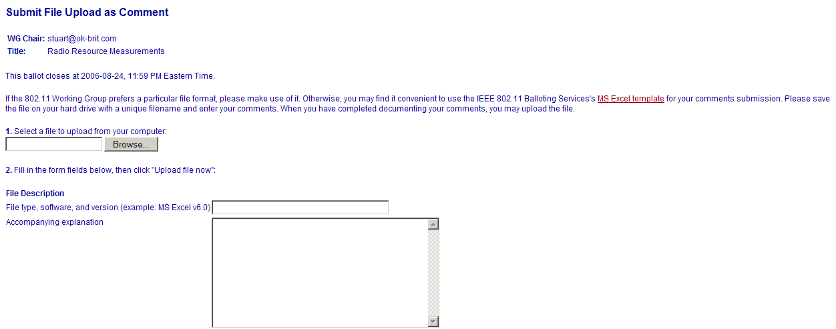
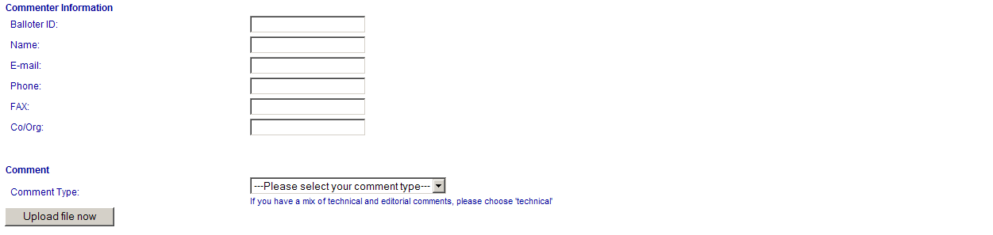
- Select “Browse…” and select your completed comment file.
- Enter the file type in the “File Description” field.
- Complete the “Commenter Information”
- In the “Comment Type”, select either “Technical” if any technical comments are included or Editorial for all else.
- Select “Upload file now”

Completing the Comment Form:

Comments are not required for this letter ballot.
Should you wish to submit comments, please use the following instructions:

- Form: The official comment form for Letter Ballot 85 must be used. This comment form is available at http://www.ieee802.org/11/LB_85_CommentForm.xls

- Names: In the header of comment response form, please fill in your name in the <First Name>, <Last Name> fields. Do not use your initials or anything else.

- Clause Column: This is the section number of the draft that your comment applies to - e.g. 2.1 or 4.2.3. If you have a comment that applies to the entire document put "General" in the section field. Don’t put “all”, “many”, “various” or any other word you may personally fancy. If the field contains anything other that a clause number or “General”, the comment will be discarded and your vote possibly invalidated. If your comment relates to a table, place the clause in which the table resides in this column and not the table number. Put only the clause number and not the words, e.g. “clause”.

- E/T Column: Please use an E or T only to indicate a technical or an editorial comment. Please use upper case only so things sort right when we get all done. Incorrectly categorized comments will be re-categorized by the Task Group chairperson.

- "Part of No vote” Column: If you say "no" in this column, we will feel free to skip that comment in terms of formally satisfying a "NO" vote. For any comment that is not part of your “NO” vote, mark it as "not part of a no vote" by entering “no” in the column. Any voter that votes “NO” should have at least one comment marked “yes” as part support for their “NO” vote. Any voter that votes “YES” should not have any comments marked “yes” in this column.

- "comment/explanation" and "recommended change" columns: These are pretty self explanatory. If you do not recommend a change the comment may be skipped as you have not asked the group to do anything. Please keep the explanation of the comment separate from what you want done as a result of your reasoning. The voting group is too large for the task group to be interpreting what you are requesting. Please remember that the operating rules state that all “No” votes MUST be accompanied by comments which include specific reasons and enough information for the group to understand what you desire in order to change your “no” to a “yes”. Simply saying “not good enough” is insufficient as the task group cannot reasonably be expected to understand what would satisfy the commenter and so invalidation of the vote is justifiable.

- Draft line numbers: If you choose to include a page / line number reference in your comments, please do so by putting is as text at the start of your comment. Do NOT put this info in the section number field. The rational is that the page/line numbers are valid only for the balloted draft version. The section numbers are more likely to still be correct in later versions.

Stuart J. Kerry, 802.11 WG Chair
E-mail: stuart@ok-brit.com

Richard Paine, TGk Chair
E-mail: richard.h.paine@boeing.com

August 9, 2006

