has the pleasure of inviting you to the TGax ad Hoc in San Diego, California, USA, from 10th to 12th of January 2018.

San Diego, 31 July 2026
Invitation to the TGax ad Hoc
From 10th to 12th of January 2018 in San Diego, California, USA
Address of the meeting | You will need to check-in first at the Front desk of Building AX (see building map in the attachment #2) to get a visitor’s badge and the WiFi guest code for each day. You must check-in daily to receive a new badge every day. Then you may proceed to the AZ Multipurpose A+B+C conference room.  Note: Building letters do not appear on the outside of the building.  The meeting will be held at:  Multipurpose Room, Qualcomm Building AZ: 10155 Pacific Heights Blvd, San Diego, CA 92121
GETTING THERE | The closest airport is San Diego Lindbergh Field International Airport (SAN)
mEETING SCHEDULE | MAC ad hoc: 9:30 am, January 10th to 6pm, January 12th  PHY ad hoc: 9:30 am to 6pm, January 12th
REGISTRATION | Distribution of badges will start ½ hour before the start of the meeting.
Qualcomm Visitor’s Badges | Please fill out the “Qualcomm Visitor Badge Form” attached and email to Darleen Craig-Ernst at dcraig@qti.qualcomm.com.
VISa | Delegates who require a personal invitation letter for their visa application should contact Darleen Craig-Ernst (dcraig@qti.qualcomm.com). Please fill out the “Letter of Invitation Request Form” attached and email to Darleen.

Power and plugs | Electricity in United States of America / USA is 120 Volts, alternating at 60 Hz. If you travel to the United States of America / USA with a device that does not accept 120 Volts at 60 Hertz, you will need a voltage converter.  Outlets in United States of America / USA generally accept a two pin, flat blade plug with one opening larger than the other to accommodate polarized plugs.    If your appliance’s plug has a different shape, you may need a plug adapter.  Please do not forget your adapter.
SEcurity & RESPECT RULES | Please note that Qualcomm cannot be held responsible for any loss of or damage to equipment so you should keep your personal belongings with you at all times.  Delegates should wear their Qualcomm issued visitor badges at all times while they are at the meeting premises.
HOTEL information | There are several hotels around the Qualcomm offices. Discounted rates can be obtained indicating that you are visiting Qualcomm offices during the stay. You must call the hotel to obtain discounted rate. Please see attachments for a list and map of local hotels.
DRIVING DIRECTIONS | Please see Attachment #1.

Transport and Local Information | Ground Transportation:  Transportation to/from the airport is provided by shuttle services for approximately $30 per person.  Average taxi rate to/from airport is $60.  Gratuities  A gratuity of 15% - 18% is customary at restaurants and for taxi drivers.  Weather  The average temperatures in San Diego in January are:  Average High Temperature: 69°F  Average Low Temperature: 47°F  For further information, please review the link below before travel departure:  www.weather.com  Time Zone  San Diego is in the Pacific time zone.  Currency and Credit Cards  The US Dollar $ is the local currency and credit cards are accepted in all major outlets.  Tourism Information  http://www.lonelyplanet.com/usa/san-diego
questions | Should you need any help or support at any time or just some advice, do not hesitate to call:  - Darleen Craig-Ernst at dcraig@qti.qualcomm.com, tel: 858-658-2040

ATTACHMENT #1

Directions from San Diego Airport to the Qualcomm AZ building at
10155 Pacific Heights Blvd
San Diego, California 92121

San Diego International Airport, 3225 North Harbor Drive San Diego, California 92101
22 min | 17.443 miles
Current Traffic: Moderate
 | Start out going northwest on Terminal Access Rd. | 0.20 miles
 | Take Terminal Access Rd toward Airport Exit/Terminal Return/Parking. | 0.22 miles
 | Turn slight right toward I-5/Downtown/Rental Car Return. | 0.50 miles
 | Turn slight right onto N Harbor Dr. | 1.08 miles
 | Turn left onto W Grape St.  - W Grape St is just past W Hawthorn St | 0.38 miles
 | Merge onto I-5 S/San Diego Fwy S.  - If you reach Albatross St you've gone a little too far | 0.57 miles
 | Merge onto CA-163 N via EXIT 16 toward Escondido. | 6.10 miles
 | Merge onto I-805 N via EXIT 7A toward Los Angeles. | 6.28 miles
 | Take the Mira Mesa Blvd/Vista Sorrento Pkwy exit, EXIT 27A. | 0.53 miles
 | Turn right onto Mira Mesa Blvd.  - If you are on Vista Sorrento Pkwy and reach Mira Sorrento Pl you've gone about 0.1 miles too far | 1.16 miles
 | Turn left onto Pacific Heights Blvd.  - Pacific Heights Blvd is 0.3 miles past Lusk Blvd  - If you reach Huennekens St you've gone about 0.3 miles too far | 0.42 miles
 | 10155 Pacific Heights Blvd, San Diego, CA 92121-4214, 10155 PACIFIC HEIGHTS BLVD is on the left.  - Your destination is 0.1 miles past Barnes Canyon Rd  - If you reach Pacific Center Blvd you've gone a little too far | 0.00 miles

ATTACHMENT #2

Directions to Qualcomm
Directions:
At exit 7A, take ramp right for I-805 North toward Los Angeles

At exit 27B, take ramp right toward Sorrento Valley Rd 0.2 mi

Keep straight onto Mira Sorrento Pl 0.3 mi
Turn left onto Scranton Rd 0.3 mi
Road name changes to Barnes Canyon Rd 0.6 mi
Turn left onto Pacific Heights Blvd 0.1 mi
Arrive at Pacific Heights Blvd
If you reach Pacific Center Blvd, you've gone too far

10155 Pacific Heights Blvd, San Diego, CA 92121

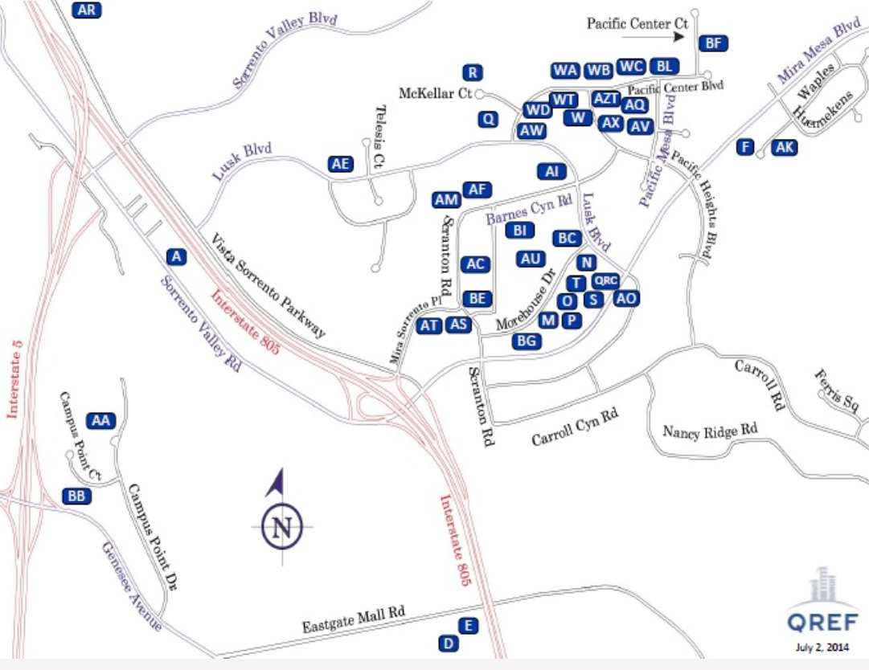

ATTACHMENT #3

Current as of: 18 June 2015
Hotel Name | Distance Miles | Internet | Parking | Complimentary Shuttle Service to Qualcomm  Buildings | Breakfast  Included | Phone | Address
HOLIDAY INN EXPRESS & SUITES SORRENTO | 0.83 | Included | Included | Yes | Yes | +1-800-972-2802  +1-858-731-0100 | 5925 Lusk Blvd.  San Diego, CA 92121
COUNTRY INN & SUITES | 0.81 | Included | Included | Yes | Yes | +1-858-558-1818 | 5975 Lusk Blvd.  San Diego, CA 92121
HYATT HOUSE SAN DIEGO SORRENTO | 0.80 | Included | Included | Yes | Yes | +1-858-597-0500 | 10044 Pacific Mesa Blvd.  San Diego, CA 92121
STAYBRIDGE SUITES SAN DIEGO | 2.10 | Included | Included | Yes | Yes | +1-877-238-8889 | 6639 Mira Mesa Blvd.  San Diego, CA 92121
COURTYARD BY MARRIOTT SORRENTO | 1.04 | Included | Included | Yes | Yes | +1-858-558-9600 | 9650 Scranton Road  San Diego, CA 92121
EMBASSY SUITES LA JOLLA | 3.62 | Included | Not  Included | Yes | Yes | +1-858-453-0400 | 4550 La Jolla Village Drive  San Diego, CA 92122
MARRIOTT LA JOLLA | 4.04 | Included | Not  Included | No | Yes | +1-858-587-1414 | 4240 La Jolla Village Drive  La Jolla, CA 92037
HYATT REGENCY LA JOLLA | 4.10 | Included | Not  Included | Yes | Yes | +1-858-552-1234 | 3777 La Jolla Village Drive  San Diego, CA 92122
RESIDENCE INN SORRENTO MESA | 0.92 | Included | Included | Yes | Yes | +1-858-552-9100 | 5995 Pacific Mesa Ct.  San Diego, CA 92121
RESIDENCE INN LA JOLLA | 4.99 | Included | Included | Yes | Yes | +1-858-587-1770 | 8901 Gilman Drive  La Jolla, CA 92037
Note: All hotels in the state of California are non-smoking facilities.

