

have the pleasure of inviting you to the TGax ad Hoc in San Diego, California, USA, from 8th to 10th of March 2017.

San Diego, 29 July 2026
Invitation to the TGax ad Hoc
From 8th to 10th of March 2017 in San Diego, California, USA
Address of the meeting | You will need to check-in first at the Qualcomm Research Center (5665 Morehouse Drive) to get a visitor’s badge and the WiFi guest code for each day. You must check-in daily to receive a new badge every day. Then you may walk next door to Building S (5535 Morehouse Drive) and proceed to conference room S-210 & S-266. Note: Building letters do not appear on the outside of the building.  The meeting will be held at:  Conference Room S-210, Qualcomm Building S: 5535 Morehouse Drive  San Diego, California 92121, USA
GETTING THERE | The closest airport is San Diego Lindbergh Field International Airport (SAN)
mEETING SCHEDULE | The meeting will start on 08 March 2017 at 10:00 am  The meeting will end on the 10 March 2017 no later than 16:00  Distribution of badges will start ½ hour before the start of the meeting.
REGISTRATION | Please send a private email to TGax chair Osama <osama.aboulmagd@huawei.com>
Qualcomm Visitor’s Badges | Please fill out the “Qualcomm Visitor Badge Form” attached and email to Darleen Craig-Ernst at dcraig@qti.qualcomm.com.
VISa | Delegates who require a personal invitation letter for their visa application should contact Darleen Craig-Ernst (dcraig@qti.qualcomm.com). Please fill out the “Letter of Invitation Request Form” attached and email to Darleen.

ELECTRONIC WORKING
Power and plugs | Electricity in United States of America / USA is 120 Volts, alternating at 60 Hz. If you travel to the United States of America / USA with a device that does not accept 120 Volts at 60 Hertz, you will need a voltage converter.  Outlets in United States of America / USA generally accept a two pin, flat blade plug with one opening larger than the other to accommodate polarized plugs.    If your appliance’s plug has a different shape, you may need a plug adapter.  Please do not forget your adapter.
SEcurity & RESPECT RULES | Please note that Qualcomm cannot be held responsible for any loss of or damage to equipment so you should keep your personal belongings with you at all times.  Delegates should wear their Qualcomm issued visitor badges at all times while they are at the meeting premises.
HOTEL information | There are several hotels around the Qualcomm offices. Discounted rates can be obtained indicating that you are visiting Qualcomm offices during the stay. You must call the hotel to obtain discounted rate. Please see attachments for a list and map of local hotels.
DRIVING DIRECTIONS | Please see Attachment #1.

Transport and Local Information | Ground Transportation:  Transportation to/from the airport is provided by shuttle services for approximately $30 per person.  Average taxi rate to/from airport is $60.  Gratuities  A gratuity of 15% - 18% is customary at restaurants and for taxi drivers.  Weather  The average temperatures in San Diego in March are:  Average High Temperature: 68°F  Average Low Temperature: 60°F  For further information, please review the link below before travel departure:  www.weather.com  Time Zone  San Diego is in the Pacific time zone.  Currency and Credit Cards  The US Dollar $ is the local currency and credit cards are accepted in all major outlets.  Tourism Information  http://www.lonelyplanet.com/usa/san-diego
questions | Should you need any help or support at any time or just some advice, do not hesitate to call:  - Darleen Craig-Ernst at dcraig@qti.qualcomm.com, tel: 858-658-2040

ATTACHMENT #1

Directions from San Diego Airport to the Qualcomm Research Center at
5665 Morehouse Drive
San Diego, California 92121-4233

San Diego International Airport, 3225 North Harbor Drive San Diego, California 92101
16.6 mi (about 25 mins)
Head west on Airport Terminal Rd | 423 ft
Slight left to stay on Airport Terminal Rd | 0.3 mi
Keep right at the fork | 443 ft
Turn left onto N Harbor Dr | 1.4 mi
Turn left onto W Grape St | 0.4 mi
Take the Interstate 5 S ramp | 0.2 mi
Merge onto I-5 S | 0.4 mi
Take exit 16 to merge onto CA-163 N toward Escondido | 6.1 mi
Take exit 7A to merge onto I-805 N toward Los Angeles | 6.3 mi
Take the Mira Mesa Blvd/Vista Sorrento Pkwy exit | 0.6 mi
Turn right onto Mira Mesa Blvd | 0.2 mi
Turn left onto Lusk Blvd. Note: This will be at the second stoplight once you exit the freeway. As a landmark, look for the Chili’s restaurant on the corner. | ~ 1.0 mi
Make a U-Turn on Morehouse Drive (first light) | ~ 0.1 mi
Turn right into the first driveway. Please tell the security guard in the guard shack that you are attending a meeting in the Qualcomm Research Center and he/she will direct you where to park. | ~ 0.1 mi
5665 Morehouse Drive, San Diego, CA 92121

ATTACHMENT #2

Directions to Qualcomm

Directions:

- I-805
- Exit MIRA MESA BLVD.
- Turn LEFT onto LUSK BLVD.
- Make a U-TURN on MOREHOUSE DR.
- Turn RIGHT into FIRST DRIVEWAY
- Qualcomm Research Center, 5665 Morehouse Drive, San Diego, CA 92121-4233
- There is a sign on the outside of the building that says “Qualcomm Research Center.”

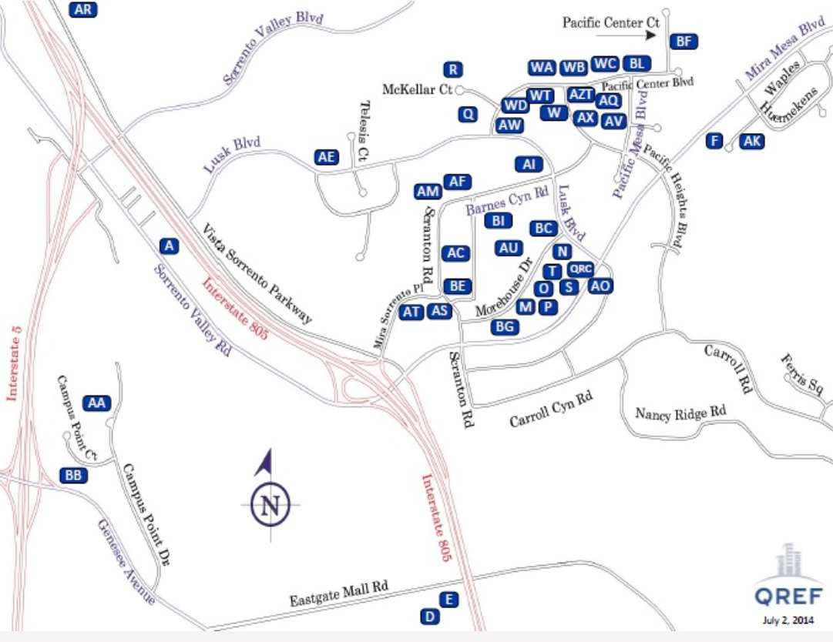

ATTACHMENT #3

Current as of: 18 June 2015
Hotel Name | Distance Miles | Internet | Parking | Complimentary Shuttle Service to Qualcomm  Buildings | Breakfast  Included | Phone | Address
HOLIDAY INN EXPRESS & SUITES SORRENTO | 0.83 | Included | Included | Yes | Yes | +1-800-972-2802  +1-858-731-0100 | 5925 Lusk Blvd.  San Diego, CA 92121
COUNTRY INN & SUITES | 0.81 | Included | Included | Yes | Yes | +1-858-558-1818 | 5975 Lusk Blvd.  San Diego, CA 92121
HYATT HOUSE SAN DIEGO SORRENTO | 0.80 | Included | Included | Yes | Yes | +1-858-597-0500 | 10044 Pacific Mesa Blvd.  San Diego, CA 92121
STAYBRIDGE SUITES SAN DIEGO | 2.10 | Included | Included | Yes | Yes | +1-877-238-8889 | 6639 Mira Mesa Blvd.  San Diego, CA 92121
COURTYARD BY MARRIOTT SORRENTO | 1.04 | Included | Included | Yes | Yes | +1-858-558-9600 | 9650 Scranton Road  San Diego, CA 92121
EMBASSY SUITES LA JOLLA | 3.62 | Included | Not  Included | Yes | Yes | +1-858-453-0400 | 4550 La Jolla Village Drive  San Diego, CA 92122
MARRIOTT LA JOLLA | 4.04 | Included | Not  Included | No | Yes | +1-858-587-1414 | 4240 La Jolla Village Drive  La Jolla, CA 92037
HYATT REGENCY LA JOLLA | 4.10 | Included | Not  Included | Yes | Yes | +1-858-552-1234 | 3777 La Jolla Village Drive  San Diego, CA 92122
RESIDENCE INN SORRENTO MESA | 0.92 | Included | Included | Yes | Yes | +1-858-552-9100 | 5995 Pacific Mesa Ct.  San Diego, CA 92121
RESIDENCE INN LA JOLLA | 4.99 | Included | Included | Yes | Yes | +1-858-587-1770 | 8901 Gilman Drive  La Jolla, CA 92037
Note: All hotels in the state of California are non-smoking facilities.
ATTACHMENT #4

Hyatt House San Diego Sorrento
Residence Inn
Sorrento Mesa
Country Inn and Suites
Holiday Inn Express
Courtyard by Marriott Sorrento
QUALCOMM

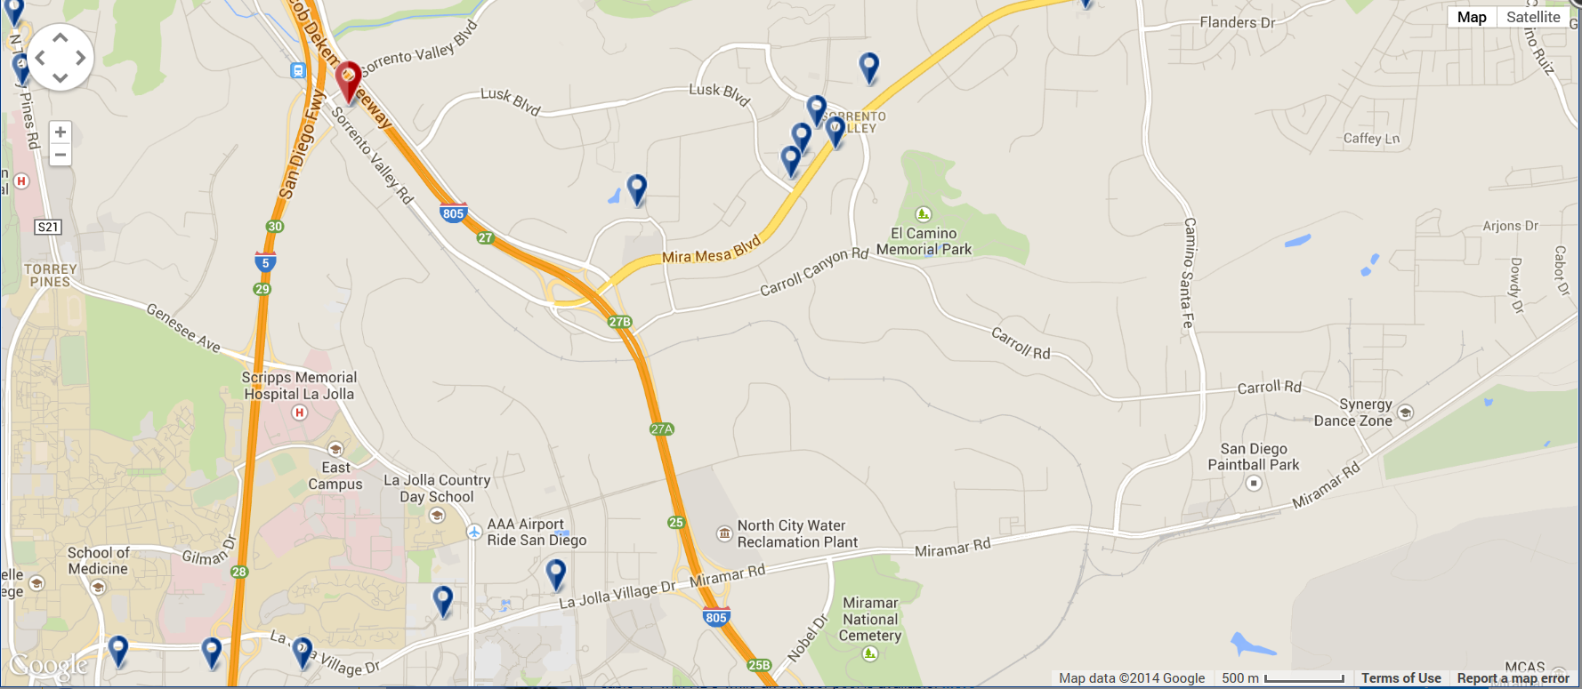
Embassy Suites
La Jolla
Marriott La Jolla
Hyatt Regency La Jolla
Residence Inn
La Jolla

