CISCO has the pleasure of inviting you to the TGax ad Hoc in San Jose, California, USA, from 28th February to 2nd of March 2018.

San Jose, 31 July 2026
Invitation to the TGax ad Hoc
From 28th of February to 2nd of March 2018 in San Jose, California, USA
Address of the meeting | You will need to check-in first at the Front desk of Building SJ-18 (see building map in the attachment #2) to get a visitor’s badge and the WiFi guest code for each day. You must check-in daily to receive a new badge every day. Then you may proceed to the Reykjavik / Dalvik conference room.  The meeting will be held at:  Reykjavik conf room, Cisco Building SJ-18: 3600 Cisco Way, San Jose, CA 95134
GETTING THERE | The closest airport is San Jose International Airport (SJC)
mEETING SCHEDULE | MAC ad hoc: 9:30 am, February 28th to 6pm, March 2nd  PHY ad hoc: 9:30 am to 6pm, March 2nd
REGISTRATION | Distribution of badges will start ½ hour before the start of the meeting.
CISCO Visitor’s Badges | Please fill out the “Cisco Visitor Badge Form” attached and email to Kassandra Ramirez at karamire@cisco.com .
VISa | Delegates who require a personal invitation letter for their visa application should contact Kassandra Ramirez (karamire@cisco.com). Please fill out the “Letter of Invitation Request Form” attached and email to Kassandra.

Power and plugs | Electricity in United States of America / USA is 120 Volts, alternating at 60 Hz. If you travel to the United States of America / USA with a device that does not accept 120 Volts at 60 Hertz, you will need a voltage converter.  Outlets in United States of America / USA generally accept a two pin, flat blade plug with one opening larger than the other to accommodate polarized plugs.    If your appliance’s plug has a different shape, you may need a plug adapter.  Please do not forget your adapter.
SEcurity & RESPECT RULES | Please note that Cisco cannot be held responsible for any loss of or damage to equipment so you should keep your personal belongings with you at all times.  Delegates should wear their Cisco issued visitor badges at all times while they are at the meeting premises.
HOTEL information | There are several hotels around the Cisco offices. Please see attachments for a list and map of local hotels.
DRIVING DIRECTIONS | Please see Attachment #1.

Transport and Local Information | Ground Transportation:  Transportation to/from the airport is provided by shuttle services for approximately $30 per person.  Average taxi rate to/from airport is $60.  Gratuities  A gratuity of 15% - 18% is customary at restaurants and for taxi drivers.  Weather  The average temperatures in San Jose in March are:  Average High Temperature: 66°F  Average Low Temperature: 47°F  March 2017 Precip Stats: Actual Month Total: 1.46 in | Average Month Total: 2.54 in  For further information, please review the link below before travel departure:  www.weather.com  Time Zone  San Jose is in the Pacific time zone.  Currency and Credit Cards  The US Dollar $ is the local currency and credit cards are accepted in all major outlets.  Tourism Information  https://www.lonelyplanet.com/search?q=San%20Jose,%20CA
questions | Should you need any help or support at any time or just some advice, do not hesitate to call:  - Kassandra Ramirex at karamire@cisco.com,

ATTACHMENT #1

Directions from San Jose Airport to the
Cisco SJ-18 building at
3600 Cisco Way
San Jose, California 95134

http://flysanjose.com/directions

ATTACHMENT #2
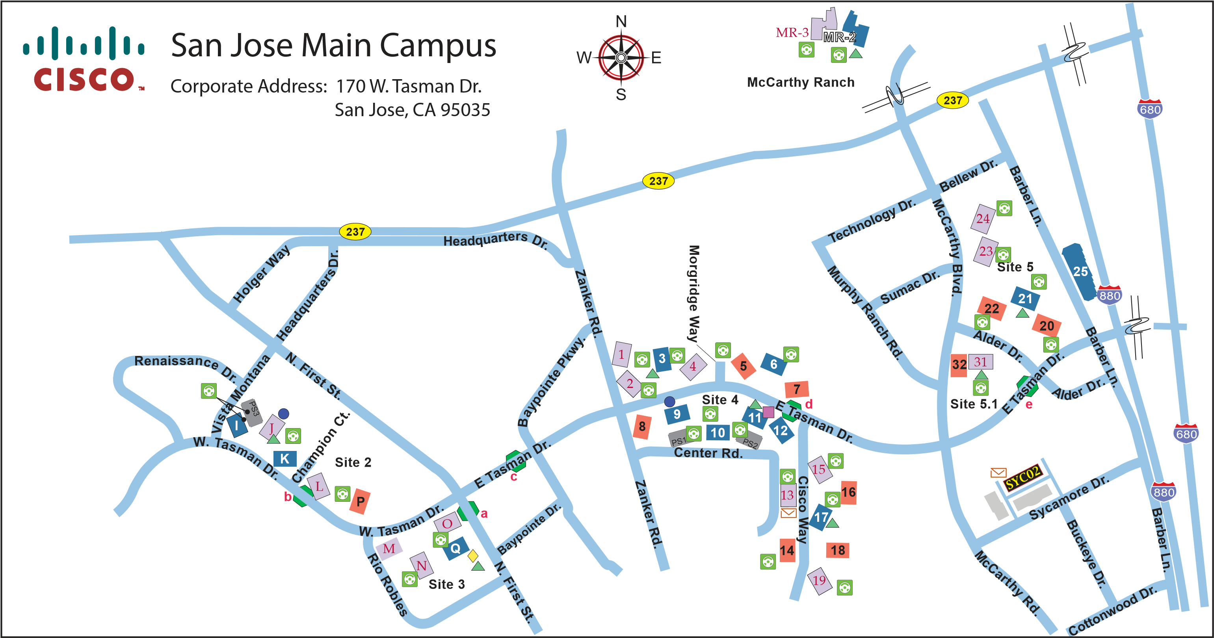
Legend | X Lobby Ambassador Building X Virtual Assistant  X Self-Service Lobby  X Badge Access Only  Café  Cisco Store Conference Center  Electric Vehicle Charging Station  LifeConnection Health & Fitness Mail Distribution Center  Light Rail Station a Tasman Station  b Champion Station  c Baypointe Station  d Cisco Way Station  e Milpitas Station | Site 2  - - 285 West Tasman Dr.  - - 255 West Tasman Dr.  - - 225 West Tasman Dr.  - - 175 West Tasman Dr.  P - 125 West Tasman Dr.  Site 3  M - 80 West Tasman Dr.  N - 125 Rio Robles  O - 10 West Tasman Dr.  Q - 3571 N. First St.  Site 4  - - 3850 Zanker Rd.  - - 3800 Zanker Rd.  - - 225 East Tasman Dr.  - - 275 East Tasman Dr. | 5 - 325 East Tasman Dr.  6 - 375 East Tasman Dr.  7 - 425 East Tasman Dr.  8 - 3750 Zanker Rd.  - - 260 East Tasman Dr.  - - 300 East Tasman Dr. 11 - 350 East Tasman Dr.  - - 400 East Tasman Dr.  - - 3675 Cisco Way  - - 3625 Cisco Way  - - 3750 Cisco Way  - - 3700 Cisco Way  - - 3650 Cisco Way  - - 3600 Cisco Way  - - 3550 Cisco Way | Site 5  20 - 725 Alder Dr.  21 - 771 Alder Dr.  - - 821 Alder Dr.  - - 560 McCarthy Blvd.  - - 510 McCarthy Blvd. 25 - 800 Barber Ln.  Site 5.1  - - 870 Alder Dr.  - - 900 McCarthy Blvd. | McCarthy Ranch  MR-2 - 135 N. McCarthy Blvd.  MR-3 - 155 N. McCarthy Blvd.  Other Buildings  Sycamore 2 - 755 Sycamore Dr.  SJCNT01 - 100 Nortech Pkwy.

Directions to Cisco SJ-18
Directions:

https://www.mapquest.com/us/ca/san-jose/95134-2205/3600-cisco-way-37.406872,-121.928132

ATTACHMENT #3

Current as of: 1 February 2018
Hotel Name | Distance Miles | Internet | Parking | Complimentary Shuttle Service to Cisco  Buildings | Breakfast  Included | Phone | Address
Note: All hotels in the state of California are non-smoking facilities.

