IEEE P802.11
Wireless LANs
WGLB0-CID40-43-56-96
Date: 2012-10-30
Author(s):
Name | Affiliation | Address | Phone | email
Matthew Fischer | Broadcom | 190 Mathilda Place, Sunnyvale, CA 94086 | +1 408 543 3370 | mfischer@broadcom.com
Abstract
Proposed resolutions for WG LB 0 CID 40, 43, 56, 96.

Revision Notes

R7:
In changes to 9.3.2.1 CS mechanism, added 10% of aSlotTime to amount of time that MAC delays after MAC slot boundary until it asserts PHY-CCARESET.request, because of the allowance for 10% of slot tolerance in SIFS.
In changes to 7.3.5.9.3 (when generated for PHY-CCARESET.request SAP), corrected reference of where slot boundaries are defined from 9.3.2.1 to 9.3.7. – the 9.3.2.1 reference is earlier in the sentence as of R6, and it is needed for the delay time after the MAC slot boundary when the SAP is issued.
In changes to 9.3.2.1 CS mechanism, added reference to slot boundaries defined in 9.19.2.3.
In changes to 9.3.7 DCF timing relations, changed “the PHY and the MAC” to “the STA” as the subject of who can tradeoff parameter values.

R6:
Modified reference to the mac slot boundaries.
Added reference to 9.3.2.1 in CS mechanism subclause.

R5:
Add diagram to show tradeoffs of MAC and PHY timing parameters.

R4:
Proposed text changes for CID 40, 43, 56 slightly modified – removed “a value that is greater than the value indicated in the PHY Charateristics table of the attached PHY” – since a later instruction replaces all of the values for those parameters with “implementation dependent”.
Changed “MAC SLOT boundary” to “MAC slot boundary”.
Added reference to slot boundaries in 9.19.2.3

R6:
Fixed CID 40 resolution (still had old reject resolution)
Fixed CID 43, 56 resolutions (changed counter to revise and update r number)
Added R2 revision notes.

R2:
Combined CID 40 with CID 43, 56.
Changed CID 40 resolution from reject to revise.
Included new editing instructions to cover CID 40.
Modified editing instructions for CID 43, 56 to give corrected modifications to parameter value modifications and timing values.

R1:
Correct the internal doc references.
Change wording of proposed text of CID 96 slightly.
Fix editor references – change from TGac to TGm.

R0:
Initial

CID 40, 43, 56

CID | Commenter | Page | Clause | Comment | Proposed Change | Resolution
40 | Brian Hart | 1638.00 | 19.3.2.4 | CCA architecture is ambiguous. IsCCARESET a rare event or an every-slot event? I think CCA should be reset at the end of a PPDU (arguably this is described in 7.3.5.9.3 and - upon NAV reset - 9.3.2.4), immediately after a frequency hop (don't care if this is described or not) and immediately after a channel change (kinda obvious - have to reset a lot - but still such guidance could be added). But still, is CCA reset on slot boundaries or not? The language on this topic is absent/unclear. E.g. clause 14, 16, 17 and 19 (2.4 GHz clauses - search for "slot") and 6.5.4.2 aCCATime definition imply that the PHY is slot aware but clauses 18 and 20 are silent. Further, how does the PHY becomes aware of the slot boundaries? 19.3.2.4 implies it is sync-ed to the last frame on the medium (not via a regular train of CCARESETs). BUT there is no requirement that the MAC clock and PHY clock be synced, or primitive to assure us of this, so in the absence of packets the PHY's estimate of slot timing can be expected to diverge from the MAC's estimate. So 19.3.2.4 does not seem to be a complete answer . | Does the PHY need to know slot timings? Be specific for all PHYs. Or is 2.4 different from 5 GHz??? If the PHY needs to know, define how does the PHY sync up initally? For all PHYs. e.g. "From the last *PPDU*"? Then define how the PHY stays in sync? Via regular CCARESETs? Or other? | Revise – Tgm editor to make changes to the draft as shown in 11-12-1256-r6 under the heading CID 40, 43, 56.
43 | Brian Hart | 1623.00 | 18.4.4 | 1) From 9.3.7, aCCATime + RXTXTurn + aAirProp + aMACProcessingDelay must equal slot time. Yet, as written in clause 18.4.4 and likely other PHY clauses too, these numbers are all "<" so must add up to "<aSIFSTime. At the very least, these parameters should be "<="  2) If the PHY does a bit better on one measure - e.g. aCCATime - it should be able to relax another measure - e.g. RXTXTurn. Yet, if it can do everything ~instantaneously, it will massively undercut SIFS and cause non-reception at the initiator. Suggestions: a) explain/define that the parameters in the equations in 9.3.7 are "max times at design time". Actual implemations may use different values and may even add a wait time so sifs/slot times are consistent. b) at implementation time, allow one PHY parameter to be traded against another as long as the sum is consistent (this is moot for the MAC since that has only 1 param - altho perhaps allow a VS trade btw MAC and PHY?). | As in comment | Revise – Tgm editor to make changes to the draft as shown in 11-12-1256-r6 under the heading CID 40, 43, 56.
56 | Dorothy Stanley | 1622.00 | 18.4.4 | 18.4.4: 1) aCCATime + RXTXTurn + aAirProp + aMACProcessingDelay must equal slot time. Yet, as written in this clause and likely other PHY clauses too, these numbers are all "<" so must add up to "<aSIFSTime. At the very least, these parameters should be "<="  2) If the PHY does a bit better on one measure - e.g. aCCATime - it should be able to relax another measure - e.g. RXTXTurn. Yet, if it can do everything ~instantaneously, it will massively undercut SIFS and cause non-reception at the initiator. Suggestions: a) explain/define that the parameters in the equations in 9.3.7 are "max times at design time". Actual implemations may use different values and may even add a wait time so sifs/slot times are consistent. b) at implementation time, allow one PHY parameter to be traded against another as long as the sum is consistent (this is moot for the MAC since that has only 1 param - altho perhaps allow a VS trade btw MAC and PHY?). | Fix, as in comment | Revise – Tgm editor to make changes to the draft as shown in 11-12-1256-r6 under the heading CID 40, 43, 56.

Discussion

CCA reset is intended to be used to synchronize the PHY CCA function with the MAC timing of SLOTS – it is not clear whether it is every SLOT or only some slots that this synchronization might need to be performed.

The commenter actually almost begins to ask the question of whether this synchronization is necessary. If it is found to be necessary, then the use of the PHY.CCARESET SAP should be more clearly described.

The origin of the PHY.CCARESET SAP has to do with the inability of the PHY to detect some receptions, either due to hidden nodes or collisions and the likelihood that these situations can create conditions where the PHY might lose its ability to accurately track the medium condition. In such cases, if the MAC NAV has been set, then the MAC information becomes the most accurate information that is available. When the MAC NAV reaches zero, if the PHY is still “lost” with regard to the current medium state, then a PHY-CCARESET would provide a reference point for the PHY to begin a new examination of the medium. Why would this alignment be needed? Because other MACs would presumably be creating transmissions that line up with the same NAV information and the CCA requirements of some PHYs clearly indicate a detection requirement that is specific to a certain timing with respect to the start of the reception.

Why is a reference point needed by the PHY even for the NAV reaches zero case?

There are many different possible PHY CCA implementations.

It is possible that some portion of the PHY’s CCA determination is based on a window of historical samples of some aspect of a reception. If the window is filled with samples that cause the assessment to be positive for medium BUSY, then the PHY is signalling medium BUSY and if this is the condition when the NAV reaches ZERO and if the perceived BUSY condition on the medium is due to a reception that matches the timing of the NAV counter reaching ZERO, then the condition that the PHY is detecting to cause it to signal medium BUSY is ending at the same time as the MAC NAV reaches zero, but it might take some non-zero time for the PHY sample window to either advance or close before the PHY will either, average down the samples to yield an IDLE result, or for the PHY to start and then complete a new sample window that indicates IDLE. I.e. in the absence of SIGNAL field length information, the PHY indication of the IDLE condition could lag the NAV indication of a clear boundary between the BUSY and IDLE condition.

So, does the PHY CCA mechanism include some sort of discretely jumping windowing function, or is it a continuous/sliding process of evaluation, and if so, what is the resolution of that continuous evaluation process, which in real life is probably also a discrete process based on a clock?

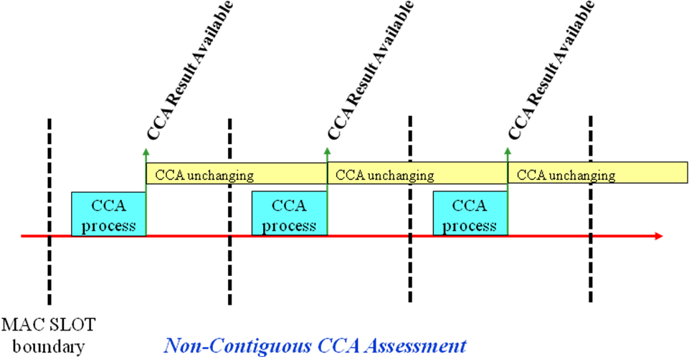

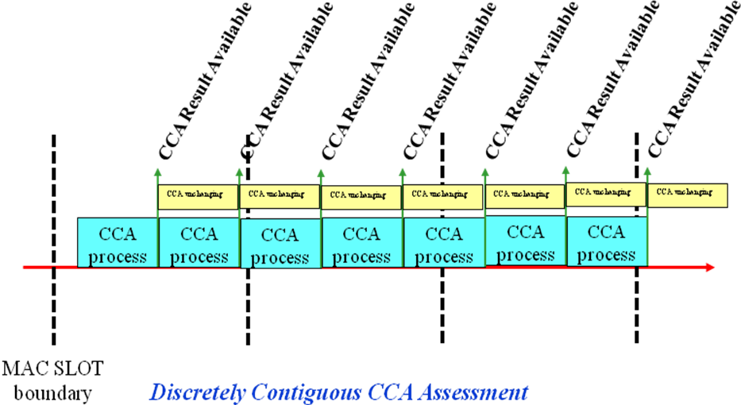

For the interesting case of an IDLE medium becoming BUSY while counting down backoff (and keeping track of slot boundaries), there are two mechanisms for the PHY to signal BUSY. Carrier detect and ED.

In either case, there is some minimum timing resolution of the assessment of the medium condition.

In either case, what is the value of the minimum assessment window relative to the duration of the SLOT? And: What does the PHY do after completing one assessment window (i.e. does it jump or does it slide)?

If the PHY immediately begins a brand new assessment window after the completion of the current one, and the duration of each assessment window is smaller than the SLOT duration then there might or might not need to be an alignment of those windows with the MAC SLOT boundaries. Let’s call this discretely contiguous assessment operation. However, if the PHY performs an assessment in a time that is less that the duration of SLOT, and then waits before starting a new assessment, then the start of the new assessment needs to be aligned with the MAC SLOT boundaries – call this non-contiguous assessment operation.

Actually, there are two forms of congituity that can be described:

- The CCA assessment process takes aCCATime to perform and then if a new assessment is needed, the entire process must restart –just for fun, let’s call this discretely contiguous
- The CCA assessment process takes aCCATime to reach the minimum specified sensitivity, but the process of assessment is continual – i.e. a sliding window contiguous

Depending on which one is typical in implementations, the language in the standard might be troubling.

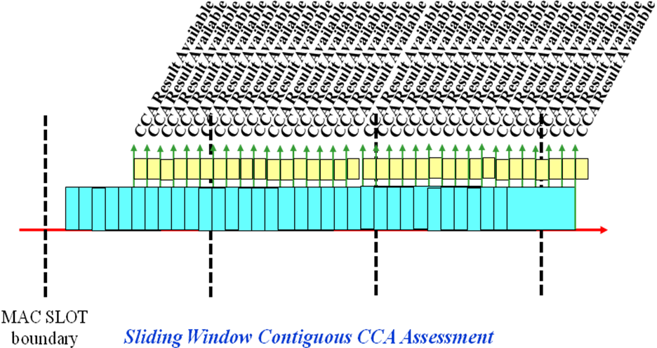

Note that in any case, the CCA assessment window can NEVER be greater than the SLOT duration, because the SLOT duration is the sum of several timing parameters, one of which is aCCATime (i.e. the CCA assessment time), so if the CCA process is contiguous, then there are always at least TWO CCA assessments performed within any randomly aligned MAC SLOT.

The real question to ask is – how often does the PHY update the CCA result?

The next question is, even assuming that there are PHYs that perform as described above, whether the current description of the use of PHY-CCARESET is correct, because it is at both the MAC and the PHY side, unconditional, yet in the description above, it would appear that if the PHY has valid SIGNAL field information which is being employed in the signalling of the CCA condition of BUSY, then the PHY probably has more accurate information about the medium condition than the MAC, and the PHY CCA condition should probably NOT be reset in this case.

But does it really matter? Maybe and maybe not.

It depends on what effect PHY-CCARESET has upon the CCA and receive functions in the PHY. If the receive operation of a valid PHY frame continues when a PHY-CCARESET is indicated, then the CCA would likely be reasserted BUSY shortly after the PHY-CCARESET, based on the continued countdown of the length found in the valid SIGNAL field.

But it is not clear what effect the PHY-CCARESET really has.

So the use of the PHY-CCARESET as described in the baseline might or might not be correct.

As to the commenter’s main question, of whether the MAC and PHY need to have a common timing with respect to slot boundaries, the answer is – “it depends” – on the frequency of update to the CCA result.

Take for example:

17.4.8.5 CCA

b) With a valid signal (according to the CCA mode of operation) present at the receiver antenna within
5 μs of the start of a MAC slot boundary, the CCA indicator shall report channel busy before the end
of the slot time. This implies that the CCA signal is available as an exposed test point. Refer to
Figure 9-14 (in 9.3.7) for a slot time boundary definition.

This is troubling because the 11a specification requires either:

PHY awareness of the slot boundaries
OR
The PHY CCA assessment time to be equal to HALF of the value SLOT minus 5 (which is HALF of 4 usec) (if the process of CCA assessment is discretely contiguous)

But the maximum allowed aCCATime is 4 usec, not 2 – i.e. if your PHY wants to use the maximum allowed CCA assessment time, then your PHY will need slot boundary synchronization.

Unless, of course, the process of CCA assessment is sliding-window contiguous (and has a small resolution, i.e. frequent update to the result), in which case, there is no problem.

Actually, discretely contiguous operation works ok here as well, if the actual implementation time for CCA assessment is << 4 usec so that the CCA updates are frequent – remember that 4 usec is an upper limit.

Clause 18 and clause 20 STA have a similar problem, but probably not as strict:

18.3.10.6 CCA requirements

The start of a valid OFDM transmission at a receive level equal to or greater than the minimum modulation
and coding rate sensitivity (–82 dBm for 20 MHz channel spacing, –85 dBm for 10 MHz channel spacing,
and –88 dBm for 5 MHz channel spacing) shall cause CS/CCA to indicate busy with a probability > 90%
within 4 μs for 20 MHz channel spacing, 8 μs for 10 MHz channel spacing, and 16 μs for 5 MHz channel
spacing.

I.e. again, if your assessment process is discretely contiguous, then you are in trouble, if you want to use the entire 4 usec allowed maximum aCCATime, but if your process is sliding-window contiguous, then you are ok (assuming a resolution << 4 usec)!

It turns out that while 4 usec is the upper bound allowed in the specification, that value is really used for determining the maximum time allowed for a 90% probability result, but it is not really the value that anyone needs to perform their CCA assessment. I.e. most CCA assessments are done in a much shorter time, and the 4 usec might be needed for low SNR receptions because the CCA assessment might fail to signal a detection event after only one or two examinations.

It might be useful to provide a new parameter for the PHY, which is the frequency of update to the CCA result, and limit this value to something less than say, 1 usec.

Alternatively, as the commenter suggests, one might consider forcing PHY-CCARESET to be performed at every MAC SLOT boundary. But further discussion, were the author not too lazy to write it out, would reveal that even this would not work, because in the case of a valid CCA implementation that operates in the non-contiguous mode, a late-starting reception would be missed. (Late starts can be caused by air propagation variation and variation in the allocation of time components of SIFS in different implementations.) (And as was seen, the specification includes a late-start performance requirement.)

Rejected proposed resolution:

The general requirements given for RX and CCA sensitivity implicitly require an implementation to either include a MAC and PHY which cooperate through the exchange of MAC SLOT timing information or an implementation in which the PHY operates in such a manner as to provide updates to the CCA result at a rate that is less than one half of the CCA assessment time.

BUT – with more thought, it turns out that it is not very difficult to provide the MAC PHY-CCARESET.request text, and it fits well with the changes proposed for CIDs 43 and 56. So for the new, proposed resolution, keep reading.

Disdainfully bitter discussion

The highlighted problem of variable PHY parameters has been known for many years, but no one seemed to care about it when the issue was raised in the past by other long-time, well-regarded and illustrious members of the committee.

Unecessary injection of irony

Let’s not try to fix this now, 20 years after the problem first appeared, just to help to alleviate the difficulties being experienced by the personnel in that one little company that is burning through an incredible amount of VC money because it cannot seem to get its products to work because of this gigantic specification problem.

Condescending one-upsmanship

In the past, there has been a woefully inadequate attempt to create language in the specification that allows the flexibility that is desired by the commenters. For example, several of the parameters of the PHY Characteristics tables of several of the PHYs read as “implementation dependent”, and often include some qualifiers with respect to making certain that the specified value of aRxTxTurnaroundTime or aSIFSTime, etc. is met, but not all of the parameters that could include such flexibility have been granted the flexibility that is desired or possible, and this partial solution has not addressed the fact that at least for the qualifier which says that aRxTxTurnaroundTime must be met, that value itself, is specified as having a range of allowable values.

And with respect to the HT PHY in subclause 20.4.4, the allowed value for several parameters specifies only that the value is “implementation dependent”, with no such qualifier with regard to for example, maintaining aRxTxTurnaroundTime that is within the specified range.

Some examples of previous failures to fix the problem:

17.3.3 DS PHY characteristics
aTxPLCPDelay Implementers may choose any value for this delay as long as the requirements of
aRxTxTurnaroundTime are met.

18.4.4 OFDM PHY characteristics
aTxRFDelay
Implementation dependent
as long as the requirements
of aRxTxTurnaroundTime
are met.

aRxRFDelay
Implementation dependent
as long as the requirements
of aSIFSTime and
aCCATime are met.

Careful examination of the timing

The only parameters of the PHY-CHARACTERISTICS that need to have fixed values are:

SIFS
SLOT
aAirPropagationTime

The values for these parameters are PHY-dependent (and in the case of aAirPropagationTime is also operating class dependent) and therefore must appear in the PHY-CHARACTERISTICS table for each PHY. All other parameters may be implementation dependent so long as the nominal specified values for these parameters are met.

aRxTxTurnaroundTime is derived from an equation which is found in:

6.5.4.2 Semantics of the service primitive

The only requirement for timing on the air is:

The start of a transmission on the air must occur no later than the airtime slot boundary plus aAirPropagationTime, but this requirement is automatically satisfied if the instructions contained herein are obeyed.

None of the values of the other parameters matters provided that aSIFSTime and aSLOTTime equations are adhered to; This can be seen if you trade time from any parameter in the diagram for any other parameter within either aSIFSTime or aSLOTTime – no matter what you do, the airtime SLOT boundaries NEVER MOVE!

Note that the CCAdel block can move within the airtime SLOT window if you trade off parameter times, but that timing block can never come closer to the left edge of that window than aAirPropagationTime, which is PERFECTLY FINE!

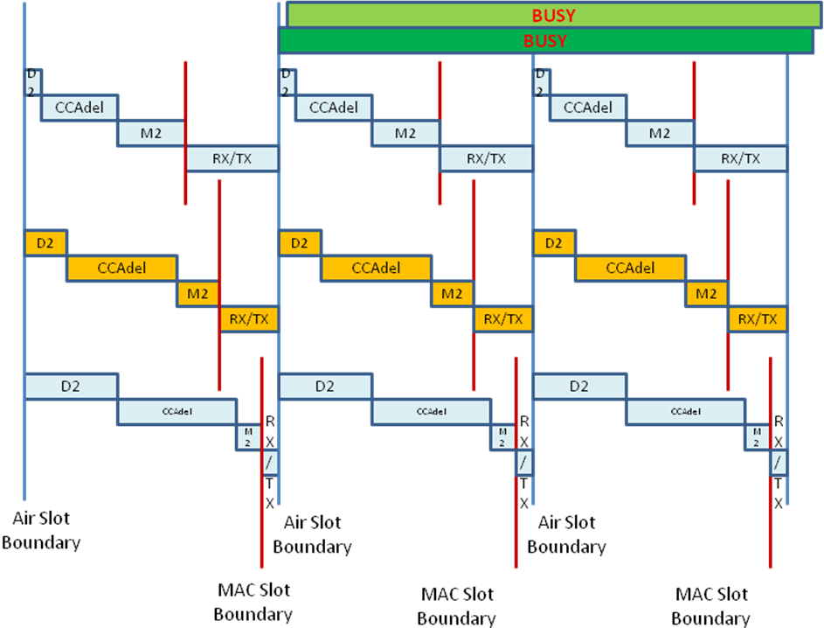

Contemptuously offered resolution:

Being justifiably suspicious of the honesty of the desire for a real solution after observing the two decades of ignoring the problem, the author hopes that he is not wasting his time in providing one now:

9.3.7 DCF timing relations

TGmc editor, in the draft, change the definition of aSIFSTime and aSlotTime where they appear in this subclause, as follows:

aSIFSTime is: aRxRFDelay + aRxPLCPDelay + aMACProcessingDelay + aRxTxTurnaroundTime.

aSlotTime is: aCCATime + aRxTxTurnaroundTime + aAirPropagationTime
+ aMACProcessingDelay.

The STA may employ any non-negative value for each of the parameters:

aRxRFDelay
aRxPLCPDelay
aMACProcessingDelay
aRxTxTurnaroundTime
aTxPLCPDelay
aTxRFDelay
aTxRampOnTime

aCCATime
aRxTxSwitchTime

provided that

1) the sum of the implemented values of:

aRxRFDelay
aRxPLCPDelay
aMACProcessingDelay
aTxPLCPDelay
aRxTxSwitchTime
aTxRampOnTime
aTxRFDelay

is equal to the value of aSIFSTime indicated in the PHY Characteristics table of the attached PHY;

2) the sum of the implemented values of:

aMACProcessingDelay
aTxPLCPDelay
aRxTxSwitchTime
aTxRampOnTime
aTxRFDelay
aCCATime

is equal to the value of aSlotTime indicated in the PHY Characteristics table of the attached PHY; and

3) the CCA sensitivity specification for the attached PHY is met (see 16.4.8.5, 17.4.8.5, 18.3.10.6, 19.4.7 and 20.3.21.5).

TGmc editor, in each of the PHY Characteristics tables in the draft, remove all inequality signs that are associated with each value specified for each parameter in each table.

TGmc editor, in each of the PHY Characteristics tables in the draft, change the values specified for each of the following parameters to “Implementation-dependent, see 6.5.4.2 and 9.3.7”

aRxRFDelay
aRxPLCPDelay
aMACProcessingDelay
aRxTxTurnaroundTime
aTxPLCPDelay
aTxRFDelay
aTxRampOnTime
aTxRampOffTime
aCCATime
aRxTxSwitchTime

TGmc editor, add a new paragraph at the end of subclause 9.3.2.1 “CS mechanism” as shown:

9.3.2.1 CS mechanism

At aRxTxTurnaroundTime + aAirPropagationTime + aRxRFDelay + aRxPLCPDelay + 10% of aSlotTime after each MAC slot boundary as defined in 9.3.7 and 9.19.2.3, the MAC shall issue PHY-CCARESET.request to the PHY.

TGmc editor, modify the text of 7.3.5.9.3 as shown:

7.3.5.9.3 When generated

This primitive is generated by the MAC sublayer for the local PHY entity at the end of a NAV timer and at a time indicated in 9.3.2.1 after each MAC slot boundary which is described in 9.3.7 and 9.19.2.3. This request can be used by some PHY implementations that may synchronize antenna diversity with slot timings.

TGmc editor, modify the text of 7.3.5.9.4 as shown:

7.3.5.9.4 Effect of receipt

The effect of receipt of this primitive by the PHY entity is to reset the PLCP CS/CCA timers to the state appropriate for the end of a received frame and to initiate a new CCA evaluation cycle. If IPI-STATE parameter is IPI-ON, the PHY entity collects IPI values when it is not transmitting or receiving and provides those values to the MAC sublayer using the IPIREPORT parameter.

CID 96

96 | Mark Hamilton | 1614.12 | 18.3.10.6 | Requirement for energy detect is unclear, the wording is inconsistent. For example, it first says, "The start of a valid OFDM transmission at a receive level ... shall cause CS/CCA to indicate busy..." The next sentence says, "If the preamble portion was missed, the receiver shall hold the CCA signal busy ..." So, does the signal 'go to' ("indicate") busy at the start of OFDM being detected at the right level, and then 'stay' ("hold") busy only as long as signal is detected about that level? That is, if no OFDM is detected to start the busy indication, does it ever go busy based solely on energy detect? Note that there is no time specified for the energy detect sentence, further implying that this detection does not start the busy indication, but rather just continues it. And, further, the next paragraph talks about the CCA-ED facility as optional, or only used in certain regulatory domains, where that (purely energy detect) is required. | Clarify this section. "Common knowledge" seems to think that pure energy detect must be used as one method for sensing a busy medium, but that seems to be contradicted by this text. However, the text is rather unclear. | Counter – Tgm editor to make changes to the draft as shown in 11-12-1256-r6 under the heading CID 96 while commenter shall read the informative NOTE that is already in the subclause, which NOTE, to borrow a word from the commenter, clearly resolves what the commenter describes as a contradiction.

Discussion

None needed.

Proposed resolution

TGac editor: modify subclause 18.3.6.10 CCA requirements as shown:

18.3.10.6 CCA requirements

The PHY shall indicate a medium busy condition by issuing a PHY-CCA.indication() when the carrier sense/clear channel assessment (CS/CCA) mechanism detects a channel busy condition. For the operating classes requiring CCA-Energy Detect (CCA-ED), the PHY shall also indicate a medium busy condition when CCA-ED detects a channel busy condition.

The start of a valid OFDM transmission at a receive level equal to or greater than the minimum modulation and coding rate sensitivity (–82 dBm for 20 MHz channel spacing, –85 dBm for 10 MHz channel spacing, and –88 dBm for 5 MHz channel spacing) shall cause CS/CCA to detect a channel busy condition with a probability > 90% within 4 μs for 20 MHz channel spacing, 8 μs for 10 MHz channel spacing, and 16 μs for 5 MHz channel spacing.

NOTE—CS/CCA detect time is based on finding the short sequences in the preamble, so when TSYM doubles, so does CS/CCA detect time.

Additionally, the PHY shall indicate a medium busy condition within 4 μs of the detection of any signal with a received energy that is 20 dB above the minimum modulation and coding rate sensitivity (–62 dBm for 20 MHz channel spacing, –65 dBm for 10 MHz channel spacing, and –68 dBm for 5 MHz channel spacing).

For improved spectrum sharing, CCA-ED is required in some bands. The behavior class indicating CCA-ED is given in Table D-2. The operating classes requiring the corresponding CCA-ED behavior class are given in E.1. A STA that is operating within an operating class that requires CCA-ED shall operate with CCA-ED. The CCA-ED shall not be required for license-exempt operation in any band.

CCA-ED shall indicate a channel busy condition when the received signal strength exceeds the CCA-ED threshold as given by dot11OFDMEDThreshold. The CCA-ED thresholds for the operating classes requiring CCA-ED are subject to the criteria in D.2.5.

NOTE—The requirement to hold the CCA signal busy for any signal 20dB above the minimum modulation and coding rate sensitivity (–62 dBm for 20 MHz channel spacing, –65 dBm for 10 MHz channel spacing, and –68 dBm for 5 MHz channel spacing) is a mandatory energy detect requirement on all Clause 18 receivers. Support for CCA-ED is an additional requirement that relates specifically to the sensitivities described in D.2.5.
References:

