IEEE P802.15
Wireless Personal Area Networks

Project | IEEE P802.15 Task Group 4a for Wireless Personal Area Networks (WPANs)
Title | Device Management Entity
Date Submitted | 9 November 2004
Source | [Rick Roberts]  [Harris Corporation]  [Melbourne, Fl] | Voice: [321-729-3018]  Fax: []  E-mail: [rrober14@harris.com]
Re:
Abstract | This contribution formally introduces the concept of the DME to TG4a. This concept was developed in 802.15.3.
Purpose | Informative
Notice | This document has been prepared to assist the IEEE P802.15. It is offered as a basis for discussion and is not binding on the contributing individual(s) or organization(s). The material in this document is subject to change in form and content after further study. The contributor(s) reserve(s) the right to add, amend or withdraw material contained herein.
Release | The contributor acknowledges and accepts that this contribution becomes the property of IEEE and may be made publicly available by P802.15.

MAC, PHY and DME Interfaces

MAC sublayer service specification

The MAC sublayer provides an interface between the SSCS and the PHY. The MAC sublayer conceptually includes a management entity called the MLME. This entity provides the service interfaces through which layer management functions may be invoked. The MLME is also responsible for maintaining a database of managed objects pertaining to the MAC sublayer. This database is referred to as the MAC sublayer PIB. Figure 1 depicts the components and interfaces of the MAC sublayer.
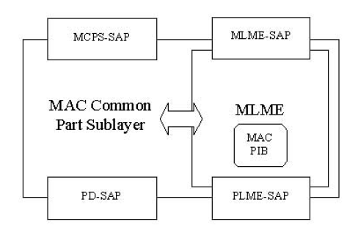
Figure 1—The MAC sublayer reference model

The MAC sublayer provides two services, accessed through two SAPs:
- The MAC data service, accessed through the MAC common part sublayer (MCPS) data SAP (MCPS-SAP)
- The MAC management service, accessed through the MLME-SAP.

These two services provide the interface between the SSCS and the PHY, via the PD-SAP and PLME-SAP interfaces. In addition to these external interfaces, an implicit interface also exists between the MLME and the MCPS that allows the MLME to use the MAC data service.

PHY service specifications

The PHY provides an interface between the MAC sublayer and the physical radio channel, via the RF firmware and RF hardware. The PHY conceptually includes a management entity called the PLME. This entity provides the layer management service interfaces through which layer management functions may be invoked. The PLME is also responsible for maintaining a database of managed objects pertaining to the PHY. This database is referred to as the PHY PAN information base (PIB). Figure 2 depicts the components and interfaces of the PHY.
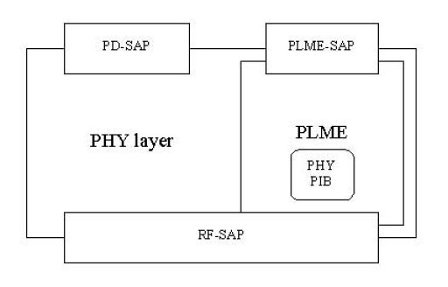
Figure 2 – The PHY reference model

The PHY provides two services, accessed through two SAPs: the PHY data service, accessed through the PHY data SAP (PD-SAP), and the PHY management service, accessed through the PLME’s SAP (PLMESAP).

The Device Management Entity (DME)

In order to provide correct MAC operation, a device management entity (DME) should be present within each DEV. The DME is a layer-independent entity that may be viewed as residing in a separate management plane or as residing “off to the side.” The exact functionality of the DME is not specified in this standard, but in general this entity may be viewed as being responsible for such functions as the gathering of layer-dependent status from the various layer management entities, reading/writing the value of layer-specific parameters and initiating/managing ranging tasks. The DME typically performs such functions on behalf of the general system management entities and implements standard management protocols. Figure 3 depicts the relationship among the management entities.

Figure 3 – stacked reference models with DME interface

The various entities within this model interact in various ways. Certain of these interactions are defined explicitly via a service access point (SAP), across which defined primitives are exchanged. Other interactions are not defined explicitly, such as the interface between the MAC and the MLME or the interface between the PHY and the PLME. The specific manner in which these MAC and PHY interfaces are integrated into the overall MAC and PHY layers are not specified within the standard. The split in functionality between the MLME and DME is intended to facilitate the formal verification of the protocol. It is not intended to be an architectural description of a particular implementation.

