IEEE P802.11
Wireless LANs
Impact of Bluetooth on 802.11 Direct Sequence
Date: September 15, 1998
Author: Greg Ennis
Ennis Associates
16331 Englewood Ave. Los Gatos CA 95032 USA
Phone: (408) 358-5544
Fax: (408) 358-5541
email: gennis@mindspring.com
Abstract

This note presents an analysis of the impact that Bluetooth systems might have when operating within a facility supporting a Direct Sequence 802.11 wireless infrastructure.

Introduction

Bluetooth is a fast frequency hopping wireless system operating in the 2.4 Gigahertz band which is likely to be introduced in a variety of products over the coming year. The primary applications for Bluetooth are along the lines of a “Personal Area Network”, involving relatively short distances (e.g. 10 meters) for communication between notebooks, cellular phones, palm units, and similar personal computing and communications devices within a “picocell”. For the most part the communication is point-to-point in nature (including voice), essentially playing the role of wireless cable replacement. However, it is also possible that Bluetooth will see applications beyond these parameters, with higher power devices spanning longer distances.

The interaction between a Bluetooth system and a colocated 802.11 wireless LAN system is examined in this paper. The focus here is on the 802.11 Direct Sequence systems, both the current 1 and 2 megabit standard and the proposed high speed extensions at 5.5 and 11 megabits/second. Although an 802.11 Frequency Hopping system will also experience interference from a colocated Bluetooth system, in general the impact on the direct sequence system will be greater. This is primarily due to the fact a narrowband transmitter will interfere with the reception of a wideband signal with a greater probability than it will with the reception of a signal on a different narrowband channel.

A model has been developed which captures the performance impact of Bluetooth interference on 802.11 packet reception, parameterized by the 802.11 packet size, fragment size, and data rate and by the Bluetooth hop period and picocell utilization. The key calculation in the model involves the determination of the probability that a Bluetooth transmitter will overlap in both time and frequency with the 802.11 DS packet. An expression for this probability is derived below. A summary of the model’s predictions is then presented via a selection of graphs covering some basic combinations of packet size and data rate.

Summary of Salient Bluetooth Characteristics

As regards the issue of Bluetooth/802.11 interaction, the following are the salient characteristics of Bluetooth:

- 79 one-megahertz channels in the 2.4 GHz band (North America)
- Fast hopping over all channels (625 microseconds – 1600 hops/second)
- 10 meter (0 dBm) typical range, but can be augmented with external power amplifier to go up to 100 m (20 dBm)
- long packets may occupy up to 5 slots – in which case no hopping occurs until the end of the packet

The analysis below will use the North American channelization as the primray focus. The situation in environments with less bandwidth available is dicussed towards the end of the paper.

Mixed Bluetooth/802.11Topology

The figure below shows the typical system topology in a mixed 802.11/Bluetooth environment. The Bluetooth picocell will likely be colocated with the 802.11 station, rather than with the 802.11 AP. Unfortunately, the dominant traffic flow will be AP-to-Station and these packets will likely be large (thus most susceptible to Bluetooth interference). Bluetooth will have the most significant impact on the large packets transmitted to the station.

AP
Large packets from AP, significant Bluetooth collisions
Small packets from station, no Bluetooth collisions
802.11 Station
Bluetooth
Picocell
Bluetooth Nodes

Based upon this picture, the model focuses on the packet reception impairments at the station which are induced by the colocated Bluetooth picocell.

Packet Collision Scenarios

To analyze the packet collision scenario, first consider the following example. Assume that the 802.11 system is transmitting large packets (say 1000 bytes, inclusive of 802.11 MAC and PHY headers). At 11 megabits/sec, a 1000 byte packet will occupy 8000/11 = 727 microseconds (actually it will be longer given the use of long headers, but for now let’s ignore this). This transmission is occurring on one of the wideband high speed 802.11 DS channels, which is nominally one-third of the bandwidth over which Bluetooth hops. If a Bluetooth transmitter within range of the receiver transmits on a 1 MHz channel which is within the wideband channel, a packet collision may occur. This is illustrated in the figure below:

26 1-MHz channels
1000 byte 802.11 packet
= 727 microseconds
366 bit Bluetooth packet
= 366 microseconds
Current Bluetooth channel
Wideband 802.11 transmission
Narrowband
Bluetooth transmission

Note that the 802.11 packet will be corrupted by the Bluetooth packet even if they overlap by only a single bit. In particular, if the Bluetooth system hopped into the wideband channel at any time less than 366 microseconds earlier than the start of the 802.11 packet, a collision would occur. Consequently, the 802.11 packet has a period of vulnerability equal to 366 + 727 microseconds = 1093 microseconds. This corresponds to slightly less than two Bluetooth hops.

The question in this particular case then is essentially the following: what is the probability that of a given pair of consecutive Bluetooth hops, at least one of the channels overlaps with a given wideband 802.11 channel? Since there is a one-third probability that any given narrowband channel overlaps with a given wideband channel, the answer is roughly 1 - (2/3)² or 56%. To summarize: if an 802.11 receiver is within range of a Bluetooth picocell that is currently supporting a full-rate synchronous link (or equivalent packet rate), then there is on the order of a 56% packet error rate induced by Bluetooth on the reception of 1000 byte 802.11 packets.

The rough estimate above can be refined and extended so as to develop a model that covers the variety of data rates and packet sizes together with the actual 802.11 packet exchange protocols (DATA-ACK with possible fragmentation taking the form of DATA-ACK-DATA-ACK-...-DATA-ACK). The full model must also consider the use of low rate headers, retransmissions, and the various interframe gaps present within 802.11 packet exchanges. The first step towards the development of the model is a more precise determination of the overlap probabilities between Bluetooth and 802.11 packet transmissions. This is presented in the next section.

Calculation of the Overlap Probability

Since the Bluetooth and 802.11 systems are not synchronized, the number of Bluetooth hops which it overlaps will depend not just on the 802.11 packet’s length but also on the time offset between the packet and the hops. Let H be the duration of a Bluetooth hop (typically 625 microseconds) and consider an 802.11 packet of duration L. Then the minimum number of hops which the 802.11 packet overlaps is

⎡L/H⎤

and the maximum number of hops overlapped is

⎡L/H⎤ + 1

where ⎡x⎤ is the least integer greater than or equal to x. The actual number of hops that the packet overlaps depends upon the relative timing of the start of the packet and the hop.

Let d be the “delta” between the last Bluetooth hop and the start of the packet as indicated in the following timing figure:
Bluetooth hop intervals

d

802.11 packet

Note that 0 < d ≤ H. If d is zero, then the 802.11 overlaps with its minimum number of Bluetooth dwell periods, namely ⎡L/H⎤. If d is greater than ⎡L/H⎤ *H - L then the 802.11 packet overlaps with ⎡L/H⎤+1Bluetooth hops. This can be readily seen by considering an example: say L = 1.3 H. Then ⎡L/H⎤ is 2, so

⎡L/H⎤ *H –L = 2H – L = .7H

and if d > .7H we have the following figure showing that the packet overlaps 3 Bluetooth dwell periods.

d >.7H
802.11 packet, L = 1.3H
H

Consequently, an 802.11 packet will overlap ⎡L/H⎤ Bluetooth dwell periods whenever

0 < d ≤ ⎡L/H⎤ *H – L

and will overlap ⎡L/H⎤ + 1 dwell periods whenever

⎡L/H⎤ *H – L < d ≤ H.

This translates into probabilities by expressing these intervals as fractions of the the interval [0, H], yielding the following:
The probability that an 802.11 packet of duration L will overlap with ⎡L/H⎤ Bluetooth dwell periods of duration H is

⎡L/H⎤ - L/H

The probability that it overlaps with ⎡L/H⎤ + 1 dwell periods is

1 - ⎡L/H⎤ + L/H

Example: a packet that is 3.2 dwell periods long will overlap with 4 dwell periods with an 80% probability and will overlap with 5 dwell periods with probability 20%.

Factoring in the Bluetooth Frequency Channels

The above analysis was concerned only with the timing relationships between an 802.11 packet and the Bluetooth hops. Now we add to this analysis the actual frequency hopping characteristics of Bluetooth and the specific frequency channelization of the 802.11 Direct Sequence standard.

In North America, 802.11 allows for three non-overlapping bands in which the DS radios may operate. Bluetooth essentially hops over the entire band. Consequently, at any given moment there is a 2/3 probability that the Bluetooth channel will be outside of any specific DS band.

We can now derive a formula that expresses the probability of a Bluetooth-induced collision for a given 802.11 DS packet of duration L on a given wideband DS channel. When this packet’s timing relationship with Bluetooth is such that it overlaps with N Bluetooth dwell periods, the probability that a Bluetooth transmitter is never on a narrowband channel within the wideband DS channel for those N dwell periods is (2/3)^{N}. From our earlier calculation of probabilities for the number of Bluetooth dwell periods overlapped by a packet we get the following:
For North American operation, the probability that an 802.11 packet of duration L experiences no Bluetooth collisions is

(2/3)^{⎡L/H⎤} (⎡L/H⎤ - L/H) + (2/3)^{(⎡L/H⎤+1)} (1 - ⎡L/H⎤ + L/H)

The corresponding probability of a Bluetooth induced collision is thus

1 - (2/3)^{⎡L/H⎤} (⎡L/H⎤ - L/H) + (2/3)^{(⎡L/H⎤+1)} (1 - ⎡L/H⎤ + L/H)

These formulas assume a fully-utilized Bluetooth picocell.

This can be understood as follows: the percentage of packets that overlap with ⎡L/H⎤ dwell periods is ⎡L/H⎤ - L/H, and the probability of no collision for such packets is (2/3)^{⎡L/H⎤} . Similarly, the percentage of packets that overlap with ⎡L/H⎤ + 1 dwell periods is 1 - ⎡L/H⎤ + L/H, and the probability of no collision for such packets is (2/3)^{⎡L/H⎤ +1}. For all packets, the probability of no collision is therefore given by the weighted sum as expressed in the above boxed formula.

The effect of partial utilization within a Bluetooth picocell can be easily accomodated by simply multiplying the above collision probability by the picocell’s percentage utilization.

Fragmentation Considerations

In general, a smaller packet will have less likelihood of experiencing a collision than a larger packet. Consequently, fragmentation of larger packets is of interest as a potential strategy on the part of 802.11 transmitters in the presence of Bluetooth.

Recall the 802.11 fragmentation mechanisms: the data within a large packet is broken into a sequence of smaller packets. This yields a sequence of DATA frames and corresponding ACK frames that are exchanged with only a short interval (SIFS) separating the ACK and the subsequent DATA transmission, thus minimizing the probability that other transmitters might seize the medium. If a collision or other transmission impairment causes a DATA-ACK exchange to fail, the transmitter will back off (essentially using the normal backoff rules), thus allowing other stations to transmit. The remaining sequence of fragments is continued as before when the transmitter is able to successfully reseize the medium.

In general, because of the additional overhead required it will always take longer to transmit a fragmented packet than the same data in an unfragmented packet. Consequently fragmentation is only beneficial if other factors make it desirable, such as interference. If fragmentation is to be worthwhile for a given packet transmission, the benefit of reduced error susceptibility must be greater than the detrimental expansion of the total transmission duration.

This is clearly a factor in the Bluetooth/802.11 analysis. In this context, a Bluetooth collision in the middle of a sequence of fragments may only affect a single fragment. This will cause the sequence to halt, forcing the transmitter to backoff prior to retransmitting the corrupted fragment followed by the remainder of the fragments.

The Model

The above expression for collision probabilities was used to develop a model that can be used to predict the performance impact that Bluetooth might have on 802.11 DS transmissions of various sizes, data rates, and fragmentation strategies. The model is implemented as a simple spreadsheet.

The basic input parameters to the model are geographic location (currently North America only), 802.11 data rate, packet size in bytes, fragment size, Bluetooth picocell utilization, and Bluetooth dwell period. In general the Bluetooth dwell period is fixed at 625 microseconds – however, given that Bluetooth asynchronous traffic may involve multi-slot packet, this dwell period may be extended. Picocell utilization can be viewed as representing the average number of Bluetooth slots in which a Bluetooth transmission occurs.

The primary output of the model for a given setting of the input parameters is the average time in microseconds for an 802.11 packet transmission to complete. This includes the effect of fragmentation and the retransmission of fragments necessitated by Bluetooth collisions. All of the components making up the total duration of a packet transmission are included, such as preamble, PLCP header, SIFs and DIFs, MAC overhead, and ACK timing.

Assumptions:

- In the case of a retransmission of a fragment (or a full packet) the model assumes that the retransmission occurs one DIFS and 7 slot times after the completion of the ACK.
- It is assumed that the 802.11 receiver needs the entire preamble to properly receive the packet, i.e. if a Bluetooth collision occurs anywhere in the preamble this has the same effect as a collision in the middle of the packet.
- Long headers are assumed on both the DATA and ACK packets
- All collisions between Bluetooth and 802.11 result in an 802.11 packet error
- Bluetooth “hop stretching” can be simulated in the model, but graphs in this paper all assume 625 microsecond dwell periods
- No other traffic present

For a given picocell utilization, transmit rate, packet size and fragment size, the ratio between actual time it takes to transmit the packet (with Bluetooth collisions and perhaps with fragmentation) and the minimum time it takes to transmit the packet (i.e. no fragmentation and no Bluetooth collisions) is called the “Degradation Factor”. The most illuminating graphs plot Degradation Factor versus fragment size. Such a plot indicates for a given packet size and a given picocell utilization whether fragmentation is beneficial or detrimental, and if beneficial allow one to determine the optimal fragment size. The following graph is an example, showing the case of 5.5 Mb/s, 1500 byte packet, and 90% Bluetooth picocell utilization.

As can be seen from the figure, without any fragmentation at all, the packet will take about 4.6 times longer to successfully be transmitted than if the Bluetooth picocell were absent. This is due to the very high probability of packet errors induced by Bluetooth in such a long packet, with resultant retransmissions. As the figure indicates, by fragmenting into fragments of 500 bytes, the degradation factor decreases to 3.4. This indicates that at this fragment size, the benefit of shorter fragments (and thus less susceptibility to Bluetooth) outweighs the overhead expansion inherent in the fragmentation. However, at smaller fragment sizes, the degradation factor increases, indicating that the overhead of fragmentation overwhelms the benefit of Bluetooth avoidance when the fragments are too small.

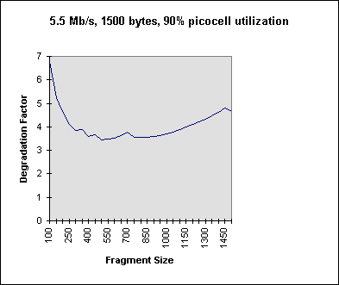

Note that the curve has some upward bumps. This reflects the fact that the fragmentation process is discrete rather than continuous, and a minor change in fragment size can suddenly force the necessity of an additional fragment transmission. This is most easily seen in the transition from one fragment (i.e. no fragmentation at all) to two fragments (i.e. a fragment size of 1499, with a last fragment containing one byte of data). This is clearly inefficient and leads to the upward bump at the far right of the curve. Similar bumps occur at other critical breakpoints in the fragmentation. This indicates that the most relevant practical fragmentation points to consider in the curves are those which occur close to the integral divisors of the packet size (e.g. for 1500 bytes the natural fragmentations occur at 750, 500, 375, 300, 250, 125, and 100 byte fragment sizes). Still, the curves give a useful depiction of the general utility of different fragment sizes for this specific transmission.

More illuminating graphs are obtained by allowing the picocell utilization parameter to also vary, yielding a family of curves. This is illustrated in the following example which extends the previous graph.

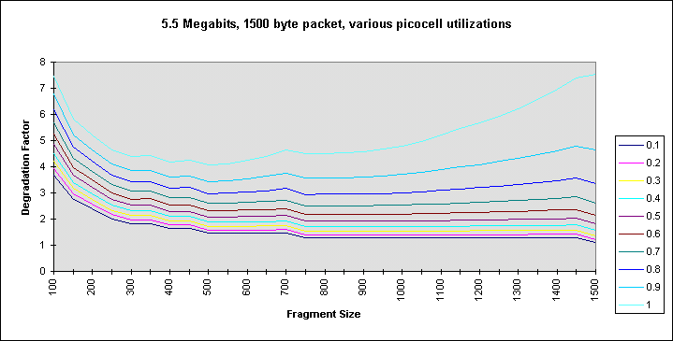

Note now that the benefits of fragmentation can be seen to accrue only in the case of very high picocell utilizations. In fact, at picocell utilizations of 50% and below the best performance (i.e. lowest degradation factor) occurs with no fragmentation, as is evident by examining the far right edges of the relevant curves. At the high levels of utilization a fragmentation of the 1500 byte packet into 3 500 byte fragments appears to be optimal.

The following graphs depict some other situations.

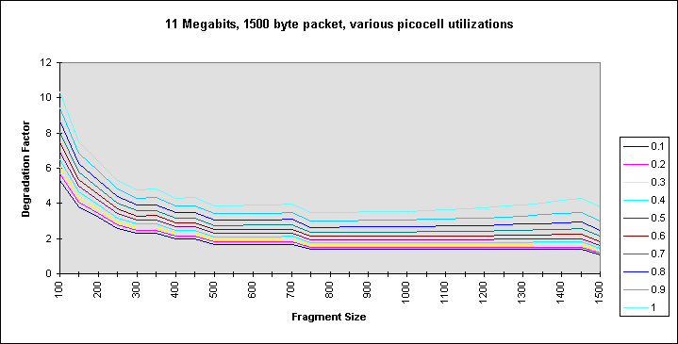

Note in the case of 11 Mb/s, 1500 byte packets that the benefits of fragmentation are virtually nonexistent.
even at the highest levels of picocell utilization.

Again, note here that at high levels of utilization it appears to be beneficial to fragment the packet into two 250 byte fragments. However, at low levels of utilization such fragmentation is unwise.

Limited Channel Environments
In geographic regions with more limited bandwidth available to the 802.11 DS system, the impact of Bluetooth collisions will be even more significant. This pertains, for example, to France, Japan, and other countries.

For example, if the number of channels available for 802.11 DS is 2 rather than 3, then the expression for the probability of non-collision will use a factor of 1/2 rather than 2/3, as follows:

For operation with 2 802.11 DS channels, the probability that an 802.11 packet of duration L experiences no Bluetooth collisions is

(1/2)^{⎡L/H⎤} (⎡L/H⎤ - L/H) + (1/2)^{(⎡L/H⎤+1)} (1 - ⎡L/H⎤ + L/H)

(Again this basic formula assumes a 100% utilized Bluetooth picocell and would be scaled appropriately with lower levels of utilization).

The impact of the number of channels on the collision probabilities can be seen in the following example, showing the “Degradation versus Fragement Size” curves for both the 2 channel and the 3 channel situations. (The 2 channel situation is the “.5” curve and the 3 channel situation is the “.67” curve):

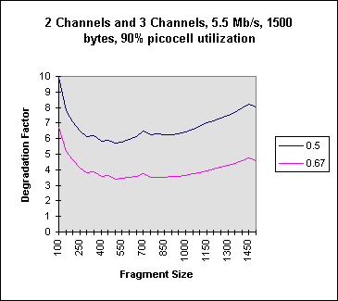

Final Thoughts

- A heavily utilized Bluetooth picocell colocated with an 802.11 station will have a significant negative impact on the performance of that station. Large packets transmitted from the AP to the station are most affected.

- Downshifting to a lower DS rate will not help – in fact, it would probably exacerbate the problem, as the 802.11 packets would be stretched in time, making them even more susceptible to Bluetooth interference.

- Reassociating with another AP would also probably not improve matters. Note that the packet exchanges used by an 802.11 station to determine quality of signal from a potential AP are short (beacons, probes and probe responses), which may very well get through easily in the presence of Bluetooth. Consequently, it is likely that a station will believe that it might get better service from a new AP, when in fact the long packets from the new AP would suffer the same Bluetooth collisions as the old.

- Fragmentation of long packets in some cases can significantly improve the ability of the 802.11 system to operate in the presence of Bluetooth.. In certain cases, this is a better strategy for an 802.11 transmitter to take rather than rate shifting or reassociation. The problem is that the decision to fragment must be made by the AP, and how is an AP to know that the transmission impairments to a given station are due to Bluetooth rather than range? This would require fancy heuristics at the AP.

- The desirability of fragmentation for a given packet depends tremendously on the utilization of the Bluetooth picocell.

- In the case of 11 megabit transmissions, fragmentation is not useful in the presence of Bluetooth. In the case of 1 and 2 megabit transmissions it is essential for long packets.

- Low rate 802.11 hoppers may not suffer from significant Bluetooth collisions. This is due to their use of narrowband channels which will only rarely overlap with Bluetooth channels. However, the longer packet size will make fragmentation necessary. Downshifting to a low-speed hopping mode of operation may be a viable solution in the presence of Bluetooth.

- The use of RTS by the AP may help some, as the station will not respond with a CTS if the RTS collides with a Bluetooth transmission. However, the success of an RTS/CTS exchange is not a good indicator of success for the data transfer, since during the data frame transmission a Bluetooth transmitter might hop into the channel and cause a collision.

