IEEE 802.15
Wireless Access Method and Physical Specification

Title: IEEE P802.15 Operating Rules

Date: June 4, 1999

Author: Tom Siep
Texas Instruments
8505 Forest Lane, ms 8723
Dallas, TX 75243
TELEPHONE: 972.480.6786
FAX: 972.480.6552
EMAIL: siep@ti.com

ABSTRACT:
This document is the proposed operating rules for the Wireless Personal Area Network (WPAN) working group of the IEEE Project 802 LAN MAN Standards Committee.
It is based on the proposed set of rules for P802.11 WLAN.
When approved it will document operating rules, standard operating procedures, and recommended practices for the WPAN working group.

Operating Rules of IEEE Project 802 Working Group 802.15

Approved <approval date>
IEEE Project 802 Wireless Personal Area Network Working Group 802.15
Copyright (c) 1999 by the Institute of Electrical and Electronic Engineers, Inc.
345 East 47th Street
New York, NY 10017, USA
All rights reserved.
Contents
1. Overview 3
2. Working Group 4
2.1. Function 4
Precedence of Operating Rules 5
2.3. Officers 5
2.4. Working Group Advisory Core 6
2.5. Submission of Papers 7
2.6. Membership 8
2.7. Working Group Plenary Meetings 8
2.8. WG Balloting 11
2.9. Maintenance of Operating Rules 11
3. Task Groups 12
3.1. Function 12
3.2. Chair 13
3.3. Secretary 13
3.4. Membership 13
3.5. Operation of the Task Group 14
3.6. Deactivation of a Task Group 16
4. P802.15 Study Groups 16
4.1. Function 16
4.2. Formation 16
4.3. Continuation 16
4.4. Study Group Operation 16
5. Maintenance 17
6. Inquiries/Interpretations 17
7. Procedure Section, Informative Annex 18
7.1. Overview of the Project Process 18
7.2. Five Criteria 20
7.3. Recommended Activities for WG Officers and Appointees 21

References

- Operating rules of IEEE project 802, LAN MAN Standards Committee (LMSC) http://grouper.ieee.org/groups/802/devdocs.html
- IEEE Standards Companion
http://standards.ieee.org/guides/companion/
- IEEE Standards Operations Manual
http://standards.ieee.org/guides/opman/
- IEEE Standards Board Bylaws
http://standards.ieee.org/guides/bylaws/
- Overview & guide to IEEE 802 / LMSC
ftp://stdsbbs.ieee.org/pub/802_main/802_Documents/ovrvw802.txt

Overview
The 802.15 Working Group (WG) is responsible for developing Wireless Personal Area Network (WPAN) standards under the auspices of the IEEE Project 802 LAN/MAN Standards Committee (P802 LMSC). The 802.15 WG is one of several working groups reporting to the P802 LMSC. The 802.15 WG operates under the Operating rules of IEEE Project 802 ( ref [1]) and the hierarchy of rules under which IEEE Project 802 operates. In the event of any conflict between the Operating Rules of 802.15 and the Operating rules of IEEE Project 802, the Operating rules of IEEE Project 802 take precedence.
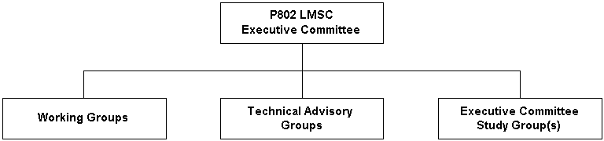
Project 802 Organizational Structure
Figure 1
The P802 LMSC Executive Committee (EC) directs the P802 LMSC. The EC serves as the EC for both the sponsor ballot groups as well as the Standards Development Groups. P802 LMSC has been divided into Working Groups, Technical Advisory Groups and, on a temporary basis, Executive Committee Study Groups to standardize technologies applicable to local and metropolitan area networks. See figure 1.
A brief overview of the standards development process is provided in clause 7.1 of this document.

Working Group

Function
The 802.15 WG's charter is to develop Physical layer and MAC sub-layer specifications for wireless Personal Area Networks based on [Carrier Sense Multiple Access/Collision Detect (CSMA/CD) protocol] or on [Carrier Sense Multiple Access /Collision Avoidance (CSMA/CA)] or [no qualification at all]. Standards efforts are carried out under Project Authorization Requests (PAR) approved by the IEEE Standards Board and assigned to 802.15 WG. Since the scope of standards work which comprises 802.15 WG activity may be widely dispersed in time, technology and structure, individual standards activities within 802.15 WG are, at the discretion of the 802.15 WG, carried out by Task Groups (TG) operating under, and reporting to, the 802.15 WG. A TG may in turn create Sub-Task Groups as necessary to accomplish the work of the TG.
The 802.15 WG is chartered to:
- define, maintain, and revise the 802.15 standard
- develop new standards in a reasonable time frame within the scope of the P802 LMSC
- forward these standards to ISO/IEC JTC1
- maintain liaisons with other groups within P802 LMSC, and other relevant standards setting bodies and Radio Spectrum regulatory bodies
The 802.15 WG activities are administered by the WG Chair who is assisted in this task by the Working Group Advisor Core (see 2.4).
The structure of 802.15 WG is illustrated in figure 2.

Precedence of Operating Rules
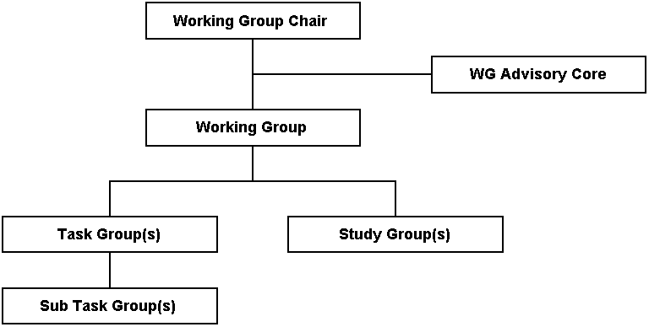
Working Group 802.15 Organization Structure
Figure 2
The rules governing Working Group Functions, Chair and Vice-Chair, Membership, meetings and the operation of a Working Group are provided by the Operating rules of IEEE Project 802 and the hierarchy of rules under which IEEE Project 802 operates. These rules are all included in this document by reference and are not reproduced here, however the reader is encouraged to become familiar with these rules in addition to the rules provided in this document. If 802.15 WG Operating Rules conflicts with the 802 Operating Rules, then the 802 Operating Rules shall take precedence.

Officers
The rules and procedures for the election of, and the terms served by, the WG Chair and Vice-Chair are contained in the Operating rules of IEEE Project 802 (See ref [1], 5.1.2). Removal of the WG Chair or Vice-Chair is also covered by this document (See ref [1], 5.1.4.5).

Chair
As stated in P802 rules, the chair of the WG is responsible for presiding over WG Plenary sessions and combined TG meeting. The chair only votes on matters before the Working Group in cases where a deciding vote must be cast.
In addition, minutes of these meetings are to be reviewed by the TG chair and made available for review by the WG one week after closure of the session.

Vice Chair
Unlike the chair, except when acting in the capacity of the chair, the vice chair, normally votes, and comments on issues with the same rights as all other voting members.

Secretary
The minutes of meetings taken by the Secretary (or designee) are to be provided to the WG chair in time to be available to the membership one week after close of the session.
The minutes of the meeting are to include documents produced by the voting process and document list. See Standards Companion for details on content and form of minutes.

Technical Editor
The Technical Editor is responsible for organizing, maintaining the draft standards in the format used by the IEEE standards department. The editor is responsible for publishing updates of draft standards as soon after a session as possible, but not later than the set "last mailing date".
Proof read and coordinates changes of documents edited by IEEE staff.
Send the IEEE P802.15 Chairperson the following:
- The pdf file of the standard
- The FrameMaker .mif file of the standard

Treasurer
802.15 WG operates without treasurer and without treasury. Occasionally there may be a need for short-term funds associate with a particular meeting. Any debts and collections shall take place within that meeting. The sponsoring group/individual will be responsible for financing short-term expenses for interim meetings. It is the responsibility of the sponsoring group/individual to provide a statement of accounts if a meeting registration fee is levied on members.

Assistants
The WG Chair may appoint and dismiss assistants to any of the above offices, as the needs of the WG change.

Working Group Advisory Core
The 802.15 WG Advisory Core (AC) functions as the coordinating body supporting the -Chair in formulations of policy and the performance of his duties. The 802.15 WG AC has no formal meetings, voting procedures, nor policies. The intent is to have the 802.15 WG AC operate in a consultative manner. There is adequate policy and procedural rigor imposed on WG 802.15 by the Operating rules of IEEE Project 802 and its hierarchy of rules.

Function
The function of the WG AC is to assist the WG Chair in performing the following tasks:
- Providing procedural and, if necessary, technical guidance to the Task Groups and Study Groups (SG) as it relates to their charters.
- Overseeing WG, TG, and SG operation to see that it is within the scope of WG 802.15.
- Examining TG draft standards proposed for submission to WG ballot.
- Considering complaints of TG and SG members and their resolution at the Plenary, TG, and SG.
- Managing WG 802.15 logistics, e.g. concurrent TG and SG meetings, etc.

Membership
Membership of the WG AC is composed of the following WG 802.15 officers:
- WG Vice-Chair and Co-Vice-Chair.
- Recording Secretary.
- Task Group Chairs.
- Study Group Chairs.

Submission of Papers

Document Numbering and File Names
P802.15 uses the LMSC document numbering scheme. Every official document produced or archived by the Working Group will have a document number assigned in the format:
802.15-yy/m[ri]
where yy is the year produced, m is a sequential number assigned by the WG secretary or designee, and ri is a revision designation. Brackets indicate the field is only present if additional versions of the document are produced and are brackets not included in the document number. The revision designation has a lower case r constant followed by a sequential number, that is assigned by the WG secretary or designee.
Draft standards for 802.15 will have the format:
802.15/Di-yy/m
where i is the Draft Revision Number, yy is the year produced, and m is a sequential number assigned by the WG secretary or designee.
File names for these documents will be in the form:
Yym[ri] IEEE P802-15 t
where yy is the year produced, m is a sequential number assigned, ri is a revision designation and t a meaningful description of the document that is also used as the title and is in the heading of the document.
Document 802.15-yy/0ri will be the master index of documents for the year yy. Each time the document list is published by its maintainer, the revision number i is incremented

Required Formats
- Documents submitted to WG 802.15 shall use the style templates supplied by the WG for all submissions. The templates are published on the WG IEEE web pages and will also be available at each WG meeting. A summary of the style is listed below:the header is as follows:
- Times (New) Roman, 14 point, bold, line below:
- Left: the month and year of issue
- Right: the text "doc: IEEE P802.15-yy/nn", where yy are the last two digit of the year and nn are the digits of the document number
- the footer is as follows:
- Times (New) Roman, 12 point, line above
- Left: the text "submission” Center: "page n", where n is the page number
- Right: optionally their name and/or company name
Save in MS Office 97 [Windows] or MS Office 98 [MAC]

Membership
The rules and procedures governing WG membership including establishment, retention, loss and rights are contained in the Operating rules of IEEE Project 802 (See ref [1], 5.1.3). The following additional requirement are imposed within WG 802.15:
- TG and SG meetings that are less than two days in duration or that take place adjunct to and co-located with the plenary meeting cannot be used to count towards neither establishing nor retaining voting rights.
- To establish voting rights participants must request to become a voter during a 802.15 WG Opening or Closing plenary meeting when additions to the voter list are solicited by the Chair from the "Nearly Voting Member" list.
- To establish and retain voting rights participants must record and maintain complete contact information in the 802.15 database.
In addition to the requirements for membership the following is highly recommended for most efficient exchange of information between members:
- Email address capable of handling large file attachments
- Laptop computer at meetings
- 802.11 WLAN card for laptop
- Flash card for laptop

Working Group Plenary Meetings
2.7.1 Plenary Session
The 802.15 WG plenary session is conducted three times a year as part of the P802 LMSC plenary sessions (see ref [5]). The 802.15 WG plenary session is a meeting of individuals interested in developing and maintaining CSMA/CA standards. Typically the 802.15 WG Opening/Closing plenary meetings are held between the opening and closing meetings of each P802 LMSC plenary (see figure 3). Occasionally there are TG or SG meetings during the Executive committee meeting on Monday morning and/or the weekend preceding the plenary (Note: meetings held before the opening of 802 plenary meeting are treated as interim meetings.)
The 802.15 WG plenary is open to all registered P802 attendees. As is the case with all 802 Working Group meetings only voting members have the right to participate in the discussions (see ref [1], 5.1.3.5). The Working Group Chairs may grant the privilege of observers to participate in discussions. Within WG 802.15 the privilege of observers to participate in discussions is granted by default.
The WG 802.15 Plenary is conducted by the Chair or the Chair's designated delegate. The 802.15 WG Opening plenary meeting will include the presentation of the following information:
- The 802.15 WG voting rules.
- The existence of these operating rules and where they can be obtained.
- The existence of the operating rules of IEEE Project 802 and where they can be obtained.
- The agenda (which was distributed earlier) including any items requiring a vote.
- The roll call of current voters.
- IPR and copyright notices
The function of the plenary meetings is to gather and disseminate information and take action as follows:
- Status reports from the Task Groups and Study Groups.
- Liaison reports from other standards organizations, other IEEE 802 WGs and TAGs.
- Reports on schedules for future plenary meetings.
- Announcements and general news.
- Vote on such matters that may be brought before it such as recommendations of its Task Groups and the election of 802.15 officers.
- Make recommendations for SEC action with respect to standards projects, P802, and liaison matters.
- Calls for interest in new work items.
- Call for relevant patents.
- Items for subsequent meetings
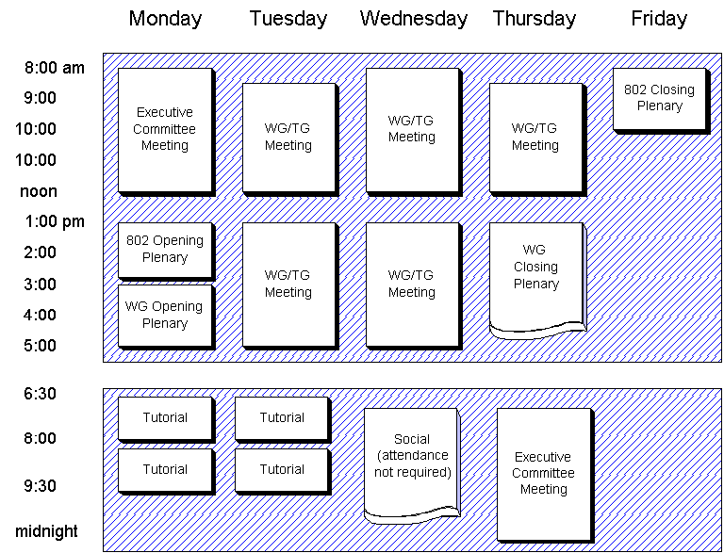
Typical Working Group 802.15 meetings during 802 Plenary week
Figure 3

2.7.2 Interim Meetings
The respective group schedules interim WG, TG, or SG meetings no later than the end of the prior plenary meeting. The date/time/place of the meeting(s) must be approved and announced at the final WG Plenary and entered in the minutes of the meeting. Official actions of these meetings are valid if one of the following occurs:
- A quorum is present
- Confirmation vote passes at the next Plenary
- Appropriate level of approval (75%+ for technical, 50%+ for procedural) from a letter ballot that has been pre-authorized by the WG at the time of the meeting approval
- Specific empowerment that has been pre-authorized by the WG at the time of the meeting approval

WG Balloting
A draft must successfully pass a WG letter ballot (conditional approval excepted) before it can be can be forwarded to the Executive Committee for approval for Sponsor Group voting. The rules and procedures governing WG letter ballots, comment resolution and confirmation letter ballots are contained in the Operating rules of IEEE Project 802 (See ref [1], 5.1.4.2.2). An overview of the process is also provided in subclause 7.1 of this document.
Addition requirements are imposed within WG 802.15 are specified by the clauses below.

Draft Standard Balloting Group
The 802.15 WG balloting group consists of all voting members of the 802.15 WG as of the close of day the ballot package distribution was completed as determined by the WG Chair.

Draft Standard Balloting Requirements
Before a draft is submitted to WG letter ballot it shall in addition have met the following requirements:
- It must be complete with no open technical issues.
- It must be made available for pre-view by the membership by the Monday during the session prior to the plenary week. If any changes are made to the draft after the draft was made available for pre-view, the textual changes shall be presented for review during the closing plenary immediately prior to the vote for approval to go to WG ballot.
- It must be formatted according to the IEEE style selected by the WG Chair. (see 2.8.3)
- It must be approved for submittal to WG ballot at the 802.15 WG closing plenary.
For a WG letter ballot to be considered valid the abstention rate must be less than 30%.

Draft Standard Formatting Requirements
The draft must be provided in the current IEEE electronic format. At a minimum this shall be completed prior to the Sponsor ballot however it is preferable that the draft be maintained in this format for its entire life.
Areas affecting existing clauses of IEEE 802.15 shall be shown in the draft in underscore and strikeout against the current standard or draft standard. Note that the current standard may not be the same as the published standard due to approved but unpublished supplements.

Maintenance of Operating Rules
WG operating rules are a requirement of the Operating Rules of IEEE Project 802, which state that the WG chair shall:
"Establish Working Group rules beyond the Working Group rules set down by the Executive Committee. These rules must be written and all Working Group members must be aware of them."
The WG 802.15 operating rules are to be made publicly available at the meetings and posted in the WG 802.15 area of the IEEE web site. Suggestions for improvements should be submitted to the Vice-Chair who will bring them up for discussion at the following plenary.
Proposed changes must be received no latter than the night before the 802.15 opening plenary. If there are any proposed changes a meeting will be held to discuss the changes. The changes will then be circulated prior to the next plenary and an announcement will be made at that WG opening plenary that a vote will be taken on the changes at the WG closing plenary (see below).
Proposed improvements shall be in written form and should include:
a) The purpose, objective, or problem the proposed change is intended to address
b) The specific text of the rule change
c) The rationale for the chosen text
Those proposing rule changes are encouraged to seek the advice of any member of the WG AC or other experienced members to help form the wording in a manner appropriate for and consistent with the WG 802.15 Operating Rules.
These rules of operation of WG 802.15 can be changed by either:
- A minimum 2/3 approval of the sum of attending WG 802.15 voting members voting "Approve" or "Do Not Approve" taken at the WG 802.15 closing plenary.
- An affirmative WG 802.15 letter ballot. This ballot shall follow the normal letter ballot requirements (see 2.8.2).
Proposed changes shall be made available for preview by the membership by the Monday prior to the plenary week. If a request is made for a letter ballot this request will be discussed and voted on at the closing plenary. A greater than 50% approval of the sum of attending WG 802.15 voting members voting "Approve" or "Do Not Approve" taken at the closing plenary is required for a change to be sent out for a WG letter ballot. This letter ballot has the same response requirements as any other ballot in terms of the maintenance of voting rights. If no such request for a letter ballot is made, or the request fails, the change itself will be voted on at the closing plenary. A motion requesting a letter ballot will take precedence over a motion to approve the changes.
The SEC of the P802 committee must approve all changes.

Task Groups

Function
The function of the Task Group is to produce a draft standard, recommended practice, guideline, supplement, or portion of a draft standard to the WG. These shall be within the scope of the P802 LMSC, the charter of the WG and under an approved PAR as established by the P802 LMSC EC and approved by the IEEE Standards Board. After the publication by the IEEE of the standard, recommended practice or guideline, the function of the TG is complete and its charter expires (see 3.5). It is a function of the WG 802.15 to maintain published 802.15 standard(s) (see Clause 5).

Chair
TG Chairs shall be appointed by the WG chair and confirmed by a TG motion that is approved by a minimum 75% majority. The chair is required to confirm that the function of secretary if performed for each TG meeting. TG meetings are not allowed to function without a secretary.

Secretary
The minutes of meetings taken by the Secretary (or designee) are to be provided to the TG chair in time to be available to the WG chair for publication a week after close of the session.
The minutes of the meeting are to include documents produced by the voting process and document list. See Standards Companion for details on content and form of minutes.

Membership
Members and observers in WG 802.15 make up the TG membership. The TG Chair may choose to establish membership rules for voting if the TG Chair believes it is necessary to ensure that the business of the TG moves forward in an orderly basis. In this case the TG shall follow the same membership requirements and the same voting rules as 802.15 WG. At the formation of a TG from a SG all SG participants are automatically granted membership of the TG.
Within WG 802.15 a TG operates by default without membership rules for voting.

Rights
The rights of the TG participants include the following:
- To receive a notice of the next meeting and agenda.
- To receive a copy of the meeting minutes.
- To vote at meetings if present and the TG is operating without membership rules for voting or participant is qualified under the WG voting rules.
- To examine all working draft documents.
- To lodge complaints about TG operation with any member of WG AC.

Meetings and Participation
All TG meetings are open to members and observers. Attention is however drawn to the registration requirements for all members and observers attending the 802 Plenary where TG meetings also occur. If the TG Chair has decided to institute membership rules only TG members have the right to participate in the discussions. In this case, the TG chair may grant observers the privilege of participating in discussions.
A TG will normally meet during the week of the P802 LMSC plenary. The WG Chair determines, taking into account TG status, if this plenary week TG meeting is required. Depending on the workload, interim TG meetings can be held between the P802 LMSC plenarys as often as required and agreed to by the TG membership. A meeting notice and agenda must be distributed to all WG 802.15 members and observers at least 30 days prior to any meeting. This notice will include as a minimum the date, time, location, host, hotel details, travel details if necessary and a stated purpose. TG meetings that are less than two days in duration or that take place adjunct to and co-located with the Plenary meeting do not count towards 802.15 WG voting rights.

Operation of the Task Group
The TG's primary responsibility is to produce a draft standard, recommended practice, or guideline in a reasonable amount of time for review and approval by the WG. Democratic procedures are to be implemented using Robert's Rules of Order in combination with WG 802.15 rules. At no time will the IEEE's operating rules, which are based upon ANSI's procedures for openness and fairness, be compromised.

Chair's Function
The Chair of a TG may decide procedural issues or may put them to a vote of the TG. The TG participants and the Chair decide technical issues by vote. The TG Chair decides what is procedural and what is technical.

Voting
There are two type of votes in the TG; votes on motions and votes in straw polls.
Where a TG is operating with membership rules for voting (see 3.3) only the TG members can make and vote on motions. Where these membership rules are not in force any TG participant is entitled to make motions, subject only to the provision that they believe that they are qualified to vote on the matter before the TG.
In all cases, regardless of any membership rules that may or may not be in force, all participants who feels qualified may participate in a straw poll.
The TG Chair defines motions as either technical or procedural. On a technical motion, a vote is carried by a minimum 75% approval of the sum of those voting "Approve" or "Do Not Approve". On a procedural motion, a vote is carried by a greater than 50% approval of the sum of those voting "Approve" or "Do Not Approve". Any vote can be subjected to ratification at the WG level under WG voting rules (See ref [1], 5.1.4.2).
The decision to define a motion as technical or procedural rests with the TG Chair. Generally a technical motion is defined as a motion that will materially effect the content of a draft. This is because a draft itself will ultimately be subject to a 75% majority vote at both WG and LMSC ballot.
The decision by the TG to request the WG to submit a draft standard or a revised standard to the WG ballot group must be ratified by the TG as a technical vote.

Task Group Chair's Responsibilities
The main responsibility of the TG Chair is to ensure the production, and to guide through the approval and publication process, a draft standard, recommended practice or guideline, or revision to an existing document as defined by the relevant PAR. The responsibilities include:
- Call meetings and issue a notice and agenda for each meeting at least 30 days prior to the meeting.
- Assure that there is a Recording Secretary for each meeting.
- Issue meeting minutes and important requested documents to members of the TG, the WG AC, and liaison groups. The meeting minutes are to include:
- list of participants
- next meeting schedule
- agenda as revised at the start of the meeting
- voting record:
- resolution
- mover and seconder
- numeric results
- Hold officer elections when necessary.
- Maintain liaison with other organizations at the direction of the WG AC or at the discretion of the TG Chair with the approval of the WG AC. All liaison and liaison statements shall be approved by the 802 EC.
- Work with the IEEE staff to complete the publication process for the draft standard, recommended practice or guideline.
Sufficient detail shall be presented in the meeting minutes to allow a person knowledgeable of the activity, but not present at the discussion, to understand what was agreed to and why. Minutes shall be distributed within 45 days of the meeting to the attendees of the meeting, all TG participants, and all liaison groups. Any TG that wishes to reference a standard developed or under development by another organization within P802 LMSC, by another IEEE group or by an external organization, should refer to the requirements of subclause 3.5.3.2 of the 802 Rules ( ref [1]).
The TG Chair reports to the WG at the closing plenary of each session that the TG has meetings. In addition to the slides presented to the WG at the closing plenary, the TG Chair is responsible for the production of a summary report to be posted to the P802.15 web site no later than 2 weeks after the close of the session.

Task Group Chair's Authority
To carry out the responsibilities cited in Section 3.4.3, the TG Chair has authority to:
- Call meetings and issue meeting minutes.
- Decide which issues are technical and which are procedural.
- Establish TG rules beyond the WG rules. These rules must be written and all TG members must be aware of them.
- Assign/unassign subtasks and task leaders or executors, e.g. secretary, subgroup Chair, etc.
- Speak for the TG to the WG.
- Determine if an organization or consortium is dominating the TG, and, if so, raise the issue to the WG AC.
- Make final determination if and how negative letter ballots are to be resolved when a draft standard, recommended practice, or guideline, is to be sent to the WG for approval for LMSC letter ballot or Standards Board approval under the guidance of the WG Chair.
- Be representative of the TG during coordination and interaction with IEEE staff.
- Collect fees to meet TG expenses as required.

Precedence of Operating Rules
If TG operating rules conflicts with the WG operating rules, then the WG operating rules shall take precedence.

Deactivation of a Task Group
After the objective of the TG is complete, its charter expires and it is deactivated. The TG or the 802.15 WG may deactivate a TG. If the TG has not completed its work within its allotted period of time, the TG can be disbanded by a vote of the TG or the 802.15 WG.

P802.15 Study Groups

Function
The function of a Study Group is to complete a defined task with specific output and in a specific time frame. Once this task is complete the function of the SG is complete and its charter expires.
The normal function of a 802.15 Study Group (SG) is to draft a complete PAR and five criteria (see 7.2) and to gain approval for them at WG 802.15, 802 EC, IEEE New Standards Committee (NesCom) and the IEEE Standards Board. The decision of whether to utilize the 802.15 WG or to establish a new WG or Technical Advisory Group (TAG) to carry out work items recommended by a SG is to be made by the EC with advice from the 802.15 WG.

Formation
A SG is formed when enough interest has been identified for a particular area of study within the scope of WG 802.15. The first step in the process is a call for interest. Any member or observer can make this at the WG 802.15 opening plenary. An 802.15 SG can then be initiated by vote of the 802.15 WG and must be approved by the 802 EC. During this approval process the 802 EC decides whether a SG is within the scope of WG 802.15. The EC determines if it should be moved to another WG or should be set up as an Executive Committee Study Group (ECSG).

Continuation
A SG exists for up to 6 months. If it has not completed its work within that time, a request must be made to the WG for an extension for up to 6 months. Any request for SG extension will be voted upon at the WG 802.15 closing plenary.

Study Group Operation
Study groups follow the operating procedures for Task Groups specified above with the following exceptions detailed below.

Study Group Meetings
These Study Group meetings do not count towards 802.15 WG voting rights unless they are held in conjunction with a WG or TG meeting. In that case they are treated as if the member attended the parallel meeting.

Voting at Study Group Meetings
Any person attending a Study Group meeting may participate in SG discussions, make motions and vote on all motions (including recommending approval of a PAR and five criteria).

Attendance List
Since Study groups may have members who are not part of the parent WG, a separate attendance list must be maintained for the meetings of the Study group. This list is to be in the same format as the WG and will be submitted as a document to the WG.

Maintenance
Maintenance of the 802.15 standard is performed by the maintenance TG. The maintenance TG is a standing TG. It requests a PAR when sufficient maintenance requests have been received for a ballot. A study group is not normally required to write the PAR for the maintenance TG.
The maintenance TG follows all the rules of a normal task Group described above with the exception that there are no TG meetings when there are no outstanding maintenance requests requiring action.

Inquiries/Interpretations
Inquiries and interpretations of standards, recommended practices or guideline that were generated by a WG 802.15 TG shall be directed to the Secretary of the IEEE Standards Board, who will forward the request to the 802.15 WG Chair. The Chair or his designate shall attempt to resolve the inquiry or interpretation if possible, and the Chair, or his designate, may petition the WG to reactivate the TG if necessary. An interpretation request may also be forwarded to the maintenance TG.
All interpretations require approval by WG 802.15 before they can be published. This approval can be given by either:
a) A minimum 75% approval of the sum of attending WG 802.15 voting members voting "Approve" or "Do Not Approve" taken at the WG 802.15 closing plenary.
b) An affirmative WG 802.15 letter ballot. This ballot shall follow the normal letter ballot requirements (see 2.8.2).
If a request is made for a letter ballot on the subject, this request will be discussed and voted on at the closing plenary. A greater than 50% approval of the sum of attending WG 802.15 voting members voting "Approve" or "Do Not Approve" taken at the WG 802.15 closing plenary is required for a interpretation to be sent out for a WG letter ballot. If no such request for a letter ballot is made, or the request fails, the interpretation itself will be voted on at the closing plenary. A motion requesting a letter ballot will take precedence over a motion to approve the interpretation.

Procedure Section, Informative Annex
This section contains procedures that are specific to certain activities within the WG. Note that some procedures, such as obtaining PARs and coordination with other standards bodies are covered by the Operating Rules of IEEE project 802 and are not reproduced here.

Overview of the Project Process
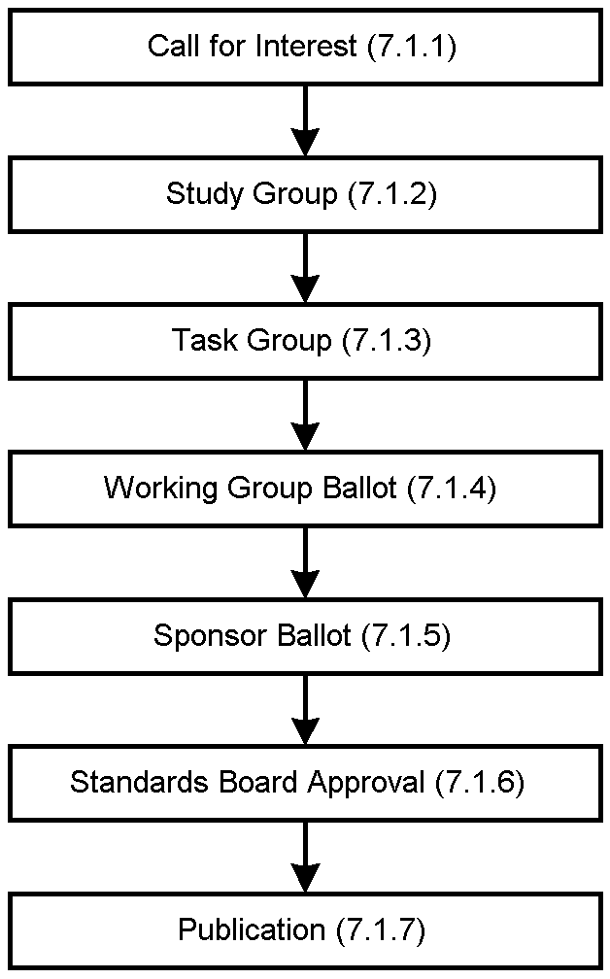
Overall Project Process
Figure 4
The following subclauses give a brief overview of the entire project process. For a detail explanation of the processes and procedures involved the reader is encouraged to consult the Operating rules of IEEE project 802, LAN MAN Standards Committee (LMSC) ( ref [1]), The IEEE Standards Companion ( ref [2]), the IEEE Standards Operations Manual ( ref [3]) and the IEEE Standards Board Bylaws ( ref [4]).
This project process is illustrated in figure 4.

7.1.1 Call for interest
A call for interest in a subject is made in the 802.15 WG plenary (see 2.7).

7.1.2 Study Group
Study Groups are covered in Clause 4 and the 802 rules (see ref [1], 5.3). Steps in this stage include:
- Develop PAR and Five Criteria (see 7.2).
- Provide a plenary week tutorial to 802.
- Obtain approval at WG 802.15, 802 EC, NesCom, and IEEE Standards Board.

7.1.3 Task Group
Task Groups are covered in Clause 3 of this document. Steps in this stage include:
- Develop goals.
- Write initial draft of standard
- Develop agreement upon completed draft.
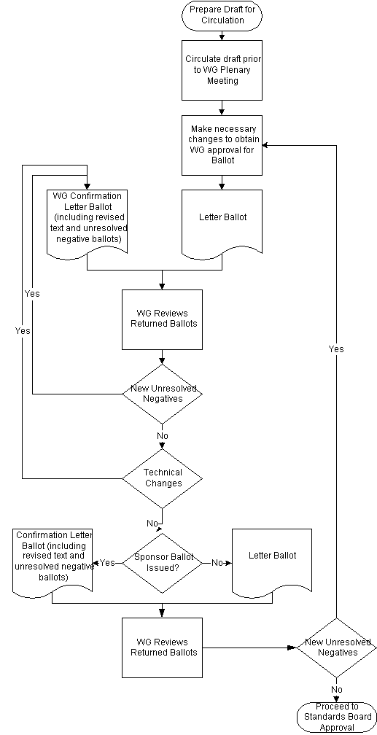
The Ballot Process
Figure 5

7.1.4 Working Group Ballot
Working Group ballots are covered in subclause 2.8 and the 802 rules (see ref [1], 5.1.4.2.2). Steps in this stage include:
- WG pre-view of document.
- Conduct WG ballots, which, by default, are electronic (FAX or email)
- Resolve comments from WG ballot.
- Re-circulate for approval including any unresolved negatives and revised areas in ballot package.
- Iterate to closure.
The WG and Sponsor balloting process is illustrated in figure 5.
Letter ballots are returned by e-mail (or by fax) after the voter fills in their vote. For e-mail returns acknowledgment is sent by Chair within two business days. It is the duty of the voter to resend email vote if it is not acknowledged in that time frame.
Voting members have an obligation to vote. Not returning two, valid, ballots in a sequence of 3 letter ballots will automatically terminate voting rights. Abstentions are only counted as valid if they are based on "lack of expertise".
All “No” votes require the submission of detailed comments as defined in the IEEE rules for Sponsor Ballots to be counted as valid.
Comments are to be returned in the format given in the ballot instruction document that accompanies the draft.

7.1.5 Sponsor ballot
Sponsor ballots are covered in detail in the IEEE Standards Companion (see ref [2]). Steps in this stage include:
- Form ballot pool using the IEEE staff. (In practice this takes about 3 months)
- Obtain approval for Sponsor ballot from WG 802.15 and 802 EC.
- Submit draft to IEEE for Sponsor ballot.
- Resolve comments from Sponsor ballot. Each comment must be answered by the WG with a response that indicates level of agreement with the comment and what actions will be taken as a result. The responses to the comments must be clear, concise, and at a technical level that addresses Sponsor ballot group member's knowledge.
- Re-circulate for approval including any unresolved negatives and revised areas in ballot package.
- Iterate to closure.

7.1.6 Standards Board Approval
- Obtain approval for submission from WG 802.15 and 802 EC.
- Check for Intellectual Property Rights requirements.
- Submit to RevCom and IEEE Standards Board for approval.

7.1.7 Publication
- Support IEEE editor in preparation for publication.
- Maintenance Phase.

Five Criteria
When a study group presents a request to the 802.15 WG for them to forward a draft PAR to 802 EC for approval, they shall in addition present a completed set of responses to the 'five criteria'. This is a set of formal criteria that the study group must demonstrate that the proposed project meets.
These five criteria are listed below:
1) Broad Market Potential
- Broad set(s) of applications.
- Multiple vendors, multiple users.
- Balance cost, LAN vs. attached stations.
2) Compatibility with IEEE Standard 802.15
- Conformance with CSMA/ CD MAC, PLS.
- Conformance with 802.2.
- Conformance with 802 Functional Requirements.
3) Distinct Identity
- Substantially different from other 802.15 specifications/ solutions.
- Unique solution for problem (not two alternatives/ problem).
- Easy for document reader to select relevant spec.
4) Technical Feasibility
- Demonstrated feasibility, reports, or working models.
- Proven technology, reasonable testing.
- Confidence in reliability.
5) Economic Feasibility
- Cost factors known, reliable data.
- Reasonable cost for performance expected.
- Total Installation costs considered.

Recommended Activities for WG Officers and Appointees

Chair
Before session tasks:
- preparation of:
- attendance list
- voter tokens
- Submit agenda items for the Monday AM Executive Committee meeting
(a week before the meeting)
- Attend the Monday AM Executive Committee meeting
- Report the status of the working group to the plenary 802 meeting
During session tasks:
- Conduct full working group meetings
- Assign task of document control and collection.
- Make sure the various tasks for the meeting operation (see below) are performed smoothly
- Check the mailbox for Executive Committee members regularly
- Keep Executive Committee members informed as early as possible about 802.15 matters requiring approval at their closing SEC night meeting
- Submit the voters list to the meeting organisers
- Update Mailing list on computer and prepare attendance list for distribution on the file server by the day before the closing plenary of the Working Group.
- Submit a hard copy of the attendance list to the meeting organisers by the final plenary session of the Working Group
- Attend the closing meeting of the Executive Committee and lead 802.15 business through the ExCom
- Report progress to the final 802 plenary meeting
- Obtain computer files of the documents for web site publication
- Maintain roll call list

After session tasks:
- Prepare agenda and venue for next meeting; publish on web site, and email to notice to members
- Manage the preparation of the meeting place as well as the venue for the next interim meeting
- Collect ballot return forms, acknowledge and merge into consolidation file(s) (if WG ballot active)
- Obtain ballot return forms from IEEE staff and merge into consolidation file(s) (if Sponsor ballot active)
- Update membership status
- Update public documents on web site
- Update Draft documents in members-only web site and send email IEEE staff to add to the Draft Standards Catalogue
- Respond to inquiries regarding the committee
- Be prepared to assign document numbers
- Work with TG chairs to prepare meeting agendas and room requirements for next session(s)
- Update list servers

Vice Chair
Typical tasks include:
- Be prepared to take over the duties of the chair in the event of temporary or permanent absence.
- Be prepared to assume or assign secretary duties when required.
- Between meetings, be prepared to respond to inquiries regarding the committee and keep the chair informed.
- Maintain oversight of document process
- During meetings, attend to any business that might otherwise prevent the chair from orderly conduct of the meetings, such as attending to emergency messages, and inquiries from the plenary staff.
- During meetings, provide a second vote count to insure accurate and fair voting.
- Assist the chair during IEEE P802 Executive Committee meetings held on initial and final days.
- Assist the chair, or be prepared to give the plenary reports at the first and last full IEEE P802 sessions.
- Act as parliamentarian using:
Roberts Rules of Order - Newly Revised (9th edition) Edited by Henry M. Robert III & William J. Evans ISBN# 0=-06-276051-3

Attendance Recorder
The objective of this task is to maintain an accurate record of attendance for voter qualification. The chair provides a book containing the necessary paperwork. The duties include:
- Be the custodian of the attendance book throughout the session.
- Make sure that people sign in for each meeting period
- Sign attendance book for officers and presenters then circulate to attendees.
- After each meeting period, cancel all unsigned blocks.
- Cancel and audit any signatures placed in any other meeting period block and initial the cancellation.
- Arbitrate any attendee record discrepancies
- make sure the book gets to all P802.15 rooms
- ensure quick circulation of the attendance book
- Regularly update chair with new participants list.
- Return the attendance book to the chairman at session end.

Document Coordinator
The primary duty of this appointed position is to keep meeting informed about document status during plenary sessions.
Duties include:
- After assignment by the chair, maintain a consistently numbered set of documents and files on flash cards and server.
- Verify document formats before presentation and circulation of materials to membership
- Update document list throughout meeting and provide to chair
- Collect all electronic presentations and working transparencies used during the meeting and file with the related document.

Meeting Coordinator
The section serves as a guideline for hosting an interim P802.15 meeting. It describes the requirements, for choosing a hotel, conference meeting rooms, and accommodations. The Meeting Coordinator is a person who resides close to the site of the interim meeting and assumes financial responsibility for costs incurred by the WG. Ideally the meeting fees should exactly cover costs, but the Meeting Coordinator is the final guarantor.
For the purposes of planning the following information must be available to the Meeting Coordinator four months before the meeting:
- Anticipated Attendance
- Guest Room Days
- Number of Large Meeting Rooms (50 places) – minimum 1 for Plenary Meeting
- Number of Small Meeting Rooms (15 places)
- SVGA Projector and Overhead Projector Rental Requirements
The Meeting Coordinator should advise the attendees in advance of the AC power options and the necessary adapters required for the country in which the meeting is to be held.

Required features of hotel facilities:
- All rooms set up classroom style, with plug strips to all tables. Each participant needs a table area of at least 1.5' x 2.5' to allow place for documentation and PC. (that is maximum 2 seats per 5' table) However, a space of 3' by 2.5' is preferred.
- In the plenary meeting room table on a raiser to accommodate the chairman, vice-chairman and secretary. A table should be arranged in the front-center of the room for the audio-visual equipment
- The plenary meeting room requires setup for a SVGA projector with camera and a screen.
- Document tables at the back of the plenary room for the network access points, the file-server, and the printer.
- Spotlights in the front of plenary room that illuminate the screen area should be able to be switched off for the time of the meeting to enable the use of overhead projectors.
- The meeting rooms should have a non-obstructed view from the table tops up to at least 10 feet, actual figure depending on the need for a large enough view on the AV screens.
- All rooms shall be locked when not in use by our groups, so material may be left with some security.
- The smaller meeting rooms require a normal overhead projector or a computer output projector. The host has the option to contact other members to carry a projector to the meeting site or to provide it from their own supply.
- Either glasses and iced water in pitchers on the tables or "water stations" in the corner of the rooms.

Desired features of hotel facilities:
- A small informal executive conference area/room (private), with some storage security and for registration of attendees.
- Seats of comfortable type with cloth instead of vinyl/plastic or other, non-woven, synthetic fabric.
- Availability for at least one of the rooms for overnight use.

Breaks
Provide for two breaks:
- About 10:00 am and provide a choice of juices (orange, tomato, grapefruit), regular coffee, decaffeinated coffee, tea and fruit.
- About 3:00 PM and provide a choice of sodas (diet and regular), regular & decaffeinated coffee, tea, brownies or cookies and some fresh fruit.

Lunch
Arrangements must be made for a quick lunches. Either provide a seated lunch/buffet, or for a cash bar for sandwiches and drinks. If the choice is for the seated lunch, the host should be aware that the banquet manager wants to get a committed number of people 2 days up to a week before the meeting. It is difficult to make an estimate with the freedom we have to give to the members to make last minute cancellations as well as showing up without announcement.
The participants can share the cost of the breaks and seated lunch. (See below, meeting cost-sharing)

Guest rooms
We would like to have rooms of maximum $ 90-150 per night. This rate should include absorption of extras volunteered by conference management and no commissions should be expensed in these costs as direct reservations benefits must be passed to attendees. Please ask for certification of these discounts passing to IEEE P802.15 benefit.
Make sure that the hotel knows that each individual pays his/her own charges. The shared costs should be reflected in the hotel bill listed as item: IEEE802.15 conference fee. The bill should be itemized each day. Each individual will share the cost of the meeting rooms and breaks for the entire week even if they only attend one day.

Block-booking with deadline date
The best way to prepare such a meeting is to ask for the reservation of a block of rooms for the estimated number of participants and let the rooms be confirmed by each participant using a pro-forma form. This form hopefully sent direct from participant by mail or FAX, without going via a travel agent and thus commissioned such agent to our detriment. The hotel must provide a confirmation either via Fax or Telephone, at the time of reservation by each attendee.
Establish a deadline, preferably not earlier than one week before the start-date of the meeting. At that time, rooms of the block booking not confirmed could be released. Using the IEEE 802.11 reflector is a vehicle to monitor and give updates to potential attendees prior the meeting.
Do not accept any commitments for the reservation of the guestroom. The hotels normally work with reservations cancelable up to 6:oo PM of the day of arrival, if reserved via a credit card. They will try to get guarantees, of course, because they commit to a larger part of their business. However, the host should not commit to those qualifications.
Sometimes the host has to guarantee only a minimum number of rooms and food service businesses to the hotel in order to qualify for discounts, such as free meeting rooms. In that case the host should conservatively take the commitment for Host Company or himself. The host should make a request to the hotel to recommend other hotels for guestrooms in the nearby area to accommodate last minute arrivals or overflow conditions.
Make sure that the Chairperson is allowed to ask hotel directly, the number of people that have registered and that she/he can obtain lists of names of the individuals that made reservations to the block booking.

Copying facilities
It is desirable for the officers of the working group to be able to make copies of documentation on the Saturday and/or Sunday before the meeting with access to a copy machine. However, if it not possible, please provide the address and directions to a copy-shop providing such services.
Little or no copying is anticipated during the meeting as the WG operates with electronic documents

Badges
Please provide a process to print and distribute badges for the whole of the meeting.

Printing
We require the use of a high-speed printer (postscript) at the meeting place. (See above for IEEE 802 printer arrangement).

Man-power during the meeting
The meetings are typically well attended by the majority of the participants. To minimize confusion and delays in the meetings during the week, it is recommended the host make the necessary provisions to assist in registration, copy machine operation, message taking and assist the officers of the meeting when needed.

Meeting cost-sharing
To share the cost of the meeting, the host can charge the participants a "conference fee" of up to $ 200 total for a 4 or 5 day meeting to bear the cost of:
- the breaks and lunches
- the audio-visuals equipment rental
- the copying and/or machine loan (if not born by the host)
- the meeting rooms (if not negotiated for "free" with the hotel for the business of the guest-rooms)
It is acceptable to assign a fixed cost for each participant, independent of the length of participation of the individual.
Arrange with the hotel for collection of the registration fee to make meeting fee payments easy by:
- Debiting the conference fee from the guest account of those staying at the hotel and crediting to the conference account
- Accepting conference fees from those not staying at the hotel (e.g. locals)
- If the hotel refuses to do so, the host has to go through the chore of collecting money from all participants and writing receipts
As we are not allowed to make a balance between meetings, we suggest that the host assumes a donation as a replacement of the saved travel and expenses cost. This allows the host to calculate a conference fee, so that we have a small shortage amounting to the fees to be paid by 2 to 3 participants. (Experience teaches that late, unexpected, arrivals will diminish this shortage) If at the end of the meeting there is, indeed, a negative balance, we must assume that the meeting coordinator will pay for that in full when undertaking this obligation at the onset.

