IEEE P802.15
Wireless PANs

PAR for Wireless Personal Area Network (WPAN)
Date: 21 May 1999
Author: Richard Ditch
Motorola
8220 E. Roosevelt St., Scottsdale, AZ 85252 USA
Phone: +1 602-441-0809
Fax: +1 602-441-0830
e-Mail: Rich_Ditch-P26658@email.sps.mot.com

Abstract

The WPAN PAR was approved by IEEE 802 on March 11, 1999 and by NESCOM on March 18, 1999.

The officers of the Working Group (WG) are:

Chairman: Bob Heile bheile@bbn.com

Vice Chairman: Ian Gifford giffordi@amp.com

Technical Editor: Tom Siep siep@ti.com

Secretary: Pat Kinney kinneypw@norand.com

Assistant Technical Editor & Secretary: Michael McInnis michael.d.mcinnis@boeing.com

The objectives for the Study Group are:
- Review WPAN/WLAN Requirements
- Determine Need for Standard
- If warranted draft a PAR for submittal
- Seek appropriate Sponsorship within 802

Revision History:

Revision 0 January 15, 1998, the Wearables Ad Hoc Committee drafts the first version of the IEEE PAR

Revision 1 April 9, 1998, SG at the Interim Meeting in Irvine, Discusses and hands off the PAR to Rich

Revision 2 May 4, 1998, Major Edits by Rich converting the old PAR to the new PAR

Revision 3 May 21, 1998, SG at the Interim Meeting in Irving, Minor Edits led by Rich

Revision 4 May 27, 1998, Minor Edits by Rich

Revision 5 May 28, 1998, Minor Edits by Rich

Revision 6 May 28, 1998, Minor Edits by Ian

Revision 7 October 26, 1998, Minor Edits by Ad Hoc SG

Revision 8 January 12, 1999, Minor Edits by the SG based on LB16 Comments –99/18 and January 29, 1999, Minor Edits & added Appendices by the SG Sub Group -99/7r1

Revision 9 March 10, Minor Edits & added Appendices by the SG -99/51

Revision 0 May 21, 1999 Converted NESCOM Approved PAR to 802.15 Document Archive

++++++++++++++++++++++++++++++++++++++++++++++++++++++++++++++
IEEE Standards Board Jan98 Project Authorization Request (PAR) Page1(Rev V9)
1. Sponsor Date 2. Assigned Project 3. PAR Approval
of Request Number DATE
[1999 Feb 04/Mar12] [P802.15] ________
[ ] PAR Signature Page Received {IEEE Staff to check Box}

4. Project Title and Working Group/Sponsor for this Project
Document type : {Place an X in only one option below}
[X] Standard for {Document stressing the verb "SHALL"}
[ ] Recommended Practice for {Document stressing the verb "SHOULD"}
[ ] Guide for {Document stressing the verb "MAY"}

TITLE: [STANDARD FOR Telecommunications and Information Exchange Between Systems - LAN/MAN Specific Requirements - Part 15: Wireless Medium Access Control (MAC) and Physical Layer (PHY) specifications for Wireless Personal Area Networks (WPAN)]

{Copyright release at the end of this form must be submitted with appropriate
signatures by postal mail or FAX (1-732-562-1571)}

Name of Working Group(WG) : [Sponsor: IEEE 802.11 WG for WLAN, Proposed Working Group: Wireless Personal Area Networks]

Name of Official Reporter (usually the WG Chair): [Bob Heile]
Title in WG: [802.15 Acting Chair] IEEE/Affiliate Memb # [01670801]
Organization: [GTE] Telephone: [+1 617 873 4835]
Address: [10 Moulton Street] FAX: [+1 508 222 0515]
City/State/Zip: [Cambridge, MA USA] EMAIL: [bheile@bbn.com]

Name of WG Chair (if different than Reporter): []
Title in WG: [] IEEE/Affiliate Memb # []
Organization: [] Telephone: []
Address: [] FAX: []
City/State/Zip: [] EMAIL: []

Name of Sponsoring Society and Committee: [IEEE 802 LAN/MAN Standards Committee]
Name of Sponsor Committee Chair: [Jim Carlo]
Relationship to Sponsor: [IEEE 802 LMSC Sponsor Chair]
Organization: [Texas Instruments] Telephone: [+1-214-480-2524]
Address: [9208 Heatherdale Drive] FAX: [+1-214-480-2611]
City/State/Zip: [Dallas, TX 76243-6332] EMAIL: [jcarlo@ti.com]

5. Describe this Project by answering each of four questions below:
5a. Update an existing PAR? {Yes/No} [ No ]
If Yes: Indicated PAR number/approval date [ ]
If YES: Attach letter indicating changes/rationale for changes.
If Yes: Is this PAR in ballot now? [ ] {Yes/No}
5b. Choose one from the following:
b1 -[ X ] New Standard
b2 -[ ] Revision of existing standard {number and year} [ ]
b3 -[ ] Supplement to existing standard {number and year} [802.11 1997]
5c. Choose one from the following:
c1 -[ X] Full Use (5-year life cycle)
c2 -[ ] Trial Use (2-year cycle)
5d. Fill in Target Completion Date to IEEE RevCom [ November 2000 ]

6. Scope of Proposed Project
[To define PHY and MAC specifications for wireless connectivity with fixed, portable and moving devices within or entering a Personal Operating Space (POS). A goal of the WPAN Group will be to achieve a level of interoperability which could allow the transfer of data between a WPAN device and an 802.11 device.

A Personal Operating Space (POS) is the space about a person or object that typically extends up to 10 meters in all directions and envelops the person whether stationary or in motion. The proposed WPAN Standard will be developed to ensure coexistence with all 802.11 Networks.]

PAR Form Page 2 of 3 (RevV9)

7. Purpose of Proposed Project:
[To provide a standard for low complexity, low power consumption wireless connectivity to support interoperability among devices within or entering the Personal Operating Space (POS). This includes devices (see 12c) that are carried, worn, or located near the body. The proposed project will address Quality of Service to support a variety of traffic classes.

Examples of devices, which can be networked, include Computers, Personal Digital Assistants (PDAs)/Handheld Personal Computers (HPCs), printers, microphones, speakers, headsets, bar code readers, sensors, displays, pagers, and cellular &amp; Personal Communications Service (PCS) phones.]

8. Intellectual Property {Answer each of the questions below}
8a.Are you aware of any patents relevant to this project?
[ Yes ] {Yes, with detailed explanation below/ No}
[ ] {Explanation}
8b. Are you aware of any copyrights relevant to this project?
[ No ] {Yes, with detailed explanation below/ No}
[ ] {Explanation}
8c. Are you aware of any trademarks relevant to this project?
[ No ] {Yes, with explanation below/ No}
[ ] {Explanation}

9. Are you aware of other standards or projects with a similar scope?
[ Yes ] {Yes, with explanation below/ No}
[Infrared Data Association (IrDA), Home Radio Frequency Working Group (HRFWG)
Bluetooth Special Interest Group (SIG), Wireless Access Protocol (WAP) Forum. These groups are not standards organizations but Industry Consortia which have similar charters and the Working Group intends to establish liaisons with these groups as appropriate. As Industry Consortia formal coordination in Item 12 may be inappropriate. The WAP coordination will be monitored for appropriateness, as this industry forum may not be developing specifications in this area.]

10. International Harmonization
Is this standard planned for adoption by another international organization?
[Yes] {Yes/No/?? if you don't know at this time}
If Yes: Which International Organization [ISO/IEC JTC1/SC6]
If Yes: Include coordination in question 13 below
If No: Explanation [ ]

11. Is this project intended to focus on health, safety or environmental
issues?
[ No ] {Yes/No/?? if you don't know at this time}
If Yes: Explanation? [ ]

12. Proposed Coordination/Recommended Method of Coordination
12a. Mandatory Coordination
SCC 10 (IEEE Dictionary) by DR
IEEE Staff Editorial Review by DR
SCC 14 (Quantities, Units and Letter symbols) by DR

12b. Coordination requested by Sponsor and Method:
[US TAG to JTC1/SC6 WG1/WG3] by [DR] {circulation of DRafts/LIaison memb/COmmon memb}
[ ] by [ ] {circulation of DRafts/LIaison memb/COmmon memb}
[ ] by [ ] {circulation of DRafts/LIaison memb/COmmon memb}
[ ] by [ ] {circulation of DRafts/LIaison memb/COmmon memb}
{Choose DR or LI or CO for each coordination request}

12c. Coordination Requested by Others:
[ ] {added by staff}

Additional Explanation Notes: {Item Number and Explanation}
[ ]{If necessary, these can be continued on additional pages}

6 Scope:
A Personal Operating Space (POS) is the space about a person or object that typically extends up to 10 meters in all directions and envelops the person whether stationary or in motion.

The proposed WPAN Standard will be developed to ensure coexistence with all 802.11 Networks.

7 Purpose:
Examples of devices, which can be networked, include Computers, Personal Digital Assistants (PDAs)/Handheld Personal Computers (HPCs), printers, microphones, speakers, headsets, bar code readers, sensors, displays, pagers, and cellular & Personal Communications Service (PCS) phones.

PAR Copyright Release and Signature Page Page 3 Rev(V9)

1. Sponsor Date 2. Assigned Project
of Request Number
[ 2-1-99 ] [P ]
Title [ ]

I hereby acknowledge my appointment as Official Reporter
(usually the WG Chair) to the
[WPAN Study Group ] {Name of Working Group}
In consideration of my appointment and the publication of the Standards
Publication identifying me, at my option, as an Official Reporter, I agree to
avoid knowingly incorporating in the Standards Publication any copyrighted or
proprietary material of another without such other's consent and acknowledge
that the Standards Publication shall constitute a "work made for hire" as
defined by the Copyright Act, and, that as to any work defined, I agree to and
do hereby transfer any right or interest I may have in the copyright to said
Standards Publication to IEEE.

Signature of Official Reporter ______________________ Date _________
Name of Official Reporter (usually the WG Chair): [Bob Heile]
Title in WG: [802.XX Acting Chair] IEEE/Affiliate Memb # [01670801]
Organization: [GTE] Telephone: [+1 617 873 4835]
Address: [10 Moulton Street] FAX: [+1 508 222 0515]
City/State/Zip: [Cambridge, MA USA] EMAIL: [bheile@bbn.com]

Submitted by: (This MUST be the Sponsor Chair or the
Sponsor's Liaison Representative to the IEEE Standards Board)

Signature of Submitter____________________________ Date ____________

Name of Sponsor Committee Chair: [Jim Carlo]
Relationship to Sponsor: [IEEE 802 LMSC Sponsor Chair]
Organization: [Texas Instruments] Telephone: [+1-214-480-2524]
Address: [9208 Heatherdale Drive] FAX: [+1-214-480-2611]
City/State/Zip: [Dallas, TX 76243-6332] EMAIL: [jcarlo@ti.com]

The submitter must be the sponsoring committee's liaison to the IEEE Standards
Board or the chair of the sponsoring committee. The PAR will not be submitted
to the Standards Board without the signature of the Official Reporter and the
Sponsor Committee Chair. Once the PAR is completed, it shall be forwarded to
the person designated by the sponsor as responsible for submitting it to the
Standards Board New Standards Committee/NESCOM (normally the sponsoring
committee's liaison to the IEEE Standards Board). Be certain to include all
attachment sheets and supporting correspondence. The submitter will be notified in writing when the PAR is received and when the PAR will be considered for approval by the Standards Board. After the Standards Board meeting, the submitter and official reporter will be notified in writing of the action taken.

Signature by IEEE Officer: _________________________Date: ___________

Title: _____________________________

Appendix A

Wireless Personal Area Networking Study Group Document Archive

Web Browser:
ftp://ftp.flexipc.com/wearablesgroup/Index.htm

FTP:
ftp://ftp.flexipc.com/wearablesgroup/

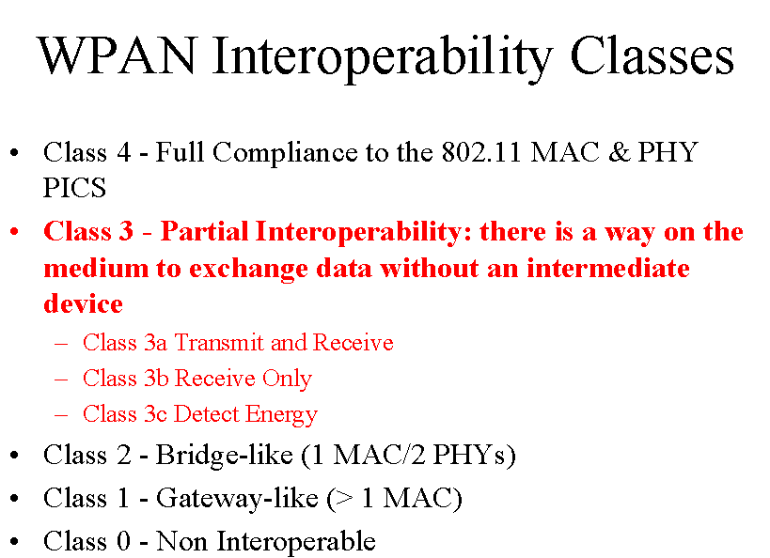
Appendix B

Wireless Personal Area Networking Study Group Definition of WPAN Interoperability Classes

Source: doc.: IEEE 802.11-99/5r1

The above graphic was presented, courtesy Pat Kinney, Intermec to the IEEE P802.11 Working Group on January 13, 1999 during the Interim Meeting in Orlando, FL USA doc.: IEEE 802.11-99/5r1. The purpose of the graphic is to provide a "communication device" between the P802.11 Members such that the WPAN SG interoperability goal is clearer. The WPAN Standard will fall into Class 3 denoted above.

Appendix C

Wireless Personal Area Networking Study Group Definition of WPAN Medium Interoperability Continuum

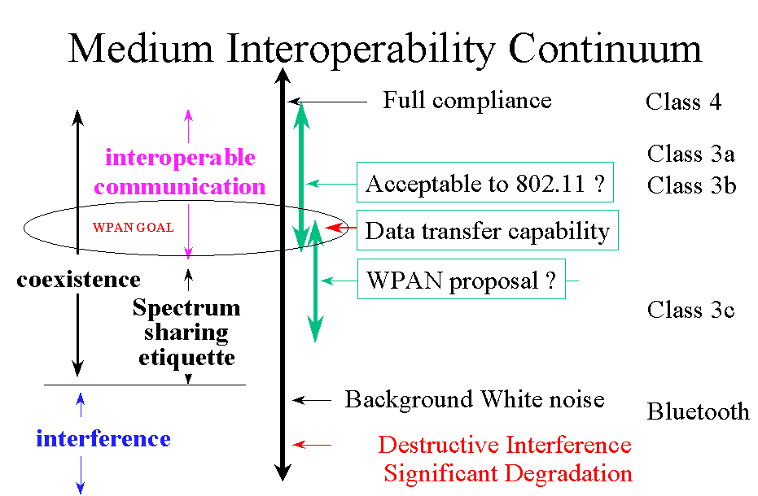
Source: doc.: IEEE 802.11-99/5r1

The above graphic was presented, courtesy Bruce Kraemer, Harris, to the IEEE P802.11 Working Group on January 13, 1999 during the Interim Meeting in Orlando, FL USA doc.: IEEE 802.11-99/5r1. The purpose of the graphic is to provide a "communication device" between the P802.11 Members such that the WPAN SG interoperability goal is clearer. The WPAN Standard will fall into the "WPAN Goal" circle denoted above.

