IEEE P802.15
Wireless Personal Area Networks
Project | IEEE P802.15 Working Group for Wireless Personal Area Networks (WPANs)
Title | IEEE Personal Communications Magazine
Date Submitted | [11 November 1999]
Source | [Ian C. Gifford]  [M/A-COM, Inc.]  [1011 Pawtucket Boulevard Lowell, MA 01853-3295 USA] | Voice: [+1 978 442 4650]  Fax: [+1 978 442 5442]  E-mail: [giffordi@ieee.org]
Re: | Submission
Abstract | [Wireless personal area networks will proliferate early in the next millennium and the IEEE P802.15 Working Group for Wireless Personal Area Networks (WPAN's) will provide the leadership in the IEEE 802 Standards Committees to establish open standards for these WPAN's. The IEEE P802.15 Working Group for WPANs will develop Wireless Personal Area Network standards for short-range wireless networks. The Working Group is cognizant of emerging industry specifications, viz., Bluetooth, HomeRF, etc. and realizes that it is important to build on the work of these groups as they enjoy significant market interest and industry participation. One of the primary motivations for this Working Group is to ensure the best use of a shared medium. This article will describe some of the known candidate radio transmission technologies that the Working Group, via open solicitations, peer review, and formal balloting, will choose from as their draft standard(s). The Authors believe that the IEEE 802 Committee provides the best forum for the development of consensus open standards and that this process will provide for rock-solid, market-accepted WPAN technologies.]
Purpose | [In early 1999 the IEEE P802.11 Study Group on WPANs was approached to participate and prepare a Paper for the IEEE Personal Communications Magazine Special Issue of the IEEE Personal Communication Systems on Connectivity for Pervasive Computing Devices. This is the draft that was submitted on 31Aug99.]
Notice | This document has been prepared to assist the IEEE P802.15. It is offered as a basis for discussion and is not binding on the contributing individual(s) or organization(s). The material in this document is subject to change in form and content after further study. The contributor(s) reserve(s) the right to add, amend or withdraw material contained herein.
Release | The contributor acknowledges and accepts that this contribution becomes the property of IEEE and may be made publicly available by P802.15.

Abstract
The process of creating international standards is a mystery to most people, even to the technologists who use them every day. This article describes the origins and processes of the IEEE Project 802.15 Working Group for Wireless Personal Area Networks and their effort to bring standardization to the Bluetooth™ Specification. The committee of experts that comprises P802.15 is chartered with codifying the physical characteristics and protocols used to construct small, low power, ad hoc networks used to wirelessly interconnect personal electronic devices.

Paving The Way for Personal Area Network Standards: An Overview of The IEEE P802.15 Working Group for Wireless Personal Area Networks

Thomas M. Siep, Texas Instruments
Ian C. Gifford, M/A-COM, Incorporated
Richard C. Braley, Federal Express Corporation
Robert F. Heile, GTE Technology Organization

A robust, detailed specification is only the first step in establishing a new technology. A complex technology such as a Wireless Personal Area Network needs the formal process of standardization to best provide for the proliferation of this wireless connectivity solution for the newly emergent pervasive computing devices. The IEEE provides numerous forums for standards development, the forum that applies to the Bluetooth™ technology is IEEE Project 802. The wide variety of manufacturers considering the Bluetooth™ technology will base some of their implementation decisions on it being an accredited IEEE standard.

The Bluetooth™ Special Interest Group has produced a specification [1] for wirelessly connecting information devices in a small, personal area. The difference between a standard and a specification is both subtle and profound. It is subtle in that both are documents that describe the technical functions of a system and the differences may not be immediately apparent. The more profound difference is in why and how they are constructed.

A specification describes the workings of what is usually one or a small number of implementations of a technology. It often makes unconscious assumptions about the architecture of those implementations of the technology. Specifications are generally narrative in content and format and seldom employ the rigorous formalisms that hallmark the standards process.

More often than not, standards are created before the physical existence of the subject system. This is especially true of systems such as the second generation digital cellular telephone networks. This lack of an existent example causes the need for a common set of unambiguous descriptors. Without a physical system to point at, a formalized document structure and language is necessary.

In some cases a company or consortium invents a technology so compelling that it has obvious applications to wide areas of usage. One preeminent example of this is Ethernet™. Invented by Xerox, it addressed a need in the late 1970’s that was not even perceived as interesting by the industry until a few years later. When such a specification exists, those interested in the standards process can take it and drive it into a rock solid and maintainable standard. The specification is expanded into a generalized and formal definition. This formal derived definition then forms the basis for further development of the technology. In the case of Ethernet virtually the same upper layer protocols now support a medium that is 1000 times faster than the original fielded version.

Evolution of WPAN Standardization
The desire for an international standard on Wireless Personal Area Networks predates the May 20, 1998 public announcement of Bluetooth™. In fact, its origins reach back to the beginnings of cellular and wireless Local Area networks.

These wireless standards developments have paralleled the creation and use of wired networks. Information transmitted over wires (voice or data) has engendered a desire to have the same service without the bother of plugging into a wall.

Cellular vs. Local Wireless
The cellular network was a natural extension of the wired telephony network that became pervasive during the mid-20th century. As the need for mobility and the cost of laying new wires increased, the motivation for a personal connection independent of location to that network also increased.

A set of standards that many cellular telephone users are at least briefly aware of defines how their devices create and maintain connectivity with the larger world of the wired telephone network. Terms such as Digital Cellular, Analog, GSM, IS-136, and IS-95 all refer back to standards accredited by national and international Standards Development Organizations.

These standards are specifically tailored to facilitate (mostly) voice communications throughout a metropolitan area. Coverage of a large area was allowed through the definition of relatively small (1 to 2 Km diameter) "cells" that cooperate with their like neighbors to create a seemingly seamless network.

During the mid-1980s it became evident that there was a need for an even smaller coverage area, this time oriented to higher mobile user densities and the emergent data traffic. These "local area" networks were needed to maintain connectivity with the wired data network of the enterprise in a way that was analogous to the need for extending the voice network for the mobile user.

Initial Local Wireless Standardization
Initial solutions to standardization of the local wireless data connectivity problem were centered in the IEEE Project 802 LAN/MAN Standards (P802) Working Group 11. Since P802 had successfully hosted the Ethernet™ standardization (IEEE P802.3 CSMA/CD) and Token Ring (IEEE P802.5), it was logical to have this Project host the new effort in local area networks.

The IEEE P802.11 Working Group for WLANs formed in 1990 to create a Wireless Local Area Network Standard. The initial process was quite contentious. At the time of the formation of the Working Group (WG) it was not clear which technologies, if any, were suitable for connecting wirelessly between mobile units and from mobile units to the Ethernet socket in the wall.

Eventually a single Medium Access Control (MAC) Sublayer protocol was created to support three different Physical Layer (PHY) protocols. This definition was embodied in the IEEE P802.11 standard, which was published in 1997.

Local vs. Personal Wireless
As technology progressed, a new set of wires became the target of ire. These are the wires that interconnect personal devices rather than individual networks. Whereas P802.11 was concerned with features such as Ethernet-matching speed and hand-off support for devices in a localized area, this newly emerging application had an even more localized purview: the personal area about the person using the device. This concept has been dubbed a Personal Area Network. The untethered version of this is, of course, called a Wireless Personal Area Network or WPAN.

The goal of the WLAN standard was connectivity to the Ethernet plug in the wall at the workplace and Ethernet-like connectivity in ad hoc situations, such as conferences. Devices that attach to the Ethernet are usually high-capability devices, such as laptops and desk top computers. These devices are relatively expensive and wireless connectivity has been justifiable for business entities as an infrastructure cost.

The WPAN's goal is replacing wires between objects that are close to each other and then hook to the larger world when/if convenient. This wire replacement technology is intended as an embedded connection between a large variety of devices, many with limited capabilities. While the WLAN technologies are specifically designed for devices in and around the office or home, a WPAN/Bluetooth™ device will travel from country to country, be used in cars, airplanes, boats and is truly designed for international use.

Because of this, much of the WPAN/Bluetooth™ technology is focused on a single standard that meets the world-wide regulatory requirements that fall into two categories: spectrum/power and security. As the radio link will contain private business and personal data/voice, security is a requirement for this. As security is heavily regulated world-wide, the technology has to conform or work with the various world wide agents to insure it meets these requirements.

In regards to spectrum and power, the technology needs to travel with the user. Unlike a typical WLAN, that is setup in one area and never moved, mobile devices travel with the users. As such the WPAN/Bluetooth™ technology needs to be designed such that a single technology meets the spectrum power requirements of the world (don't want to break the law when crossing a border).

Formation of the WPAN Working Group
As was mentioned earlier, the WPAN standardization effort actually predates the public announcement of Bluetooth™. It also predates other personal wireless technologies, such as HomeRF™ .

The IEEE standards process begins with a Study Group (SG). The interested individuals first petition the appropriate IEEE organization for sponsorship as a SG. In this case a group led by some of the authors [RCB, ICG, and RFH] asked the IEEE Project 802 Executive Committee for sponsorship as a SG chartered to study creating or deriving a standard for WPANs.

A SG has one purpose in life: create a Project Authorization Request (PAR) and in the case of IEEE802 sponsorship it is also submitted with a response to the Standards Development Criteria of how this new project request shall meet the IEEE802 family of LANs Five Criteria (see below). If the SG decides that a Standard, Recommended Practice, or Guideline is not required for the given application, the SG merely ceases to exist.

Since Project 802 already had an active WG involved in wireless communications, the Executive Committee established the WPAN SG under P802.11. It was thought that since it was a wireless problem, the best place to solve it was in a group that already had a wireless solution (three of them, in fact).

A valiant effort was made by the SG to meld the needs of a WPAN standard with the infrastructure defined by the WLAN standard. Had that been possible, the WPAN effort would now be labeled something like “P802.11e”. However, after one year the SG concluded that the architecture defined by the MAC (Medium Access Control) in P802.11 was not a good fit for the spartan needs of a WPAN. Not all members of the hosting WG agreed with this conclusion and the Executive Committee was presented with two recommendations for proceeding: authorize a Task Group under P802.11 or authorize a new Working Group at the same level as P802.11.

The IEEE 802 Executive Committee decided and the IEEE Standards Board approved the formation of a new working group to create a Wireless Personal Area Network (WPAN) standards, named IEEE P802.15. The Working Group was created on March 18, 1999.

Project Authorization
The Project Authorization Request (or PAR) approved by the IEEE-SA Standards Board's NesCom (New Standards Committee) in March 1999 sets the allowable activities for the WG.

One of the things that the PAR does is set the official title for the new working group. It is:
Communication Protocol Layers
Figure 1

STANDARD FOR Telecommunications and Information Exchange Between Systems - LAN/MAN Specific Requirements - Part 15: Wireless Medium Access Control (MAC) and Physical Layer (PHY) specifications for Wireless Personal Area Networks (WPANs)

In the PAR, the WPAN Working Group’s purpose is defined to establish a standard for wireless communication within a Personal Operating Space (POS). A POS is the space about a person or object that extends up to 10 meters in all directions and envelops the person whether stationary or in motion. Specifically, it is to provide a standard for low complexity, low power consumption wireless connectivity to support interoperability among devices within or entering the POS. This includes devices that are carried, worn, or located near the body. The project is also chartered with addressing Quality of Service to support a variety of traffic classes.
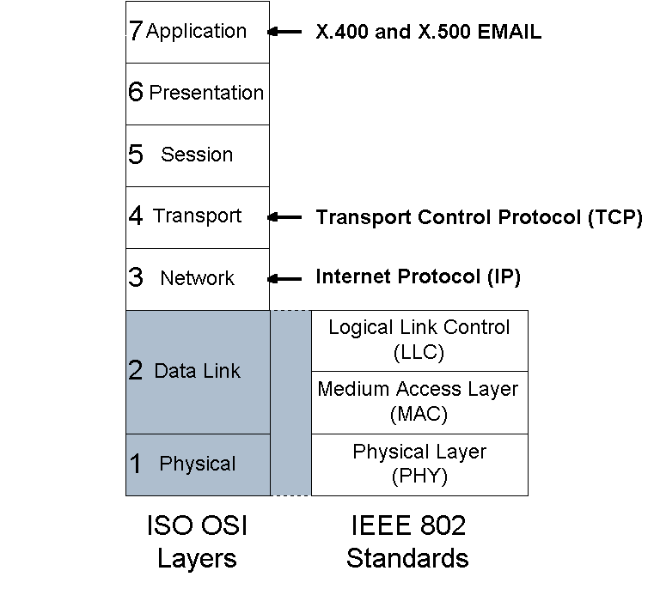
Figure 1, International Standards Organization’s Open System Interconnect Reference Model with IEEE 802’s Model
The scope of work for the P802.15 WPAN activity is to define PHY and MAC specifications for wireless POS connectivity. Figure 1 shows the ISO OSI model, the IEEE P802’s modification of it within which P802.15 is doing its work. The ISO/OSI Reference Model addresses the entire protocol stack from physical medium to the interface to user applications. Note that the P802.15 WG only addresses the bottom layer and a half of the ISO model. The lowest layer defines how information is transferred to another like entity, in the case of the WPAN this is the radio definition. The bottom half of the ISO Data Link corresponds to the Medium Access Control Sublayer (MAC) which decides how and when the radio should be used for communication. The other half of the Data Link Layer has been standardized as IEEE P802.2 and maintains logical associations between the upper layers of the communicating systems. All PHY and MAC standards use the same LLC in P802.

Five (make it Six) Criteria
As part of the PAR a separate document, is required by IEEE802 justifying the creation of a new 802 Family standard, must be submitted. There are five standard development criteria that shall be met to satisfy the new 802 Project justification. They are a series of criteria that the writers of the PAR must address:

- Broad Market Potential
- Compatibility With IEEE 802 Family Of Standards
- Distinct Identity
- Technical Feasibility
- Economic Feasibility
To which the P802.11 chair and Study Group Sponsor added a sixth criteria:

- Strategy For WPAN Coexistence In The 2.4 GHz Band

Broad market potential involves three aspects: broad sets of applicability; multiple vendors and numerous users; and balanced costs. The WPAN PAR responded by citing the increasing adoption of wearable and hand-held computing and communicating devices, and the proliferation of peripheral devices for them as evidence for broad applicability. It pointed to the broad base of company participation (more than 30) in the WPAN Study Group for evidence of multiple vendors. Balanced costs were the easiest to address: the likelihood of low cost implementations was the primary reason for the formation of the SG.

It makes sense that in order to assume the identity of an 802 Standard, compatibility with IEEE 802 family of standards is a requirement. The PAR pledged that the MAC (Medium Access Control) Layer of the Wireless Personal Area Network (WPAN) Standard will be compatible with the IEEE 802 requirements for architecture, management, and inter-networking. That characteristic is all that is necessary for compatibility.

Having a distinct identity is also a common-sense criterion. A Standard should not be established if it is not substantially different from other IEEE 802 standards, does not offer one unique solution per problem (not two solutions to a problem), or is not easy for the document reader to select the relevant specification. Here the WPAN PAR concentrated on low cost, low power consumption and small form factor wheras the 802.11 standard optimized for data throughput over distance and mobility. These differentiated goals provided the basis for separate standards.

A purely theoretical solution to a problem that has little or no technical feasibility should not become a Standard. An IEEE Standard must have demonstrated system feasibility, proven technology with reasonable testability, and some measure of confidence in the reliability of products based upon it. For this criterion the PAR cites data from existing products and prototypes representing candidate approaches provide and concludes there is confidence in the reliability of the proposed solutions.

Although the IEEE has strict prohibitions about talking about prices, costs are an essential consideration when considering a PAR. The justification for economic feasibility revolves around having known cost factors with reliable data to support it: a reasonable cost for performance with reasonable installation costs. The PAR reiterates its commitment to low cost, ad hoc, connectivity with minimal operator intervention in answer to this requirement.

In answer to the sixth criteria, “Strategy for WPAN Coexistence In The 2.4 GHz Band”, the SG acknowledged that coexistence with WLANs in the 2.4 GHz band is a critical success factor. The document defined Coexistence as minimizing mutual interference such that the effect of the addition of a WPAN to a WLAN coverage area has approximately the same effect as adding an additional, non-co-operating WLAN, localized to the WPAN coverage area.

Coexistence and Interoperability: a fundamental concern
There are many efforts in the marketplace to address the need to eliminate wired connections between personal electronic devices. Another purpose of the standards efforts is to provide a common forum for these competing and complimentary industry thrusts to address how they can all coexist and thrive. As mentioned above, one of the criteria for the creation of a WPAN Working Group was that we address this fundamental issue.

Interoperability is an often-misused term. It is sometimes used to describe the ability for different kinds of wireless systems to operate in the same airspace without problem. That is more properly a matter of coexistence. Interoperability involves the ability to exchange data between unlike devices in an efficient manner.

This definition is by no means universally held. The WPAN WG has recognized this and is currently in the process of hosting yet another Study Group to help define and refine these concepts. The scope of the project is to develop a common and precise definition of coexistence and interoperability. It will also address the development a model of an IEEE 802.15 Wireless Personal Area Network coexisting with an IEEE P802.11 Wireless Local Area Network i.e., FHSS and DSSS on the 2.4 GHz medium. Other potential tasks include development of a set of recommended practices for IEEE P802.15 devices operating in an IEEE P802.11 WLAN environment and suggestions for modifications to the IEEE P802.15 standard to improve coexistence with IEEE P802.11 WLAN devices.
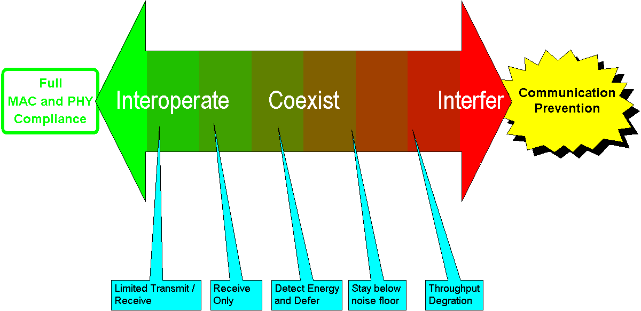

Figure 2. The Interoperability/Interference Continuum

Figure 2 illustrates the complexity of the coexistence problem. The rectangle on the left represents the perfect world in terms of two independent communications systems that share the same wireless medium. Full interoperation means that if they chose, they could completely comprehend each other’s protocols and take steps to avoid adversely affecting each other. The opposite end of the scale is where the two systems conflict to such an extent that they prevent any communication.

The Process of Creating a Standard
The creation of a standard is not a dry, detached process. Instead it is a lively, sometimes emotional, exchange between some of the world's experts on the subject. As may be expected, the experts sometimes disagree. It is a process of give-and-take, where everyone has to give at least a little.

Additionally, there are five imperative principles that drive the standards process: due process, openness, consensus, balance, and the right of appeal. The IEEE802 rigorously enforces these principles.

Each unique technology requires its own standard and standards making body to provide an adequate forum for discussion and debate. This forum establishes a clearinghouse for inputs from a great variety of sources. They range from semiconductor manufacturers responsible for producing chips based on the standard, to users who will employ the devices and applications made possible by the standard.

Call for Proposals
On May 6, 1998 the IEEE P802.11 WPAN Study Group (as it was called then) initiated a Call For Proposals (CFP). The WPAN CFP for straw models for Medium Access Control and Physical Layers was closed on March 12, 1999.

Subsequently in June of 1999 candidate contributions were requested for the IEEE P802.15 Working Group for Wireless Personal Area Networks (WPANs), for a "WPAN Draft Standard". It was stated in the Call that if parties were interested but did not have a draft standard, they were requested to send in a letter of intent with an estimate of when a proposal could be expected.

The parameters for the requested proposal were:
Scope of Proposed Project: To define PHY and MAC specifications for wireless connectivity with fixed, portable and moving devices within or entering a Personal Operating Space (POS). A goal of the WPAN Group will be to achieve a level of interoperability which could allow the transfer of data between a WPAN device and an 802.11 device. A Personal Operating Space (POS) is the space about a person or object that typically extends up to 10 meters in all directions and envelops the person whether stationary or in motion. The proposed WPAN Standard will be developed to ensure coexistence with all 802.11 Networks.

Purpose of Proposed Project: To provide a standard for low complexity, low power consumption wireless connectivity to support interoperability among devices within or entering the Personal Operating Space (POS). This includes devices (see examples below) that are carried, worn, or located near the body. The proposed project will address Quality of Service to support a variety of traffic classes.

This CFP was communicated to all companies that had participated in the WPAN studies as well as various industry consortia, such as HomeRF™ and Bluetooth™.

Bluetooth™ Responds
The first official meeting of P802.15 was at the July 1999 IEEE 802 Plenary meeting in Montreal. That meeting coincided with the closure of the CFP. The only respondent to it was the Bluetooth™ Special Interest Group which sent a letter of intent stating that Bluetooth™ wished to be a candidate for the WPAN standard.

The WPAN Working Group was enthusiastic. It was initially thought that the way was clear for incorporating Bluetooth™ technology into the P802.15 Standard. Reality set it quickly, however. While it was understood that there would be some negotiations on the details of the relationship, it was not envisioned that it would take months to work out. Trying to forge a relationship between a non-profit organization like the IEEE and a group of associated, independent companies is not an easy task. Copyright agreements, licensing arrangements, and intellectual property rights all had to be examined and agreed to.

In the mean time, an unofficial group of IEEE P802.15 people (who were also Bluetooth™ SIG members) volunteered to work with the SIG to start the process of transliterating the specification(s) [2] into a standard. These volunteers “just happened” to be SIG members, conversant in wireless communications, and knowledgeable in IEEE 802 forms and formats. It was this group of experts and technical editors that made the first translation from the Bluetooth™ specification to a prototype P802.15 Draft Standard. This allowed the Bluetooth™ SIG to consider a good approximation of the final form for turnover to the IEEE.

The major concern of the Bluetooth™ SIG was that the P802.15 standard needed to maintain compatibility with Bluetooth™ specification in order to:
- Prevent consumer and user confusion that could result from non-interoperable specifications, and
- Provide a mechanism to test interoperability between Bluetooth™ and P802.15 solutions by maintaining appropriate testing interfaces.

These two concerns prompted the Bluetooth™ SIG to impose some conditions for the IEEE to meet in order to be able to cite any relationship to the original specification. The conditions laid down were that the resultant Standard:
- Be 100% compatible with the Bluetooth™ 1.0 Foundation Specification
- Maintain the inclusion of the Bluetooth™ testing interfaces as described in the Bluetooth™ specification
- Any 802.15 extensions beyond the Bluetooth™ 1.0 specification must not break interoperability with existing Bluetooth™ 1.0 certified radios and be approved by the Bluetooth™ SIG Promoters

The WG agreed to and followed the conditions to produce the Draft Standard that they are now in the process of reviewing and approving. However, it was noted that the IEEE Peer Review process would bring forth valuable comments and the Bluetooth™ Specification contributors would be made clear on how to participate in the editing and ballot processes of the IEEE to realize the fruit of the standards-making process.

Creating a Draft Standard
In the IEEE, Standards making (unlike the law or sausage) is an open process that invites the participation of all interested and knowledgeable individuals in the field. With the exception of the original rearrangement of sections of the 1.0A Bluetooth™ specification into something more closely resembling an IEEE 802 standard, all the work has been (and continues to be) done in a public forum. Even the preliminary work that was not part of the IEEE process was documented in presentations to the IEEE P802.15 Working Group as it was done.

The first step in transforming the Bluetooth™ Specification 1.0A into IEEE 802 format was done using a simple cut and paste method. The chief editor was responsible for the physical rearrangement of the document prior to any fan-out of editing tasks. Gross-level changes by the chief editor were a necessary prerequisite to the fine-tuning to be done by his team of technical editors.

P802.15 Document Structure

The most important rule was that the technical content of the document was not to be changed. After a few false starts, the Chief Technical Editor adopted a strategy to make sure that the Bluetooth™ and P802.15 remained consistent: the applicable sections of the Bluetooth™ Specification were imported intact into the Standard. The structure and flow of those sections remains unchanged from the original. What the IEEE is supplying is illustrated in figure 3.

Figure 3, Origins of the P802.15 Document
The darker shaded folders represent sections lifted directly from the Bluetooth™ Specification sections A, B, C, D, and the Generic Access Profile. The white folders are the portions added by the P802.15 Working Group. They represent a significant “value add” to the original specification. The folders on the left of the figure are common to most 802 documents. They provide a set of common reference points for understanding the document being read. Clause 5, in particular, is a good discussion of what this technology is and how the Standard came into being.

The folders on the right side are items that contribute significant technical content to the Standard that is above and beyond what is contained in the original specification. It does not establish a new technology, it amplifies and clarifies that which is already contained in the Bluetooth™ description.

The folder on Service Access Points summarizes and regularizes all the logical interfaces between this standard and the layers in the ISO model that it supports. Information for these interfaces was distributed throughout the first four chapters of the Bluetooth™ Specification as well as a chapter on Host Computer Interfaces.

The Protocol Implementation Conformance Statement (PICS) Proforma is a prototype for a form to be filled out by a manufacturer of a device that claims conformance to the P802.15 Standard. It is essentially a checklist of requirements and options that has been extracted from the text of the Standard. In this case, it comes from Clauses 6 and 7.

Formal definitions of the MAC and PHY are normative diagrams and tables of how the protocol described by the Standard actually works. They are written in Specification and Description Language (SDL), which itself is an ITU standard, z.100. A machine-executable copy of the SDL for P802.15 will be available as part of the Standard.

IEEE Formalisms

The text as delivered to editors of each section by the chief editor. It was largely unmodified from the original. Changes to the text were to be done only for the following reasons:
- Regularization of Requirements
- Changes to enhance the clarity and readability of text
- Changes required to adopt the IEEE 802 nomenclature and formalisms

A major advantage of the use of formal, precise language is the ease in identification and understanding of the specific requirements of the protocol. The words "shall", "may", and "option" all have specific meanings that are defined by the IEEE. The word shall is used to indicate mandatory requirements strictly to be followed in order to conform to the standard and from which no deviation is permitted (shall equals is required to). Each time a “shall” occurs in the text of a standard it calls for a testable attribute of any implementation that claims to adhere to it. The use of the word must is less strong and can not be used when stating mandatory requirements; must is only used to describe unavoidable situations.

EXAMPLE: Error messages shall be displayed on the bottom line of the LCD. In the event of multiple errors, the display routine must display the most important message, as defined…

The word may is used to indicate a course of action permissible within the limits of the standard (may equals is permitted).

EXAMPLE: The communications device may elect to power down for periods of time.

The word can is used for statements of possibility and capability, whether material, physical, or causal (can equals is able to).

EXAMPLE: The user can terminate the connection at any time.

Future Steps
The process of standardization has begun. The Working Group is currently in the process of reviewing the first submission.

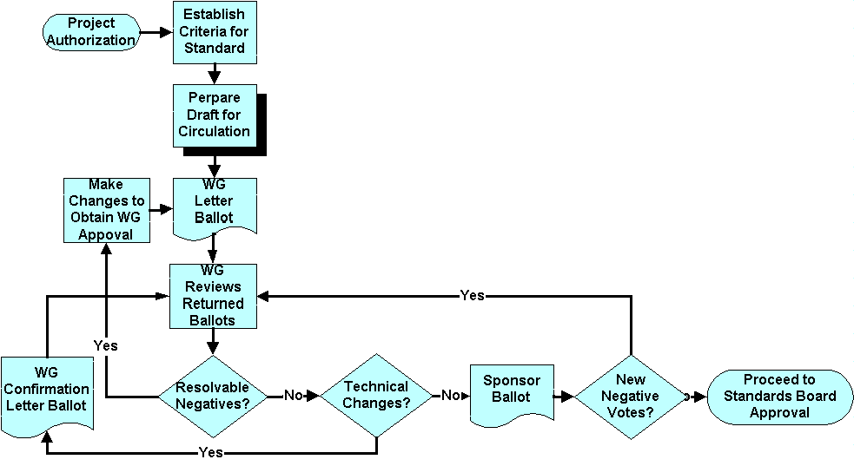
Figure 4, the process of establishing a Standard
As of Nov99
Figure 4 shows the process for creating, reviewing and submitting a Draft Standard to the IEEE Standards Board. At the beginning is the Project Authorization (PAR) that was discussed above. Once that is done, the PAR and 5 (or 6) criteria are used to generate a document that concisely states the criteria upon which any proposed standard will be judged.

The next step is the actual creation of the document to be reviewed. The source of the document may be either as an invention of the WG (as was done in P802.11) or the adoption of an existing industry specification. As mentioned above, the WG elected to adopt the Bluetooth™ Specification as the base for its Standard.
Once the WG is satisfied that the Draft Standard (as it is now called) is reasonably close to an acceptable state, it is distributed among the members of the WG to be reviewed. This initial review period lasts for 30 days and culminates in an electronic vote. The members have three options for their votes:
- Abstain
- Approve
- Do Not Approve

Abstention neither counts for or against the Draft. If the number of Approval votes is greater than 70% of the total of the non-abstentions, the Draft is eligible to go to the next stage. The WG may choose not to forward the Draft, however. As part of any “Do not Approve” vote, voters must specify not only what specific items that they object to and what changes in the Draft would need to be made to have it meet their approval. These objections, referred to as “comments”, require resolution.

The WG must review all ballots and respond to every negative vote of a technical nature. Each comment is “resolved” by either agreeing with the comment and changing the Draft or declining the comment and responding to the reviewer in writing why the change they suggest will not be applied. After delivery of any declined comments, one of the comment resolution team members contacts the reviewer and inquires whether the answer to the comment is acceptable. If so, the objection is dropped. If not, the comment and the reply are recorded in a document that travels with the Standard throughout the review process. All subsequent reviews of the Draft will include this entry.
Once all the ballots have been reviewed and appropriate changes have been made, the text of the Draft is inspected to ascertain if any technical changes have been made. If that is the case, the Draft must be resubmitted to the WG for a confirmation ballot. Confirmation ballots only consider things that have changed during the course of comment resolution. All other text is subject only to editorial changes. The period of time for a confirmation ballot is typically 10 days, although it may be longer if large or complex changes have been made to the Draft.

Once the WG is satisfied with the Draft, it forwards it on to its first general public review, the Sponsor Ballot. Up until this point membership in the WG was required to have access to the Draft. With Sponsor Ballot the larger technical community reviews the Draft in much the same manner as the WG. Any negative votes with comments are handled in the same way as with the internal WG votes, with any unresolved comments being appended to the Draft.

A 70% approval by the sponsor ballot allows it to be forwarded to the IEEE Standards Board, which has a final review of the Draft and all the procedure documents associated with it. Unless significant procedural errors are found or an egregious error is uncovered the Standards Board will approve the Draft as an official IEEE Standard.

Conclusion
The process of creating a new Standard is a long, involved, but understandable process. The openness and peer review offered by the process help to create better standards, even if they often take longer than a group of individuals or companies working in private.

Wireless Personal Area Networks will proliferate early in the next millennium and the IEEE P802.15 Working Group for Wireless Personal Area Networks (WPAN's) is providing the leadership in the IEEE 802 Standards Committees to establish open standards for these WPAN's.

The first Standard derived by P802.15 from the Bluetooth™ v1.0 A Foundation Specification is addressing the requirements for Wireless Personal Area Networking (WPAN) for a new class of computing devices. This class, collectively referred to as pervasive computing devices includes, PCs, PDAs, peripherals, cell phones, pagers and consumer electronic devices to communicate and interoperate with one another. The Authors anticipate that this standard will be approved by the IEEE Standards Board on or before December 2000. Just in time for the millennium i.e., 2001-2100 is the true millennium. The P802.15 Working Group is paving the way for Personal Area Network Standards that will be - Networking the World™.

Acknowledgements
The IEEE P802.15 Working Group has been supported by numerous organizations and individuals during the last two (2) years - to all of you thanks. The Authors would also like to personally thank our IEEE Sponsors Jim Carlo, Chair 802 and Vic Hayes, Chair P802.11 who have contributed much to our understanding of the IEEE legacy as well as the future of the IEEE.

More information:
http://grouper.ieee.org/groups/802/15/index.html
http://www.bluetooth.com/

References

[1] "Bluetooth™ Architecture and Overview", Jaap Haartsen, IEEE Personal Communications, The Magazine of Nomadic Communications and Computing - Special Issue on Short-Range Connectivity, February 2000.
[2] "Specifications of the Bluetooth™ System, Volume 1 v1.0 A 'Core' and Volume 2 v1.0 A 'Profiles', Bluetooth™ Special Interest Group, July 26, 1999.

Biography

Tom Siep was born in Denver, Colorado, USA. He is a Group Member Technical Staff in the Wireless Communications Business Unit of Texas Instruments. He has responsibility for coordinating Short Distance Wireless communications Research and Development. Tom earned a Bachelors degree in Management from the University of California a Fullerton and a Masters in Information Systems from the University of Texas at Dallas. He has twenty-five years experience in many facets of communications and information systems. In the last fifteen years Tom has championed the cause of Local Area and Personal Area Wireless communications at TI by providing technical leadership in the implementation of several pilot wireless communications systems for TI customers and through his IEEE Standards participation. He is also currently the Chief Technical Editor for the IEEE 802.15 standardization of portions of the Bluetooth™ Specification. His e-mail address is siep@ti.com.

Ian Gifford was born in Framingham, Massachusetts, USA. He received a Bachelors in Economics from Boston University, Boston Massachusetts, USA, in 1981. He is Vice Chair of the IEEE P802.15 Working Group for WPANs and Director of Standards at M/A-COM, Inc. a Tyco Company, in Lowell, Massachusetts, USA. For the past 15 years he has worked on wireless solutions for wide area, local area and personal area networks. His e-mail address is giffordi@tycoelectronics.com.

Dick Braley was born in Birrmingham, Alabama, USA. He received his Bachelors and Masters Degrees in physics from Case Institute of Technology in Cleveland, Ohio. He is the ex-Chair of the IEEE P802.11 Wireless Personal Area Network (WPAN) Study Group, and Manager of Systems Design and Development in the Courier Technology Department at FedEx in Memphis, Tennessee, U.S.A. He initiated the WPAN standards development activity within the IEEE in 1997 and has played a key role in championing the WPAN efforts within the P802.11 Working Group. At FedEx, his primary responsibilities are in the wireless systems development area, developing wearable computing system networking for support of courier technologies and providing a wide range of wireless technologies to help differentiate FedEx from its competitors. His e-mail address is rcbraley@fedex.com.

Bob Heile was born in Chicago, Illinois, USA. He received his Bachelor of Arts from Oberlin College, Oberlin, Ohio in 1966 and his Masters and Ph.D. in Physics from The Johns Hopkins University, Balitimore, MD in 1973. He is Chair of the IEEE P802.15 Working Group for WPANs and Vice President of Emerging Business Planning with GTE's Technology Organization, in Waltham, Massachusetts. He was Vice Chair of the P802.11 WPAN Study Group leading to the formation of P802.15. For the past 15 years he has worked on wireless solutions for wide area, local area and personal area networks. His e-mail address is bheile@bbn.com .

Disclaimer
This article represents the views of the authors and does not necessarily reflect the official policies or practices of the IEEE. It also does not necessarily reflect the official company positions of the author’s employers.

-EOF-

IEEE P802 celebrates its 20th anniversary this year. The IEEE 802 Local and Metropolitan Area Network Standards Committee has the basic charter to create, maintain, and encourage the use of IEEE/ANSI and equivalent IEC/ISO JTC 1 standards primarily within layers 1 and 2 of the OSI (Open System Interconnection) Reference Model. The committee has met at least three times per year as a Plenary body ever since it was formed in February 1980.
More information about the WLAN Working Group is available at http://grouper.ieee.org/groups/802/11/index.html
See http://www.homerf.org
There are many of them, see http://www.ieee.org
This class of devices includes laptop computers, cellular telephones, Personal Digital Assistants (PDAs), Handheld Personal Computers (HPCs), microphones, speakers, headsets, bar code readers, sensors, displays, pagers, among others.
Source: http://grouper.ieee.org/groups/802/15/pub/Proposals.htm
The old saying is “Lovers of the Law and lovers of sausage have something in common: neither should see either being made.”
An optional Bluetooth™ interface that is not in the P802.15 standard.
Having to do with how the protocol works, not editorial issues such as style.

