IEEE P802.15
Wireless Personal Area Networks

Project | IEEE P802.15 Working Group for Wireless Personal Area Networks (WPANs)
Title | IEEE Personal Communications Magazine
Date Submitted | [27, August 1999]
Source | [Ian C. Gifford]  [M/A-COM, Inc.]  [1011 Pawtucket Boulevard Lowell, MA 01853-3295 USA] | Voice: [+1 978 442 4650]  Fax: [+1 978 442 5442]  E-mail: [giffordi@amp.com]
Re: | Submission
Abstract | [Wireless personal area networks will proliferate early in the next millennium and the IEEE P802.15 Working Group for Wireless Personal Area Networks (WPAN's) will provide the leadership in the IEEE 802 Standards Committees to establish open standards for these WPAN's. The IEEE P802.15 Working Group for WPANs will develop Wireless Personal Area Network standards for short-range wireless networks. The Working Group is cognizant of emerging industry specifications, viz., Bluetooth, HomeRF, etc. and realizes that it is important to build on the work of these groups as they enjoy significant market interest and industry participation. One of the primary motivations for this Working Group is to ensure the best use of a shared medium. This article will describe some of the known candidate radio transmission technologies that the Working Group, via open solicitations, peer review, and formal balloting, will choose from as their draft standard(s). The Authors believe that the IEEE 802 Committee provides the best forum for the development of consensus open standards and that this process will provide for rock-solid, market-accepted WPAN technologies.]
Purpose | [In early 1999 the IEEE P802.11 Study Group on WPANs was approached to participate and prepare a Paper for the IEEE Personal Communications Magazine Special Issue of the IEEE Personal Communication Systems on Connectivity for Pervasive Computing Devices. This is the draft that was submitted on 31Aug99.]
Notice | This document has been prepared to assist the IEEE P802.15. It is offered as a basis for discussion and is not binding on the contributing individual(s) or organization(s). The material in this document is subject to change in form and content after further study. The contributor(s) reserve(s) the right to add, amend or withdraw material contained herein.
Release | The contributor acknowledges and accepts that this contribution becomes the property of IEEE and may be made publicly available by P802.15.

Abstract

Wireless personal area networks will proliferate early in the next millennium and the IEEE P802.15 Working Group for Wireless Personal Area Networks (WPAN's) will provide the leadership in the IEEE 802 Standards Committees to establish open standards for these WPAN's. The IEEE P802.15 Working Group for WPANs will develop Wireless Personal Area Network standards for short-range wireless networks. The Working Group is cognizant of emerging industry specifications, viz., Bluetooth, HomeRF, etc. and realizes that it is important to build on the work of these groups as they enjoy significant market interest and industry participation. One of the primary motivations for this Working Group is to ensure the best use of a shared medium. This article will describe some of the known candidate radio transmission technologies that the Working Group, via open solicitations, peer review, and formal balloting, will choose from as their draft standard(s). The Authors believe that the IEEE 802 Committee provides the best forum for the development of consensus open standards and that this process will provide for rock-solid, market-accepted WPAN technologies.

Paving The Way for Personal Area Network Standards: An Overview of The IEEE P802.15 Working Group for Wireless Personal Area Networks.

Richard C. Braley, Federal Express Corporation
Ian C. Gifford, M/A-COM, Inc.
Robert F. Heile, GTE Technology Organization

Introduction

In March 1999 the IEEE 802 Local and Metropolitan Area Network Standards Committee formed a new Working Group to develop standards for Wireless Personal Area Networks for portable and mobile computing devices. Portable and mobile computing devices are defined as unobtrusive computing devices, networking devices, software and peripherals which are worn or carried by individuals to enhance their ability to perform productive work as well as provide entertainment.

The new group is designated Project 802.15 Working Group for Wireless Personal Area Networks (WPANs). The Standards created by P802.15 will address the requirements for wireless personal area networking of a new class of computing devices. This class, collectively referred to as pervasive computing devices includes, PCs, PDAs, peripherals, cell phones, pagers and consumer electronic

devices to communicate and interoperate with one another.

The P802.15 Working Group intends to work closely with Special Interest Groups such as Bluetooth and Industry Consortia namely HomeRF. The Working Group will also solicit industry input, in general, on market requirements and technical solutions for a WPAN with 0 to 10 metre range, data rates of less than 1Mbit/s, low power consumption, small size (less than 0.5 cubic inches) and low cost relative to target device. The goal is to create standards that have broad market applicability and deal with the issues of coexistence and interoperability.

The formation of the P802.15 Working Group marked the end of a year of intensive work as a Study Group under the sponsorship of P802.11, the Working Group for Wireless Local Area Networks. Being a part of P802.11 was very helpful in drafting the Project Authorization Request (PAR) leading to the decision to establish P802.15. The two groups are committed to working closely with one another in the standards development process.

In March 1999 the IEEE 802 Local and Metropolitan Area Network Standards Committee formed another Wireless Working Group - P802.16 Broadband Wireless Access (BWA).

IEEE 802 Wireless Working Group Positioning

The positioning of these newly formed wireless Projects e.g., P802.15 and P802.16 vs. the existing P802.11 has been discussed. In terms of data rate vs. mobility the following graphic Figures 1 & 2 have been discussed in P802.15 Working Group.

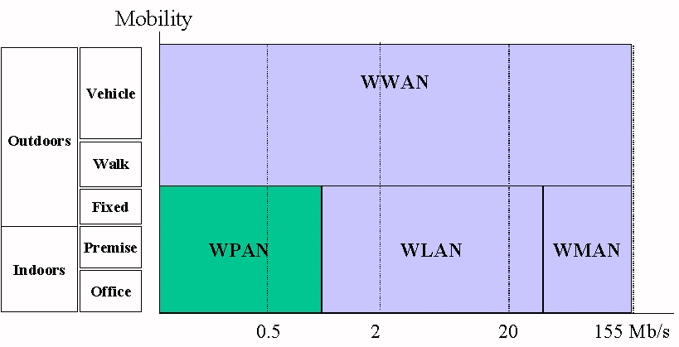
Figure 1 Wireless WAN to WPAN vs. Data Rates and Mobility Chart
Figure 1 describes the various "wireless" geographic terms e.g., Wide Area Networks, Metropolitan Area Networks, Local Area Networks and Personal Area Networks and their respective data rates vs. mobility.

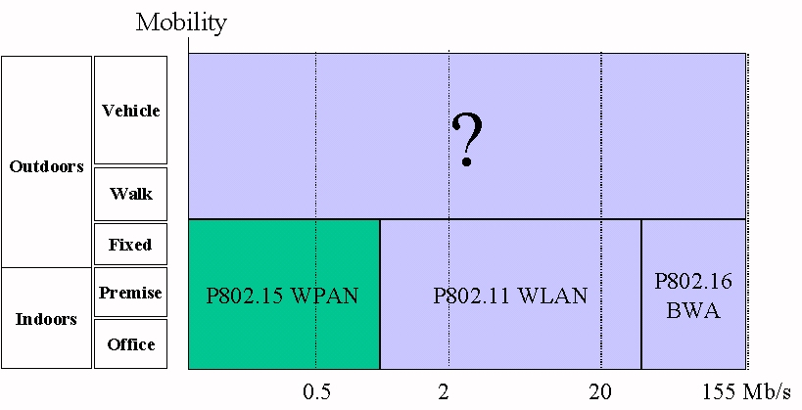
Figure 2 IEEE 802 Wireless Standards Positioning vs. Data Rates and Mobility Chart

Figure 2 positions the various IEEE 802 "wireless" Working Groups e.g., P802.16 Broadband Wireless Access (BWA) a.k.a. Metropolitan Area Networks, P802.11 Local Area Networks and P802.15 Personal Area Networks and their respective data rates vs. mobility.

IEEE P802.15 Working Group Sponsor

The IEEE P802.15 Working Group is a standards working group on WPAN and is sponsored by the IEEE 802 LMSC. The IEEE 802 Local and Metropolitan Area Network Standards Committee has the basic charter to create, maintain, and encourage the use of IEEE/ANSI and equivalent IEC/ISO JTC 1 standards primarily within layers 1 and 2 of the OSI (Open System Interconnection) Reference Model. The committee has met at least three times per year as a Plenary body ever since it was formed in February 1980. An explicit objective since inception has been the goal of establishing international standards in JTC 1. The IEEE series of standards are known as IEEE 802.xxx and the JTC 1 series of equivalent standards are known as ISO/IEC 8802-nnn. In the IEEE 802 context "local" means campus and "metropolitan" means intracity.

The IEEE 802 LMSC is sponsored by the IEEE Computer Society and submits standards through the IEEE Standards Association. The IEEE Computer Society is the oldest and largest association of computer professionals in the world. It offers its 100,000 members comprehensive program of publications, meetings, and technical and educational activities, encouraging an active exchange of information, ideas, and innovation. The society is the world's leading publisher of technical material in the computing field. Headquartered in Washington, DC, the society serves its members from offices in Los Alamitos, California, USA; Tokyo, Japan; and Brussels, Belgium.

The Need for Standards

In the last few years, the communications industry has witnessed explosive growth in mobile computing and related communications areas. The fact that the Bluetooth SIG has over one thousand (1,000) Adopters further amplifies the directions that will be taken by the users and manufacturers of mobile technologies over the next few years. As the user community for mobile computing continues to grow and the variety of such devices proliferates, the need for standards becomes obvious. Driven by the need for mobile communications in service industries, maintenance and training organizations and a very mobile work force, as well as a whole host of other applications, the user community will be demanding standards-based technologies because they will likely result in:

- Multiple suppliers of the technologies and services to enhance competition
- Cost-effective devices, services and implementation
- Open systems for interoperability, and ease of use
- Standard interfaces
- World-wide acceptance of standards-based technology

These benefits clearly demonstrate the need for standards in an environment that faces growth patterns that may even exceed that of the cellular phone market. In addition to the growth in the business community, personal use of mobile computing technologies will also likely witness explosive growth. Interoperability between mobile computing devices in a nomadic society where laptops, cell phones, palmtops, and similar “wearable” technologies enhance productivity and will provide seamless communications for the public, support the need for standards for the WPAN that will provide the basis for the network connectivity required to support highly moblie services. In fact, these thoughts provided the impetus to initiate the activity to develop IEEE standards for the WPAN.

History of the Evolution of IEEE P802.15

The chain of events leading to the formation of IEEE P802.15 began in June 1997 when the IEEE Ad Hoc "Wearables" Standards Committee was initiated by one of the Authors [RCB] during an IEEE Standards Activities Board (SAB) meeting. According to Braley, the purpose of the Committee was to "encourage development of standards for wearable computing and solicit IEEE support to develop standards." The consensus recommendation to Braley from those that attended the SAB meeting was that he bring his request to encourage such standards development to the IEEE Portable Applications Standards Committee (PASC).

During the PASC Plenary Meeting in July 1997, an IEEE Ad Hoc Committee was assembled (17 attendees) to discuss "Wearables" Standards. The Committee identified several areas that could be considered for standardization, including short range wireless networks or Personal Area Networks (PANs), peripherals, nomadicity, wearable computers, and power management. Of these, the committee determined that the best area of focus was the Wireless PAN because of its broad range of application. The IEEE Ad Hoc "Wearables" Standards Committee met twice more – once in December 1997 and again in January 1998. During the January 1998 meeting it was agreed that the 802 LAN/MAN Standards Committee (LMSC) was probably a more suitable home for the groups activities, especially with a PAN focus. Two delegates were sent to the IEEE P802.11 Interim Meeting, that was taking place that same month, to get reactions and to gain support for the proposal. At that meeting it was agreed to propose the formation of a Study Group under P802.11 at the March Plenary of 802. A WPAN Tutorial was organized to socialize the idea within 802. The result was that in March 1998, the "Wearables" Standards Ad Hoc Committee under PASC became the IEEE P802.11 Wireless Personal Area Network (WPAN) Study Group within LMSC with the goal of developing a Project Authorization Request (PAR) for the development of a WPAN standard.

At the time the Study Group was formed, there had been no other publicized initiatives in the WPAN space other than IrDA, the Infrared Data Association, which, because of its line-of-sight restrictions, did not adequately address the problem. By the time the work of the Study Group concluded, a year later, both the Bluetooth Special Interest Group and HomeRF were active in developing WPAN specifications. By March 1999, when the Study Group and P802.11 submitted the PAR to the 802 Executive Committee for approval, Bluetooth had over 600 adopter companies and HomeRF had over 60. Because of the significance of these groups in the WPAN market space, it was felt that the standards development process would be better served if a new Working Group were formed to address the problem rather than attack it as a Task Group under P802.11. The PAR was approved and the new group was designated as IEEE P802.15 Working Group for Wireless Personal Area Networks.

Current Status

During the July 1999 Plenary of the IEEE 802 the P802.15 Working Group had its first session. There were sixty-three (63) attendees over the week long meeting and thirty-nine (39) Working Group attendees achieved Voting Member status.

The Operating Rules of IEEE Project 802 Working Group P802.15 were reviewed and approved. The provisional officers were elected for the balance of the term and approved by the 802 Executive Committee. A Study Group was formed to make a recommendation on how to best deal with coexistence and draft a PAR if appropriate. A Marketing Committee was formed to advise on how to best position our activities and to provide insight on what the market really wants. Finally we formed a Task Group to begin the work of rapidly developing our first draft standard. The Task Group is designated Task Group 1 (TG1) and was formed as a direct result from the Bluetooth Special Interest Group submission.

The Authors believe the Montreal Meeting was a successful meeting. The Working Group received a total of thirty-three (33) submissions and/or documents; all of these were posted to the P802.15 Working Group Web Site.

WPAN Requirements

The P802.15 Task Group 1 (TG1) Functional Requirements are evolving. As such the Authors have provided an overview of the Functional Requirements and it is to be understood that these requirements will be expanded in the near future once the TG1 Draft Standard is submitted.

Personal Area Networks

A Personal Area Network (PAN) is distinguished from other types of data networks in that communications are normally confined to a person or object that typically extends up to 10 meters in all directions and envelops the person whether stationary or in motion. The term Personal Operating Space (POS) is also used interchangeably.

Wireless Personal Area Network

A Wireless Personal Area Network (WPAN) is a wireless ad hoc data communications system which allows a number of independent data devices to communicate with each other. A Personal Area Network is distinguished from other types of data networks in that communications are normally confined to a person or object that typically extends up to 10 metres in all directions and envelops the person whether stationary or in motion. This is in contrast to Local Area Network (LAN), Metropolitan Area Network (MAN), and Wide Area Network (WAN) which are moderately sized geographic area, such as a single building, campus, city, or that may interconnect facilities in different parts of a country or of the world.

The worldwide 2.4 GHz Industrial, Scientific, Medical shall be the frequency of interest for WPANs. It is noted that there are efforts at harmonizing the spectrum allocation such that there is a minimum of 83.5 MHz worldwide.

Piconet network

A Piconet a.k.a. ad hoc network is a network composed solely of stations within mutual communication range of each other via the wireless medium. A Pico network is typically created in a spontaneous and unobtrusive manner. The principal characteristic of a Piconet network is its limited temporal and spatial extent.

These limitations allow the act of creating and dissolving the Piconet network to be sufficiently straightforward and convenient so as to be achievable by non-technical users of the network facilities (i.e. no specialized 'technical skills' are required with little and/or no investment of time or additional resources required beyond the stations which are to participate in the WPAN network).

Connected Devices

WPANs shall be capable of supporting at least seven (7) connected devices in a Piconet. Additionally, a Scatternet, which is to say multiple independent and non-synchronized piconets, can be formed. Thus each Piconet shall have eight (8) logical channels but the connected devices can be quite large due to Scatternets. [1]

Transmission Rates

The transmission rate over WPANs shall be less than 1Mbit/s. The scatternet can achieve an aggregate throughput of over 10 Mbit/s or 20 voice channels within a fully expanded scatternet.[1]

Distance

PANs shall be capable of operating over an area up to 10 metres in diameter. To support other uses, for example the home environment, the PAN can extend the range (up to 100m). This scatternet structure also makes it possible to extend the radio range by simply adding additional Bluetooth units acting as bridges at strategic places.[1]

Addition and Removal of Devices

WPANs shall be designed such that user data devices and medium access units can be easily added or removed. The connection of data devices to, or the disconnection of data devices from, the PAN shall not introduce a transient fault lasting more than one second.

These WPAN Functional Requirements anticipate the requirements of the P802.15 Task Group 1 draft standard. The Functional Requirement Document will be revised further.

Why Not P802.11 ?

In June, 1997, the IEEE Standards Board approved the IEEE P802.11 Standards for Wireless Local Area Networks (WLAN’s). As indicated earlier in this article, the IEEE P802.11 WPAN Study Group was sponsored by P802.11 because it seemed to be the most natural fit at the time, based on the knowledge base of the members. However, as a result of the Ad Hoc Committee activities and the ensuing activities of the WPAN Study Group, it became apparent that a new Working Group would be required. In the paragraphs to follow, the rationale for not selecting the IEEE P802.11 Standard for WPAN’s will be clarified.

As noted in the previous section, the WPAN requirements that resulted from numerous SG meetings and Calls for Applications clearly are intended for shorter range, lower data rates, and are more severely impacted by power consumption. After numerous efforts to develop an acceptable technical approach for the WPAN Standard, the Protocol Implementation Conformance Statement (PICS) was reviewed with the intent of making acceptable modifications to satisfy the WPAN requirements and still remain within the P802.11 Working Group. Even with the reduction of MAC sublayer protocol capabilities and PHY layer capabilities, it was concluded that the P802.11 WLAN Standards would not be acceptable for WPAN standards. There continues to be on-going discussions regarding an P802.11 Lite version that may be acceptable for WPAN’s. If such a standard is forthcoming, and is determined to be acceptable to P802.15, then it could be introduced via PAR and considered for standardization.

The Authors note that in the WPAN Study Group investigation of the P802.11 MAC sublayer, as it applies to WPAN applications, the Authors were advised that a number of changes to the P802.11 MAC sublayer needed to be made. Specifically:

- Providing stations with the ability to rotate the Access Point responsibility, including a mechanism that will recognize when an Access Point is lost
- Adding power management modes to the Access Point
- Removing the Request To Send/Clear To Send handshake
- Significantly slimming the Management Information Base, an
- Eliminating support for Independent Basic Service Set

These changes would extend the current capabilities of P802.11 and simplify the implementation of P802.11 stations. However, the Authors are not aware of any submissions to the P802.15 Working Group from P802.11 Working Group.

In conclusion, it is essential that mobile computing devices be as power efficient as possible. This is consistent with the short range requirement for WPAN and many other characteristics. The evaluation of the WPAN Study Group clearly implied to the Study Group leadership that IEEE P802.11 was not the correct solution for WPAN, and as a result the request was made to move along a different path that resulted in the formation of the IEEE P802.15 Working Group.

Coexistence and Interoperability Issues

The issue of coexistence is one of the more vexing problems that must be addressed when dealing with a shared medium such as an ISM (Industrial, Scientific, Medical) band. In a wired environment or in a licensed band, there is only a single use. The issue is one of interoperability which will be discussed in more detail later. In ISM bands both Primary and Secondary uses are allowed. Secondary uses are unlicensed, but must follow certain rules e.g., FCC 47 C.F.R. Part 15, etc. relating to total radiated power and the use of spread spectrum modulation schemes. Interference among the various uses is not addressed as long as the rules are followed. The attractiveness of operation in an ISM band is the fact that no license is required. The downside is the fact that the bands must be shared and potential interference tolerated.

Under normal circumstances, interference is not a major problem. The spread spectrum and power rules are fairly effective in dealing with multiple users in these bands provided the radios are physically separated. Multiple uses, including self-interference of multiple users of the same application, have the effect of raising the noise floor in the band resulting only in some degradation of performance. When the radios of different applications are operating in the same band and are in close proximity, the picture is somewhat different. Transmitters close to other receivers can easily saturate the receiver front ends effectively shutting down operations.

Because of its almost global availability, a popular band for WPANs is the 2.4 GHz ISM band. Microwave ovens are a primary user of the band at 2.45 GHz. In addition, P802.11 has standards for WLANs operating in this band, and HomeRF, Bluetooth and several cordless phone manufacturers are planning to operate there as well. With modest physical separation of the radios, initial studies indicate that all these applications can coexist with some degradation in performance. However, a major problem arises because P802.11 devices, HomeRF devices and WPAN devices will likely all come together in a Laptop and may come very close together at a desktop. Without some careful planning things will not work forcing the marketplace to weed out solutions that have not adequately addressed the problem. Within 802, addressing coexistence between P802.15 WPANs and P802.11 WLANs has been mandated by the Executive Committee.

At a different level is the issue of interoperability. There are two classes of interoperability. The first is ‘intra-standard’ interoperability. It is important that two devices that conform to the P802.15 standard interoperate with one another at the Physical Layer. The second is ‘inter-application’ interoperability. It may also be desirable to have WPAN and WLAN or other devices interoperate at some higher layer. The issues of coexistence and interoperability are related as shown in Figure 3.

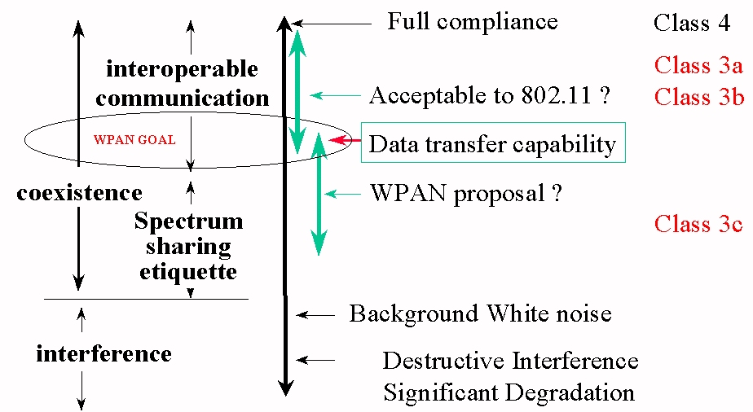
Figure 3 Coexistence/Interoperability Continuum

The various classes of interoperability are defined in the bullet list below.

WPAN Interoperability Classes
- Class 4 - Full Compliance to the P802.11 MAC & PHY PICS
- Class 3 - Partial Interoperability: there is a way on the medium to exchange data without an intermediate device
- Class 3a Transmit and Receive
- Class 3b Receive Only
- Class 3c Detect Energy
- Class 2 - Bridge-like (1 MAC/2 PHYs)
- Class 1 - Gateway-like (> 1 MAC)
- Class 0 - Non Interoperable

Devices that interoperate can coexist since they are able to exchange information and are aware of the others operation. The degree of coexistence is dependent on the degree of interoperability. Fully interoperable implies the highest degree of coexistence. At a basic level, energy detect, or listen-before-talk is more etiquette oriented and permits close proximity coexistence at reduced performance levels. In the absence of more effective schemes, the default would be to let an application deal with the problem at higher layers, but this is sure to be performance inefficient.

Bottom line, coexistence is an issue that must be dealt with especially when the Authors consider the number of embedded platforms like cell phones, laptops, PDAs, and pagers that will contain a successful WPAN standard and the likely proximity of these devices to WLANs and home networks. By comparison although inter-application interoperability is important, because it enhances the seamless network experience and simplifies the issues of coexistence, it is not a show-stopper. In an effort to deal more effectively with the problem, P802.15 is working on a coexistence Project Authorization Request. The goal is to create a series of reports describing the impact of a WPAN on a WLAN in the same vicinity, and visa versa and to develop a set of Recommended Practices for both the WPAN and WLAN to maximize coexistence. This work could result in some modifications or extensions to the WPAN and/or WLAN standards to improve coexistence.

The Tragedy of the Commons

The 2.4 GHz Industrial, Scientific, Medical (ISM) spectrum has a radio population problem which has no technical solution; it requires a fundamental extension in morality. Hence the tragedy. It is our considered professional judgment that the 2.4 GHz ISM spectrum or "commons" will require that the participants impose a set of additional rules for reducing the probability of interference in the 2.4 GHz general unlicensed band; a so called "Spectrum Etiquette".

The IEEE P802.15 Coexistence Study Group was formed during the July 1999 Plenary. The Study Group motion read: "To approve the formation of a Study Group within P802.15 to determine the need and if warranted, develop a PAR on coexistence for submission to the SEC by the November 1999 Plenary." The Authors believe this Study Group could be the vessel to recommend a set of additional rules for reducing the probability of interference in the 2.4 GHz general unlicensed band. The Study Group recommendation should be considered as a submission to the leading world Regulators e.g., FCC, CEPT, MPT, etc. and/or an IEEE Recommended Standard. Here are the various types of Standards Documents:

- Standard--mandatory (shall)
- Recommended Practice--suggested procedures (should)
- Guide--guidelines (may)

Perhaps the simplest summary of this 2.4 GHz ISM overpopulation problem is this: the commons, if justifiable at all, is justifiable only under conditions of low-population density. As the radio population has increased, the commons will have to be abandoned in one aspect after another. The introduction of rules to reduce the probability of interference in the 2.4 GHz general unlicensed band may be unpopular but they also may preserve the band and the original intent for unlicensed ISM communication devices.

New MAC and PHY Layers

The IEEE P802.15 Working Group's charter is to develop Medium Access Control sublayer and Physical layer standards for wireless Personal Area Networks based on [Carrier Sense Multiple Access/Collision Detect (CSMA/CD) protocol] or on [Carrier Sense Multiple Access /Collision Avoidance (CSMA/CA)] or [no qualification at all].

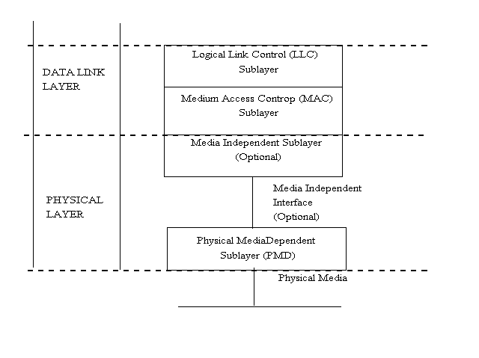
Figure 4 IEEE 802 Local and Metropolitan Area Network Model

The LAN/MAN Network Model shown in Figure 4 allows individual protocol and service layers to be replaced as needed without requiring changes in other protocols or service layers used to realize the desired LAN service.. The IEEE P802.15.1 Task Group understands that the intention of this LAN/MAN Network Model is to allow individual standards solutions to realize the desired network services. The Authors believe that the functional requirements of the PAN services will not be affected by this LAN/MAN Model. However, the Authors may need to initiate work in the P802.1 High Level Interface (HILI) Working Group and/or P802.2 Logical Link Control (LLC) Working Group to help facilitate this new network area into the 802 Family.

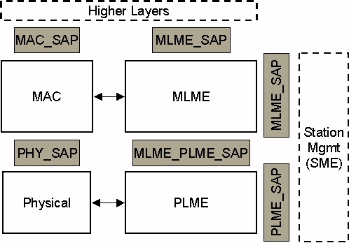
Figure 5 The P802.15.1 WPAN Network Model

Figure 5 describes the latest embodiment of the P802.15.1 Task Groups WPAN Network Model. As stated above the P802.11 MAC sublayer and PHY layer were reviewed but it appeared and stills appears to the IEEE P802.15 that the WPAN power requirements will not be met. Therefore, the IEEE P802.15 Working Group has begun to review the issues related to deriving a standard from an industry specification.

In Figure 6 the Authors are describing the Bluetooth to IEEE correspondence at the lower layers.

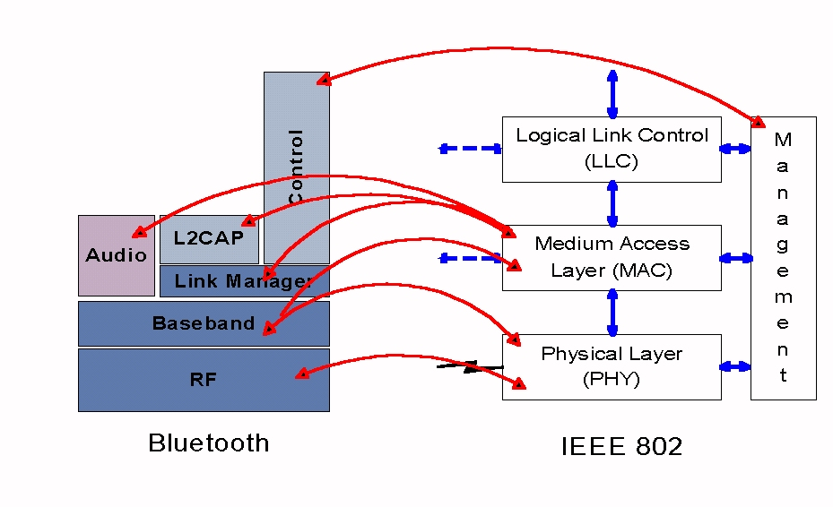
Figure 6 Bluetooth/IEEE P802.15.1 Correspondence

The Authors believe that the first WPAN Draft Standard will have a new MAC sublayer and PHY layer and that they will be derived from the Industry work done in the Bluetooth Special Interest Group.

Existing Options for Standardization

The IEEE P802.15 has been reviewing Industry as well as Standards based solutions to try and not reinvent any wheels. To that end, the Authors have conducted numerous calls to actively solicit proposals as well as applications to help us identify candidate radio transmission technologies.

During the First Call For Proposals, May 1998 to March 1999, the IEEE received five (5) submissions - May1998: GTE Technology Organization, Intermec Technologies Corporation, M/A-COM, Inc. Proposals. July 1998: Motorola, Inc. Proposal. January 1999: Eastman Kodak Company Proposal. During the Second Call For Proposals, June 1999 to July 1999, the IEEE received one (1) submission - Bluetooth Special Interest Group. [Authors note: AmeriSys, Inc. provided an "application" proposal however the frequency of interest was 13.56 MHz and did not meet the WPAN Requirements. A WPAN-LR (Low Rate) Study Group is likely to evolve from this and other low rate applications.]

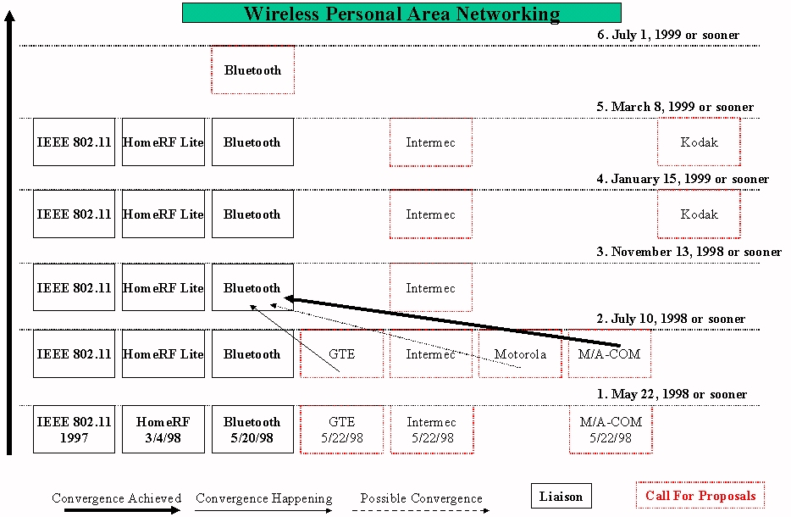
Figure 7 WPAN Roadmap

Figure 7 describes, over time, the incoming candidate proposals that the IEEE P802.15 Working Group has been reviewing. The Bluetooth proposal is actually a Letter Of Intent rather than an actual proposal or draft standard submission.

Additionally, the Authors are aware of WPAN interests in the IEEE P802.11 as well as external to IEEE e.g., AmeriSys, Inc. HomeRF WG, Personal Electronic Devices Inc. and XETRON Corporation.

The IEEE P802.15 also conducted a Call For Applications, July 1998 to November 1998, which provided eight (8) submissions - September 1998: Federal Express Corporation, The Boeing Company, Personal Electronic Devices Inc., Symbol Technologies Inc., Texas Instruments Inc. Applications. October 1998: Eastman Kodak Company Application. November 1998: AmeriSys, Inc. Application.

The introduction of additional WPAN draft standard submissions to the Working Group such as a "low rate" or "high rate" WPAN standard is likely and therefore we anticipate using the following nomenclature: (1) "WPAN" (Task Group 1 a Bluetooth derivation), (2) WPAN-Low Rate or "WPAN-LR", and WPAN-High Rate or "WPAN-HR". These terms will help differentiate the multiplicity of standards that the Working Group will entertain.

Selection of Bluetooth as The First P802.15 Standard

As noted in the previous section, and at the end of the Second Call For Proposals, the P802.15 Working Group received only one response - Bluetooth Special Interest Group.

One of the major goals for the IEEE P802.15 as well as for Bluetooth is global usage. While the WLAN technologies are specifically designed for devices in and around the office or home, a WPAN/Bluetooth device will travel from country to country, be used in cars, airplanes, boats and is truly designed for international use.

Because of this, much of the Bluetooth technology is focused on a single standard that meets the world-wide regulatory requirements that fall into two categories: spectrum/power and security. As the radio link will contain private business and personal data/voice, security is a requirement for this. As security is heavily regulated world-wide, the technology has to conform or work with the various world wide agents to insure it meets these requirements.

In regards to spectrum and power, the technology needs to travel with the user. Unlike a typical WLAN, that is setup in one area and never moved, mobile devices travel with the users. As such the technology needs to be designed such that a single technology meets the spectrum power requirements of the world (don't want to break the law when crossing a border).

These areas are key attributes of Bluetooth (which was designed for this personal area networking) which the Authors don't believe are addressed in the variety of WLAN devices.

Specifically, the Bluetooth Special Interest Group intends to submit their Specification for use by the IEEE P802.15 Working Group to develop the P802.15 technology. It is the desire of the Bluetooth SIG that the IEEE P802.15 standard maintain compatibility with Bluetooth specification in order to:

- Prevent consumer and user confusion that could result from non-interoperable specifications, and
- Provide a mechanism to test interoperability between Bluetooth and P802.15 solutions by maintaining appropriate testing interfaces.

The Bluetooth 1.0 A Foundation specification was made publicly available on July 26, 1999. The 1.0 specification includes an official “Bluetooth Specification Version 1.0 A Foundation Core” and “Bluetooth Specification Version 1.0 A Foundation Profiles.”
The Bluetooth Specification Version 1.0 A Foundation Core provides the details for creating products using the Bluetooth radio architecture. Where as, the Bluetooth Specification Version 1.0 Foundation Profiles provides the guidelines for ensuring interoperability between devices enabled with the Bluetooth technology.

The IEEE has signed a limited, non-exclusive, non-transferable license from the Bluetooth SIG to adopt or adapt and copy a portion of the Bluetooth Specification to be used as base material in the IEEE Standards Project P802.15, on the condition that the IEEE P802.15 standard is:

- 100% compatible with the Bluetooth 1.0 A Foundation Specification (as measured by a certified Bluetooth test house)
- Maintains and requires inclusion of Bluetooth testing interfaces as described in the current Bluetooth specification (to allow interoperability testing between Bluetooth and P802.15 compliant solutions)
- Any P802.15 extensions (beyond Bluetooth 1.0 specification) must not break interoperability with existing Bluetooth 1.0 certified radios and be approved by the Bluetooth SIG Promoters.

Therefore, the selection process was the Second Call For Proposals and the act of submitting a draft standard to the IEEE P802.15 will be the first step in the IEEE standardization process.

The authors understand that the Bluetooth SIG is currently in discussions with ETSI to develop a world-wide standard based on Bluetooth that covers the entire Bluetooth capabilities stack. Also if these discussions go forward, then the Bluetooth SIG would like ETSI and IEEE coordinates their efforts so that both standards interoperate. The IEEE feels a cooperative arrangement could be agreed to by both Standards Development Organizations. The Authors would envision IEEE carrying the ETSI standard so users could get both and the same for ETSI by having them carry the IEEE standard. Therefore, in the final analysis there would be only one (1) standard derived from the Bluetooth v1.0A Foundation Specification. In other words IEEE P802.15.1 is Bluetooth lower layers and ETSI is Bluetooth minus IEEE 802.15 standard. It is understood that compliance to the Bluetooth specification is determined by a Qualified Bluetooth Test House. Also that IEEE/ETSI document changes must not break this compliance. And finally the Bluetooth Qualification Review Board (BQRB) determines what compliance means.

Again, the Authors believe that the first WPAN Draft Standard will be derived from the Industry work recently completed in the Bluetooth Special Interest Group.

Conclusions and Future Directions

Wireless personal area networks will proliferate early in the next millennium and the IEEE P802.15 Working Group for Wireless Personal Area Networks (WPAN's) is providing the leadership in the IEEE 802 Standards Committees to establish open standards for these WPAN's.

The first Standard derived by P802.15 from the Bluetooth v1.0 A Foundation Specification is addressing the requirements for Wireless Personal Area Networking (WPAN) for a new class of computing devices. This class, collectively referred to as pervasive computing devices includes, PCs, PDAs, peripherals, cell phones, pagers and consumer electronic devices to communicate and interoperate with one another. The Authors anticipate that this standard will be approved by the IEEE Standards Board on or before December 2000. Just in time for the millennium i.e., 2001-2100 is the true millennium. The P802.15 Working Group is paving the way for Personal Area Network Standards that will be - Networking the World™.

For additional or more current information on the IEEE P802.15 Working Group for Wireless Personal Area Networks (WPANs) please point your Internet browser at: http://grouper.ieee.org/groups/802/15/index.html

Acknowledgments

This IEEE working group has been supported by numerous organizations and individuals during the last two (2) years - to all of you thanks. The Authors would also like to personally thank our IEEE Sponsors Jim Carlo, Chair 802 and Vic Hayes, Chair P802.11 who have contributed much to our understanding of the IEEE legacy as well as the future of the IEEE.

References

[1] "Bluetooth Architecture and Overview", Jon Inouye (Intel), IEEE Personal Communications Magazine, Special Issue of the IEEE Personal Communication Systems on Connectivity for Pervasive Computing Devices

Biographies

Dick Braley [birth & education?] He is the ex Chair of the IEEE P802.11 Wireless Personal Area Network (WPAN) Study Group, and Manager of Systems Design and Development in the Courier Technology Department at FedEx in Memphis, Tennessee, U.S.A. He initiated the WPAN standards development activity within the IEEE in 1997 and has played a key role in championing the WPAN efforts within the P802.11 Working Group. At FedEx, his primary responsibilities are in the wireless systems development area, developing wearable computing system networking for support of courier technologies and providing a wide range of wireless technologies to help differentiate FedEx from its competitors. His e-mail address is rcbraley@fedex.com.

Ian Gifford was born in Framingham, Massachusetts, USA. He received a Bachelors in Economics from Boston University, Boston Massachusetts, USA, in 1981. He is Vice Chair of the IEEE P802.15 Working Group for WPANs and Director of Standards at M/A-COM, an AMP Division, in Lowell, Massachusetts, USA. For the past 15 years he has been focusing on Wireless LANs, MANs, and WANs. His e-mail address is giffordi@amp.com.

Bob Heile [birth & education?] He is Chair of the IEEE P802.15 Working Group for WPANs and Vice President of Emerging Business Planning with GTEís Technology Organization, in Waltham, Massachusetts. He was Vice Chair of the P802.11 WPAN Study Group leading to the formation of P802.15. For the past 15 years he has worked on wireless solutions for wide area, local area and personal area networks. His e-mail address is bheile@bbn.com.

