IEEE P802.15
Wireless Personal Area NetworksTM

Project | IEEE P802.15 Working Group for Wireless Personal Area NetworksTM (WPANs)
Title | TG2 Submission to Bluetooth SIGnal
Date Submitted | [June 8, 2000]
Source | [Steve Shellhammer]  [Symbol Technologies]  [One Symbol Plaza, MS B-2]  [Holtsville, NY 11742] | Voice: [(631) 738-4302]  Fax: [(631) 738-4618]  E-mail: [shell@symbol.com]
Re: | []
Abstract | [Text to be submitted to the Bluetooth SIG for incorporation to an upcoming issue of the Bluetooth SIGnal.]
Purpose | [For review and comment by member of IEEE 802.15 before submission to Bluetooth SIG.]
Notice | This document has been prepared to assist the IEEE P802.15. It is offered as a basis for discussion and is not binding on the contributing individual(s) or organization(s). The material in this document is subject to change in form and content after further study. The contributor(s) reserve(s) the right to add, amend or withdraw material contained herein.
Release | The contributor acknowledges and accepts that this contribution becomes the property of IEEE and may be made publicly available by P802.15.


WPANs™ − A Progress Report

One of the major concerns within the IEEE, and the wireless community in general, is the fact that Bluetooth™ and IEEE 802.11 both operate in the same 2.4 GHz Industrial, Scientific, and Medical (ISM) band. In addition, Bluetooth will be embedded within portable devices that are likely to be used in a facility that is equipped with an IEEE 802.11 Wireless Local Area Network (WLAN). Since both Bluetooth and the WLAN operate in the same band there will be some mutual interference between the two wireless networks. Because there has been concern regarding this mutual interference, the IEEE has established a Project within 802.15 called Task Group 2 (TG2) to address the issue of coexistence of these two wireless networks. The purpose of the Task Group is twofold. First, to develop what is being referring to as a Coexistence Model quantifying the effect of the mutual interference of the two wireless networks. Second, to develop Coexistence Mechanisms to facilitate coexistence of Bluetooth and IEEE 802.11 WLANs. Both the Models and the Mechanisms will be documented in an IEEE Recommended Practice.

The initial focus of the Task Group has been the development of the Coexistence Model. Multiple wireless devices are said to ‘coexist’ if they can be collocated without significantly impacting the performance of any of these devices. The final model, due March 2001, will consist of four major sections: Physical (PHY) Layer models, Medium Access Control (MAC) Layer models, RF Propagation models, and Data Traffic Models, as illustrated in Figure 1.

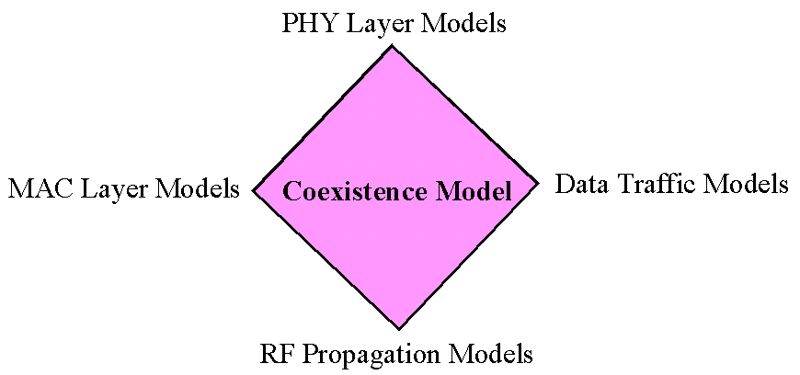

Figure 1: The Four Areas of the Coexistence Model

For example, one of the PHY Layer models will give the bit error rate (BER) of an IEEE WLAN, in the presence of a local Bluetooth Piconet. The higher-layer model will use the results of the PHY model, incorporate the Data Traffic Models and the WLAN MAC Model to quantify the impact of Bluetooth on the WLAN network parameters, like network throughput and latency. Similarly, the Task Group will model the impact of an IEEE 802.11 WLAN on Bluetooth.

The Task Group also plans to investigate the mutual interference of the High-Rate WPAN, being developed in Task Group 3, and both Bluetooth and an 802.11 WLAN. All the IEEE documents that have been presented at the Task Group 2 meetings can be found on the IEEE 802.15 web site.

Recently the Bluetooth SIG has established a Working Group on Coexistence. A liaison between TG2 and the Bluetooth Coexistence group has recently been established. The two groups are currently in the process of investigating opportunities for collaboration.

In order to encourage cooperation both the 802.15 WPAN Working Group and the 802.11 WLAN Working Group will vote on the Coexistence Recommended Practice.

Issue 6 of the Bluetooth SIGnal provided a progress report on the IEEE 802.15 Task Group 1 which is deriving a Wireless Personal Area Network standard based on the Bluetooth v 1.0 Foundation Specification. Bluetooth SIGnal Issue No. 8 will have an update on the activities of IEEE 802.15 Task Group 3, a Higher-Rate WPAN.

Dr. Stephen J. Shellhammer
Symbol Technologies, Inc.
Chairman IEEE 802.15.2
www.ieee802.org/15/

