IEEE P802.15
Wireless Personal Area Networks
Project | IEEE P802.15 Working Group for Wireless Personal Area Networks (WPANs)
Title | IEEE P802.15 Operating Rules
Date Submitted | [25 May 2000]
Source | [Tom Siep]  [Texas Instruments]  [12500 TI Blvd, MS 8723  Dallas, TX 75243] | Voice: [+1 214 480 6786]  Fax: [+1 972 761 5581]  E-mail: [siep@ti.com ]
Re: | [99001r6P802-15_Operating-Rules.doc, WPAN-Rules.doc, and WPAN-Rules.pdf]
Abstract | [IEEE P802.15 Operating Rules, as approved on 7Jul99 by the IEEE 802.15 WG for WPANs.]
Purpose | [These are the official rules of the IEEE Project 802.15 Working Group for Wireless Personal Area Networks™ the purpose of this revision is to identify internal and external rule changes and to keep the WG Rules up to date and accurate. Additionally, the Web Master will produce an online version of the rules once they are agreed to.]
Notice | This document has been prepared to assist the IEEE P802.15. It is offered as a basis for discussion and is not binding on the contributing individual(s) or organization(s). The material in this document is subject to change in form and content after further study. The contributor(s) reserve(s) the right to add, amend or withdraw material contained herein.
Release | The contributor acknowledges and accepts that this contribution becomes the property of IEEE and may be made publicly available by P802.15.


Operating Rules of IEEE Project 802 Working Group P802.15

Revised effective November 6, 2000

IEEE Project 802 Wireless Personal Area Network™ Working Group P802.15
Copyright (c) 2000 by The Institute of Electrical and Electronics Engineers, Inc.
3 Park Avenue, 17th Floor
New York, New York
10016-5997 U.S.A.
All rights reserved.

Contents
1. Overview 6
2. Working Group 6
2.1. Function 6
2.2. WG Officers 7
2.3. WG Advisory Core 8
2.4. WG Membership 9
2.5. Operation of the WG 10
2.6. Submission of Papers Error! Bookmark not defined.
2.7. WG Balloting 18
3. Task Groups 19
3.1. TG Function 19
3.2. TG Officers 19
3.3. TG Membership 20
3.4. Operation of the TG 20
3.5. Deactivation of a TG 22
4. Study Groups 22
4.1. Function 22
4.2. Formation 23
4.3. Continuation 23
4.4. Study Group Operation 23
5. Maintenance 24
6. Inquiries/Interpretations 24
7. Procedures 24
7.1. Overview of the Project Process 24
7.2. Call for interest Error! Bookmark not defined.
7.3. Study Group 25
7.4. Task Group 25
7.5. Working Group Ballot 25
7.6. Sponsor ballot 27
7.7. Standards Board Approval 28
7.8. Publication 28
8. Recommended Activities for WG Officers and Appointees 29
8.1. Chair 30
8.2. Vice Chair 32
8.3. Attendance Recorder 32
8.4. Document Coordinator 33
8.5. Meeting Coordinator (Local Host) Error! Bookmark not defined.

References

- Operating rules of IEEE Project 802, LAN MAN Standards Committee (LMSC)
http://grouper.ieee.org/groups/802/rules.pdf
- IEEE Standards Companion
http://standards.ieee.org/guides/companion/
- IEEE Standards Operations Manual
http://standards.ieee.org/sa/sa-om-main.html
- IEEE Standards Board Bylaws
http://standards.ieee.org/sa/sa-bylaws-main.html
- Overview & guide to IEEE 802 / LMSC
http://grouper.ieee.org/groups/802/overview2000.pdf
- IEEE 802 LMSC Guidelines
http://grouper.ieee.org/groups/802/chairguides.pdf

Please note that these documents may be revised periodically. The latest edition will be made available at the IEEE Standards website at no charge. The documents on the IEEE Standards website are considered to be the definitive version (http://standards.ieee.org/guides/index.html). For further information, contact the IEEE Standards Department, 445 Hoes Lane, Piscataway, NJ 08855-1331, USA.

Overview
The 802.15 Working Group (WG) for Wireless Personal Area Networks™ (WPANs™) develops Personal Area Network standards for short distance wireless networks under the auspices of the IEEE Project 802 LAN/MAN Standards Committee (P802 LMSC). The 802.15 WG is one of several working groups reporting to the P802 LMSC. The 802.15 WG operates under the Operating rules of IEEE Project 802 ( ref [1]) and the hierarchy of rules under which IEEE Project 802 operates. In the event of any conflict between the Operating Rules of 802.15 and the Operating rules of IEEE Project 802, the Operating rules of IEEE Project 802 take precedence.
The P802 LMSC Executive Committee (EC) directs the P802 LMSC. The EC serves as the EC for both the sponsor ballot groups as well as the Standards Development Groups. P802 LMSC has been divided into Working Groups, Technical Advisory Groups and, on a temporary basis, Executive Committee Study Groups to standardize technologies applicable to local and metropolitan area networks. See figure 1.
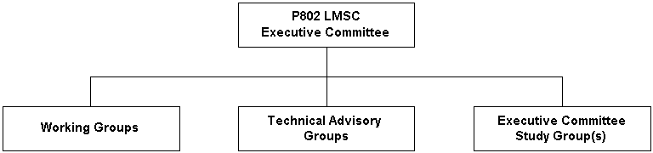
Project 802 Organizational Structure
Figure 1
A brief overview of the standards development process is provided in clause 7.1 of this document.

Working Group

Function
The 802.15 WG's charter is to develop Physical layer and MAC sub-layer specifications for wireless Personal Area Networks™ based on [Carrier Sense Multiple Access/Collision Detect (CSMA/CD) protocol] or on [Carrier Sense Multiple Access /Collision Avoidance (CSMA/CA)] or [no qualification at all]. Standards efforts are carried out under Project Authorization Requests (PAR) approved by the IEEE Standards Board and assigned to 802.15 WG. Since the scope of standards work which comprises 802.15 WG activity may be widely dispersed in time, technology and structure, individual standards activities within 802.15 WG are, at the discretion of the 802.15 WG, carried out by Task Groups (TG) operating under, and reporting to, the 802.15 WG. A TG may in turn create Sub-Task Groups as necessary to accomplish the work of the TG.
The 802.15 WG is chartered to:
- define, maintain, and revise the 802.15 standards
- develop new standards in a reasonable time frame within the scope of the P802 LMSC
- forward these standards to ISO/IEC JTC1
- maintain liaisons with other groups within P802 LMSC, and other relevant standards setting bodies and Radio Spectrum regulatory bodies
The 802.15 WG activities are administered by the WG Chair who is assisted in this task by the Working Group Advisory Core (see 2.3).
The structure of 802.15 WG is illustrated in figure 2.

WG Officers
The rules and procedures for the election of, and the terms served by, the WG Chair and Vice-Chair are contained in the Operating rules of IEEE Project 802 (See ref [1], 5.1.2). Removal of the WG Chair or Vice-Chair is also covered by this document (See ref [1], 5.1.4.5).

Chair
As stated in P802 rules, the chair of the WG is responsible for presiding over WG Plenary sessions and combined TG meetings. The chair only votes on matters before the Working Group in cases where a deciding vote must be cast.
In addition, minutes of TG meetings are to be reviewed by the TG chairs and made available for review by the WG one week after closure of the session.

Vice Chair
Unlike the chair, except when acting in the capacity of the chair, the vice chair, normally votes, and comments on issues with the same rights as all other voting members.

Secretary
The minutes of meetings taken by the Secretary (or designee) are to be provided to the WG chair in time to be available to the membership one week after close of the session.
The minutes of the meeting are to include documents produced by the voting process and document list. Sufficient detail should be presented in the meeting minutes to allow a person knowledgeable of the activity, but not present at the discussion, to understand what was agreed to and why. Minutes shall be posted to the WG web site within 7 days of the close of the meeting. See Standards Companion for details on content and form of minutes.

Technical Editor
The Technical Editor is responsible for organizing, maintaining the draft standards in the format used by the IEEE standards department. The editor is responsible for publishing updates of draft standards as soon after a session as possible.
Proof read and coordinates changes of documents edited by IEEE staff.
Send the IEEE P802.15 Chairperson the following:
- The Acrobat .pdf file of the standard
- The FrameMaker .fm & .book files of the standard
- The Figures or graphic .eps files used in the standard

Treasurer
802.15 WG operates without treasurer and without treasury. Occasionally there may be a need for short-term funds associate with a particular meeting. Any debts and collections shall take place within that meeting. The sponsoring group/individual will be responsible for financing short-term expenses for interim meetings. It is the responsibility of the sponsoring group/individual to provide a statement of accounts if a meeting registration fee is levied on members.

Assistants
The WG Chair may appoint and dismiss assistants to any of the above offices, as the needs of the WG change.

WG Advisory Core
The 802.15 WG Advisory Core (AC) functions as the coordinating body supporting the Chair in formulations of policy and the performance of his duties. The 802.15 WG AC has no formal meetings, voting procedures, nor policies. The intent is to have the 802.15 WG AC operate in a consultative manner. There is adequate policy and procedural rigor imposed on WG 802.15 by the Operating rules of IEEE Project 802 and its hierarchy of rules.

Function
The function of the WG AC is to assist the WG Chair in performing the following tasks:
- Providing procedural and, if necessary, technical guidance to the Task Groups and Study Groups (SG) as it relates to their charters.
- Overseeing WG, TG, and SG operation to see that it is within the scope of WG 802.15.
- Examining TG draft standards proposed for submission to WG ballot.
- Considering complaints of TG and SG members and their resolution at the Plenary, TG, and SG.
- Managing WG 802.15 logistics, e.g. concurrent TG and SG meetings, etc.
- Manage liaison activities between meetings of the WG.

Membership
Membership of the WG AC is composed of the following WG 802.15 officers:
- WG Chair.
- WG Vice-Chair and/or Co-Vice-Chairs.
- Recording Secretary.
- Task Group Chairs.
- Study Group Chairs.
- Technical Editor

WG Membership
The rules and procedures governing WG membership including establishment, retention, loss and rights are contained in the Operating rules of IEEE Project 802 (See ref [1], 5.1.3). The following additional requirement are imposed within WG 802.15:
- TG and SG meetings do not count towards 802.15 WG voting rights unless they are held in conjunction with a WG meeting. In that case they are treated as if the member attended the parallel meeting within the WG.
- To establish voting rights participants must request to become a voter during a 802.15 WG Opening or Closing plenary meeting when additions to the voter list are solicited by the Chair from the "Nearly Voting Member" list.
- To establish and retain voting rights participants must record and maintain complete contact information in the 802.15 database
- Voting rights are established by participation in 2 plenary meetings within 4 consecutive plenary meetings. One interim meeting may be substituted for a plenary meeting. Participation is defined as attending 75% of all meetings during an officially sanctioned session of the WG
- Voting rights may be lost by:
- Failure to pay conference fee
- Missing two out of three consecutive letter ballots
- Failure to maintain contact information
In addition to the requirements for membership the following is highly recommended for most efficient exchange of information between members:
- E-Mail address capable of handling large >1MB file attachments
- Remote Internet & Web access & HTML Browser
- Laptop computer at meetings
- MS Office 2000 & PKWARE Zip/Unzip Utility or compatible
- 802.11 WLAN card for laptop
- Flash card for laptop

Operation of the WG

Chair's Function
The Chair of a WG may decide procedural issues or may put them to a vote of the WG. The WG participants and the Chair decide technical issues by vote. The WG Chair decides what is procedural and what is technical.

WG Plenary Meetings

Plenary Session
The 802.15 WG plenary session is conducted three times a year as part of the P802 LMSC plenary sessions (see ref [5]). The 802.15 WG plenary session is a meeting of individuals interested in developing and maintaining WPAN standards. Typically the 802.15 WG Opening/Closing plenary meetings are held between the opening and closing meetings of each P802 LMSC plenary (see figure 2). Occasionally there are TG or SG meetings during the Executive committee meeting on Monday morning and/or the weekend preceding the plenary (Note: meetings held before the opening of 802 plenary meeting are treated as interim meetings.)
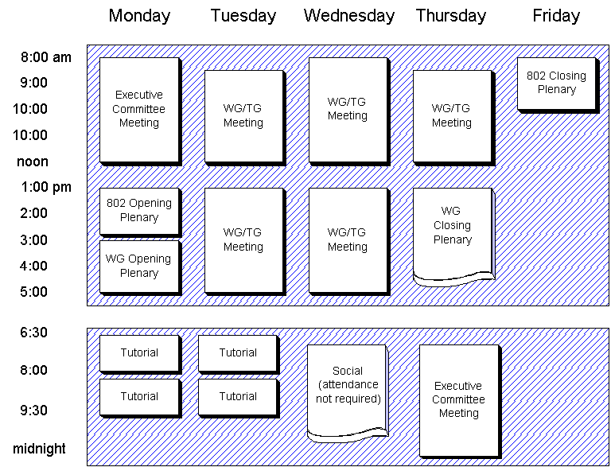
Typical Working Group 802.15 meetings during 802 Plenary week
Figure 2
The 802.15 WG plenary is open to all registered P802 attendees. As is the case with all 802 Working Group meetings only voting members have the right to participate in the discussions (see ref [1], 5.1.3.5). The Working Group Chairs may grant the privilege of observers to participate in discussions.
The WG 802.15 Plenary is conducted by the Chair or the Chair's designated delegate. The 802.15 WG Opening plenary meeting will include the presentation of the following information:
- The roll call of current voters.
- The agenda (which was distributed earlier) including any items requiring a vote.
In addition the following information is on the 802.15 web site and should be read and understood by participants.
- The existence of these operating rules and where they can be obtained.
- The existence of the operating rules of IEEE Project 802 and where they can be obtained.
- IPR and copyright notices
The function of a plenary meeting is to gather and disseminate information and take action as follows:
- Status reports from the Task Groups and Study Groups.
- Liaison reports from other standards organizations, other IEEE 802 WGs and TAGs.
- Reports on schedules for future plenary meetings.
- Announcements and general news.
- Vote on such matters that may be brought before it such as recommendations of its Task Groups and the election of 802.15 officers.
- Make recommendations for SEC action with respect to standards projects, P802, and liaison matters.
- Calls for interest in new work items.
- Call for relevant patents
- Items for subsequent meetings

Interim Meetings
The respective group schedules interim WG, TG, or SG meetings no later than the end of the prior plenary meeting. The date/time/place of the meeting(s) must be approved and announced at the final WG Plenary and entered in the minutes of the meeting. Official actions of these meetings are valid if one of the following occurs:
- A quorum is present
- Confirmation vote passes at the next Plenary
- Appropriate level of approval (75%+ for technical, 50%+ for procedural) from a letter ballot that has been pre-authorized by the WG at the time of the meeting approval
- Specific empowerment that has been pre-authorized by the WG at the time of the meeting approval

Ad Hoc and Liaison Meetings
Any AC member may call Ad Hoc and Liaison meetings. They have no official status and do not count for voting rights purposes. Not binding actions may be taken at these meetings unless specifically chartered by the WG. Since they may involve negotiation of proprietary information, they may be closed to the general membership of the WG. The "Ad Hoc and Liaison" meeting Agendas will be approved by anyone in the Working Group AC prior to Working Group distribution as discussed in these Operating Rules.

Voting
There are two type of votes in the WG; votes on motions and votes in straw polls.
Only the WG members can make and vote on motions.
All participants may participate in a straw poll at the discretion of the WG Chair.
The WG Chair defines motions as either technical or procedural. On a technical motion, a vote is carried by a minimum 75% approval of the sum of those voting "Approve" or "Do Not Approve". On a procedural motion, a vote is carried by a greater than 50% approval of the sum of those voting "Approve" or "Do Not Approve".
The decision to define a motion as technical or procedural rests with the WG Chair. Generally a technical motion is defined as a motion that will materially affect the content of a draft. This is because a draft itself will ultimately be subject to a 75% majority vote at the LMSC ballot.
The decision by the WG to submit a draft standard or a revised standard to the WG ballot group must be ratified as a technical vote.

Minimum Meeting Notification Requirements
A meeting notice and agenda must be distributed to all WG 802.15 members and observers at least 30 days prior to any WG meeting. This notice will include as a minimum the date, time, location, host, hotel details, travel details if necessary and a stated purpose.

Precedence of Operating Rules
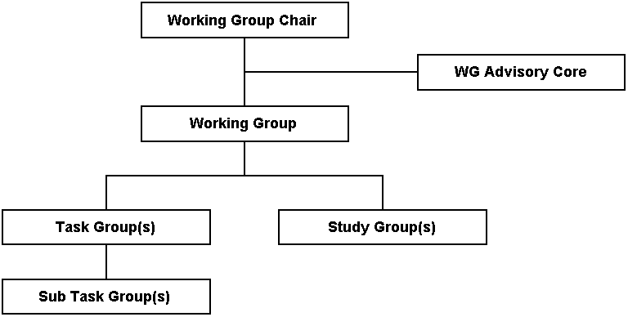
Working Group 802.15 Organization Structure
Figure 3
The rules governing Working Group Functions, Chair and Vice-Chair, Membership, meetings and the operation of a Working Group are provided by the Operating rules of IEEE Project 802 and the hierarchy of rules under which IEEE Project 802 operates. These rules are all included in this document by reference and are not reproduced here, however the reader is encouraged to become familiar with these rules in addition to the rules provided in this document. If 802.15 WG Operating Rules conflicts with the 802 Operating Rules, then the 802 Operating Rules shall take precedence.

Maintenance of Operating Rules
WG operating rules are a requirement of the Operating Rules of IEEE Project 802, which state that the WG chair shall:
"Establish Working Group rules beyond the Working Group rules set down by the Executive Committee. These rules must be written and all Working Group members must be aware of them."
The WG 802.15 operating rules are to be made publicly available and posted in the WG 802.15 area of the IEEE web site. Suggestions for improvements should be submitted to the Vice-Chair who will bring them up for discussion at the following plenary.
Proposed changes to WG operating rules must be received no later than the day before the 802.15 opening plenary. If there are any proposed changes a meeting shall be held to discuss the changes. The changes shall then be circulated at least one week prior to the next plenary and an announcement shall be made at that WG opening plenary that a vote shall be taken on the changes at the WG closing plenary (see below).
Proposed changes shall be in written form and should include:
- The purpose, objective, or problem the proposed change is intended to address
- The specific text of the rule change
- The rationale for the chosen text
These rules of operation of WG 802.15 can be changed by either:
- A vote taken at the closing plenary of 802.15 WG, passing with a least 2/3 approval of those voting either for or against.
- An affirmative WG 802.15 letter ballot. This ballot shall adhere to the normal letter ballot requirements (see 2.7.2).
The Chair shall decide which of the above methods shall be used. The SEC of the P802 committee must approve all changes.

Working Group Standard Procedures
The following list describes the normal content and operations of Plenary and Interim P802.15 meetings.
- The Working Group meetings start promptly at 8:00 a.m. and ends promptly at 5:00 p.m. or per the approved meeting agenda.
- A Working Group "Session" refers to a set of meeting days that may not be contiguous. A Working Group "Meeting" refers to a single day's meeting. The intermediate adjournments from day to day, or the recesses taken during the day, do not destroy the continuity of the meetings, which in reality constitute one session.
- The reports from the Task Groups and Study Groups deal primarily with issues related to P802.15 as a whole or Liaison coordination. Reports of those items that will be covered in the Plenary and Interim meetings should be minimized to avoid duplication of discussions.
- Robert’s Rules of Order are used in Working Group "Plenary and Interim" meetings. The following items control debate procedures. The Chair or vote of the WG may modify them for a specific period, as necessary.
- Issues brought before the Full Working Group for resolution by vote should be phrased as a motion and distributed, if possible, to the Working Group Chair before the meeting.
- The maker of the motion has up to five minutes of uninterrupted time to explain the motion and to answer questions about it. After this, the seconder of the motion will be sought.
- Each Working Group member has two minutes of uninterrupted time to state an opinion about the motion. It is not necessary that all two minutes be used.
- The debate is confined only to the current motion.
- If the Working Group extensively modifies a TG’s motion the Task Group Chair may withdraw the motion and present it to the Working Group at the next meeting or session (which ever comes first).
- When the Working Group meeting on the evening fails to cover all agenda items (except for informational items), the clock stops at 5:00 p.m. the Chairman has the discretion to extend that meeting agenda time to allow the Working Group the necessary time to resolve the agreed to agenda items.

Documentation and Submission of Papers

Types of documents
The IEEE standards making is an open process and the IEEE P802.15 WG will make use of the following documents:
- Member and Non Member contributions
- WG contributions (provided as meeting inputs by officials or outputs produced at a meeting)
- Draft deliverables
All documents will be stored permanently on the IEEE server (see x) with the IEEE P802.15 Release and Notice appended via the required Templates.
The responsibility of maintaining the contents of the applicable directories on the IEEE server lies with the secretaries or the chairmen of the applicable meeting in conjunction with the Web Master.

Document Numbering and File Names
P802.15 uses the LMSC document numbering scheme. Every official document produced or archived by the Working Group will have a document number assigned in the format:
802.15-yy/m[ri]
where yy is the year produced, m is a sequential number assigned by the WG secretary or designee, and ri is a revision designation. Brackets indicate the field is only present if additional versions of the document are produced and are brackets not included in the document number. The revision designation has a lower case r constant followed by a sequential number, that is assigned by the WG secretary or designee.
Draft standards for 802.15 will have the format:
802.15/Di-yy/m
where i is the Draft Revision Number, yy is the year produced, and m is a sequential number assigned by the WG secretary or designee.
File names for these documents will be in the form:
Yym[ri]P802-15t
where yy is the year produced, m is a sequential number assigned, ri is a revision designation and t a meaningful description of the document that can also be used as the title and is in the heading of the document.
Document 802.15-yy/0ri will be the master index of documents for the year yy. Each time the document list is published by its maintainer, the revision number i is incremented
File names for these documents will be in the form:
Yy000[ri]P802-15t

Required Formats
All contributions shall be generated with the current Microsoft Office applications: Word, Powerpoint, Excel Access, Project, etc. Documents should be saved in the then generally accessible or current file revision format. When a different application is used, the Adobe Acrobat pdf version of the then generally accessible or current file revision format should be provided. . The author can and should back-save dependent on the application release cycle.

Graphics included in submissions will be in one of the following formats:
- Joint Photographic Experts Group (JPEG) .jpg
- Graphic Interchange Format (GIF) .gif
- Windows bitmap .bmp
Documents submitted to WG 802.15 shall use the style templates supplied by the WG for all submissions. The Microsoft Word shall be used for text submissions, Microsoft PowerPoint will be used for presentations, Microsoft Excel will be used for spreadsheets, and Microsoft Access shall be used for database submissions. When Word or PowerPoint submissions are made, the templates published on the WG 802.15 web page must be used.
Special fields are used in the templates to assure adherence to document standards. Information on how to change <title> and other required fields is contained in the Word template. DO NOT replace field codes with text. The Microsoft Word & PowerPoint templates have a notice and release statement that applies to all contributions to the WG. DO NOT delete these clauses. If you are exempt from these clauses i.e., USA Government Workers, etc. please contact a WG Officer and ask permission to modify the template clauses prior to submission.

Web Server file structure
The IEEE P802.15 Web Server shall have the directory structure as specified below:
- http://www.ieee802.org/15/index.html <IEEE P802.15 Home Page
- http://www.ieee802.org/15/pub/xxxx/yyyzz/ <Session or Meeting Sub Directory x=Year (2000), y=Month (Jul), z=Year (00)
- http://www.ieee802.org/15/pub/private/ <WG Drafts
- http://www.ieee802.org/15/pub/privatex/ <TG Drafts x=Task Group 1 (1)
The server will have HTML pages added to assist Internet Browsers in navigating the site. Critical items such as next meeting venue documents, rules, minutes, drafts, etc. will all be easily obtained via the WWW and/or via FTP and the file structure indicated above.

WG Balloting
A draft must successfully pass a WG letter ballot (conditional approval excepted) before it can be can be forwarded to the Executive Committee for approval for Sponsor Group voting. The rules and procedures governing WG letter ballots, comment resolution and confirmation letter ballots are contained in the Operating rules of IEEE Project 802 (See ref [1], 5.1.4.2.2). An overview of the process is also provided in subclause 7.1 of this document.
Addition requirements are imposed within WG 802.15 are specified by the clauses below.

Draft Standard Balloting Group
The 802.15 WG balloting group consists of all voting members of the 802.15 WG as of the close of day the ballot package distribution was completed as determined by the WG Chair.

Draft Standard Balloting Requirements
Before a draft is submitted to WG letter ballot it shall in addition have met the following requirements:
- It must be complete with no open technical issues.
- It must be made available on the web site a week before the meeting before it is to be discussed. All changes made to the draft after the initial posting shall be presented for review during the closing plenary immediately prior to the vote for approval to go to WG ballot.
- It must be formatted according to the IEEE style specified the WG templates
- It must be approved for submittal to WG ballot at the 802.15 WG closing plenary.
For a WG letter ballot to be considered valid the abstention rate must be less than 30%.
When present, state diagrams shall take precedence over text.

Draft Standard Formatting Requirements
The draft must be provided in the current IEEE electronic format. At a minimum this shall be completed prior to the Sponsor ballot however it is preferable that the draft be maintained in this format for its entire life.
Changes to the IEEE 802.15 current or draft standard shall be shown in underscore and strikeout. Note that the current standard may not be the same as the published standard due to approved but unpublished supplements.

Task Groups

TG Function
The function of the Task Group is to produce a draft standard, recommended practice, guideline, supplement, or portion of a draft standard to the WG. These shall be within the scope of the P802 LMSC, the charter of the WG and under an approved PAR as established by the P802 LMSC EC and approved by the IEEE Standards Board. After the publication by the IEEE of the standard, recommended practice or guideline, the function of the TG is complete and its charter expires (see 3.5). It is a function of the WG 802.15 to maintain published 802.15 standard(s) (see Clause 5).

TG Officers

TG Chair
TG Chairs shall be appointed by the WG Chair and confirmed by a motion that is approved by a minimum 75% majority of attending WG members. The TG Chair is required to confirm that the function of secretary is performed for each TG meeting. TG meetings are not allowed to function without a secretary or designee.

Secretary
The minutes of meetings taken by the Secretary (or designee) are to be provided to the TG chair in time to be available to the WG chair for publication a week after close of the session.
The minutes of the meeting are to include documents produced by the voting process and document list. See Standards Companion for details on content and form of minutes.

TG Membership
The TG will draw its membership from the WG. The TG shall have the same voting rules as 802.15 WG.

Operation of the TG
The TG's primary responsibility is to produce a draft standard, recommended practice, or guideline in a reasonable amount of time for review and approval by the WG. Democratic procedures are to be implemented using Robert's Rules of Order in combination with WG 802.15 rules. At no time will the IEEE's operating rules, which are based upon ANSI's procedures for openness and fairness, be compromised.

Chair's Function
The Chair of a TG may decide procedural issues or may put them to a vote of the TG. The TG participants and the Chair decide technical issues by vote. The TG Chair decides what is procedural and what is technical.

Meetings and Participation
All TG meetings are open to members and observers. The TG chair may grant observers the privilege of participating in discussions.
A TG shall normally meet during the WG plenarys. Additionally, the TG may meet as often as required and agreed to by the TG participants. A meeting notice and agenda must be distributed to all WG 802.15 members and observers at least 30 days prior to any meeting. This notice will include as a minimum the date, time, location, host, hotel details, travel details if necessary and a stated purpose. Task group meetings not held in conjunction with WG meetings do not count towards P802.15 voting rights.

Voting
There are two type of votes in the TG; votes on motions and votes in straw polls.
Only the TG members can make and vote on motions.
All participants may participate in a straw poll at the discretion of the TG Chair.
The TG Chair defines motions as either technical or procedural. On a technical motion, a vote is carried by a minimum 75% approval of the sum of those voting "Approve" or "Do Not Approve". On a procedural motion, a vote is carried by a greater than 50% approval of the sum of those voting "Approve" or "Do Not Approve". Any vote can be subjected to ratification at the WG level under WG voting rules.
The decision to define a motion as technical or procedural rests with the TG Chair. Generally a technical motion is defined as a motion that will materially affect the content of a draft. This is because a draft itself will ultimately be subject to a 75% majority vote at both WG and LMSC ballot.
The decision by the TG to request the WG to submit a draft standard or a revised standard to the WG ballot group must be ratified by the TG as a technical vote.

Task Group Chair's Responsibilities
The main responsibility of the TG Chair is to ensure the production, and to guide through the approval and publication process, a draft standard, recommended practice or guideline, or revision to an existing document as defined by the relevant PAR. The responsibilities include:
- Call meetings and issue a notice and agenda for each meeting at least 30 days prior to the meeting.
- Assure that there is a Recording Secretary for each meeting.
- Issue meeting minutes and important requested documents to members of the TG, the WG AC, and liaison groups. The meeting minutes are to include:
- list of participants
- next meeting schedule
- agenda as revised at the start of the meeting
- voting record:
- resolution
- mover and seconder
- numeric results
- Hold officer elections when necessary.
- Maintain liaison with other organizations at the direction of the WG AC or at the discretion of the TG Chair with the approval of the WG AC. All liaison and liaison statements shall be approved by the 802 EC.
- Work with the IEEE staff to complete the publication process for the draft standard, recommended practice or guideline.
Sufficient detail should be presented in the meeting minutes to allow a person knowledgeable of the activity, but not present at the discussion, to understand what was agreed to and why. Minutes shall be posted to the WG web site within 7 days of the close of the meeting. Any TG that wishes to reference a standard developed or under development by another organization within P802 LMSC, by another IEEE group or by an external organization, should refer to the requirements of subclause 3.5.3.2 of the 802 Rules ( ref [1]).
The TG Chair reports to the WG at the closing plenary of each session that the TG has meetings. In addition to the presentation to the WG at the closing plenary, the TG Chair is responsible for the production of a summary report to be posted to the P802.15 web site no later than 2 weeks after the close of the session.

Task Group Chair's Authority
To carry out the responsibilities cited in Section 3.4.3, the TG Chair has authority to:
- Call meetings and issue meeting minutes.
- Decide which issues are technical and which are procedural.
- Establish TG rules beyond the WG rules. These rules must be posted to the WG web site.
- Assign/unassign subtasks and task leaders or executors, e.g. secretary, subgroup Chair, etc.
- Speak for the TG to the WG.
- Determine if an organization or consortium is dominating the TG, and, if so, raise the issue to the WG AC.
- Make final determination if and how negative letter ballots are to be resolved when a draft standard, recommended practice, or guideline, is to be sent to the WG for approval for LMSC letter ballot or Standards Board approval under the guidance of the WG Chair.
- Be representative of the TG during coordination and interaction with IEEE staff.
- Collect fees to meet TG expenses as required.

Precedence of Operating Rules
If TG operating rules conflicts with the WG operating rules, then the WG operating rules shall take precedence.

Deactivation of a TG
After the objective of the TG is complete, its charter expires and the TG is deactivated. The TG or the 802.15 WG may deactivate a TG. If the TG has not completed its work within its allotted period of time, the TG can be disbanded by a vote of the TG or the 802.15 WG.

Study Groups

Function
The function of a Study Group is to complete a defined task with specific output and in a specific time frame. Once this task is complete the function of the SG is complete and its charter expires.
A common function of a 802.15 Study Group (SG) is to draft a complete PAR and five criteria and to gain approval for them at WG 802.15, 802 EC, IEEE New Standards Committee (NesCom) and the IEEE Standards Board. The decision of whether to utilize the 802.15 WG or to establish a new WG or Technical Advisory Group (TAG) to carry out work items recommended by a SG is to be made by the EC with advice from the 802.15 WG.

Formation
A SG is formed when enough interest has been identified for a particular area of study within the scope of WG 802.15. The first step in the process is a call for interest. Any member or observer can make this at the WG 802.15 opening plenary. An 802.15 SG can then be initiated by vote of the 802.15 WG and must be approved by the 802 SEC. During this approval process the 802 EC decides whether a SG is within the scope of WG 802.15. The SEC determines if it should be moved to another WG or should be set up as an Executive Committee Study Group (ECSG).

Continuation
A SG exists for up to 6 months. If it has not completed its work within that time, a request must be made to the WG for an extension for up to 6 months. Any request for SG extension will be voted upon at the WG 802.15 closing plenary.

Study Group Operation
Study groups follow the operating procedures for Task Groups specified above with the following exceptions detailed below.

Study Group Meetings
These Study Group meetings do not count towards 802.15 WG voting rights unless they are held in conjunction with a WG or TG meeting. In that case they are treated as if the member attended the parallel meeting.

Voting at Study Group Meetings
Any person attending a Study Group meeting may participate in SG discussions, make motions and vote on all motions (including recommending approval of a PAR and five criteria).

Attendance List
Since Study groups may have members who are not part of the parent WG, a separate attendance list must be maintained for the meetings of the Study group. This list is to be in the same format as the WG and will be submitted as a document to the WG.

Maintenance
Maintenance of the 802.15 standard is performed by the maintenance TG. The maintenance TG is a standing TG. It requests a PAR when sufficient maintenance requests have been received for a ballot. A study group is not normally required to write the PAR for the maintenance TG.
The maintenance TG follows all the rules of a normal task Group described above with the exception that there are no TG meetings when there are no outstanding maintenance requests requiring action.

Inquiries/Interpretations
Inquiries and interpretations of standards, recommended practices or guideline that were generated by a WG 802.15 TG shall be directed to the Secretary of the IEEE Standards Board, who will forward the request to the 802.15 WG Chair. The Chair or his designate shall attempt to resolve the inquiry or interpretation if possible, and the Chair, or his designate, may petition the WG to reactivate the TG if necessary. An interpretation request may also be forwarded to the maintenance TG.
All interpretations require approval by WG 802.15 before they can be published. This approval can be given by either:
a) A minimum 75% approval of the sum of attending WG 802.15 voting members voting "Approve" or "Do Not Approve" taken at the WG 802.15 closing plenary.
b) An affirmative WG 802.15 letter ballot. This ballot shall follow the normal letter ballot requirements.
If a request is made for a letter ballot on the subject, this request will be discussed and voted on at the closing plenary. A greater than 50% approval of the sum of attending WG 802.15 voting members voting "Approve" or "Do Not Approve" taken at the WG 802.15 closing plenary is required for a interpretation to be sent out for a WG letter ballot. If no such request for a letter ballot is made, or the request fails, the interpretation itself will be voted on at the closing plenary. A motion requesting a letter ballot will take precedence over a motion to approve the interpretation.

Procedures
This section contains procedures that are specific to certain activities within the WG. Note that some procedures, such as obtaining PARs and coordination with other standards bodies are covered by the Operating Rules of IEEE project 802 and are not reproduced here.

Overview of the Project Process
The following subclauses give a brief overview of the entire project process. For a detail explanation of the processes and procedures involved the reader is encouraged to consult the Operating rules of IEEE project 802, LAN MAN Standards Committee (LMSC) ( ref [1]), The IEEE Standards Companion ( ref [2]), the IEEE Standards Operations Manual ( ref [3]) and the IEEE Standards Board Bylaws ( ref [4]).
This project process is illustrated in figure 4.

Call for interest
A call for interest in a subject is made in the 802.15 WG plenary.

Study Group
Study Groups are covered in Clause 4 and the 802 rules (see ref [1], 5.3). Steps in this stage include:
- Develop PAR and Five Criteria (see 7.2).
- Provide a plenary week tutorial to 802.
- Obtain approval at WG 802.15, 802 EC, NesCom, and IEEE Standards Board.
Overall Project Process
Figure 4

Task Group
Task Groups are covered in Clause 3 of this document. Steps in this stage include:
- Develop goals.
- Write initial draft of standard
- Develop agreement upon completed draft.

Working Group Ballot
Working Group ballots are covered above and the 802 rules (see ref [1], 5.1.4.2.2). Steps in this stage include:
- WG preview of document.
- Conduct WG ballots, which, by default, are electronic (email)
- Resolve comments from WG ballot.
- Re-circulate for approval including any unresolved negatives and revised areas in ballot package.
- Iterate to closure.
This process is illustrated in figure 5.

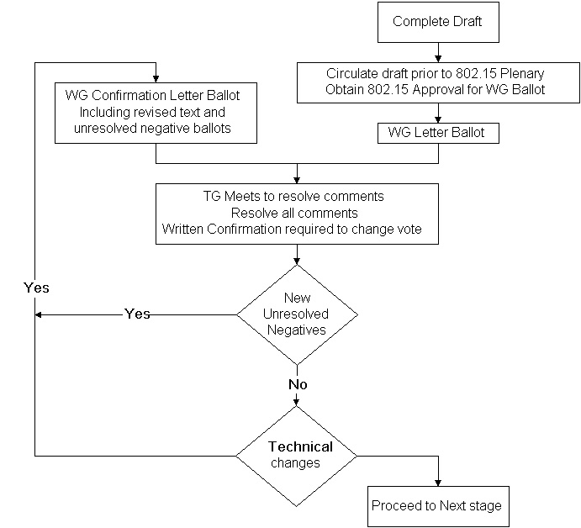

Letter ballots are returned by e-mail after the voter fills in their vote. For e-mail returns acknowledgment is sent by Chair within one business day. It is the duty of the voter to re-send e-mail vote if it is not acknowledged in that time frame.
Voting members have an obligation to vote. Not returning two, valid, ballots in a sequence of 3 letter ballots will automatically terminate voting rights. Abstentions are only counted as valid if they are based on "lack of expertise".
All “No” votes require the submission of detailed comments as defined in the IEEE rules for Sponsor Ballots to be counted as valid.
Comments are to be returned in the format given in the ballot instruction document that accompanies the draft.

Sponsor ballot
Sponsor ballots are covered in detail in the IEEE Standards Companion (see ref [2]). Steps in this stage include:
- Form ballot pool using the IEEE staff. (In practice this takes about 3 months)
- Obtain approval for Sponsor ballot from WG 802.15 and 802 EC.
- Submit draft to IEEE for Sponsor ballot.
- Resolve comments from Sponsor ballot. Each comment must be answered by the WG with a response that indicates level of agreement with the comment and what actions will be taken as a result. The responses to the comments must be clear, concise, and at a technical level that addresses Sponsor ballot group member's knowledge.
- Re-circulate for approval including any unresolved negatives and revised areas in ballot package.
- Iterate to closure.

This process is illustrated in figure x.
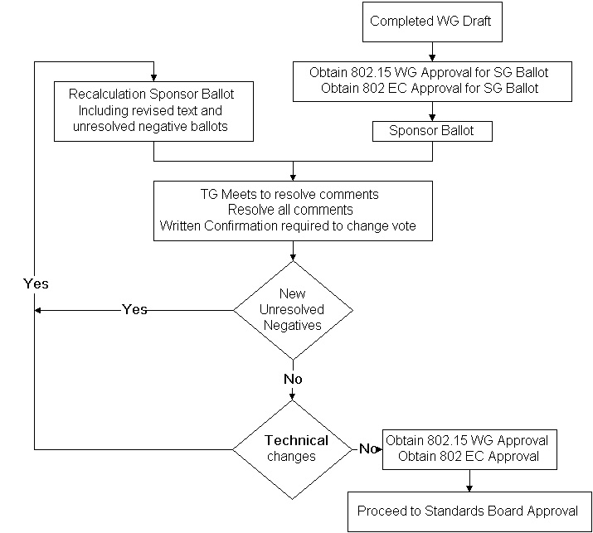

Standards Board Approval
- Obtain approval for submission from WG 802.15 and 802 EC.
- Check for Intellectual Property Rights requirements.
- Submit to RevCom and IEEE Standards Board for approval.

Publication
- Support IEEE editor in preparation for publication.
- Maintenance Phase.

The Ballot Process
Figure 5

IEEE 802 Five Criteria
When a study group presents a request to the 802.15 WG for them to forward a draft PAR to 802 EC for approval, they shall in addition present a completed set of responses to the IEEE 802 'five criteria'. This is a set of formal criteria that the study groups have to demonstrate, to their Sponsor IEEE 802 LMSC, that the proposed project meets.

These five criteria are listed below:

1) Broad Market Potential
- Broad set(s) of applications.
- Multiple vendors, multiple users.
- Balance cost, LAN vs. attached stations.

2) Compatibility with IEEE Standard 802.15
- Conformance with 802.15.1 MAC
- Conformance with 802.2.
- Conformance with 802 Functional Requirements.

3) Distinct Identity
- Substantially different from other 802.15 specifications/ solutions.
- Unique solution for problem (not two alternatives/ problem).
- Easy for document reader to select relevant spec.

4) Technical Feasibility
- Demonstrated feasibility; reports - - working models.
- Proven technology, reasonable testing.
- Confidence in reliability.

5) Economic Feasibility
- Cost factors known, reliable data.
- Reasonable cost for performance expected.
- Total Installation costs considered.

Recommended Activities for WG Officers and Appointees

Chair
Before session tasks:
- preparation of:
- attendance list
- voter tokens
- Submit agenda items for the Monday AM Executive Committee meeting
(a week before the meeting)
- Attend the Monday AM Executive Committee meeting
- Report the status of the working group to the plenary 802 meeting
During session tasks:
- Conduct full working group meetings
- Assign task of document control and collection.
- Make sure the various tasks for the meeting operation (see below) are performed smoothly
- Check the mailbox for Keep Executive Committee members informed as early as possible about 802.15 matters requiring approval at their closing SEC night meeting
- Submit the voters list to the meeting organisers
- Maintain mailing lists.
- Submit a hard copy of the attendance list to the meeting organisers by the final plenary session of the Working Group
- Attend the closing meeting of the Executive Committee and lead 802.15 business through the ExCom
- Report progress to the final 802 plenary meeting [Editor Note: This may be eliminated.]
- Obtain computer files of the documents on the Flash PC Cards for attending session participants, upload to the local Wireless LAN Server and then web site publication
- Maintain roll call list

After session tasks:
- Prepare agenda and venue for next meeting; publish on web site, and email the notice to members at least 30 days prior to event
- Manage the preparation of the meeting place as well as the venue for the next interim meeting
- Collect ballot return forms, acknowledge and merge into consolidation file(s) (if WG ballot active)
- Obtain ballot return forms from IEEE staff and merge into consolidation file(s) (if Sponsor ballot active)
- Update membership status i.e., Voter, Nearly Voter, Aspirant, and Liaison
- Update public documents on web site
- Update Draft documents in members-only web site and send e-mail to IEEE staff to add to the Draft Standards Catalogue
- Respond to inquiries regarding the committee
- Be prepared to assign document numbers
- Work with TG, SG, Committee chairs to prepare meeting agendas and room requirements for next session(s)
- Update list servers

Vice Chair
Typical tasks include:
- Be prepared to take over the duties of the chair in the event of temporary or permanent absence.
- Be prepared to assume or assign secretary duties when required.
- Between meetings, be prepared to respond to inquiries regarding the committee and keep the chair informed.
- Maintain oversight of document process
- During meetings, attend to any business that might otherwise prevent the chair from orderly conduct of the meetings, such as attending to emergency messages, and inquiries from the plenary staff.
- During meetings, provide a second vote count to insure accurate and fair voting.
- Assist the chair during IEEE P802 Executive Committee meetings held on initial and final days.
- Assist the chair, or be prepared to give the plenary reports at the first and last full IEEE P802 sessions. [Editor Note: This last day may be eliminated.]
- Act as parliamentarian using:
Robert’s Rules of Order - Newly Revised (9th Edition) Edited by Henry M. Robert III & William J. Evans ISBN# 0-06-276051-3

Attendance Recorder
The objective of this task is to maintain an accurate record of attendance for voter qualification. The chair provides a book containing the necessary paperwork. The duties include:
- Be the custodian of the attendance book throughout the session.
- Make sure that people sign in for each meeting period
- Sign attendance book for officers and presenters then circulate to attendees.
- After each meeting period, cancel all unsigned blocks.
- Cancel and audit any signatures placed in any other meeting period block and initial the cancellation.
- Arbitrate any attendee record discrepancies
- make sure the book gets to all P802.15 rooms
- ensure quick circulation of the attendance book
- Regularly update chair with new participants list
- Return the attendance book to the chairman at session end.

Document Coordinator
The primary duty of this appointed position is to keep meeting informed about document status during plenary sessions.
Duties include:
- After assignment by the chair, maintain a consistently numbered set of documents and files on flash cards and server.
- Verify document formats before presentation and circulation of materials to membership
- Update document list throughout meeting and provide to chair
- Collect all electronic presentations and working transparencies used during the meeting and file with the related document.

Liaison Officials
The responsibility of a liaison official is to facilitate the exchange of information between the IEEE P802.15 WG and a given liaison body. This includes assuring that the WG responds properly to requests for information and co-ordination from a given liaison body; it also includes providing information to a given liaison body according to the relevant decisions of the AC and/or Liaison Officer. Finally, the Liaison Officials will provide input (ongoing or 30 days prior to the next session) to the Liaison Officer as a supplement to Liaison Report, which is provided to the Full WG at the start of each session. The following is a current list of active liaisons is provided as of the release of these approved Operational Rules:
- IEEE 802, 802.1, 802.2, 802.11, 802.16
- Bluetooth Special Interest Group
- HomeRF Working Group
- ETSI Bran Project
- Digital Imaging Group

External Representation
Voting Members of the WG may represent the IEEE P802.15 WG at conferences, meetings of other fora (with which the WG has no liaison arrangement), seminars, etc.
Any documents for such events shall
- bear the IEEE P802 logo as displayed on the front page of this document and be free of other branding graphics e.g., Personal Company Logos, etc.
- be clearly marked as containing material derived from the work of the IEEE P802.15 WG and, as applicable, approved by the WG.
- be made available to the membership through the IEEE server
Documents relating to future work and objectives of the IEEE WG P802.15 Projects shall be approved by the AC and/or the TG Chair responsible for the Project.
The use of the IEEE logo is specified at http://www.ieee.org/

Meeting Coordinator (Local Host)
Three time a year (typically January, May, and September) the Working Group will seek from its membership, candidates to host a interim P802.15 meeting. In a separate document titled “Guidelines For Hosting Interim Meetings” the WG describes in detail the requirements, for choosing a hotel, conference meeting rooms, and accommodations; it is available via the Web Site. The following is just a short summary of the key deliverables required by the WG of the Host.
The Meeting Coordinator is a person who resides close to the site of the interim meeting and assumes financial responsibility for costs incurred by the WG. Ideally the meeting fees should exactly cover costs, but the Meeting Coordinator is the final guarantor.

Meeting cost-sharing
To share the cost of the meeting, the host can charge the participants a "conference fee" for a 4 or 5 day meeting to bear the cost of:
- the breaks and lunches
- the audio-visuals equipment rental
- the copying and/or machine loan (if not born by the host)
- the meeting rooms (if not negotiated for "free" with the hotel for the business of the guest-rooms)
It is acceptable to assign a fixed cost for each participant, independent of the length of participation of the individual.
Arrange with the hotel for collection of the registration fee to make meeting fee payments easy by:
- Debiting the conference fee from the guest account of those staying at the hotel and crediting to the conference account
- Accepting conference fees from those not staying at the hotel (e.g. locals)
- If the hotel refuses to do so, the host has to go through the chore of collecting money from all participants and writing receipts
As we are not allowed to make a balance between meetings, we suggest that the host assumes a donation as a replacement of the saved travel and expenses cost. This allows the host to calculate a conference fee, so that we have a small shortage amounting to the fees to be paid by 2 to 3 participants. (Experience teaches that late, unexpected, arrivals will diminish this shortage) If at the end of the meeting there is, indeed, a negative balance, we must assume that the meeting coordinator will pay for that in full when undertaking this obligation at the onset.

Finacial Report
The host must make a statement of the debits and credits for the chairman's records and make a financial report at the next meeting, from the hosted meeting, for approval by the P802.15 committee.

Check List
- Projectors and, or Overhead Projectors
- Sufficient AC outlets (Extension cords)
- Copy provision (optional)
- Badges
- High Speed Printer and supply of Paper
- Availability of Network Server, Hub, and WLAN from sponsors
- Break Service
- Hosted Social Event (if Possible)
- Financial plan to base the participant sharing fee on

Mailing Lists
Currently there are five (5) IEEE e-mail Mailing Lists in use; two (2) for the WG Membership and two(2) for different project areas and one (1) Joint Mailing List for P802.11 and P802.15 traffic. The following table provides a current summary of these lists:

ORGANIZATION | WG | WG | TG1 | TG2 | WGs (802.15& .11)
ACCESS | Public | Privat | Private | Public | Private
E-MAIL | stds-802-wpan@ieee.org | stds-802-15@ieee.org | stds-802-15-1@ieee.org | stds-802-15-2@ieee.org | stds-802-jt11-15@ieee.org
PARTICIPANTS  (as of 22Jun00) | 279 subscribers | 65 subscribers | 17 subscribers | 101 subscribers | 3 subscribers
MODERATOR | WG Chair | WG Chair | TG1 Chair | TG2 Chair | WGs Chair
MAINTENANCE | WG Assistant Secretary | WG Assistant Secretary | WG Assistant Secretary | WG Assistant Secretary | WG Assistant Secretary
DESCRIPTION | This reflector is for the Group's official business. Technical discussions and questions, comments on presentations and documents, meeting announcements, etc., are welcome. Commercial activities are not permitted. | This reflector is exclusively for the Group's official business. Technical discussions and questions, comments on presentations and documents, meeting announcements, etc., are welcome. Commercial activities are not permitted. | This reflector is for the Task Group's editorial business. Discussions on the Draft Std. Editing and related traffic are welcome. Commercial activities are not permitted. | This reflector is for the Task Group's official business. Technical discussions and questions, comments on presentations and documents, meeting announcements, etc., are welcome. Commercial activities are not permitted. | This reflector is exclusively for the Group's official business. It is a redirect for joint traffic that would be sent to both stds-802-11 and stds-802-15 at the same time. In effect sending to the address copies to both WG Mailing Lists.

You can add yourself to the Public Reflectors by filling out and sending in the following online form http://www.ieee802.org/15/pub/Form.html or by sending an e-mail to one of the WG Officers – currently the Assistant Secretary. The Private Mailing Lists are available only to 802.15 Meeting Participants and/or Technical Editors for Drafts please contact WG or TG Chair moderating the list.
History

Document History
1.0 Version | May 5, 1999 | All new.
2.0 Version | July 10, 2000 | Minor corrections in the document, updated balloting graphics, reduced Interim Meeting Coordinator text by generating a separate less formal document.

