IEEE P802.15
Wireless Personal Area Networks™

Project | IEEE P802.15 Working Group for WPANs™
Title | Guidelines For Hosting Interim Meetings, a Joint WG Draft
Date Submitted | [11Jul00]
Source | [Ian C. Gifford]  [M/A-COM, Inc.]  [1011 Pawtucket Boulevard  Lowell, MA USA 01853-3295] | Voice: [+1 978 442 4650]  Fax: [+1 978 442 5442]  E-mail: [giffordi@ieee.org]
Re: | [Operating Rules of IEEE Project 802 Working Group P802.15, SJK-Final-Guidelines-for-hosts-of-IEEE-P802.doc (an 802.11 Document), and feedback from the May00 and Sep00 Hosts)]
Abstract | [This document describes the guidelines for hosting the IEEE 802.11/802.15 Joint Interim Meetings.]
Purpose | [The purpose of the Guidelines For Hosting Interim Meetings is to make it easier for potential hosts to step forward and support the IEEE 802.11/802.15 Joint Interim Meetings. The Author of this submission suggests that during the July 2000 Plenary Joint Session of 802.11/802.15 they agree upon a common set of guidelines (this document) for their collocated Interims or share each other’s guidelines and future modifications, if any, to their potential Hosts for Interim Meetings. Also, a new 802.11/802.15 joint document numbering system is requested to archive and track joint documents e.g., this document, Venue documents, etc.]
Notice | This document has been prepared to assist the IEEE P802.15. It is offered as a basis for discussion and is not binding on the contributing individual(s) or organization(s). The material in this document is subject to change in form and content after further study. The contributor(s) reserve(s) the right to add, amend or withdraw material contained herein.
Release | The contributor acknowledges and accepts that this contribution becomes the property of IEEE and may be made publicly available by P802.15.



Guidelines For Hosting Interim Meetings for the IEEE 802.11/802.15 Working Groups

Version 1.0

Table of Contents
1. Summary 4
2. Scope 5
2.1. Abbreviations 5
3. References 5
4. Interim Meetings 6
4.1. Frequency 6
4.2. Venue and Hosting 6
4.3. Hosting Costs and Conference Fees 6
4.3.1. Meeting cost-sharing 6
4.3.2. Guest rooms 7
4.3.3. Hotel Block-booking with deadline date 8
4.3.4. Financial Report 8
4.4. Meeting invitation and registration 9
4.5. Agenda 9
5. Meeting Requirements 9
5.1. Meeting Coordinator Requirements 9
5.2. Required features of hotel facilities: 10
5.3. Desired features of hotel facilities: 10
5.4. Breaks 10
5.5. Lunch 11
5.6. Copying facilities 11
5.7. Badges 11
5.8. Printing 11

Summary
The following document defines the joint requirements, for hosting Interim Meetings of the IEEE 802.11/802.15 Working Groups e.g., choosing a hotel, participant reservation forms, conference meeting room layouts, the latest meeting room logistics & accommodations, financial reporting & spreadsheets, etc. The intention is for potential hosts to review this document and to submit their names as candidates to be considered by the IEEE P802.11/802.15 Working Group Interim Meeting organizers.

IEEE Project 802.11 is a standards working group on wireless local area networks. Visit: http://www.ieee802.org/11/

IEEE Project 802.15 develops PAN standards for short distance wireless networks; a.k.a. WPANs™. Visit: http://www.ieee802.org/15/

The IEEE 802.11/802.15 Working Groups are sponsored and therefore part of the 802 Local and Metropolitan Area Network Standards Committee (LMSC) of the IEEE Computer Society. During the course of its standards development activities these WGs are in session six (6) times per year – three (3) times in Plenary Session and three (3) times in Interim Session. It is these later sessions that the IEEE 802.11/802.15 has created this document - Guidelines For Hosting Interim Meetings.

In January, May, and September of each year, the IEEE 802.11/802.15 Working Groups meet jointly at one location. These interim meetings are scheduled one (1) year ahead and are attended by about 175 people [estimate based on a Jun00 projection - 802.11 (100) and 802.15 (75)]. As is our custom the WG will seek from its membership, candidates for hosting our joint interim meetings. For information about upcoming interim (& plenary) meetings, visit: http://www.ieee802.org/15/pub/Meeting_Plan.html

In March, July, and November of each year, the IEEE 802.11/802.15 Working Groups meet in conjunction with all the subgroups of LMSC at one location. These plenary meetings are scheduled 1-2 years ahead and are attended by about 500 people. For information about upcoming plenary meetings, visit: http://www.ieee802.org/meeting/index.html

The IEEE LMSC coordinates with other national and international standards groups, with some standards initiated here now published by ISO as international standards. There is strong
International participation here, and some meetings are held outside the U.S.

If you would like to become a host please contact one of the IEEE 802.11/802.15 officers and we will be glad to provide additional information to help you decide to become a host.

Scope
This document contains all the internal guidelines, rules and procedures of the IEEE 802.11/802.15, which are necessary for the efficient work of its projects.

Abbreviations
For the purposes of the present document, the following abbreviations apply:

ABBREVIATION | DEFINITION
AC | Advisory Core
IEEE | Institute of Electrical and Electronics Engineers, Inc.
P802.11 | Project 802.11 Working Group for WLAN
P802.15 | Project 802.15 Working Group for WPAN
WLAN | Wireless Local Area Network
WPAN | Wireless Personal Area Network

References
The following document contains provisions, which, through reference in this text, constitutes provisions of the present document.

[1] Operating Rules of IEEE Project 802 Working Group 802.11
http://www.ieee802.org/11/ (in revision at the time of this draft)

[2] Operating Rules of IEEE Project 802 Working Group 802.15
http://www.ieee802.org/15/pub/Rules/WPAN-Rules.html

[3] Guidelines For Hosting Interim Meetings (this document)
http://www.ieee802.org/15/pub/Rules/Guidelines-For-Hosting-Interim-Meeting.html

Please note that these documents may be revised periodically. The latest edition will be made available at the above-mentioned IEEE Web Sites.

Note: The documents on the IEEE 802.15 Web Site are considered to be the definitive version (http://www.ieee802.org/15/ ).

Interim Meetings

Frequency
There are three (3) Interim Meetings per year, which are typically the 2nd full week of January, the 2nd full week of May, and the 3rd full week of September of each year. The IEEE 802.11/802.15 Working Groups meet jointly at this one location. These interim meetings shall be scheduled at least one (1) year ahead and are attended by about 175 people [estimate based on a Jun00 projection - 802.11 (100) and 802.15 (75)].

Venue and Hosting
The interim meetings are determined during the Joint Meeting of the IEEE 802.11/802.15. During these joint sessions the Chair of either WG would initiate a Call For Interest in hosting up and coming Interim Meetings based on the level of hosting responses their would be a straw poll to determine level of interest, in joint session, for a particular venue.

Additionally, the candidate host could make a submission to the Joint Meeting and/or Full WG to indicate interest in lieu of a Call For Interest.

Our venue goal is to equitably alternate between major areas of North American, European, and Asia Pacific continents. The IEEE 802.11/802.15 Working Group membership is internationally based and as such we welcome all interested Hosts and Venues of our Interim Meetings. We have recently been hosted (interims) in Japan, Israel, the Netherlands, as well as the USA.

Finally, the Marketing Committee of IEEE 802.11/802.15 will maintain a DB to advise if there are planned Industry Events near (in time or location) the Interim Meetings. The primary purpose is to avoid conflict with industry events and/or to time Interim’s (or Industry) to help our Membership attend both the Interim Meetings as well as the Industry events i.e., serial vs. parallel.

Hosting Costs and Conference Fees
In theory, the Hosts costs are zero, however, experience suggests that there are too many unknowns and that Hosts should budget paying out of pocket USD$3,000.00. It is recommended that the Host actively use the meeting participants conference fee or “shared costs” to achieve a zero balance at the end of the session.

Meeting cost-sharing
To share the cost of the meeting, the host can charge the participants a "conference fee" for a 4 or 5 day meeting to bear the cost of:
- the breaks and lunches
- the audio-visuals equipment rental
- the copying and/or machine loan (if not born by the host)
- the meeting rooms (if not negotiated for "free" with the hotel for the business of the guest-rooms)

It is acceptable to assign a fixed cost for each participant, independent of the length of participation of the individual.

Arrange with the hotel for collection of the registration fee to make meeting fee payments easy by:
- Debiting the conference fee from the guest account of those staying at the hotel and crediting to the conference account
- Accepting conference fees from those not staying at the hotel (e.g. locals)
- If the hotel refuses to do so, the host has to go through the chore of collecting money from all participants and writing receipts

The WGs are not allowed to make a balance between meetings, it is suggested that the member host assumes a donation as a replacement of their saved travel and expenses cost. This allows the host to calculate a conference fee, so that we have a small shortage amounting to the fees to be paid by 2 to 3 participants. (Experience teaches that late, unexpected, arrivals will diminish this shortage) If at the end of the meeting there is, indeed, a negative balance, we must assume that the meeting coordinator will pay for that in full when undertaking this obligation at the onset.

Guest rooms
The membership would like to pay a between USD$ 90.00-150.00 per night for Hotel guest rooms. This rate should include absorption of extras volunteered by conference management and no commissions should be expensed in these costs as direct reservations benefits must be passed to attendees. Please ask for certification of these discounts passing to the WGs benefit.
Make sure that the hotel knows that each individual pays his/her own charges. The shared costs should be reflected in the hotel bill listed as item: IEEE802 conference fee. The ongoing shared costs bill should be itemized each day and therefore the final shared cost amount can be managed. For example the Host could use $325.00 as the shared costs estimate up and till the start of the session and then on Monday (the opening day) the participant level will be known and therefore the shared cost can be changed up or down based on the this new knowledge. Typically the shared cost should be charged on Tuesday 1:00pm to maximize the Hotel’s bill back method.

Note 1: Each participant will share the cost of the meeting rooms and breaks for the entire week even if they only attend one day.
Note 2: For participants that are local but not in the Hosting Hotel i.e., live in the vicinity or are in another Hotel the Host will establish a method to charge these individuals e.g., cash, credit card, etc.

Hotel Block-booking with deadline date
It is recommended that the best way to prepare for such a meeting is to identify a few local candidate Hotels and conduct a formal Request For Quotation (see appendix A) or an informal negotiation; asking for the reservation of a block of guest & meeting rooms for the estimated number of participants and determine if (1) they have availability based on the target Interim dates provided or see 4.1 Frequency, (2) if they are competitive to our target guest room rate, and (3) competitive Hotel to Hotel. Based on this information the Host should be able to identify their primary Hotel and to proceed with the more detailed negotiations to determine if this Hotel can provide the necessary Venue for a successful IEEE Interim Meeting.

Once the Hotel is confirmed let the guest rooms be confirmed by each participant using a pro-forma form (appendix C). This form hopefully sent direct from participant by mail or FAX, without going via a travel agent and thus commissioned such agent to our detriment. The hotel must provide a confirmation either via Fax or Telephone, at the time of reservation by each attendee.

Establish a deadline, preferably not earlier than one week before the start-date of the meeting. At that time, rooms of the block booking not confirmed could be released. Using the joint IEEE 802.11/802.15 reflector <stds-802-jt11-15@ieee.org> is the preferred vehicle to monitor and give updates to potential attendees prior the meeting.

Do not accept any commitments for the reservation of the guestroom. The hotels normally work with reservations cancelable up to 6:00 PM of the day of arrival, if reserved via a credit card. They will try to get guarantees, of course, because they commit to a larger part of their business. However, the host should not commit to those qualifications.

Sometimes the host has to guarantee only a minimum number of rooms and food service businesses to the hotel in order to qualify for discounts, such as free meeting rooms. In that case the host should conservatively take the commitment for Host Company or himself. The host should make a request to the hotel to recommend other hotels for guestrooms in the nearby area to accommodate last minute arrivals or overflow conditions.

Make sure that the Chairperson is allowed to ask hotel directly, the number of people that have registered and that she/he can obtain lists of names of the individuals that made reservations to the block booking.

Financial Report
The host must make a statement of the debits and credits for the IEEE 802.11/802.15 Chairman's records and make a financial report at the next meeting, from the hosted meeting, for approval by the Joint P802.11/P802.15 committee.

Meeting invitation and registration
The IEEE is contribution driven and the Host is required to provide a Meeting invitation a.k.a., venue document to the IEEE 802.11/802.15 WGs that describes the event. The Host can obtain a Joint WG document number to make the submission from either of the WG Chairs or designee.

As a minimum the venue document should have an official IEEE document number, date of Interim Meeting (supplied by WG), Hotel name, address, telephone number
Meeting Coordinator

Agenda
From the Hosts point of view the Interim Meetings typically have the following key agenda activities:

Saturday | Sunday | Monday | Tuesday | Wednesday | Thursday | Friday
 |  | Session Opens 8a |  |  | Session Closes 5p
Early arrivals | Majority of participants arrive | Balance of participants arrive |  |  | Majority of participants depart | Balance of participants depart
 | Reg/Info Desk 6p-9p | Reg/Info Desk 7a-6p | Reg/Info Desk 7a-6p | Reg/Info Desk 7a-6p | Reg/Info Desk 7a-6p
 |  | Cont. Breakfast 7:30-9a | Cont. Breakfast 7:30-9a | Cont. Breakfast 7:30-9a | Cont. Breakfast 7:30-9a
 |  | Coffee Svs 10-10:30a | Coffee Svs 10-10:30a | Coffee Svs 10-10:30a | Coffee Svs 10-10:30a
 |  | Lunch 12n-1p | Lunch 12n-1p | Lunch 12n-1p | Lunch 12n-1p
 |  | Coffee Svs 3-3:30p | Coffee Svs 3-3:30p | Coffee Svs 3-3:30p | Coffee Svs 3-3:30p
 |  |  |  | Optional Social Event 6p-9p

Meeting Requirements
Each Interim Meeting will be slightly different based on venue, WG project activity levels, etc. therefore the following requirements are offered as a starting point. The Host should expect to receive or can help draft a Hotel RFQ (see Appendix A – Hotel RFQ example), which will have the specific needs for the Interim in question.

Meeting Coordinator Requirements
For the purposes of planning the following information must be available to the Meeting Coordinator four months before the meeting:
- Anticipated Attendance
- Guest Room Days
- Number of Large Meeting Rooms (100 seats) - minimum 2 per Meeting
- Number of Small Meeting Rooms (50 seats or less) - minimum 4 per Meeting
- SVGA LCD Projector and Overhead Projector Rental Requirements (the IEEE 802 has purchased LCD Projectors which can be loaned out for Interim Meetings)
- 802.11 WLAN Network (AP, Server, (WGs will specify PHY Layer) etc.)

The Meeting Coordinator should advise the attendees in advance of the AC power options and the necessary adapters required for the country in which the meeting is to be held.

Required features of hotel facilities:
· All rooms set up classroom style and/or boardroom style with AC plug strips to all tables. Each participant needs a table area of at least 1.5' x 2.5' to allow place for documentation and PC. (that is maximum 2 seats per 5' table) However, a space of 3' by 2.5' is preferred.

· In the full WG meeting rooms tables on a riser to accommodate the chairman, vice-chairman and secretary. A table should be arranged in the front-center of the room for the audio-visual equipment with an AC plug strip
· The full WG meeting rooms requires setup for a SVGA LCD projector with camera and a screen.
· Document tables at the back of the full WG meeting rooms for miscellaneous handouts, etc. (one room will have a WLAN network access points, the file-server, and the printer).
· Spotlights in the front of plenary room that illuminate the screen area should be able to be switched off for the time of the meeting to enable the use of LCD projectors.
· The meeting rooms should have a non-obstructed view from the table tops up to at least 10 feet, actual figure depending on the need for a large enough view on the AV screens.
· All rooms shall be locked when not in use by our groups, so material may be left with some security.
· The smaller meeting rooms require a normal overhead projector or a computer output projector. The host has the option to contact other members to carry a projector to the meeting site or to provide it from their own supply.
· Either glasses and iced water in pitchers on the tables or "water stations" in the corner of the rooms.

Desired features of hotel facilities:
· A small informal executive conference area/room (private), with some storage security and for registration of attendees.
· Seats of comfortable type with cloth instead of vinyl/plastic or other, non-woven, synthetic fabric.
· Availability for at least one of the rooms for overnight use.

Breaks
Provide for two breaks:
· About 10:00 am and provide a choice of juices (orange, tomato, grapefruit), regular coffee, decaffeinated coffee, tea, and fruit or pastries.
· About 3:00 PM and provide a choice of sodas (diet and regular), regular & decaffeinated coffee, tea, brownies or cookies and some fresh fruit.

Lunch
Arrangements must be made for a quick lunches. Either provide a seated lunch/buffet, or for a cash bar for sandwiches and drinks. If the choice is for the seated lunch, the host should be aware that the banquet manager wants to get a committed number of people 2 days up to a week before the meeting. It is difficult to make an estimate with the freedom we have to give to the members to make last minute cancellations as well as showing up without announcement.
The participants can share the cost of the breaks and seated lunch. (See above, meeting cost-sharing)

Copying facilities
It is desirable for the officers of the working group to be able to make copies of documentation on the Saturday and/or Sunday before the meeting with access to a copy machine. However, if it not possible, please provide the address and directions to a copy-shop providing such services.
Little or no copying is anticipated during the meeting as the WG operates with electronic documents

Badges
Please provide a process to print and distribute badges for the whole of the meeting.

Printing
We require the use of a high-speed printer (postscript) at the meeting place.
8.5.10. Man-power during the meeting
The meetings are typically well attended by the majority of the participants. To minimize confusion and delays in the meetings during the week, it is recommended the host make the necessary provisions to assist in registration, copy machine operation, message taking and assist the officers of the meeting when needed.

Appendix A – Hotel RFQ (Example)

IEEE 802 – BLUETOOTH/INTEL MEETING
JANUARY 2001

- General Info:

Name of Meeting: IEEE 802 – Bluetooth/Intel Meeting
Dates: 15-19Jan01; backup dates 8-12Jan01 & 22-26Jan01 (in priority)
Location: Santa Clara/San Jose, CA USA
No. of People: 125-175
Host: John Webb, Intel
Contacts: Ian Gifford, Vice-Chair – 802.15
Tony Jeffree, Chair – 802.1
Stuart Kerry, Chair – 802.11
Bob Heile, Chair – 802.15
Meeting Planner: TBD

- Guest Room Requirements:

Day/Date: | # of Guest Rooms Required:
Saturday, 13Jan01 | 15
Sunday, 14Jan01 | 125
Monday, 15Jan01 | 150
Tuesday, 16Jan01 | 150
Wednesday, 17Jan01 | 150
Thursday, 18Jan01 | 60
Friday, 19Jan01 | Check-out
Total Number of Guest Rooms Blocked | 650

- Meeting Space/AV Requirements:

Day/Date: | Meeting: | Time: | # of People: | Style: | AV:
Sun. 14Jan | Reg/Info Desk | 6p-9p | set-up | --- | ----
Mon. 15Jan | 802.11#1 | 8a-5p | 100 | CR | 2S+OH
 | 802.11#2 | 8a-5p | 70 | CR | 2S+OH
 | 802.15#1 | 8a-5p | 100 | CR | 2S+OH
 | 802.15#2 | 8a-5p | 40 | CR | S+OH
 | 802.15#3 (TG1) | 8a-5p | 20 | US | S+OH+FC
 | 802.15#4 | 8a-5p | 10 | BR | S+OH
 | Reg/Info Desk | 7a-6p | --- | --- | ---
Tues. 16Jan | 802.11#1 | 8a-5p | 100 | CR | 2S+OH
 | 802.11#2 | 8a-5p | 70 | CR | 2S+OH
 | 802.15#1 | 8a-5p | 100 | CR | 2S+OH
 | 802.15#2 | 8a-5p | 40 | CR | S+OH
 | 802.15#3 (TG1) | 8a-5p | 20 | US | S+OH+FC
 | 802.15#4 | 8a-5p | 10 | BR | S+OH
 | 802.1 | 8a-5p | 40 | CR | S+OH
 | Reg/Info Desk | 7a-6p | --- | --- | ---
Wed. 17Jan | 802.11#1 | 8a-5p | 100 | CR | 2S+OH
 | 802.11#2 | 8a-5p | 70 | CR | 2S+OH
 | 802.15#1 | 8a-5p | 100 | CR | 2S+OH
 | 802.15#2 | 8a-5p | 40 | CR | S+OH
 | 802.15#3 (TG1) | 8a-5p | 20 | US | S+OH+FC
 | 802.15#4 | 8a-5p | 10 | BR | S+OH
 | 802.1 | 8a-5p | 40 | CR | S+OH
 | Reg/Info Desk | 7a-6p | --- | --- | ---
Thu. 18Jan | 802.11#1 | 8a-5p | 100 | CR | 2S+OH
 | 802.11#2 | 8a-5p | 70 | CR | 2S+OH
 | 802.15#1 | 8a-5p | 100 | CR | 2S+OH
 | 802.15#2 | 8a-5p | 40 | CR | S+OH
 | 802.15#3 (TG1) | 8a-5p | 20 | US | S+OH+FC
 | 802.15#4 | 8a-5p | 10 | BR | S+OH
 | 802.1 | 8a-12p | 40 | CR | S+OH
 | Reg/Info Desk | 7a-6p | --- | --- | ---

Registration/Information Desk (Reg/Info Desk):
  - Required from Sunday, 14Jan at 6:00pm until Thursday, 18Jan at 6pm
  - Hotel Signage indicating IEEE Meeting location (lobby and Reg/Info Desk)
  - 2-8’ Skirted Tables (1-Reg + 1- Info) with 2 chairs
  - 1 Bulletin Board
  - 1 Telephone
  - 1 Wastebasket

Please note: -2 people per 6’table or 3 people per 8’ table
-2 rooms for 100/70 people each (802.11#1+#2)- should be side by side
-2 rooms for 100/70 people each (802.15#1+#2)- should be side by side
  - Reg/Info can be located in foyer area near to meeting space
  - some risers may be required in rooms (to be confirmed)
  - water stations in back of the meeting rooms
  - 2 –6’ skirted table back of the meeting rooms – for documents
  - confirm access to internet service in meeting rooms
  - see AV specs below

- FOOD AND BEVERAGE ARRANGEMENTS:

Day/Date: | Function: | Time: | # of People: | Location:
Mon. 15Jan | Cont. Breakfast | 7:30-9a | 125
 | Coffee Svs | 10-10:30a | 150
 | Lunch | 12n-1p | 150
 | Coffee Svs | 3-3:30p | 150
Tue. 16Jan | Cont. Breakfast | 7:30-9a | 150
 | Coffee Svs | 10-10:30a | 150
 | Lunch | 12n-1p | 150
 | Coffee Svs | 3-3:30p | 150
Wed. 17Jan | Cont. Breakfast | 7:30-9a | 150
 | Coffee Svs | 10-10:30a | 150
 | Lunch | 12n-1p | 150
 | Coffee Svs | 3-3:30p | 150
*optional | Social Event | ~6 - ~9p | 175 | TBD
Thu. 18Jan | Cont. Breakfast | 7:30-9a | 150
 | Coffee Svs | 10-10:30a | 150
 | Lunch | 12n-1p | 150
 | Coffee Svs | 3-3:30p | 150

Please note:
- Please provide catering menus and costs for the functions indicated above, along with tax and grats applicable.
- Please be aware that the Host may want to Host a Social Event on Wednesday Evening 17Jan01. More info to follow.

- AUDIO VISUAL REQUIREMENTS:

  - 2S+OH – require 2 screens with 1 overhead projector on a table
  - S+OH – require 1 screen with 1 overhead projector on a table
  - S – require 1 screen with a table for LCD
  - LCD projectors to be supplied by IEEE
  - Power bars to be supplied by hotel (or IEEE)
  - Extension cords to be provided by hotel
  - FC – Flipcharts with a full pad of paper and fresh pack of markers

- BILLING INFORMATION:

Please specify your billing/deposit policies in your proposal; there will be more information to follow from the group’s Meeting Planner.

Summary: (Request for Proposal)

Please forward via email, fax or courier, a hotel proposal along with a compete meeting package for our review. Please submit this proposal to:

Appendix B – Meeting Planner (Optional)

The Host can use their own in-house Meeting Planners or a Professional Meeting Planner to help facilitate the work prior to the session e.g., Hotel Negotiation, Hotel Walk through, etc. as well as during the session e.g., Staffing Reg/Info Desk, Hotel Liaison, etc. Additionally, the following IEEE 802 LMSC Plenary Meeting Planner has a wealth of information on how to facilitate a successful IEEE meeting as well as indicated an interest in planning our Interim Meetings:

Face-to-Face Events, Inc.
2699 Iversen Court
Santa Clara, CA. 95051
Attention: Dawn C. Slykhouse
TEL: (408) 241-8906
FAX: (408) 241-8918
E-M: dawns@facetoface-events.com

Note 1: Some of the more recent IEEE 802.11/802.15 Interim Meeting Hosts have used Face-to-Face Events, Inc. to assist them in their hosting duties.
Note 2: The Hotel guest room rate should include absorption of extras volunteered by conference management and no commissions should be expensed in these costs as direct reservations benefits must be passed to attendees. Please ask for certification of these discounts passing to the WGs benefit.

Appendix C - Reservation Form

IEEE 802.11/802.15 Interim Meeting Reservation Form
(Exact Hotel Name), (City), (State/Province), (Country)
(Month) (1st Day) to (Last day), (Year)

□ Yes, I plan to attend (Please complete all information below) □ No, I cannot attend (Please fill in name and address)
Participant: □Dr. □Mr. □Mrs. □Ms. □Other _______ ☑ (cut & paste for use in form)
I am primarily attending IEEE: □802.11, □802.15 or □Both, □Other: ___________
___________________________________________________________________________________________
Last Name First Name Name for Badge (if different)

_______________________________________________________________________________________________________
Company
_______________________________________________________________  Address | Phone: _____________________________
_______________________________________________________________  City State/Province | Fax: _____________________________
_______________________________________________________________  Country Zip/Postal Code | E-mail: _____________________________

Hotel Reservations:  Arrival Date: _____________________________________  Departure Date: _________________________________  □Single: 1 person, 1 bed (king $99.00+tax)  □Double: 2 persons, 1bed (king $99.00+tax)  □Double: 2 persons,2beds (queens $99.00+tax)  □Smoking Room  □Non-Smoking Room  Special Requests: _______________________________  ____________________________________________________ | Credit Card Information:  □AMEX, □VISA, □MASTER, □DISCOVER, □DINERS CLUB, □Other ☑ (cut & paste for use in form)  Card Number: ___________________________________  Exp. Date: _________________________________ ______  Name On Card: __________________________________  Signature: ________________________________________

Note 1: This form can be sent directly to the Meeting Coordinator (Host) or directly to Hotel. It is up to the Host and their resources.
Note 2: This form is suggested but the Host can use whatever method to make the reservation process work e.g., The IEEE P802.15 Web Master can also provide an online version of this form to make the reservation process completely electronic. Visit: http://www.ieee802.org/15/pub/RSVP.html

Appendix D – Financial Report (Example)

It is required that every Host provides a Financial Report to the WGs for their review, approval, and records. Here is an example of a recent Report:

IEEE 802.11 & 802.15 Meeting Expenses
Date | Company | Description | Purpose | Amount
10/1/00 | Federal Express * | Shipping Charges | IEEE Equipment from U.S.A. | $ (138.00)
10-14/1/2000 | David Intercontinental | Audio Visual Equipment | LC Projectors | $ (515.00)
10-13/1/2000 | David Intercontinental | Meeting Rooms | Meetings (two additional meeting roms) | $ (1,223.00)
10/1/00 | David Intercontinental | Banquet Charges | Monday's Seminar (lunch + breaks) | $ (1,815.00)
11/1/00 | David Intercontinental | Banquet Charges | Tuesday's Seminar (lunch + breaks)$ | $ (1,776.00)
12/1/00 | David Intercontinental | Banquet Charges | Wednesday's Seminar (lunch + breaks)$ | $ (1,737.00)
13/1/00 | David Intercontinental | Banquet Charges | Thursday's Seminar (lunch + breaks)$ | $ (1,737.00)
10-14/1/2000 | David Intercontinental | Telephone Line | Telephone + calls | $ (363.00)
10-14/1/2000 | David Intercontinental | Open telephone line | Internet Access | $ (105.00)
9/21/99 | Egged Tlalim |  | Admin Coverage | $ (589.00)
10-14/1/2000 | Egged Tlalim | Office Equipment | Fax, Copying Machine | $ (269.00)
2/1/00 | Federal Express | Shipping Charges | IEEE Equipment to USA | $ (480.00)
 |  |  | Total | $ (10,747.00)
Attendees | Meeting Fee | Amount Collected | Amount to IEEE 802 Committees
43 | $250.00 | $10,750.00
3 (Breezecom) | $250.00 | $750.00
 |  | $11,500.00 | $753.-

Source: 00568W-Financials_of_the_Tel Aviv_mtg.xls

Appendix E - Meeting Room Layouts

KEY: Types of Equipment Required: Room Set-Ups:
OH = Overhead Projector & Screen US = U-Shaped
HM = Hand Microphone CR = Classroom
HT = Head Table with Power Strip BR = Boardroom
HI = High Intensity OH & Screen TH = Theater
SP = Speaker Phone for BR setup XC = Extra Chairs
PD = Podium with Microphone REC = Reception
FC = Flipchart with markers TBA = To Be Announced
LCD = PC Screen Projector & Screen (≥SVGA, ≥450 lumens)

Meeting Room Layout #1

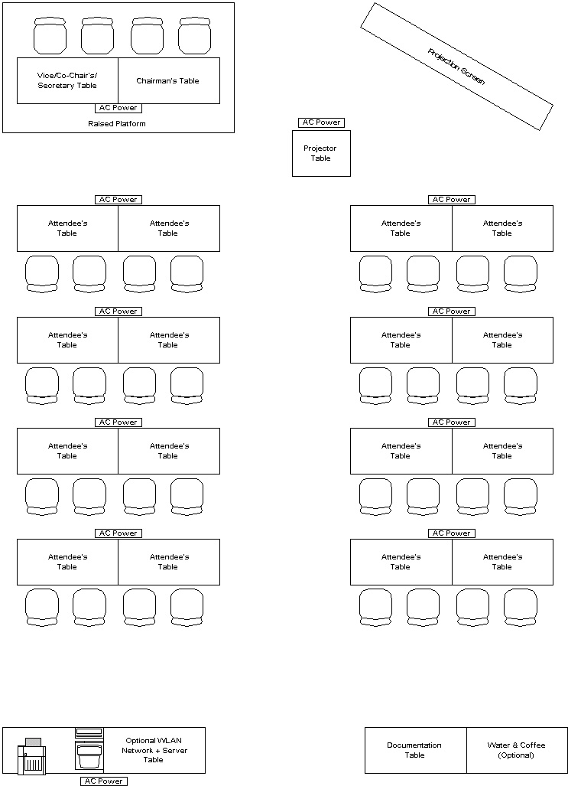

Meeting Room Layout #2

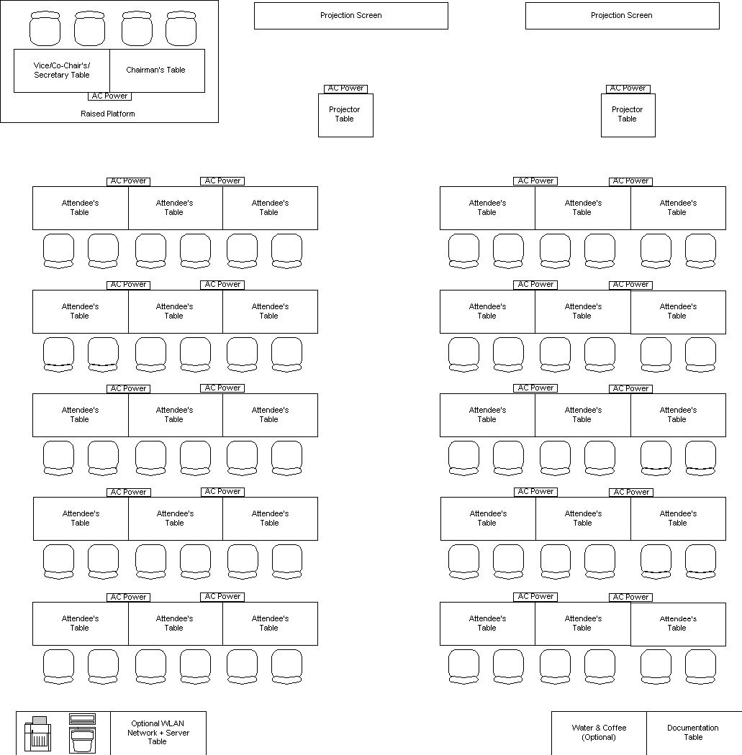

Meeting Room Layout #3
