IEEE P802.15
Wireless Personal Area Networks

Project | IEEE P802.15 Working Group for Wireless Personal Area Networks (WPANs)
Title | A Physical Layer submission for the High Rate 802.15.3 Standard
Date Submitted | [11 July, 2000]
Source | [Walter L. Davis]  [Motorola, Inc.]  [1303 E. Algonquin Road  Schaumburg, Illinois 60196] | Voice: [847-576-1849]  Fax: [847-576-5292]  E-mail: [Walt.Davis@motorola.com]
Re: | [Physical layer proposal, in response of the Final Call for Proposal.]
Abstract | [This contribution is a WPAN proposal for a high performance 30 Megabit per second, 5GHz system that addresses the requirements of a large number of wireless multimedia applications. The system is based on proven, low cost RF technology at the Physical Layer level, and on an extension of the BlueTooth TDMA protocol at the MAC layer. It provides for real-time transport of a number of real-time data streams while offering the advantages of quick time to market via the use of proven technology and low system cost due to the use of simple receivers and transmitters. It also provides for the low power drain that is essential for personal portable applications by making extensive use of protocol based battery saving techniques.]
Purpose | [To consider this proposal for the definition of a high rate wireless PAN.]
Notice | This document has been prepared to assist the IEEE P802.15. It is offered as a basis for discussion and is not binding on the contributing individual(s) or organization(s). The material in this document is subject to change in form and content after further study. The contributor(s) reserve(s) the right to add, amend or withdraw material contained herein.
Release | The contributor acknowledges and accepts that this contribution becomes the property of IEEE and may be made publicly available by P802.15.
A Physical Layer proposal for the High Rate 802.15.3 Standard

This document describes a proposed Physical Layer for a high speed Wireless Personal Area Network system that is focused on meeting the needs of low cost, real-time multimedia applications. The target applications involve the transmission of real-time video and audio multimedia signal streams together with less time critical computer communication and telephony signals between devices on or near people.

This new Physical Layer is based on simple, proven and low cost RF technologies, and meets the performance criteria established by the 802.15.3 Working Group. More specifically, the new Physical Layer is based on a direct FM radio link that operates in the unlicensed 5 GHz band. The system uses four-level, direct FM modulation of a fixed carrier signal, enabling the use of simple receiver and transmitter architectures, and also uses directional antennas to minimize interference and eliminate the problems associated with multi-path delay spread. The directional antenna pattern is envisioned as an array of four individual antennas with approximately 90° beam widths that can be formed on a printed circuit board or module substrate, and the proposed physical layer supports the automatic selection of the “best” antenna for the active link.

The companion MAC layer proposal is based on an extension of the BlueTooth protocol, and is also similar in many respects to the real-time extensions that have been proposed for the 802.11 protocol. The TDMA-like transmission format can support the transmission of several (up to 63) data streams with priorities that range from the highest priority real-time requirements such as video, to interruptible, low priority non-time critical tasks such as computer file transfers. The present Physical Layer proposal is designed to support the needs of the MAC Layer at a lower cost than either the current BlueTooth or 802.11 physical layers.

Together, the proposed Physical Layer and MAC Layer, are focused on providing a low cost system that will operate reliably, be relatively immune to interference, and not interfere with devices operating in its vicinity. In addition, multi-format operation – i.e., BlueTooth1 + the new format - is envisioned and very practical.
- System Operation:

Half-Duplex, isochronous operation that supports real-time multimedia data transport among up to 63 nodes. The system supports a mesh topology that allows peer-to-peer, point-to-point and point-to-multipoint operation.

- Operating Frequency:

The system will operate in the 5.15 to 5.25 GHz and 5.25 to 5.35 GHz segments of the 5 GHz ISM band. Operation in this band will provides for unlicensed operation in the U.S. North America, South America (pending) and Asia.

- Modulation Technique:

4-Level Direct FM as depicted in Figure 2. The use of the this simple modulation technique makes the receiver design simple and low cost – a linear receiver front-end, such as that required for OFDM modulation is not needed – rather, a traditional, lower cost limiting design can be used. The cost of the transmitter is also reduced relative to other approaches. Thus, the cost of the RF transceiver is lower than the cost of the current frequency hopping BlueTooth transceivers on an equivalent unit volume basis.

- Modulation Rate:

15 MegaSymbols per second of Four Level FM = 30 Megabits per second.

- Signal Bandwidth:

12 MegaHertz at –20 dB. The spectrum of the transmitted signal is shown in Figure 2.

- Number of Channels:

The 5.15 to 5.35 band will accommodate 13 channels spaced 15 MHz apart as shown in Figure 3. The 10 MHz spacing from the band ends insures that the splutter into the adjacent spectrum will be well below the FCC limit of –28 dB below the carrier power.

The low capture ratio of the receiver and the directional antennas will allow for a high degree of frequency re-use in a close geographic area, so that a large number of channels is not needed.

- Antenna System:

The system will use a simple array of very low cost directional antennas that can be etched patterns on the transceiver printed circuit board or substrate. At 5 GHz, a quarter wave stub is 0.6 inches long, so the antenna pattern can be very small in terms of occupied board area.

The “best” antenna is selected by evaluating the quality of the received signal during synchronization blocs embedded in the signaling format. The quality of the signal can be judged by either the received signal strength or bit error rate.

An illustration of an appropriate set of antenna patterns is shown in Figure 4.

- Delay Spread Protection:

The combination of the low capture ratio (5 to 6 dB) and the directional selectivity provided by the antenna system provide excellent immunity to multi-path generated delay spread. Reflected signals are at least –3 dB down from the main signal, and increased path losses plus the antenna gives another –4 dB to – 10 dB of path loss, insuring rejection of nearly all multi-path signals.

- Receiver Architecture:

As mentioned previously, the receiver associated with the new Physical Layer can be a simple Direct FM design. One such configuration for a commercial, single conversion 5 GHz receiver is shown in Figure 5. A more cost effective direct conversion or “Zero IF” architecture is shown in Figure 6.

Both of these receiver architectures can be implemented on a single integrated circuit chip fabricated with commercially available SiGe BiCMOS fabrication process. Several manufacturers now have SiGe BiCMOS in production, and are capable of providing low cost, single chip 5 GHz transceivers. In addition, the RF selectivity elements of the receiver can readily be implemented as filter structures on ceramic or other substrate materials.

Because of the simple nature of the receiver, it is anticipated that, at comparable unit volumes, it will be lower cost than the more complex receiver required for BlueTooth.

- Receiver Sensitivity:

Data from existing products that use 10 Megabit per second FSK modulation at 5 GHz indicate that, with a 5 dB receiver noise figure, a receiver for the proposed system would provide an uncorrected bit error rate of 1E-4 at an input power level of –90 dBm.

- Transmitter Architecture:

The transmitter configuration required to support the new Physical Layer can also be a simple conventional direct FM design, as shown in Figure 5. The transmitter in this system does not have to frequency hop, leading to a simpler design relative to the current BlueTooth system.

- Transmitter Power Output:

200 milliwatts maximum. The constant envelope FM modulation permits a limiting power amplifier to be used, which greatly simplifies the transmitter design and lowers its cost relative to other approaches.

- Operating System Range:

>10 meters with <20 milliwatts output power for clear line-of-site operation
>10 meters with <200 milliwatts output power for transmissions through obstacles

- Comparison to Solution Criteria Matrix:

Unit Manufacturing Cost: The manufacturing cost will be less than 1.5 times BlueTooth due to the simplified Receiver and Transmitter configurations. The new MAC is expected to require 50,000 gates to implement versus the 40,000 needed to implement the 802.15.1 MAC, which amounts to a MAC cost difference of less than $0.10. Further, the added cost of operating at 5 GHz versus 2.4 GHz is minimal. The expected system cost in volume is less than $30.

Interference and Susceptibility: Due to the robust nature of the simple receiver design, the in-band and out-of-band performance is in the “+” category. Current commercial 5 GHz products based on a similar design have >35 dB of interference protection.

Intermodulation Resistance: The robust nature of the receiver design yields excellent Intermodulation Resistance. The commercial 5 GHz products referred to previously have Intermodulation levels that are better than 60dB above the reference sensitivity. In this case, 60 dB above –90bDm would be -30dBm.

Jamming Resistance: The jamming test has not been performed, but it is anticipated that the low capture ratio of the receiver will provide enhanced performance in this area.

Multiple Access: The system is designed to allow up to 13 co-located systems to operate
without affecting one another. Each channel can transport up to three video data streams as well as up to 60 other data streams. Thus, the rating is in the “+” category.

Coexistence: In that the proposed system operates at 5 GHz, it can readily co-exist with 802.15.1 systems, and sources 1 and 2 are covered. It will also co-exist with 2.4 GHz 802.11b systems. More tests need to be conducted for the other two cases, but the wideband FM modulation used in the proposed system should have minimum impact of the spread spectrum and frequency hopped signals of the other protocols. The rating based on current information is “Same” pending further evaluation.

Interoperability: The proposed system will be able to communicate with 802.15.1 devices via dual-mode operation. Here, an 802.15.1 MAC can be added to the system (estimated complexity ~ 40,000 logic gates, or about 1 mm² at $0.12 incremental cost on a CMOS chip), and the frequency synthesizer in the transceiver can provide for dual-band 2.4 GHz and 5 GHz operation.

Manufactureability: The proposed system is based on proven RF and IC technologies. A similar 5 GHz transceiver is in production, and the IC technologies needed to provide the projected costs are readily available. A sample of a working transceiver will be shown during the July 10, 2000 presentation, and working demo is also planned. The rating is “+”.

Time to Market: The proposed system could be deployed in 4Q2001 in volume. The rating is “+”.

Regulatory Impact: The operation of the proposed system meets existing regulatory standards in Asia and North America. The regulatory bodies in South America are moving the adopt the U.S. standards, and there is a proposal pending in Europe to license similar 5 GHz 802.11 systems. The current rating is “False” pending these changes.

Maturity of Solution: The proposed system is based on proven RF and IC technologies. A similar 5 GHz transceiver is in production, and the IC technologies needed to provide the projected costs are readily available. A sample of a working transceiver will be shown during the July 10, 2000 presentation, and working demo is also planned. The rating is “+”.

Scalability: The proposed system is scalable in the areas of power consumption, data rate, cost and function. The power consumption will be improved over time by improvements in the level of circuit integration and by improvements in the battery saving schemes used in the protocol. The data rate can be adjusted up or down by adjusting the number of levels used in the FM symbol – i.e., by switching form four-level modulation to two-level or eight level modulation. The cost will scale dramatically with increases in unit volume and in the level of circuit integration. Finally, the functionality can be scaled by adding support for multiple MAC layers, by providing for multi-band RF operation, or by changing system features such as the number of nodes that can be in a system, the number of real-time priority levels serviced, etc. The rating is “+”.

General Solution Criteria Comparison Values

CRITERIA | REF. |  | Comparison Values
 |  | - | Same | +
Unit Manufacturing Cost ($) as a function of time (when product delivers) and volume | 2.1 | > 2 x equivalent Bluetooth 1 | 1.5-2 x equivalent Bluetooth 1 value as indicated in Note #1  Notes:  1. Bluetooth 1 value is assumed to be $20 in 2H2000.  2. PHY and MAC only proposals use ratios based on this comparison | < 1.5 x equivalent Bluetooth 1
Interference and Susceptibility | 2.2.2 | Out of the proposed band: Worse performance than same criteria  In band: -: Interference protection is less than 25 dB (excluding co-channel and adjacent channel) | Out of the proposed band: based on Bluetooth 1.0b (section A.4.3)  In band: Interference protection is less than 30 dB (excluding co-channel and adjacent and first channel) | Out of the proposed band: Better performance than same criteria  In band: Interference protection is less greater than 35 dB (excluding co-channel and adjacent channel)
Intermodulation  Resistance | 2.2.3 | < -45 dBm | -35 dBm to –45 dBm | > -35 dBm
Jamming Resistance | 2.2.4 | Any 2 devices listed jam | Handle Microwave, 802.15.1 (2 scenarios) and 802.15.3 | Also handles 802.11 (a and/or b)
Multiple Access | 2.2.5 | No Scenarios work | Handles Scenario 2 | One or more of the other 2 scenarios work
Coexistence  (Evaluation for each of the 5 sources and the create a total value using the formula shown in note #3) | 2.2.6 | Individual Sources: 0%  Total: < 3 | Individual Sources: 50%  Total: 3 | Individual Sources: 100%  Total: > 3
Interoperability | 2.3 | False | True | N/A
Manufactureability | 2.4.1 | Expert opinion, models | Experiments | Pre-existence examples, demo
Time to Market | 2.4.2 | Available after 1Q2002 | Available in 1Q2002 | Available earlier than 1Q2002
Regulatory Impact | 2.4.3 | False | True | N/A
Maturity of Solution | 2.4.4 | Expert opinion, models | Experiments | Pre-existence examples, demo
Scalability | 2.5 | Scalability in 1 or less than of the 5 areas listed | Scalability in 2 areas of the 5 listed | Scalability in 3 or more of the 5 areas listed

Symbol
“0”
Symbol
“3”
Symbol
“1”
Symbol
“2”
Figure 1
Modulation Waveform for Four Level FM
f_{o} +7.5 MHz
f_{o} -7.5 MHz
f_{o} +2.5 MHz
f_{o} -2.5 MHz

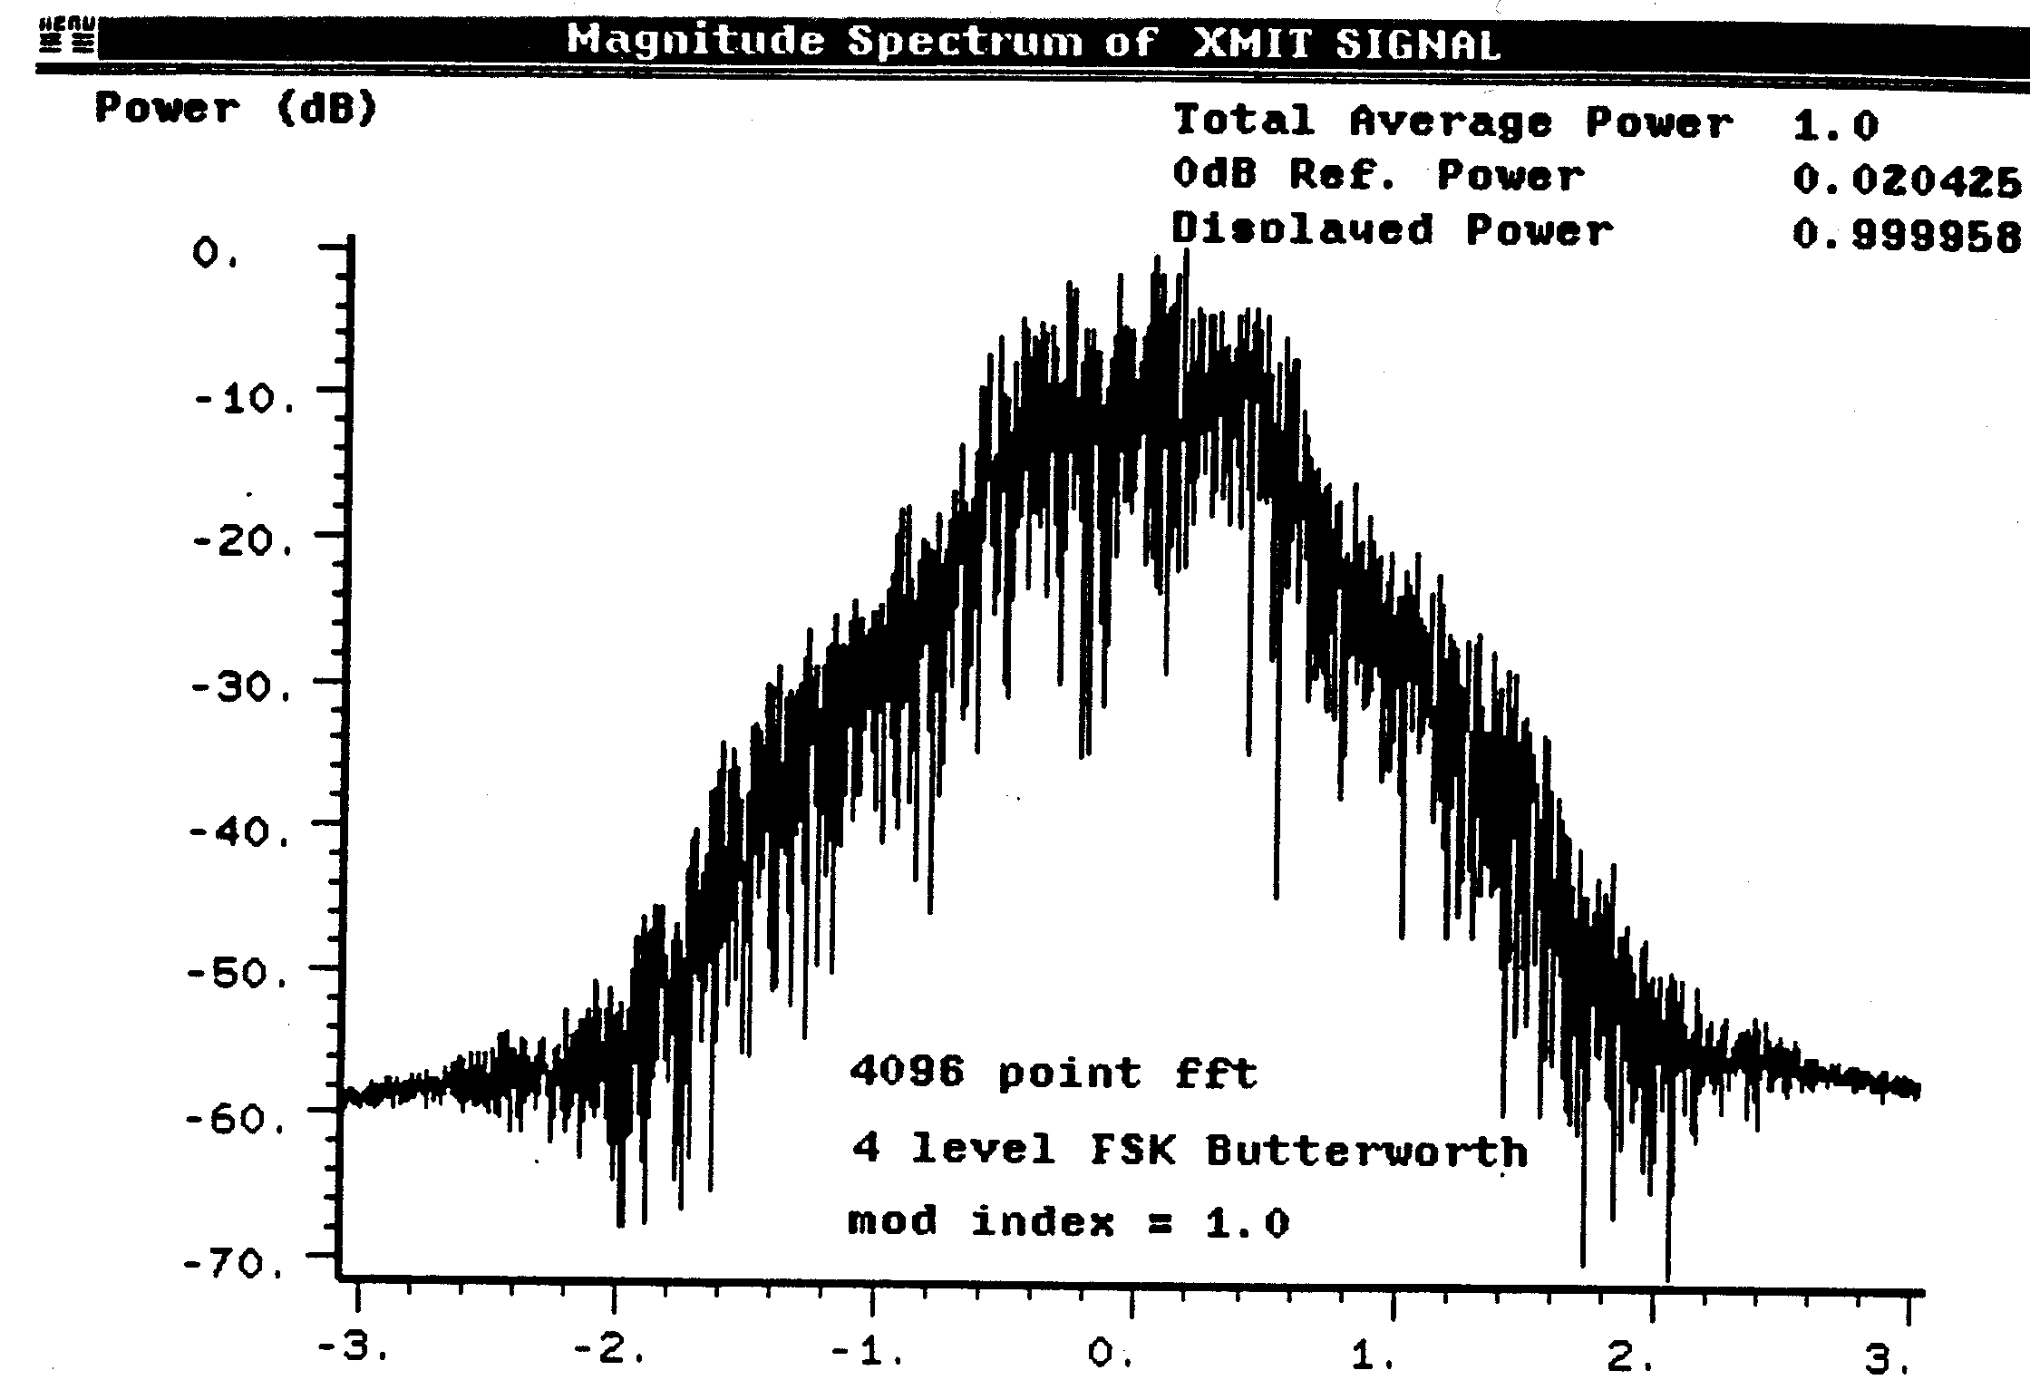
-20 dB BW
= ~ 12 MHz
Figure 2 Spectrum of Transmitted Signal
+7.5 MHz
-7.5 MHz
+15 MHz
-15 MHz

Antenna Array is printed on PC board or substrate,
or is plated on housing and has four broad beam patterns.
~90° Beam Width
Figure 4Example of Directional Antenna Patterns

