IEEE P802.15
Wireless Personal Area Networks

Project | IEEE P802.15 Working Group for Wireless Personal Area Networks (WPANs)
Title | Physical Layer Submission to Task Group 3
Date Submitted | Original: July 7th 2000  R4 update: September 11, 2000
Source | [Anand Dabak]  [Texas Instruments]  [12500 TI Boulevard, Dallas, Tx 75243] | Voice: [ 214-480-3289]  Fax: [ 972-761-6967]  E-mail: [ dabak@ti.com]
Re: | Changes in r4 to r5  - Appendix G on power consumption.  - Appendix F for video transmission
Abstract | A high rate WPAN with three modes is proposed. The mode 1 is Bluetooth, the mode 2 uses 64 QAM with Bluetooth hopping and transmits up to 3.9 Mbps. The mode 3 uses 16 QAM and transmits up to 44 Mbps. The cost of (mode 1 + mode 2) is estimated to be less than 1.2 x cost of Bluetooth and that of (mode 1 + mode 3) is estimated to be less than 1.5 x of Bluetooth.
Purpose | Discussion
Notice | This document has been prepared to assist the IEEE P802.15. It is offered as a basis for discussion and is not binding on the contributing individual(s) or organization(s). The material in this document is subject to change in form and content after further study. The contributor(s) reserve(s) the right to add, amend or withdraw material contained herein.
Release | The contributor acknowledges and accepts that this contribution becomes the property of IEEE and may be made publicly available by P802.15.
Physical Layer Submission to Task Group 3
Texas Instruments
1 September 2000
Authors: Anand Dabak, Tim Schmidl, Mohamed Nafie, Yaron Kaufmann, Oren Eliezer, Onn Haran, Alan Gatherer

- Introduction
In this document we propose a PHY layer solution to the IEEE 802.15 Task Group 3 that offers the best solution in terms of complexity vs. performance according to the criteria document [1] outlining the requirements for high rate wireless personal area network (WPAN) systems. The required data rates to be supported by the proposed high rate WPAN are given in [1]. The data rates for audio are 128-1450 kbps, for video are 2.5-18 Mbps and for computer graphics are 15, 38 Mbps. In order to have a cost-effective solution covering this wide range of data rates, we propose a three mode system in the 2.4 GHz band, the three modes comprising:
- Mode 1 being the Bluetooth 1.0 system having a data rate of 1 Mbps.
- Mode 2 using the same frequency hopping (FH) pattern as Bluetooth using a 64 QAM scheme to support a data rate of up to 3.9 Mbps.
- Mode 3 using direct sequence spread spectrum (DSSS) transmitting up to 44 Mbps
The proposed system parameters are summarized in table 1.1 below:

Table 1.1: Summary of the proposed system parameters
Mode | Data rate (Mbps) | Target application | Receiver sensitivity | Power consumption (‘2001)
 |  |  |  | Rx. average | Tx. average
Mode 1.0 (Bluetooth) | 1 Mbps |  | -84 dBm* | 33 mW | 20 mW
Mode 2.0 | 2.6-3.9 Mbps | Audio | -78 dBm | 53 mW | 40 mW
Mode 3.0 | 22-44 Mbps | Video, computer graphics | -69 dBm | 83 mW | 63 mW
*: Bluetooth specification is –70 dBm

Not all three modes must reside in each device. The most common combinations are likely to be:
- Devices capable of handling mode 1 and mode 2 covering Audio and Internet Streaming data rates of up to 2.5 Mbps while supporting Bluetooth interoperability.
- Devices capable of handling mode 1 and mode 3 covering DVD video-High Quality Game applications of up to 38 Mbps while supporting Bluetooth interoperability.
It is likely that access points and devices such as desktop or notebook PCs will be able to support the highest rate for any given device, i.e., will have all 3 modes.
The common configurations for the proposed system are shown in figure 1.1:

Configuration 1: Audio and internet streaming applications
Mode 1 (Bluetooth)
Mode 2(2.6-3.9 Mbps)
Configuration 2: video, computer graphics applications
Mode 1 (Bluetooth)
Mode 3(22-44 Mbps)

Figure 1.1: The different configurations for the proposed system.
Thus the key aspects of our proposed system are:
- Interoperability with Bluetooth: A high rate WPAN piconet can accommodate several mode 1 (Bluetooth) and mode 2 or mode 3 devices simultaneously.
- High throughput: In mode 3 the high rate WPAN supports 6 simultaneous connections each with a data rate of 21 Mbps giving a total throughput of 6 x 21 = 126 Mbps over the whole 2.4 GHz ISM band. In mode 2 the high rate WPAN supports the same number of connections as Bluetooth with a data rate of up to 3.9 Mbps each.
- Coexistence: There is only a 10% reduction in throughput for a Bluetooth connection in the vicinity of the proposed WPAN. The probe, listen and select (PLS) technique of the high rate WPAN implies a 0% reduction in throughput for an 802.11 WLAN in the vicinity of the proposed WPAN.
- Jamming resistance: The probe, listen and select (PLS) technique ensures that the WPAN system avoids interference from microwave ovens, Bluetooth and 802.11, thus making it robust to jamming.
- Low cost: The similarity of the WPAN system to Bluetooth implies that the total cost for a device supporting mode 1 and mode 2 is expected to be less than 1.2x the cost of Bluetooth, and the total cost for a device supporting mode 1 and mode 3 will be less than 1.5 x the cost of Bluetooth.
- Low sensitivity level: The sensitivity for mode 2 is –78 dBm for a nominal packet error rate of 10⁻¹ and for mode 3 is –69 dBm for a packet error rate of 10⁻⁴.
- Low power consumption: The estimated power consumption for mode 2 by next year is 53 mW average for receive and 40 mW average for transmit. The estimated power consumption for mode 3 is 83 mW average for receive and 63 mW average for transmit.
- FCC compliance: Since the proposed FH pattern and channel bandwidth for mode 2 are the same as Bluetooth and the DSSS system of mode 3 is similar to 802.11b, the proposed system is designed to be FCC compliant.
- Compatibility with Bluetooth MAC: Because of the similarity of the proposed high rate WPAN system to Bluetooth, the Bluetooth MAC with modifications can be employed.
- Low risk solution: The proposed WPAN system has similarities to Bluetooth and 802.11. The proposed Turbo codes are similar to those implemented for the 3rd generation cellular systems. Since all the above are mature technologies, this should allow a fast low risk implementation of the proposed system.

2.0 System Description: Mode 2
Operation mode 1 in the proposed system is Bluetooth, which is described in detail in the Bluetooth specification document. This section describes operation mode 2 of the system. Table 2.1 summarizes the system parameters for mode 2 and also compares it to mode 1 of the system:

Table 2.1: System parameter definition for mode 2

Parameters | Mode 1  (Bluetooth) | Mode 2
Frequency hopping | 1600 hops/sec | Same as Bluetooth
Filter spectrum |  | Same as Bluetooth (table 2.2)
Modulation | GFSK | 16, 64 QAM
Maximum data rate | 1 Mbps | 2.6, 3.9 Mbps
Acquisition |  | Using mode 1 then switch to mode 2
Transmit power | 0 dBm | 0 dBm, 6 dBm
Distance | 10 m. | 10 m.
Nominal packet error rate | 10 % | 10 %
Fading margin | 24 dB | 24 dB
Noise figure + receiver degradations | 13 dB | 13 dB
Total margin | 24 + 13 = 37 dB | 24 + 13 = 37 dB
Receiver sensitivity | -84 dBm* | -84, -78 dBm
Coding | ARQ | ARQ + convolutional code across packets

*: Bluetooth specification is –70 dBm
As mentioned in the table 2.1, the Bluetooth sensitivity is –70 dBm. However, this specification is very relaxed and typically the sensitivity can be achieved at –84 dBm. The symbol rate for mode 2 is 0.65 Msymbols/s giving a bit rate of 2.6 Mbits/s for 16 QAM and 3.9 Mbits/s for 64 QAM. The transmit spectrum mask for mode 2 is the same as Bluetooth and is given in table 2.2 below, where the transmitter is assumed to transmit on channel M and the adjacent channel power is measured on channel number N.

Table 2.2: Transmit spectrum mask for high rate WPAN mode 2.

Frequency offseth | Transmit power
+/- 500 kHz | -20 dBc
|M-N| = 2 | -20 dBm
|M-N| >= 3 | -40 dBm
The above spectrum mask can be achieved using a raised cosine filter of alpha = 0.54 and a 3 dB bandwidth of 0.65 MHz for the symbol rate of mode 2 of the proposed system. The Master and Slave first synchronize to each other and communicate using mode 1 and then enter mode 2 upon negotiation. Figure 2.1 shows the transition diagram for the Master and Slave to enter and exit mode 2.

Master and slave in mode 1. Transmit Sniff and Beacon for other mode 1 devices. Negotiate to enter mode 2 of higher speed transmission.
Master and slave transmit and receive in mode 2. Negotiate to enter back into mode 1, or revert to mode 1 upon extended loss of connection.

Figure 2.1: State transition diagram for Master and Slave to enter and exit mode 2.

The entry into and exit from mode 2 is negotiable between the Master and the Slave. The frame format structure for the Master to Slave and the Slave to Master transmission in Mode 2 is similar to that of Mode 1 and is shown in figure 2.2:
20 symb.
32 symb.
27 symb.
LSB
MSB
0-1780 symb.
Preamble
30.8 μs
Sync. Word
49.2 μs
Header
41.5 μs
Payload
0-2738 μs
40 bits
64 bits
54 bits
0-7120 bits for 16 QAM
0-10680 bits for 64 QAM

Figure 2.2: Frame structure for mode 2

The Preamble consists of the pattern (1+j)*{1, -1, 1, -1, 1, -1, 1 ,–1, 1, -1, 1, -1, 1, –1, 1, -1, 1, -1, 1, -1} and it aids in the initial symbol timing acquisition of the receiver. The Preamble is followed by the 64 bit sync. word used by Bluetooth transmitted using quadrature phase shift keying (QPSK) implying 32 symbol transmission of mode 2. The sync. word is followed by the 54 bit header of Bluetooth transmitted using QPSK modulation implying 27 symbols of mode 2. The farthest constellations in the 16/64 QAM are employed for the transmission of the Preamble, Sync. Word and Header as shown in figure 2.3 for 16 QAM.

Used for Preamble, Sync. word and Header transmission

Figure 2.3: The 16 QAM constellation and constellation points used for transmission of Preamble, Sync. Word and Header for mode 2 is shown.

The Header is followed by a payload of 1 slot or up to 5 slots, similar to Bluetooth. The maximum number of bits in the payload is thus 7120 bits for 16 QAM and 10680 bits for 64 QAM transmission. The Master can communicate with multiple slaves in the same piconet some slaves in mode 2 and others in mode 1 as shown in figure 2.4:
Master
Slave 1
Slave 2
Slave 3
Mode 1
Mode 2
Mode 1

Figure 2.4: Master communicating simultaneously to some Slaves in mode 1 and others in mode 2.

For an SCO HV1 link between the Master and Slaves 1, 3 and Slave 2 in mode 2, the timing diagram for the system is shown in figure 2.5 below:
M
M
S₃
S₁
Mode 1
M
S₁
M
S₂
M
S₂
M
S₃
Mode 1
Mode 2
Mode 2
Mode 1
Mode 1
Mode 1
Mode 1
Mode 2
Mode 2
Mode 1
Mode 1

Figure 2.5: Timing diagram for Master communicating with Slaves 1, 3 on an SCO HV1 link and Slave 2 in mode 2.

The Master sustains the Sniff and Beacon operations to keep other mode 1 units synchronized. The link manager in the Master ensures this by prioritizing those packets over mode 2.

A block diagram for receiver algorithms for acquisition and packet reception in mode 2 is shown in figure 2.6:

Set automatic gain control (AGC) and acquire symbol timing using preamble
Acquire sync. word and packet timing
Do channel estimation using sync. word
Receive header
Receive packet

Figure 2.6: Block diagram of receiver algorithms for acquisition and packet reception in mode 2

A receiver block diagram for mode 2 is shown in figure 2.7.
LNA
Filter
RF/IF
BPF filter
IF to baseband mixer, amplifier
I
Q
A/D
A/D
Filter
Filter
Automatic gain control (AGC)
D/A
Symbol timing acquisition
Sync. word acquisition, channel estimation
Header, packet demod.
Rate ½, K = 5, Viterbi decoder (for ARQ packets only)
CRC check
Bits out
Tx/Rx Switch
gain control

Figure 2.7: The receiver block diagram for mode 2 is shown.
The transmitter block diagram for mode 2 is shown in figure 2.8:

PA
Filter
IF/RF
BPF Filter
Upconvert to IF
I
Q
D/A
D/A
Filter
Filter
Tx/Rx Switch
Data
bits in

Figure 2.8: The transmitter block diagram for mode 2 .

Several blocks can be shared between the transmitter and the receiver of figures 2.7 and 2.8 to reduce the overall cost of the transceiver. Similarly, several blocks of the transmitter and receiver can be shared between modes 1 and 2, thus reducing the overall cost of a transceiver supporting both mode 1 and mode 2.

A convolutional code of rate ½, K = 5 is used to improve the packet error rate performance in the presence of automatic repeat requests (ARQ). Whenever the CRC of a packet is detected in error, the transmitter sends the parity bits in the retransmission. The receiver combines the received data across packets in the Viterbi decoder to improve the overall performance of the receiver. A flow diagram of the scheme is shown in the figure 2.9 below:
Transmitter, data bits
Receiver
Rate ½, K = 5 encoding
Send source data bits
CRC correct ?
No, request ARQ
Send parity bits
Combine data and parity bits. Do Viterbi decoding.
CRC correct ?
Yes, pass data to higher layer
Yes, pass data to higher layer
No, Discard previous packet. Request ARQ
Send data bits
Combine data and parity bits. Do Viterbi decoding.
Yes, pass data to higher layer
CRC correct ?
No, Discard previous packet. Request ARQ
CRC correct ?
No
CRC correct ?
Yes, pass data to higher layer
No
Yes, pass data to higher layer

Figure 2.9: A flow diagram of the ARQ and error correction mechanism in mode 2 .

Figure 2.10 below compares the throughput of Bluetooth against that of the proposed Mode 2 assuming a single path independent Rayleigh fading channel for each hopping frequency. This is a reliable model for mode 2, considering the exponential decaying channel model specified in the criteria document [1].

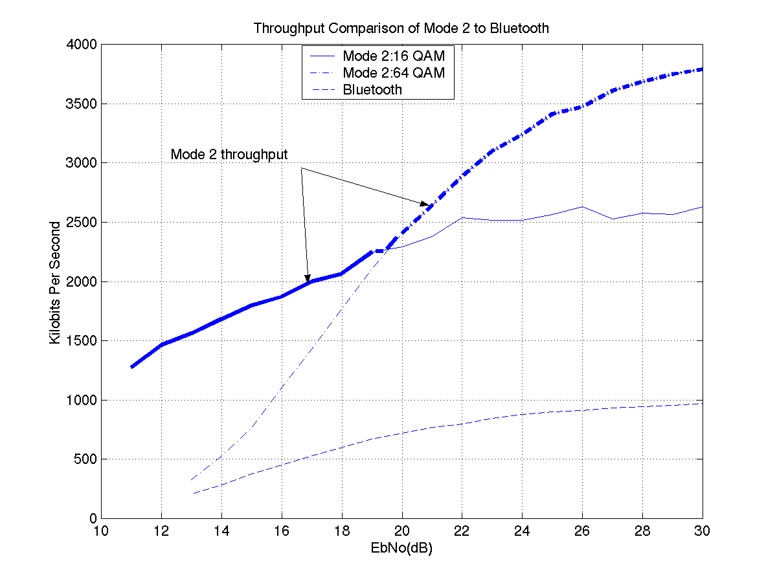

Figure 2.10: Simulation results of the throughput comparison of Mode 2 to Bluetooth

The x-axis is the average Eb/N0 of the channel over all the hopping frequencies. The results show that for 16 QAM mode 2 achieves 2.6 x throughput of Bluetooth and for 64 QAM it achieves 3.9 x throughput of Bluetooth (when the Eb/No is sufficiently high), similar to the ratios of the proposed transmission bit rates (2.6Mbps and 3.9Mbps respectively).
3.0 Mode 3 System Description

Table 3.1 summarizes the system parameters for mode 3.

Table 3.1: System parameter definition for mode 3.

Parameters | 1 | 2 | 3 | 4 | 5
Filter spectrum | 802.11b | 802.11b | 802.11b | 802.11b | 802.11b
Modulation | QPSK | QPSK | 16 QAM | 16 QAM | 16 QAM
Scrambling code length | 256 | 256 | 256 | 256 | 256
Symbol rate | 11 Msps | 11 Msps | 11 Msps | 11 Msps | 11 Msps
Coding | Rate ½, Turbo (SCCC) | None | Rate ½, Turbo (SCCC) | Rate ¾, Turbo (SCCC) | None
ARQ | Optional | Optional | Optional | Optional | Optional
Data rate | 11 Mbps | 22 Mbps | 22 Mbps | 33 Mbps | 44 Mbps
Transmit power | -1 dBm | 8 dBm | 4 dBm | 8 dBm | 15 dBm*
Distance | 10 m. | 10 m. | 10 m. | 10 m. | 10 m.
Bit error rate | 1e-8 | 1e-8 | 1e-8 | 1e-8 | 1e-8
Packet error rate | 1e-4 | 1e-4 | 1e-4 | 1e-4 | 1e-4
Fading margin | 24 dB | 24 dB | 24 dB | 24 dB | 24 dB
Noise figure + receiver degradations | 13 dB | 13 dB | 13 dB | 13 dB | 13 dB
Total margin | 24 + 13 = 37 dB | 24 + 13 = 37 dB | 24 + 13 = 37 dB | 24 + 13 = 37 dB | 24 + 13 = 37 dB
Receiver sensitivity | -85 dBm | -76 dBm | -80 dBm | -76 dBm | -69 dBm
Frequency diversity | Band selection | Band selection | Band selection | Band selection | Band selection
*Updated in Appendix E.

The symbol rate in the different modes is set to 11 Msymbols/s which is the same 802.11(b). The transmit spectrum mask is also specified to be the same as 802.11(b) and is given in Table 3.2. Also, comparing to table 2.1, notice that the total margin allocated for mode 3 is the same as Bluetooth.

Table 3.2: Transmit spectrum mask for mode 3 (same as 802.11(b)).

Frequency offset | Transmit power
fc | 0 dBc
+/- 11MHz | -30 dBc
+/- 22 MHz | -50 dBc

As is done in mode 2, here also the master and slave start communicating in mode 1. If both devices agree to switch to mode 3, the probe, listen and select (PLS) protocol for frequency band selection is activated. This protocol allows the master to choose the best contiguous 22 MHz band in the entire 79 MHz band to transmit on using mode 3. This gives frequency diversity gains. The simulation results for the packet error rate (PER) for the 802.15.3 exponential channel model as specified in [1] for a delay spread of 25 ns comparing probe, listen and select (PLS) versus no PLS is shown in figure 3.1 below. The delay spread of 25 ns. gives a frequency diversity of 3 to the PLS technique over the 79 MHz ISM band.
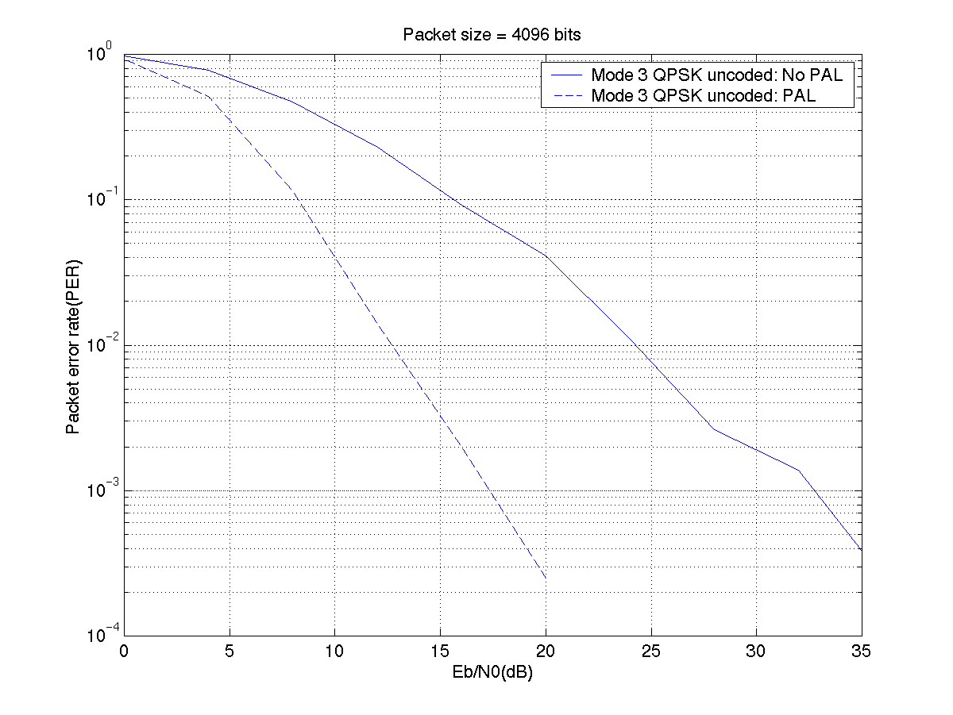
Mode 3 QPSK uncoded : No PLS

Mode 3 QPSK uncoded : PLS

Figure 3.1: The performance gains by using probe, listen and select (PLS) technique are shown. The 802.15.3 exponential fading channel model with a delay spread of 25 ns. gives a frequency diversity of 3 to the PLS over the 79 MHz ISM band.

Therefore, a system employing modes 1 and 3 can be described by the following:
- Begin transmission in mode 1 and identify good 22 MHz contiguous bands.
- Negotiate to enter mode 3. After spending a time T₂ in mode 3 come back to mode 1 for time T₁.
- The master can communicate with other Bluetooth devices using mode 1 and also transmit the Beacon, Paging signals for mode 1.
- Identify good 22 MHz bands.
- Again negotiate to enter mode 3, this time possibly on a different 22 MHz band.

In order to have a better coexistence with the 802.11, the 22 MHz bands that are selected can be constrained to certain subbands. Thus band 1 can be 2402-2428 MHz, the band 2 can be 2428-2454 MHz and band 3 can be 2454-2480 MHz. Thus there are four possibilities (in steps of 1 MHz) for a 22MHz band selection in the band 1. The PLS technique in the Bluetooth mode allows a fine selection over 4 MHz in band 1 to choose a 22 MHz band. Similarly, bands 2 and band 3 allow four possibilities each in steps of 1 MHz for the 22 MHz band selection.
An example with T₁=25 ms and T₂= 225 ms is shown in Figure 3.2. These choices allow transmission of 6 video frames of 18 Mbps HDTV MPEG2 video every 250 ms. We now give the state transition diagram to and from mode 3 to mode 1.
System in mode 1 (Bluetooth 1.0) for 25 ms. Transmit Sniff and Beacon signals for mode 1 devices. Communication with other Bluetooth devices, 17.5 ms. Search for good frequencies (PLS) for 7.5 ms.
System in mode 3 achieves high data transmission on one of the good 22 MHz bands selected in mode 1. Revert to mode 1 after 225 ms to find a new good frequency and communicate with other Bluetooth devices. Or revert to mode 1 upon extended loss of connection
Slot timing of
625 μs of Bluetooth
is maintained.

Figure 3.2: An example state transition diagram of the system operating in modes 1 and 3 is shown.

A master can thus communicate with several devices in mode 1 while communicating with other devices in mode 3 as shown in Figure 3.3.

Master
Slave 1
Slave 2
Slave 3
Mode 1
Mode 3
Mode 1

Figure 3.3: Master communicating simultaneously to some slaves in mode 1 and others in mode 3.

A timing diagram illustrating transmission in modes 1 and 3 is shown in figure 3.4.
Mode 1
Mode 3
Mode 1
Mode 3
Mode 1
Mode 3
0
25
250
275
500
525
Time (
ms
)
17.5
ms
7.5
ms
Communicate with other Blueooth devices (paging, sniff, beacon etc.)
Select good 22 MHz band using Probe, listen and select (PLS)
T₁
T₂

Figure 3.4: An example timing diagram for modes 1 and 3 is shown. The Master and Slave communicate in Mode 3 for T₂ = 225 ms while the remaining T₁ = 25 ms are used for communicating with other Slaves and for probe, listen and select (PLS) to determine the best 22 MHz transmission for the next transmission in mode 3.

The Mode 3 maintains the 625 μs. slot timing of Bluetooth. Hence the Master sustains the Sniff and Beacon operations to keep other mode 1 units synchronized whenever the system returns to mode 1.

3.1 Probe, listen and select (PLS) Procedure
Since the Bluetooth (mode 1) hardware is capable of hopping at the maximum rate of 3200 hops/s, this rate is used for channel sounding. This means that the duration of each slot is 312.5 microseconds. A pseudorandom hopping pattern is used. This pattern is chosen such that the entire 79 MHz range is sampled in 5 MHz steps to identify the best 22 MHz frequency band. Using this hopping pattern the master sends the slave short packets of the format shown in Figure 3.5 in mode 1 (Bluetooth). Notice that the master-to-slave packet is the same as a Bluetooth ID packet. The slave estimates the channel quality based upon the correlation of the access code. After 16 packets (each of time duration 312.5 microseconds), the slave will decide on the best contiguous 22 MHz channel to use in mode 3, and will then send the index of the lowest frequency of that band to the master for 8 times using 8 slots (each of time duration 312.5 microseconds). This index will be a number from 1 to (79 (bandwidth of ISM band)– 22 (bandwidth in mode 3) = 57), and so it needs a maximum of 6 bits. These 6 bits are repeated 3 times, so the payload of that packet will be a total of 18 bits. This leaves 226 μs for the turn around time.
Preamble
4 bits
Access Code
64 bits
Channel Edge Frequency Index
6*3 = 18 bits
Slave-to-master packet
Preamble
4 bits
Access Code
64 bits
Master-to-slave packet
7.5 ms
5.0 ms
2.5 ms
16 Master to Slave packets of 325 μs at 3200 Hz.
8 Slave to Master
packets of 325 μs
at 3200 Hz.

Figure 3.5: The timing diagram for the PLS procedure and the Master to Slave and the Slave to Master packets used for PLS.
The channel state of each 1 MHz sampling can be estimated by the correlation of the access code. This gives a good estimate of the amplitude of the fading parameter in that 1 MHz channel. The best 22 MHz channel can then be chosen using this information.
The hopping pattern is defined as follows:
Let o={0,5,10,15,20,25,30,35,40,45,50,55,60,65,70,75}.
The ith PLS frequency is defined to be
f(i)=(x+o(i))mod(79)
Here x is the index of the Bluetooth hopping frequency that would occur at the beginning of the PLS procedure. That is x = 0, 1, 2, …, 78. Here i is taken sequentially from the following pseudo random sequence:
P={16,4,10,8,14,12,6,1,13,7,9,11,15,5,2,3}.
The 8 slots on which the slave transmits to the master uses the first 8 frequencies of the sequence f(i); i = 1, 2, …, 8.
The above procedure can be summarized as follows:
- Master sends to the slave the ID packet on the frequencies determined by the sequence f(i). The transmit frequency is given by (2402 + f(i)) MHz.
- Slave estimates the quality of each channel using the correlation of the access code.
- After 16 slots, the slave estimates the best 22 MHz channel using all the measurements it has accumulated.
- The slave sends to the master the index of the lowest frequency of the best channel.
- The slave repeats step 4 a total of 8 times.
- Transmission starts in mode 3.

The PLS procedure applied to the exponentially fading 802.15.3 channel for a delay spread of 25 ns is shown in figure 3.6 where in the 79 MHz channel is sampled using the PLS procedure. The delay spread of 25 ns gives rise to a frequency selective channel over the 80 MHz ISM band. The frequency selectivity depends upon the channel conditions and it varies at different points in space and also varies across time at the same point in space depending upon the doppler rate of the environment. Figure 3.6 gives three examples of the typical channel response. It can be seen from figure 3.6 that the PLS procedure can identify the frequency nulls in the band and can be used to identify good 22 MHz band for the mode 3 transmission.
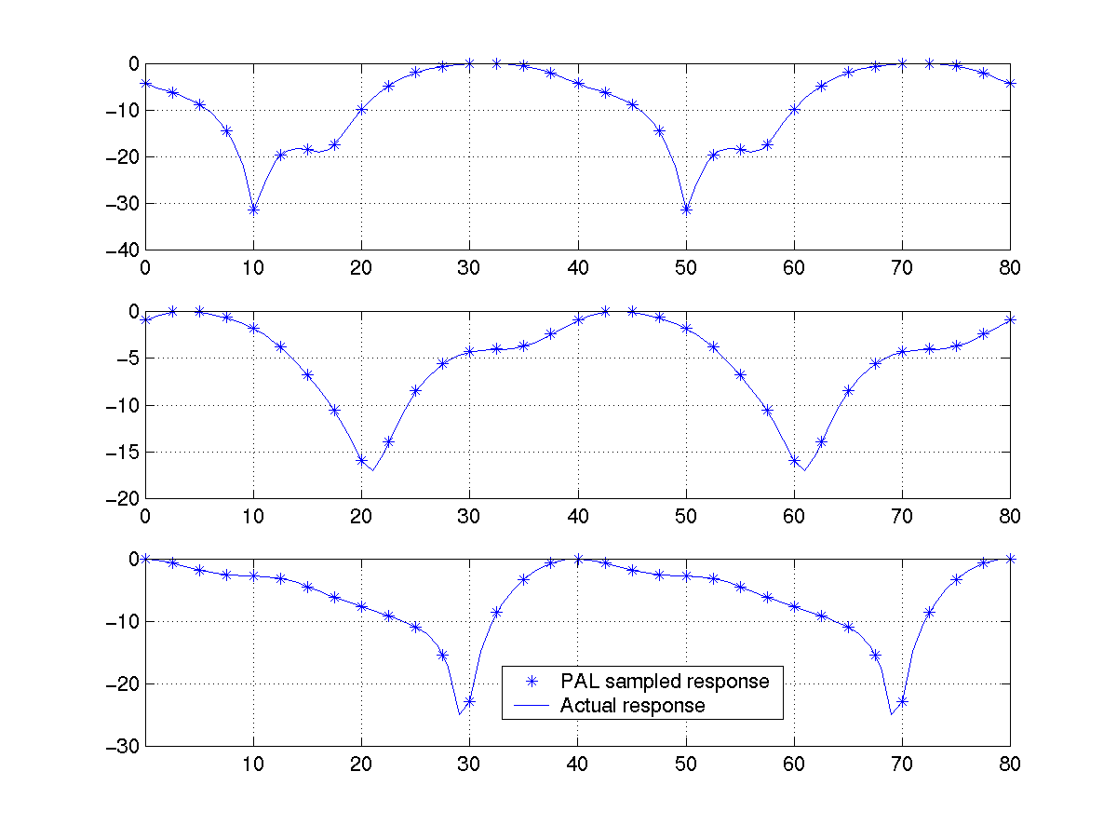
Figure 3.6: The sampling of 802.15.3 exponentially fading channel for a delay spread of 25 ns. at a 5 MHz spacing is shown. We can see that the a 5 MHz spacing can identify good 22 MHz contiguous bands in the 79 MHz bandwidth.

3.2 Slot Format for Mode 3
Several packets are transmitted from the Master to the Slave and vice versa in the time slot period T₂ allocated for mode 3 (see figure 3.4). A nominal packet size of 200 microseconds is used. During the initial handshake, the master and the slave agree on a certain number of packets to be sent in each direction. They also agree on the modulation scheme to be used in each direction. For the sake of simplicity, we discuss the techniques used in one-way communications. Two-way communications slot formats and ARQ techniques can be done similarly.
Figure 3.7 gives the slot format for the one way transmission (either from Master to Slave or Slave to Master without ARQ).

200 μs
One way Communications
with no ARQ
Master To Slave
T₂ s
T₂ s
200 μs
Master To Slave
Master To Slave
One way Communications with ARQ
Master To Slave
ARQ Packets from Slave to Master.

Figure 3.7 Slot Format in mode 3 is shown for the case of one way transmission from the Master to Slave without and with ARQ. The two way data transmission from Master to Slave and Slave to Master is also similar and is negotiated between the Master and Slave in the beginning of the transmission.

3.2.1 Retransmission Technique

ARQ and retransmissions are optional. Retransmissions can increase the system performance in case it is hit by an interferer (such as a Bluetooth device). In case of one-way communications, and if the ARQ is activated, the device receiving the communication sends a short packet of length half of a normal packet (100 microseconds) at the end of a certain number of packets. This number is agreed upon in initial handshaking. This short packet is preceded and followed by 100 microsecond guard intervals. In the short packet the reception of the packets is acknowledged. The index of packets whose CRC (cyclic redundancy check) did not match is indicated. Refer to figure 3.7 for one way transmission with ARQ. The retransmission technique is as follows:

- The master sends the slave a maximum of 100 (or a number negotiated between the Master and Slave) packets with CRC at the end of the packet.
- The slave checks if the packets were received without error.
- The slave sends the master a packet that has a payload of 100 bits (the ARQ packet in figure 3.7). Each bit corresponds to a received packet. The bit is 1 if the packet was received with no error, and is zero if it is received in error. A CRC is appended at the end of the ARQ packet.
- If the master receives the acknowledgment correctly, the master retransmits the requested packets to the slave. If the master does not receive the acknowledgment correctly then,

- The master sends the slave a packet of size 100 μs asking the slave for an acknowledgement.
- The master then listens for the slave’s transmission.
- Steps (a) and (b) are repeated by the master until it receives the acknowledgment and retransmits the packets or until the time slot T₂ ends wherein the Master and Slave have negotiated to go into Mode 1.
- Steps 2-4 are repeated until all the packets are received by the Slave correctly or the time slot slot T₂ ends wherein the Master and Slave have negotiated to go into Mode 1.
- If the time slot T₂ does not end in steps 4,5 the Master sends new packets to the Slave.
If the Master finishes sending all its packets before the time slot ends, it can go to mode 1 and communicate with other Bluetooth devices.

Point-to-multipoint communications is achieved by time division multiplexing between various slaves. Each time slot for each slave will be preceded by a PLS slot between the master and the concerned slave.

A flow diagram for the above is shown in figure 3.8:

Yes, pass data to higher layer, and send ARQ to master
Send 100 packets
CRC of all the packets correct ?
Received ARQ packet?
No, wait for master transmission
Received packets ?
Send Requested Packets
Yes
No
Send Request for ARQ
Yes
Data Packets ?
Yes
Master
Slave
Time slot ended ?
No
Yes, go to mode 1
All packets received correctly ?
No
Yes, done
Request ARQ of the packets whose CRC did not check
No
Request ARQ of all expected packets

Figure 3.8: The flow diagram for packet one way packet transmission in Mode3 with ARQ.

3.3. Packet Format

Each of the 200μs length packet in figure 3.7 consists of data bits and a CRC of length 32 bits. The CRC is a 32-bit sequence generated using the following polynomial

D³²+D²⁶+D²³+D²²+D¹⁶+D¹²+D¹¹+D¹⁰+D⁸+D⁷+D⁵+D⁴+D²+1.

This packet format is shown in figure 3.9:

MSB
0-2184 symb.
Payload
32 bits
16 QAM: 8736 bits
QPSK: 4368 bits
CRC
LSB

Figure 3.9: The data packet format for Mode 3 is shown.
Several of the packets in figure 3.9, the number of which is agreed upon in the initial handshake, are preceded by a training sequence for acquisition of timing, automatic gain control and packet timing. Typically 10 packets are preceded by the training sequence.

Figure 3.10 shows the format of the training sequence.
.
22 symb.
32 symb.
Preamble
2 μs
Sync. Word
2.9 μs
Header
2.45 μs
44 bits
64 bits
54 bits
27 symb.

Figure 3.10: The format of the training sequence for Mode 3 is shown. Several of the Mode 3 packets in figure 3.9 are preceded by the training sequence for initial acquisition.

Figure 3.11 illustrates diagrammatically the slot format of period T₂ s in mode 3 in more detail including the training sequence and the CRC.
Payload
Payload
Payload
Payload
. . . . .
Preamble
Sync.
word
Header
CRC
CRC
CRC
CRC

Figure 3.11: The slot format in Mode 3 shown in more detail.

The preamble consists of the pattern (1+j)*{1, -1, 1, -1, 1, -1, 1 -1, 1, -1, 1, -1, 1 -1, 1, -1, 1, -1, 1, -1, 1, -1} and it aids in the initial symbol timing acquisition by the receiver. The preamble is followed by the 64-bit sync. word used by Bluetooth transmitted using quadrature phase shift keying (QPSK) implying 32 symbol transmission of mode 3. The sync. word is followed by the header transmitted using QPSK modulation. The farthest constellations in the 16 QAM are employed for the transmission of the preamble, sync. word and header. The header is followed by a payload such that the total time occupied by the packet is 200 microseconds. The payload is then followed by the 32-bit CRC. No packet header number is required because no new packets are transmitted unless all the old packets have been received successfully. A single bit is allocated to each packet not received correctly and requested for retransmission in the ARQ packet.

The ARQ packet is of length 100 μs. and each ARQ packet is preceded by the training sequence. Since the payload of the ARQ packet is only 100 bits a repetition code is used to protect the ARQ payload. The ARQ packet format is shown in figure 3.12 below:

22 symb.
32 symb.
Preamble
2 μs
Sync. Word
2.9 μs
Header
2.45 μs
44 bits
64 bits
54 bits
27 symb.
1019 symb.
Payload (100 bits),
32 bits
CRC
100 μsec turn around time
100 μsec turn around time
100 μs ARQ packet length
repetition coded

Figure 3.12: The ARQ packet format is shown.

The above procedure allows the transmission of HDTV MPEG2 video at 19.8 Mbps. Assume that 24 frames/ s is transmitted for MPEG2 video. Thus, the Master transmits to the Slave 100 packets each of length 200μs, carrying a data payload of 2184 symbols. Assuming that 10 such packets are preceded by the training sequence of 81 symbols (figure 3.10), and we employ 16 QAM with rate ½ coding, we require 227.5 ms for transmission of 6 video frames. This leaves 15 ms for servicing other mode 1 devices in the piconet and 7.5 ms for PLS. Table 3.2 summarizes the transmission parameters for HDTV MPEG2 video transmission using mode 3:

Table 3.2: System parameters for transmission of MEPG2 HDTV video using Mode 3 are given.

MPEG2 HDTV Video transmission using Mode 3
Video data rate | 19.8 Mbps
Video frames/s | 24
Video frames/Mode 3 slot | 6
Mode 3 data rate | 22 Mbps
Coding | Rate ½, Turbo
Modulation | 16 QAM
Time in Bluetooth mode (T₁ ms) | 22.5 ms
Time in Bluetooth mode for other devices | 15 ms
Time in Bluetooth mode for PLS | 7.5 ms
Mode 3 packet size | 4.4 Kbits
Data bits/packet | 4368
CRC bits/packet | 32
Mode 3 packet length | 200 μs
Number of packets/slot | 1134
Length of training sequence | 81 symbols, 7.36 μs
Number of packets/training sequence | 10
Number of training sequences/packet | 114
Time required to transmit video frames with ARQ (slot time in mode 3, T₂ ms) | 225.2+1.5+0.76 = 227.5 ms

3.4 Transmitter and Receiver

The receiver algorithms for acquisition and packet reception in mode 3 are similar to mode 2. The receiver block diagram is shown in Figure 3.13.
Set automatic gain control (AGC) and acquire symbol timing using preamble
Acquire sync. word and packet timing
Do channel estimation using sync. word
Receive header
Receive packet

Figure 3.13: Block diagram of receiver algorithms for acquisition and packet reception in mode 3 is shown.

A receiver block diagram for the mode 3 is shown in Figure 3.14.

LNA
Filter
RF/IF
BPF Filter
IF to baseband mixer, amplifier
I
Q
A/D
A/D
Filter
Filter
Automatic gain control (AGC)
D/A
Symbol timing acquisition
Sync. word acquisition, channel estimation
Header, packet demod.
Tx/Rx Switch

Turbo Decoder
CRC check
Bits out
Descrambler

Figure 3.14: The receiver block diagram for mode 3 is shown.

The demodulator includes channel estimation, equalization, and symbol-to-bit mapping. The transmitter block diagram for mode 3 is shown in Figure 3.15.

PA
Filter
IF/RF
BPF Filter
Upconvert to IF
I
Q
A/D
A/D
Filter
Filter
Tx/Rx Switch
Data
bits in
Modulator
Cover Sequence

Figure 3.15: The transmitter block diagram for mode 3 is shown.

3.5 Modulation

Two modulation options are used.
3.5.1 QPSK
The cover sequence, S= {S_{i}}; i = 1, 2, .., 256,, used in 802.11 is used to spread the transmitted symbols. The mapping from bits to symbols is shown in Figure 3.16.
(1,0)
(1,1)
(0,0)
(0,1)
(0,0)
(1,0)
(0,1)
(1,1)
S_{i} =1
S_{i} =0

Figure 3.16: QPSK constellation for Mode 3.

3.5.1 16-QAM
The cover sequence, S = {S_{i}}; i = 1, 2, .., 256, used in 802.11 is used to spread the transmitted symbols. The mapping from bits to symbols is shown in Figure 3.17.
(1,1,1,1)
(1,0,1,1)
(1,1,0,1)
(1,0,0,1)
(1,1,0,0)
(1,0,0,0)
(0,0,0,1)
(0,1,0,1)
(0,0,0,0)
(0,1,0,0)
(0,1,1,1)
(0,0,1,1)
(0,0,1,0)
(0,1,1,0)
(1,1,1,0)
(1,0,1,0)
S_{i} =1
(1,1,1,1)
(1,1,1,0)
(1,1,0,0)
(1,1,0,1)
(1,0,1,1)
(1,0,1,0)
(1,0,0,0)
(1,0,0,1)
(0,1,1,1)
(0,1,1,0)
(0,1,0,1)
(0,1,0,0)
(0,0,0,0)
(0,0,0,1)
(0,0,1,1)
(0,0,1,0)
S_{i} =0

Figure 3.17: 16-QAM constellation..

3.6 Channel model and Channel Equalization
The exponentially delayed Rayleigh channel shown in Figure 3.18 is used to test the performance of our proposed systems.
Figure 3.18: Channel impulse response.

The complex amplitudes of the channel impulse response are given by
$$h_{i}=N(0,{σ_{k}^{2}}/2)+\text{jN}(0,{σ_{k}^{2}}/2)$$
$$σ_{k}^{2}=σ_{0}^{2}e^{{−{\text{kT}}_{s}}/{T_{\text{RMS}}}}$$
$$σ_{0}^{2}=1−e^{{−T_{s}}/{T_{\text{RMS}}}}$$
T_{RMS} = 25

This channel in mode 3 requires equalization, and this can be done in a variety of ways, we will briefly describe two of them.
3.6.1 Block MMSE-DFE Equalizer
A block diagram of an MMSE equalizer is shown in figure 3.19.
Bit Soft decisions
to threshold device
or to turbo decoder
Q
I
MMSE EQUALIZER
BLOCK DFE
Soft
Decisions

Figure 3.19: Block MMSE-DFE equalizer.
The Block MMSE-DFE Equalizer consists of an MMSE equalizer, followed by a block DFE. The MMSE produces decisions on all the symbols using the minimum mean squared error criterion and an estimate of the channel. The DFE subtracts the decisions of all the symbols obtained by the MMSE from the input signal and then produces a matched filter soft-decisions on all the symbols. These are then fed to the soft-decisions block that produces soft decisions on the bit-level. These are in turn fed to the turbo-decoder or to a threshold device in case of an uncoded system

3.6.2 MAP Equalizer
A block diagram of the MAP equalizer is shown in figure 3.20.

Q
I
MAP
EQUALIZER
Bit
Probabilities
Bit Probabilities
To threshold device
or to turbo decoder

Figure 3.20: MAP equalizer.
The MAP equalizer maximizes the aposteriori probability of the transmitted symbols given the received signal and an estimate of the channel. These are then converted to bit probabilities by summing over the symbols

3.7 Turbo coding

Video transmission typically requires a BER of 10⁻⁸, so turbo coding is used to achieve this error rate. Parallel concatenated convolutional codes (PCCC) are known to have an error floor at about 10⁻⁷, while serial concatenated convolutional codes (SCCC) do not have an error floor around these error rates and can meet the BER requirements. The SCCC given below in figure 3.21 was originally proposed in [3].

D
D
π
D

Figure 3.21: Block diagram of the proposed serial concatenated convolutional code (SCCC) is shown [3].

3.8 Simulation Results

The results of Monte-Carlo simulations are given in Figures 3.22 to 3.28. In all simulations a frame size with 4096 information bits was used and average of 3 iterations was used for Turbo decoding. Figures 3.22 and 3.23 show the FER and BER in an AWGN channel. Figures 3.24 and 3.25 show the FER and BER in the 802.15.3 multipath channel without fading. Figures 3.26 and 3.27 show the FER and BER in the 802.15.3 multipath channel with fading. Figure 3.28 shows the FER in a single-path Rayleigh fading channel.
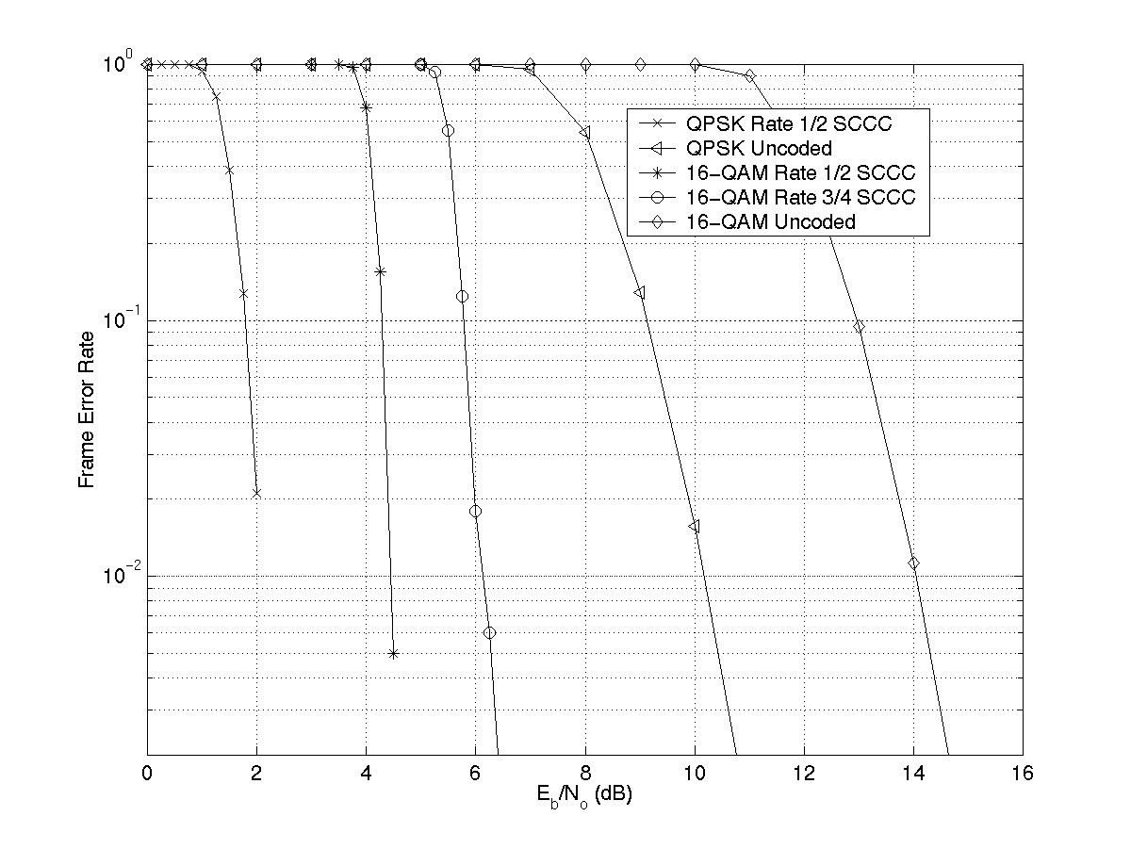
Figure 3.22: Frame error rate performance with a block size of 4096 information bits in an AWGN channel.

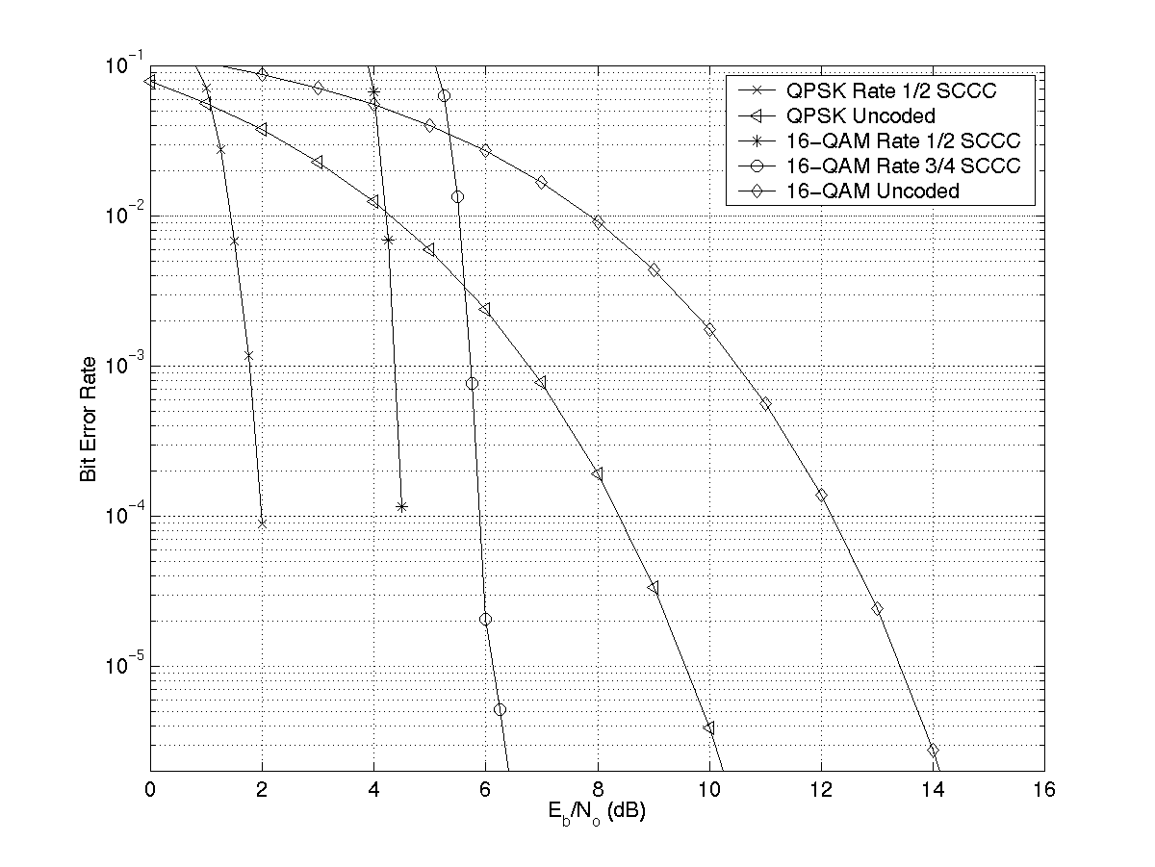
Figure 3.23: Bit error rate performance with a block size of 4096 information bits in an AWGN channel.

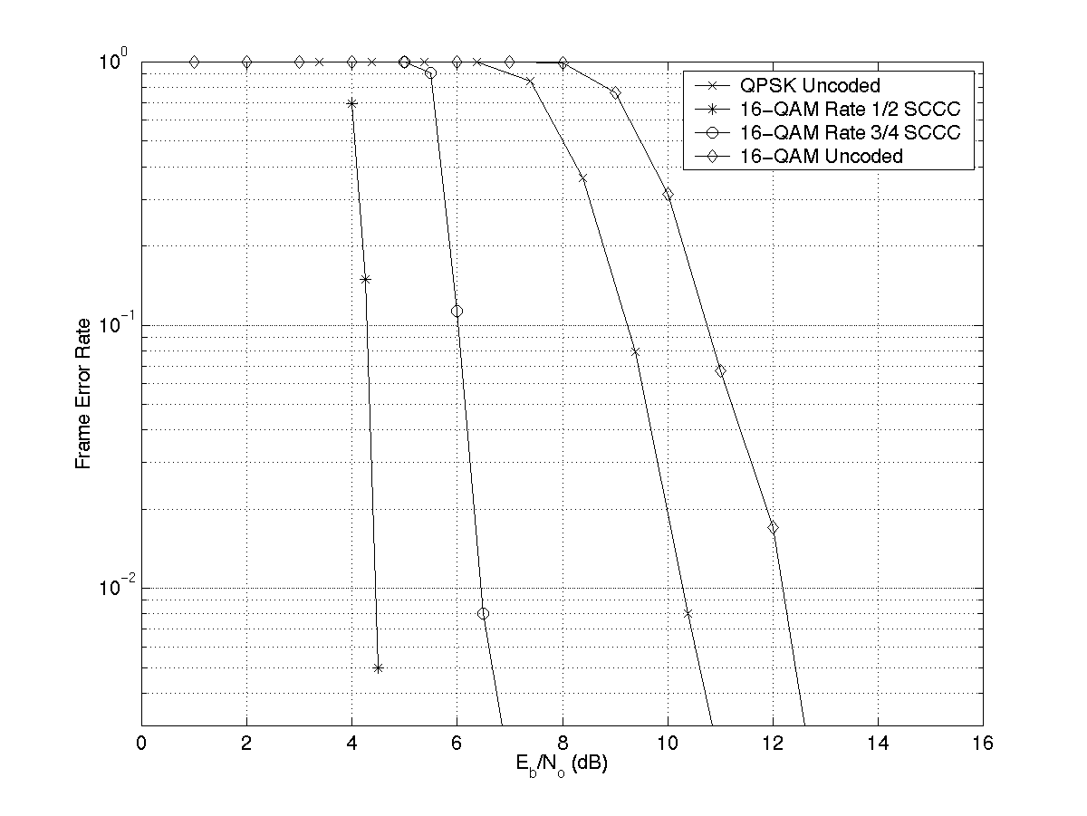
Figure 3.24: Frame error rate performance with a block size of 4096 information bits in the 802.15.3 multipath channel with no fading.

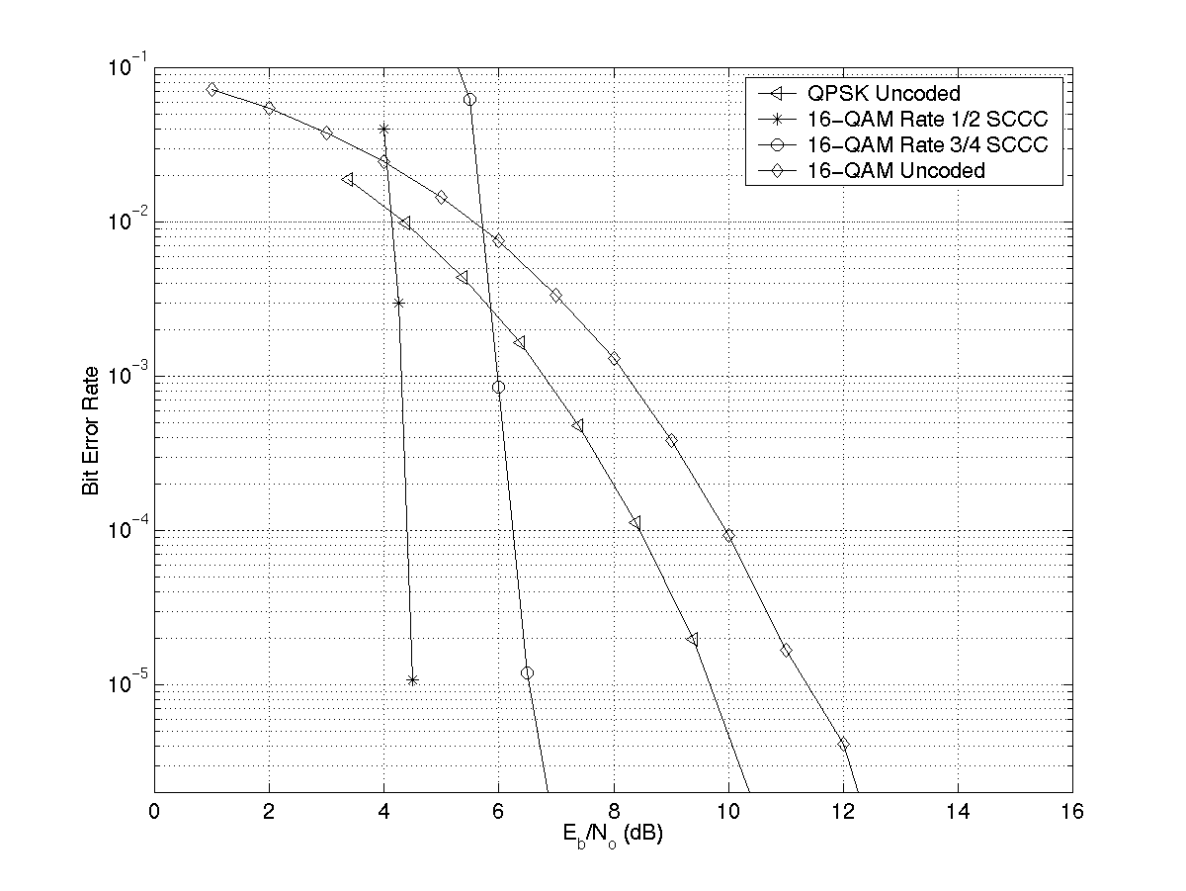
Figure 3.25: Bit error rate performance with a block size of 4096 information bits in the 802.15.3 multipath channel with no fading.

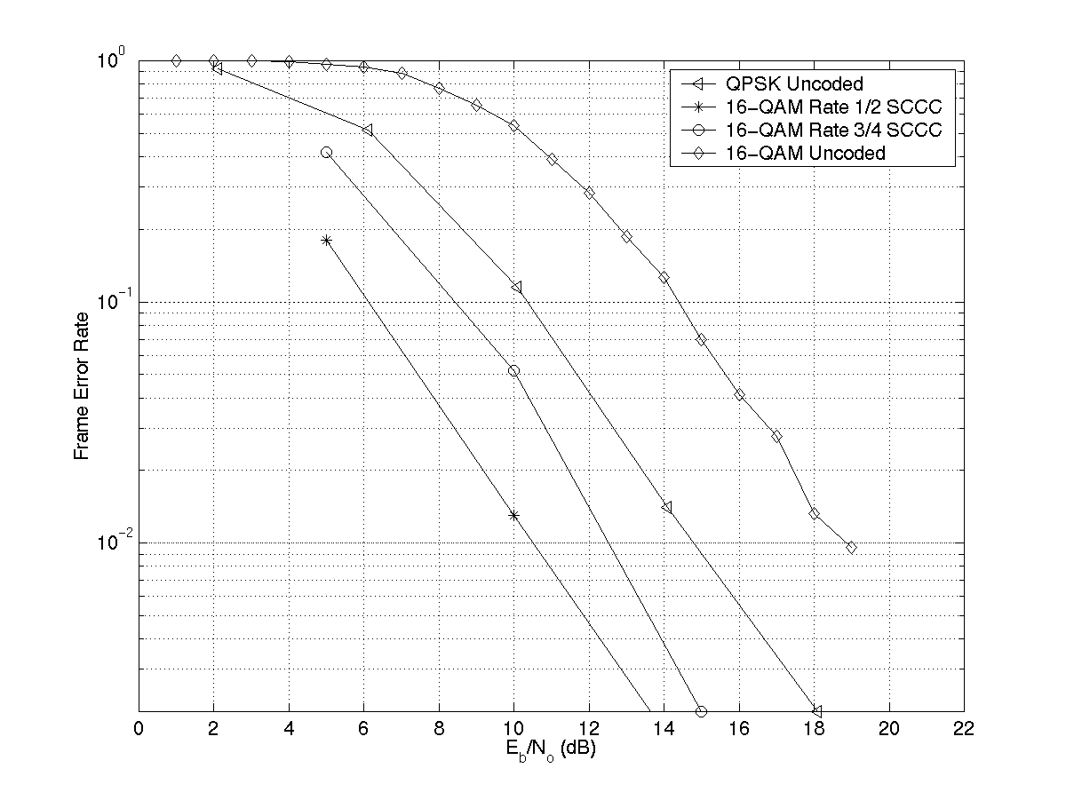
Figure 3.26: Frame error rate performance with a block size of 4096 information bits in the 802.15.3 multipath channel with fading.
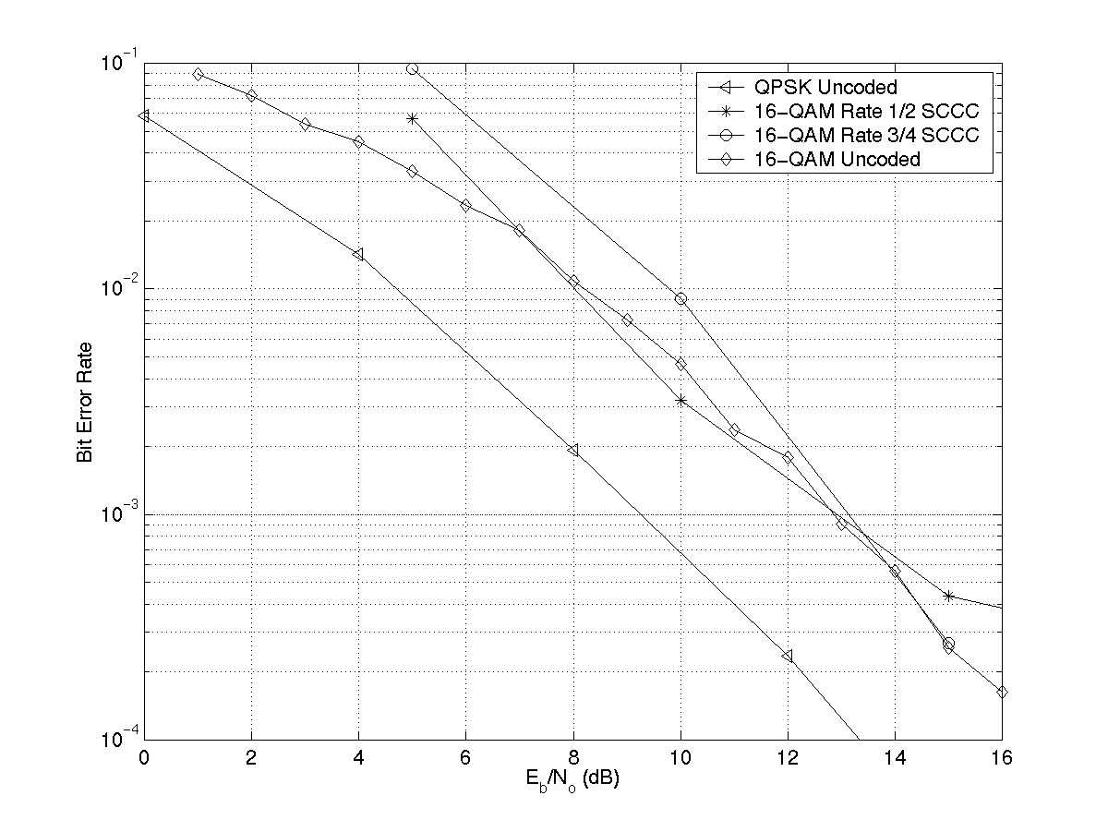
Figure 3.27: Bit error rate performance with a block size of 4096 information bits in the 802.15.3 multipath channel with fading.

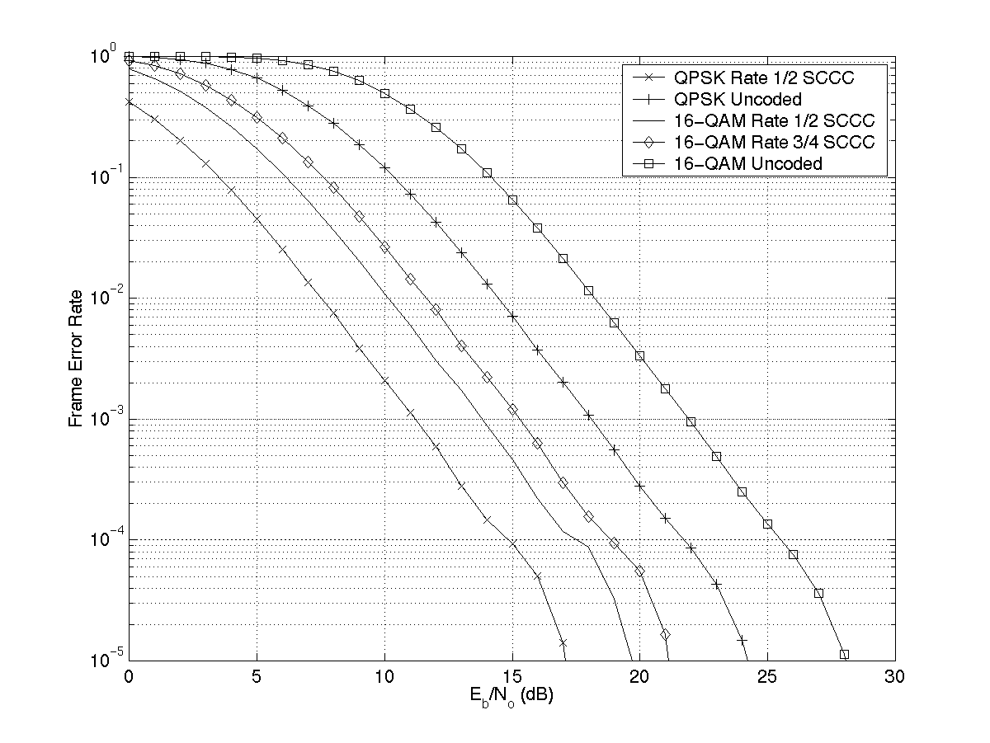
Figure 3.28: Frame error rate performance with a block size of 4096 information bits in a single path Rayleigh fading channel.

3.9 System Extensions
One of the constraints of the WPAN system is that the transceiver should fit on a compact flash card. Because of the constraint of the size of compact flash card, a single antenna is assumed for transmit and receive. However, if the form factor is not a concern, it is possible to use two antennas for transmit and receive diversity. Simple schemes like switched diversity can be incorporated easily transparent to the other devices in the piconet. The modulation techniques in the proposed high rate WPAN are also applicable to more complex transmit diversity techniques namely, space time coding, beam forming and others. However implementation of these techniques is not considered in the current approach to reduce the time to market and complexity considerations. Multiple antennas offer an attractive future option to increase the data rate and/or increase the range of WPAN’s.
The modulation schemes in the proposed system also allow more complex coding schemes like parallel concatenated trellis coded modulation (PCTCM) and serially concatenated trellis coded modulation (SCTCM). We are currently analyzing these schemes in further detail. A lower/equal complexity turbo trellis code which has a better performance than the proposed Turbo code can easily be incorporated in the present system.

4.0 General solution criteria
In this section we give the details for each of the items in the general solution criteria for evaluation given in [1].
4.1 Unit manufacturing cost
The figures 2.7, 2.8 give the transceiver block diagram for mode 2. Most of receiver RF, analog blocks namely, the front end filter, LNA, RF/IF converter, band pass filter can be shared between the modes 1 and 2. The baseband for mode 2 requires additional logic for receive filtering, AGC, timing acquisition, channel estimation, QAM demodulation and Viterbi decoding in the case of ARQ. The estimated extra gate count for mode 2 for the above functions is 10,000 gates. The extra complexity for mode 2 over mode 1 is shown pictorially in figure 4.1 below. The additional functionality for mode 2 marginally increases the total cost of mode 1 + mode 2 over mode 1. Hence taking into account the additional hardware for mode 2, the total cost of mode 1 + mode 2 is estimated to be 1.2x the total cost of mode 1 by itself.
RF
Baseband (PHY+MAC)

Mode 2: 10,000 gates
Mode 2
Mode 1
Mode 1

Figure 4.1: The additional hardware required for mode 2 over the mode 1 hardware is shown schematically. The total cost of (mode 1 + mode 2) is expected to less than 1.2xcost of mode 1 hardware.

The figures 3.14, 3.15 give the transceiver block diagram for mode 3. Most of receiver RF, analog blocks namely, the front end filter, LNA, RF/IF converter can be shared between the modes 1 and 3. The implementation of mode 1 + mode 3 will require an additional band pass filter over mode 1 implementation because of the larger bandwidth compared to mode 1. The baseband for mode 3 requires additional logic for AGC, timing acquisition, channel estimation, QAM demodulation, Equalization and Turbo decoding. The estimated extra gate count for mode 3 for the above functions is 100,000 gates. The extra complexity for mode 3 over mode 1 is shown in figure 4.2. The additional functionality for mode 3 marginally increases the total cost of mode 1 + mode 3 over mode 1. However, this does not add significantly to the overall cost. Hence taking into account the additional hardware for mode 3, the total cost of mode 1 + mode 3 is estimated to be less than 1.5x the total cost of mode 1 by itself.

RF
Baseband (PHY+MAC)

Mode 3: 100,000 gates
Mode 3
Mode 1
Mode 1

Figure 4.2: The additional hardware required for mode 3 over the mode 1 hardware is shown schematically. The total cost of (mode 1 + mode 3) is expected to be less than 1.5xcost of mode 1 hardware.

4.2 Interference and Susceptibility
The proposed high speed WPAN to Bluetooth the system achieves the out of band and in band blocking as given in table 4.1 below for both mode 2 and mode 3. The desired signal is set 3 dB above the reference sensitivity level and the measured bit error rate (BER) is 10⁻³ for mode 2 and 10⁻⁸ for mode 3.

Table 4.1: Out of band blocking of the proposed high rate WPAN system is given.

Interfering signal frequency | Interfering signal power
30 MHz-2000 MHz | -9 dBm
2000-2400 MHz | -26 dBm
2500-3000 MHz | -26 dBm
3000 MHz-12.75 GHz | -9 dBm

Exceptions for 24 frequencies are permitted similar to Bluetooth specification in section A 4.3. The in band blocking that can be achieved by the proposed high rate WPAN is given in table 4.2.

Table 4.2: The in band blocking of the proposed high rate WPAN system with respect to the desired signal is given.

 | Interference frequency | Level
Mode 2 | >= 3 MHz | > 35 dB
Mode 3 | >= 25 MHz | > 35 dB

The above inband performance is achieved with an IF filter.

4.3 Intermodulation resistance
The intermodulation parameters and the specified levels for testing the intermodulation characteristics of the proposed high rate WPAN are given in table 4.3:

Table 4.3: Intermodulation resistance parameters for the proposed high rate WPAN system

Mode | Desired signal | Interfering signals | f_{offset} | Interfering signal level
2 | At frequency f₀ = f_{c} and 3 dB above sensitivity, transmit 64 QAM. | Sinusoid at f₁ = f_{c} + f_{offset} and Bluetooth at f₂ = f_{c} + n*f_{offset}. | 1 MHz | -33 dBm
3 | At frequency f₀ = f_{c} and 3 dB above sensitivity, transmit system 2 of mode 3. | Sinusoid at f₁ = f_{c} + f_{offset} and Bluetooth at f₂ = f_{c} + n*f_{offset}. | 25 MHz | -33 dBm

Another measurement for testing the IM2 in the case of direct conversion receiver is a 802.15.1 signal 100 % AM modulated at a rate of 2 kHz located at 1 MHz frequency steps in the band. The desired signal is again 3 dB above the receiver sensitivity and measure a BER of 10⁻³ for mode 2 and 10⁻⁸ for mode 3. The specified AM modulated signal level for mode 2 is –32 dBm.

The specified AM modulated signal level for mode 3 is –31 dBm.

4.4 Jamming resistance:
For mode 3, choose the QPSK uncoded 22 Mbps system for testing. As specified in [1], a jammer is said to be handled if the net throughput of the desired system does not fall below 50 % for a given jammer interference power. The jamming resistance under the different scenarios is;
- Microwave oven at 3m: Because of the probe, listen and select (PLS) technique of mode 3, the frequency band over which the microwave oven is operating will not be selected by the mode 3 for transmission. This would imply that there is no impact on the throughput of mode 3. Thus the throughput of mode 3 is 100 % in the presence of the microwave oven.
- An 802.15.1 transmitting at 1 mW with one HV1 connection: Whenever there is collision of the 802.15.1 packets the mode 3 packets will be lost. The probability of this collision is the bandwidth of mode 3/total 802.15.1 bandwidth = 0.2. The lost mode 3 packets will be retransmitted using the ARQ mechanism, but the overall throughput will be reduced to 80 %. Since the throughput does not fall below 50 %, proposed system handles the 802.15.1 jamming interference.
- An 802.15.1 transmitting at 1mW with bi-directional DH5 packets: The analysis is the same as part (b) and impacts the throughput by the same amount.
- An 802.15.3 transferring video: Because of the probe, listen and select (PLS) technique of mode 3, the frequency band over which the jammer is operating will not be selected by mode 3 for transmission. There could be few collisions when the jamming system enters mode 1 periodically. This occurs 10 % of the time out of which 20 % of the time there may be collision. Thus the throughput of mode 3 is reduced to 98 %.
- An 802.11(a) piconet transmitting at 100mW transferring an HDTV video stream compressed with MPEG 2: Since 802.11(a) is in a different frequency band it has no impact on the throughput of mode 3.
- An 802.11(b) piconet transmitting at 100 mW transferring an HDTV video stream compressed with MPEG 2: Because of the probe, listen and select (PLS) technique of mode 3, the frequency band over which the 802.11 (b) is operating will not be selected by mode 3 for transmission. . This would imply that there is no impact on the throughput of mode 3. Thus the throughput of mode 3 is 100 % in the presence of the microwave oven.

For mode 2 the throughput impact is the same as 802.15.1 and is as follows;

- Microwave oven at 3m: The bandwidth of microwave oven is about 10 MHz [2] with a duty cycle of 50 %. Whenever the mode 2 packet collides with the microwave oven, the packet is lost. The probability of this collision is 6 % implying that the throughput is reduced to 94 %.
- 802.15.1 transmitting at 1 mW with one HV1 transmission: Whenever the 802.15.3 mode 2 collides with 802.15.1, the packet is lost. Hence the throughput of mode 2 taking into account the probability of collision is 98 %.
- An 802.15.1 transmitting at 1mW with bi-directional DH5 packets: The analysis is the same as part (b) and impacts the throughput by the same amount.
- An 802.15.3 transferring video: The jammer collides with mode 2 20 % of time, implying that the throughput of mode 2 is reduced to 80 %.
- An 802.11(a) network transmitting at 100mW transferring an HDTV video stream compressed with MPEG 2: Since 802.11(a) is in a different frequency band it has no impact on the throughput of mode 3.
- An 802.11(b) network transmitting at 100 mW transferring an HDTV video stream compressed with MPEG 2: Whenever the mode 2 packet collides with the 802.11 (b) packets, it is lost. The probability of this happening is 20 %. Hence the throughput of mode 2 is reduced to 80 %.

The results of jamming resistance are summarized in table 4.4 below:

Table 4.4: Jamming resistance of proposed high rate WPAN compared to Bluetooth.

 | Mode 2 | Mode 3 | Bluetooth
Microwave oven at 3m | 94 % | 100 % | 94 %
802.15.1 transmitting at 1 mW with one HV1 | 98 % | 80 % | 98 %
802.15.1 transmitting at 1 mW with bi-directional DH5 | 98 % | 80 % | 98 %
802.15.3 transferring HDTV video | 80 % | 98 % | 80 %
802.11(a) at 100 mW | 100 % | 100 % | 100 %
802.11(b) at 100 mW | 80 % | 100 % | 80 %

4.5 Multiple access

The multiple access capability of the proposed high rate WPAN with two other systems co-located and operating in a coordinating manner is;
- All three systems transferring HDTV video stream compressed with MPEG 2: Due to the probe, listen and select (PLS) technique of the proposed high rate WPAN, the three systems will choose mutually exclusive bands for operation or they can be time multiplexed in the same band. In either case the net throughput remains to be 100 %.
- The desired system transferring HDTV video stream compressed with MPEG2 and the other two transferring asynchronous data with a payload size of 512 bytes. Due to the probe, listen and select (PLS) technique of the proposed high rate WPAN, the three systems will choose mutually exclusive bands for operation or they can be time multiplexed in the same band. In either case the net throughput remains to be 100 %.
- The desired system transferring asynchronous data with a payload size of 512 bytes and one other system transferring asynchronous data with a payload size of 512 bytes and the third transferring a HDTV video stream compressed with MPEG2. Due to the probe, listen and select (PLS) technique of the proposed high rate WPAN, the three systems will choose mutually exclusive bands for operation or they can be time multiplexed in the same band. In either case the net throughput remains to be 100 %.

The results of the multiple access criteria are summarized in table 4.5:

Table 4.5: The results of the multiple access criteria are summarized.

 | Mode 3 throughput
2 other systems transmitting HDTV video stream with MPEG2 | 100 %
2 other systems asynchronous data with payload of 512 bytes | 100 %
One system transmitting MPEG2 HDTV video and one system transmitting asynchronous data with payload 512 bytes | 100 %

4.6 Coexistence: Impact on other systems

Coexistence is the throughput of an alternate system in the presence of the proposed high rate WPAN. The different coexistence scenarios are:

- (a) An 802.15.1 piconet with one HV1 transmission active.

The mode 3 system interfers with the Bluetooth signal 20 % of the time. Hence the throughput of 802.15.1 is reduced to 80 %.
(b)
A 802.15.1 transferring data with DH5 packets bi-directionally. The scenario is transmission powers and the distances between devices are the same as shown in figure 4.3. In this case, the same analysis as in case (a) of coexistence holds good implying that the throughput of 802.15.1 is reduced to 80 %.
(c) An 802.11 (b) network transmitting data with 500 byte packets bi-directionally. Both devices are transmitting at 100 mW. Because of the probe, listen and select (PLS) technique, the proposed high rate WPAN will choose a frequency band different from the 802.11 (b) implying no throughput loss for the 802.11 (b) network. Hence the throughput of 802.11 (b) will be 100 %.
- An 802.11 (a) data connection transferring a HDTV video stream compressed with MPEG2. Because the proposed high rate WPAN network does not operate in the frequency band of the 802.11 (a) network, no loss in throughput of 802.11 (a) occurs.
- An 802.11 (b) data connection transferring HDTV video stream compressed with MPEG 2. Both 802.11 (b) devices transmit at 100 mW. Because of the probe, listen and select (PLS) technique, the proposed high rate WPAN will choose a frequency band different from the 802.11 (b) implying no throughput loss for the 802.11 (b) network. Hence the throughput of 802.11 (b) will be 100 %.

A summary of the results of coexistence tests is given in table 4.6:

Table 4.6: A summary of the results of the existence tests is given.

 | Effective throughput
802.15.1, HV1 voice, 1 mW | 80 %
802.15.1 DH5, 1 mW | 80 %
802.11 (b), bidirectional data at 100 mW | 100 %
802.11 (a), MPEG2 at 100 mW | 100 %
802.11 (b), MPEG2 at 100 mW | 100 %

4.7 Interoperability with 802.1.5.1
The mode 1 of the proposed high rate WPAN is Bluetooth, which is interoperable with modes 2 and 3. Hence the proposed high rate WPAN is interoperable with Bluetooth.

4.8 Technical feasibility of the proposed solution.

    - Manufacturability: The proposed solution is very similar to Bluetooth in its RF requirements. The QAM modulation and Turbo codes have been accepted for the high rate cellular systems and 3rd generation cellular systems. Hence we believe that the proposed solution can be manufactured using proven technologies.
    - Time to market: Commercial product for the proposed high rate WPAN should be available by 4Q2001.
    - Regulatory impact: The proposed high rate WPAN uses the same frequency hopping as Bluetooth for modes 1 and 2. For mode 3 it uses the direct sequence spreading similar to 802.11 (b). Following the FCC compliance test as given in FCC part 15.247 section C(2) the spreading gain for QPSK and 16 QAM was calculated by simulations and is plotted in figures 4.4 and 4.5 below. We can see that the spreading gain of the proposed system is more than 10 dB, as required by the FCC.

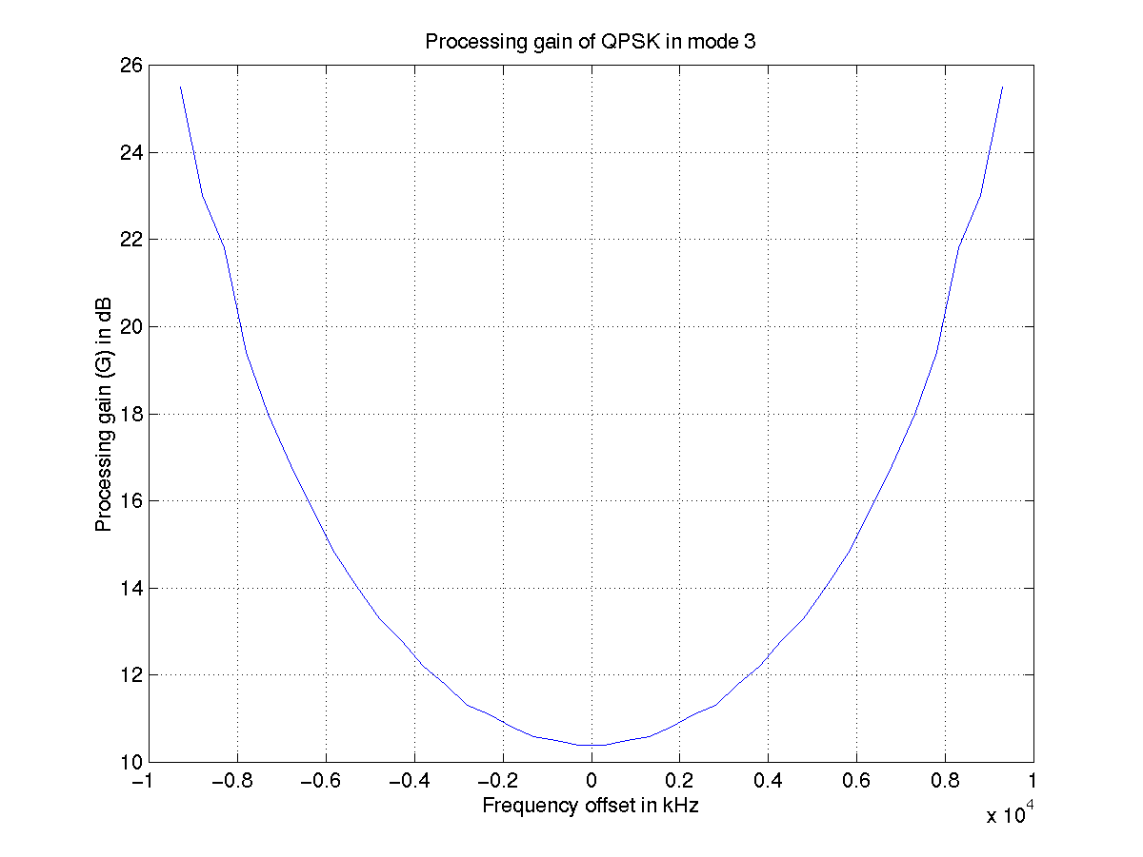
Figure 4.4: Processing gain of QPSK system in mode 3.

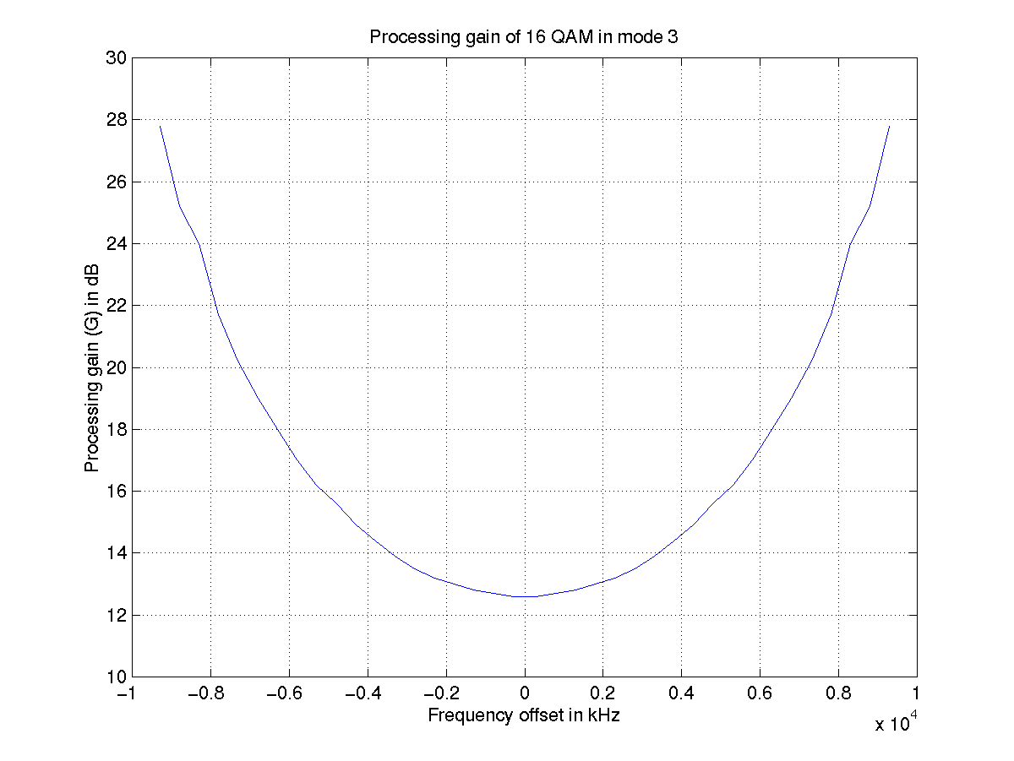
Figure 4.5: Processing gain of 16 QAM system in mode 3.

    - Maturity of solution: The proposed high speed WPAN uses globally accepted concepts with proven technical maturity in other systems namely Bluetooth, cellular systems and 802.11. Texas Instruments has done detailed simulation experiments for the proposed system and shown that the system works. Hence we believe the overall solution is mature enough to allow a quick time to market.
    - Scalability: The proposed solution offers some unique concepts that allow scalability of the implementation both at design time and at run time. For example, the option to use or not use the Turbo codes is a design time parameter. On the other hand, depending upon the power consumption of the device the number of iterations of the Turbo codes can be made variable making it a real time parameter. Similarly, the different data rates that are supported can be made variable in real time depending upon propagation conditions and environment. The scalability of the proposed solution is given in table 4.7 below:

Table 4.7: The scalability criteria for the proposed high rate WPAN are summarized.

Power consumption | Scalable (real time + design time)
Data rate | Scalable (real time + design time)
Frequency band of operation | ISM band at of 2.4 GHz
Cost | Scalable (design time)
Function | Scalable (real time + design time)

5.0 PHY Layer Criteria
In this section we consider the PHY layer criteria for the proposed high rate WPAN
  - Size and form factor: The proposed high rate WPAN hardware would fit on a compact flash card while leaving space for other modules.
  - Minimum MAC/PHY throughput: The proposed system in mode 3 supports 22 Mbps at PHY layer. Excluding the MAC overhead of about 5 % this yields a user data rate of 21 Mbps. Also, the partition of the data from the Master to the Slave and vice versa is adaptive.
  - High End MAC/PHY throughput: The proposed system in mode 3 supports a maximum data rate of 44 Mbps at the PHY layer. Excluding MAC overhead of about 5 % this yields a user data rate of 42 Mbps.
  - Frequency band: The proposed high rate WPAN operates in the 2.4 GHz ISM band between frequencies 2.402-2.480 GHz.
  - Number of simultaneously operating full throughput PAN’s: The proposed high rate WPAN accommodates 3 simultaneous transmissions of 42 Mbps each. Time multiplexing 2 PAN’s in each of the frequency bands yields a total of 6 simultaneous PAN’s operating at 21 Mbps each giving a net through put of 126 Mbps.
  - Signal acquisition method: The modes 2 and 3 both employ packet preamble and sync. word similar to Bluetooth to acquire and track the gain, timing, frequency and channel estimates.
  - Range: The proposed system always uses Bluetooth as the mode 1 for initiation of connection. This ensures that the proposed system can initiate a connection within a 10 m. radius more than 99.9 % of the time.
  - Sensitivity for the proposed system transmitting 22 Mbps is –80 dBm for a bit error rate of 10⁻⁸ which is required for MPEG2 HDTV video transmission.
  - Multipath immunity: With an equalizer the proposed system has a delay spread tolerance of greater than 50 ns.
  - Power consumption: Referring back to section 4.1, figure 4.1 the proposed system requires 10,000 additional gates in digital logic and some additional RF hardware over the Bluetooth receiver. This implies an extra power consumption of about 2 mW for baseband and a similar number for RF. Hence overall the expected receive power consumption for the mode 2 system is expected to be similar to Bluetooth. On the transmit side, mode 2 employs 16 QAM which requires power amplifier (PA) back off which reduces the PA efficiency. Assuming the efficiency of PA after backoff to be 10 %, this implies a PA power consumption of 10 mW for 0 dBm transmit power. Overall, the estimated power consumption for receive in mode 2 is 106 mW peak power and 80 mW transmit peak power in year 2001.
Referring to figure 4.2 the proposed system requires 100,000 additional gates in digital logic and additional RF hardware over the Bluetooth receiver to implement mode 3. This implies an extra baseband power consumption of 50 mW for baseband receive. On the transmit side, again assuming a PA efficiency of 10 % implies a 25 mW of PA power consumption for 4 dBm transmit power. Overall, the estimated power consumption for receive in mode 3 is 165 mW peak power and 135 mW peak power for transmit next year. The power consumption is summarized in table 5.1:

Table 5.1: The power consumption for the proposed solution is summarized.

Power consumption | Receive | Transmit
Mode 1 | 65 mW peak, 33 mW average | 40 mW peak, 20 mW average
Mode 2 | 106 mW peak, 53 mW average | 80 mW peak, 40 mW average
Mode 3 | 165 mW peak (65 mW RF + 100 mW baseband), 83 mW average | 135 mW peak (65 mW RF + 70 mW baseband), 63 mW average.

6.0 MAC layer for the proposed PHY
Because of the similarities of the proposed system to Bluetooth, a Bluetooth MAC can be employed with some modifications. Figure 6. gives the block diagram of how the Bluetooth MAC can be modified to suit the proposed PHY.

MLME
L2CAP
Link Manager
LMP
Baseband
Radio
SAP Interface
L2CAP SAP
SCO SAP
Air Interface
HCI SAP
LLC SAP
PHY
MAC

Figure 6.1: The Bluetooth MAC being used for the proposed PHY. The shaded regions indicate the blocks of Bluetooth MAC that will need modifications.

The impact of the TI proposal on a well constructed Bluetooth MAC will be minimal. The HCI interface, L2CAP, and LMP will all have to comprehend the commands to change data rate. In the case of a Master, the MAC will have to do extra book keeping to keep a slot-by-slot current data rate value. The mechanism for identifying and utilizing good bands also must be implemented. In addition, the MAC will have to manipulate the controls necessary to tell the baseband to change from and to the higher rates when necessary.

References:
[1] IEEE P802.15 Working Group for Wireless Personal Area Networks (WPANs), TG3-Criteria-Definitions, 11th May 2000.
[2] Ad Kamerman, Nedim Erkocevic, “Microwave Interference on Wireless LAN’s operating in the 2.4 GHz ISM band”, Proceedings of IEEE PIMRC conference, 1997, volume 3, pages 1221-1227.
[3] D. Divsalar and F. Pollara, “Serial and hybrid concatenated codes with applications”, in Proceedings International Symposium of Turbo Codes and Applications, Brest France, September 1997, pp.80-87.

Appendix A:
1st Pass Pugh Matrix Comparison Value

General Solution Criteria Comparison Values

CRITERIA | Criteria Document Reference |  | Comparison Values
 |  | - | Same | +
Unit Manufacturing Cost ($) as a function of time (when product delivers) and volume  (See sec. 4.1) | 2.1 | > 2 x equivalent Bluetooth 1 | 1.5-2 x equivalent Bluetooth 1 value as indicated in Note #1  Notes:  1. Bluetooth 1 value is assumed to be $20 in 2H2000.  2. PHY and MAC only proposals use ratios based on this comparison | < 1.5 x equivalent Bluetooth 1  
Interference and Susceptibility  (See sec. 4.2) | 2.2.2 | Out of the proposed band: Worse performance than same criteria  In band: -: Interference protection is less than 25 dB (excluding co-channel and adjacent channel) | Out of the proposed band: based on Bluetooth 1.0b (section A.4.3)  In band: Interference protection is less than 30 dB (excluding co-channel and adjacent and first channel) | Out of the proposed band: Better performance than same criteria  In band: Interference protection is less greater than 35 dB (excluding co-channel and adjacent channel) 
Intermodulation  Resistance  (See sec. 4.3) | 2.2.3 | < -45 dBm | -35 dBm to –45 dBm | > -35 dBm  
Jamming Resistance  (See sec. 4.4) | 2.2.4 | Any 3 sources jam | Any 2 sources jam | No more than 1 source jams  
Multiple Access  (See sec. 4.5)) | 2.2.5 | No Scenarios work | Handles Scenario 2 | One or more of the other 2 scenarios work  
Coexistence  (Evaluation for each of the 5 sources and the create a total value using the formula shown in note #3)  (See sec. 4.6) | 2.2.6 | Individual Sources: 0%  Total: < 3 | Individual Sources: 50%  Total: 3 | Individual Sources: 100%  Total: > 3  (Total=7)  
Interoperability  (See sec. 4.7) | 2.3 | False | True | N/A
Manufactureability  (See sec. 4.8.1) | 2.4.1 | Expert opinion, models | Experiments | Pre-existence examples, demo  
Time to Market  (See sec. 4.8.2) | 2.4.2 | Available after 1Q2002 | Available in 1Q2002 | Available earlier than 1Q2002  
Regulatory Impact  (See sec. 4.8.3) | 2.4.3 | False | True | N/A
Maturity of Solution  (See sec. 4.8.4) | 2.4.4 | Expert opinion, models | Experiments | Pre-existence examples, demo  
Scalability  (See sec. 4.8.5) | 2.5 | Scalability in 1 or less than of the 5 areas listed | Scalability in 2 areas of the 5 listed | Scalability in 3 or more of the 5 areas listed  

Note 3: Total equation for coexistence value calculation. Individual comparison values (-, same, +) are represented by the following numbers: - equals –1, same equals 0, + equals +1. The individual comparison values will be represented as IC in the equation below, with the subscript representing the source number referenced.

Total = 2 * IC₁ + 2 * IC₂ + IC₃ + IC₄ + IC₅

Phy Protocol Criteria

CRITERIA | Criteria Document Reference |  | Comparison Values
 |  | - | Same | +
Size and Form Factor  (See sec. 5.1) | 4.1 | Larger | Compact Flash Type 1 card | Smaller  
Minimum MAC/PHY Throughput  (See sec. 5.2) | 4.2.1 | 20 Mbps (without MAC overhead) | 20 Mbps + MAC overhead | > 20 Mbps  
High End MAC/PHY Throughput (Mbps)  (See sec. 5.3) | 4.2.2 | 20 – 39 Mbps | 40 Mbps + MAC overhead | 40 Mbps  
Frequency Band  (See sec. 5.4) | 4.3 | N/A (not supported by PAR) | Unlicensed | N/A (not supported by PAR)
Number of Simultaneously Operating Full-Throughput PANs  (See sec. 5.5) | 4.4 | < 4 | 4   | >4
Signal Acquisition Method  (See sec. 5.6) | 4.5 | N/A | N/A | N/A
Range  (See sec. 5.7) | 4.6 | < 10 meters | > 10 meters | N/A
Sensitivity  (See sec. 5.8) | 4.7 | N/A | N/A | N/A
Delay Spread Tolerance greater than 25 ns.  (See sec. 5.9) | 4.8 |  | False | True
Power Consumption  (the peak power of the PHY combined with an appropriate MAC)  (See sec. 5.10) | 4.9 | > 1.5 watts | Between .5 watt and 1.5 watts | < .5 watt

Appendix B: Channel spacing for T.I. proposal to 802.15.3

This is a response to criterion 4.4, “The number of simultaneously operating full throughput PAN’s” for the T.I. proposal to IEEE 802.15.3. The T.I. proposal employs the same spectrum mask as the IEEE 802.11 (b) given in table (1) below:

Frequency offset | Transmit power
fc | 0 dBc
+/- 11MHz | -30 dBc
+/- 22 MHz | -50 dBc

Using the above spectrum mask, 3 simultaneously operating full throughput WPAN’s can operate similar to 802.11 (b) as shown in figure A.1 below:

Channel 1
Channel 6
Channel 11
2483.5 MHz
2412 MHz
2437 MHz
2462 MHz

Figure B.1: The 802.15.3 frequency allocation similar to 802.11 accommodating 3 WPAN’s is shown.

However, it is also possible to accommodate 4 WPAN’s simultaneously as shown in figure A.2 below:

Channel 1
Channel 5
Channel 9
2483.5 MHz
Channel 13
2402 MHz
2422 MHz
2442 MHz
2462 MHz
2482 MHz

Figure B.2: Simultaneous operation of the proposed 4 WPAN’s is shown. Accommodating channel 13 (shown in dotted line) requires compliance with FCC 15.209.

Accommodating channel 13 (shown in dotted line) requires compliance with FCC 15.209 for radiation limits in the frequencies above 2483.5 MHz. According to FCC 15.209, the specified field strength above 960 MHz is 500 microvolts/meter at a distance of 3 m. In the 2.4 GHz band this field strength is measured using an average detector implying an average radiated power of –41.2 dBm in any one MHz band.

The T.I. proposal mode 3 requires a transmit power of 4 dBm for the minimum throughput of 20 Mbps. Figure A.3 plots the transmit power in each 1 MHz band from 2472 MHz to 2492 MHz for a total transmit power of 4 dBm. A square root raised cosine (SRRC) filter of α = 0.8 with a response that extends over 3 symbols on either side is used is used at the transmitter. The filter response is shown in figure A.4. As can be seen from figure A.3, the transmit power beyond 2483.5 MHz is less than –50 dBm. This is less than the FCC allowed power of –41.2 dBm power.

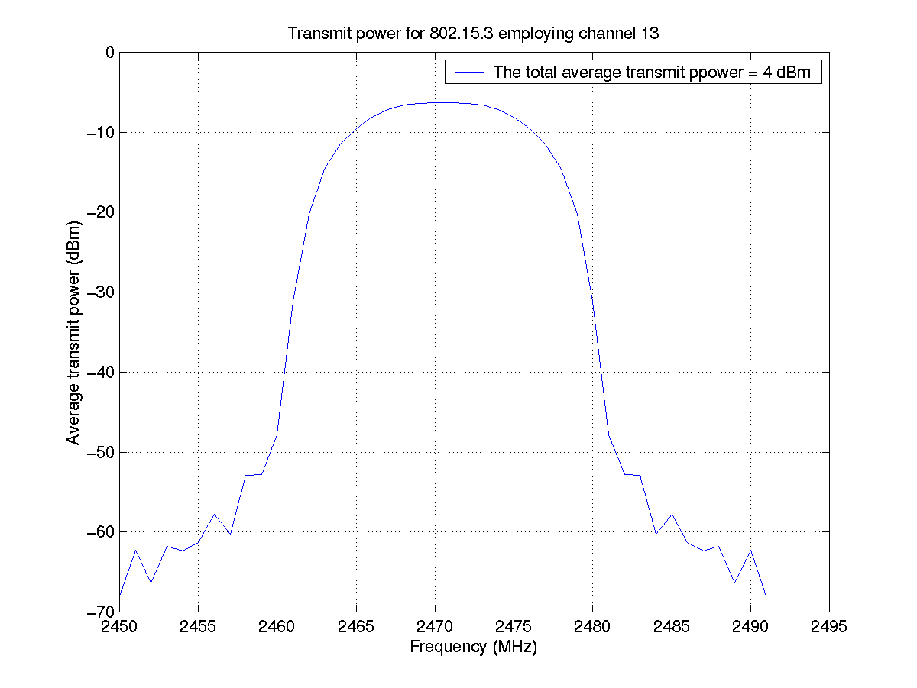
Figure B.3: The transmit power for 802.15.3 employing channel 13 is shown. The power transmitted beyond 2483.5 is less than –50 dBm. This is less than the FCC allowed –41.2 dBm.
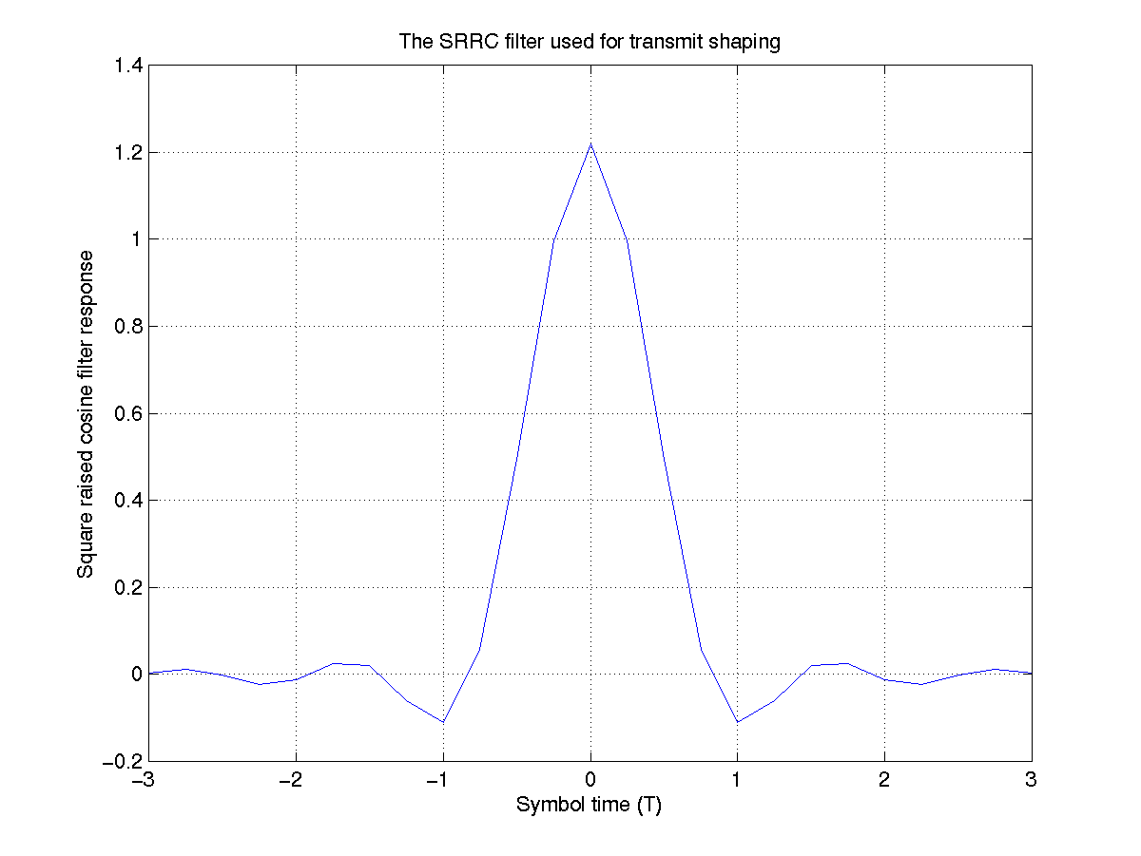
Figure B.4: The transmit SRRC filter employing three symbols is shown.

The peak to average ratio (PAR) for 16 QAM employing the α = 0.8 SRRC filter is 5.8 dB. We propose to back off the power amplifier by 7 dB from the 1 dB compression point to operate it in the linear region. Operating the PA in the linear region guarantees FCC 15.209 compliance. The PA efficiency due to the 7 dB backoff is 10 %. The transmit power required for the minimum throughput of 20 Mbps and a range of 10 m. is 4 dBm (table 3.1). Hence the total power consumption by the PA is 25 mW. The peak DC power consumed by the PA is similar to the average DC power and is equal to 25 mW.
Hence, 802.15.3 should be able to fit 4 minimum throughput WPAN’s in the 2480-2483.5 ISM band.
Appendix C

Radio functionality, baseband functionality and external components

(1) Radio functionality/size:
- Backward compatibility with 802.15.1 is achieved by sharing the antenna, Tx/Rx switch, antenna filter, LNA, RF mixer, IF mixer and power amplifier (PA).
- The PA is backed off by 7 dB and has an efficiency of 10 % in the proposed 802.15.3 mode. The required transmit power for the minimum throughput of 20 Mbps and a range of 10 m. is 4 dBm (2.5 mW). Hence the average power consumed by the PA for the throughput of 20 Mbps is 2.5*10 = 25 mW.
- The RF chip area is 10 mm² in RFBiCMOS technology.

- Baseband functionality/size (PHY baseband only):
- Two A/D’s each with a precision of 8 bits is employed at a speed of 22 MHz.
- Two D/A’s each with a precision of 6 bits are employed at a speed of 44 MHz.
- A 16 tap fractionally spaced (half symbol) digital filter is employed for matched filtering.
- A 3 feed forward tap and 2 feedback tap eqaulizer at symbol spacing is employed.
- A Turbo decoder is employed for forward error correction (FEC). The Turbo decoder requires a total of 50 K gates plus 13 Kbytes of RAM.
- CMOS chip area, gate count and process technology: The total number of gates for the digital filter, equalizer and the Turbo deocoder is 86.4 K and 13 Kbytes of decoder RAM. Using the 0.13 micron technology the total chip area for the A/D, D/A converter, digital filter, equalizer, Turbo decoder and decoder RAM is 3.1 mm².

- Total number of chips and external components for the overall PHY solution: The total number of chips in the solution are two, the RF chip and the baseband chip. The external components include 2 crystal oscillators, 2 IF filters, external FLASH memory for MAC, estimated of size 1 Mbits, and an external SRAM, estimated of size 256 Kbytes.

Appendix D: Delay spread tolerance

To assess the delay spread tolerance of the proposed system, the transmit power was set to 10 dB above receiver sensitivity and the effective information E_{b}/N₀ for the Turbo decoder was calculated. The 16 QAM, rate ½ coded system giving 22 Mbps was used for simulations. A total of 1000 trials were conducted for an rms delay spread of 25 ns. Figure E.1 plots the results:
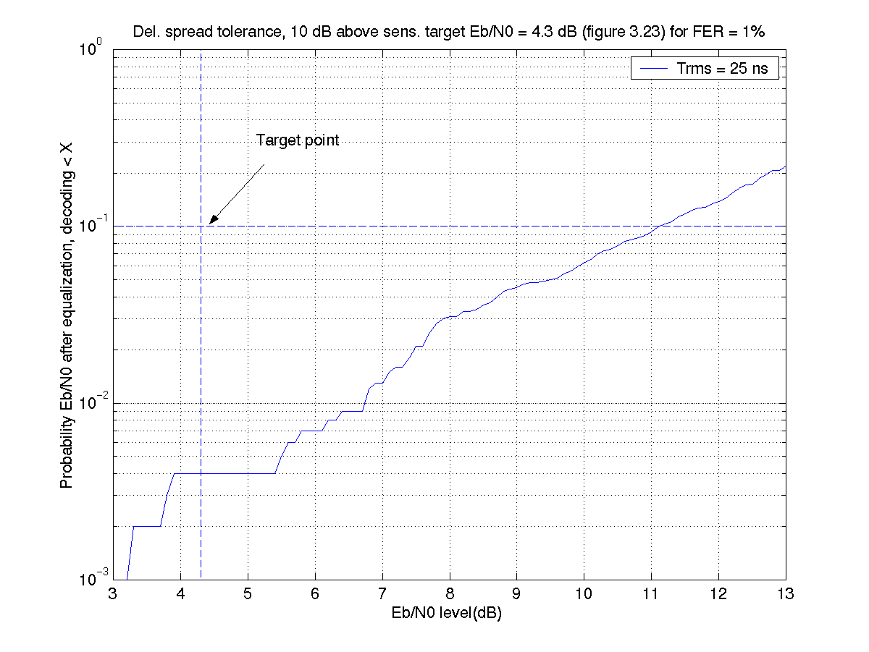
Figure E.1: The effective information E_{b}/N₀ for the Turbo decoder is shown for the 802.15.3 channel. The transmit signal power is set to 10 dB above receiver sensitivity. A total of 1000 trials were conducted for a delay spread of 25 ns.

Figure E.1 shows that the system achieves an Eb/N0 greater than 11 dB, 90 % of the time which is more than the minimum required Eb/N0 of 4.3 dB for this system (figure 3.21). Hence the delay spread tolerance of the system is greater than 25 ns.

Appendix E: Regulatory Impact
The transmit filter spectrum for the proposed system with the maximum transmit power in any 1 MHz bandwidth set to the FCC 15.249 allowed –1.25 dBm is shown in the figure E.1 below. Summing the total transmit power over the whole band we get that the maximum FCC 15.249 allowed transmit power for the proposed system is 9 dBm.

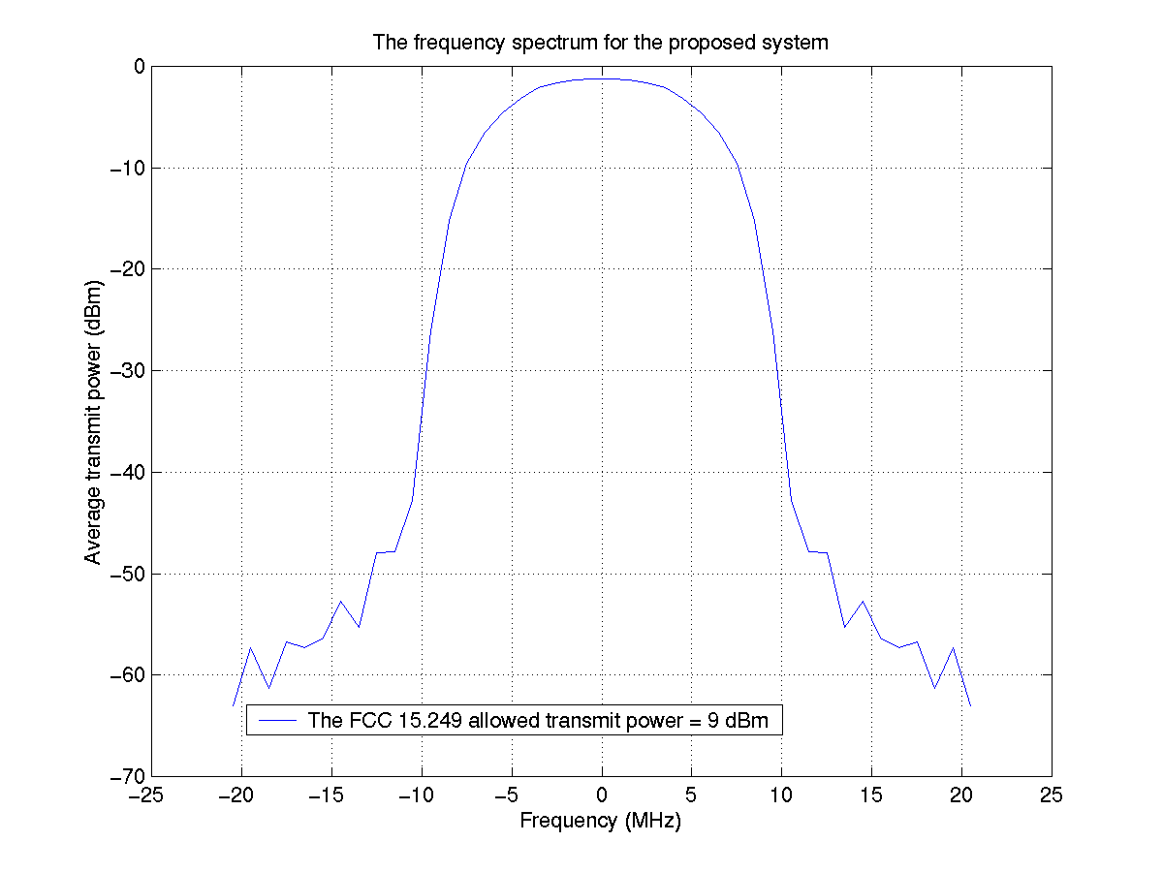
Figure E.1: The transmit filter spectrum for the proposed system is shown. The maximum transmit power allowed by FCC 15.249 in any 1 MHz band is –1.25 dBm. Summing this power over the whole band, the maximum FCC allowed transmit power is 9 dBm.

In order to have FCC compliance for the maximum data rate of 44 Mbps (table 3.1) of the proposed system, we propose to transmit the 44 Mbps data rate below the FCC allowed transmit power at 8 dBm. The receiver sensitivity is still –69 dBm assuming the (noise figure + receiver degradations) to be 13 dB.
This transmission power allows a range of 5 m. with a fading margin of 24 dB. However, this fading margin is quite relaxed and alternatively the maximum data rate of 44 Mbps can be achieved over 10 m. with a fading margin of 17 dB.
Similarly, the above spectrum is valid for the 22 Mbps uncoded data rate in table 3.1. Since the total transmit power for this data rate is 8 dBm, which is less than the FCC allowed power of 9 dBm, this data rate also complies with FCC 15.249.

Table E.1 below summarizes the transmit powers for the different transmission rates in mode 3.

Table E.1: Summary of the total transmit powers for the different data rates.

Parameters | 1 | 2 | 3 | 4 | 5
Filter spectrum | 802.11b | 802.11b | 802.11b | 802.11b | 802.11b
Modulation | QPSK | QPSK | 16 QAM | 16 QAM | 16 QAM
Scrambling code length | 256 | 256 | 256 | 256 | 256
Symbol rate | 11 Msps | 11 Msps | 11 Msps | 11 Msps | 11 Msps
Coding | Rate ½, Turbo (SCCC) | None | Rate ½, Turbo (SCCC) | Rate ¾, Turbo (SCCC) | None
ARQ | Optional | Optional | Optional | Optional | Optional
Data rate | 11 Mbps | 22 Mbps | 22 Mbps | 33 Mbps | 44 Mbps
Total transmit power | -1 dBm | 8 dBm | 4 dBm | 8 dBm | 8 dBm
Maximum average power in any 1 MHz band | -11.25 dBm | -2.25 dBm | -6.25 dBm | -2.25 dBm | -2.25 dBm
FCC 15.249 compliance | Yes | Yes | Yes | Yes | Yes

Appendix F: Achieving high data rate throughput

In this appendix we show how a 20.8 Mbps MAC/PHY throughput can be achieved by the Mode 3 data rate of 22 Mbps.

Table F.1: System parameters for MAC/PHY transmission of MEPG2 HDTV video using Mode 3 are given.

MPEG2 HDTV Video transmission using Mode 3
Video data rate | 20.8 Mbps
Video frames/s | 24
Video frames/Mode 3 slot | 6
Mode 3 data rate | 22 Mbps
Coding | Rate ½, Turbo
Modulation | 16 QAM
Time in Bluetooth mode (T₁ ms) | 7.5 ms
Time in Bluetooth mode for PLS | 7.5 ms
Mode 3 packet size | 4.4 Kbits
Data bits/packet | 4368
CRC bits/packet | 32
Mode 3 packet length | 200 μs
Number of packets/slot | 1190
Length of training sequence | 81 symbols, 7.36 μs
Number of packets/training sequence | 10
Number of training sequences/packet | 120
Number of ARQ’s | 12
Time required to transmit video frames | 238 + 0.90 + 3.6 = 242.5 msec.

The link manager protocol (LMP) is only employed in the beginning of the video session and hence it employs a very small overhead. The header format in figure 3.10 includes all the MAC overhead. Thus the effective MAC/PHY throughput achieved by the system is 20.8 Mbps for the 22 Mbps physical rate. Using a calculation similar to table F.1, the effective MAC/PHY throughput for the 44 Mbps physical rate will be 20.8*2 = 41.6 Mbps.
Appendix G: Detailed Size and Power Consumption Numbers

1.0 Radio functionality, baseband functionality and external components

(1) Radio functionality/size:
- Backward compatibility with 802.15.1 is achieved by sharing the antenna, Tx/Rx switch, antenna filter, LNA, RF mixer, IF mixer and power amplifier (PA).
- The PA is backed off by 7 dB and has an efficiency of 10 % in the proposed 802.15.3 mode. The required transmit power for the minimum throughput of 20 Mbps and a range of 10 m. is 4 dBm (2.5 mW). Hence the average DC power consumed by the PA for the throughput of 20 Mbps is 2.5*10 = 25 mW. The peak DC power consumption is the same as the average DC power consumption because of the fast signal transition and is also equal to 25 mW.
- The estimated RF chip area is 15 mm² in RFBiCMOS technology and 50 mm² including the packaging. The crystals size is 30 mm² and the external filters size is 100 mm², including the packaging.
- Baseband functionality/size (PHY baseband only):
- Two A/D’s each with a precision of 8 bits is employed at a speed of 22 MHz.
- Two D/A’s each with a precision of 6 bits are employed at a speed of 44 MHz.
- A 16 tap fractionally spaced (half symbol) digital filter is employed for matched filtering.
- A 3 feed forward tap and 2 feedback tap eqaulizer at symbol spacing is employed.
- A Turbo decoder is employed for forward error correction (FEC). The Turbo decoder requires a total of 50 K gates plus 13 Kbytes of RAM.
- CMOS chip area, gate count and process technology: Using the 0.13 micron technology the gate count and the chip area for the baseband blocks is given in table B.1:

Table B.1: The gate count and chip area of the baseband blocks is shown.

Baseband block | Gate count | Chip area
A/D size | N/A | 2 mm²
D/A size | N/A | 0.32 mm²
Digital filter | 22.4K | 0.14 mm²
Equalizer | 14K | 0.09 mm²
Turbo Decoder | 50K | 0.32 mm²
Decoder RAM | 13Kbytes | 0.23 mm²

- Total number of chips and external components for the overall PHY solution: The total number of chips in the solution are two, the RF chip and the baseband chip. The external components include 2 crystal oscillators, 2 IF filters, external FLASH memory for MAC, estimated of size 1 Mbits, and an external SRAM, estimated of size 256 Kbytes.

- Criteria 4.1, 4.9 and 2.1

- Criterion 4.1, Size and Form Factor: The total size occupied by each chip and each external component is listed in table B.2 below:

Table B.2: The packaging area occupied by each component/chip is given. The complete (PHY+MAC) solution will fit on a size smaller than compact flash card.

Component/chip | Package size (mm²)
RF | 50 mm²
Baseband (PHY + MAC) | 150 mm²
Filters | 100 mm²
Crystals | 30 mm²
FLASH memory (estimated) | 80 mm²
SRAM (estimated) | 50 mm²
Total occupied area | 460 mm²

- Criterion 4.9 Power consumption: The total itemized average and peak power consumption for the receiver is shown in table B.3. A 50% duty cycle from transmit to receive is assumed to calculate the average power consumption. A 0.13 micron process is assumed.

Table B.3: The total itemized power consumption for the 802.15.3 receiver is shown. A transmit/receive duty cycle of 50 % is assumed to calculate the average power consumption.

Function | Average power consumption for receive (mW) | Peak power consumption for receive (mW)
RF (receive) | 32.5 mW | 65 mW
A/D | 5 mW | 10 mW
Digital filters | 2.5 mW | 5 mW
Equalizer | 1 mW | 2 mW
Turbo decoder | 8 mW | 16 mW
Total PHY power consumption | 49 mW | 98 mW
MAC power consumption  (estimated) | 25 mW | 50 mW
Total PHY + MAC power consumption | 74 mW | 148 mW

The total itemized power consumption for the transmitter is shown in table B.4. A 0.13 micron process is assumed.

Table B.4: The total itemized power consumption for the 802.15.3 transmitter is shown. A transmit/receive duty cycle of 50% is assumed to calculate average power consumption.

Function | Average power consumption for transmit (mW) | Peak power consumption for transmit (mW)
PA | 12.5 mW | 25 mW
RF transmit (excluding PA) | 32.5 mW | 65 mW
D/A | 3 mW | 6 mW
Digital filters | 2 mW | 4 mW
Total PHY power consumption | 50 mW | 100 mW
MAC power consumption  (estimated) | 25 mW | 50 mW
Total PHY + MAC power consumption | 75 mW | 150 mW

- Criterion 2.1, Unit manufacturing cost: Table B.5 summarizes the receive/transmit blocks shared between 802.15.1 and 802.15.3, and the extra cost of implementing 802.15.3.

Table B.5: A summary of the transmit and receive blocks shared by 802.15.1 and 802.15.3 is given.

Transmit/receive block | Shared by 802.15.1 and 802.15.3? | Estimated additional implementation cost
Antenna | Yes | None
Tx/Rx switch | Yes | None
Antenna filter | Yes | None
LNA | Yes | None
RF mixer | Yes | None
IF filter | No | Small
IF mixer | Yes | None
PA | Yes | None
A/D and D/A | No | Small
Digital filters | No | Small
Equalizer | No | Small
Turbo Decoder | No | Small
MAC | Yes | Small
Total cost of implementing 802.15.3 + 802.15.1 |  | Less than 1.5X cost of implementing 802.15.1

From the above table we can see that most of the RF blocks of the transmit and receive are shared between 802.15.1 and 802.15.3. The blocks that are not shared are mostly digital blocks. Hence the extra cost incurred for implementing these blocks is expected to be small. Thus the overall unit manufacturing cost of implementing the (802.15.3 + 802.15.1) solution is expected to be less than 1.5 times the cost of implementing 802.15.1.

