IEEE P802.15
Wireless Personal Area Networks

Project | IEEE P802.15 Working Group for Wireless Personal Area Networks (WPANs)
Title | IEEE 802.15 R2SG Minutes Session #8/Scottsdale
Date Submitted | 14 July, 2000
Source | [Ian C. Gifford]  [M/A-COM, Inc.]  [1011 Pawtucket Boulevard Lowell, MA 01853-3295, USA] | Voice: [+1 978 442 4650]  Fax: [+1 978 442 5442]  E-mail: [giffordi@ieee.org]
Re: | 802.15 Plenary Meeting in LaJolla
Abstract | IEEE 802.15 R2SG Minutes
Purpose | Official minutes of the Radio2 Study Group Session
Notice | This document has been prepared to assist the IEEE P802.15. It is offered as a basis for discussion and is not binding on the contributing individual(s) or organization(s). The material in this document is subject to change in form and content after further study. The contributor(s) reserve(s) the right to add, amend or withdraw material contained herein.
Release | The contributor acknowledges and accepts that this contribution becomes the property of IEEE and may be made publicly available by P802.15.

IEEE 802.15 Interim Meeting – Session #8
Radisson Resort & Spa
7171 North Scottsdale Road
Scottsdale, AZ 85253-3696 USA
18-22Sep00

Monday, September 18, 2000
6:30p R2SG Chairperson, T Siep, called the meeting to order. 25 people present.
6:31 The Agenda was reviewed and approved. (doc.: IEEE 802.15-00/256r0)
Motion to approve made by Tom Siep, seconded by Ian Gifford, following no discussions nor objections motion was approved by unanimous consent.
6:33 The Chair decided to postpone the Session #7/La Jolla minutes review and approval until the Thursday timeslot, in order to provide for more SG discussion.
6:35 The Chair provided an overview of the R2SG Monday Meeting contribution (doc.: IEEE 802.15-00/300r0)
6:55 Open discussion ensued.
8:30 Tom adjourned the meeting.

Thursday, September 21, 2000
3:35p R2SG Chairperson, T Siep, called the meeting to order.
3:36 The Agenda was reviewed and approved. (doc.: IEEE 802.15-00/256r0)
Motion to approve made by Tom Siep, seconded by Mary DuVal, following no discussions nor objections motion was approved by unanimous consent.
3:40 Session #7/La Jolla Minutes were reviewed and approved. (doc.: IEEE 802.15-00/235r0)
Motion to approve made by Tom Siep, seconded by Ian Gifford, following no discussions nor objections motion was approved by unanimous consent.
3:45 The Chair provided an overview of the R2SG Monday Meeting contribution (doc.: IEEE 802.15-00/300r0)
4:00 Open discussion ensued.
4:05 Carl Stevenson introduced himself and indicated he was the BT Radio2 WG Chair but indicated he was speaking as an individual and not for the Bluetooth™ SIG.
4:07 Carl indicated that there were no contributions prepared by the Bluetooth™ SIG (BSIG). Carl went on to discuss his role and that the BSIG was interested in the IEEE 802.15 WG for WPANs™ but that they were only observing the SG and the 802.15 activities at this time.
4:09 Carl suggested that when referring to the Bluetooth™ SIG the IEEE enforce the practice of affixing the ™ to the word Bluetooth™. An alternate was suggested “BSIG”; which would obviously not require the ™ and is easier to write.
4:11 Carl provided an oral description of the BSIG standing working groups and expert groups.

There are currently four BT SIG groups:
- Radio2 (official)
- HCI (Proposed)
- BlueRF (Proposed)
- PAN (Official) working on network layer and above.

4:12 Chatschik Bisdikian provided additional clarification to the BSIG Organization description.
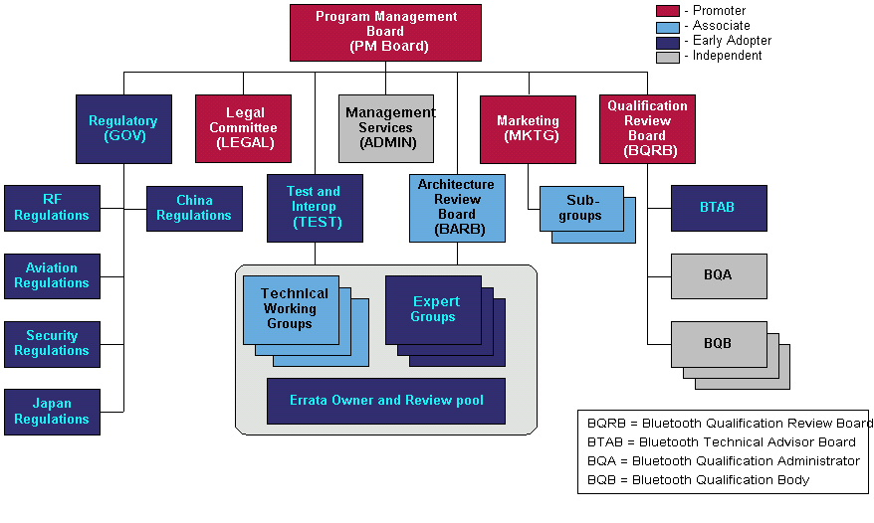
Source: BSIG Associate Participation Process v0.2.ppt

4:15 Tom reminded the SG that the R2SG was going to create a draft liaison that would be submitted to the BSIG PM. He continued to refine his R2SG Monday Meeting contribution (doc.: IEEE 802.15-00/300r0) to help facilitate the process.
4:16 Tom overviewed the R2SG Scope from contribution (doc.: IEEE 802.15-00/300r0):
- Provide a formal vehicle within IEEE 802.15 to track the activities of the Bluetooth SIG Radio2 Working Group (and related activities) and recommend appropriate action to 802.
- 2.0 Specification/Radio2 could be an extension to the existing 802.15.1 PAR
- 2.0 Specification/Radio2 could be a supplement to 802.15.1
- 2.0 Specification/Radio2 may become available to the IEEE in 2001 as another derivative work product or something else
4:17 Tom deleted the “extension” part of the Scope Statement after a PAR vs. Task Group discussion ensued on the floor i.e., Gifford/Heile/Gifford. The real issue being debated was one that a few of the TG3 candidate proposals have centered on since Aug00:
- If the same MAC is used, then this project is called 802.15.1a, since it is really aimed to be placed in the same standard as 802.15.1.
- If a different MAC is used, then this project would be called 802.15.3, and would be a completely separate WPAN™ standard.
4:26 Ian Gifford suggested the R2SG use a one page graphic.
4:29 Tom asked the participant to submit TG3 summary information for inclusion into the R2SG Closing/Liaison Report (doc.: IEEE 802.15-00/278r0)
4:30 R2SG Chair, Tom Siep, adjourned the session. R2SG would like to thank our Host, Motorola and Face to Face Events, Inc. for a well organized meeting.

Tentative Minutes Signed Off Friday, September 29, 2000

