IEEE P802.15
Wireless Personal Area Networks

Project | IEEE P802.15 Working Group for Wireless Personal Area Networks (WPANs)
Title | Physical Layer Submission to Task Group 3
Date Submitted | August 16th 2000
Source | [Anand Dabak, Tim Schmidl, Mohamed Nafie]  [Texas Instruments]  [12500 TI Boulevard, Dallas, Tx 75243] | Voice: [ 214-480-4389]  Fax: [ 972-761-6967]  E-mail: [ dabak@ti.com]
Re:
Abstract | Clarification for the channel spacing for T.I. proposal to 802.15.3.
Purpose | Discussion
Notice | This document has been prepared to assist the IEEE P802.15. It is offered as a basis for discussion and is not binding on the contributing individual(s) or organization(s). The material in this document is subject to change in form and content after further study. The contributor(s) reserve(s) the right to add, amend or withdraw material contained herein.
Release | The contributor acknowledges and accepts that this contribution becomes the property of IEEE and may be made publicly available by P802.15.
Channel spacing for T.I. proposal to 802.15.3

This is a response to criterion 4.4, “The number of simultaneously operating full throughput PAN’s” for the T.I. proposal to IEEE 802.15.3. The T.I. proposal employs the same spectrum mask as the IEEE 802.11 (b) given in table (1) below:

Frequency offset | Transmit power
fc | 0 dBc
+/- 11MHz | -30 dBc
+/- 22 MHz | -50 dBm

Using the above spectrum mask, 3 simultaneously operating full throughput WPAN’s can operate as shown by the solid lines in the figure below:
2402 MHz
Channel 1
Channel 5
Channel 9
2422 MHz
2442 MHz
2462 MHz
2482 MHz
2483.5 MHz
Channel 13

Figure 1: The proposed WPAN’s are shown.

We propose to operate a fourth WPAN, shown by dotted lines in the above figure. The proposed WPAN needs to comply with the FCC regulations for radiation limits in the frequencies above 2483.5 MHz. According to FCC 15.209, the specified field strength above 960 MHz is 500 microvolts/meter at a distance of 3 m. In the 2.4 GHz band this field strength is measured using an average detector implying an average radiated power of –41.2 dBm in any one MHz band.

The T.I. proposal mode 3 requires a transmit power of 4 dBm for the minimum throughput of 20 Mbps. Figure 2 plots the transmit power in each 1 MHz band from 2472 MHz to 2492 MHz for a total transmit power of 4 dBm. A square root raised cosine (SRRC) filter of α = 0.8 with a response that extends over 3 symbols on either side is used is used at the transmitter. The filter response is shown in figure 3. As can be seen from figure 2, the transmit power beyond 2483.5 MHz is less than –50 dBm. This is less than the FCC allowed power of –41.2 dBm power. The complexity of implementing an SRRC filter extending over 3 symbols is not significant. Hence, 802.15.3 should be able to fit 4 minimum throughput WPAN’s in the 2480-2483.5 ISM band.

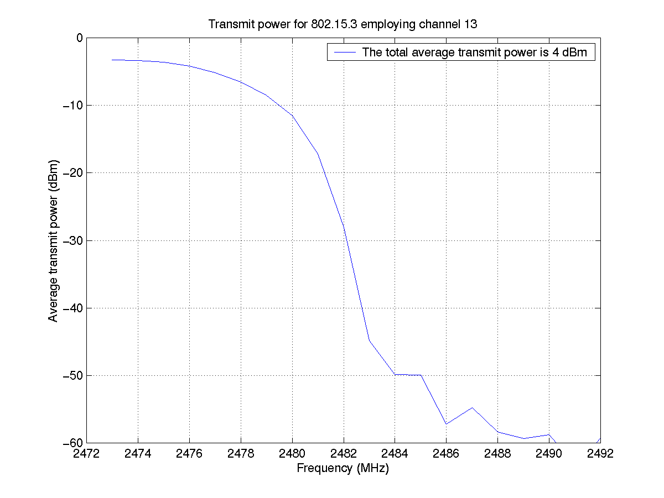
Figure 2: The transmit power for 802.15.3 employing channel 13 is shown. The power transmitted beyond 2483.5 is less than –50 dBm. This is less than the FCC allowed –41.2 dBm.
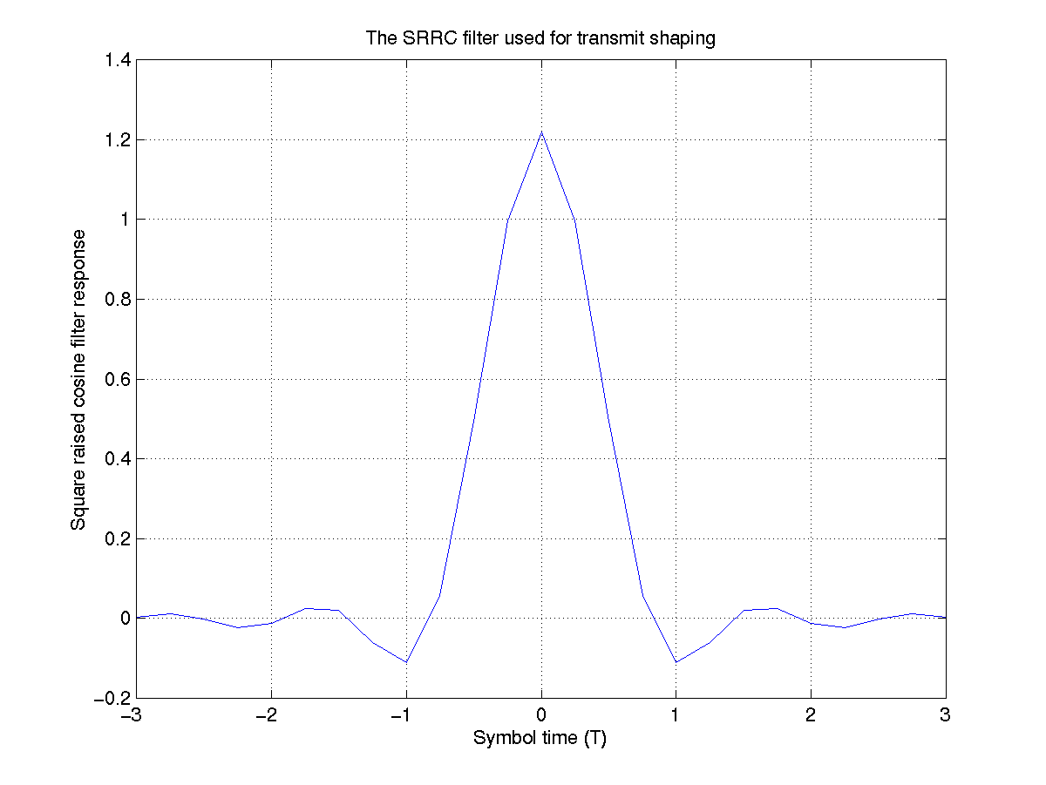
Figure 3: The transmit SRRC filter employing three symbols is shown.

