IEEE P802.15
Wireless Personal Area Networks
NOTE: To change <title> and other required fields, select File➔Properties and update the appropriate fields in the Summary tab. DO NOT replace field codes with text. After updates are entered, delete this paragraph and update all fields (ctl-A then F9) Note: dates will not be updated until document is saved. After fields are updated, delete this paragraph..

Project | IEEE P802.15 Working Group for Wireless Personal Area Networks (WPANs)
Title | MAC Modeling and System Simulation Results
Date Submitted | 25 June 2001
Source | Nada Golmie  NIST  100 Bureau Dr. Stop 8920  Gaithersburg MD 20899 | Voice: (301) 975-4190  Fax: (301) 590-0932  E-mail: nada@nist.gov
 | The is proposed text for clauses 8,9,10, and 11 of the Recommended Practice Document
Abstract | []
Purpose | []
Notice | This document has been prepared to assist the IEEE P802.15. It is offered as a basis for discussion and is not binding on the contributing individual(s) or organization(s). The material in this document is subject to change in form and content after further study. The contributor(s) reserve(s) the right to add, amend or withdraw material contained herein.
Release | The contributor acknowledges and accepts that this contribution becomes the property of IEEE and may be made publicly available by P802.15.

Clause 8. Medium Access Control (MAC) Layer
We used OPNET to develop a simulation model for the Bluetooth and IEEE 802.11 protocols. For the IEEE 802.11 protocol, we used the model available in the OPNET library.
For Bluetooth, we partially implemented the Baseband and L2CAP layers according to the specifications~\cite{Bluet99}. We assume that a connection is already established between the master and the slave and that the synchronization process is complete. The connection type is either SCO for voice or ACL for data traffic.
A MAC protocol generally consists of a collection of components, each performing a special function, such as the support of higher layer traffic, the synchronization process, the bandwidth allocation, and the contention resolution mechanism.

In this sequel, we highlight the features that are the most relevant to our work on interference, namely, we give a brief description of the MAC state machine, the frequency hopping, the error detection and correction schemes, and the interface to the physical layer.

MAC State Machine
Each of the Bluetooth and IEEE 802.11 MAC protocols is implemented as a state machine. Transitions from one state to another are generally triggered by the occurrence of events such as the reception or transmission of packets. Higher layer message arrivals require packet encapsulation and often segmentation if the message is too long. The information available in the packet determines the type of packet processing and encapsulation required. For example, Bluetooth ACL connections require L2CAP encapsulation while SCO connections only require baseband encapsulation. The packet is then enqueued and awaits a transmission opportunity. Since SCO packets need to be transmitted at fixed intervals, Bluetooth SCO packets have priority over Bluetooth ACL packets.

Transmission of packets follows each protocol's rules. Bluetooth transmission is based on a polling mechanism where the master controls the usage of the medium including its own transmission. In order to model the slotted nature of the channel, a virtual clock is implemented that generates self-interrupts every 625 μs. A master device starts its transmission in an odd numbered slot, while an even numbered slot is reserved for a slave transmission.
On the other hand, the IEEE 802.11 protocol uses CSMA/CA that allows a station to access the medium if the station is not receiving a packet or waiting for an acknowledgement from a previous transmission, after the medium has been idle for a period of time.

Frequency Hopping
Frequency usage constitutes another major component of the protocol model. Bluetooth implements a frequency hopping mechanism that uses 79 channels of the frequency band available at a maximum rate of 1600 hops/s depending on the packet size. Both master and slave devices are synchronized and follow the same random frequency hopping sequence. This frequency sequence is derived at the master and slave devices and depends on the master's clock
and its Bluetooth address. The algorithm for generating the sequence works as follows.
Given a window of 32 contiguous frequencies in the 2.402-2.483 GHz range, a sequence of 32 frequencies is chosen randomly. Once all 32 frequencies in that set have been visited once, a new window of 32 frequencies is selected. This new window includes 16 of the frequencies previously visited and 16 new frequencies. For the IEEE 802.11, we focus in this study on the Direct Sequence mode which uses a fixed frequency that occupies 22 MHz of the frequency band. The center frequency is selected among 11 available channels.

Error Detection and Correction
Error detection and correction is an essential component in the interference study.
For Bluetooth, the device first applies the error correction algorithm corresponding to the packet encapsulation used. HV1 packets have a total packet length of 366 bits including a header and an access code of 126 bits; they use a payload of 80 information bits, a 1/3 FEC rate and are sent every T__{SCO}=2 or 1250 μs. In case of an error occurrence in the payload, the packet is never dropped. A 1/3 FEC is applied to the packet header while a Hamming code (d=14) is applied to the access code. Uncorrected errors in the header and access code lead to a packet drop.
On the other hand, DM5 packets use a 2/3 rate FEC to correct payload. Errors in the header or access code are corrected by a 1/3 FEC and a Hamming code, respectively. Uncorrected errors lead to dropping packets and the use of the ARQ scheme. For IEEE 802.11, errors are detected by checking the Frame Check Sequence (FCS) that is appended to the packet payload. In case an error is found, the packet is dropped and is then later retransmitted. Otherwise, a positive ACK notifies the source of a correct reception.

Interface to Physical Layer
The OPNET MAC models were interfaced to the physical layer models described in the previous section in order to simulate the overall system. The step-by-step simulation process works as follows. Traffic is generated by sources located above the MAC layer. The message is then passed to the MAC layer where it undergoes encapsulation and obeys the MAC transmission rules. The packet is then sent to an interface module before it is passed to the PHY layer.

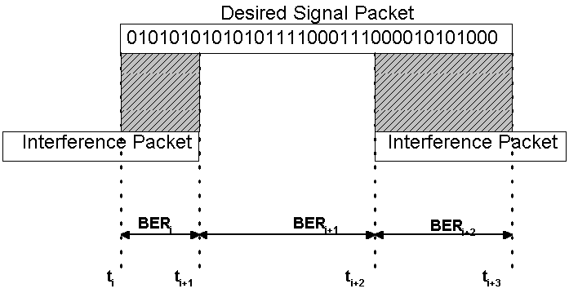
Figure 1: MAC / PHY Interface

This interface module is required to capture all changes in the channel state (mainly in the energy level) while a packet is transmitted. At the end of each packet transmission, a list is generated consisting of all interfering packets, the collision duration, the timing offset, the frequency, the power and the topology of the scenario used. This list is then passed to the physical layer module along with a stream of bits representing the packet being transmitted. The physical layer returns the bit stream after placing the errors resulting from the interference as shown in Figure 1. Note that each bit is corrupted according to the receiver's performance given the SIR computed from the collision information.

Clause 9: Data Traffic Models
For Bluetooth, we consider two types of application, namely voice and internet traffic. For voice, we assume a symmetric stream of 64 kbits/s each way using HV1 packet encapsulation. For modeling internet traffic, we consider a LAN access application. This is typically a connection between a PC and an Access Point or between two PCs, and it allows for exchanging TCP/IP or UDP-like traffic. Both slave and master devices generate IP packets according to the
distribution presented in Table 1. The packet interarrival time is exponentially distributed with a mean equal to 29.16 ms, which corresponds to a load of 30 % of the channel capacity (248 kbits/s for both directions). Packets are encapsulated with DM5 Baseband packets after the
corresponding PPP, RFCOMM, and L2CAP packet overheads totaling 17 bytes are added.

Message Size (bytes) | 64 | 128 | 256 | 512 | 1024 | 1518
Probability | 0.6 | 0.06 | 0.04 | 0.02 | 0.25 | 0.03
Table 1: IP Traffic Distribution

For the WLAN, we use the IP traffic distribution presented in Table1. We set the offered load to 30% of the channel capacity, which corresponds to mean packet interarrival times of 2.52 ms and 10.56 ms for the 11 Mbits/s and the 1 Mbits/s systems, respectively.

Clause 10: Performance Metrics
At the MAC layer, a set of performance metrics is defined to include access delay, probability of packet loss and residual number of errors in the Bluetooth voice packets. The access delay measures the time it takes to transmit a packet from the time it is passed to the MAC layer until it is successfully received at the destination. The access delay for the Bluetooth LAN traffic is measured at the L2CAP layer in order to account for retransmission delays. Packet loss measures the number of packets discarded at the MAC layer due to errors in the bit stream. This measure is calculated after performing error correction.
The residual number of errors in the Bluetooth voice packets measures the number of errors that
remain in the packet payload after error correction is performed.

Clause 11: Coexistence Modeling Results (DRAFT – Partial Results)

We present simulation results to evaluate the performance of Bluetooth in the presence of WLAN interference and vice versa. All simulations are run for 30 seconds of simulated time. The performance measurements are logged at the slave device for Bluetooth and at the Mobile device for the WLAN. The mean access delay result is normalized by the mean delay when no interference is present. We use the configuration and system parameters shown in Table 2.

Simulation Parameters | Values
Propagation Delay | 5μs/Km
Length of simulation run | 30 seconds
Bluetooth Parameters | Values
LAN Packet Interarrival Time | 29.16 ms
ACL Baseband Packet Encapsulation | DM5
SCO Baseband Packet Encapsulation | HV1
Transmitted Power | 1 mW
Slave Coordinates | (0,0) meters
Master Coordinates | (1,0) meters
WLAN Parameters
Packet Interarrival Time for 1 Mbits/s | 10.56 ms
Packet Interarrival Time for 11 Mbits/s | 2.52 ms
Transmitted Power | 25 mW
AP Coordinates | (0,15) meters
Mobile Coordinates | (0,d) meters
Packet Header | 224 bits
Slot Time | $2 * 10^{-5}$ seconds
SIFS Time | $1 * 10^{-5}$ seconds
DIFS Time | $5 * 10^{-5}$ seconds
CW_{min} | 31
CW_{max} | 1023
Fragmentation Threshold | None
RTS Threshold | None
Short Retry Limit, Long Retry Limit | 4,7
Table 2: Simulation Parameters

We present the results from four different simulation experiments that show the impact of WLAN interference on Bluetooth devices and vice versa for two different applications, namely voice and data traffic. Table 3 provides a summary of these four cases, while Figure 2 shows the experimental topology. Please note that the WLAN access point (AP) is fixed at (0,15) meters, while the WLAN mobile is free to move along the vertical axis, i.e. its coordinates are (0,d). The Bluetooth devices are fixed at the given locations. In the first two experiments, the mobile is the generator of the 802.11 data, while the AP is the sink. In the last two experiments the traffic is generated at the AP.

Experiment | Desired Signal | Interferer Signal | WLAN AP | WLAN Mobile
1 | BT Voice | 802.11 | Sink | Source
2 | BT LAN | 802.11 | Sink | Source
3 | 802.11 | BT Voice | Source | Sink
4 | 802.11 | BT LAN | Source | Sink

Table 3: Summary of the Experiments

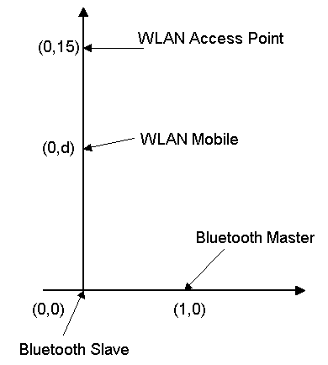
Figure 2: Experiment Topology
Figure 3: Impact of Interference on Packet Loss: WLAN 11 Mbits/s
Figures 3 and 4 show the impact of interference on packet loss for all four experiments using WLAN 11 Mbits/s and 1 Mbits/s respectively.

Figure 4: Impact of Interference on Packet Loss: WLAN 1 Mbits/s
Figures 5 and 6 give the impact of interference on the mean access delay for experiments 2 and 4 using WLAN 11 Mbits/s and 1 Mbits/s respectively.

Figure 5: Impact of Interference on Mean Access Delay: WLAN 11 Mbits/s

Figure 6: Impact of Interference on Mean Access Delay: WLAN 1 Mbits/s

Figure 7 gives the impact of interference on the number of residual errors in the Bluetooth voice packets for experiment 1 for WLAN 11 and 1 Mbits/s.

Figure 7: Impact of Interference on residual errors in Bluetooth Voice packets

