IEEE P802.15
Wireless Personal Area Networks

Project | IEEE P802.15 Working Group for Wireless Personal Area Networks (WPANs)
Title | IEEE 802.15.2 Clause 14.1 Collaborative co-located coexistence mechanism
Date Submitted | [July 6, 2001]
Source | [Robert E. Van Dyck & A. Soltanian]  [NIST]  [100 Bureau Drive, MS 8920]  [Gaithersburg, MD 20899] | Voice: [(301) 975-2923]  Fax: [(301) 590-0932]  E-mail: [vandyck@antd.nist.gov]
Re:
Abstract | [Text submission for IEEE 802.15.2 Clause 14.1]
Purpose | [Initial Text Submission]
Notice | This document has been prepared to assist the IEEE P802.15. It is offered as a basis for discussion and is not binding on the contributing individual(s) or organization(s). The material in this document is subject to change in form and content after further study. The contributor(s) reserve(s) the right to add, amend or withdraw material contained herein.
Release | The contributor acknowledges and accepts that this contribution becomes the property of IEEE and may be made publicly available by P802.15.

In this section, we discuss an interference suppression technique, denoted deterministic frequency nulling, designed to mitigate the effect of 802.15.1/Bluetooth interference on 802.11b. Since the Bluetooth signal has a bandwidth of approximately 1 MHz, it can be considered a narrowband interferer for the 22 MHz wide 802.11b signal. The basic idea of the suppression technique is to put a null in the 802.11b’s receiver at the frequency of the Bluetooth signal. However, since Bluetooth is hopping to a new frequency for each packet transmission, the 802.11b receiver needs to know the frequency hopping pattern, as well as the timing, of the Bluetooth transmitter. This knowledge is obtained by employing a Bluetooth receiver as part of the 802.11b receiver. Thus, this is a collocated, collaborative method. Since it is primarily a physical layer solution, it can be integrated with the MEHTA MAC layer solution. This section discusses the procedure and the results for the 1 Mbit/sec 802.11b direct sequence spread spectrum system.

Editor’s Note: add the 11 Mb/s and maybe adaptive processing.

Figures~\ref{fig:reject1}(a) and (b) show the block diagrams of the 1 Mbit/sec IEEE 802.11b transmitter and receiver, respectively. Note that between the chip matched filter and the PN correlator is an adjustable transversal filter. The optimal coefficients of this filter are estimated and then used to update the filter. Figure~\ref{fig:transversal} shows the structure of the transversal filter.

Editor’s Note: Question of implementation. One could estimate these coefficients or one could preprogram them.

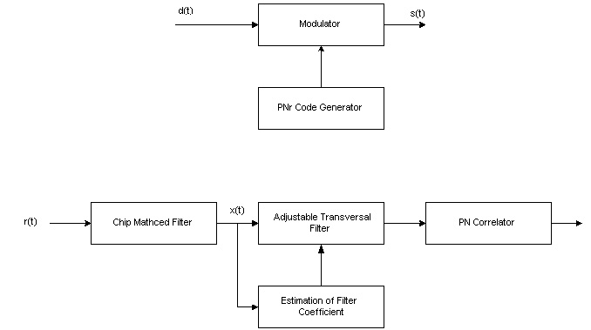
\epsffile{reject1.jpg}
\caption{(a)/(b) Block diagrams of the 1 Mbits/sec IEEE 802.11 system, employing frequency nulling.
(a) Transmitter. (b) Receiver.}
\label{fig:reject1}

Note: correct misspelling. Estimation and/or preselection.
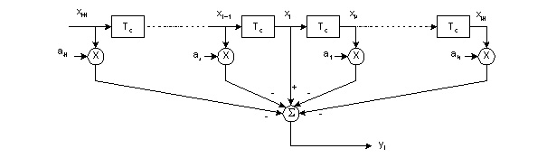
\epsffile{transversal.jpg}
\caption{Adjustable transversal filter used in the 802.11 receiver.}
\label{fig:transversal}

First let us assume that the interferer is a pure tone. Consider the central tap in the transversal filter. At time iT, it can be written as~\cite{milstein:82b}
$$x_{i}=d_{i}+V_{j}\text{cos}(2{πf}_{j}{\text{iT}}_{c}+θ)+n_{i},$$
where $T_{c}$ is the sampling interval equal to the chip time, $d_{i}$ is the signal amplitude, and $V_{j}$ and $f_{j}$ are the amplitude and frequency of the interferer. $θ$ is a random phase angle with a uniform distribution. The objective is to find the tap weights that minimize the error.

When the interference is stationary, one can employ the Wiener solution to find the optimum tap weights. These optimal tap coefficients, $a_{k,\text{opt}}$, are found by solving the following system of equations~\cite{milstein:82b, ketchum:82}
$\sum_{\begin{matrix}k=−N \\ k≠0\end{matrix}}^{N}{r(l−k)a_{k,\text{opt}}=\begin{matrix}r(l), & l=−N,⋯−1,1,⋯,N\end{matrix}}$,
where the autocorrelation function is given by $r(m)=E\left\{x_{i}x_{i−m}\right\}$, and the samples, $x_{i}$, are as shown in Figure~\ref{fig:transversal}.

The first assumption is that the PN sequence is sufficiently long. This implies that the PN signal samples at the different taps are uncorrelated. In this case, the solutions for the optimal tap weights have the simple form~\cite{milstein:82b}
$a_{k,\text{opt}}=2A\text{cos}(kΩT)=A(e^{\text{jk}ΩT}+e^{−\text{jk}ΩT})$,
where $Ω=2{πf}_{j}$, and the parameter A is given by
$A=\frac{J}{2(S+σ_{n}^{2})+J[2N−1+\frac{\text{sin}(2N+1)ΩT}{\text{sin}ΩT}]}$. \label{eq:jammer1}

Note 1: Confirm that we are measuring S, J, and the noise power at the input to the chip matched filter, not at the input to the transversal filter. We may also want to change J to I.

Eq. ( \ref{eq:jammer1}) shows that one needs estimates of the signal power, S, the interferer power, J, and noise power, $σ_{n}^{2}$. In many traditional military jamming scenarios, the signal-to-noise ratio (SNR) can be relatively low. Fortunately for 802.11b systems in typical configurations, the SNR is often quite high. So, we can neglect the noise power in this equation. Still, one needs an estimate of the carrier-to-inference (CIR) ratio to determine the optimal tap coefficients. One also needs an estimate of the offset in frequency, $Ω$, between the 802.11b signal and the interferer. In a collaborative system, this frequency is assumed known a priori.
Note 2: Confirm that we are measuring CIR and CNR at the input to the chip matched filter. Also, change CIR and CNR to SIR and SNR, respectively, ensuring that they are correctly measured.
Note 3: Give the length of the transversal filter used. N=3? Make sure that we really did assume the CIR was – 20 dB.

Figure~\ref{fig:norejectperform} shows the bit error rate performance of the 1 Mbits/sec 802.11 system for an AWGN channel with Bluetooth interference. We measure CIR and CNR at the input to the chip matched filter. Without any type of interference suppression, a CIR value of –5 dB is needed for acceptable performance at all frequency offsets. If the offset is at least 5 MHz, then a value of approximately –11 dB is acceptable. Figure~\ref{fig:rejectperform} shows the performance when the adjustable transversal filter is used. When using Eq.(\ref{eq:jammer1}), we assumed that the CIR was –20 dB. Even when there is a mismatch between the assumed CIR and the actual CIR, the performance is greatly improved. Even for the worst case of a 1 MHz offset, a CIR of –20 dB gives a bit error rate below ${\text{10}}^{−3}$.

Note: We could mention that one could estimate the CIR instead of assuming a value. How much does this improve performance?

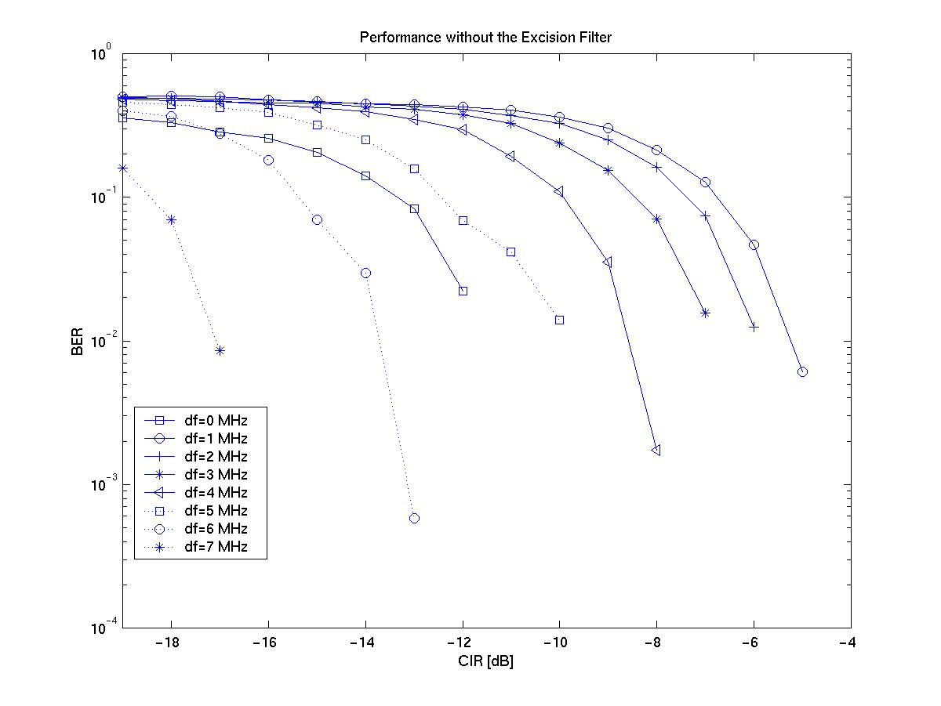
\epsffile{NoRejectperform2.jpg}
\caption{BER performance of 1 Mbits/sec 802.11 receiver with Bluetooth interference and
without any interference suppression. AWGN channel.}
\label{fig:norejectperform}

Note 4: Do we need this figure, since it is similar, if not identical to the one in Clause 6? One possibility is to have both before and after on the same plot. We do not need to show for all of these frequencies.

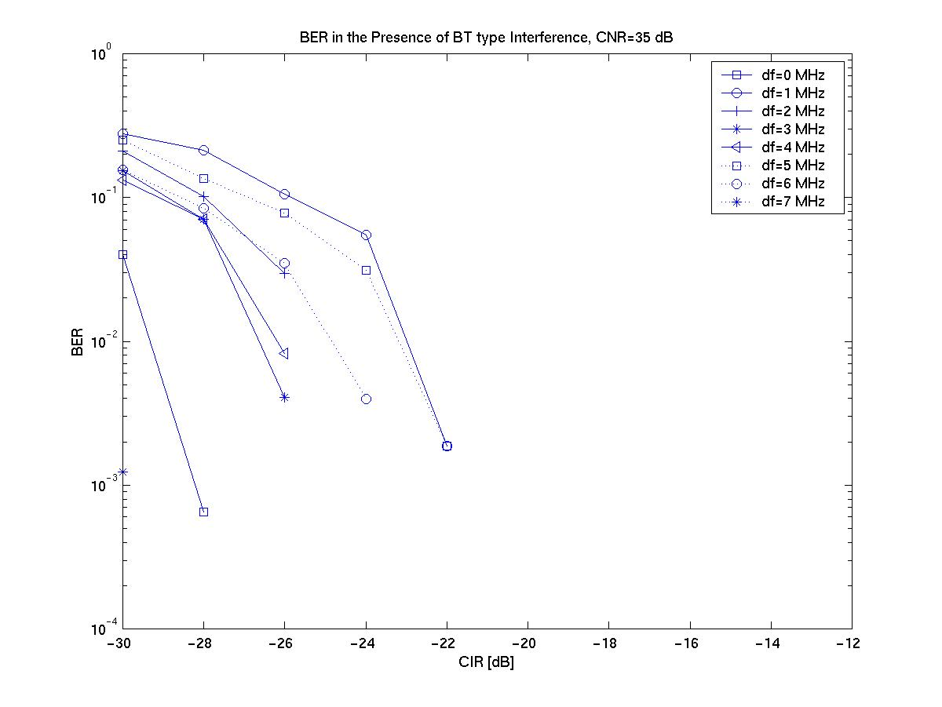
\epsffile{Rejectperform.jpg}
\caption{BER performance of 1 Mbits/sec 802.11 receiver with Bluetooth interference and
with adjustable transversal filtering. AWGN channel.}
\label{fig:rejectperform}

11 Mbits/sec CCK System
Note 5: Write this section

Bibliography

Note 6: I think this is actually Li and Milstein.

\bibitem{milstein:82b} L. B. Milstein and L.-M. Li, “Rejection of narrow-band interference in PN spread-spectrum systems using transversal filters,” IEEE Trans. on Comm., vol. COM-30, pp. 925-928, May 1982.

\bibitem{ketchum:82} J. W. Ketchum and J. G. Proakis, “Adaptive algorithms for estimating and suppressing narrow-band interference in PN spread-spectrum systems,” IEEE Trans. on Comm., vol. COM-30, pp. 913-924, May 1982.

\bibitem{schilling:80} D. L. Schilling, L. B. Milstein, R. L. Pickholtz and R. W. Brown, ``Optimization of the processing gain of an M-ary direct sequence spread spectrum communication system,'' IEEE Trans. Comm., pp. 1389-1398, Aug. 1980.

\bibitem{milstein:82} L. B. Milstein, S. Davidovici, and D. L. Schilling, ``The effect of multiple-tone interfering signals on a direct sequence spread spectrum communication system,'' IEEE Trans. Comm., vol. 30, pp. 436-446, Mar. 1982.

