IEEE 802.15
Wireless Personal Area Networks™

Project | IEEE 802.15 Working Group for Wireless Personal Area Networks (WPANs)
Title | Draft WPAN Article for IEEE Microwave & Spectrum Magazines
Date Submitted | [February 25, 2001]
Source | [Ian Gifford]  [M/A-COM, Inc.]  [1011 Pawtucket Boulevard  Lowell, MA USA 01853-3295] | Voice: [+1 978 442 4650]  Fax: [+1 978 442 5442]  E-mail: [giffordi@ieee.org]
Re: | [Verbal 12Jan01 from Roger Marks]
Abstract | [An article that provides an update on the IEEE 802.15 – as of 25Feb01.]
Purpose | [The purpose of this Magazine Article is to promote the emerging wireless standards-making WGs inside of IEEE 802 and the IEEE Computer Society. There is reason to believe we can place this article into IEEE Spectrum and/or other IEEE Magazines NLT this Summer.]
Notice | This document has been prepared to assist the IEEE 802.15. It is offered as a basis for discussion and is not binding on the contributing individual(s) or organization(s). The material in this document is subject to change in form and content after further study. The contributor(s) reserve(s) the right to add, amend or withdraw material contained herein.
Release | The contributor acknowledges and accepts that this contribution becomes the property of IEEE and may be made publicly available by 802.15.

Wireless Personal Area Networks™: An Overview of the IEEE 802.15 Working Group
Ian C. Gifford, M/A-COM, Inc.

Introduction

In March 1999 the IEEE 802 Local and Metropolitan Area Network Standards Committee formed a new Working Group to develop communications standards for Wireless Personal Area Networks™ for portable and mobile computing devices. Portable and mobile computing devices are defined as unobtrusive computing devices, networking devices, software and peripherals which are worn or carried by individuals to enhance their ability to perform productive work as well as provide entertainment.

The new group is designated Project 802.15 Working Group for Wireless Personal Area Networks (WPANs™). The standards created by 802.15 are addressing the requirements for wireless personal area networking of a new class of computing devices. This class, collectively referred to as pervasive computing devices includes, PCs, Notebooks, PDAs, peripherals, cell phones, pagers and consumer electronic devices to communicate and interoperate with one another.

Since it’s inception, the 802.15 Working Group has established close working relationships with Special Interest Groups such as Bluetooth™ and Industry Consortia namely HomeRF™. The Working Group is also soliciting industry input, in general, on market requirements and technical solutions for WPANs with 0 to 10 meter range. A variety of data rates from substantially less than 1Mbit/s to in excess of 20 Mbits/s are being considered. Maintaining low power consumption, small size (less than 0.5 cubic inches) and low cost relative to target device are primary considerations. The goal is to develop draft standards that have broad market applicability and deal with the issues of coexistence and interoperability.

The group currently has four authorized projects underway. The first under Task Group 1 is developing a standard based on the Bluetooth™ Specification(s) Version 1.1. The second is Task Group 2, which is developing a recommended practice for Coexistence of WLAN and WPAN devices in unlicensed bands. The third is Task Group 3, which is developing a High Rate WPAN standard in excess of 20 Mbits/s intended for digital imaging and multimedia applications. The fourth is Task Group 4, which is developing a Low Rate WPAN standard 2 Kbits/s to 200 Kbits/s intended for interactive toys, sensors and automation needs for wireless communications. TG4 may also address the location tracking capabilities required to support uses of smart tags and badges.

Additionally, the Working Group decided early on that they needed a publicity committee to manage the information and communication of the projects. The Publicity Committee (PC) works across all projects and promotes the WPAN brand and helps to promote creation of technical articles, joint marketing communications, Trade Show events, etc. for the IEEE, IEEE-SA, SDOs, Regulators, and Industry.

History of the Evolution of IEEE 802.15

The chain of events leading to the formation of IEEE 802.15 began in June 1997 when the IEEE Ad Hoc "Wearables" Standards Committee was initiated during the IEEE New Opportunities in Standards Committee (NosCom) held in Cleveland, OH USA on 24Jun97. The purpose of the Committee was to "encourage development of standards for wearable computing and solicit IEEE support to develop standards." The consensus recommendation from the NosCom meeting was that the interested individuals should conduct their standards development in the IEEE Portable Applications Standards Committee (PASC).

During the PASC Plenary Meeting in July 1997, an IEEE Ad Hoc Committee was assembled (17 attendees) to discuss "Wearables" Standards on 16Jul97 in Nashua, NH USA. The Committee identified several areas that could be considered for standardization, including short-range wireless networks or Personal Area Networks (PANs), peripherals, nomadicity, wearable computers, and power management. Of these, the committee determined that the best area of focus was the Wireless PAN because of its broad range of application. The IEEE Ad Hoc "Wearables" Standards Committee met twice more – once on 2Dec97 in Cleveland, OH USA and again on 14-15Jan98 in Memphis, TN USA. During the January 1998 meeting it was agreed that the 802 LAN/MAN Standards Committee (LMSC) was probably a more suitable home for the groups activities, especially with a PAN focus. Two delegates were sent to the IEEE 802.11 Working Group for Wireless Local Area Networks Interim Meeting that was taking place that same month, to get reactions and to gain support for the proposal. At that meeting it was agreed to propose the formation of a Study Group under 802.11 at the March 1998 Plenary of 802. A Conference Tutorial was presented to socialize the WPAN idea within 802. The result was that in March 1998, the "Wearables" Standards Ad Hoc Committee under PASC became the IEEE 802.11 Wireless Personal Area Network (WPAN) Study Group within LMSC with the goal of developing a Project Authorization Request (PAR) for the development of a WPAN standard.

At the time the Study Group was formed, there had been no other publicized initiatives in the WPAN space other than the Infrared Data Association‘s IrDA specification. IrDA’s line-of-sight restrictions do not allow it to adequately address the WPAN applications. By the time the work of the Study Group concluded, a year later, both the Bluetooth™ Special Interest Group and HomeRF™ were active in developing WPAN specifications. By March 1999, when the Study Group and 802.11 submitted the PAR to the 802 Executive Committee for approval, Bluetooth™ had over 600 adopter companies and HomeRF™ had over 60. Because of the significance of these groups in the WPAN market space, it was felt that the standards development process would be better served if a new Working Group were formed to address the problem rather than pursue it as a Task Group under 802.11. The PAR was approved and the new group was designated as IEEE 802.15 Working Group for Wireless Personal Area Networks.

Current Status (as of February 23, 2001)

802.15 Overview

Session #10 of the IEEE 802.15 Working Group for Wireless Personal Area Networks took place on 15-19January 2001 in Monterey, CA USA. As in the past this session was collocated with the IEEE 802.11 Working Group for Wireless Local Area Networks as well as the Joint IEEE/ETSI-BRAN/MMAC 5 GHz Globalization Study Group meeting. This meeting set a record attendance of 328 people of these 110 people attended the WPAN session; each trying to attend one or more of the 4 project tracks. There are currently 74 active voting members in 802.15.

At the March 2001 IEEE 802 LMSC Plenary, it is expected that the TG1’s draft standard IEEE 802.15.1/D0.8.0 will be approved by the 802.15 Working Group and then forwarded to the SEC for their review and approval for commencement of Sponsor Ballot. TG2 will make a motion to the SEC to form an Executive Committee Study Group (ECSG) to investigate a new “802 Wireless Coexistence Group”. TG3 will hold a Task Group vote on their baseline draft standard. TG4 will finalize their MAC & PHY criteria selection document, establish criteria weighting, finalize selection process, and the nine candidates will present their top level Call For Proposal responses.

Figure 1 depicts the 802.15 Working Group and the 4 Project planning timelines.

YEAR | 1999 |  |  |  | 2000 |  |  |  | 2001 |  |  |  | 2002 |  |  |  | 2003
PROJECT\QUARTER | Q1 | Q2 | Q3 | Q4 | Q1 | Q2 | Q3 | Q4 | Q1 | Q2 | Q3 | Q4 | Q1 | Q2 | Q3 | Q4
802.15 Working Group
802.15 Publicity Committee
802.15.1 Task Group 1
802.15.2 Task Group 2
802.15.3 Task Group 3
802.15.4 Task Group 4
 |  | = Project active |  |  |  |  | = Project slippage |  |  |  |  |  | = Project closed
Figure 1 802.15 Project Planning, as of 25Feb01
It is presumed that the various projects will follow up with, new projects, supplements to projects, and maintenance project requests. Therefore, the 802.15 Working Group lifecycle will likely continue into 2003 or further.

Task Group 1 (TG1): WPAN™-Bluetooth (Wireless Personal Area Network).

Task Group 1 (TG1) is deriving a draft standard based on the Bluetooth™ Specification Version 1.1 under IEEE PAR 802.15.1. The project is late; current project planning puts the completion of their draft standard at Dec01 – which is a 12-month slip.

On Sep00 the IEEE finalized a limited, non-exclusive, non-transferable license from the Bluetooth™ SIG to adopt or adapt and copy a portion of the Bluetooth™ Specification to be used as base material in the IEEE Standards Project 802.15.1, on the condition that the IEEE 802.15.1 standard is:

- 100% compatible with the Bluetooth™ v1.1 Foundation Specification (as measured by a certified Bluetooth™ test house)
- Maintains and requires inclusion of Bluetooth™ testing interfaces as described in the current Bluetooth™ specification (to allow interoperability testing between Bluetooth™ and 802.15.1 compliant solutions)
- Any 802.15.1 extensions (beyond Bluetooth™ v1.1 specification) must not break interoperability with existing Bluetooth™ v1.1 certified radios and be approved by the Bluetooth™ SIG Promoters.

The SIG’s Voting Draft of the complete Bluetooth Specification was updated on 19Jan01 and the FrameMaker source was made available to the TG1 Editor-in-Chief for standards development. In addition, the Bluetooth PICS/PIXIT and profile ICS/profile IXIT proforma Version 0.9 document was also provided for inclusion to the draft. The Core and Profile Specifications represent the basis for the Bluetooth Version 1.1 Specification and include the critical and recommended errata approved by the SIG on 30Nov00. Task Group 1 provided the SIG the IEEE 802.15 WG Letter Ballot #3 (LB3) comments and a portion of these were approved and included in Version 1.1. IEEE LB3 Voters that had comments on derivative text were added to the list of contributors in the Bluetooth specifications.

The focus of IEEE Project 802 is on the lower two layers (data link and physical) as such the LLC/MAC boundary defines the Bluetooth layers or parts used by IEEE 802.15.1 in their derivative work – “L2CAP and below”. Figure 2 shows the protocol stacks in the OSI 7-layer model and in the Bluetooth wireless technology and their relation as it pertains to the 802.15.1 standard.
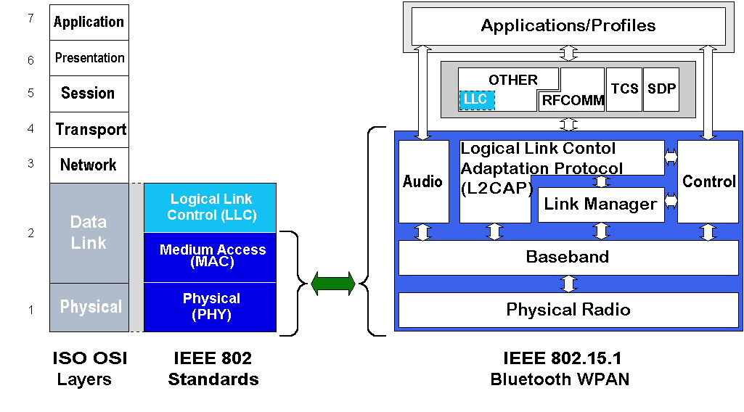
Figure 2 Mapping of ISO OSI to scope of WPAN standard

The Task Group 1 Editing Team turned the derivative work around and released the 1200 page IEEE Draft 802.15.1/D0.8.0–2001 to the Working Group for review and it was approval for release to Letter Ballot #8. LB8 is a 30-day ballot, which runs from 9Feb01 to 11Mar01.

Entering Session #11 and based on the results of LB8 the primary objective is to resolve LB8 comments, if any. Also we will review the parallel editorial edits applied to IEEE Draft 802.15.1/D0.8.0–2001 prior to Sponsor Balloting commencement. The key outstanding edits are applying the IEEE Standards Style Manual, reviewing the non derivative draft text for obvious updates e.g., reviewing the SDL Model gaps from v1.0B to the latest Version 1.1 text and bringing the model up to date with the IEEE Draft P802.15.1/0.8.0 standard.

Task Group 2 (TG2): WPAN™-Coexistence (Wireless Personal Area Networks-Coexistence).

Task Group 2 (TG2) is developing a draft recommended practice for Coexistence of WLAN and WPAN devices in unlicensed bands under IEEE PAR 802.15.2. The project is late; current project planning puts the completion of their draft recommended practice at Mar02 – which is a 12-month slip.

One of the major concerns within the IEEE, and the wireless community in general, is the fact that Bluetooth™ and IEEE 802.11 both operate in the same 2.4 GHz Industrial, Scientific, Medical (ISM) band. In addition, Bluetooth will be embedded within portable devices that are likely to be used in a facility that is equipped with an IEEE 802.11 Wireless Local Area Network (WLAN). Since both Bluetooth and the WLAN operate in the same band there will be some mutual interference between the two wireless networks. Because there has been concern regarding this mutual interference, the IEEE has established a Project within 802.15 called Task Group 2 (TG2) to address the issue of coexistence of these two wireless networks. The goal of the Task Group is twofold. First, the TG2 will develop what is being referring to as a Coexistence Model quantifying the effect of the mutual interference of the two wireless networks. Second, the TG2 will develop Coexistence Mechanisms to facilitate coexistence of Bluetooth and IEEE 802.11 WLANs. Both the Models and the Mechanisms will be documented in an IEEE Recommended Practice.

The initial focus of the Task Group has been the development of the Coexistence Model. Multiple wireless devices are said to ‘coexist’ if they can be collocated without significantly impacting the performance of any of these devices. The final model, due March 2001, will consist of four major sections: Physical (PHY) Layer Models, Medium Access Control (MAC) Layer Models, RF Propagation Models, and Data Traffic Models, as illustrated in Figure 3.
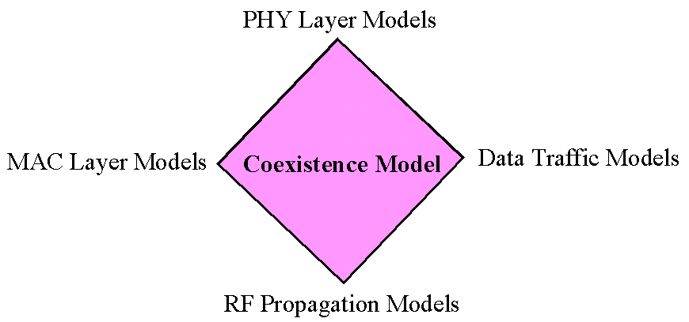
Figure 3 802.15.2, The Four Areas of the Coexistence Model

For example, one of the PHY Layer Models will give the bit error rate (BER) of a Bluetooth Piconet, in the presence of an IEEE 802.11 WLAN. The higher-layer model will use the results of the PHY model, incorporate the Data Traffic Models and the WLAN MAC Model to quantify the impact of IEEE 802.11 WLAN on the Bluetooth Piconet network parameters, like network throughput and latency. Similarly, the Task Group will model the impact of a Bluetooth Piconet on an IEEE 802.11 WLAN. The Task Group also plans to provide a recommended practice on the mutual interference of the WPAN-HR, being developed in Task Group 3, and both Bluetooth and an 802.11 WLAN.

The Bluetooth SIG has established a Working Group on Coexistence. A liaison between TG2 and the Bluetooth Coexistence group has been established. The two groups are currently in the process of investigating opportunities for collaboration.

In order to encourage cooperation both the 802.15 WPAN Working Group and the 802.11 WLAN Working Group will vote on the Coexistence Recommended Practice.

Executive Committee Study Group (ECSG) on Coexistence

Finally, the TG2 Leadership has brought forth a question as to whether there should be an IEEE 802 Wireless Coexistence Group vs. individual coexistence initiatives in each wireless Working Group. For example 802.11 recently formed the 5 GHz Study Group. One of the SG goals appears to be to harmonize all the 5 GHz WLANs (802.11a, HiperLAN2, MMAC) into a single worldwide 5 GHz WLAN standard or at a minimum, ensure that the systems coexist. During Session #10 the 802.15 WG approved a motion from 802.15.3 to inform the IEEE 5GSG that 802.15.3 is interested in producing a 5 GHz PHY using a common 802.15.3 MAC. Additionally, the 802.16 Task Group 4 (TG4): WirelessHUMAN™ (Wireless High-Speed Unlicensed Metropolitan Area Networks) recently received 17 contributions and is primarily focused on the 5 GHz bands.

Scenario 1 – status quo
- Keep 802.11 5GSG unchanged so they can continue working on their specific tasks at hand.
- Keep 802.15 TG2 & TG3 unchanged so they can continue working on their specific tasks at hand.
- Keep 802.16 TG2 & TG4 unchanged so they can continue working on their specific tasks at hand.

Scenario 2 – change
- Form an IEEE 802 Wireless Coexistence Group e.g., new WG, Joint TG [sic], or LMSC Technical Advisory Groups (TAG).

Again, during the March 2001 IEEE 802 LMSC Plenary, it is expected that the TG2 will make a motion to the SEC to form an Executive Committee Study Group (ECSG) to investigate a new “802 Wireless Coexistence Group” and specifically two questions in more detail - What would be the function of this new group? What would be the organization of this new group?

Task Group 3 (TG3): WPAN™-HR (Wireless Personal Area Networks High Rate).

During Session #9 (6-9Nov00) the 6 candidate PHY Layer and 4 candidate MAC Sublayer proposals were reduced to 1 PHY and 1 MAC. Based on this the TG3 began their resolution of the remaining MAC and PHY issues, via their post session teleconference calls.

During Session #10 the IEEE Draft 802.15.3 was begun as well as review of MAC/PHY interfaces. A proposal –01/024r2 describing an 8-State Trellis Coded Modulated 16/32/64-QAM physical layer operating in the unlicensed 2.4 GHz band was chosen over a competing M-ary, Bi-Code Keying proposal –00/210r13. The proposed system provides adaptive data rates from 33 Mbit/s to 55 Mbit/s depending on application requirements and channel conditions. Motion accepted: 16/5/0 with 82% confirmation vote.
- 16QAM/TCM – 33 Mbit/s
- 32QAM/TCM – 44 Mbit/s
- 64QAM/TCM – 55 Mbit/s

Two new work items were initiated:
- non-802 SAPs i.e., study 802.15.1 to determine what interfaces will be required, investigate how to switch between modes. May not need to support all profiles (e.g., audio).
- Additional PHYs i.e., 5 GHz.

802.15.3 Characteristics
802.15.3 MAC Characteristics | 802.15.3 PHY Characteristics
Proven support for mobile wireless personal area networks (WPAN) | 2.4 GHz using 802.11 channels
Enables WPANs to interact with wired infrastructure access points | Base mode of 22Mbps uncoded
Enables a WPAN to temporarily separate into two subnets and then recombine via an efficient re-authentication and re-association procedure | Higher order codes could allow 33,44,55 Mbps
Provides proven protocol support for efficient power management policies
Redundant master coordinators
Repeater service
Virtual data streams (asynchronous/isochronous)
Negotiating QoS parameters in a WPAN environment
Dynamic channel selection and/or migration
Adaptive FEC and selective retransmission ARQs
An efficient Slot Cycle TDMA algorithm for accessing the RF medium
Bounded latencies
Support for negotiating channel bandwidth allocations

During Session #11 (12-15Mar01) TG3 will hold a Task Group vote on their baseline draft standard.

Task Group 4 (TG4): WPAN™-LR (Wireless Personal Area Networks Low Rate).

Following the 7Dec00 approval of its PAR, Task Group 4 held its first meetings during Session #10 and received and heard 8 WPAN-LR Call For Application contributions. Discussions indicated general agreement among the proposals, and consolidation is progressing. As of 23Feb01 there had been 10 letter of intents submitted and 1 had been withdrawn – leaving 9 candidates for either a MAC/PHY or standalone MAC or PHY.

TG4 remains on schedule. In Figure 4 the TG4 Project Planning indicates that they will meet their PAR expected date of submission for initial Sponsor Ballot of March 2002. The projected completion date for submittal to RevCom is July 2002.

During Session #11 (12-15Mar01) TG4 proposal presentations will be informative in nature. Just giving a brief overview of the proposal and why it meets the criteria as stated in the criteria summary matrix document -01/068r2. Additionally, TG4 is planning on discussing the weighting of the matrix items. During Session #12 the details of the selection criteria will be discussed. The elimination process will be started at this session.
Figue 4 802.15.4 Project Plan, 19Jan01

In conclusion this WPAN will differentiate itself in a few key areas. For example the target cost for a TG4 device should not significantly impact the BOM (Bill Of Material) cost of the targeted product (see PAR), for instance less than 25% of the BOM cost of an intelligent thermostat.

Conclusions and Future Directions

At first glance the operation and objectives of a WPAN may appear to resemble with those of a wireless LAN (WLAN), like IEEE 802.11. Both the WLAN and WPAN technologies allow a device to connect to its surrounding environment and exchange data with it over an unlicensed, wireless link. However, WLANs have been designed and are optimized for usage of transportable, computing (client) devices, such as notebook computers. WPAN devices are even more mobile. The two technologies differ in three fundamental ways:
- Power levels and coverage
- Control of the media
- Lifespan of the network

Wireless personal area networks will proliferate early in the new millennium and the IEEE 802.15 Working Group for Wireless Personal Area Networks (WPAN's) is providing the leadership in the IEEE 802 Standards Committees to establish open standards for these WPAN's.

More info: http://ieee802.org/15/

Biographies

Ian Gifford was born in Framingham, Massachusetts, USA. He received a Bachelors in Economics from Boston University, Boston Massachusetts, USA, in 1981. He is Director of Standards at M/A-COM, Inc., a Tyco Electronics Company, in Lowell, Massachusetts, USA. For the past 15 years he has worked on wireless solutions for wide area, local area and personal area networks. Additionally, he is an active member in a number of Standards Development Organization's e.g., ITU-R, TIA, and Committee T1 as well as a few Industry Special Interest Groups and Alliances e.g., Bluetooth(TM) Special Interest Group, etc. He is also currently Vice Chair of the IEEE 802.15 Working Group for WPANs. His e-mail address is giffordi@tycoelectronics.com.

