 | INTERNATIONAL TELECOMMUNICATION UNION
 | RADIOCOMMUNICATION  STUDY GROUPS | DRAFT Revision to  Document 8A-9B/89-E  19 October 2001  English only
Received: DRAFT 11/13/01

Subject: Task RLAN

NOTE: This is a draft of a revision to document 8A-9B/89-E, intended for future submission. This revision has added material relevant to 802.11a, and DFS in 802.11a
France
Working document towards a PRELIMINARY DRAFT NEW RECOMMENDATION on Dynamic Frequency Selection
in 5GHz RLANs

1 Summary
This draft describes the spectrum sharing mechanisms DFS (Dynamic Frequency Selection) which is a feature of the 5 GHz RLAN standards ETSI BRAN HIPERLAN/2 and IEEE 802.11a+h. DFS has been employed in wireless systems to augment system capacity and spectral efficiency.
Furthermore, it has been identified as also being a feature, which permits sharing with other services in the 5 GHz band.

2 Introduction
RLANs must coexist with radar in the 5 GHz frequency bands. Link budget calculations have shown that interference mitigation techniques are required to enable sharing of RLAN with other services such as radar systems. This working document towards a PDNR describes the interference mitigation technique(s) Dynamic Frequency Selection as specified in the 5 GHz RLAN standards, with performance calculations based on typical implementations.
The DFS feature was specified in the 5 GHz RLAN standards initially in order to mitigate interference among uncoordinated RLAN clusters, and to provide optimised spectral efficiency for high capacity high bit rate data transmission.
Extension of the use of DFS as described herein allows RLANs to avoid interfering with other services including radar services. The general principle applied is that RLANs shall detect interference and identify radar interferers and shall not use those frequencies used by the radar.
Description of a test and criteria which may be used to ensure compliance of RLANs is also included.
Although one approach could be to exactly specify the radar detection algorithm and to test if the algorithm is correctly implemented, development of the specification and its testing would be an expensive and time-consuming task. A simpler and more flexible approach is to specify the performance required of the DFS and to test if the performance is achieved by the RLAN devices.

List of Terms and Abbreviations

802.11a Supplement to IEEE 802.11. High speed physical layer specification in the 5 GHz band, using OFDM
802.11 Tge Task group “e”. The purpose of this group is to enhance the current 802.11 MAC to expand support for LAN applications with Quality of Service requirements
802.11 TGh Task group “h”. The purpose of this group is to enhance the current 802.11 MAC and 802.11a PHY with DFS and TPC capabilities
AP Access Point (of RLAN)
BPSK Binary Phase Shift Keying (modulation)
Contention window The period of time in which an AP or MT must choose a random back-off before accessing the medium after a successful transmission, or when the medium has been found to be busy
DCF Distributed Coordination Function. An access method between AP and MT based upon CSMA/CA.
DFS Dynamic Frequency Selection
DIFS Distributed inter frame space
DLC Data Link Control (Layer in OSI protocol model)
ETSI European Telecommunications Institute
FWA Fixed Wireless Access
HCF Hybrid Coordination Function
IEEE Institute of Electrical & Electronics Engineers
LAN Local Area Network
MAC Medium Access Control
MT Mobile Terminal (of RLAN)
OFDM Orthogonal Frequency Division Modulation
PHY Physical Layer (Layer in OSI protocol model)
16QAM Quadrature Amplitude Modulation with 16 point constellation
64QAM Quadrature Amplitude Modulation with 64 point constellation
QPSK Qudrature Phase Shift Keying
RLAN Radio Local Area Network (= WLAN)
RLC Radio Link Control
RRC Radio Resource Control
SIFS Short inter frame space
TPC Transmit Power Control
WLAN Wireless Local Area Network (= RLAN)

4 Shared Frequency Bands
The bands which are considered for RLAN sharing in WRC-03 Agenda item 1.5 are listed in Table 1.
Table 1
Existing and Proposed RLAN Allocations (Resolution 736 WRC-2000)
Band | Allocated | Proposed additional allocations
5 150-5 250 MHz | AERONAUTICAL RADIONAVIGATION  FIXED-SATELLITE (Earth-space)  S5.446 (RDSS feederlinks)  S5.447 (MOBILE) | MOBILE (RLAN)
5 250-5 350 MHz | EARTH EXPLORATION-SATELLITE (active)  RADIOLOCATION  SPACE RESEARCH (active)  S5.448 (RADIONAVIGATION) | MOBILE (RLAN)  FIXED (FWA) for Region 3
5 470-5 570 MHz | MARITIME RADIONAVIGATION  Radiolocation  S5.450 (AERONAUTICAL RADIONAVIGATION) | RADIOLOCATION (upgrade)  EARTH EXPLORATION-SATELLITE (active)  MOBILE (RLAN)
5 570-5 650 MHz | MARITIME RADIONAVIGATION  Radiolocation  S5.450 (AERONAUTICAL RADIONAVIGATION)  S5.452 (MET RADAR 5 600-5 650 MHz) | RADIOLOCATION (upgrade)  MOBILE (RLAN)
5 650-5 725 MHz | RADIOLOCATION  Amateur  Space Research (deep space)  S5.453 (FIXED AND MOBILE)  S5.454 (SPACE RESEARCH)  S5.455 (FIXED) | MOBILE (RLAN)

5 Wireless LAN (WLAN, RLAN)
Figure 1 shows a basic layout of RLANs, where two independent networks are installed near to each other. The AP is the access point to a fixed backbone network such as an Ethernet LAN or an IEEE 1394 network. The MTs can associate and dissociate with APs in the radio coverage area. The two radio coverage areas are shown to overlap in the figure. The core fixed networks for the APs are in general not the same and therefore there is no coordination between the two independent coverage areas. DFS within each independent wireless network may be used to control the radio frequency to allow independent RLANs to co-exist in overlapping zones. DFS allows each AP to choose a frequency with sufficiently low interference, and TPC reduces the range of interference from terminals, increasing spectral efficiency via more frequent channel re-use within a given geographic area. DFS may also permit detection of other services, which could interfere or be interfered with.
DFS and TPC are implemented in the RLAN standards HIPERLAN/2, IEEE 802.11a+h [and HiSWANa]. DFS is introduced in sections below.

Figure 1
Basic RLAN layout

6 Overview of HIPERLAN/2

HIPERLAN/2 Data Rates
The PHY layer of HIPERLAN/2 is based on Orthogonal Frequency Division Multiplexing (OFDM) modulation. In order to improve the radio link capability due to different interference situations and distance of MTs to the access point, a multi-rate PHY layer is applied, where the "appropriate" mode will be selected by a link adaptation scheme. The data rate ranging from 6 to 54 Mbit/s can be varied by using BPSK, QPSK, 16QAM or 64QAM modulation of the OFDM sub-carriers.

HIPERLAN/2 Protocol [1][2][3]
Figure 2 is an overview of the HIPERLAN/2 protocol stack. ETSI BRAN HIPERLAN/2 specifies the Physical, Data Link Control and Convergence Layers. Above the Convergence Layer are the layers, which are not covered by the standard, which are implementation and application specific. The figure shows an example of where the higher layers control the radio through the Radio Resource Control (RRC) functions, which are defined in the RLC (Radio Link Control) sections of the standard. Decisions about power level for transmission or which frequency channel to use, are made in higher layer software and control messages are sent to the RLC, which then configures the radio in the Physical Layer.

Figure 2
HIPERLAN/2 Protocol stack
The radio operation and radio resource allocation in the wireless network are controlled by the RLC entities communicating peer-to-peer within an associated MT – AP pair. There are three channels over the wireless link that can be used for RLC Control communication:
1 Broadcast channel BCH. It is used by the AP to broadcast information to all its associated MT in its radio neighbourhood.
2 Dedicated control channel DCCH. Used for all control information that needs to be exchanged between a specific MT and AP.
3 Random Access channel RCH. A contention-based period of each time frame, during which any MTs that have no other way to communicate with the AP send their control information through the RCH time slots.

The radio resource control (RRC) is responsible for the surveillance and efficient use of available frequency resources.
The functions in the RLC for the support of the RRC are:
• Dynamic Frequency Selection: HIPERLAN/2 may operate in a "Plug-and-Play" manner and will not require frequency planning. The decision on the selection of a frequency channel is, in the first step when no MTs are associated, based on the AP's own measurements. During operation, the situation may change and the AP could switch communication to a different frequency channel. The decision when to perform a frequency change and to which frequency can be based on both measurements by the AP and the associated MTs. The DFS supporting functions of the RLC allow for:

• measurements by MTs and AP: The terminal may do measurements on its own or on a different channel, either based on its own decision or as ordered by the AP

• reporting of the obtained measurements from MTs to the AP

• frequency change of the AP and its associated MTs

• MT alive procedure: In order to make sure that the AP does not reserve resources unnecessarily for an MT, the AP may request it to report if it is still alive

• MT absence function: The MT may want to scan for a different frequency channel in order to find out whether it shall perform a handover and to which new AP it shall change. This function is triggered by the MT

• Power saving function: Many MTs will be battery driven. Therefore, HIPERLAN/2 supports an efficient scheme to support the conservation of battery power.

• Transmit Power Control: AP and MT will support means to adapt their transmission power to the current requirements of the radio link.

• Handover: The RRC will decide when to perform a handover and support its execution.

• AP absence function: The AP may want to scan the currently used frequency in order to detect interference.

The control messages from the Control Plane and the user Data from the User Plane are time-division mutiplexed onto the radio channel in a sequence of OFDM symbols organised in bursts within regular Frames. The structure and timing of the frames is described in the next section.

HIPERLAN/2 Frames
Figure 3 shows the time framing of transmission in HIPERLAN/2 . OFDM symbols are normally 4 us in duration (they may optionally be 3.6us - when a short cyclic prefix is used). Symbols are concatenated into bursts on the PHY Layer which consist of a Preamble and a sequence of data symbols representing the Payload. The length of the burst within a frame depends on the amount of data to be transmitted. The bursts are organised into phases within MAC Frames. A MAC Frame is 2ms. It is clear that the occupation of the frames and the amount of frames containing transmitted bursts will be dependent on the traffic load downlink from the AP and the sum of uplink traffic from MTs. To make interference measurements, the empty space may be utilized, or transmission must be shut down during the measurements. The latter case impacts traffic capacity of the RLAN.

Figure 3 – HIPERLAN/2 Frames

7 Overview of IEEE 802.11a+h

Relationship Between 802.11, 802.11a, TGh (802.11h), and TGe (802.11e)
The 802.11 standard defines a wireless Media Access Control protocol, along with several physical layer implementations. The 802.11a supplement defined a new physical layer in the 5GHz frequency band. It uses the MAC as defined in 802.11.
Task group “h” was formed to enhance this standard by adding indoor and outdoor channel selection for 5GHz license exempt bands in Europe; and to enhance channel energy measurement and reporting mechanisms to improve spectrum and transmit power management. These efforts are concentrated in the areas of DFS and TPC. A first draft of the standard has been completed and is in revision. When the draft is completed and approved, it will become 802.11h, a supplement to the 802.11 standard that provides DFS and TPC in the 5GHz band.
Task group “e” was formed to address this issue and improve Quality of Service (QoS). This is a revision to the 802.11 MAC, and will apply to all 802.11 PHY layers. While it is not directly related to DFS or TPC, it does modify the protocol and includes some facilities for dealing with overlapping AP coverage areas. A first draft of the standard has been completed and is in revision. When the draft is completed and approved, it will become 802.11e, a supplement to the 802.11 standard that provides QoS for all 802.11 PHY layers. For the purposes of this submission, 802.11e has no effect on the ability of 802.11a networks to find and avoid radar systems.

802.11a Data Rates

The PHY layer of IEEE802.11a is based on Orthogonal Frequency Division Multiplexing (OFDM) modulation. In order to improve the radio link capability due to different interference situations and distance of MTs to the access point, a multi-rate PHY layer is applied, where the "appropriate" mode will be selected by a link adaptation scheme. The data rate ranging from 6 to 54 Mbit/s can be varied by using BPSK, QPSK, 16QAM or 64QAM modulation of the OFDM sub-carriers.

802.11a Frame Formats
Figure 4 shows the time framing of transmission in 802.11a. OFDM symbols are normally 4 us in duration. Symbols are concatenated into bursts on the PHY Layer which consist of a Preamble and a sequence of data symbols representing the Payload. The length of the burst within a frame depends on the amount of data to be transmitted. The shortest possible burst has a duration of 28 us (1 byte in payload) and the longest of 3.1 ms (BPSK in payload, r=1/2, 2314 bytes).
Figure 4 – 802.11a Frames

802.11a Media Access Mechanisms
The 802.11 standard provides two media access mechanisms, the Distributed Coordination Function (DCF), and the Point Coordination Function (PCF). The DCF access mechanism is based on CSMA/CA, commonly known as listen before talk. The random access is slotted, with a random backoff time selected within the contention window following a busy medium condition. In addition, all directed traffic uses immediate positive acknowledgment (ACK frame) where retransmission is scheduled by the sender if no ACK is received. Figure 5 (same as figure 49, 802.11) shows a typical access sequence. A Short Inter-Frame Spacing (SIFS) is used between a packet and its acknowledgement (ACK). After the acknowledgement packet, MTs have to wait a Distributed Inter-Frame Space (DIFS), as well as a random portion of the contention window.
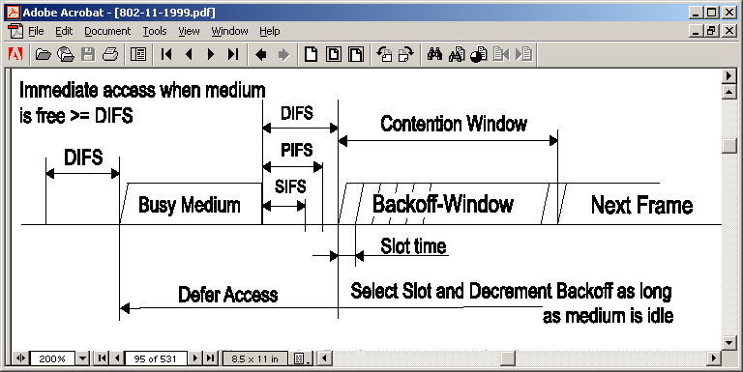
Figure 5 – DCF Interframe Spacing

Access via the PCF mechanism is shown in figure 6 (same as figure 62, 802.11). The PCF access mechanism is based on polling by the AP. In this mode the AP has control over which nodes transmit and when they transmit. The AP first issues a PCF beacon, informing all MTs that they must wait until they are polled before transmitting. After that, the AP can commence polling of the MTs. Polls can be combined with data payloads, as well as with acknowledgments of previous packets. Once polled, MTs can respond with combined data and acknowledgements. The gaps between packets in this mode are generally SIFS or PIFS, although the AP can always leave the medium idle for any length of time it chooses.
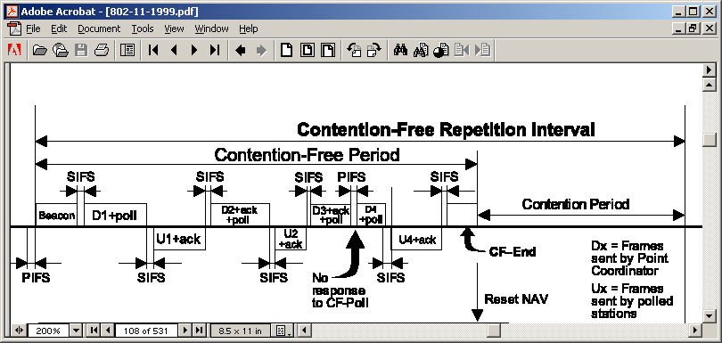
Figure 6 – PCF Interframe Spacing

Task Group e (TGe) is currently defining an extension of the 802.11 standard to provide higher quality of service. Although this work has not completed, two enhanced access mechanisms are likely to be supported. Enhanced-DCF (eDCF) is similar to DCF, but nodes are given different contention windows based on the priority of their traffic. The Hybrid Coordination Function (HCF) follows along the lines of PCF, but includes TDMA style operation, similar to those described for Hiperlan2.
The most important aspect of the access mechanisms relative to DFS are how frequently, and what percentage of the time the medium is free of traffic such that radar pulses could be detected. In all access mechanisms, the maximum packet length is just over 3ms. Following such a packet, there is at least a SIFS period (16us).
In the DCF mode, between an acknowledgment and the next data packet, there is a DIFS as well as on average ½ of a contention window. This window starts out at 135us and increases exponentially as there are more collisions. Because the contention window increases with collisions, as the network load increases, the medium occupancy in DCF mode saturates. The following graph (figure 7) shows the percentage time that the medium is idle vs. network load. The network has been loaded with a varying number of UDP or TCP streams, each stream fully loading a single MT. For 802.11a in DCF mode, the medium occupancy can never exceed ~85%.
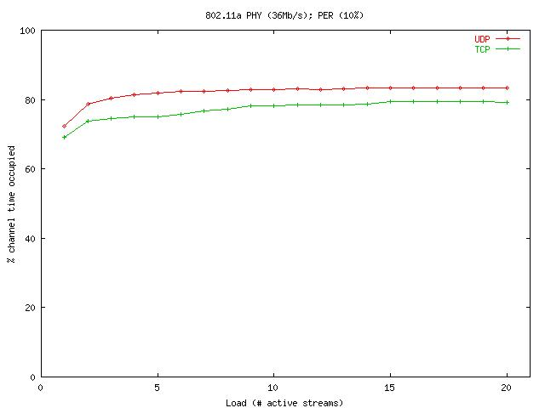
Figure 7 – Medium Occupancy vs. MTs Transmitting Fully Loaded Data Streams

In PCF and HCF modes, the AP can directly control the medium occupancy. While very high medium occupancy rates can theoretically occur, the AP can easily limit this to any value in order to insure sufficient time to detect radar pulses.

802.11a Protocol Stack

Figure 8 shows the elements in an 802.11 station architecture. IEEE802.11 specifies PMD, PLCP and MAC sublayers on the data path, and PHY and MAC layer management entities (LME) and station management entity (SMT) in the management plane.
Figure 8 – 802.11 Protocol Stack

- PMD (Physical Medium Dependant) - defines the characteristics and method of transmitting and receiving data through a wireless medium between two or more stations each using OFDM signals.
- PLCP (Physical Layer Convergence Protocol) - defines convergence functions which adapt the capabilities of the PMD to the Physical Layer service access point.
- MAC (Medium Access Control) - defines Contention and Contention Free services at the MAC service access point using Distributed, Point and, possibly, Hybrid coordination functions (DCF, PCF, HCF).
- PHY LME; MAC LME – provide the layer management service interfaces through which layer management functions may be invoked.
- SMT – is a layer-independent entity providing status gathering, layer parameter control and system management functions using mechanisms provided by the LMEs. Management functions include transmit power control and channel selection.

802.11 Management Packets and Beacons
Terminals may find an 802.11 WLAN by listening for beacons from the AP.

The 802.11 MAC specifies a timing synchronisation function (TSF), using beacons and probe responses, to define a timing structure for WLAN operations. The timing structure enables scheduling of contention free periods and terminal wake-ups in power-save mode. MTs are able to spend a significant amount of their time in a sleep mode. During this sleep mode their receivers can be completely shut down. MTs wake based on the established time synchronization with the AP.

Beacons and probe response frames also contain other management information, including identity, capability and traffic maps for mobile terminal power save functions. Other management packets provide association, authentication and traffic map services and information. DFS information is carried by management frames, and fields within the beacons and probe response messages. The contents of the DFS related messages are detailed in the next section.

8 DFS

DFS in HIPERLAN/2 [3][4][5][6][7]
HIPERLAN/2 uses a centralized DFS protocol, where each AP decides independently, which frequency is used within the cell. Optionally, frequency planning could be also used to give the AP a list of preferred frequencies.
The Dynamic Frequency Selection (DFS) in HL/2 systems shall result in equal usage of available frequencies and avoid interference to other devices using the same spectrum. Every AP collects interference measurements and chooses an operating frequency based on the measurement results. The DFS algorithm is out of the scope of the current specification.

DFS Measurements in HIPERLAN/2
The criterion used for DFS is mainly received signal strength (RSS). APs can make RSS measurements themselves and/or request mobile terminals (MT) to make measurements. The measurements can be done on the currently-used or another frequency. A MT may also do self-initiated measurements and request to report the results to the AP. The AP may then poll the MT for the result or may ignore the request. APs and MTs shall be able to decode possible BCH transmissions of other APs at a given frequency. This may enable interference from a nearby AP coverage area to be distinguished from other sources of interference.

The physical layer of HIPERLAN/2 is able to perform RSS measurement procedures, for example :
- a single RSS measurement particularly on the broadcast burst phase BCH (Short measurement)
- a series of RSS measurements with period 8 μs at any position of the MAC frame (Percentiles measurement)
- a single RSS measurement on the BCH and a series of RSS measurements at least 8 μs later (Complete measurement)

The measurement request can be made over a specified time period with an accuracy between +/- 10 dB and +/- 5 dB, which depends on the power level [2].

All HIPERLAN/2 MTs must be able to perform the RSS measurements required for DFS. The current assumption is that the AP performs interference measurements (or receive measurement results from associated MTs) on a frequency before the frequency is used for communication.

DFS messages in HL/2
The following DLC messages are available in the the HL/2 RLC specification. These messages enable efficient centralized DFS operation. The DFS can be executed without re-establishing the connections.

AP_ABSENCE message
If the AP has associated MTs, the AP has to broadcast an AP_ABSENCE message before it can make measurements on the other frequencies or to inform MTs they are forbidden during the absence time from transmitting. AP_ABSENCE informs all MTs when the AP is not transmitting and when it starts normal operation again. The absence should not be too long, i.e. sleeping MTs should not be affected.
INDICATION_OF_THE_MEASUREMENT_TIME message.
In order for the MT to measure the used frequency, the AP has to make sure that there are no own cell transmissions. I.e. either the AP has sent the AP_ABSENCE message or it indicates with INDICATION_OF_THE_MEASUREMENT_TIME, the idle periods for the measurements. This ensures that the measured field strength is really interference.
DFS_MEASUREMENT_COMPLETE_REQUEST message
DFS_MEASUREMENT_PERCENTILES_REQUEST message
DFS_MEASUREMENT_SHORT_REQUEST message
An AP can request the MT measurements with DFS_MEASUREMENT_x_REQUEST either by broadcasting it or by dedicating it to a single MT. In SHORT format an MT tries only to decode and report HL/2 BCH content to the AP at the given frequency. In PERCENTILES request the MT measures interference level distribution and reports percentile values to the AP. In COMPLETE request the MT executes both the above tasks.
CHANGE_FREQUENCY message
If the AP finds it necessary to change the operating frequency, it starts to send a CHANGE_FREQUENCY message, which includes e.g. the new frequency, the time remaining on the current frequency and the start time on the new frequency. During the remaining time, all the sleeping MTs have to be woken.

DFS in IEEE 802.11a+h
IEEE 802.11h uses a centralized Dynamic Frequency Selection (DFS) protocol, whereby each AP decides which frequency is used within the cell. DFS in IEEE 802.11h systems shall result in equal usage of a regulated minimum number of channels and avoid interference to licensed devices using the same spectrum. The DFS algorithm is out of the scope of the current specification.

The DFS procedures provide for the:
- Measuring of channels directly by an AP or MT or by another MT on behalf of the AP or MT.
- Reporting of measurements by an MT as the result of a request or autonomously.
- Selection of channels and the announcing of channel switches.

DFS Measurements in IEEE 802.11h
The criteria used for DFS are based on received signal strength (RSS). APs can make RSS measurements themselves and/or request MTs to make measurements. The measurements can be done on the currently-used or another frequency. Measurements may be reported by a MT either in raw form or as the outcome of processing to identify the presence of a licensed user in the spectrum. A MT may also do self-initiated measurements and report the results to the AP.
APs and MTs may also decode transmissions of other APs and MTs (both IEEE 802.11 and Hiperlan/2) at a given frequency. This may enable interference from a nearby cell to be distinguished from licensed users.

The measurement request and reporting framework is extensible and provides for the definition of new measurement requests and reports as may be required by regulatory authorities. Currently defined measurements include:
- RSS histograms over a period specified in the measurement request from a starting
- Identification of primary users
- Identification of other RLANs

The measurement request can be made over a specified time period with an accuracy between +/- 5 dB for RSS ≤ -57dBm and –5dB for RSS >-57dBm.

Measurements are taken in IEEE 802.11 WLANs both before a channel is used and while a channel is being used. An AP measuring a channel does so in a protected period so that MTs associated with the AP do not attempt transmissions to the AP during the measurement period.

DFS Messages in 802.11h
The following messages are available in the IEEE 802.11h specification. These messages enable efficient DFS operation.

Association Request Frames; Re-association Request Frames:
Supported Channels element
The Supported Channels element contains a list of channels in which an AP or MT is capable of operating.
Beacon Frames; Probe Response Frames:
Channel Switch Announcement element
The Channel Switch Announcement element allows an AP (or, for ad-hoc mode, an initiating MT) to advertise when it is changing to a new channel and the channel number of the new channel.
Channel Measurement Request frames:
Basic Channel Measurement Request element
Extended Channel Measurement Request element
An AP or MT uses Channel Measurement Request frames containing one or more Basic or Extended Channel Measurement Request elements to request other stations to measure one or more channels.
A Basic Channel Measurement Request element contains a request that the receiving station undertake measurements for a specified duration to determine if a licensed user is operating in a particular channel.
An Extended Channel Measurement Request element contains a request that the receiving station undertake measurements for a specified duration in a particular channel. This request contains an ID field that identifies the format and contents of the measurement request. The IEEE is responsible for allocating the ID number space. ID equal to 0 indicates an RSSI Histogram Request.
Channel Measurement Report frames:
Basic Channel Measurement Report element
Extended Channel Measurement Report element
An AP or MT uses Channel Measurement Report frames containing one or more Basic or Extended Channel Measurement Report elements to report the result of measurements.
A Basic Channel Measurement Report element contains the measured channel number and a measurement summary that includes the following indications:
- at least one valid 802.11 frame was decoded during the measurement period.
- at least one PLCP preamble was detected without a subsequent valid signal field during the measurement period.
- the measurement has detected transmissions in the channel that cannot be characterized as either from a licensed user or an unlicensed user.
- the measurement has detected a licensed user operating in the channel.
- the measurement shows a clean channel - no users (licensed or unlicensed) are operating in the channel.
An Extended Channel Measurement Report element contains the measured channel number, a measurement report and an ID that identifies the format and contents of the measurement report. The IEEE is responsible for allocating the ID number space. ID equal to 1 indicates an RSSI Histogram Report, which contains 8-bit densities over the measurement period for eight defined RSSI ranges.

9.0 Interference mitigation via DFS
HIPERLAN/2 and 802.11a+h will have similar interference mitigation properties via DFS. This is because the physical layers of the two systems are nearly identical. These systems will have similar RSS systems, and therefore similar radar detection thresholds and false alarm probabilities.
While the MAC protocols are different, their medium occupancy is similar. As will be shown below, both systems detect radar systems quite well when the medium occupancy is ~80% or less. For HIPERLAN/2 and 802.11a in PCF or HCF mode, this limit of medium occupancy can be guaranteed by the APs. For 802.11a in DCF mode, medium occupancy is limited to this level by design.
HIPERLAN/2 and 802.11a+h have similar network start-up sequences, such that radar detection will be similar in start-up mode.
Finally, the measurements being made, and management frames used to communicate them, are also similar. Both record histograms of signal magnitudes. Both can detect radar pulses above a certain threshold.
Therefore, the following analysis applies to both systems equally.

Spreading
In order to facilitate better sharing conditions with the EESS (active) and FSS (Earth to Space) services Dynamic Frequency Selection associated with the channel selection mechanism is required to provide a uniform spread of the loading of WLAN devices across a minimum of 330MHz . By utilising a random channel selection procedure DFS will reduce the effect of cumulative interference into satellite receivers that can be caused by a high number of WLAN devices initially selecting the lower part of the proposed mobile allocation in the 5GHz band to operate.

Radar detection and avoidance

Results of calculations of probability of interference to radar based on the use of DFS are presented in this section. A test method will be described in the next section which can ensure RLAN devices meet non-interference criteria.

9.2.1 Link budget analysis
Mutual interference levels between radar systems and RLANs using simple line of sight link budget calculations have been presented in [9] [11]and show that in general, if the RLAN is within the range of the radar (i.e. within its view angle and horizon) the RLAN signal can interfere with the radar, and inversely, the radar signal will be received at the RLAN with a high peak power level. In addition, link budget calculations are presented in Annex 1 on the basis of the characteristics available in the PDNR developed by WP8B in [8]. It is therefore concluded from these calculations that a) RLANs must have a means to avoid transmitting directly into the radar antenna view zone, and b) the peak signal power of radar pulses at the RLAN is always above –61 dBm at the radio horizon and well within the sensitivity range of an RLAN receiver. The value of –61 dBm for the Radar signal level at RLAN receiver is considered since this value is under consideration for the detection threshold value of radar signal power which will activate the DFS mechanism (see 9.2.3.3 and 9.2.4.2 for further details). These calculations may be reviewed when some of the radar characteristics which are needed for the calculations will be available (such as transmitter and receiver bandwidths, receiver noise figure…).

9.2.2 Comparison threshold technique
The basic technique for DFS avoidance of interference is to compare the interfering signal level with a reference or threshold level. Identification of a distinct characteristic of the interfering signal e.g. its time signature may also be possible to improve identification probability. This method requires further study.

Several studies on the coexistence of HIPERLAN/2 and radar in the same frequency band have been conducted with respect to representative radar e.g. [12][13][14]. These radar signals are summarized in Table 2. It should be noted that these representative signals have been brought to the attention of WP 8B for comments and may be reviewed in particular to be consistent with the PDNR ITU-R M.[8B-Char] [8].

Radar signal type | Operating frequency range (MHz) | Bandwidth (MHz) | Burst length (ms) / no. of pulses | Scan Rate (sec) | Pulse width (µs) | Pulse repetition frequency, PRF (pps)
Radar signal 1  (cf. [14]) | >5250 | 14 | 26 / 18 | 10 | 1 | 700
Radar signal 2  (Maritime, [14]) | 5450 – 5820 | 2 | 5 / 10 | 2 | 0.2 | 1800
Radar signal 3  (Meteorological, [14]) | 5600 – 5800 | 0.6 | 500 / 165 | 144 | 2 | 330
Table 2: Parameters of representative radar signals
In these studies, the generally used concepts of detection probability (of a radar signal) and false alarm probability are introduced to characterize the RLAN’s radar detection/identification performance. These are explained in more details below.

An additional important parameter is the power of the radar test signal at the RLAN receiver input, at which the radar signal is detected. This power threshold is discussed below (9.2.3.3 and 9.2.4.2). The specification of the threshold can be determined separately since the detection probability is not impacted once the signal is above the threshold.

9.2.3 DFS for radar detection
DFS in the context of radar detection comprises a start-up mode and a mode of normal operation. The start-up mode is entered immediately after power-on of an access point and enables reliable detection of continuously transmitting radar which may be present before start-up. Start-up mode may be repeated at will, but normally with a long period e.g. hours or days so that RLAN traffic is minimally disturbed. The normal operation mode is when the RLAN detects radar during normal communications, which is of relevance for an occasionally transmitting radar or a moving radar.
HIPERLAN/2 and 802.11a+h are communications systems that are typically centrally controlled through access points. Therefore, it is assumed that the DFS intelligence for radar detection and avoidance operates in the access points.

The DFS in HIPERLAN/2 and 802.11a+h is based on measurements of received signal strength (RSS), although the presence of interference may be signaled by a burst of packet errors. Hence, radar detection as evaluated in this document is also based on RSS measurements. The general method is to compare RSS with a threshold and to assume the presence of a radar signal if RSS exceeds the threshold. The threshold that is considered in this document is defined at the RLAN receiver input and is referred to as “detection threshold of radar signal power”.

9.2.3.1 Start-up mode
After the RLAN access point is switched on the first time or after a set-up, the access point enters the start-up mode. In this mode, the access point does not transmit; it only measures RSS on the frequencies it is able to transmit on. The access point checks which frequencies are occupied by radar. These frequencies are "marked" and will not be used by the access point. At the end of the start-up mode, the access point starts its mode of normal operation only transmitting on unmarked frequencies.
In start-up mode each frequency is measured for a certain time T. A radar signal is detected if the RSS exceeds the threshold during the measurement interval T. The total duration of the start-up phase may be up to N·T with N denoting the number of available frequencies. The reliability of radar detection increases with the duration of the start-up phase. However it should be kept within reasonable limits since the RLAN is not available during the start-up time.

9.2.3.2 Mode of normal operation
Occasionally transmitting radar or moving radar, radar with a tracking antenna are kinds of radar which may not be in use before the RLAN AP is switched on and may therefore not be detected during the start-up phase.
For the detection of such radar, the RLAN can measure RSS during any time in which the medium is free, i.e., when the access point does not transmit nor receive a signal from a mobile terminal. These measurements are only accomplished on the frequency that is currently used by the access point. Like in the start-up mode, a radar is detected if RSS exceeds the threshold.
The performance of radar detection during normal operation depends on the available unused time on the medium, which in turn is dependent on the traffic load. Hence, the time until a radar signal is detected may be longer than in start-up mode.

9.2.3.3 Co-channel interference from other RLAN cells and detection threshold
RLANs can be used to build wireless networks with high capacity, which comprise a number of access points distributed in a certain area where neighboring access points use different frequencies. Depending on the number of available frequencies and the number of uncoordinated networks in the same area, frequencies need to be re-used at certain distances. Results of related studies have been presented in [15][16].
The system capacity of these radio networks is maximum if the system is interference limited, i.e., co-channel interference from other radio cells using the same frequency dominates over thermal noise : co-channel interference power is greater than noise power for all devices in a radio cell. Propagation conditions within the channel vary due to the nature of radio networks.
Therefore, it is highly desirable to tolerate co-channel intra-system interference with a power significantly greater than the receiver sensitivity i.e. at least -85 dBm for HIPERLAN/2 and 802.11a.

These considerations have high relevance in the context of coexistence with radar. If the threshold for radar detection is set very low to enable detection of radar signals with very low power, co-channel interference from other RLAN cells much above receiver sensitivity might not be tolerated. Hence, the distance to an access point that can re-use the same frequency would need to be very high and spectral efficiency is reduced. Some environments like the exhibition hall example in [16]could not be supplied with full RLAN service.

9.2.4 Performance Parameters
The performance of the DFS concept for radar co-existence is presented and discussed in this section, and appropriate performance parameters will be introduced.
As identified above, two radar types can be distinguished when considered from a RLAN receiver's point of view:
- Continuously transmitting radar, e.g., stationary radar, and
- Occasionally transmitting radar, e.g., movable radar.

The concepts of start-up mode and mode of normal operation address these respectively and two performance parameters are defined: detection probability (DP) and false alarm probability (FAP). These are often used in the area of detection theory.
Note that both performance parameters are probabilities, where several assumptions with regard to random distribution of the signals are taken. For instance, the timing phase of the radar signal is assumed random with respect to symbol and frame structure of the RLAN.

9.2.4.1 Radar detection probability (DP)
Radar detection probability is defined as the probability that radar is detected if a radar signal is present at the RLAN receiver input. It characterises the reliability that radar can be detected and respective frequencies avoided.
The detection probability is mainly determined by the shape of the radar signal. Since the radar detection mechanism is assumed to be based on RSS, the radar signal power is not a relevant parameter as long as it is above the pre-defined threshold.

9.2.4.2 False alarm probability (FAP)
The received signal of a RLAN access point always includes noise and potentially co-channel interference from other RLAN cells. Due to the modulation scheme OFDM, co-channel interference and noise with identical power have an almost identical impact on the error rate performance of a RLAN communication. These contributions from noise and interference affect the RSS measurements that are used for radar detection.
Noise and interference can be modelled as a Gaussian random process with zero mean and given power. Due to their random nature, they will cause RSS values which may exceed the radar detection threshold even if there is no radar signal. The probability that a RLAN device erroneously detects radar in the absence of any radar signal is called false alarm probability.
The false alarm probability characterises the tolerance to noise and interference; it is not relevant with regard to the risk of interfering radar. For instance, false alarm probability has an impact on the capacity of a RLAN network. As explained in 9.2.3.3, some tolerance of co-channel interference from other RLAN cells is desired to achieve high system capacity. If the false alarm probability was high even for low co-channel interference power, or even worse for the noise power level, the frequencies to be shared with radar would be avoided unnecessarily often, becoming unusable.
Main factors influencing the false alarm probability are the detection threshold of radar signal power and the measurement time. The measurement time is an important parameter because the probability that values of a random process exceed a threshold increases significantly with time.

9.2.5 Performance Results
Calculated performance results of radar detection of HIPERLAN/2 are presented and discussed in this section. The calculations are conducted for the three radar test signals in Table 2. The performance is presented in terms of radar detection probability and false alarm probability. The results are directly applicable to 802.11a+h for equivalent loads and therefore medium occupancies.
The detection threshold of radar signal power has been chosen equal to –61 dBm as proposed in [12]. The impact of a different threshold will be discussed with the results on false alarm probability.
Radar detection is based on RSS measurements, which have a limited accuracy. The absolute accuracy of RSS is specified in the physical layer specification ([2], Table 16) with ±5 dB. Therefore, the threshold that is actually used needs to be 5 dB lower than the nominal detection threshold of radar signal power. Since the hardware has a varying front-end amplification and the worst case needs to be guaranteed, the typical radar signal power that can be detected by most devices will be lower than the nominal threshold. It can be concluded that the RSS inaccuracy does not worsen radar detection probability; it rather improves the radar detection capability of most devices which typically have a better RSS accuracy. However, it increases the false alarm probability, which can reduce RLAN system capacity.

9.2.5.1 Start-up mode
In start-up mode the access point measures all implemented frequencies to check for presence of interfence signals.
The detection probability for radar as a function of time after the start of the start-up phase is depicted in Figure 4 for the three radar signals of Table 2 for radar signal power greater than the threshold. (If the radar signal power is smaller than the threshold, the detection probability is equal to zero).
The detection probability starts at approximately zero with the beginning of the start-up phase and increases linearly with time up to 100%. The probability of 100% is reached at the time that is equal to the radar burst interval.
An implementation of DFS in a RLAN access point would have a certain duration of the start-up phase, e.g. 10 seconds per frequency. In this case, radar signals 1 and 2 would be detected with 100% probability if they were present during the start-up phase. Radar signal 3 would be detected with about 7% probability; however, the detection procedure would continue during normal operation to achieve a reasonable detection probability. Alternatively, the detection probability for radar signal 3 could be increased to 100% by increasing the duration of the start-up phase to at least 144 seconds on each respective frequency. This could lead to an unacceptable duration of the total start-up phase with scanning of all frequencies, or network unavailability if the start-up phase is repeated from time to time.
Since radar signal 3 represents a signal from meteorological radar, occasional rare interference for a few milliseconds may be acceptable.
In any case, the duration of the start-up phase is a parameter requiring further discussion, as well as the burst interval of the radar signal 3 which seems questionable.

Radar signal 2
Radar signal 1
Radar signal 3
Figure 9: Radar detection probability for radar test signals with a power greater than the threshold as a function of time in start-up mode

The previous result for the detection probability requires that the radar signal power exceeds the threshold at the RLAN receiver input. The threshold chosen determines the false alarm probability which determines tolerance to co-channel interference from other RLAN cells, which in turn determines the capacity of a RLAN network.
The false alarm probability was investigated as a function of co-channel interference power. Note also that the probability that noise and/or interference exceeds a given threshold increases with time.

The false alarm probability for radar detection for a start-up phase duration of 10 seconds and threshold –61 dBm is depicted in Figure 10 as a function of co-channel interference power. The result is a very steep curve that reaches 100% at a co-channel interference power of about –83.3 dBm. A reasonable point of operation may be a false alarm probability of 10⁻⁸, which is achieved at –84.5 dBm. In the HIPERLAN/2 standard the receiver sensitivity is equal to –85 dBm (-82dBm for 802.11a). Hence the tolerable interference power is almost at the lowest possible limit, even though the detection threshold at the receiver input is equal to –61 dBm. Therefore the detection threshold could not be set below –61 dBm otherwise thermal noise would cause unacceptable false alarm probabilities and cause the RLAN to erroneously "mark" frequencies as occupied by radar.
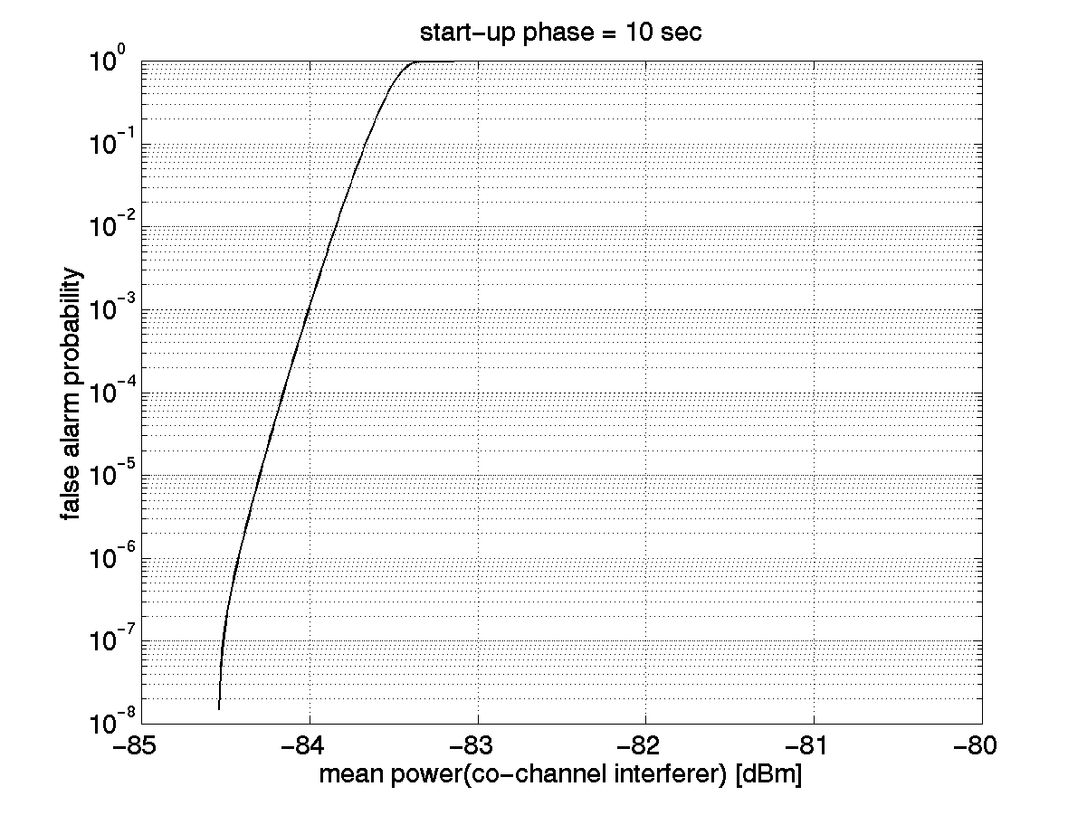
Figure 10: False alarm probability as a function of power of co-channel intra-system interference for start-up phase of 10 seconds; detection threshold of radar signal power –61 dBm

The analysis related to the false alarm probability of radar detection in HIPERLAN/2 leading to the figure 5 above is detailed in Annex 2.

9.2.5.2 Normal operation mode
The mode of normal operation, during which communication takes place, involves radar detection measurements in empty parts of the MAC frame. Therefore, traffic load, i.e. usage of the MAC frame, has an impact on radar detection performance. The following results were obtained for different levels of traffic, but assuming equal loading within successive MAC frames for simplicity reasons. They were also calculated independently of a start-up phase. The results characterise the behavior at the appearance of a radar signal during normal operation which was not present during the start-up phase.
In normal mode of operation, RLAN communication is taking place. Hence there is a certain probability that a RLAN signal is transmitted while a radar signal is received. This interference probability is defined here as the probability that a radar burst (comprising a series of radar pulses) is interfered with by a RLAN signal. A radar burst is considered to be interfered with if there is a RLAN transmission during any part of the radar burst.

As examples, the interference probabilities for the second, third and 12th burst after appearance of the radar signals are depicted in Figures 11a, 11b and 11c. The interference probability for the first radar burst is obviously equal to one, because any overlap of radar signal and RLAN signal is counted as an interference case.

Radar signal 3 can be detected reliably during the first radar burst up to very high loads. Therefore, the interference probability for the second and following bursts is very small even for a traffic load up to 90%. The reason is the high number of pulses per burst. The figures only show one point, because a limited number of load values was evaluated, and only one of them led to any interference. The interference probability for radar signal 2 is slightly higher than for radar signal 1. These small differences are mainly caused by the different number of pulses per burst of radar signal 1 and 2.
For an example 50% load of HIPERLAN/2, the probability of interfering with the second burst of a newly appearing radar signal of type 2 is about 1%. It decreases rapidly for subsequent bursts. After the third radar burst, the interference probability is practically zero.

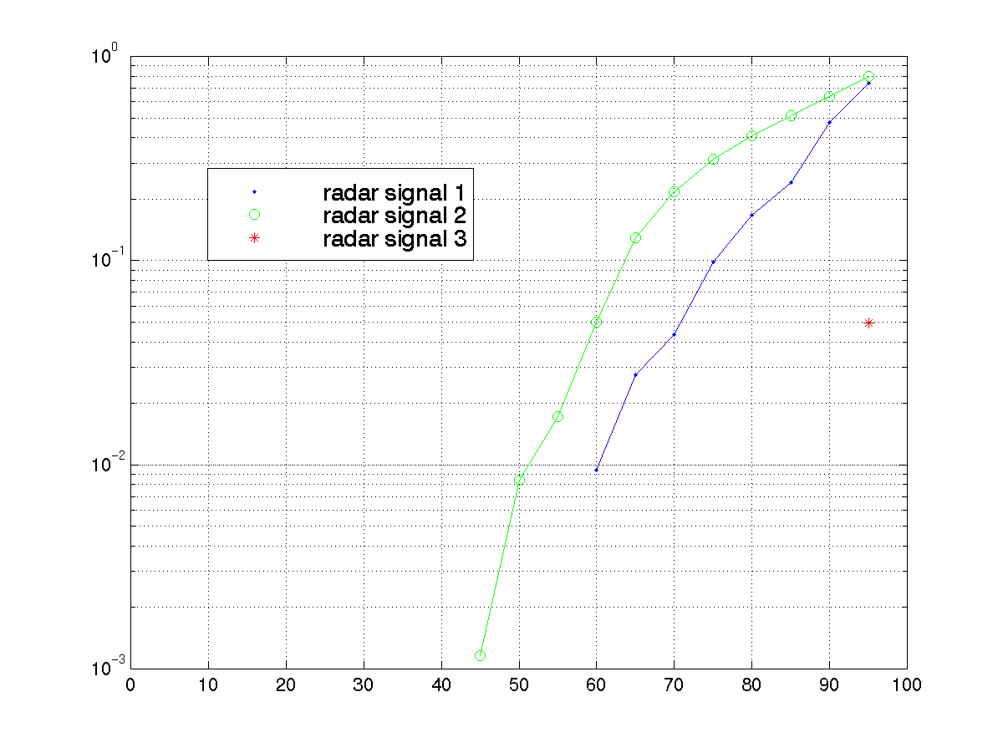
Interference probability
Traffic load [%]
Probability of interference in 2nd radar burst

Figure 11a : Probability that HIPERLAN/2 transmission interferes with the 2nd radar burst in normal mode of operation; parameter: index of radar test signal; constant load L; power of radar test signal above threshold; start-up phase not taken into account

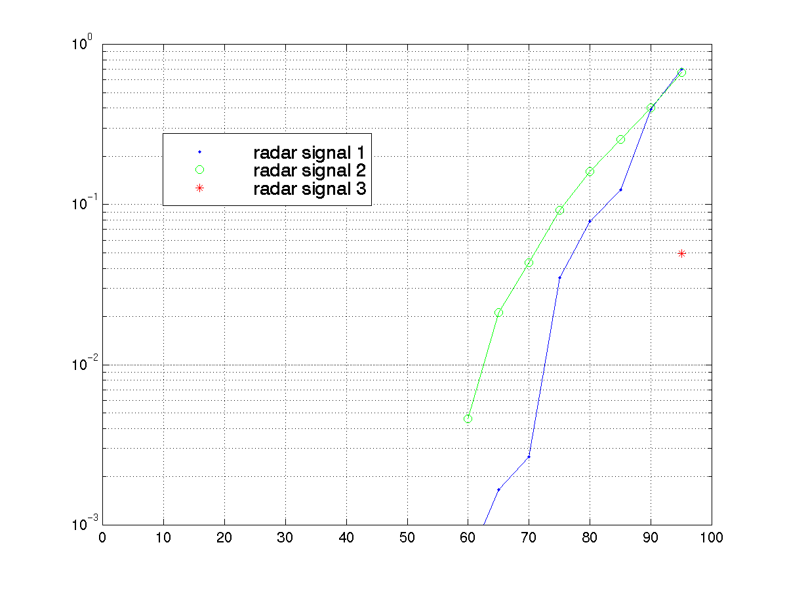
Interference probability
Traffic load [%]
Probability of interference in 3rd radar burst
Figure 11b: Probability that HIPERLAN/2 transmission interferes with the 3rd radar burst in normal mode of operation; parameter: index of radar test signal; constant load L; power of radar test signal above threshold; start-up phase not taken into account
Probability of interference in 12th radar burst
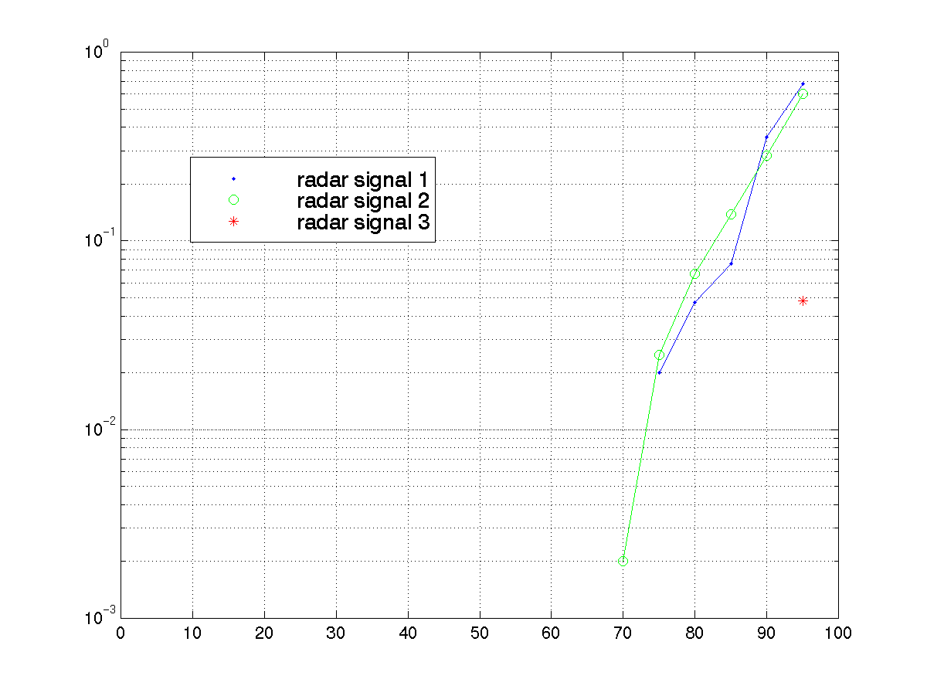
Interference probability
Traffic load [%]
Figure 11c : Probability that HIPERLAN/2 transmission interferes with the 12th radar burst in normal mode of operation; parameter: index of radar test signal; constant load L; power of radar test signal above threshold; start-up phase not taken into account

As mentioned above, false alarm probability is mainly influenced by time and power of noise and interference. The result for the start-up mode in Figure 5 indicates that the false alarm probability is below 10⁻⁸ if the power of co-channel interference from other RLAN cells is less than
-84.5 dBm. Therefore, this value is assumed as the power of received co-channel interference for the following evaluation of false alarm probability during normal operation. For a traffic load of 50%, the result as a function of time is depicted in Figure 7.
The false alarm probability starts with 10⁻⁸ at the beginning of the normal mode of radar detection. It increases rapidly during the first hour and tends towards a moderate slope after some hours. The false alarm probability after one day is about 7⋅10^{–5}, which would seem acceptable if a kind of start-up phase is repeated with a period of about one day.
It should be noted again that tolerance to co-channel interference from other RLAN cells with a power of –84.5 dBm is obtained for a radar detection threshold equal to –61 dBm, a value which is meaningful to enable usage of all RLAN frequencies.

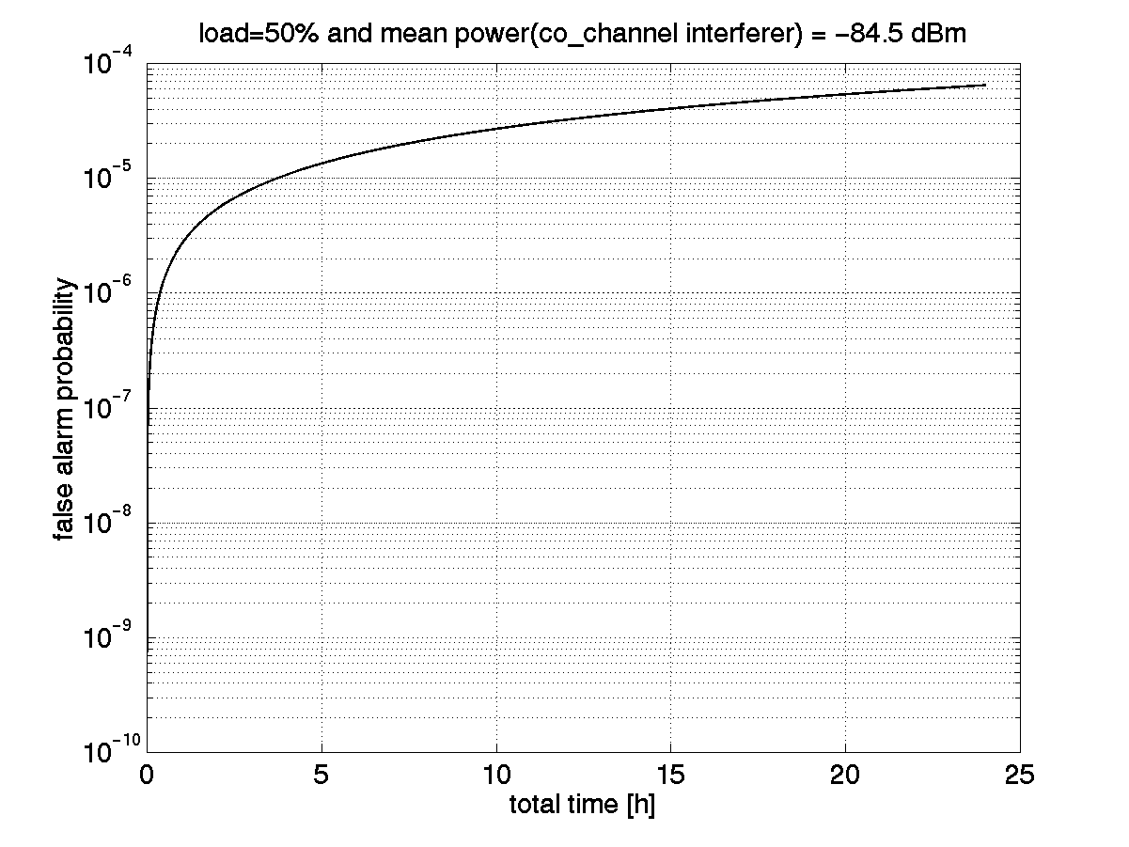
Figure 12: False alarm probability for radar test signals as a function of time in mode of normal operation; 50% load (usage of MAC frame) and power of co-channel intra-system interference equal –84.5 dBm (cf. Fig. 5); start-up phase not taken into account; detection threshold of radar signal power –61 dBm

9.2.6 Summary
Co-existence of RLANs with radar using DFS may employ threshold comparison DFS in two modes: start-up mode and normal operation mode.
The detection probability during the start-up phase depends on the radar signal characteristics and the duration of the start-up phase. It is equal to 100% for all radar signals that were present at the beginning of the start-up phase and whose burst interval is shorter than the duration of the start-up phase. A long start-up phase provides very reliable detection of continuously transmitting radar even with very long burst intervals like radar signal 3, but the required long start-up phase may result in unacceptable down-time for the RLAN network user. Therefore, a compromise between both requirements of high radar detection performance and short start-up phase seems appropriate. Signals that may not be detected with 100% probability during the start-up phase, such as radar signal 3, can continue to be searched for during normal operation.

The reliability of radar detection by a RLAN with DFS, even while devices are communicating, is given in terms of interference probability, i.e., the probability that the RLAN interferes with any part of a radar burst. For radar signal 3, the interference probability for the second and following bursts is very small even for a traffic load up to 90%. For radar signal 1 and 2, and a HIPERLAN/2 traffic load of 50%, the probability of interfering with the second burst of a newly appearing radar signal of type 2 is about 1%. It decreases rapidly for subsequent bursts, and after the third radar burst, the interference probability is practically equal to zero.

The false alarm probability influences the capacity of RLAN networks. A detection threshold of radar signal power at the RLAN receiver input of –61 dBm, leads to a tolerance of co-channel interference from other RLAN cells with a power of up to –84.5 dBm. Hence
–61 dBm is the lowest possible threshold due to the HIPERLAN/2 receiver sensitivity of –85 dBm. Since RSS measurements have a tolerance of ±5 dB, the typical effective threshold will be somewhat lower.

It follows from this manner of implementing DFS that any interference detected during empty time on the medium i.e.when RLAN access points expect no traffic signals, and which exceeds a threshold of –61 dBm, is defined to be radar interference. Hence the RLAN system has identified the interfering signal as radar.

9.2.7 DFS employing signal characteristics identification
[TBD]

Conformance testing of Dynamic Frequency Selection
One goal of the DFS is to keep interference to radar as low and short-lived as possible. As seen in preceding sections, the ideal requirement that RLAN shall disturb radar not at all can only be achieved if the start-up mode measures for a sufficiently long time before transmission starts. In practice the duration of the start-up phase must be limited. Therefore a risk remains that certain radar signals with long burst period would not be detected during the start-up phase. This may result in a short radar disturbance until the radar signal is detected during the normal mode of the AP.
For the case that radar signals appear after the RLAN has started transmission, disturbance to radar cannot be avoided for a certain limited time.
Therefore the following general performance criterion is defined: RLAN shall not disturb more than N_max successive radar bursts after a radar interferer exceeds the specified detection threshold on the same frequency used by the RLAN. The RLAN must vacate the frequency before the (N_max+1) radar burst occurs.
If the RLAN is already in the normal mode of operation when the radar signal appears, the radar detection performance depends of course on the traffic load L₀ of RLAN. For traffic load L₀ ≤ 50%, N_max = 4 can be taken as first working assumption [19].
The case that radar is already operating when the RLAN AP is switched on is seen as less critical, because the AP can use the start-up phase for an improved radar detection before any transmission is allowed. During the start-up phase the AP disturbs radar not at all, and the probability of radar detection is higher than during the normal mode where the measurement periods can be restricted by traffic.
Therefore, this test focuses on the more critical case of radar detection during the normal mode of RLAN.

Radio Conformance Test method
The conformance tests are based on representative radar test signals, which are defined by the operating frequency range, the bandwidth, the pulse repetition frequency PRF, the pulse width W, the burst length L, the burst period P and the pulse shape. Example radar test signals are given in Table 2. To facilitate the generation of test signals, they are assumed rectangular, as shown in Figure 13. These radar test signals can easily be generated using standard digital signal generators.

Test description
The test equipment consists of an AP under test and a signal generator. The AP shall transmit data with constant load in each MAC-frame. The signal generator is capable of generating any of the radar test signals. The output of the signal generator may be connected via cable with the antenna reference point (ARP) of the AP, such that the signal pulses are received at the ARP with S0 dBm.
The transmission of constant traffic load by the AP may be verified by a measurement device (e.g. oscilloscope). such that no MT needs to be involved in this test.

Figure 13: Radar test signal (example)

Test procedure
Signal generator and AP are disconnected (or the power of the signal generator is switched off).
The AP operates on a certain channel c with constant traffic load L₀. (In HIPERLAN/2, for L₀ =50%, 1 ms out of 2 ms is used for data transmission). The bandwidth of the radar test signal is within the bandwidth of the channel used by the AP.
At a certain time T0 the signal generator and the AP are connected (or the power of the signal generator is switched on). At time T1 the first radar burst is received at the AP.
Required result: at time TD = T1 + (N_max - 1)⋅P the AP has left the channel (see Figure 14). The test result may be controlled by ‘signal’ on the tested channel before T0 and ‘no signal’ on the tested channel at TD and later.
The test cases are varied for all radar test signals and all channels available for the RLAN and the radar test signal.

Figure 14: Timing condition for radar detection (example)

References
- ETSI TR 101 683 Technical Report Broadband Radio Access Networks (BRAN); HIPERLAN Type 2; System Overview
- ETSI TR 101 475 Technical Specification Broadband Radio Access Networks (BRAN); HIPERLAN Type 2; Physical (PHY)layer
- ETSI TR 101 761-2 Technical Specification Broadband Radio Access Networks (BRAN); HIPERLAN Type 2; Data Link Control (DLC) Layer; Part 2: Radio Link Control (RLC) sublayer
- ETSI BRAN HL11_5INT1A “DCA – A general framework for HL2 Systems”, Intracom, Dec 1998
- ETSI BRAN HL11ERI8A “DCA for H/2”, Ericsson, Oct 1998
- ETSI BRAN HL12TRS3A “Multi-frame structure and scanning for AFS and HO”, Jan 1999
- ETSI BRAN HL14NOK4a "Dynamic Frequency Selection (DFS) protocol proposal", June 1999
- PDNR ITU-R M.[8B-Char] Characteristics of and protection criteria for radiolocation, aeronautical, radionavigation, and meteorological radars operating in the frequency bands between 5250 and 5850 MHz, Annex 1 to Document 8A-9B/61. May 30, 2001.
- ERC Report 72: Compatibility Studies Related to the Possible Extension Band for HIPERLAN at 5 GHz. May 1999.
- Rec. ITU_R M.1461: Procedures for determining the potential for interference between radars operating in the radiodetermination service and systems in other services.
- SE36(01)24Rev1, BRAN23d066: Liaison statement to ETSI BRAN on HIPERLAN issues with regard to WRC03 Agenda. March 1, 2001.
- BRAN23d074: Study on co-existence of HIPERLAN/2 with radar. Source: Ericsson. April 2001.
- BRAN23d124: Sample radar test signal for the testing of DFS in HIPERLAN Type 2. Liaison statement to ERC PT SE36. April 2001.
- SE36(01)58, BRAN24d015: Liaison statement to ETSI BRAN; radar test signal and other considerations related to the DFS in HIPERLAN Type 2. May 2001.
- Johan Torsner, Göran Malmgren. Radio network solutions for HIPERLAN/2. Proc. of VTC’99 Spring, pp. 1217-1221.
- Jörg Huschke, Gerd Zimmermann. Impact of decentralized adaptive frequency allocation on the system performance of HIPERLAN/2. Proc. of VTC’2000 Spring.
- ETSI TS 101 475 V1.2.2: Broadband Radio Access Networks (BRAN); HIPERLAN Type 2; physical (PHY) layer.
- ERC/DEC/(99)23: ERC Decision of 29 November 1999 on the harmonised frequency band to be designated for the introduction of High Performance Radio Local Area Networks (HIPERLANs).
- BRAN25d072: Performance of radar detection of HIPERLAN/2. Source: Ericsson Sept. 2001.
Annex 1
Link budget calculations between RLAN and radar
Aeronautical Radiovavigation, Meteo Radar type per 8A-9B/61 annex 1 | A | C | E | F | G
Function | Meteo | Meteo | Meteo | Meteo | Meteo
Platform | Air/Ship/Ground | Ground | Ground | Air/Ground | Ground
Tx Power into antenna, peak (kW) | 250 | 250 | 250 | 250 | 250
Antenna gain dBi | 46 | 44 | 50 | 40 | 40
Peak EIRP (dBW) | 100 | 98 | 104 | 94 | 94
Modulation | NA | NA | NA | NA | NA
RF Bandwidth ( MHz)
PRF (pps) | 50, 250, 1200 | 0-4000 | 2000 | 250-1180 | 259
Pulse Width (microsec) | 2 | 0.05-18 | 1.1 | 0.8-2 | 3
Tuning range (MHz) | 5300-5700 | 5600-5650 | 5600-5650 | 5300-5700 | 5600-5650
Path Loss for MCL -61dBm at RLAN | -191 | -189 | -195 | -185 | -185
Free Space Distance for MCL d (km) f=5,5 GHz | 15365 | 12204 | 24351 | 7700 | 7700
Distance to radio horizon (km) ) | 347 | 51 | 51 | 347 | 51
Max radar detection distance (km) | 347 | 51 | 51 | 347 | 51
Attenuation at max distance (dB) | -158 | -141 | -141 | -158 | -141
Signal into RLAN antenna (dBm) at max distance | -28 | -13 | -7 | -34 | -17
Signal into Radar antenna (dBW) at max distance, 1W RLAN | -158 | -141 | -141 | -158 | -141
Signal into Radar receiver (dBW) | -112 | -97 | -91 | -118 | -101
Signal into Radar receiver (dBm), 1W RLAN | -82 | -67 | -61 | -88 | -71
Signal into Radar antenna (dBW) at max distance for 200mW RLAN | -165 | -148 | -148 | -165 | -148
Signal into Radar receiver (dBm), 200mW RLAN | -89 | -74 | -68 | -95 | -78
Allowable Radar Rx interference Power (dBm) [ 20MHz BW ?] | -110 | -110 | -110 | -110 | -110
Margin to -61 dBm for radar signal at RLAN receiver | 33 | 48 | 54 | 27 | 44
Margin For RLAN signal at radar receiver | 21 | 36 | 42 | 15 | 32
CONCLUSION FOR SHARING
HL detects Radar | yes | yes | yes | yes | yes
HL signal could interfere | yes | yes | yes | yes | yes
DFS threshold> -61dBm | yes | yes | yes | yes | yes

Radiolocation Radar type per 8A-9B/61 annex 1 | H | K | L | M | N | O | O
Function | Instrumentation | Instrumentation | Instrumentation | Surface/air search | Surface/air search | Research / Earth Imaging | Research/ Earth Imaging
Use | Ground | Ground | Ground | Ship | Ship | Air | Air
Tx Power into antenna, peak (kW) | 250 | 1000 | 165 | 360 | 285 | 1 | 16
Antenna gain dBi | 38.3 | 45.9 | 42 | 28 | 30 | 26 | 26
Peak EIRP (dBW) | 92 | 106 | 94 | 84 | 85 | 56 | 68
Modulation | NA | pulse/chirp pulse | Chirp pulse | Linear FM | none | FM, non-linear/linear
Bandwidth (MHz) |  |  |  |  | 1.2-16
PRF (pps) | 3000 | 20-1280 | 320 | 500 | 2400-750 | tbd | tbd
Pulse Width (microsec) | 1 | 0.25-50 | 100 | 20 | 0.1-1 | 7 or 8
Tuning range (MHz) | 5300 | 5400-5900 | 5400-5900 | 5300 | 5450-5825 | 5300
Path Loss for MCL -61dBm at RLAN | -183 | -197 | -185 | -175 | -176 | -147 | -159
Free Space Distance for MCL d (km) f=5,5 GHz | 6332 | 30377 | 7876 | 2321 | 2600 | 97 | 389
Distance to radio horizon (km) ) | 51 | 347 | 51 | 51 | 51 | 347 | 347
Max radar detection distance (km) | 51 | 347 | 51 | 51 | 51 | 29 | 29
Attenuation at max distance (dB) | -141 | -158 | -141 | -141 | -141 | -136 | -136
Signal into RLAN antenna (dBm) at max distance | -19 | -22 | -17 | -27 | -26 | -50 | -38
Signal into Radar antenna (dBW) at max distance, 1W WLAN | -141 | -158 | -141 | -141 | -141 | -136 | -136
Signal into Radar receiver (dBW) | -103 | -112 | -99 | -113 | -112 | -110 | -110
Signal into Radar receiver (dBm) | -73 | -82 | -69 | -83 | -82 | -80 | -80
Signal into Radar antenna (dBW) at max distance for 200mW WLAN | -148 | -165 | -148 | -148 | -148 | -143 | -143
Signal into Radar receiver (dBm) | -80 | -89 | -76 | -90 | -89 | -87 | -87
Allowable Radar Rx interference Power (dBm) [ 20MHz BW ?] | -110 | -110 | -110 | -110 | -110 | -110 | -110
Margin to -61 dBm for radar signal at RLAN receiver | 42 | 39 | 44 | 34 | 35 | 11 | 23
Margin For RLAN signal at radar receiver | 30 | 21 | 34 | 20 | 21 | 23 | 23
CONCLUSION FOR SHARING
HL detects Radar | yes | yes | yes | yes | yes | yes | yes
HL signal could interfere | yes | yes | yes | yes | yes | yes | yes
DFS threshold> -61dBm | yes | yes | yes | yes | yes | yes | yes

Annex 2
False Alarm Probability of Radar Detection in RLANs
Introduction
This annex describes in detail the false alarm probability in the start-up mode of the radar detection algorithm proposed for HIPERLAN2 and 802.11a+h. The proposed radar detection algorithm is a conservative one resulting in a reliable radar detection performance. It is based on the assumption that a frequency is occupied by a radar signal if one received signal strength (RSS) measurement exceeds a certain threshold.
Definition of Radar Detection False Alarm Probability
The received signal of a RLAN access point (AP) always includes noise and potentially co-channel interference from other RLAN cells. Due to the modulation scheme OFDM, co-channel interference and noise with identical power have an almost identical impact on the error rate performance of a RLAN communication. These contributions from noise and interference affect the RSS measurements that are used for radar detection.
Noise and interference can be modelled as a Gaussian random process with zero mean and given power. Due to their random nature, they will cause RSS values, which exceed the radar detection threshold even if there is no radar signal. The probability that a RLAN device erroneously detects radar in the absence of any radar signal is called radar detection false alarm probability (FAP).
Received Signal Strength Measurement
The way, how to perform RSS measurements is not completely defined in the HIPERLAN2 or 802.11h standards. Both standards provide for RSS measurements and reporting by the MTs. Measurements at the AP are not defined. Here it is assumed that AP and MT are based on the same hardware and therefore the AP is able to perform the same RSS measurement.
Moreover, it is assumed that RSS measurements used for radar detection in the AP calculate the mean value of the received signal power:
$$S_{\text{RSS}}(k)=\frac{1}{N}\sum_{i=1}^{N}{{\left|r(i+\text{kN})\right|}^{2}}$$
where r(i) represents the sampled version of the receive signal. The averaging length N is not specified in the standard.
In case that only noise or interference is present at the receiver the RSS measurements will provide a mean value of the noise or interference power:
$$S_{\text{RSS}}(k)=\frac{1}{N}\sum_{i=1}^{N}{{\left|z(i+\text{kN})\right|}^{2}}$$
where z(i) represents complex, zero mean, Gaussian distributed received signal samples with variance $σ^{2}$.
Statistics of RSS in the Presence of WGN
In case that only white Gaussian noise or an interferer signal with the same statistics is present, the RSS values $S_{\text{RSS}}$ are central, chi-square distributed with N degrees of freedom. This results in a probability density function (pdf) [3]
$$p_{\text{RSS}}(x)=\frac{x^{N−1}}{{\left(\frac{2σ^{2}}{N}\right)}^{N}Γ(N)}\text{exp}\left(\frac{−\text{xN}}{2σ^{2}}\right)$$
where $Γ$ represents the gamma function. With the substitution $y=\text{10}⋅{\text{log}}_{\text{10}}x$ one obtain the pdf in logarithmic representation, which is a more convenient one. This yields:
$$p_{\text{RSS}\text{log}}=\frac{\text{ln}(\text{10})}{\text{10}}\frac{{\text{10}}^{\frac{\text{yN}}{\text{10}}}}{{\left(\frac{2σ^{2}}{N}\right)}^{N}Γ(N)}\text{exp}\left(−\frac{N⋅{\text{10}}^{{\text{10}}/y}}{2σ^{2}}\right)$$
For the cumulative distribution function (cdf) it follows:
$$F_{\text{RSS}\text{log}}(y)=\int_{0}^{y}{p_{\text{RSS}}(u)} \text{du}$$
which cannot be expressed in closed form.
Effect of Interference or Noise Signal on RSS Measurements
In the so-called start-up mode the AP measures the RSS on each frequency to be shared with radar for a certain time TR. In this document it is assumed that the AP checks every potential radar frequency for TR=10s. Moreover, it is assumed that the sampling rate at the receiver is Ts=50ns. In this case
$$M=\frac{T_{R}}{{\text{NT}}_{S}}$$
RSS values are taken into account for the decision, whether radar is present or not.
The shortest pulse width of the three radar test signals proposed in [9]is 0.2μs (see also section9.2.2 of the main document). As long as the RSS measurement interval is longer than half of this shortest duration it can happen that a radar pulse falls between two consecutive RSS measurements. In this case the measured averaged signal strength would be lower than the actually received signal power at the antenna reference point (ARP) during the radar pulse. Therefore, an RSS measurement length of 0.1μs is assumed, i.e. only N=2 samples are taken into account for one RSS measurement.
The probability that at least one RSS value exceeds a certain power level y within 10s can be assessed as follows:
$$\text{Pr}(\text{RSS}>y)=1−{\left[F_{\text{RSS}\text{log}}(y)\right]}^{M}$$
This probability is equal to the FAP if the certain power level y is equal to the radar detection threshold. This probability is shown in Fig.1. It can be seen that FAP is smaller than 10⁻⁸, if the radar detection threshold is 13dB above the mean power level of the interferer or noise signal. FAP ≤10⁻⁸ is seen as a sufficiently low FAP.
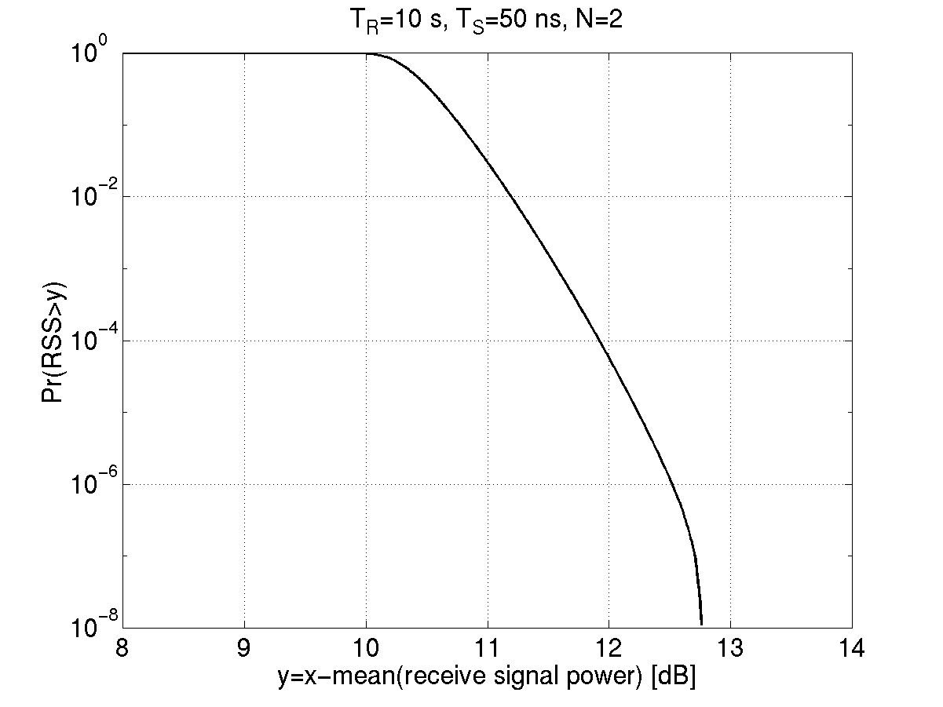
Figure 1: Probability that at least one RSS value exceeds a certain power level relative to the mean power of the interferer or noise signal.
The x-axis shows the normalized power y [dB] of the interference or noise signal with an actual power x [dB].
Effect of RSS Measurement Accuracy on FAP
In the H2 standard the accuracy of the RSS0 measurements are defined as +-5dB for power levels above –88dBm [2] . Similar accuracies are being considered in the 802.11h standardization process. In case that MTs and APs are based on the same hardware it follows that there are some APs, whose RSS values indicate a 5dB lower power than the actual power at ARP. Therefore, the internal threshold must be 5dB lower than the radar detection threshold. The working assumption for the radar detection threshold is –61dBm. Therefore, the internal threshold must be set to –66dBm for all APs because the actual accuracy of the RSS measurements is not known.
On the other hand there are APs, whose RSS values indicate a 5dB higher power than the actual receive power at ARP. In case there is an actual power level of –71dBm present at ARP caused by an interferer, these APs will measure an RSS value of –66dBm. Therefore, those APs cause a false alarm even for an interferer signal with an instantaneous power of 10dB lower than the radar detection threshold of –61dBm.
Conclusion
In the section before the previous one it was shown that a wanted low FAP≤10⁻⁸ is obtained if the radar detection threshold is 13dB above the mean power level of the interferer or noise signal.
In the previous section it was shown that some APs cause a false alarm if the instantaneous power of an interferer or noise signal is 10 dB lower than the radar detection threshold.
The over-all conclusion is that for a desired FAP of approx. 10⁻⁸ for a start-up phase of 10s per frequency, the mean power of an interferer or noise signal must be 23dB below the radar detection threshold. Assuming a radar detection threshold of –61dBm the tolerable mean interference or noise power is then –84dBm.
References
- SE36(01)24Rev1, BRAN23d066: Liaison statement to ETSI BRAN on HIPERLAN issues with regard to WRC03 Agenda. March 1, 2001.
- ETSI TS 101 475 V1.2.2: Broadband Radio Access Networks (BRAN); HIPERLAN Type 2; physical (PHY) layer.
- J.G. Proakis: Digital Communications, McGraw-Hill, 3.ed, 1995.
_______________

