IEEE P802.15
Wireless Personal Area Networks

Project | IEEE P802.15 Working Group for Wireless Personal Area Networks (WPANs)
Title | Combined Text for Collaborative Coexistence Mechanism Clause
Date Submitted | [November 8, 2001]
Source | [Jim Lansford, Adrian P Stephens, Robert Van Dyck and Steve Shellhammer]  [Mobilian/NIST/Symbol]  [7431 NW Evergreen Pkwy, Hillsboro, OR 97124, USA]  [Robert E. Van Dyck, Amir Soltanian]  [NIST]  [100 Bureau Drive, MS 8920]  [Gaithersburg, MD 20899]  [Steve Shellhammer]  [Symbol Technologies]  [One Symbol Plaza, MS B-2]  [Holtsville, NY 11742] | Voice: [ +1 (503) 681-8600 ]  Fax: [ ]  E-mail:  [ jim.lansford@mobilian.com  adrian.stephens@mobilian.com ]  Voice: [(301) 975-2923]  Fax: [(301) 590-0932]  E-mail: [{vandyck,amirs}@antd.nist.gov]  Voice: [(631) 738-4302]  Fax: [(631) 738-4618]  E-mail: [shell@symbol.com]
Re: | 00308r0P802-15_TG2-Stage0_PHY_Model.ppt  00360r0P802-15_TG2-Mobilian-coexistence-proposal.ppt  01164r0P802-15_TG2-Mobilian-Symbol-802.11-Bluetooth.ppt  01172r0P802-15_TG2-Mobilian-Symbol-summary.ppt  01300r1P802-15_TG2-Mobilian-draft-text.doc  01340r0802-15_TG2-Clause14.1.doc  01364r0P802-15_TG2_Clause14p1_Nist.doc
Abstract | This document defines the collaborative coexistence mechanism which is the initial text for clause 14.1 (clause numbers may change) of the recommended practice.
Purpose | This document contains draft text for the 802.15.2 recommended practice.
Notice | This document has been prepared to assist the IEEE P802.15. It is offered as a basis for discussion and is not binding on the contributing individual(s) or organization(s). The material in this document is subject to change in form and content after further study. The contributor(s) reserve(s) the right to add, amend or withdraw material contained herein.
Release | The contributor acknowledges and accepts that this contribution becomes the property of IEEE and may be made publicly available by P802.15.

Note, comments by the author that are not intended to be part of the final document are introduced by: “[ed – “.

[Ed Note: Clause numbers will change in the actual standard.]

Change Request #1 Add the following text to Clause 11.1 of Draft IEEE Std 802.15.2/D01-2001.

Collaborative Coexistence Mechanism

Introduction (Informative)

The collaborative coexistence mechanism provides coexistence of a Wireless Local Area Network (WLAN) (in particular IEEE 802.11b) and a Wireless Personal Area Network (WPAN) (in particular IEEE 802.15.1 ) by sharing information between collocated 802.11b and 802.15.1 devices and locally controlling transmissions to avoid interference. No new on-air signaling is required. This mechanism is interoperable with legacy devices that do not include this feature.

[Ed: We need to decide whether we are going to use the more general terms like WLAN and WPAN or the more specific terms like 802.11b and 802.15.1 in a number of places within the recommended practice.]

The collaborative coexistence mechanism defined in this recommended practice consists of two Medium Access Control (MAC) layer techniques and one Physical (PHY) layer technique. The two MAC layer techniques both involve coordinated scheduling of packet transmission between the two wireless (WLAN and WPAN) networks. The PHY layer technique is a programmable notch filter in the 802.11b receiver to notch out the narrow-band Bluetooth interferer.

The first MAC layer technique, Alternating Wireless Medium Access (AWMA), partitions the WLAN beacon-to-beacon interval into two time segments: one segment for the WLAN and one segment for the WPAN. Each wireless network restricts their transmissions to their allocated time segment, which prevents interference between the two wireless networks.

In AWMA a WLAN radio and a WPAN radio are collocated in the same physical unit. This allows for a wired connection between the WLAN radio and the WPAN radio. This wired communication link is used by the collaborative coexistence mechanism to coordinate access to the wireless medium, between the WLAN and WPAN.

In the PTA technique, the 802.11b STA and 802.15.1 node are collocated. There is no need to be either the 802.11b AP or the 802.15.1 master. Each attempt to transmit by either the 802.11b or the 802.15.1 is submitted to PTA for approval. PTA can deny a transmit request that would result in collision. The PTA technique can support 802.15.1 SCO links.

Overall Structure
Section 14 describes collaborative coexistence mechanisms between an 802.11b device and an 802.15.2 device that are collocated .

(Ed: add the following definition:
Collocation: Two devices are “Collocated” when their antennas are positioned less than 0.5m apart.)

Figure 1 shows the overall structure of the collaborative coexistence mechanism.

The AWMA transmission control entity is integrated with the WLAN MAC layer and provides a Medium Free signal to the Bluetooth Baseband layer. This is a binary signal that gates when the WLAN and WPAN can each transmit packets.

The 802.11b MAC and 802.15.1 LM + LC entities provide status information to the PTA (Packet Traffic Arbitrator) control entities. The PTA control entity receives a per-transmission transmit request (Tx Request) and issues a per-transmission transmit confirm (Tx Confirm) to each radio to indicate whether the transmission can proceed. The Tx Confirm carries a status value that is one of: allowed or denied. The Tx Request and Tx Confirm are discrete signals exchanged for every packet transmission attempt.
Figure 1 – Overall Structure of 802.11b / 802.15.1 Coexistence Mechanism
[Ed: This figure needs to be modified to properly illustrate transmission control in AWMA]

Alternating Wireless Medium Access (AWMA)
The IEEE 802.11 WLAN Access Point sends out a beacon at a periodic interval. The beacon period is T_{B}. AWMA subdivides this interval into two subintervals: one for WLAN traffic and one for WPAN traffic. Figure 14.1.x illustrates the separation of the WLAN beacon interval into two subintervals. The WLAN interval begins just prior to the WLAN target beacon transmit time (TBTT). The time from the beginning of the WLAN interval to the TBTT is specified as T₁. The duration of WLAN subinterval is T_{WLAN}. The duration of the WPAN subinterval is T_{WPAN}. The combined duration of these two subintervals must equal the WLAN beacon period. So T_{WLAN} + T_{WPAN} = T_{B}. Table 14.1.x specifies the allowed range of values for T₁.

[Editor Comment: Not sure if it is necessary to specify the allowed range of values for T₁]
Figure 14.1.x: Timing of the WLAN and WPAN subintervals

Minimum value of T₁ | Maximum value of T₁
TBD | TBD
Table 14.1.x: Allowed range of values for T₁

WLAN/WPAN Synchronization
AWMA requires that a WLAN node and the WPAN master are collocated in the same physical unit (e.g. both within a single laptop computer). AWMA requires the WLAN node to control the timing of the WLAN and WPAN subintervals. All WLAN nodes connected to the same Access Point are synchronized, and hence have the same TBTT time. As a result all units that implement AWMA have synchronized WLAN and WPAN subintervals. The WLAN node is required to send a physical synchronization signal to the WPAN master, which is in the same physical unit as the WLAN node. That synchronization signal specifies both the WLAN interval and the WPAN interval. This synchronization signal is called the Medium Free signal. When the Medium Free signal is True that signals that the Medium is free of WLAN traffic. Figure 14.1.x illustrates the Medium Free signal.

Figure 14.1.x: Medium Free Signal

Restriction on WLAN and WPAN Transmissions
AWMA requires that all WLAN transmissions are restricted to occur during the WLAN subinterval. Similarly, all WPAN transmissions are restricted to the WPAN subinterval. The WLAN mobile units and the WLAN Access Points all share a common TBTT, so along with shared knowledge of the value of T₁ and T_{WLAN}, all WLAN devices must restrict their transmissions to be within the common WLAN subinterval.
The WPAN devices collocated with the WLAN nodes must be a WPAN master device. In particular, if the WPAN device conforms to IEEE 802.15.1 all Asynchronous Connectionless (ACL) data transmissions are controlled by the WPAN master. In particular, WPAN slaves can only transmit ACL packets if in the previous time slot the WPAN slave received an ACL packet. Therefore, the WPAN master must end transmission long enough before the end of the WPAN subinterval so that the longest slave packet allowed (e.g. a five-slot 802.15.1 packet) will complete its transmission prior to the end of the WPAN interval. Figure 14.1.x illustrates the timing requirement. The value of T_{M} must be large enough so as to ensure that the value of T_{S} is greater than zero.
IEEE 802.15.1 supports Synchronous Connection-Oriented (SCO) packets, for voice traffic. These packets occur on a regular basis with a fixed period. There are several SCO packet types, depending on the level of forward error correction. For example, an HV3 link repeats every 6 slots. The first two slots are used for SCO packets and the last four packets can either be used for ACL packets or remain unused time slots. In IEEE 802.15.1 a time slot is 0.625 ms. So the SCO HV3 period is 3.75 ms. This is a small fraction of the typical WLAN beacon period. As a result if the WLAN beacon period is subdivided into two subintervals, the WPAN SCO packets can not be restricted to the WPAN interval. As a result the AWMA coexistence mechanism does not support IEEE 802.15.1 SCO links.

Figure 14.x: Timing of WPAN packets

Controlling Transmission of Legacy 802.11 Stations
An optional feature in AWMA the IEEE 802.11 Access Point can transmit a Clear-to-Send (CTS) packet addressed its own 802.11 MAC address, at the end of the WLAN interval. The duration field in the CTS packet should be sufficiently long to ensure that the legacy IEEE 802.11 stations will not transmit until the next WLAN subinterval. This technique causes the legacy IEEE 802.11 nodes to conform to the AWMA policy of not transmitting WLAN traffic during the WPAN subinterval.

Change Request #2 Add the following text to Clause 11.1 of Draft IEEE Std 802.15.2/D01-2001.

Changes shown thus made to R2 forming R3 at the TG2 meeting on Monday in Dallas, Jan 2002.

PTA Technique

Introduction to PTA (Informative)
The PTA control entity provides per-packet authorization of all transmissions.

PTA uses its knowledge of the duration of 802.11b activity and future 802.15.1 activity a number of slots into the future to predict collisions. When a collision would occur, PTA prioritizes transmissions based on simple rules that depend on the priorities of the various packets.

Known Physical-Layer Characteristics

The 802.11b PHY operates on a known frequency-static channel. The 802.15.1 PHY hops following a known hopping pattern. At any time, the 802.15.1 signal can be within or outside the pass-band

of the 802.11b PHY. These are the in-band and out-of-band cases, and they affect the probability of a collision .

The different collision cases are summarized in Table 1.

Table 1 – Collision Cases as a Function of Local Activities
Local 802.11b Activity | Local 802.15.1 Activity
Local 802.11b Activity | Transmit |  | Receive
Local 802.11b Activity | In-band | Out-of-band | In-band | Out-of-band
Transmit | Transmit | None | Transmit-Receive or None | Transmit-Receive or None
Receive | Transmit-Receive or None | Transmit-Receive or None | Receive | None

The different collision types are defined in Table 2.
Table 2 - Definition of Collision Types
Collision Type | Definition
Transmit | Both radios are transmitting in-band. One or both of the packets will be received with errors.
Receive | Both radios are receiving in-band. One or both of the packets will be received with errors.
Transmit-Receive | One radio is transmitting and the other is receiving.  The locally received packet is received with errors.
None | Simultaneous activity of the two radios does not increase the packet error rate.

In the case of “Transmit-Receive or None” collisions, whether there is a collision or not depends on a number of PHY-related parameters that can include: transmit power, received signal strength and the difference between 802.11b and 802.15.1 center frequencies.
An implementation predicts the difference between these collision outcomes based on its knowledge of the operating parameters of its PHY. So, based on PHY-layer parameters, an implementation predicts whether a collision occurs. The algorithm for predicting packet collisions is outside the scope of this standard.

Implementation constraints can also introduce addition types of “collisions” based on simultaneous conflicting demands for hardware resources. For example, a single-antenna system is unlikely to be able to transmit and receive simultaneously.

PTA Structure
Figure 2 shows the structure of theAPTA Control Entity. Each devico has a corresponding control entity to which it submits its transmit requests. This control entity allows or denies the request based on the known state of both radios.
Figure 2 – Structure of the PTA Entity

Known 802.11b State
The PTA Control assumes that the following state defined in Table 3 is available from the 802.11b MAC.
Table 3 - Known 802.11b State
802.11b State Item | Definition
current802.11bState | Indicates the current activity of the 802.11b MAC in terms of current or expected receive and transmit activity.  The decision logic described in 6.1.4.7 requires that the state variable indicate if 802.11b radio is idle, transmitting or receiving .  Additional states can be exposed through this interface to support local priority policy as described in section 6.1.4.8.
Channel | Channel number
End Time | Time of the end of the current activity. This can be based on the last duration value received or transmitted in an MPDU header.

When a transmit request is made from the 802.11b MAC, the following information described in Table 4 is known.
Table 4 - 802.11b Tx Request State
802.11b Tx Request Parameter | Description
Packet Type | Type of the MPDU
Duration | On-air duration of the MPDU

Known 802.15.1 State
The PTA Control assumes that the state described in Table 5 is available from the 802.15.1 MAC.

Table 5 - Known 802.15.1 State
802.15.1 State Item | Description
current802.15.1State | Describes the current activity of the 802.15.1 Baseband in terms of current or expected receive and transmit activity.  The decision logic described in 6.1.4.6 requires that the state variable indicate if 802.15.1 stack is idle, transmitting or receiving.
Channel List | List of channels for the current and future slots.
Packet Type | Indicates the type of packet predicted for the current and future slots.
Duration | On-air duration of the current packet
Slot End Time | Time at the end of the current slot (i.e. at the next slot edge).

802.11b Control
The purpose of the 802.11b Control entity is to allow or deny transmit requests from the 802.11b MAC. The Tx Request signal is sent when the 802.11b MAC has determined that it can transmit according to its own protocol – i.e. after any required backoff has completed.

On receipt of a Tx Request signal, the 802.11b Control immediately generates a Tx Confirm signal containing a status value that is either allowed or denied. Figure 3 defines how the status value is selected.

The effect of a denied result on the 802.11b MAC protocol depends on the access mechanism currently in use. This is defined in Table 6
Table 6 - Effect of Denied status on the 802.11b MAC
Access Mechanism | Effect of Tx Confirm (status=denied)
DCF | The denied result appears to be a transient carrier-sense condition that requires a DIFS time to expire before a subsequent transmit request can be made. The denied result has no effect on the contention window (CW) or retry variables because no transmission has occurred.
PCF  (as CF-pollable STA) | No transmission from the STA occurs, and the PC can resume transmission after a PIFS.
PCF as PC | No transmission from the PC occurs, and the PC can resume transmission after a PIFS.

Figure 3 - Decision Logic for 802.11b Tx Request
Table 7 defines the conditions examined by the decision logic.
Table 7 - Conditions Examined by 802.11b Tx Request Decision Logic
Condition | Definition
Current collision | There is a transmit or transmit-receive collision between the current 802.15.1 activity and the 802.11b transmit request
Future collision | There is a transmit or transmit-receive collision between the 802.15.1 activity scheduled for a future slot and the current 802.11b Tx Request. For a collision to occur in a slot, the requested 802.11b transmit activity must continue until at least the start of that slot.
802.15.1 current slot priority >  802.11b packet priority | Does the priority of the current 802.15.1 activity havegreater priority than the requested 802.11b packet. See section 6.1.4.8. ?
802.15.1 future slot priority >  802.11b packet priority | Does the priority of the future colliding 802.15.1 activity have greater priority than the requested 802.11b packet. 6.1.4.8. ?
Is 802.15.1 currently transmitting? | The current802.15.1State is in a transmitting state.

802.15.1 Control
In response to a Tx Request signal, the 802.15.1 control immediately generates a Tx Confirm signal containing a status value that is either allowed or denied. Figure 4 defines how the status value is selected.

The effect of the denied result on the 802.15.1 stack is to prevent 802.15.1 transmission during the whole slot (or slot half in the case of scan (paging and inquiry) sequences).

Figure 4 - Decision Logic for 802.15.1 Tx Request
Table 8 defines the conditions examined in the execution of this decision logic.
Table 8- Conditions Examined by 802.15.1 Tx Request Decision Logic
Condition | Definition
Response or SCO? | True if the Tx Request packet type is Slave ACL, ID, FHS or SCO
Collision? | Does a transmit or transmit-receive collision occur between the 802.15.1 transmit request and the current state of the 802.11b stack ?
Slave Slot Collision? | Doea a transmit-receive collision occur between the slave response to the 802.15.1 transmit request and the current state of the 802.11b stack ?
current802.11bState priority >  802.15.1 packet priority ? | Is the priority of the 802.11b current state greater than the 802.15.1 Tx Request packet priority? See section 6.1.4.8.

Priority Comparisons
The decision logic that allows or denies a packet transmit request uses a priority comparison between the state of the requested transmit packet and the known state of the other protocol stack.

An implementation defines priority values for each separate state value exposed by its protocol stack, and for each transmit packet type.

Recommended Priority Comparisons

Implementors of this recommended practice can choose various ways of assigning priorities to packets according to their applications. The following sections describe two possible implementations: fixed and randomized priorities.

Fixed Priority
In this priority assignment, an 802.15.1 SCO packet should have a higher priority than 802.11b DATA MPDUs and an 802.11b ACK MPDU should have a higher priority than all 802.15.1 packets.

Randomized Priority
The priorities of the packets can be assigned based on a randomized mechanism. A random variable r uniformly distributed between [0,1] along with a threshold T (0≤T<1) are used. If the incoming packet is from an 802.11b device, a priority of 2 is assigned to it if the random number r is smaller than T. Otherwise, a priority of 0 is assigned. If the incoming packet is from an 802.15.1 device, a priority of 1 is assigned.

Maintaining QoS (informative)
A device can optionally monitor QoS by defining metrics (such as PER and delay) per protocol stack. It can use these metrics to bias its priorities in order to meet locally-defined fairness criteria.

Note, an implementation may need additional communication not shown here to decide whether to admit a connection-setup with particular QoS requirements, given knowledge of QoS commitments in the other protocol stack.

Maintaining SCO QoS (informative)
An implementation can optionally attempt to maintain SCO QoS so as not to exceed some level of SCO packet loss. It does this by monitoring the SCO PER and comparing with a threshold. The priority of the SCO packet is increased when the SCO PER is above the threshold.

Change Request #3 Add the following text to Clause 11.1 of Draft IEEE Std 802.15.2/D01-2001.

Deterministic Spectral Excision for PHY Layer Coexistence

In this section, we discuss an interference suppression technique, denoted deterministic frequency excision, designed to mitigate the effect of 802.15.1/Bluetooth interference on 802.11b. Since the Bluetooth signal has a bandwidth of approximately 1 MHz, it can be considered a narrowband interferer for the 22 MHz wide 802.11b signal. The basic idea of the suppression technique is to put a null in the 802.11b’s receiver at the frequency of the Bluetooth signal. However, since Bluetooth is hopping to a new frequency for each packet transmission, the 802.11b receiver needs to know the frequency hopping pattern, as well as the timing, of the Bluetooth transmitter. This knowledge is obtained by employing a Bluetooth receiver as part of the 802.11b receiver. Thus, this is a collocated, collaborative method. Since it is primarily a physical layer solution, it can be integrated with the PTA MAC layer solution. This section discusses the procedure and the results for the 1 Mbit/sec 802.11b direct sequence spread spectrum system.

Ed. Note 1: add the 11 Mb/s (and maybe adaptive processing).

Figures~\ref{fig:reject1}(a) and (b) show the block diagrams of the 1 Mbit/sec IEEE 802.11b transmitter and receiver, respectively. Note that between the chip matched filter and the PN correlator is an adjustable transversal filter. The optimal coefficients of this filter are estimated and then used to update the filter. Figure~\ref{fig:transversal} shows the structure of the transversal filter.

Ed. Note 2: Question of implementation. One could estimate these coefficients or one could preprogram them.

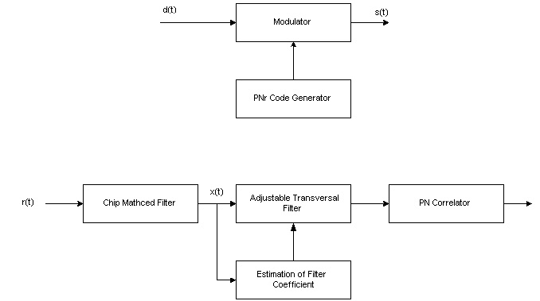
\epsffile{reject1.jpg}
\caption{(a)/(b) Block diagrams of the 1 Mbits/sec IEEE 802.11 system, employing
frequency nulling. (a) Transmitter. (b) Receiver.}
\label{fig:reject1}
Ed. Note 3: correct misspelling. Estimation and/or preselection.

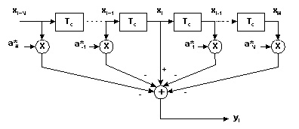
\epsffile{transversal.jpg}
\caption{Adjustable transversal filter used in the 802.11 receiver.}
\label{fig:transversal}

First let us assume that the interferer is a pure tone. Consider the central tap in the transversal filter. At time iT, it can be written as~\cite{milstein:82b}
$$x_{i}=d_{i}+V_{j}\text{cos}(2{πf}_{j}{\text{iT}}_{c}+θ)+n_{i},$$
where $T_{c}$ is the sampling interval equal to the chip time, $d_{i}$ is the signal amplitude, and $V_{j}$ and $f_{j}$ are the amplitude and frequency of the interferer. n_{i} is the random noise, and$θ$ is a random phase angle with a uniform distribution. The objective is to find the tap weights that minimize the error.

When the interference is stationary, one can employ the Wiener solution to find the optimum tap weights. These optimal tap coefficients, $a_{k,\text{opt}}$, are found by solving the following system of equations~\cite{milstein:82b, ketchum:82}
$\sum_{\begin{matrix}k=−N \\ k≠0\end{matrix}}^{N}{r(l−k)a_{k,\text{opt}}=\begin{matrix}r(l), & l=−N,⋯−1,1,⋯,N\end{matrix}}$,
where the autocorrelation function is given by $r(m)=E\left\{x_{i}x_{i−m}^{}\right\}$, and the samples, $x_{i}$, are as shown in Figure~\ref{fig:transversal}.

The first assumption is that the PN sequence is sufficiently long. This implies that the PN signal samples at the different taps are uncorrelated. In this case, the solutions for the optimal tap weights have the simple form~\cite{milstein:82b}
$a_{k,\text{opt}}={\text{Ae}}^{\text{jk}ΩT_{c}}$,
where $Ω=2{πf}_{j}$, and the parameter A is given by
$A=\frac{I}{(S+σ_{n}^{2})+2\text{IN}}$. \label{eq:jammer1}

Eq. ( \ref{eq:jammer1}) shows that one needs estimates of the signal power, S, the interferer power, I, and the noise power, $σ_{n}^{2}$. In many traditional military jamming scenarios, the signal-to-noise ratio (SNR) can be relatively low. Fortunately, for 802.11b systems in typical configurations, the SNR is often quite high. So, we can neglect the noise power in this equation. Still, one needs an estimate of the signal-to-interference (SIR) ratio to determine the optimal tap coefficients. We assume that the SIR value is fixed and equal to –20 dB; this is a typical value. Using this assumption, it is no longer necessary to estimate the SIR. One still needs an estimate of the offset in frequency, $Ω$, between the 802.11b signal and the interferer. In a collaborative system, this frequency offset is assumed known a priori.

Figure~\ref{fig:norejectperform} shows the bit error rate performance of the original 1 Mbits/sec 802.11 system for an AWGN channel with Bluetooth interference. We measure SIR and SNR at the input to the chip matched filter. Without any type of interference suppression, an SIR value of –5 dB is needed for acceptable performance at all frequency offsets. If the offset is at least 5 MHz, then a value of approximately –11 dB is acceptable. Figure~\ref{fig:rejectperform} shows the performance when the adjustable transversal filter, with N = 3, is used. When using Eq.(\ref{eq:jammer1}), we assumed that the SIR was –20 dB. Even when there is a mismatch between the assumed SIR and the actual SIR, the performance is greatly improved. Even for the worst case of a 1 MHz offset, an SIR of –32 dB gives a bit error rate below ${\text{10}}^{−3}$.

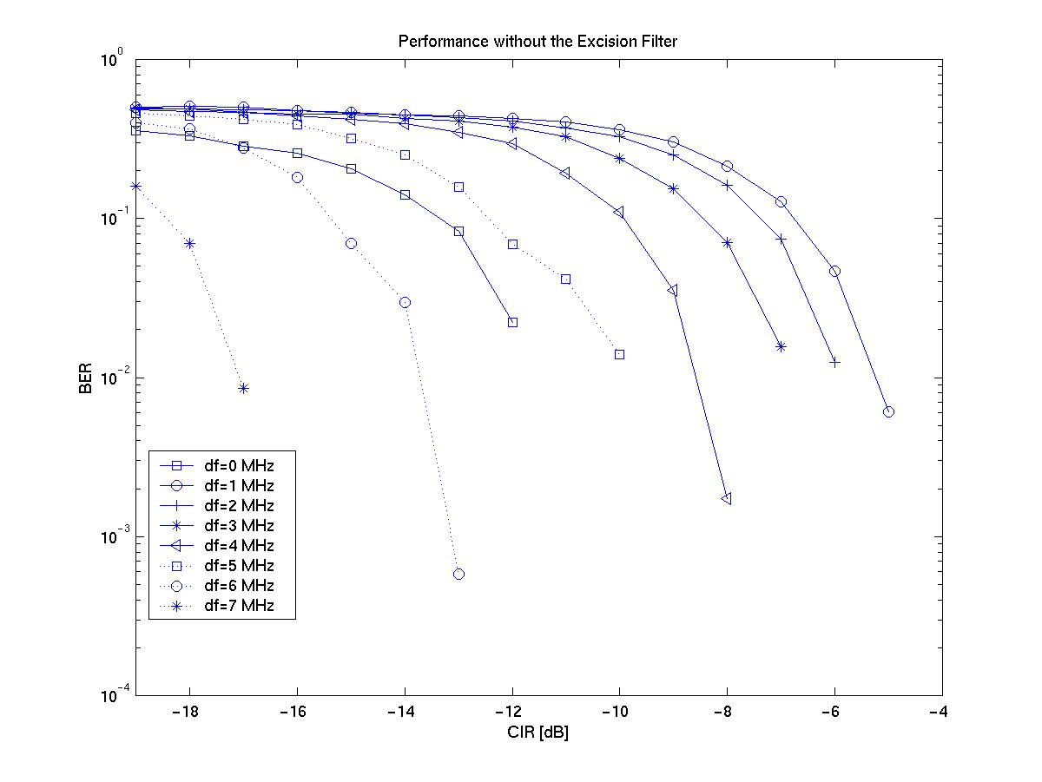
\epsffile{NoRejectperform2.jpg}
\caption{BER performance of 1 Mbits/sec 802.11 receiver with Bluetooth interference and
without any interference suppression. AWGN channel.}
\label{fig:norejectperform}

Ed. Note 8: Do we need this figure, since it is similar, if not identical to the one in Clause 6? One possibility is to have both before and after on the same plot. We do not need to show for all of these frequencies.

\epsffile{Rejectperform.eps}
\caption{BER performance of 1 Mbits/sec 802.11 receiver with Bluetooth interference and
with adjustable transversal filtering. AWGN channel. High SNR case.}
\label{fig:rejectperform}

11 Mbits/sec CCK System
Ed. Note 9: Write this section

Bibliography

Ed. Note 10: I think this is actually Li and Milstein.

\bibitem{milstein:82b} L. B. Milstein and L.-M. Li, “Rejection of narrow-band interference in PN spread-spectrum systems using transversal filters,” IEEE Trans. on Comm., vol. COM-30, pp. 925-928, May 1982.

\bibitem{ketchum:82} J. W. Ketchum and J. G. Proakis, “Adaptive algorithms for estimating and suppressing narrow-band interference in PN spread-spectrum systems,” IEEE Trans. on Comm., vol. COM-30, pp. 913-924, May 1982.

\bibitem{schilling:80} D. L. Schilling, L. B. Milstein, R. L. Pickholtz and R. W. Brown, ``Optimization of the processing gain of an M-ary direct sequence spread spectrum communication system,'' IEEE Trans. Comm., pp. 1389-1398, Aug. 1980.

\bibitem{milstein:82} L. B. Milstein, S. Davidovici, and D. L. Schilling, ``The effect of multiple-tone interfering signals on a direct sequence spread spectrum communication system,'' IEEE Trans. Comm., vol. 30, pp. 436-446, Mar. 1982.

Although this document consistently references 802.15.1, not Bluetooth ™, the mechanism is equally applicable to both 802.15.1 and Bluetooth.
The term device includes 802.11b access points and stations and 802.15.1 radios.
The word packet is used here to mean an 802.11 MPDU or an 802.15.1 baseband packet.
A collision occurs when packets from the 802.11 and 802.15.1 are transmitted simultaneously resulting in the loss of one or both packets.
Note, the receiving states include waiting for expected responses such as a CTS or ACK MPDU.
The Number of slots into the future is a local matter.
The meaning of “future” in table 5 is a local to the PTA. It may be a few 802.15.1 slots. There is no benefit looking further into the future than the length of the current 802.11b transmit request.

