IEEE P802.15
Wireless Personal Area Networks

Project | IEEE P802.15 Working Group for Wireless Personal Area Networks (WPANs)
Title | Combined Text for Collaborative Coexistence Mechanism Clause
Date Submitted | [November 8, 2001]
Source | [Jim Lansford, Adrian P Stephens, Robert Van Dyck and Steve Shellhammer]  [Mobilian/NIST/Symbol]  [7431 NW Evergreen Pkwy, Hillsboro, OR 97124, USA]  [Robert E. Van Dyck, Amir Soltanian]  [NIST]  [100 Bureau Drive, MS 8920]  [Gaithersburg, MD 20899]  [Steve Shellhammer]  [Symbol Technologies]  [One Symbol Plaza, MS B-2]  [Holtsville, NY 11742] | Voice: [ +1 (503) 681-8600 ]  Fax: [ ]  E-mail:  [ jim.lansford@mobilian.com  adrian.stephens@mobilian.com ]  Voice: [(301) 975-2923]  Fax: [(301) 590-0932]  E-mail: [{vandyck,amirs}@antd.nist.gov]  Voice: [(631) 738-4302]  Fax: [(631) 738-4618]  E-mail: [shell@symbol.com]
Re: | 00308r0P802-15_TG2-Stage0_PHY_Model.ppt  00360r0P802-15_TG2-Mobilian-coexistence-proposal.ppt  01164r0P802-15_TG2-Mobilian-Symbol-802.11-Bluetooth.ppt  01172r0P802-15_TG2-Mobilian-Symbol-summary.ppt  01300r1P802-15_TG2-Mobilian-draft-text.doc  01340r0802-15_TG2-Clause14.1.doc  01364r0P802-15_TG2_Clause14p1_Nist.doc
Abstract | This document defines the collaborative coexistence mechanism which is the initial text for clause 14.1 (clause numbers may change) of the recommended practice.
Purpose | This document contains draft text for the 802.15.2 recommended practice.
Notice | This document has been prepared to assist the IEEE P802.15. It is offered as a basis for discussion and is not binding on the contributing individual(s) or organization(s). The material in this document is subject to change in form and content after further study. The contributor(s) reserve(s) the right to add, amend or withdraw material contained herein.
Release | The contributor acknowledges and accepts that this contribution becomes the property of IEEE and may be made publicly available by P802.15.

Note, comments by the author that are not intended to be part of the final document are introduced by: “[ed – “.

– Collision Cases as a Function of Local Activities

The different collision types are defined in
- Definition of Collision Types

In the case of “Transmit-Receive or None” collisions, whether there is a collision or not depends on a number of PHY-related parameters that can include: transmit power, received signal strength and the difference between 802.11b and 802.15.1 center frequencies.
An implementation predicts the difference between these collision outcomes based on its knowledge of the operating parameters of its PHY. This section does not attempt to standardize that decision. So, based on PHY-layer parameters, an implementation predicts whether a collision occurs.

Implementation constraints can also introduce addition types of “collisions” based on simultaneous conflicting demands for hardware resources. For example, a single-antenna system is unlikely to be able to transmit and receive simultaneously.

MEHTA Structure

- Known 802.11b State

When a transmit request is made from the 802.11b MAC, the following information described in
- 802.11b Tx Request State

Known 802.15.1 State
The MEHTA Control assumes that the state described in
- Known 802.15.1 State

802.11b Control
The purpose of the 802.11b Control entity is to allow or deny transmit requests from the 802.11b MAC. The

- Conditions Examined by 802.11b Tx Request Decision Logic

802.15.1 Control
In response to a

- Conditions Examined by 802.15.1 Tx Request Decision Logic

Priority Comparisons
The decision logic that allows or denies a packet transmit request uses a priority comparison between the state of the requested transmit packet and the known state of the other protocol stack.

An implementation defines priority values for each separate state value exposed by its protocol stack, and for each transmit packet type.

Recommended Priority Comparisons
An 802.15.1 SCO packet should have a higher priority than 802.11b DATA MPDUs.
An 802.11b ACK MPDU should have a higher priority than all 802.15.1 packets.
Other priority comparisons are a implementation-specific.

Maintaining QoS
A device can optionally monitor QoS by defining metrics (such as PER and delay) per protocol stack. It can use these metrics to bias its priorities in order to meet locally-defined fairness criteria.

In the case of an 802.11e stack, the device can record these metrics per traffic class and bias its priorities in order to meet known per traffic class QoS commitments.

Note, an implementation may need additional communication not shown here to decide whether to admit a connection-setup with particular QoS requirements, given knowledge of QoS commitments in the other protocol stack.

Maintaining SCO QoS
An implementation can optionally attempt to maintain SCO QoS so as not to exceed some level of SCO packet loss. It does this by monitoring the SCO PER and comparing with a threshold. The priority of the SCO packet is increased when the SCO PER is above the threshold.

Change Request #3 Add the following text to Clause 11.1 of Draft IEEE Std 802.15.2/D01-2001.

Deterministic Spectral Excision for PHY Layer Coexistence

In this section, we discuss an interference suppression technique, denoted deterministic frequency excision, designed to mitigate the effect of 802.15.1 interference on 802.11b. Since the Bluetooth signal has a bandwidth of approximately 1 MHz, it can be considered a narrowband interferer for the 22 MHz wide 802.11b signal. The basic idea of the suppression technique is to put a null in the 802.11b’s receiver at the frequency of the Bluetooth signal. However, since Bluetooth is hopping to a new frequency for each packet transmission, the 802.11b receiver needs to know the frequency hopping pattern, as well as the timing, of the Bluetooth transmitter. This knowledge is obtained by employing a Bluetooth receiver as part of the 802.11b receiver. Thus, this is a collocated, collaborative method. Since it is primarily a physical layer solution, it can be integrated with the PTA MAC layer solution. This section discusses the procedure, which is applicable to all basic rate sets in 802.11b (1, 2, 5.5, and 11 Mbit/s) and the results for the 1 Mbit/s 802.11b direct sequence spread spectrum system.

Ed. Note 1: add the 11 Mb/s (and maybe adaptive processing).

Figures~\ref{fig:reject1}(a) and (b) show the block diagrams of the 1 Mbit/s IEEE 802.11b transmitter and receiver, respectively. Note that between the chip matched filter and the PN correlator is an adjustable transversal filter. The optimal coefficients of this filter are estimated and then used to update the filter. Figure~\ref{fig:transversal} shows the structure of the transversal filter.

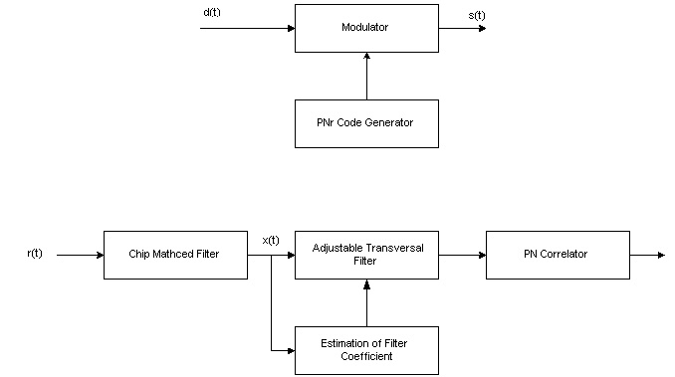
\epsffile{reject1.jpg}
\caption{(a)/(b) Block diagrams of the 1 Mbits/sec IEEE 802.11 system, employing
frequency nulling. (a) Transmitter. (b) Receiver.}
\label{fig:reject1}
Ed. Note 3: correct misspelling. Estimation and/or preselection.

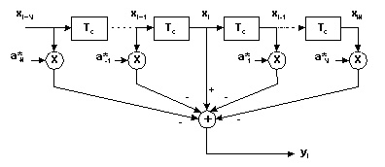
\epsffile{transversal.jpg}
\caption{Adjustable transversal filter used in the 802.11 receiver.}
\label{fig:transversal}

14.2.1 Calculation of adaptive tap weights

First let us assume that the interferer is a pure tone. Consider the central tap in the transversal filter. At time iT, it can be written as~\cite{milstein:82b}
$$x_{i}=d_{i}+V_{j}\text{cos}(2{πf}_{j}{\text{iT}}_{c}+θ)+n_{i},$$
where $T_{c}$ is the sampling interval equal to the chip time, $d_{i}$ is the signal amplitude, and $V_{j}$ and $f_{j}$ are the amplitude and frequency of the interferer. n_{i} is the random noise, and$θ$ is a random phase angle with a uniform distribution. The objective is to find the tap weights that minimize the error.

When the interference is stationary, one can employ the Wiener solution to find the optimum tap weights. These optimal tap coefficients, $a_{k,\text{opt}}$, are found by solving the following system of equations~\cite{milstein:82b, ketchum:82}
$\sum_{\begin{matrix}k=−N \\ k≠0\end{matrix}}^{N}{r(l−k)a_{k,\text{opt}}=\begin{matrix}r(l), & l=−N,⋯−1,1,⋯,N\end{matrix}}$,
where the autocorrelation function is given by $r(m)=E\left\{x_{i}x_{i−m}^{}\right\}$, and the samples, $x_{i}$, are as shown in Figure~\ref{fig:transversal}.

The first assumption is that the PN sequence is sufficiently long. This implies that the PN signal samples at the different taps are uncorrelated. In this case, the solutions for the optimal tap weights have the simple form~\cite{milstein:82b}
$a_{k,\text{opt}}={\text{Ae}}^{\text{jk}ΩT_{c}}$,
where $Ω=2{πf}_{j}$, and the parameter A is given by
$A=\frac{I}{(S+σ_{n}^{2})+2\text{IN}}$. \label{eq:jammer1}

Eq. ( \ref{eq:jammer1}) shows that one needs estimates of the signal power, S, the interferer power, I, and the noise power, $σ_{n}^{2}$. In many traditional military jamming scenarios, the signal-to-noise ratio (SNR) can be relatively low. Fortunately, for 802.11b systems in typical configurations, the SNR is often quite high. So, we can neglect the noise power in this equation. Still, one needs an estimate of the signal-to-interference (SIR) ratio to determine the optimal tap coefficients. We assume that the SIR value is fixed and equal to –20 dB; this is a typical value. Using this assumption, it is no longer necessary to estimate the SIR. One still needs an estimate of the offset in frequency, $Ω$, between the 802.11b signal and the interferer. In a collaborative system, this frequency offset is assumed known a priori.

14.2.2 Simulation results (informative)

Figure~\ref{fig:norejectperform} shows the bit error rate performance of the original 1 Mbit/sec 802.11b system for an AWGN channel with 802.15.1 interference. We measure SIR and SNR at the input to the chip matched filter. Without any type of interference suppression, an SIR value of –5 dB is needed for acceptable performance at all frequency offsets. If the offset is at least 5 MHz, then a value of approximately –11 dB is acceptable. Figure~\ref{fig:rejectperform} shows the performance when the adjustable transversal filter, with N = 3, is used. When using Eq.(\ref{eq:jammer1}), we assumed that the SIR was –20 dB. Even when there is a mismatch between the assumed SIR and the actual SIR, the performance is greatly improved. Even for the worst case of a 1 MHz offset, an SIR of –32 dB gives a bit error rate below ${\text{10}}^{−3}$.

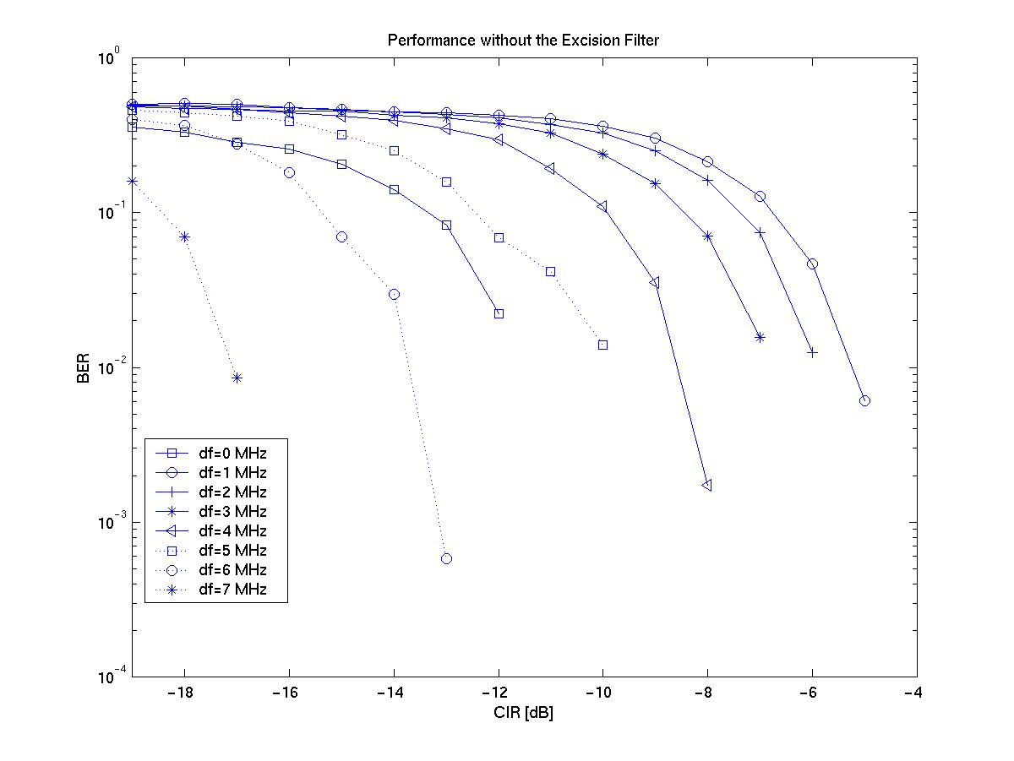
\epsffile{NoRejectperform2.jpg}
\caption{BER performance of 1 Mbits/sec 802.11 receiver with Bluetooth interference and
without any interference suppression. AWGN channel.}
\label{fig:norejectperform}

Ed. Note 8: Do we need this figure, since it is similar, if not identical to the one in Clause 6? One possibility is to have both before and after on the same plot. We do not need to show for all of these frequencies.

\epsffile{Rejectperform.eps}
\caption{BER performance of 1 Mbits/sec 802.11 receiver with Bluetooth interference and
with adjustable transversal filtering. AWGN channel. High SNR case.}
\label{fig:rejectperform}

11 Mbit/s CCK System
Ed. Note 9: Write this section

Bibliography

Ed. Note 10: I think this is actually Li and Milstein.

\bibitem{milstein:82b} L. B. Milstein and L.-M. Li, “Rejection of narrow-band interference in PN spread-spectrum systems using transversal filters,” IEEE Trans. on Comm., vol. COM-30, pp. 925-928, May 1982.

\bibitem{ketchum:82} J. W. Ketchum and J. G. Proakis, “Adaptive algorithms for estimating and suppressing narrow-band interference in PN spread-spectrum systems,” IEEE Trans. on Comm., vol. COM-30, pp. 913-924, May 1982.

\bibitem{schilling:80} D. L. Schilling, L. B. Milstein, R. L. Pickholtz and R. W. Brown, ``Optimization of the processing gain of an M-ary direct sequence spread spectrum communication system,'' IEEE Trans. Comm., pp. 1389-1398, Aug. 1980.

\bibitem{milstein:82} L. B. Milstein, S. Davidovici, and D. L. Schilling, ``The effect of multiple-tone interfering signals on a direct sequence spread spectrum communication system,'' IEEE Trans. Comm., vol. 30, pp. 436-446, Mar. 1982.

Although this document consistently references 802.15.1, not Bluetooth ™, the mechanism is equally applicable to both 802.15.1 and Bluetooth.
The word packet is used here to mean an 802.11 MPDU or an 802.15.1 baseband packet.
A collision occurs when packets from the 802.11 and 802.15.1 are transmitted simultaneously resulting in the loss of one or both packets.
Note, the receiving states include waiting for expected responses such as a CTS or ACK MPDU.
The Number of slots into the future is a local matter.

