IEEE P802.15
Wireless Personal Area Networks

Project | IEEE P802.15 Working Group for Wireless Personal Area Networks (WPANs)
Title | New Text for Clauses 9 and 11
Date Submitted | January 14, 2001
Source | Nada Golmie  NIST  100 Bureau Dr. Stop 8920  Gaithersburg MD 20899 | Voice: (301) 975-4190  Fax: (301) 590-0932  E-mail: nada.golmie@nist.gov
Abstract | [This contribution presents new text for Clauses 9 and 11. The text given here is presented a replacement to what is currently in the draft recommended practices document]
Purpose | [The new text for clauses 9 and 11 is provided for inclusion in the recommended practices document. ]
Notice | This document has been prepared to assist the IEEE P802.15. It is offered as a basis for discussion and is not binding on the contributing individual(s) or organization(s). The material in this document is subject to change in form and content after further study. The contributor(s) reserve(s) the right to add, amend or withdraw material contained herein.
Release | The contributor acknowledges and accepts that this contribution becomes the property of IEEE and may be made publicly available by P802.15.

Clause 9. Data Traffic Models

For Bluetooth, we consider two types of applications, namely voice and data traffic. For voice, we assume a symmetric stream of 64 kbits/s each way using HV1 packet encapsulation. For data we use DH5 packets. The packet interarrival time is exponentially
distributed, and its mean in seconds is computed according to

t_{b} = 2 * N * T_{s}/ l,

where l is the offered load; N is the number of slots occupied by a packet. For DH5, N=5. T_{s} is the slot size equal to 625μs.
For the WLAN, the packet payload is fixed to 12,000 bits and l is varied. The packet interarrival
time in seconds, t_{w} is exponentially distributed, and its mean is computed according to

t_{w} =( (192/1,000,000)+ (12,224/payload_data_rate))/l,

where the 192-bit PLCP header is sent at 1 Mbits/s and the payload_data_rate is either 1 or 11 Mbits/s.

Clause 11: Coexistence Modeling Results

We present simulation results to evaluate the performance of Bluetooth in the presence of WLAN interference and vice versa. All simulations are run for 30 seconds of simulated time. The performance measurements are logged at the slave device for Bluetooth and at the Mobile device for the WLAN. The mean access delay result is normalized by the mean delay when no interference is present. We use the configuration and system parameters shown in Table 1.

Simulation Parameters | Values
Length of simulation run | 30 seconds
Bluetooth Parameters | Values
Data Packet Interarrival Time | 12.5 ms
ACL Baseband Packet Encapsulation | DH5
SCO Baseband Packet Encapsulation | HV1
Transmitted Power | 1 mW
Slave Coordinates | (0,0) meters
Master Coordinates | (1,0) meters
WLAN Parameters
Packet Interarrival Time for 1 Mbits/s | 24.8 ms
Packet Interarrival Time for 11 Mbits/s | 2.6 ms
Transmitted Power | 25 mW
AP Coordinates | (0,15) meters
Mobile Coordinates | (0,d) meters
Packet Header | 224 bits
Table 1: Simulation Parameters

We present the results from four different simulation experiments that show the impact of WLAN interference on Bluetooth devices and vice versa for two different applications, namely voice and data traffic. Table 3 provides a summary of these four cases, while Figure 2 shows the experimental topology. Please note that the WLAN access point (AP) is fixed at (0,15) meters, while the WLAN mobile is free to move along the vertical axis, i.e. its coordinates are (0,d). The Bluetooth devices are fixed at the given locations. In the first two experiments, the mobile is the generator of the 802.11 data, while the AP is the sink. In the last two experiments the traffic is generated at the AP.

Experiment | Desired Signal | Interferer Signal | WLAN AP | WLAN Mobile
1 | BT Voice | 802.11 | Sink | Source
2 | BT data | 802.11 | Sink | Source
3 | 802.11 | BT Voice | Source | Sink
4 | 802.11 | BT data | Source | Sink

Table 2: Summary of the Experiments

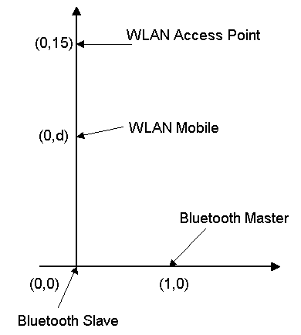
Figure 1: Experiment Topology

All four experiments are repeated for 802.11 1 Mbits/s and 11 Mbits/s Direct Sequence Spread Spectrum (DSSS) and 1 Mbits/s Frequency Hopping (FH) systems.

Clause 11.1 802.11 1 Mbits/s Direct Sequence and Bluetooth Interference

Scenarios 1 and 2

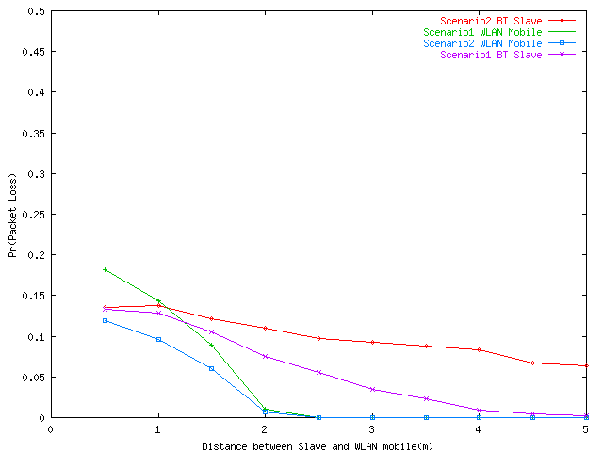
Figure 2: Probability of Packet Loss - 1 Mbits/s Direct Sequence
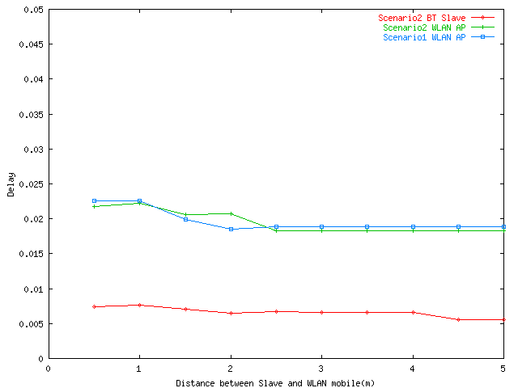
Figure 3: Access Delay (seconds) - 1 Mbits/s Direct Sequence

Scenarios 3 and 4
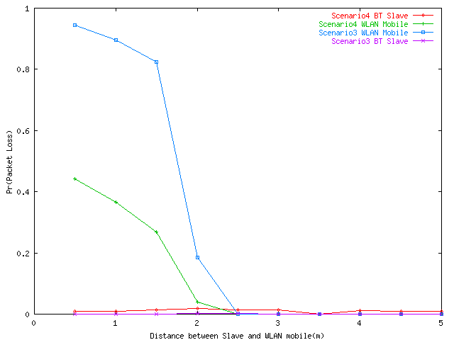
Figure 4: Probability of Packet Loss - 1 Mbits/s Direct Sequence
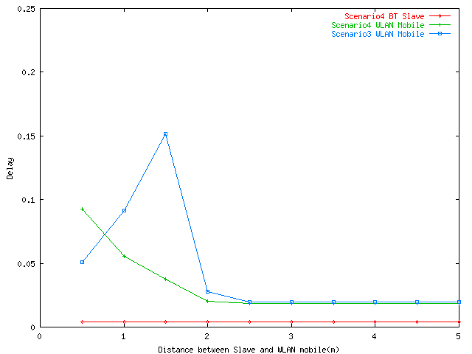
Figure 5: Delay (seconds) - 1 Mbits/s Direct Sequence

Clause 11.2 802.11 11 Mbits/s Direct Sequence and Bluetooth Interference

Scenarios 1 and 2
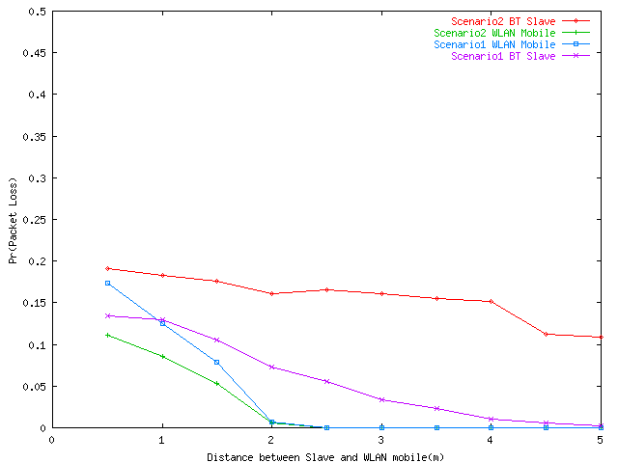
Figure 6: Probability of Packet Loss - 11 Mbits/s Direct Sequence

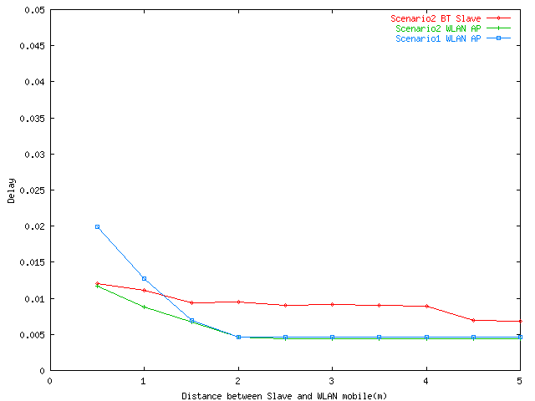
Figure 7: Access Delay (seconds) - 11 Mbits/s Direct Sequence

Scenarios 3 and 4

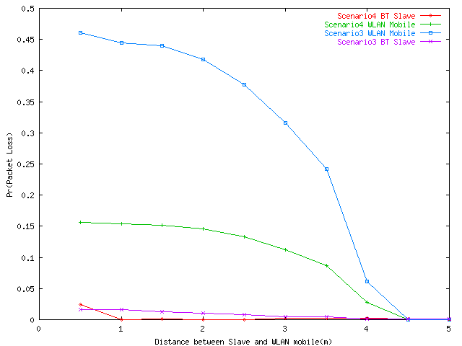
Figure 8: Probability of Packet Loss - 11 Mbits/s Direct Sequence
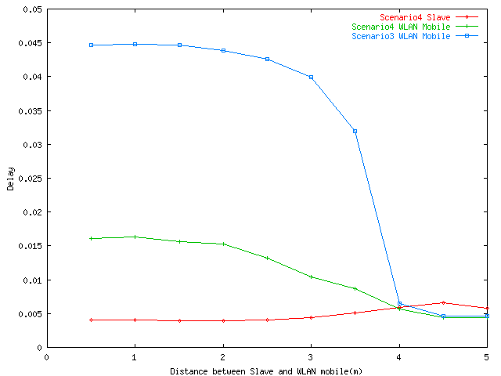
Figure 9: Access Delay (seconds) - 11 Mbits/s Direct Sequence

Clause 11.3 802.11 1 Mbits/s Frequency Hopping and Bluetooth Interference
Scenarios 1 and 2
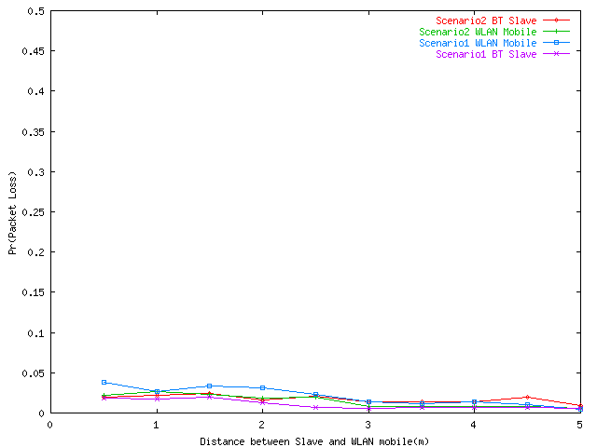
Figure 10: Probability of Packet Loss - 1 Mbits/s Frequency Hopping
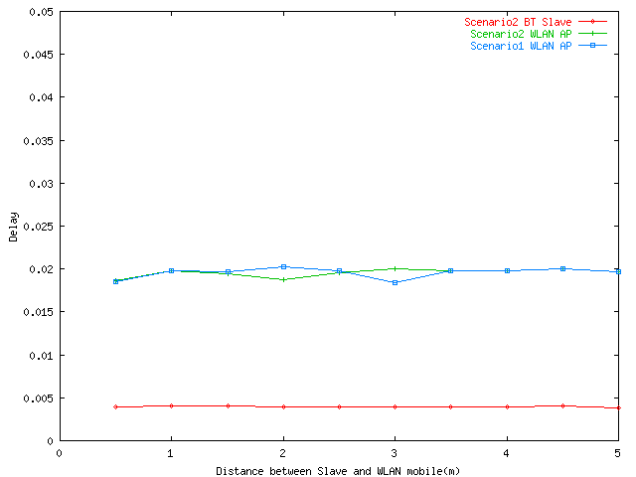
Figure 11: Access Delay (seconds) - 1 Mbits/s Frequency Hopping

Scenarios 3 and 4
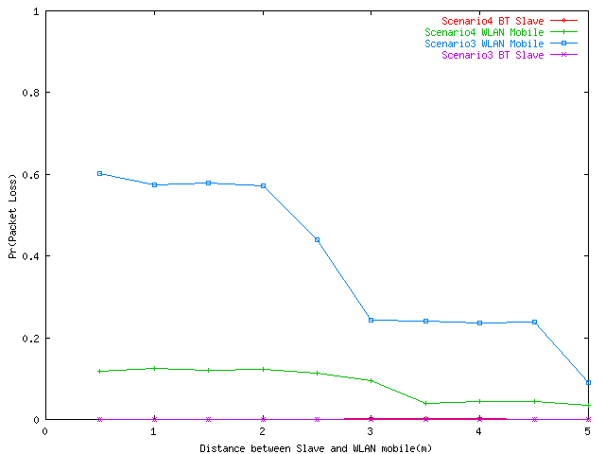
Figure 12: Probability of Packet Loss - 1 Mbits/s Frequency Hopping
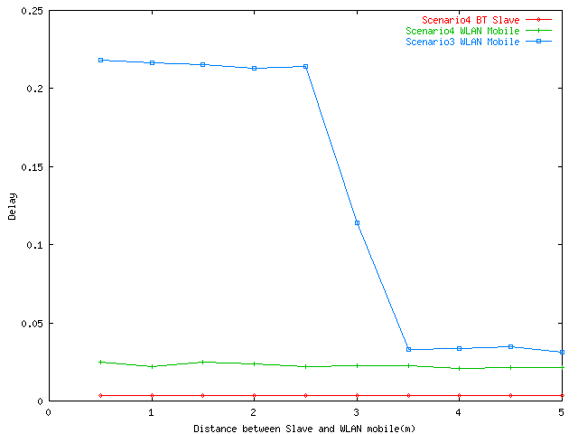
Figure 13: Delay (seconds) - 1 Mbits/s Frequency Hopping

