IEEE P802.15
Wireless Personal Area Networks

Project | IEEE P802.15 Working Group for Wireless Personal Area Networks (WPANs)
Title | New Text for Clauses 9 and 11
Date Submitted | January 14, 2001
Source | Nada Golmie  NIST  100 Bureau Dr. Stop 8920  Gaithersburg MD 20899 | Voice: (301) 975-4190  Fax: (301) 590-0932  E-mail: nada.golmie@nist.gov
Abstract | [This contribution presents new text for Clauses 9 and 11. The text given here is presented a replacement to what is currently in the draft recommended practices document]
Purpose | [The new text for clauses 9 and 11 is provided for inclusion in the recommended practices document. ]
Notice | This document has been prepared to assist the IEEE P802.15. It is offered as a basis for discussion and is not binding on the contributing individual(s) or organization(s). The material in this document is subject to change in form and content after further study. The contributor(s) reserve(s) the right to add, amend or withdraw material contained herein.
Release | The contributor acknowledges and accepts that this contribution becomes the property of IEEE and may be made publicly available by P802.15.

Change Request #1

Clause 9 Data Traffic Models

For Bluetooth, we consider two types of applications, namely voice and data traffic. For voice, we assume a symmetric stream of 64 kbits/s each way using HV1 packet encapsulation. For data we use DH5 packets. The packet interarrival time is exponentially
distributed, and its mean in seconds is computed according to

t_{b} = 2 * N * T_{s}/ l,

where l is the offered load; N is the number of slots occupied by a packet. For DH5, N=5. T_{s} is the slot size equal to 625μs.
For the WLAN, the packet payload is fixed to 12,000 bits and l is varied. The packet interarrival
time in seconds, t_{w} is exponentially distributed, and its mean is computed according to

t_{w} =( (192/1,000,000)+ (12,224/payload_data_rate))/l,

where the 192-bit PLCP header is sent at 1 Mbits/s and the payload_data_rate is either 1 or 11 Mbits/s.

Change Request # 2

Clause 11: Coexistence Modeling Results

In this section simulation results are presented to evaluate the performance of Bluetooth in the presence of WLAN interference and vice versa. The configuration and system parameters used are shown in Table 1.

Simulation Parameters | Values
Length of simulation run | 30 seconds
Bluetooth Parameters | Values
Data Packet Interarrival Time | 12.5 ms
Data Offered Load | 50%
ACL Baseband Packet Encapsulation | DH5
SCO Baseband Packet Encapsulation | HV1
Transmitted Power | 1 mW
Slave Coordinates | (0,0) meters
Master Coordinates | (1,0) meters
WLAN Parameters
Packet Interarrival Time for 1 Mbits/s | 24.8 ms
Packet Interarrival Time for 11 Mbits/s | 2.6 ms
Offered Load | 50%
Transmitted Power | 25 mW
AP Coordinates | (0,15) meters
Mobile Coordinates | (0,d) meters
Packet Header | 224 bits
Table 1: Simulation Parameters
Four different simulation scenarios are conducted to show the impact of WLAN interference on Bluetooth devices and vice versa for two different applications, namely voice and data traffic. Table 3 provides a summary of these four cases, while Figure 2 shows the experimental topology. Please note that the WLAN access point (AP) is fixed at (0,15) meters, while the WLAN mobile is free to move along the vertical axis, i.e. its coordinates are (0,d). The Bluetooth devices are fixed at the given locations. In the first two experiments, the mobile is the generator of the 802.11 data, while the AP is the sink. In the last two experiments the traffic is generated at the AP.

Scenario | Desired Signal | Interferer Signal | WLAN AP | WLAN Mobile
1 | BT Voice | 802.11 | Sink | Source
2 | BT data | 802.11 | Sink | Source
3 | 802.11 | BT Voice | Source | Sink
4 | 802.11 | BT data | Source | Sink

Table 2: Summary of the Experiments

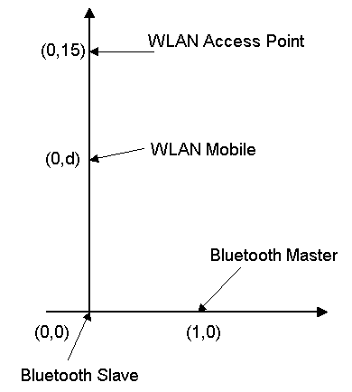
Figure 1: Experiment Topology
All four experiments are repeated for 802.11 1 Mbits/s and 11 Mbits/s Direct Sequence Spread Spectrum (DSSS) and 1 Mbits/s Frequency Hopping (FH) systems.
All simulations are run for 30 seconds of simulated time. The performance measurements are logged at the slave device for Bluetooth and at the AP and Mobile devices for WLAN.

Clause 11.1 802.11 1 Mbits/s Direct Sequence and Bluetooth Interference

Scenarios 1 and 2

Figure 2 depicts the probability of packet loss for scenarios 1 and 2 where the Bluetooth piconet is closer to the WLAN source.
The probability of packet loss for both Bluetooth voice (scenario 1) and data (scenario 2) is 13% at 0.5 meters. The packet loss drops gradually for Bluetooth voice for distances greater than 2 meters. However, it remains at 7% for Bluetooth data when the WLAN source is 5 meters away.
The probability of packet loss for the WLAN corresponds to the loss of ACK messages at the WLAN mobile device. Observe a WLAN packet loss of 18% in scenario 1 where Bluetooth voice is the interferer, as opposed to 12% in scenario 2 where Bluetooth data is the interferer signal.
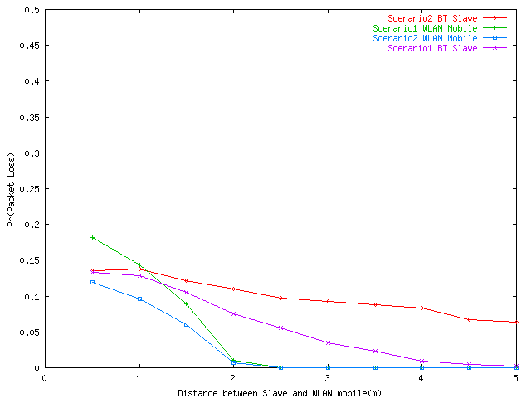
Figure 2: Probability of Packet Loss - 1 Mbits/s Direct Sequence

The access delay curves given in Figure 3 closely follow the packet loss trends described in Figure 2. The delay for WLAN (observed at the sink) is around 23 ms for distances less than 2 meters, and drops to 19 ms beyond 2 meters where the packet loss is zero.
For Bluetooth data the delay curve remains at 7 ms between 0.5 and 5 meters since the packet loss is still high at 5 meters.

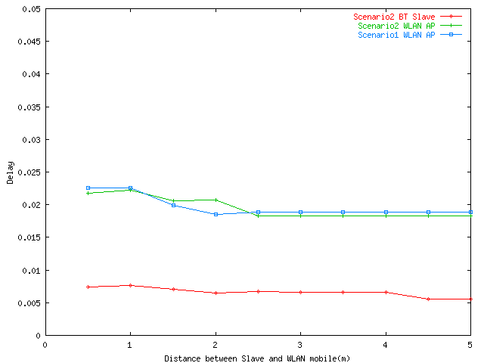
Figure 3: Access Delay (seconds) - 1 Mbits/s Direct Sequence

Scenarios 3 and 4
Figures 4 gives the packet loss for scenarios 3 and 4. Note that the packet loss when the WLAN receiver is close to a Bluetooth voice connection (95%) is double than when it is close to a Bluetooth data connection (45%).
The packet loss for Bluetooth is negligible in this case since the WLAN source is far from the Bluetooth piconet (15 meters) and does not affect the receiver.
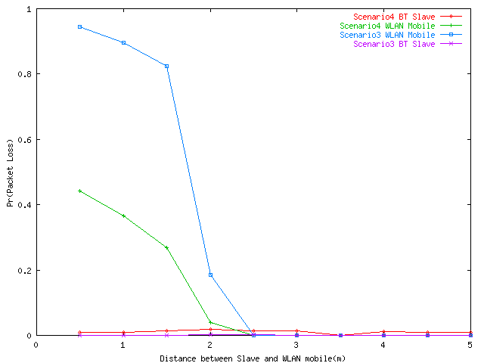
Figure 4: Probability of Packet Loss - 1 Mbits/s Direct Sequence

Figure 5 gives the delay curves for scenarios 3 and 4. Note that delays generally follow the packet loss trends. The spike in the WLAN delay for scenario 3 between 0.5 and 2 meters is due to the extremely high packet loss rate. Basically very few packets are going through for 0.5 and 1 meters. The delay at 1.5 meters is 150 ms, that is an order of magnitude greater than the delay at 2 meters that is around 18 ms.
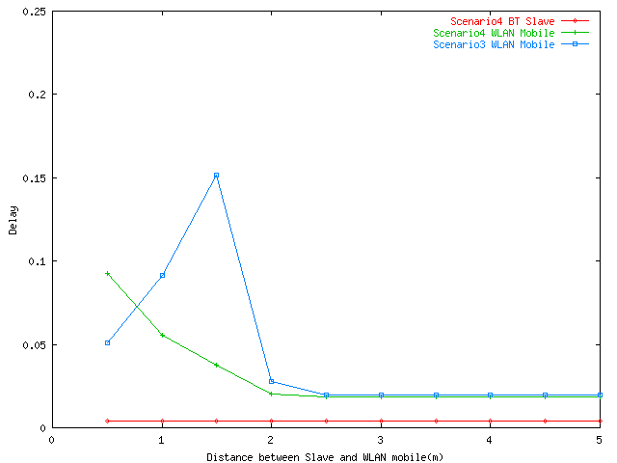
Figure 5: Delay (seconds) - 1 Mbits/s Direct Sequence

Clause 11.2 802.11 11 Mbits/s Direct Sequence and Bluetooth Interference

Scenarios 1 and 2
Figure 6 gives the packet loss for scenarios 1 and 2. The effect of the WLAN 11 Mbits/s interference is on Bluetooth leads slightly higher packet loss (20%) for Bluetooth data compared with the 1 Mbits/s WLAN interference (13% in Figure 2). The packet loss for the Bluetooth voice is comparable to the results obtained with the WLAN 1 Mbits/s interference. The 11 Mbits/s WLAN ACK loss rate is also comparable to 1 Mbits/s WLAN ACK rate obtained in Figure 3 since the ACK packet is always sent at 1 Mbits/s.

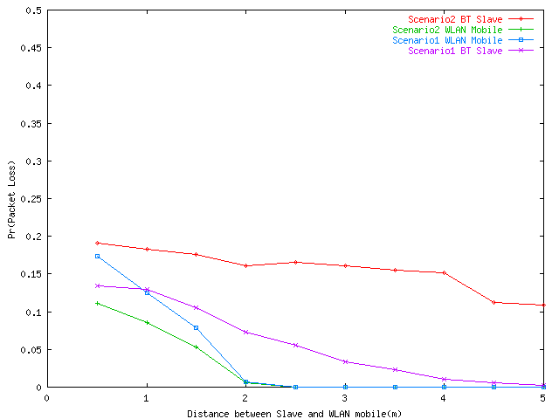
Figure 6: Probability of Packet Loss - 11 Mbits/s Direct Sequence
Figure 7 depicts the delay for scenarios 1 and 2. The delay for the Bluetooth data connection starts at 12 ms for a distance of 0.5 meters and drops to 7 ms for a distance of 5 meters.
The delay for the WLAN in scenario 1 and 2 start at 20 ms and 13 ms respectively at a distance of 0.5 meters and converge to 5 ms beyond 2 meters.
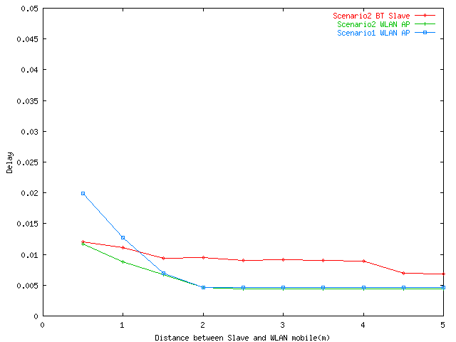
Figure 7: Access Delay (seconds) - 11 Mbits/s Direct Sequence

Scenarios 3 and 4
Figure 8 gives the packet loss for scenarios 3 and 4. Note that the packet loss for the 11 Mbits/s WLAN direct sequence is half the packet loss for the 1 Mbits/s WLAN direct sequence at 0.5 meters for scenario 3 (Figure 4). However, unlike the sharp drop in packet loss observed for the 1 Mbits/s WLAN for distances beyond 2 meters, the packet loss for the 11 Mbits/s remains greater than 25% until a distance of 4 meters. This is due to the robustness of the Barker code used in the 1 Mbits/s as opposed to the CCK used in the 11 Mbits/s.
The same applies to scenario 4. The packet loss observed for the 11 Mbits/s WLAN is also about half the packet loss obtained for the 1 Mbits/s.
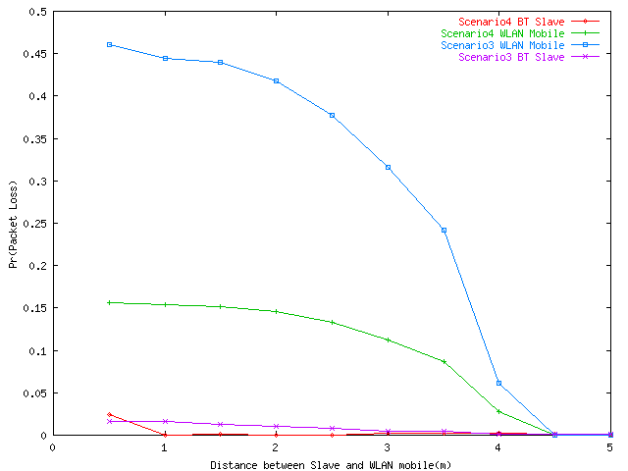
Figure 8: Probability of Packet Loss - 11 Mbits/s Direct Sequence
Figure 9 illustrates the delay for scenarios 3 and 4. The delay curves follow the packet loss trends described previously.
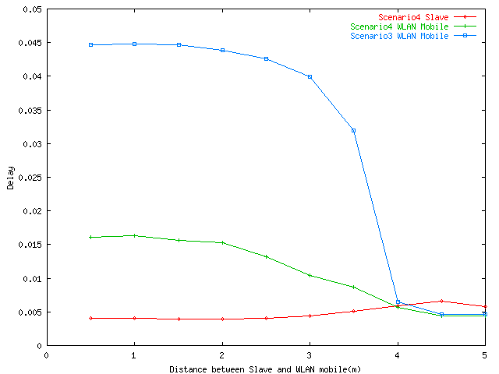
Figure 9: Access Delay (seconds) - 11 Mbits/s Direct Sequence

Clause 11.3 802.11 1 Mbits/s Frequency Hopping and Bluetooth Interference
Scenarios 1 and 2

Figure 10 depicts the packet loss for scenarios 1 and 2. The packet loss for both the Bluetooth and WLAN is negligible (below 5%). Thus, the interference of the WLAN frequency hopping system with Bluetooth is limited.
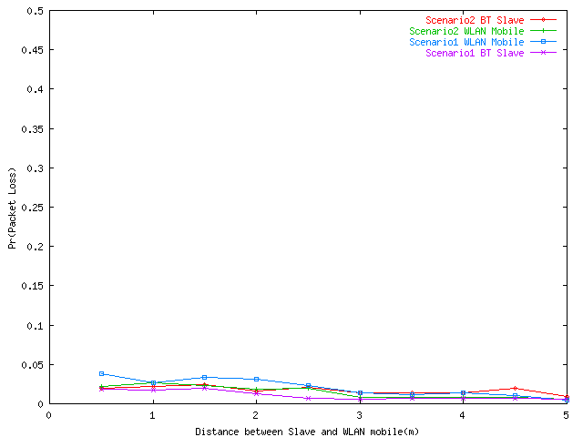
Figure 10: Probability of Packet Loss - 1 Mbits/s Frequency Hopping
Figure 11 gives the delay for scenarios 1 and 2. The curves are flat and reflect the packet loss curves illustrated in Figure 10.
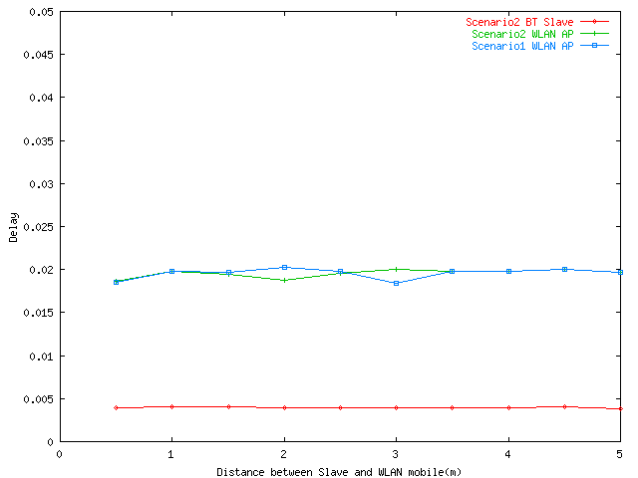
Figure 11: Access Delay (seconds) - 1 Mbits/s Frequency Hopping

Scenarios 3 and 4
Figure 12 gives the probability of packet loss for scenarios 3 and 4. The effect of Bluetooth voice interference on the WLAN frequency hopping system (scenario 3) leads to 60% of packet loss at 0.5 meters. The packet loss drops 10% at 5 meters. The impact of Bluetooth data on WLAN results in 17% of packet loss.
The packet loss of Bluetooth is zero for scenarios 3 and 4 due to the fact that the WLAN source is 15 meters away from the Bluetooth receiver.

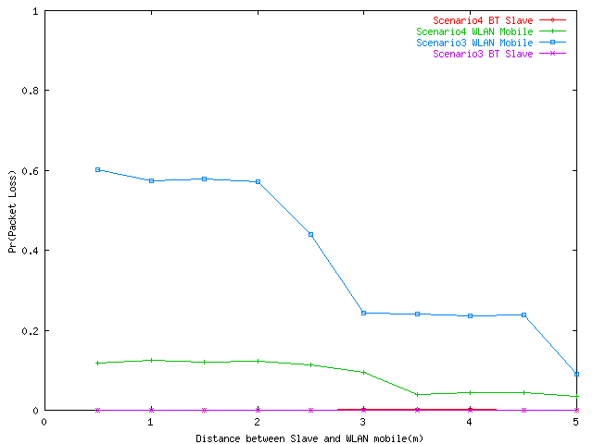
Figure 12: Probability of Packet Loss - 1 Mbits/s Frequency Hopping
The packet loss observed in Figure 12 for WLAN (scenario 3) leads to extremely high delays in Figure 13 (230 ms).
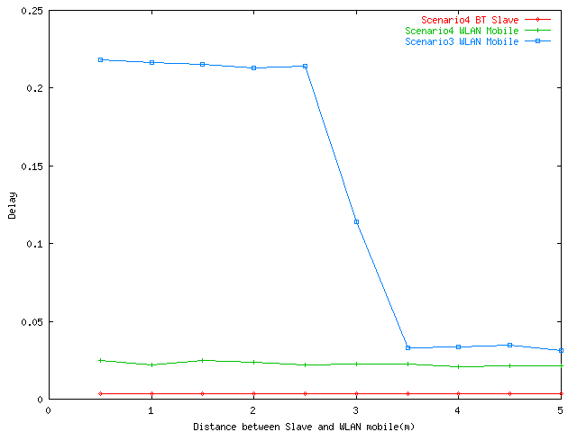
Figure 13: Delay (seconds) - 1 Mbits/s Frequency Hopping

