IEEE P802.15
Wireless Personal Area Networks
Project | IEEE P802.15 Working Group for Wireless Personal Area Networks (WPANs)
Title | SG3a Technical Requirements
Date Submitted | [June 17, 2002]
Source | [Kai Siwiak]  [Time Domain Corporation]  [7057 Old Madison Pike,  Huntsville, AL 35806]  [Jason Ellis- alternate technical editor: General Atomics] | Voice: [256-990-9062]  Fax: [256-922-0387]  E-mail: [kai.siwiak@timedomain.com]  E-mail: [jason.ellis@ga.com]
Re:
Abstract | [Definitions for the proposal evaluation for Study Group 3a]
Purpose | [This is a working document that will become the repository for the terms and definitions to be used in the selection process for a Draft Standard for TG3.]
Notice | This document has been prepared to assist the IEEE P802.15. It is offered as a basis for discussion and is not binding on the contributing individual(s) or organization(s). The material in this document is subject to change in form and content after further study. The contributor(s) reserve(s) the right to add, amend or withdraw material contained herein.
Release | The contributor acknowledges and accepts that this contribution becomes the property of IEEE and may be made publicly available by P802.15.

Table of Contents

Introduction 2
1.0 PHY Layer Technical Characteristics 3
2.0 Bit Rate and Range 3

3.0 Aggregate BIT Rates and Capacity 6
4.0 Coexistence AND interference Resistance 7
5.0 Channel Model 8
6.0 Power Consumption 8
7.0 Quality of Service 9
8.0 Form Factor 9
9.0 Cost 10
10.0 Supplements to 802.15.3 functionality 10
11.0 Regulatory 10

Introduction

This document and the Selection Criteria 02/105 provide the technical content for the project to develop an alternate physical layer (alt-PHY). This alt-PHY shall be a supplement to the proposed IEEE 802.15.3 Standard. This revision of the Technical Requirements Document, 02/104r10, references draft 10 of the proposed IEEE 802.15.3 Standard.

This document serves two purposes. It is first a summary of the 8 application presentations from the Study Group 3a call for applications. Second it defines the fundamental requirements implied by applications but not necessarily stated explicitly. The selection criteria document, 02/105 will guide proposers on how to respond to a call for proposals. It also provides amplification on key areas not addressed in 02/104. The study group may update this document as discoveries are made while working on the 02/105 document.

1.0 PHY Layer Technical Characteristics

Anticipated high-level characteristics of the alt-PHY layer are: high bit rates at low ranges, lower bit rates at higher ranges; low power consumption; high capacity in a shared sense, and highly scalable. Specific detailed requirements associated with these (and other) characteristics are described in the sections that follow.

2.0 Bit Rate and Range

A bit rate of at least 110 Mb/s at 10 meters is required at the PHY-SAP. The packet error rate used for this requirement is 8% for 1024 octet frame body. The transmit EIRP is fixed by regulatory emission limits. An additional higher bit rate of at least 200 Mb/s at 4 meters is required. Scalability to rates in excess of 480 Mb/s is desirable even if at reduced ranges. Figure 1 shows a reference partitioning.

Figure 1 – Reference partitioning

[The following applications tables are sourced from: 02/170r2]

Wireless Peripherals – H.323 / T.120 Video Conferencing
This application involves a set of wireless peripherals (at range <= 4m) being used for a H.323 videoconferencing session (e.g., NetMeeting) using video, audio, and application sharing over a broadband connection or a corporate Intranet Ethernet connection.

Application  Ingredients | Data Format | Min Data Rate | Max Data Rate
Video Camera | MPEG2 resolution w/o compression | 75Mb/s | 150Mb/s
Monitor | Varying compression | 63Mb/s | 1Gb/s
H.323 comm  (broadband) | H.261/H.263, G.711/G.723, T.120 | 128kb/s | 10Mb/s
Audio (mono) | PCM | 64kb/s | 64kb/s
Mass storage |  | 50Mb/s | 240 Mb/s
Mouse |  | < 9600 b/s | < 9600 b/s
Keyboard |  | < 9600 b/s | < 9600 b/s
Total |  | 188+ Mb/s | 1.4+ Gb/s

Home Theater
This application involves a set of wireless consumer electronics devices (at range <= 10 m) that might be used in a home theater room. The key focus of this collection of devices is the video and audio signals. A wireless web pad would allow the user to explore details about the programs being viewed using an Internet connection.

Application  Ingredients | Data Format | Min Data Rate | Max Data Rate
Monitor/Projector | HD Video | 19.2 Mb/s | 19.2 Mb/s
Audio (speakers) | 5.1 to 10.2 channels (24 bits) | 13.8 Mb/s | 27.6 Mb/s
Web Pad | Internet (streaming media) | 10 Mb/s | 10 Mb/s
Remote Controller |  | ?? | ??
Total |  | 43 Mb/s | 56.8 Mb/s

Interactive Applications

This application has significant market appeal in that wireless links will not only improve the ease of setup/positioning and storage, but they will also promote safer operation (fewer wires to trip over). The requirements are listed here in order of priority, with the display and audio transmission having a higher priority than the game controllers.

Application  Ingredients | Data Format | Min Data Rate | Max Data Rate
Monitor/Projector | XGA w/ Varying compression | 63 Mb/s | 1 Gb/s
Audio (speakers) | 5.1 to 10.2 channels (24 bits) | 13.8 Mb/s | 27.6 Mb/s
Interactive controller | (Reaction Sensitive) | ?? | ??
Total

Content Downloading
These applications concentrate on reducing the user’s waiting time when downloading large loads of information, such as video, audio and digital images. The transfer time indicates the amount of time the user spends waiting for a typical data transfer to complete.

Content Downloaded | Data Format | Data Rate | Transfer Time
Audio | MP3 | 60 Mb/s | 10 sec
 | CD | 90 Mb/s | 60 sec
Photos | Varied Compression | 90 Mb/s | 10 sec
Movies | DV | ?? (higher) | ??
Total

These are minimum download rates for an initial implementation. Consumer desire is always that faster downloads are better and thus significant importance is attached to the ability of the proposed technology to significantly increase download rates in the future.

Requirement | Source
100 / 200 / 400 and 480 Mb/s up to 4.5 m range | 02/031r0
20 Mb/s to 10 m range | 00/075r0
60 Mb/s, 90, >100 Mb/s (kiosk) | 02/043r0
2-25 Mb/s; 31-63 Mb/s 10 m and 30 m | 02/047r0
6-32 Mb/s; 15-50 Mb/s; 20-70 Mb/s; 30-100 Mb/s 10 m or 30-50 m range | 02/119r0
2 Mb/s to 300 Mb/s: scalable >10 m range to 3 m range | 02/137r1
1.5 Mb/s, 12 Mb/s, 480 Mb/s to < 5 m range;  10 -1000 Mb/s desired | 02/139r0
50 Mb/s – 500 Mb/s 1 m on body to 5 m ranges: scalable – very low bit rate to high bit rate | 02/143r0

3.0 Aggregate Bit Rates and Capacity

The bit rates and ranges specified in section 2.0 shall be achievable on each piconet for operation with at least 3 other piconets operating in close proximity even with some degree of performance degradation.

An example application scenario from 02/139r0 shown below involving wireless peripherals (monitor, camera, mass storage, etc.) in high-density corporate offices illustrates the need for this requirement.
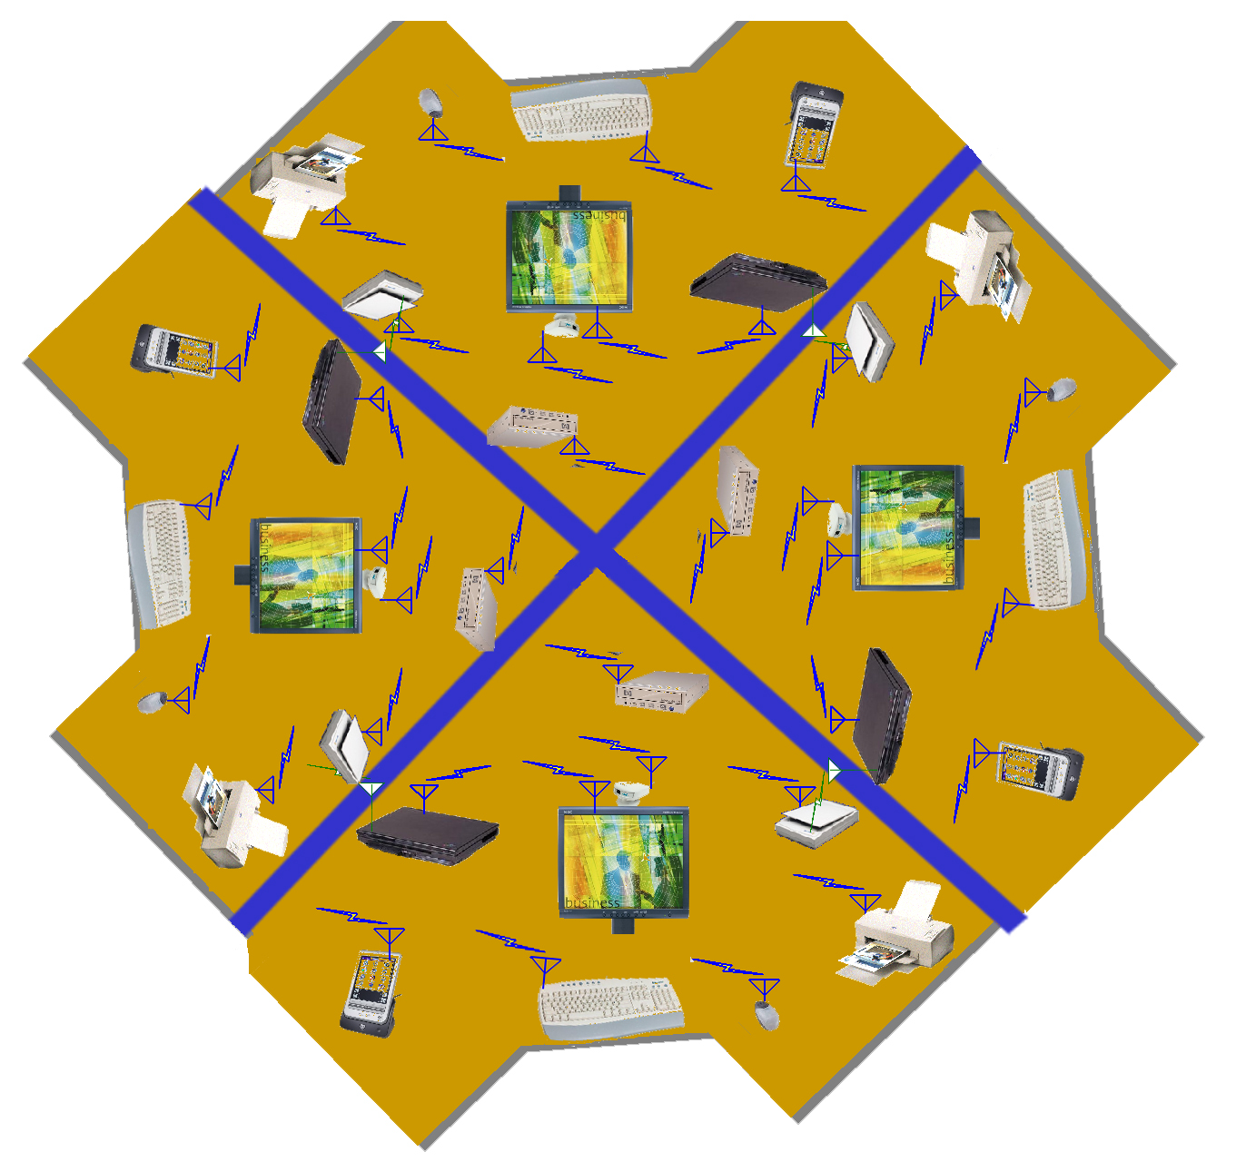

Requirement | Source
3 non-overlap channels, min effective throughput 50 Mb/s each | 02/031r0
multiple simultaneous channels | 02/119r0
4 to 8 non-overlap channels, to 300 Mb/s shared | 02/137r1
addressing of <127 devices per host | 02/139r0
Large capacity, many devices (private addresses) | 02/143r0

4.0 Coexistence and Interference Resistance
The PHY shall be able to coexist with other wireless devices that may be in close proximity to IEEE 802.15.3a devices. This includes both interference from 802.15.3a devices to other wireless systems as well as interference from other wireless systems or radiators to 802.15.3a devices.

Coexistence and interference resistance shall, at a minimum, be considered for the following wireless devices: Bluetooth™ (802.15.1), IEEE 802.11, IEEE 802.15 (3&4), IEEE 802.16, and ISM cordless phones. Interference resistance to radiators like microwave ovens shall also be considered. The criteria for 'coexistence' and the technique for evaluating the criteria shall be discussed in Document 02/105..

Requirement | Source
Coexistence with other 802, Bluetooth™, Cellular, PCS, GPS, 2.4 GHz and 5 GHz devices | 02/043r0, 02/137r1, 02/139r0, 02/143r0
Operates within 1 m of 802, Bluetooth™, Cellular, PCS and GPS | 02/119r0
Must work with incumbent networks | 02/137r1
Must support combinations of network technologies | 02/137r1
Shall be capable of (802.15.3) 22 Mb/s QPSK mode | 02/102r0
Robust in multipath (indoor) | 02/143r0

5.0 Channel Model

Performance in a multipath environment is a critical feature for the SG3a alt-PHY. Document (02/XXXSG3a) provides a reference alt-PHY channel model. The intention is to use existing narrow band channel models (such as the 802.11 model) for non-UWB alt-PHY proposals. The individual proposers should make use of the SG3a models as they become available as a basis for evaluating the performance of their proposals. Individuals submitting proposals that are not addressed by the rf channels selected by the Study Group are encouraged to provide specific details of the channel models used with references to literature, use in other standards, and/or research.

Requirement | Source
Wide band channel model (to be defined) | 02/137r1
JTC residential A | 02/031r0

6.0 Power Consumption

The alt-PHY should consume less than 100 mW for 110 Mb/s and less than 250 mW for 200 Mb/s in either the transmit state or the receive state. A power save state is also required.

The proposer should indicate the possible power management actions that can be initiated by the proposed 802.15.3 Standard "PHY-PWRMGT.request". Furthermore, the proposers should provide text including a table that indicates the number of power save levels offered and how much power each level saves.

Note: Document 02/043, a response to the SG3a call for applications, provides power consumption information relevant to this sub-clause. The document indicates tolerable power consumption for each of the desired applications, where the alt-PHY and MAC together constitute the desired maximum power consumption. 802.15.3SGa has yet to address the impact of combining the alt-PHY and MAC power consumptions into the requirements document.

Requirement | Source
350-450 mW on CamCorder; 150-200 mW Still Digital camera; <100 mW in PDA; 90mW in wireless robot control | 02/043r0
Possible on battery operated devices | 02/047r0, 02/143r0
Low power and advanced power management; low power density | 02/102r0
40-80 mW battery power; and 150-500 mW mains | 02/119r0
Power management | 02/139r0

7.0 Quality of Service

The uncorrected (i.e., without re-transmissions) error rate as defined in clause 2 is 8% packet error rate. The proposer is encouraged to show techniques that will yield an ‘equivalent’ bit error rate of <10⁻⁹ at the PHY SAP. Data should be provided that shows the added complexity, power consumption, and latency due to any relevant signal processing. In addition, estimates should be given to indicate the PHY overhead due to preambles and PHY headers.

Requirement | Source
“Best remedy” for QoS | 02/043r0
10⁻⁹ BER: video; isochronous capable | 02/047r0
10⁻¹² BER: USB-LL | 02/139r0
Secure communications; privacy in PAN | 02/143r0
High quality audio / video at high bit rate | 02/147r0

8.0 Form Factor

The PHY components should be capable of fitting into a form factor consistent with a camera, PDA, NIC cards or other small form factors of hand-held devices and storage mediums. The antenna size and form factor should be consistent with a small form factor without deviating significantly from the original device size.

Requirement | Source
Not a factor in some applications | .
easy to integrate into consumer devices, especially portable | 02/119r0
memory stick, SD card, Media Card compatible size | 02/102r0
5cm x 2.15cm x 0.28 cm without antenna but with MAC: cameras | 02/043r0

9.0 Cost

Cost/complexity estimates should be provided in terms of die size estimates, semiconductor process requirements, gate count estimates, and major external components. The target complexity is to be stated relative to Bluetooth™. Additionally, it is important to have the possibility of mixing very low complexity devices and very low cost devices that trade off performance with cost.

Requirement | Source
Cost and BOM similar to Bluetooth™ | 02/119r0, 02/043r0, 02/031r0

10.0 Supplements to 802.15.3 functionality

It is envisioned that the alt-PHY project will allow supplements to 802.15.3. In addition to the PHY itself, the project may include MAC functionality necessary to support the selected PHY.

It is required that the alt-PHY operate with the 802.15.3 MAC without fundamental change in operation. It is also required that any enhancements or modifications are enabled by reference to alt-PHY specific PIB parameters.

As an example, from the project request, document 01/532r0 (alt-PHY study group proposal), location awareness is considered as a possible feature of certain alt-PHY technologies and is an example of supplemental MAC functionality. Such a provision may be supported by the PHY PIB parameters in the 802.15.3 d10 MAC or via supplemental MAC capabilities provided by the alt-PHY project.

11.0 Regulatory

The alt-PHY standard will comply with necessary geopolitical or regional regulations.

