IEEE P802.15
Wireless Personal Area Networks
Project | IEEE P802.15 Working Group for Wireless Personal Area Networks (WPANs)
Title | SG3a Technical Requirements
Date Submitted | [June 1, 2002]
Source | [Kai Siwiak]  [Time Domain Corporation]  [7057 Old Madison Pike,  Huntsville, AL 35806] | Voice: [256-990-9062]  Fax: [256-922-0387]  E-mail: [kai.siwiak@timedomain.com]
Re:
Abstract | [Definitions for the proposal evaluation for Study Group 3a]
Purpose | [This is a working document that will become the repository for the terms and definitions to be used in the selection process for a Draft Standard for TG3.]
Notice | This document has been prepared to assist the IEEE P802.15. It is offered as a basis for discussion and is not binding on the contributing individual(s) or organization(s). The material in this document is subject to change in form and content after further study. The contributor(s) reserve(s) the right to add, amend or withdraw material contained herein.
Release | The contributor acknowledges and accepts that this contribution becomes the property of IEEE and may be made publicly available by P802.15.

Table of Contents

Introduction 2
1.0 PHY Layer Technical Requirements 3
2.0 Data Throughput and Range 3
Wireless Peripherals – H.323 / T.120 Video Conferencing 4
Home Theater 4
Gaming 4
Content Downloading 5
3.0 Aggregate Data Rates and Capacity and Addressing 6
4.0 Coexistence, Interference Resistance 7
5.0 Channel Model 7
6.0 Power Consumption 8
7.0 Quality of Service 8
8.0 Form Factor 9
9.0 Cost 9
10.0 Supplements to 802.15.3 functionality 9
11.0 Regulatory 10

Introduction

This document and the Selection Criteria 02/105 provide the technical content for the project to develop an alternate physical layer (alt-PHY). This alt-PHY shall be a supplement to the nearly complete 802.15.3 standard. This document serves two purposes. It is first a summary of the 8 application presentations from the Study Group 3a call for applications. Second it defines the fundamental requirements implied by applications but not necessarily stated explicitly. The selection criteria document, 02/105 will guide proposers on how to respond to a call for proposals. It also provides amplification on key areas not addressed in 02/104. The study group may update this document as discoveries are made while working on the 02/105 document.

1.0 PHY Layer Technical Characteristics

Anticipated high-level characteristics of the alt-PHY layer are: : high data rates, but only at low ranges, lower rates at higher ranges; low power consumption; and high capacity in a shared sense. Specific detailed requirements associated with these (and other) characteristics are described in the sections that follow.

{Substitute editor- Jason Ellis (General Atomics) editing rev 6 and rev7 on 16 May 02}

2.0 Bit Rate and Range

A bit rate of at least 110 Mbps at 10 meters is required at the PHY-SAP. The packet error rate used for this requirement is 8% for 1024 octet frame body. The transmit EIRP is fixed by regulatory emission limits. An additional higher bit rate of at least 200 Mbps at 4 meters is required. Scalability to rates in excess of 480 Mbps is desirable even if at reduced ranges. Figure 1 shows a reference partitioning.

{Editor note: for PLCP- add this is where FEC resides}
Figure 1 – Reference partitioning

[The following applications tables are sourced from: 02/170r2]

Wireless Peripherals – H.323 / T.120 Video Conferencing
This application involves a set of wireless peripherals (at range <= 4m) being used for a H.323 videoconferencing session (e.g., NetMeeting) using video, audio, and application sharing over a broadband connection or a corporate Intranet Ethernet connection.

Application  Ingredients | Data Format | Min Data Rate | Max Data Rate
Video Camera | MPEG2 resolution w/o compression | 75Mbps | 150Mbps
Monitor | Varying compression | 63Mbps | 1Gbps
H.323 comm  (broadband) | H.261/H.263, G.711/G.723, T.120 | 128kbps | 10Mbps
Audio (mono) | PCM | 64kbps | 64kbps
Mass storage |  | 50Mbps | 240 Mbps
Mouse |  | < 9600 bps | < 9600 bps
Keyboard |  | < 9600 bps | < 9600 bps
Total |  | 188+ Mbps | 1.4+ Gbps

Home Theater
This application involves a set of wireless consumer electronics devices (at range <= 10 m) that might be used in a home theater room. The key focus of this collection of devices is the video and audio signals. A wireless web pad would allow the user to explore details about the programs being viewed using an Internet connection.

Application  Ingredients | Data Format | Min Data Rate | Max Data Rate
Monitor/Projector | HD Video | 19.2 Mbps | 19.2 Mbps
Audio (speakers) | 5.1 to 10.2 channels (24 bits) | 13.8 Mbps | 27.6 Mbps
Web Pad | Internet (streaming media) | 10 Mbps | 10 Mbps
Remote Controller |  | ?? | ??
Total |  | 43 Mbps | 56.8 Mbps

Interactive Applications

This application has significant market appeal in that wireless links will not only improve the ease of setup/positioning and storage, but they will also promote safer operation (fewer wires to trip over). The requirements are listed here in order of priority, with the display and audio transmission having a higher priority than the game controllers.

Application  Ingredients | Data Format | Min Data Rate | Max Data Rate
Monitor/Projector | XGA w/ Varying compression | 63 Mbps | 1 Gbps
Audio (speakers) | 5.1 to 10.2 channels (24 bits) | 13.8 Mbps | 27.6 Mbps
Interactive controller | (Reaction Sensitive) | ?? | ??
Total

Content Downloading
These applications concentrate on reducing the user’s waiting time when downloading large loads of information, such as video, audio and digital images. The transfer time indicates the amount of time the user spends waiting for a typical data transfer to complete.

Content Downloaded | Data Format | Data Rate | Transfer Time
Audio | MP3 | 60 Mbps | 10 sec
 | CD | 90 Mbps | 60 sec
Photos | Varied Compression | 90 Mbps | 10 sec
Movies | DV | ?? (higher) | ??
Total

These are minimum download rates for an initial implementation. Consumer desire is always that faster downloads are better and thus significant importance is attached to the ability of the proposed technology to significantly increase download rates in the future.

Requirement | Source
100 / 200 / 400 and 480 Mb/s up to 4.5 m range | 02/031r0
20 Mb/s to 10 m range | 00/075r0
60 Mb/s, 90, >100 Mb/s (kiosk) | 02/043r0
2-25 Mb/s; 31-63 Mb/s 10 m and 30 m | 02/047r0
6-32 Mb/s; 15-50 Mb/s; 20-70 Mb/s; 30-100 Mb/s 10 m or 30-50 m range | 02/119r0
2 Mb/s to 300 Mb/s: scalable >10 m range to 3 m range | 02/137r1
1.5 Mb/s, 12 Mb/s, 480 Mb/s to < 5 m range;  10 -1000 Mb/s desired | 02/139r0
50 Mb/s – 500 Mb/s 1 m on body to 5 m ranges: scalable – very low bit rate to high bit rate | 02/143r0

3.0 Aggregate Bit Rates and Capacity

The bit rates and ranges specified in section 2.0 shall be achievable on each piconet for operation with at least 3 other piconets operating in close proximity even with some degree of performance degradation.

An example application scenario from 02/139r0 shown below involving wireless peripherals (monitor, camera, mass storage, etc.) in high-density corporate offices illustrates the need for this requirement.
{Editor note: new picyure supplied by Chuck, via Rick – 30 May 02}
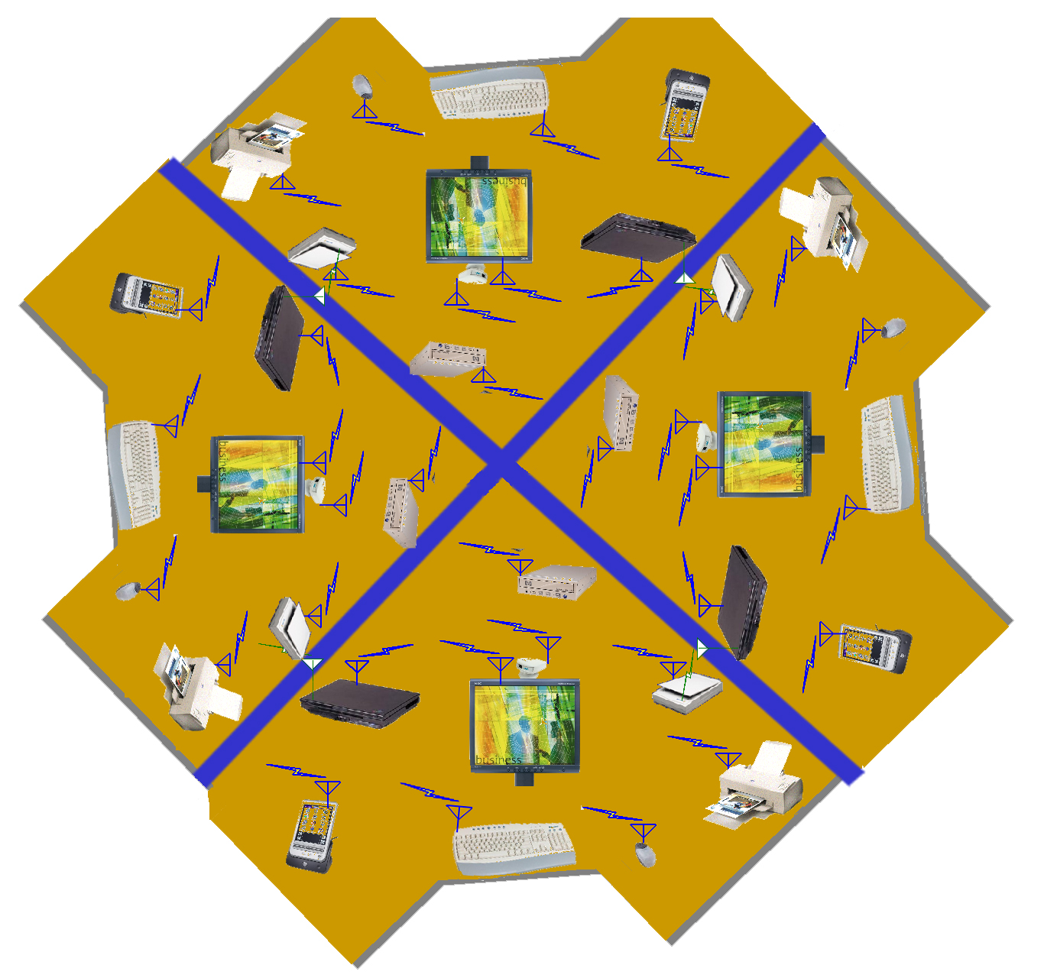

Requirement | Source
3 non-overlap channels, min effective throughput 50 Mb/s each | 02/031r0
multiple simultaneous channels | 02/119r0
4 to 8 non-overlap channels, to 300 Mb/s shared | 02/137r1
addressing of <127 devices per host | 02/139r0
Large capacity, many devices (private addresses) | 02/143r0

4.0 Coexistence and Interference Resistance

The PHY should coexist will current 802 devices that share the same frequencies of operation. {editor note: Jeff / Michael to provide text because this has to be addressed}

Requirement | Source
Coexistence with other 802, Bluetooth™, Cellular, PCS, GPS, 2.4 GHz and 5 GHz devices | 02/043r0, 02/137r1, 02/139r0, 02/143r0
Operates within 1 m of 802, Bluetooth™, Cellular, PCS and GPS | 02/119r0
Must work with incumbent networks | 02/137r1
Must support combinations of network technologies | 02/137r1
Shall be capable of (802.15.3) 22 Mb/s QPSK mode | 02/102r0
Robust in multipath (indoor) | 02/143r0

5.0 Channel Model

Performance in a multipath environment is a critical feature for the SG3a alt-PHY. Document (02/XXXSG3a) provides a reference alt-PHY channel model. The intention is to use existing narrow band channel models (such as the 802.11 model) for non-UWB alt-PHY proposals. The individual proposers make use of the SG3a models as they become available as a basis for evaluating the performance of their proposals. Individuals submitting proposals that are not addressed by the RF channels selected by the Study Group are encouraged to provide specific details of the channel model used with references to literature, use in other standards, and/or research.

Requirement | Source
Wide band channel model (to be defined) | 02/137r1
JTC residential A | 02/031r0

6.0 Power Consumption
The alt-PHY should consume less than 100 mW for 110 Mbps and less than 250 mW for 200 Mbps in either the transmit state or the receive state. A power save state is also required, according to the PHY PIB PS specifications. {Jay Bain to provide text}

Requirement | Source
350-450 mW on CamCorder; 150-200 mW Still Digital camera; <100 mW in PDA; 90mW in wireless robot control | 02/043r0
Possible on battery operated devices | 02/047r0, 02/143r0
Low power and advanced power management; low power density | 02/102r0
40-80 mW battery power; and 150-500 mW mains | 02/119r0
Power management | 02/139r0

7.0 Quality of Service

The uncorrected (i.e., without re-transmissions) error rate as defined in clause 2 is 8% packet error rate. The proposer is encouraged to show techniques that will yield an ‘equivalent’ bit error rate of <10⁻⁹ at the PHY SAP. Data should be provided that shows the added complexity, and power consumption, and latency due to any relevant signal processing. In addition, estimates should be given to indicate the PHY overhead due to preambles and PHY headers.

Requirement | Source
“Best remedy” for QoS | 02/043r0
10⁻⁹ BER: video; isochronous capable | 02/047r0
10⁻¹² BER: USB-LL | 02/139r0
Secure communications; privacy in PAN | 02/143r0
High quality audio / video at high bit rate | 02/147r0

8.0 Form Factor

The PHY components should be capable of fitting into a form factor consistent with a camera, PDA, NIC cards or other small form factors of hand-held devices. The antenna size and form factor should be consistent with a small form factor without deviating significantly from the original device size.

Requirement | Source
Not a factor in some applications | .
easy to integrate into consumer devices, especially portable | 02/119r0
memory stick, SD card, Media Card compatible size | 02/102r0
5cm x 2.15cm x 0.28 cm without antenna but with MAC: cameras | 02/043r0

9.0 Cost

Cost/complexity estimates should be provided in terms of die size estimates, semiconductor process requirements, gate count estimates, and major external components. The target complexity is to be stated relative to Bluetooth™. Additionally, it is important to have the possibility of mixing very low complexity devices and very low cost devices that trade off performance with cost.

Requirement | Source
Cost and BOM similar to Bluetooth™ | 02/119r0, 02/043r0, 02/031r0

10.0 Supplements to 802.15.3 functionality

It is envisioned that the alt-PHY project will allow supplements to 802.15.3. In addition to the PHY itself, the project may include MAC functionality necessary to support the selected PHY.

It is required that the alt-PHY operate with the 802.15.3 MAC without fundamental change in operation. It is also required that any enhancements or modifications are enabled by reference to alt-PHY specific PIB parameters.

As an example, from the project request, document 01/532r0 (alt-PHY study group proposal), location awareness is considered as a possible feature of certain alt-PHY technologies and is an example of supplemental MAC functionality. Such a provision may be supported by the PHY PIB parameters in the current 802.15.3 standard or via supplemental MAC capabilities provided by the alt-PHY project.

11.0 Regulatory

The alt-PHY standard will comply with necessary geopolitical or regional regulations.

