IEEE P802.15
Wireless Personal Area Networks

Project | IEEE P802.15 Working Group for Wireless Personal Area Networks (WPANs)
Title | UWB Channel Modeling Contribution from Intel
Date Submitted | [24 June, 2002]
Source | [Jeff Foerster and Qinghua Li]  [Intel Research and Development]  [JF3-206  2111 N.E. 25th Ave.  Hillsboro, OR 97124] | Voice: [503-264-6859]  Fax: [503-264-3483]  E-mail: [jeffrey.r.foerster@intel.com]
Re: | [In response to the Call for Contributions on Ultra-wideband Channel Models (IEEE P802.15-02/208r1-SG3a).]
Abstract | [This contribution proposes a UWB path loss and multipath model for assisting in the evaluation of possible UWB physical layer submissions for a high-rate extension to IEEE 802.15.3.]
Purpose | [In this paper, we propose a method for standardizing link budgets to use in comparing different UWB PHY proposals for achieving the desired throughputs and ranges for the standard. In addition, we present some multipath channel measurements that were preformed by Intel and compare these measurements with different channel models that have been considered by the industry for indoor channels. The results suggest a possible UWB multipath channel model that could be used to compare different UWB PHYs.]
Notice | This document has been prepared to assist the IEEE P802.15. It is offered as a basis for discussion and is not binding on the contributing individual(s) or organization(s). The material in this document is subject to change in form and content after further study. The contributor(s) reserve(s) the right to add, amend or withdraw material contained herein.
Release | The contributor acknowledges and accepts that this contribution becomes the property of IEEE and may be made publicly available by P802.15.
UWB Channel Modeling Contribution from Intel

Introduction

The purpose of this contribution is to respond to the UWB channel modeling call for contributions (IEEE P802.15-02/208r1-SG3a) to assist the IEEE 802.15.3a study group in evaluating different UWB PHY proposals. The goal here is not to provide a universal model for all environments in which UWB devices will be operating, but rather to provide a set of tools that can be used to fairly evaluate the performance of different UWB PHY proposals in realistic channels.

Path Loss and Link Budget Model

There have been many proposed path loss models in the literature (see [1]-[8] for examples), but the purpose of this channel model is to fairly compare different physical layer proposals at the target operating distances. This can be done by simply adopting the free space path loss model and asking the proposers to provide the resulting link margin that will be available to make up for additional channel losses, implementation losses, waveform distortion, imperfect multipath energy capture, etc. Note that the IEEE 802.15.2 indoor path loss model, for example, which is a bifurcated model with free space loss out to 8 meters and 3.3 path loss exponent greater than 8 meters, only differs by 1.26 dB from free space at the target distance of 10 meters. Therefore, the simple free space path loss model will be close to the IEEE 802.15.2 path loss at the target ranges of interest. Of course, this does not include any losses that might be caused by propagation through walls, furniture, or other obstacle. The table below identifies the parameters needed by the proposer and how those parameters could be used to compute the final link margin. This model is based on the narrowband path loss calculations (known as the Friis transmission formula), and the applicability of this model to UWB systems depends on the assumptions about the frequency response of the antennas, which is discussed next.

A justification of using the narrowband path loss model for UWB systems was actually presented in [9], and is replicated here for completeness. Assuming perfect isotropically radiating antennas at the transmitter and receiver, the received power as a function of frequency, can be expressed as the following:
$P_{R}(f)=\frac{P_{T}(f)G_{T}(f)G_{R}(f)c^{2}}{(4πd)^{2}f^{2}}$ (1)
where $P_{T}(f)$ is the average transmit power spectral density ($P_{\text{ave}}=\int_{−∞}^{∞}{P_{T}(f)G_{T}(f)\text{df}}$ is the total average transmit power), c is the speed of light, and $G_{T}(f)$ and $G_{R}(f)$ are the transmit and receive antenna frequency response, respectively. Clearly, this depends on the frequency response of the antennas, which may be difficult to generalize. However, since the FCC regulations for UWB requires the transmitter to meet a certain electric field strength limit (500 uV/m for UWB systems operating between 3.1 and 10.6 GHz) at a specified range (3 m), which is equivalent to a total transmit power spectral density limit, then it would desirable to have the product $P_{T}(f)G_{T}(f)$ be flat within the bandwidth of interest. On the other hand, it may be difficult to generalize that the receiving antenna will be flat across the desired frequency band. However, as a first order approximation, a flat frequency response, isotropic antenna is considered next. So, for a perfectly flat UWB waveform occupying the band $f_{c}−W/2$ to $f_{c}+W/2$ with power spectral density $P_{\text{ave}}$/W, and a flat frequency response of the receiving antenna with constant gain across the whole bandwidth ($G_{R}$), the total average received power at the output of the receiving antenna will be given by the following [9]:
$\begin{aligned}P_{\text{Rave}}=\int_{f_{c}−W/2}^{f_{c}+W/2}{P_{R}(f)\text{df}}=\frac{P_{\text{ave}}G_{R}c^{2}}{W(4πd)^{2}}\left[\frac{1}{f_{c}{−W}/2}−\frac{1}{f_{c}{+W}/2}\right]=\frac{P_{\text{ave}}G_{R}c^{2}}{(4πd)^{2}f_{c}^{2}}\left[\frac{1}{1−{\left(W/2f_{c}\right)}^{2}}\right] \\ P_{\text{Rave}}=P_{\text{ave}}^{\text{NB}}\left[\frac{1}{1−{\left(W/2f_{c}\right)}^{2}}\right]\end{aligned}$ (2)

where
$P_{\text{ave}}^{\text{NB}}=\frac{P_{\text{ave}}G_{R}c^{2}}{(4πd)^{2}f_{c}^{2}}$ (3)
corresponds to the well known narrowband path loss model equation and the second term accounts for the difference between the narrowband and wideband model. For the largest fractional bandwidth allowed by the FCC (occupying 3.1-10.6 GHz), $P_{\text{Rave}}$ will differ from $P_{\text{ave}}^{\text{NB}}$ by only 1.5 dB, and this difference becomes smaller for smaller fractional bandwidths. Also note that the FCC rules results in W<2f_{c}, so the singularity in the above equation can be ignored at W=2f_{c}.

Alternatively, we can repeat the above analysis for an Rx antenna response of $G_{R}(f)=4{πA}_{R}{f^{2}}/{c^{2}}$ where $A_{R}$ is the effective area of the antenna (e.g., the antenna has a fixed effective aperture). This type of response yields a greater gain for higher frequencies. In this case the above analysis results in the average received power given by:
$P_{\text{Rave}}=\frac{P_{\text{ave}}4{πA}_{R}}{(4πd)^{2}}=\left(\frac{P_{\text{ave}}c^{2}}{(4πd)^{2}f_{c}^{2}}\right)\left(\frac{4{πA}_{R}f_{c}^{2}}{c^{2}}\right)=P_{\text{ave}}^{\text{NB}}G_{R}(f_{c})$ (4)
where $G_{R}(f_{c})$ is the antenna gain at the center frequency of the transmitted waveform.

Therefore, it appears that the narrowband model can be used to approximate the path loss for a UWB system, based on the assumptions discussed above. This is also consistent with the results for the 1 meter LOS path loss that was measured in [7] and [8] based on UWB bandwidths of 1.25 GHz and 6 GHz, respectively.

The following table lists the parameters and equations that could be used by the proposers to demonstrate the ability of the PHY to close the link at the throughputs and target operating ranges desired for the standard. The highlighted parameters below are up to the proposers to define, while all other parameters will be consistent with all proposals so easy comparisons can be made.
Table 1: Medium Rate Link Budget
Parameter | Value | Value
Throughput | > 110 Mbps | > 200 Mbps
Average Tx power ($P_{T}$) | dBm | dBm
Tx antenna gain ($G_{T}$) | 0 dBi | 0 dBi
$f_{c}$: center frequency of waveform | Hz | Hz
Path loss at 1 meter ($L_{1}=\text{20}{\text{log}}_{\text{10}}(4{{πf}_{c}}/c)$)  $c=3×{\text{10}}^{8}$ m/s | dB | dB
Path loss at d m ($L_{2}=\text{20}{\text{log}}_{\text{10}}(d)$) | 20 dB at d=10 meters | 12 dB at d=4 meters
Rx antenna gain ($G_{R}$) | 0 dBi | 0 dBi
Rx power ($P_{R}=P_{T}+G_{T}+G_{R}−L_{1}−L_{2}$ (dB)) | dBm | dBm
Noise Bandwidth at antenna port (W) | Hz | Hz
Noise power ($N=−\text{174}+\text{10}{\text{*log}}_{\text{10}}(W)$) | dBm | dBm
Rx Noise Figure ($N_{F}$) | 7 dB | 7 dB
Rx Noise Power ($P_{N}=N+N_{F}$) | dBm | dBm
Processing gain ($P_{G}$ : please explain how this is derived) | dB | dB
Minimum C/N (S) | dB | dB
Link Margin ($M=P_{R}+P_{G}−P_{N}−S$) | dB | dB
Proposed Min. Rx Sensitivity Level | dBm | dBm

Although the proposers may need to alter the above table for their specific UWB PHY proposal, it gives them an initial framework of the kind of justification and detail that should be part of the proposal. The final desired output of the link budget should be a final Link Margin that will be needed to account for additional channel losses, implementation losses, waveform distortion, imperfect multipath energy capture, amplitude fading, etc.

Multipath Model

Although there are both frequency domain and time domain models that may be appropriate for UWB systems, we chose to focus our work on evaluating discrete time models. This model is based upon the following channel impulse response model:
$h(t)=\sum_{l=0}^{L−1}{α_{l}}δ(t−τ_{l})$ (5)
where $α_{l}$ is the amplitude fading factor on path l (could be complex), $τ_{l}$ is the random delay of path l, L is the number of multipath components, and $δ(t)$ is the Derac delta function. There are several parameters that need to be defined to complete this particular model, and each will be addressed in the following subsections.

RMS Delay Spread
Typical values for the multipath delay spread of indoor channels have been reported to be between 15 nsec in a residence to over 100 nsec in an office to a 150 nsec in a commercial building [10]. Other measurements at 10 meter distances suggest RMS delay spreads of 19-47 nsec [17]. In addition, the multipath delay spread has been found to increase as the separation distance between the receiving and transmitting antenna is increased. The following table shows some of the published RMS delay spread numbers that have been suggested for the indoor channel (both industry adopted models and published academic papers).

Ref. | Application | Delay spread | Comments
[10] | WPAN (ITU P.1238) | RMS values:  70 nsec for Residential  100 nsec for office  150 nsec for commercial | WSSUS model with tap-delay line and Gaussian distributed taps
[11] | 802.11 LAN for evaluating HRb proposals | 25 nsec  100 nsec  250 nsec | WSSUS model with tap-delay line and Gaussian distributed taps with zero mean (Rayleigh fading)
[12] | IEEE 802.15.3 High rate PAN | 25 nsec minimum | WSSUS model with tap-delay line and Gaussian distributed taps with zero mean (Rayleigh fading)
[13] | Indoor at distances up to 30 meters (results here for 10 meters) | < 20 nsec for LOS  < 70 nsec for NLOS  for 2.4 GHz | Delay spreads for 2.4 GHz tends to be higher than 11.5 GHz. Delay spread increase with distance separation.
[14] | Indoor at ~ 1.5 GHz | Ave. rms delay spreads:  Brick: 26-30 ns  Concrete: 28-29 ns  Office: 25 & 50 ns  LOS factory: 96 ns  OBS factory: 105 ns | Max rms delay spreads:  Brick: < 70 ns  Concrete: < 70 ns  Office: 50 & 218 ns  LOS factory: 300 ns  OBS factory: 300 ns
[15] | UWB propagation indoor < 10 meters | Delay spreads on the order of 100 nsec observed | Suggests ray tracing not feasible for UWB. Number of dominant paths is much greater than 5 and < 50.
[16] | UWB propagation at 6, 10, and 17 m separation | -- | Multipath energy varies by at most 5 dB (suggests fading is not of Rayleigh type)
[17] | 900 MHz in office building environment. Paths were mostly OBS. Distances varied from 1-100 ft. | Mean RMS delays of 16, 40, 55 nsec for 3 different office buildings | Max. RMS delays of 48, 55, 146 nsec. Temporal variations followed closely to lognormal dist. rather than Rayleigh.
[18] | 12,000 measurements in 2 office buildings in frequency band of 900-1300 MHz | Mean values between 20-30 nsec for 5-30 m antenna separations, values of 11-20 nsec for 10 m separation. | Results agreed with a value of 26 nsec and 25 nsec from cited refs. Of [19] and [21] in paper.
[8] | 870 channel realizations (LOS and NLOS) in a condo setting using 2-8 GHz frequency band) | Mean RMS delay spread of 12.94 nsec, and mean excess delay of 13.59 nsec.
[7] | 300,00 channel realizations collected in 23 homes using 4.375-5.625 GHz frequency band) | Mean RMS delay spread of 8.2 nsec, and mean excess delay of 4.2 nsec.
[19] | 906 UWB channel soundings in an office using a 2 GHz center freq. With 1.5 GHz bandwidth pulse. | Mean RMS delay of 5.22 nsec

These results, and trying to stick with those published in [12] and [18], suggest that a fairly conservative RMS delay spread of 25 nsec would be a good initial starting point for PAN type applications with antenna separations of about 10 meters or less. Shorter RMS delay spreads could be considered for shorter ranges (5 meters or less). Results in [18] (few measurements have been done with such short range), found average RMS delay spreads of around 17 nsec at these short ranges. As a result of this wide variation, the final multipath model should consider a range of RMS channel delay spreads.

Multipath Amplitude Distribution
It is reported in [18] that the empirical distribution of path amplitudes fits the lognormal distribution better than both Rayleigh and Nakagami distributions. We compute the empirical distribution of path amplitudes using Intel measurement data (see Appendix for a description of these measurements) and adopt similar approaches as [18] to compare the fittings of lognormal and Rayleigh. Among 870 measured channel realizations, the lognormal distribution passed the Kolmogorov-Smirnov test on 1% significance level with larger rate than the one of Rayleigh distribution as shown in Table 2. The fitting of the cumulative distribution function (CDF) to lognormal and Rayleigh distributions are shown in Figures 1-3, which used a maximum likelihood estimate of the distribution parameters to the measurement data. The good lognormal fit observed in these figures is typical of all cases including different occultation conditions and antenna separations. The comparison results demonstrate that the distribution of path amplitude fits lognormal distribution better than Rayleigh distribution.

Table 2 Pass rates of Kolmogorov-Smirnov test for different channel occultation and antenna separations.
 | Pass Rate of Lognormal (%) | Pass Rate of Rayleigh (%)
LOS, 1-20 m | 55 | 0
NLOS, 1-20 m | 25 | 0
LOS, 1-5 m | 30 | 0
NLOS, 1-5 m | 30 | 0
LOS, 5-20 m | 50 | 25

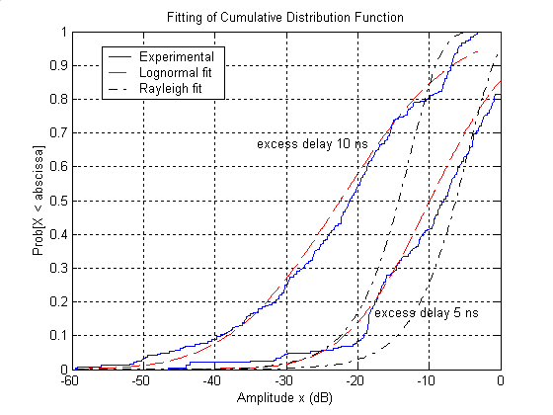
(a)
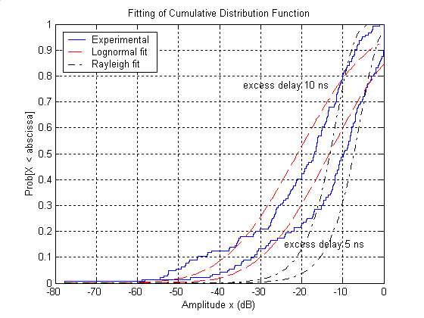
(b)
Figure 1 Distribution of signal amplitudes. The measured channels are of antenna separation from 1 to 5 meters. Distributions for LOS and NLOS channels are in (a) and (b) respectively. The peak amplitude of each channel is normalized to unity.
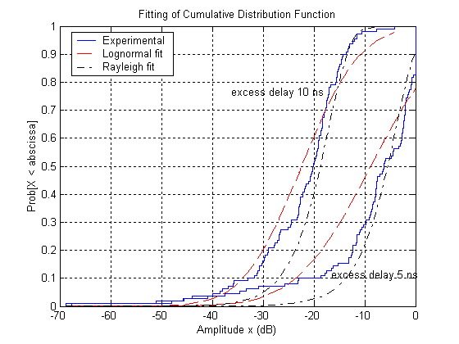
(a)
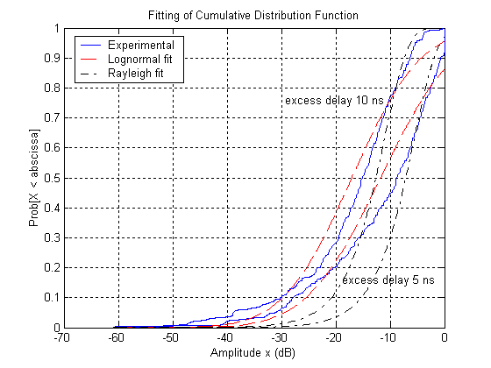
(b)
Figure 2 Distribution of signal amplitudes. The measured channels are of antenna separation from 5 to 20 meters. Distributions for LOS and NLOS channels are in (a) and (b) respectively. The peak amplitude of each channel is normalized to unity.

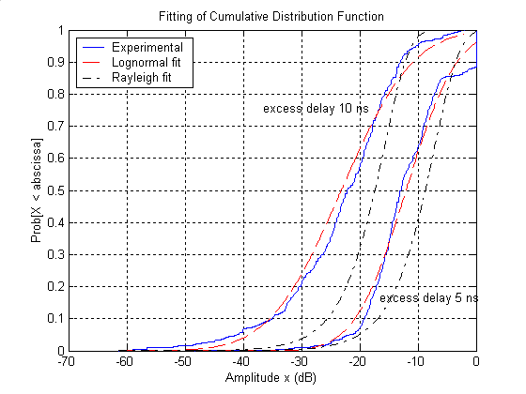
(a)
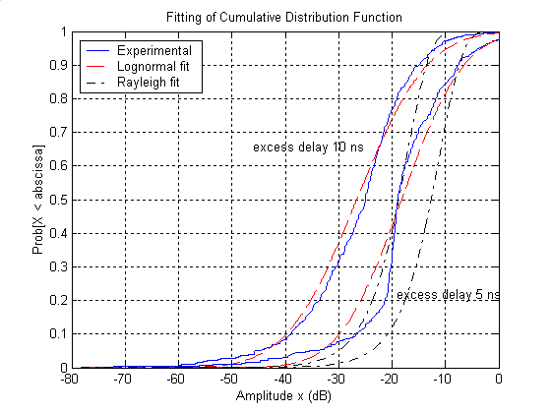
(b)
Figure 3 Distribution of signal amplitudes. The measured channels are of antenna separation from 1 to 20 meters. Distributions for LOS and NLOS channels are in (a) and (b) respectively. The peak amplitude of each channel is normalized to unity.
Computation results of the amplitude in dB (i.e., 20 log₁₀[amplitude]) demonstrate that the variance of log amplitude for fixed excess delay doesn’t vary much with excess delay. The results for 1-5 m and 1-20 m channels are shown in Figure 4 and similar results are seen for other separations. In the figure, a threshold, -20 dB, is set to select path so that weak paths close to noise level are excluded. A mean of 4.8 dB for 1-20 m channels is observed for the standard deviation and this result match with the one reported in [18], which is 4.2-5.3 dB for antenna separation 1-10 meter.
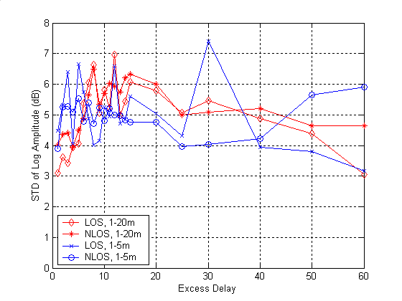
Figure 4 The standard deviation of log amplitude. The antenna separation ranges are 1-5 meters and 1-20 meters. The peak of each channel realization is normalized to unity.

Multipath Model Comparison

The following sections compare different multipath channel models with the Intel measurements to see which model best approximates the measurement data characteristics. Since it is difficult to quantify the ‘best fit’ channel model to the measurements, we focused on three key channel characteristics: mean excess delay ($τ_{m}$), RMS delay spread ($τ_{\text{rms}}$), and mean number of multipath components with an amplitude within 10 dB of the peak return (NP_{10dB}). Then, the critical parameters for each model were determined by trying to fit the above listed channel characteristics. In some cases, non-line-of-sight (NLOS) and LOS channels characteristics were considered separately to determine how the model could be adjusted based upon different channel characteristics.

802.11 Model
The 802.11 model is documented in an IEEE 802.11b standard groups document, IEEE 802.11-00/282r2. It assumes that the channel impulse responses are output of finite impulse response (FIR) filters. The filter taps are independent complex Gaussian variables with average power profile that decays exponentially as shown in Figure 5. The taps are given by
where
(6)

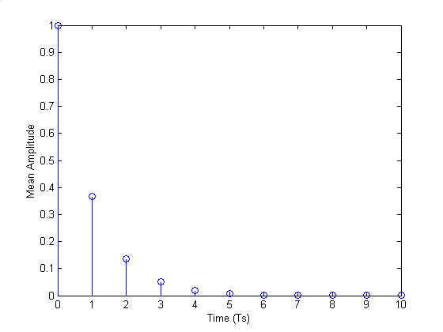
Figure 5 Average power profile of Rayleigh model.
The model is evaluated by the following example. We fix sampling rate and sampling time at 6 GHz and 167 ps respectively, equivalent to the minimum resolution obtained from the channel measurements. Channel realization with RMS delay 5 ns, 10 ns, 15 ns, 20 ns, 25 ns are generated from the model. We count the number of paths that are within –10 dB from the maximum peak path for each channel realization. The empirical distributions of path numbers are plotted in the following figure. Intel’s measurement [8] reports that RMS delays are 7-15 ns, and the mean number of paths is about 33 for a minimum multipath resolvability of 167 psec (corresponding to a 6 GHz measurement bandwidth). Also shown is the distribution of the number of paths generated from the Rayleigh model.

Table 3 Simulated and measured results for Rayleigh model compared to Intel’s measurements.
Simulated | τ_{rms} (ns) | 5 | 10 | 12.94 | 15 | 20 | 25
Simulated | Mean NP_{10dB} | 31 | 53 | 65 | 73 | 91 | 109
Measured | τ_{rms} (ns) |  |  | 12.94
Measured | Mean NP_{10dB} |  |  | 33

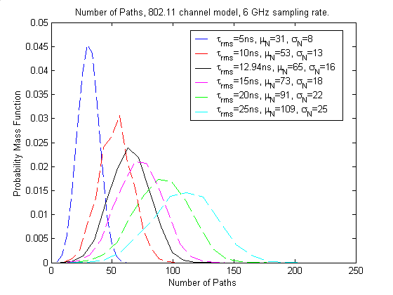
Figure 6 Simulated distribution of path numbers. In the figure, μ_{N} is the mean number of path and σ_{N} is the standard deviation of path number.
It is seen that the path number difference between the model's prediction and Intel’s measurements is roughly a factor of two, suggesting that the model may not be able to accurately model the channel characteristics observed from actual measurements.

Saleh-Valenzuela Model (S-V)
The major difference between Saleh-Valenzuela model [1] and 802.11 model is that Saleh-Valenzuela model doesn’t assume the arrival of paths on each sampling time interval. Instead, two Poisson models are employed in the modeling of the arrival time. The first Poisson model is for the first path of each path cluster and the second Poisson model is for the paths (or rays) within each cluster. Following the terminology in [1], we define
T_{l} = the arrival time of the first path of the l-th cluster;
τ_{k,l} = the delay of the k-the path within the l-th cluster relative to the first path arrival time, T_{l};
Λ = cluster arrival rate;
λ = ray arrival rate, i.e., the arrival rate of path within each cluster.
By definition, we have . The distribution of cluster arrival time and the ray arrival time are given by
(7)
The magnitude of the k-th path within the l-th cluster is denoted by β_{kl}. It is Rayleigh distributed with a mean given by
(8)
where is the average power of the first arrival of the first cluster. Illustrations of channel impulse responses are shown below in Figure 7 and the double exponential decay model in Figure 8.
Figure 7 An illustration of channel impulse response.
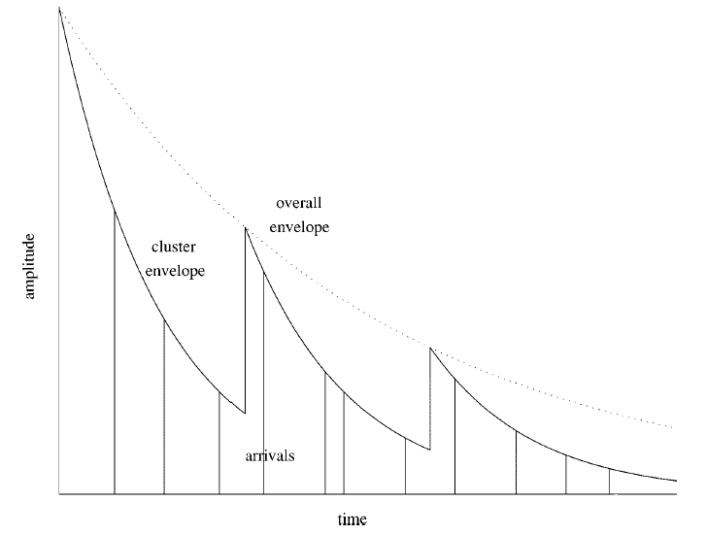
Figure 8 An illustration of exponential decay of mean cluster power and ray power within clusters (copied from [24]).
Next, we find a Saleh-Valenuela model that fits our measurement data [8] well by brute force search. The simulated and measured results are listed in the tables below. The difference between the measured and the simulated is within 3.63%.

Table 4 Simulated and measured results for Saleh-Valenuela model evaluation using Intel’s results. Simulation results are generated from Saleh-Valenzuela model with Γ=15 ns, γ=6 ns, Λ=1/13 ns, λ=1/0.35 ns. Measurement results are reported in [8].
Simulated | τ_{m} (ns) | 13.53
Simulated | τ_{rms} (ns) | 13.41
Simulated | Mean NP_{10dB} | 34
Measured | τ_{m} (ns) | 13.59
Measured | τ_{rms} (ns) | 12.94
Measured | Mean NP_{10dB} | 33

As will be shown in a following section from our measurements, this model seems to fit observations that path arrivals tend to come in clusters rather than uniformly spaced in time. This phenomenon was also observed in several other indoor channel measurements [1,2,18,20]. In addition, the above results suggest that reasonable model parameters can be found that fit the channel characteristics we have observed.

Δ-K Model
The Δ-K model was proposed in [23]. A good fit to empirical indoor propagation data using the discrete time version of the model is reported in [18]. The discrete time model is described next. In the model, time axis is partitioned into bins with width Δ. Denote the probability of having a path in bin l as P_{l}. If there is a path in the previous bin, bin l-1, P_{l}=K λ_{l}; otherwise, P_{l}=λ_{l} where λ_{l} is given by
(9)
where r_{l} is the empirical bin occupancy rate for bin l. The path arrival process exhibits clustering for K > 1, and the path arrival tends to be more evenly spaced for K < 1. The impulse response of bin l is denoted as α_{l}, and the path amplitude |α_{l} | is lognormal distributed with an exponentially decaying multipath intensity profile (MIP). We add path polarity, $p_{l}$, to the model to account for pulse inversions caused by channel reflections, where we assume $p_{l}$ is equiprobable +/-1. The following equations describe these relationships.
$α_{l}=p_{l}\left|α_{l}\right|$
$\text{20}{\text{log}}_{\text{10}}(\left|α_{l}\right|)∝\text{Normal}(μ_{l},σ^{2})$, or $\left|α_{l}\right|={\text{10}}^{n/{\text{20}}}$ where $n∝\text{Normal}(μ_{l},σ^{2})$ (10)
$$E\left[{\left|α_{l}\right|}^{2}\right]=Ω_{0}e^{{−T_{l}}/Γ}$$
where T_{l} is the excess delay of bin l and $Ω_{0}$ is the mean power of the first path of the first cluster. The μ_{l} is given by
$μ_{l}=\frac{\text{10}\text{ln}(Ω_{0})−\text{10}{T_{l}}/Γ}{\text{ln}(\text{10})}−\frac{σ^{2}\text{ln}(\text{10})}{\text{20}}$ (11)
We use the Δ-K model to fit the measurements in [8] next. Model parameters were found to best meet the NLOS+LOS measurement data, the NLOS measurement data only, and the LOS measurement data only.

Table 5 Simulated and measured results for Δ-K model evaluation using Intel’s results. Simulation results are generated from Δ-K model with Δ=0.125 ns, K=2.5, Γ=13 ns, r_{i}=0.6, σ =4.8 dB. Measurement results are reported in [8].
Simulated | τ_{m} (ns) | 13.13
Simulated | τ_{rms} (ns) | 12.82
Simulated | Mean NP_{10dB} | 34
Measured | τ_{m} (ns) | 13.59
Measured | τ_{rms} (ns) | 12.94
Measured | Mean NP_{10dB} | 33

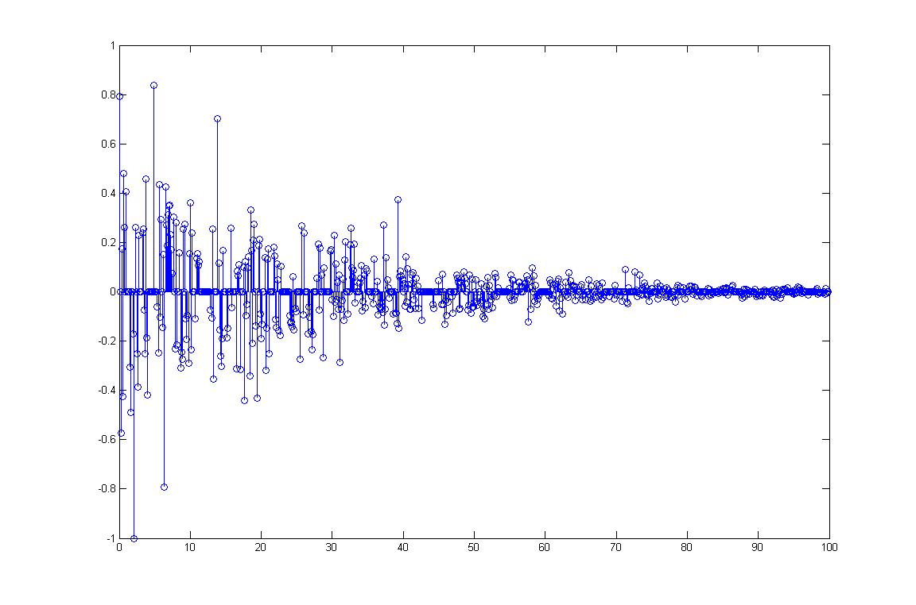
Figure 9 One channel realization generated from Δ-K model using the same parameter as the ones in Table 5.
Table 6 Simulated and measured results for LOS UWB channels. Simulation results are generated from Δ-K model with Δ=0.125 ns, K=2.5, Γ=4.3 ns, r_{i}=0.15, σ =4.8 dB. Measurement results are reported in [8].
Simulated | τ_{m} (ns) | 4.11
Simulated | τ_{rms} (ns) | 4.21
Simulated | Mean NP_{10dB} | 7
Measured | τ_{m} (ns) | 4.01
Measured | τ_{rms} (ns) | 8.88
Measured | Mean NP_{10dB} | 7

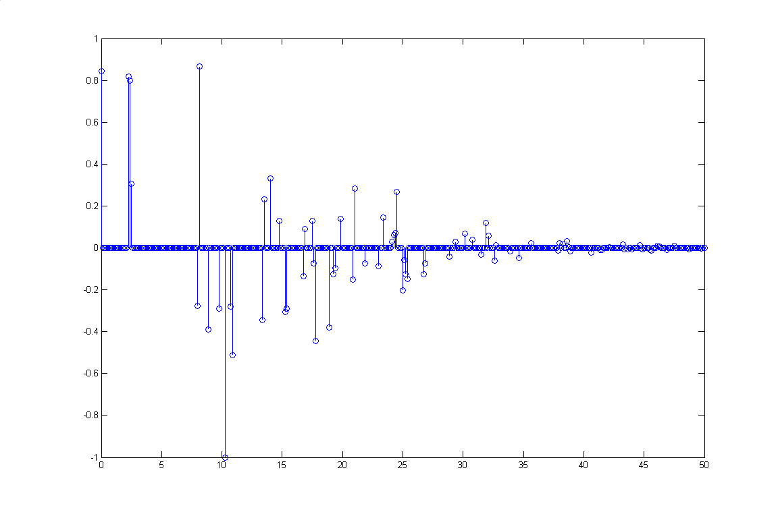
Figure 10 One channel realization generated from Δ-K model using the same parameters as in Table 6.
Table 7 Simulated and measured results for NLOS UWB channels. Simulation results are generated from Δ-K model with Δ=0.125 ns, K=2.5, Γ=18 ns, r_{i}=0.45, σ =4.8 dB. Measurement results are reported in [8].
Simulated | τ_{m} (ns) | 17.67
Simulated | τ_{rms} (ns) | 16.77
Simulated | Mean NP_{10dB} | 35
Measured | τ_{m} (ns) | 17.36
Measured | τ_{rms} (ns) | 14.53
Measured | Mean NP_{10dB} | 35
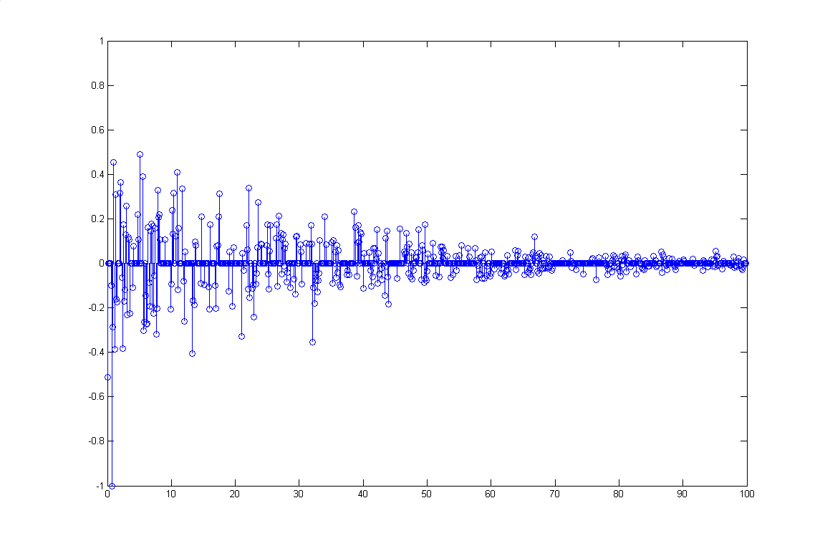
Figure 11 One channel realization generated from Δ-K model using the same parameters as in Table 7.
This model can also capture the multipath clustering phenomenon, similar to the S-V model. In Table 5, mean excess delay, rms delay, and mean path number generated by the model fit the measurements including LOS and NLOS well. But from Table 6 and Table 7, we see that the model can’t fit both mean excess delay and rms delay at the same time for either LOS or NLOS channels due to the limitation that only one exponential slope is available.

Proposed Model based on Intel Measurements
The clustering of path arrivals in UWB channels was reported in [20] and the clustering effect of other wireless indoor channels can be found in [1,18,23]. The measurement results of Intel also demonstrate this effect. The double-exponential decay model seems to provide enough degrees of freedom to easily match the channel measurements, and, as will be shown below, can be used to match the NLOS and LOS channel characteristics separately. The major difference between the double-exponential model and the single exponential model (embodied in the Δ-K model) is that the path amplitude in each subsequent cluster is not necessarily less than the one in the previous cluster in the double-exponential model. Two typical channel realizations captured by Intel, one line-of-sight (LOS) and one non-line-of-sight (NLOS), are plotted in Figure 12 and Figure 13, respectively, which shows that there does appear to be clusters of multipath arrivals.
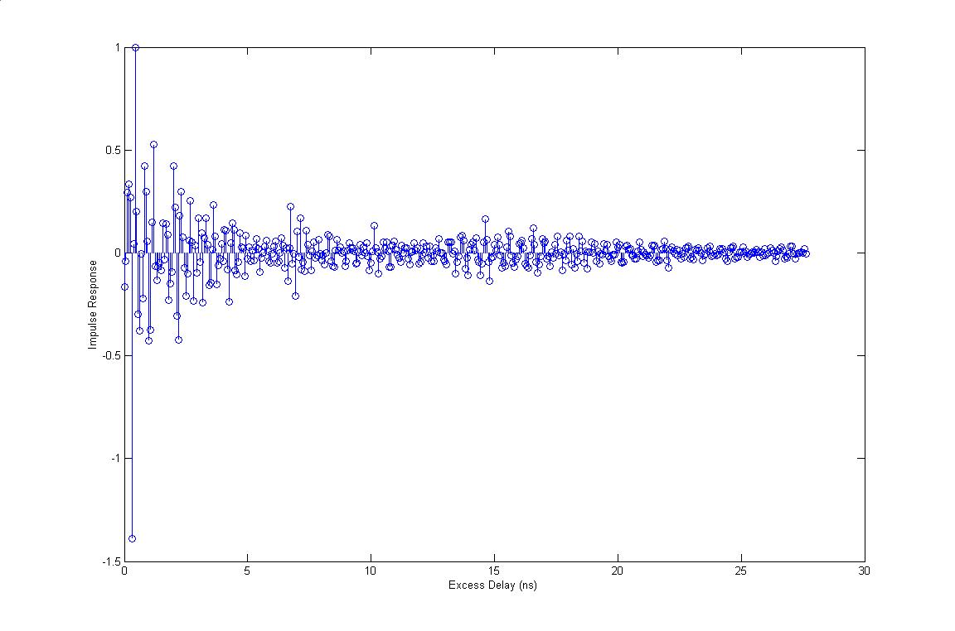
Figure 12 One typical LOS channel realization captured in a townhouse.
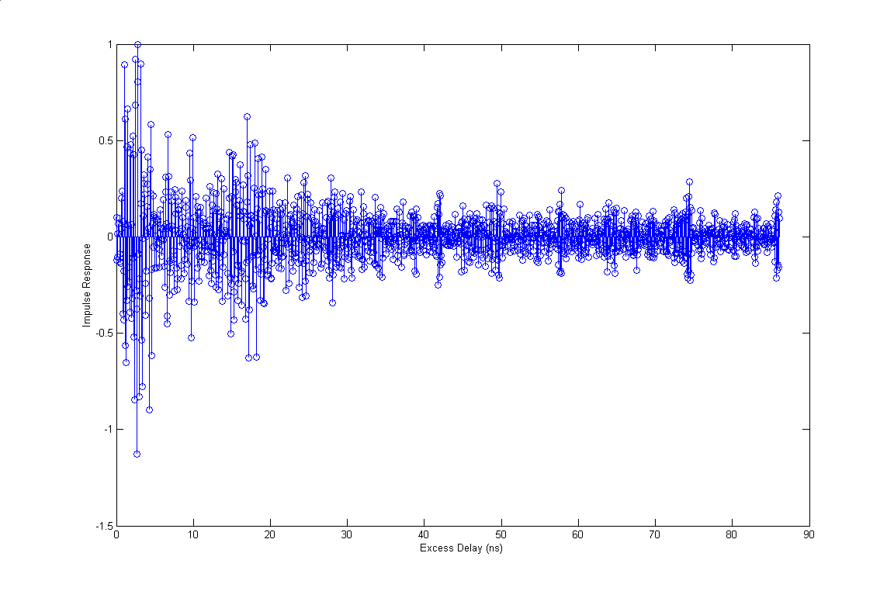
Figure 13 One typical NLOS channel realization captured in a townhouse.
Based on this clustering phenomenon observed in the measurements, we propose an UWB channel model derived from the Saleh-Valenuela model with one slight modification. We recommend using a lognormal distribution rather than a Rayleigh distribution for the multipath gain magnitude, since our observations show that the lognormal distribution seems to better fit the measurement data. Therefore, the multipath model consists of the following, discrete time impulse response:
$h(t)=\sum_{l=0}^{L}{\sum_{k=0}^{K}{α_{k,l}δ(t−T_{l}−τ_{k,l})}}$ (12)
where $α_{k,l}$ is the multipath gain coefficient, $T_{l}$ is the delay of the l^{th} cluster, and $τ_{k,l}$ is the delay of the k^{th} multipath component relative to the l^{th} cluster arrival time ($T_{l}$).

One consideration for the multipath model channel coefficients, $α_{k,l}$, is whether they should be real or complex (with a magnitude and phase term). Some considerations are the following:
- If real coefficients are adopted, then the channel coefficients could be defined as $α_{k,l}=p_{k,l}β_{k,l}$, where $p_{k,l}$ is equally likely to take on the values of +/-1, and $β_{k,l}$ is the lognormal fading term. The term $p_{k,l}$ is used to account for the random pulse inversion that can occur due to reflections, as observed in the measurements. Then, the real impulse response of the channel could be convolved with the real UWB transmitted waveform.
- If complex coefficients are adopted, the complex, baseband equivalent channel model would need to be convolved with the complex, baseband representation of the transmitted waveform. For UWB pulsed systems, the meaning of phase is a bit ambiguous since it is not necessarily carrier based. Since phase is directly related to delay for a given center frequency, it might be easier to account for phase for a specific waveform by converting it into a delay given a center frequency of the channel and/or waveform. Since we have not characterized the distribution of the phase term, we can only suggest that a uniformly distributed phase in $\left[0,2π\right]$ could be a good model, based upon previous indoor channel models. In this case, the channel coefficients can be modeled as $α_{k,l}=β_{k,l}e^{−{jφ}_{k,l}}$, where $φ_{k,l}$ is the random phase term uniformly distributed in $\left[0,2π\right]$, and $β_{k,l}$ is the lognormal fading term.
- Due to the simplicity of the real channel coefficients, and to avoid the ambiguity of phase for an UWB waveform, we suggest adopting $α_{k,l}=p_{k,l}β_{k,l}$, where $p_{k,l}$ is equally likely to take on the values of +/-1, and $β_{k,l}$ is the lognormal fading term.

Finally, the proposed model uses similar definitions as previously described for the S-V model, and are repeated here for completeness.
T_{l} = the arrival time of the first path of the l-th cluster;
τ_{k,l} = the delay of the k-the path within the l-th cluster relative to the first path arrival time, T_{l};
Λ = cluster arrival rate;
λ = ray arrival rate, i.e., the arrival rate of path within each cluster.
By definition, we have . The distribution of cluster arrival time and the ray arrival time are given by
(13)

The channel coefficients are defined as follows:
$α_{k,l}=p_{k,l}β_{k,l}$
$\text{20}\text{log}\text{10}(β_{k,l})∝\text{Normal}(μ_{k,l},σ^{2})$, or $\left|β_{k,l}\right|={\text{10}}^{n/{\text{20}}}$ where $n∝\text{Normal}(μ_{l},σ^{2})$ (14)
$$E\left[β_{k,l}^{2}\right]=Ω_{0}e^{{−T_{l}}/Γ}e^{{−τ_{k,l}}/γ}$$
where T_{l} is the excess delay of bin l and $Ω_{0}$ is the mean power of the first path of the first cluster, and $p_{k,l}$ is equiprobable +/-1. The μ_{l} is given by
$μ_{l}=\frac{\text{10}\text{ln}(Ω_{0})−\text{10}{T_{l}}/Γ−\text{10}{τ_{k,l}}/γ}{\text{ln}(\text{10})}−\frac{σ^{2}\text{ln}(\text{10})}{\text{20}}$ (15)

We used the proposed model to fit our measurements. The measurements include both LOS and NLOS channels with antenna separation 1-20 meters. In Table 8, mean excess delay, rms delay, and mean path number generated by the model fit the measurements including LOS and NLOS well. Also from Table 9 and Table 10, we see that the model fit both mean excess delay and rms delay at the same time for either LOS or NLOS channels.

Table 8 Simulated and measured results for Intel model evaluation using Intel’s results. Simulation results are generated from Intel model with Γ=13 ns, γ=6 ns, Λ=1/13 ns, λ=1/0.23 ns, σ =4.8 dB. Measurement results are reported in [8], where both LOS and NLOS channels with antenna separation 1-20 m are included.
Simulated | τ_{m} (ns) | 13.69
Simulated | τ_{rms} (ns) | 13.80
Simulated | Mean NP_{10dB} | 33
Measured | τ_{m} (ns) | 13.59
Measured | τ_{rms} (ns) | 12.94
Measured | Mean NP_{10dB} | 33

Table 9 Simulated and measured results for LOS UWB channels using Intel’s model. Simulation results are generated from Intel model with Γ=16 ns, γ=1.6 ns, Λ=1/60 ns, λ=1/0.5 ns, σ =4.8 dB. Measurement results are reported in [8].
Simulated | τ_{m} (ns) | 4.70
Simulated | τ_{rms} (ns) | 8.81
Simulated | Mean NP_{10dB} | 7
Measured | τ_{m} (ns) | 4.01
Measured | τ_{rms} (ns) | 8.88
Measured | Mean NP_{10dB} | 7

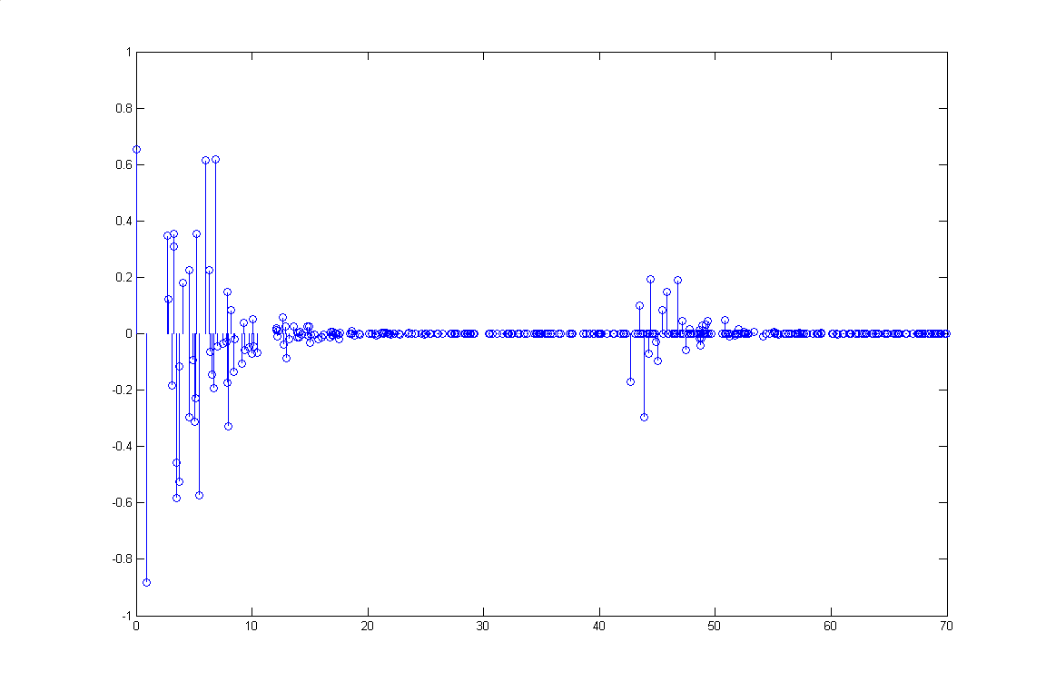
Figure 14 One LOS channel realization generated from Intel model using the same parameter as the ones in Table 9.
Table 10 Simulated and measured results for NLOS UWB channels using Intel’s model. Simulation results are generated from Intel model with Γ=16 ns, γ=8.5 ns, Λ=1/11 ns, λ=1/0.35 ns, σ =4.8 dB. Measurement results are reported in [8].
Simulated | τ_{m} (ns) | 17.22
Simulated | τ_{rms} (ns) | 15.59
Simulated | Mean NP_{10dB} | 35
Measured | τ_{m} (ns) | 17.36
Measured | τ_{rms} (ns) | 14.53
Measured | Mean NP_{10dB} | 35

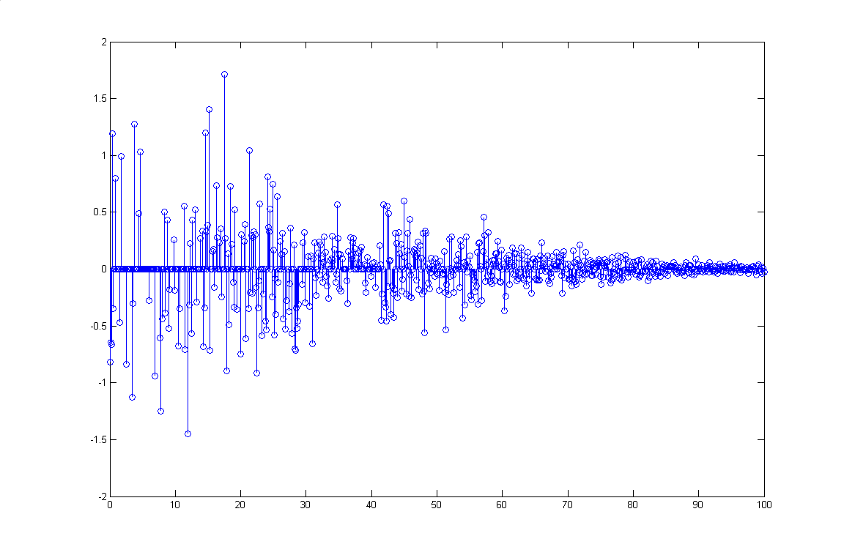
Figure 15 One NLOS channel realization generated from Intel model using the same parameter as the ones in Table 10.
The above results show that the proposed model fits the measurements taken in the home environment for both LOS and NLOS. Of course, this only represents a small set of channel data, and other environments should also be considered. Therefore, we looked at how the model could be adapted to represent other possible channel conditions that might be appropriate for consideration. As shown above, there are 5 key parameters that define the model:

Λ = cluster arrival rate;
λ = ray arrival rate, i.e., the arrival rate of path within each cluster;
Γ = cluster decay factor;
γ = ray decay factor;
σ = standard deviation of lognormal fading term (dB).
These model parameters were found using a brute force search to match different channel characteristics, considering mean excess delay ($τ_{m}$), RMS delay ($τ_{\text{rms}}$), and number of significant paths that cross a 10 dB threshold (NP_{10dB}). The following table provides the results of this search.

Table 11 Example multipath channel characteristics and corresponding model parameters.
Channel Characteristics | NLOS* | NLOS# | NLOS# | LOS# | LOS*
Mean excess delay (nsec) ($τ_{m}$) | 17 | 22 | 27 | 3 | 4
RMS delay (nsec) ($τ_{\text{rms}}$) | 15 | 20 | 25 | 5 | 9
NP_{10dB} | 35 | 40 | 45 | 4 | 7
Model Parameters
Λ (1/nsec) | 1/11 | 1/14 | 1/15 | 1/22 | 1/60
λ (1/nsec) | 1/0.35 | 1/0.33 | 1/0.32 | 1/0.94 | 1/0.5
Γ | 16 | 22 | 30 | 7.6 | 16
γ | 8.5 | 10 | 10 | 0.94 | 1.6
σ (dB) | 4.8 | 4.8 | 4.8 | 4.8 | 4.8
* Based on Intel measurements.
# Example of other possible channel characteristics to test.
The above channel characteristics were just simply chosen as representing possible indoor environments that were not covered by our measurements, but they seem to represent reasonable extensions. Also note that there may be many model parameters that meet the above channel characteristics, and the above does not represent a completely exhaustive search, but should be useful for the comparative analysis of different UWB PHYs.

Interference Model

A proposed model and method of measuring the impact of interference has already been submitted in document IEEE P802.15-02/212r1-SG3a.

Channel Distortion Model

The above multipath model is based upon the summation of a number of reflections that appear at the receiver. Any frequency selectivity caused by the actual reflective surface or propagation through objects was not taken into account. In addition, the frequency selectivity of the transmit and receive antennas or any distortion caused by RF components like non-flat group delay is not taken into account. We suggest treating this as ‘implementation loss’ in the link budget, since the affect on system performance of these distortions will depend on the implementation.

Summary of Channel Model

A summary of the channel model parameters are given in the following table:

Table 12 Summary of proposed channel model.
Parameter | Model
Path loss | Free space propagation using example link budget model to yield final link margin and proposed minimum sensitivity level.
Multipath model | Time domain multipath model, given by  $$h(t)=\sum_{l=0}^{L}{\sum_{k=0}^{K}{α_{k,l}δ(t−T_{l}−τ_{k,l})}}$$  with a double-exponential decay intensity profile based on the S-V model.
Channel Characteristics | Table 11 provides 5 different example channel characteristics that represent both LOS and NLOS channels. These characteristics are based on different mean excess delay, RMS delay spread, and mean number of paths.
Multipath Model Parameters | The proposed model requires defining the following parameters:  Λ = cluster arrival rate;  λ = ray arrival rate, i.e., the arrival rate of path within each cluster;  Γ = cluster decay factor;  γ = ray decay factor;  σ = standard deviation of lognormal fading term (dB).  Table 11 provides values for different channel characteristics.

Procedure for each multipath realization (using parameters in Table 11):
- Determine cluster arrival times ($T_{l}$) using the exponential inter-arrival time distribution (stop when $T_{l}>\text{10}Γ$). Round $T_{l}$ to the next higher multiple of 167 psec to yield a discrete model with minimum resolvable path spacings of 167 psec (corresponding to a 6 GHz waveform).
- Determine ray arrival times ($τ_{k,l}$) using the exponential inter-arrival time distribution (stop when $τ_{k,l}>\text{10}γ$). Round $τ_{k,l}$ to the next higher multiple of 167 psec to yield a discrete model with minimum resolvable path spacings of 167 psec (corresponding to a 6 GHz waveform). Note that, it may be possible for a cluster arrivals and ray arrivals to occur at the same time. When this occurs, we recommend just summing up the arrivals at each time interval.
- Determine $p_{k,l}$, with are equally likely +/- 1.
- Set $Ω_{0}=1$.
- Determine $μ_{k,l}$.
- Determine $β_{k,l}$.
- Determine $α_{k,l}=p_{k,l}β_{k,l}$.
- Compute the total energy of the channel ($E=\sum_{l=0}^{L}{{\sum_{k=0}^{K}{\left|α_{k,l}\right|}}^{2}}$).
- Normalize the total energy of the channel to unity: $h(t)=\frac{1}{\sqrt{E}}\sum_{l=0}^{L}{\sum_{k=0}^{K}{α_{k,l}δ(t−T_{l}−τ_{k,l})}}$.

Since different UWB waveforms may be proposed, which may have different bandwidths and, thus, different minimum multipath resolution, we suggest allowing the proposers to modify the above model as appropriate to match their analysis/simulation capabilities with their particular UWB waveform. For UWB bandwidths less than 6 GHz, the above model could still be used with minimum path spacings of 167 psec. Alternatively, to reduce the sampling rates for lower bandwidth waveforms, the channel realizations using the above procedure could be low-pass filtered to the desired bandwidth and re-sampled with a higher minimum path spacing. For UWB bandwidths greater than 6 GHz, the above model could still be used, but will not include paths that may arrive at a resolution less than 167 psec. In this case, the proposer could simply use the above model as an approximation (7.5 GHz is the maximum allowable FCC bandwidth, which is not significantly greater than the 6 GHz bandwidth used by measurements to derive the above model parameters), or reduce the minimum path spacing to the inverse of the UWB bandwidth and use the same parameters for the model as given above.

References

[1] A. Saleh and R. Valenzuela, “A Statistical Model for Indoor Multipath
Propagation,” IEEE JSAC, Vol. SAC-5, No. 2, Feb. 1987, pp. 128-137.
[2] T. S. Rappaport and S. Sandhu, “Radio-Wave Propagation for Emerging Wireless Personal Communication Systems,” IEEE Antennas and Propagation Magazine, Vol. 36, No. 5, pg. 14-24, Oct. 1994 and the references therein.
[3] K. Pahlavan and A. Levesque, Wireless Information Networks, John Wiley and
Sons, 1995.
[4] K-W Cheung, J. Sau, and R. Murch, “A New Empirical Model for Indoor Propagation Prediction,” IEEE Trans. On Vehic. Tech.,Vol. 47, No. 3, pp. 996-1001, Aug. 1998.
[5] J.M. Cramer, R.A. Scholtz, and M.Z. Win, “On the analysis of UWB communication channel,” Proceedings of MILCOM 1999, Vol. 2, pp. 1191-1195, 1999.
[6] IEEE 802.15.2 channel model for measuring coexistence.
[7] S. Ghassemzadeh, R. Jana, C. Rice, W. Turin, and V. Tarokh, “A Statistical Path Loss
Model for In-Home UWB Channels,” IEEE UWBST, May 2002.
[8] L. Rusch, C. Prettie, D. Cheung, Q. Li, and M. Ho, “Characterization of UWB
Propagation from 2 to 8 GHz in a Residential Environment,” submitted to JSAC, Dec.
2001.
[9] S. Soliman, “Report of Qualcomm Incorporated,” In the matter of revision of Part 15 of
the Commission’s Rules Regarding Ultra-Wideband Transmissions Systems, ET Docket
No. 98-153, March 5, 2001.
[10] Model suggested by ITU P.1238 which was described in IEEE 802.15-00/294r1.
[11] Model used for the evaluation of the IEEE 802.11g high rate PHY, described in
document IEEE 802.11-00/282r2 & IEEE 802.11-00/211r9.
[12] Model suggested to evaluate the 802.15.3 PHY layers, described in document
00110r13P802-15_TG3-Criteria-Definitions.
[13] G. Janssen, P. Stigter, and R. Prasad, “Wideband Indoor Channel Measurements
and BER Analysis of Frequency Selective Multipath Channels at 2.4, 4.75, and
11.5 GHz,” IEEE Trans. Commun., Vol. 44, No. 10, Oct. 1996.
[14] T. S. Rappaport and S. Sandhu, “Radio-Wave Propagation for Emerging Wireless
Personal-Communication Systems,” IEEE Antennas and Propagation Magazine,
Vol. 36, No. 5, 1994. (a survey paper)
[15] M. Z. Win and R. A. Scholtz, “Energy Capture vs. Correlation Resources in
Ultra-Wideband Bandwidth Indoor Wireless Communications Channels,” 1997.
[16] M. Z. Win and R. A. Scholtz, “On the Robustness of Ultra-Wide Bandwidth
Signals in Dense Multipath Environments,” IEEE Comm. Letters, Vol. 2, No. 2,
Feb. 1998.
[17] K. Pahlavan and A. Levesque, Wireless Information Networks, John Wiley and
Sons, 1995.
[18] H. Hashemi, “Impulse Response Modeling of Indoor Radio Propagation
Channels,” IEEE JSAC, Vol. 11, No. 7, Sept. 1993, pp. 967-978.
[19] S. Yano, “Investigating the Ultra-Wideband Indoor Wireless Channel,” VTC 2002
Conference proceedings.
[20] J. Cramer, R. Scholtz, M. Win, “Evaluation of an Ultra-Wideband Propagation Channel,”
submitted to IEEE JSAC 2001.
[21] R. Cramer, “An Evaluation of Ultra-Wideband Propagation Channels,” Ph.D.
dissertation, Dept. of Electrical Engineering, University of Southern California, 2000.
[22] W. Turin, et al., “Autoregressive Modeling of an Indoor UWB Channel,” submitted to
IEEE UWBST 2002.
[23] H. Suzuki, “A Statistical Model for Urban Radio Propagation,” IEEE Transactions on
Communications, pp. 673-680, July 1977.
[24] Q. H. Spencer, B. D. Jeffs, M. A. Jense, A. L. Swindlehurst, "Modeling the Statistical
Time and Angle of Arrival Characteristics of an Indoor Multipath Channel," IEEE JSAC,
Vol. 18, No. 3, March 2000.
[25] C. Prettie, et al., “Spatial Correlation of UWB Signals in a Home Environment,” IEEE
UWBST 2002, May 2002.

Appendix A

This appendix contains some figures and tables from a paper that has been submitted to JSAC for publication that provide some of the results of the UWB channel measurements that were captured by Intel (see also [25]). Since this paper is not published yet, we chose not to copy specific text in the paper to prevent any potential copyright issues from arising. The authors of this paper are Leslie Rusch, Cliff Prettie, David Cheung, Qinghua Li, and Minnie Ho with Intel Research and Development (Leslie Rusch is now a Professor at Laval University in Quebec, Canada), and this information is being provided with the author’s permission.

Following is a list of some of the notation, for clarity:
- PB: Pass band method of analyzing the measurement data. Since the data collection was over the bandpass spectrum from 2-8 GHz, the resulting data is complex. This data can be zero padded in the frequency domain prior to taking an IFFT to provide real data (interpolates in the time domain). The paper goes into more details why this might be useful.
- CB: Complex baseband method of analyzing the measurement data. The data is modeled as an equivalent baseband wavefrom from –3 to +3 GHz.
- Win: This refers to frequency domain windowing of the data to potentially get greater time domain resolution. A Hamming window is used in this case prior to taking an IFFT.
- FA: Refers to frequency domain analysis of windowing the data prior to taking an IFFT.

Figures

Figure 1a Townhouse layout where channel impulses are measured. The spots in the figure denote the locations of transmitter and receiver antennas

Tables
Table 1a Mean excess delay in ns for various time resolutions (bin sizes), windowing methods, etc.

Table 2a τ_{RMS} in ns for various time resolutions (bin sizes), windowing methods, etc.

Table 3a Number of paths within a 10 dB threshold of the peak path

