IEEE P802.15
Wireless Personal Area Networks

Project | IEEE P802.15 Working Group for Wireless Personal Area Networks (WPANs)
Title | Comments On LOS First Cluster
Date Submitted | 04 Nov 2002
Source | [Juergen Kunisch]  [IMST GmbH]  [Carl-Friedrich-Gauß-Str. 2  47475 Kamp-Lintfort  Germany] | Voice: [+49 2842 981 454]  Fax: [+49 2842 981 499]  E-mail: [kunisch@imst.de]
Re:
Abstract | This document contains a response to a message of Naiel Askar (naiel.askar@ga.com) on stds-802-15-SG3a (Sent: Thursday, October 24, 2002 12:42 PM) regarding properties of the first cluster in LOS conditions. The response was originally posted on stds-802-15-SG3a (Sent: Monday, October 28, 2002 11:32 AM).
Purpose
Notice | This document has been prepared to assist the IEEE P802.15. It is offered as a basis for discussion and is not binding on the contributing individual(s) or organization(s). The material in this document is subject to change in form and content after further study. The contributor(s) reserve(s) the right to add, amend or withdraw material contained herein.
Release | The contributor acknowledges and accepts that this contribution becomes the property of IEEE and may be made publicly available by P802.15.
Dear All,

just a few comments regarding the los-first-cluster-multiple-rays
issue.

To follow Naiels suggestion,

> The multiple rays in the first cluster of LOS should be there only
> if supported by experimental data. I think the owners of experimental
> data should check this, if not done already.

I have enclosed a plot that shows the magnitude of a measured baseband impulse response (IR) as function of delay and rx displacement for LOS conditions (los-mag.tif, similar to the plot shown in doc 02281r0). Actually, the plot is composed of 150 IR's taken over a distance (rx displacement, not tx-rx separation!) of 150 cm (one IR per 1 cm). The IR's are determined using a Kaiser-Bessel frequency domain window (cf. kb20.tif, top plot: window, bottom plot: corresponding impulse shape; sidelobe suppression is > 45 dB) that matches the measurement band (1-11 GHz). Put another way, the plot shows the response of the channel to an impulse that has a shape corresponding to this particular window.

Now, what do we have?
First, there is a strong single LOS component.
For a detailed assessment of LOS component fading, have a look at
los-fade.tif:
The top left plot shows the magnitude of the LOS component, as function of distance (150 samples). There is a trend due to the decreasing tx-rx distance; if this trend is removed, the residual variations are within app. 0.05 dB (bottom left).

That means, in this case, there is effectively no fading of the LOS component
on wavelength scale, i.e. there are no multiple unresolvable rays (with
*different* propagation directions) hidden inside the LOS component.
[
Note that fading is visible at the crossing of several traces, e.g.
in the area around (18ns, 0.6m);
]

Behind the LOS component (again los-mag.tif), however, there are some (less)
strong trailing echoes visible within app. .5 ns = 15 cm behind the LOS
component.

It is highly likely that these are caused by the antennas (e.g. diffraction
at edges of the biconic antenna), i.e. what we see here is the "intrinsic"
antenna impulse response. Consequently, yes, there may be a "LOS cluster" with multiple rays.
[
Note that going from baseband to passband will also introduce some
deterministic "ringing" around each strong echo, which is not to be mistaken
as representing echoes due to "different rays".
]

But, if so, there seems to be no obvious reason that this LOS cluster will
follow some statistic which e.g. underlies S-V models (Poisson arrival
process, Rayleigh or Nakagmami or Lognormal amplitude process, etc.).
If this cluster is due to the antenna, it is a deterministic phenomenon.

As Matt has put it:

> The data in question (CM1) is actually synthetic data.
...
> Why would we suppose this has anything to do with the antenna?"

Therefore, from the modeling perspective, I see mainly two options:

1) Decide this effect is second order, and ignore it; then represent the
LOS component by just one echo.

2) Take it into account, but then treat it as a deterministic effect (which
it is). This is like adding a dedicated antenna model (a filter).

In view of the envisioned purpose of the model, I would prefer option 1).

Regards,

Juergen

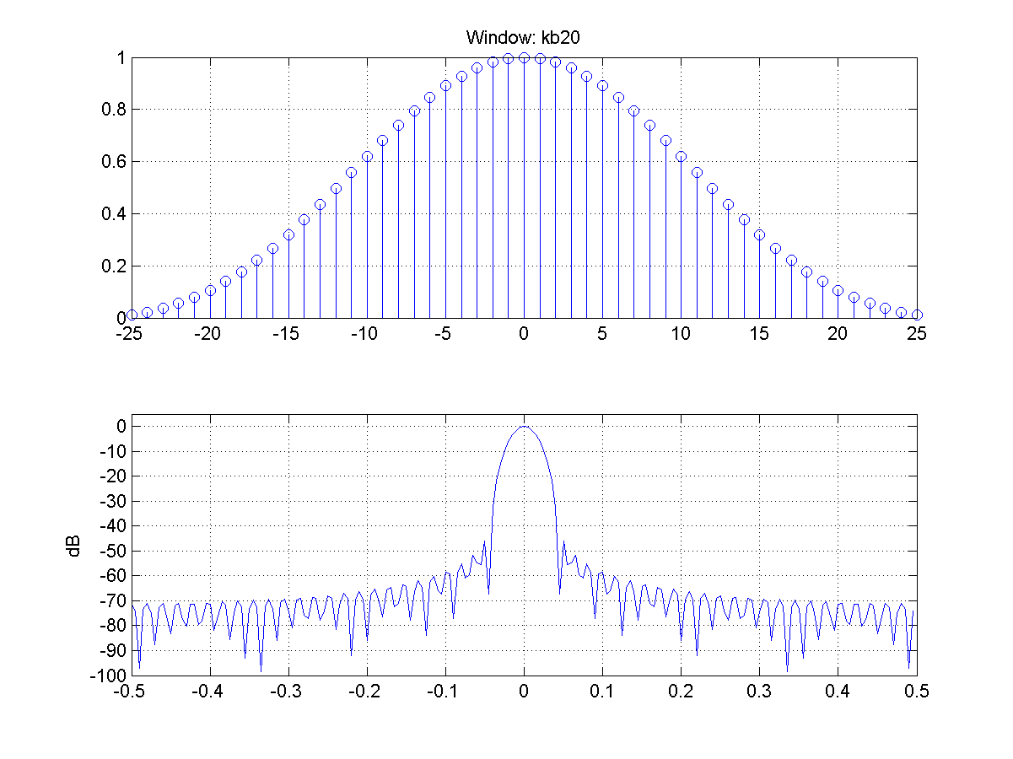
Fig. 1 (kb20.tif)
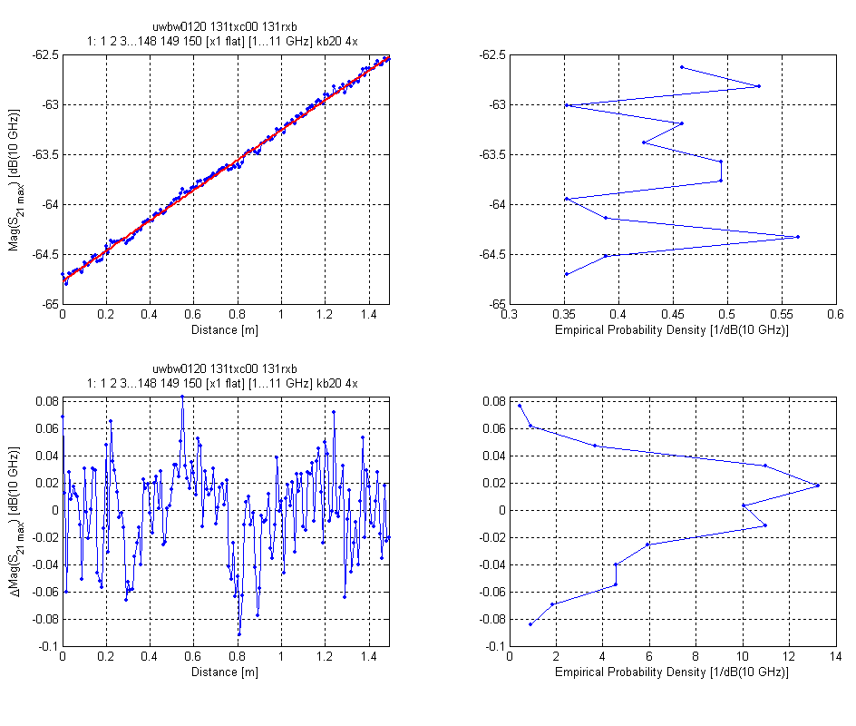
Fig. 2 (los-fade.tif)
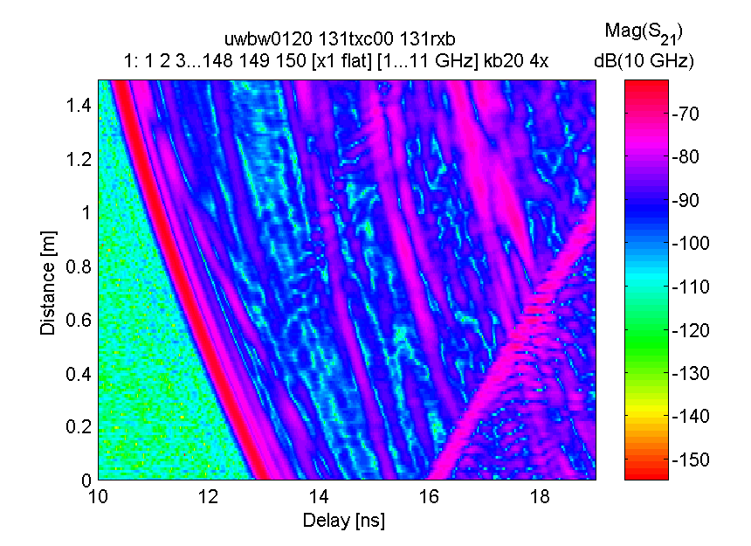
Fig. 3 (los-mag.tif)

