IEEE P802.15
Wireless Personal Area Networks

Project | IEEE P802.15 Working Group for Wireless Personal Area Networks (WPANs)
Title | TI Physical Layer Proposal for IEEE 802.15 Task Group 3a
Date Submitted | 12 May, 2003
Source | [Anuj Batra et al.]  [Texas Instruments, Inc.]  [12500 TI Blvd, Dallas, TX 75243] | Voice: [214-480-4220]  Fax: [972-761-6966]  E-mail: [batra@ti.com]
Re: | [If this is a proposed revision, cite the original document.]  [If this is a response to a Call for Contributions, cite the name and date of the Call for Contributions to which this document responds, as well as the relevant item number in the Call for Contributions.]  [Note: Contributions that are not responsive to this section of the template, and contributions which do not address the topic under which they are submitted, may be refused or consigned to the “General Contributions” area.]
Abstract | A high rate WPAN with data rates from 55 Mbps to 480 Mbps is proposed.
Purpose | Discussion
Notice | This document has been prepared to assist the IEEE P802.15. It is offered as a basis for discussion and is not binding on the contributing individual(s) or organization(s). The material in this document is subject to change in form and content after further study. The contributor(s) reserve(s) the right to add, amend or withdraw material contained herein.
Release | The contributor acknowledges and accepts that this contribution becomes the property of IEEE and may be made publicly available by P802.15.

Physical Layer Submission to 802.15 Task Group 3a:
Time-Frequency Interleaved
Orthogonal Frequency Division Multiplexing
(TFI-OFDM)

Anuj Batra, Jaiganesh Balakrishnan, Anand Dabak

Ranjit Gharpurey, Paul Fontaine, Jerry Lin

Jin-Meng Ho, Simon Lee

Texas Instruments, Inc.
12500 TI Blvd, M/S 8649
Dallas TX 75243

May 14x, 2003
Executive Summary

For initial deployment (quick time to market) of the proposed UWB systems, and development of low cost, low power CMOS solutions we propose to employ only three bands with bandwidth 528 MHz each and center frequencies 3432, 3960 and 4488 MHz respectively. The proposed system can in fact support up to a total of 14 bands, each with a bandwidth of 528 MHz and with center frequencies that range from 3432 MHz to 10296 MHz. Due to larger propagation loss at higher frequencies, only marginal gains are found by including the higher bands, which can be added in the future as RF technology improves. We employ time-frequency interleaving across the bands and employ orthogonal frequency division multiplexing (TFI-OFDM) with BPSK/QPSK modulation on the tones. Each OFDM symbol occupies a minimum of 500 MHz bandwidth at all times, as required by the FCC.

Employing OFDM for modulation allows the TFI-OFDM to be viewed as both a full-band and a sub-band system. Hence TFI-OFDM inherits advantages from both the full-band and sub-band UWB systems. Further, by appending a guard interval after the OFDM symbol, sufficient time (9.5 ns) is provided to allow both the transmitter and receiver to switch from one band to another. This allows a single transmit and receive analog chain at the receiver at all times, while still collecting significant multi-path energy. The proposed UWB system provides a wireless PAN with data payload communication capabilities of 55, 80, 110, 160, 200, 320, and 480 Mb/s. A summary of the TFI-OFDM system is as follows:

- Average transmit power: The average transmit power is –10.3 dBm per band.
- Receiver sensitivity: The receiver sensitivity for 110 Mbps is –80.5 dBm.
- Range: The range for 110 Mbps in AWGN is 20.5 m and 11.6 m in CM3 multi-path channels.
- Power consumption: The total transmit power consumption for 110 Mbps is 93 mW, the total receive power consumption for 110 Mbps is 155 mW in 90 nm technology and 15 μW in deep sleep.
- CMOS implementation: Since only the lower bandwidth (3.1 GHz – 4.8 GHz) is going to be used in the initial deployment of UWB systems, the proposed TFI-OFDM system can be built completely in current CMOS technology.
- U-NII interference suppression: Since the TFI-OFDM system completely avoids all transmission in the U-NII band, the front-end filter design for rejecting interference from the U-NII band is simplified.
- TFI-OFDM requires only one transmitter chain and one receiver chain at all times: The guard interval between OFDM symbols ensures that only one transmit chain is needed to generate the TFI-OFDM waveform and that a single RF chain is sufficient to receive at all times despite collecting significant multi-path.
- Early time-to-market: The majority of the TFI-OFDM system can be implemented in standard digital CMOS logic and the analog implementation complexity can be minimized, which results in an early time-to-market.
- Compliance with worldwide regulations/compliance with future systems: Channels and individual tones can be dynamically turned on and off in order to comply with changing regulations.
- Antenna is easier to design: OFDM has an inherent robustness against gain, phase, and group delay variation that may be introduced by a broadband antenna.

Table of Contents

1 UWB Physical Layer 7
1.1 Introduction 7
1.1.1 Choice of bandwidth for the proposed UWB system 7
1.1.2 Time-frequency interleaved OFDM 9
1.1.2.1 TFI-OFDM as a full-band system 10
1.1.2.2 TFI-OFDM as a sub-band system 12
1.1.2.3 Advantages of a TFI-OFDM system 14
1.1.3 Overview of the proposed UWB system description 15
1.1.3.1 Mathematical description of the signal 15
1.1.3.2 Discrete-time implementation considerations 16
1.1.4 Scope 16
1.1.5 UWB PHY function 17
1.1.5.1 PLCP sublayer 17
1.1.5.2 PMD sublayer 17
1.1.5.3 PHY management entity (PLME) 17
1.2 UWB PHY specific service parameter list 18
1.2.1 Introduction 18
1.2.2 TXVECTOR parameters 18
1.2.2.1 TXVECTOR LENGTH 18
1.2.2.2 TXVECTOR DATARATE 19
1.2.2.3 TXVECTOR SCRAMBLER_INIT 19
1.2.2.4 TXVECTOR TXPWR_LEVEL 19
1.2.3 RXVECTOR parameters 19
1.2.3.1 RXVECTOR LENGTH 19
1.2.3.2 RXVECTOR RSSI 19
1.2.3.3 RXVECTOR DATARATE 20
1.3 UWB PLCP sublayer 21
1.3.1 Introduction 21
1.3.2 PLCP frame format 21
1.3.2.1 RATE-dependent parameters 22
1.3.2.2 Timing-related parameters 22
1.3.3 PLCP preamble 22
1.3.4 Header modulation 26
1.3.5 PLCP header 26
1.3.5.1 Date rate (RATE) 27
1.3.5.2 PLCP length field (LENGTH) 27
1.3.5.3 PLCP scrambler field (SCRAMBLER) 28
1.3.6 Data scrambler 28
1.3.7 Tail bits 29
1.3.8 Convolutional Encoder 29
1.3.9 Pad bits 33
1.3.10 Bit interleaving 34
1.3.11 Subcarrier constellation mapping 34
1.3.12 Pilot subcarriers 36
1.3.13 OFDM modulation 36
1.4 General requirements 39
1.4.1 Operating channel frequencies 39
1.4.1.1 Operating frequency range 39
1.4.1.2 Channel numbering 39
1.4.2 PHY layer timing 40
1.4.2.1 Interframe spacing 40
1.4.2.2 Receive-to-transmit turnaround time 40
1.4.2.3 Transmit-to-receive turnaround time 40
1.4.2.4 Time between successive transmissions 41
1.4.2.5 Channel switch time 41
1.4.3 Header check sequence 41
1.5 Transmitter specifications 42
1.5.1 Transmit PSD mask 42
1.5.2 Transmit center frequency tolerance 42
1.5.3 Symbol clock frequency tolerance 42
1.5.4 Clock synchronization 42
1.6 Receiver specification 43
1.6.1 Receiver sensitivity 43
1.6.2 Receiver CCA performance 43
2 Self evaluation matrix 44
2.1 General solution criteria 44
2.2 PHY protocol criteria 45
2.3 MAC protocol enhancement criteria 46
3 Detailed responses to selection criteria and self-evaluation matrix 47
3.1 Unit manufacturing cost 47
3.2 Signal robustness 47
3.2.2 Interference and susceptibility 47
3.2.2.1 Microwave oven 48
3.2.2.2 Bluetooth and IEEE 802.15.1 interferer 48
3.2.2.3 IEEE 802.11b and IEEE 802.15.3 interferer 48
3.2.2.4 IEEE 802.11a interferer 49
3.2.2.5 IEEE 802.15.4 interferer 49
3.2.2.6 Generic in-band modulated interferer 49
3.2.2.7 Generic in-band tone interferer 50
3.2.2.8 Out-of-band interference from intentional and unintentional radiators 51
3.2.3 Coexistence 51
3.2.3.1 IEEE 802.11a interferer 52
3.2.3.2 IEEE 802.11b interferer 52
3.3 Technical feasibility 52
3.3.1 Manufacturability 52
3.3.2 Time to market 52
3.3.3 Regulatory impact 52
3.4 Scalability 53
3.5 Location awareness 53
4 Alternate PHY required MAC enhancements and modifications 53
4.1 Introduction 53
4.2 Frame format enhancement for time-frequency interleaving 55
4.2.1 Time-frequency interleaving information element 55
4.2.2 Piconet parameter change information element 55
4.2.3 Beacon frame 55
4.3 Management enhancements for time-frequency interleaving 56
4.3.1 TFI PHY PIB 56
5 PHY layer criteria 57
5.1 Size and form factor 57
5.2 PHY-SAY payload bit rate and data throughput 57
5.2.1 Payload bit rate 57
5.2.2 Packet overhead 57
5.2.3 PHY-SAP throughput 58
5.3 Simultaneously operating piconets 58
5.4 Signal acquisition 62
5.5 System 64
5.6 Link budget 71
5.7 Sensitivity 72
5.8 Power management modes 72
5.9 Power consumption 72
5.10 Antenna practicality 73
6 Appendix 73
6.1 Cyclic prefix length 73
6.2 Peak-to-average ratio 74
6.3 FFT/IFFT complexity 75

UWB Physical Layer

Introduction

This clause specifies the PHY entity for a UWB system that utilizes the unlicensed 3.1 – 10.6 GHz UWB band, as regulated in the United States by the Code of Federal Regulations, Title 47, Section 15. The UWB system provides a wireless PAN with data payload communication capabilities of 55, 80, 110, 160, 200, 320, and 480 Mb/s. The support of transmitting and receiving at data rates of 55, 110, and 200 Mb/s is mandatory. The proposed UWB system employs orthogonal frequency division multiplexing (OFDM). The system uses a total of 122 sub-carriers that are modulated using quadrature phase shift keying (QPSK). Forward error correction coding (convolutional coding) is used with a coding rate of 11/32, ½, 5/8, and ¾.

Choice of bandwidth for the proposed UWB system

An important parameter in the design of a UWB system is choice of the operating bandwidth. This choice impacts not only the link budget and correspondingly the overall system performance, but also affects the receiver, especially in terms of the LNA and mixer design, and the speed at which the digital-to-analog converters (DACs), the analog-to-digital converters (ADCs), and ultimately the baseband signal processing operate.

The overall system performance is related to the received power, which is a function of the difference between the total transmit power and the path loss. Since the FCC defines average power in terms of dBm per MHz, the total transmit power can be expressed completely in terms of the operating bandwidth. If the lower frequency f_{L} of the operating bandwidth is fixed at 3.1 GHz and upper frequency f_{U} is varied between 4.8 GHz and 10.6 GHz, then the total transmit power P_{TX}(f_{U}) can be expressed as follows:

$P_{\text{TX}}(f_{U})=−\text{41}\text{.}\text{25}+\text{10}{\text{log}}_{\text{10}}(f_{U}−f_{L}) (\text{dBm})$.

This equation assumes that the transmit power spectral density is flat over the entire bandwidth. The path loss, which attenuates the transmitted signal, is also a function of the lower and upper frequencies of the operating bandwidth. The path loss model specified by the IEEE 802.15.3a channel modeling committee is given as follows:

$P_{L}(f_{g},d)=\text{20}{\text{log}}_{\text{10}}\left[\frac{4{πf}_{g}d}{c}\right]$,

where f_{g} is the defined as the geometric average of the lower and upper frequencies, d is the distance measured in meters, and c is the speed of light.

The effects of increasing the upper frequency past 4.8 GHz will now be examined. In Figure 1, the received power at a distance of 10 meters as a function of the upper frequency is plotted. From this figure, it can be seen that the received power increases by at most 2.0 dB (3.0 dB) when the upper frequency is increased to 7.0 GHz (10.5 GHz). On the other hand, increasing the upper frequency to 7.0 GHz (10.5 GHz) results in the noise figure for the broadband LNA increasing by at least 1.0 dB (2.0 dB). All relative changes in received power and noise figure were made with respect to an upper frequency of 4.8 GHz. Thus, the overall link margin will increase by at most 1.0 dB when increasing the upper frequency past 4.8 GHz, but at the expense of higher complexity and higher power consumption.

Figure 1 – Received power as a function of upper frequency.

Another important criterion to keep in mind when selecting the operating bandwidth is that interferers may potentially lie within the band of interest. For example, in the United States, the U-NII band occupies the bandwidth from 5.15 GHz – 5.85 GHz, while in Japan, the U-NII band occupies the bandwidth from 4.9 GHz – 5.1 GHz. Both of these U-NII bands lie right in the middle of the allocated UWB spectrum (see Figure 2). If a UWB device uses an upper frequency that is larger than 6.0 GHz, then it will have to deal with the interference produced by IEEE 802.11a systems. It may be possible to mitigate, to some extent, this interference by using either static or adaptive notch filters or by using complicated baseband mitigation algorithms at the UWB receiver, but this mitigation will come at the expense of increased complexity. Conversely, the same UWB device will generate interference for IEEE 802.11a systems. To prevent generation of this interference, UWB devices will have to incorporate a notch filter at the transmitter to prevent emission within the U-NII band. Effectively, the presence of the U-NII band breaks the UWB spectrum into two distinct and orthogonal bands that are free from interference: 3.1 GHz – 4.8 GHz, and 6.0GHz – 10.6 GHz (see Figure 2).

Since the gains from using the higher band (6.0 GHz – 10.6 GHz) are incremental, we propose to use the lower band 3.1 – 4.8 GHz for the initial deployment of the proposed UWB system. Some other reasons for using the smaller operating bandwidth is that the front-end RF components, such as the LNA and mixer, can be built in current CMOS technologies with low noise figure; the signal processing can be done at lower speed, implying that the sampling rates for the ADC can be smaller, and the timing requirement can be relaxed. As a result, the final solution will have lower complexity and can be manufactured using standard, and mature CMOS technologies, which implies an early time-to-market and low cost and low power solution.

In summary, the reasons for choosing the lower band for initial deployment are as follows:

- Incremental gains from larger operating bandwidths,
- Lower sampling rates for the ADC,
- Relaxed timing requirements,
- Complete CMOS solutions for the proposed UWB system,
- Lower cost,
- Lower power,
- Early time-to-market,
- Scalability.

Even though the initial deployment will be centered around the lower band, the system will be designed in a scalable fashion, so that as the RF technology improves, the higher band can be added gracefully into the system.

Figure 2 – U-NII band within the UWB spectrum

Time-frequency interleaved OFDM

For a UWB system to be successful in the market place, it needs to be designed to operate in heavy multi-path environment, with possible RMS delay spreads of up to 25 ns. To achieve the best performance, the receiver needs to be able to rake in as much energy as possible. One method for collecting the energy is to use a RAKE receiver. To capture the majority of the multi-path energy, a long RAKE receiver with many fingers is typically required. However, building a long RAKE receiver and assigning the many fingers to the correct delays can be very complicated. Another approach for combating multi-path is to use orthogonal frequency division multiplexing (OFDM). OFDM combats multi-path by introducing a cyclic prefix at the beginning of each symbol. Introducing a sufficiently long cyclic prefix ensures that the linear convolution with the channel impulse response looks like a circular convolution and that the FFT is the ideal detector at the receiver. An example of an OFDM scheme that can be used for a UWB system is shown in Figure 3. The proposed UWB scheme is referred to as Time-Frequency Interleaved OFDM (TFI-OFDM). There are two ways of viewing TFI-OFDM: as either a full-band system or as a sub-band system. We now explain how the TFI-OFDM system can be viewed as both a full-band system and a sub-band system.

TFI-OFDM as a full-band system

Figure 3 shows a system that uses a 512-point IFFT with a tone spacing of 4.125 MHz to generate a signal that spans the entire bandwidth from 3168 MHz to 5280 MHz.

Figure 3 – An example of a multi-carrier OFDM system

The full-band TFI-OFDM system is similar to that of conventional OFDM except that only a contiguous subset of the tones are used for a single OFDM symbol. Between consecutive OFDM symbols, different subsets of tones are used. This is equivalent to coding the data in both time and frequency. By varying the subset of tones as a function of time (or OFDM symbol), we can lower the speed of the DAC (and correspondingly the ADC at the receiver), we can exploit the frequency diversity of the channel, and we can obtain the same transmit power as a full-band signal (that occupies the complete bandwidth spanned by the IFFT).

Since the minimum bandwidth requirements for a UWB signal is 500 MHz, we do not need to transmit on all tones to be a compliant UWB system. In fact, we only need to transmit on 122 tones to generate a signal that has a bandwidth greater than 500 MHz. To simplify the implementation, we can restrict our attention to subsets that contain a total of 128 consecutive tones. Therefore, the 512-point IFFT can be divided into 4 non-overlapping sets of 128 tones. Since only 128 tones are used to generate a single OFDM symbol, the 512-point IFFT can be replaced by a much lower complexity 128-point IFFT.

An example of how the data is transmitted on different subsets of tones is shown in Figure 4. In this example, data is transmitted in the first OFDM symbol on the first 128 tones (tones 1 through 128). For the second OFDM symbol, data is transmitted on tones 257 through 384 (third set of tones). For the third OFDM symbol, the data is transmitted on tones 129 through 256 (second set of tones). For the fourth OFDM symbol, the data is transmitted on the first 128 tones (tones 1 through 128), and so on. The period for this time-frequency coding pattern is three.

Figure 4 – A frequency-domain representation illustrating TFI-OFDM viewed as a full-band system

TFI-OFDM as a sub-band system

An alternative view of the time-frequency coding of TFI-OFDM in the time-domain is shown in Figure 5, where the OFDM symbols are interleaved across both time and frequency. In this example, the first OFDM symbol is transmitted on channel #1, the second OFDM symbol is transmitted on channel #3, the third OFDM symbol is transmitted on channel #2, the fourth OFDM symbol is transmitted on channel #1, and so on. In this example, we have implicitly assumed that the time-frequency interleaving is performed across three OFDM symbols; however, in practice, the interleaving period can be much longer. The exact length and pattern of the time-frequency interleaving may differ from superframe to superframe and piconet to piconet.

Figure 5 – An example of the time-frequency interleaving used in the proposed UWB PHY.

From this figure, we also see that a guard interval is inserted after each OFDM symbol. By inserting the guard interval between OFDM symbols, we can reduce the complexity of the transmitter. Instead of using a 512-point IFFT and a single carrier frequency, we can implement the same system using a 128-point IFFT and variable carrier frequencies. The reason that we can use a 128-point IFFT is that data is transmitted only on 128 of the 512 tones that are available at the IFFT. The guard interval is included to ensure that the transmitter and receiver have sufficient time to switch from the current channel to the next channel. Thus, the TFI-OFDM system can be viewed as both a full-band UWB system and as a sub-band UWB system.

An example of a block diagram for a transmit architecture that implements the TFI-OFDM PHY is shown in Figure 6. Note that this transmitter does indeed generate the signals shown in Figure 4 and Figure 5. The structure of the transmitter is very similar to that of a conventional wireless OFDM physical layer, except that the carrier frequency is changed according to the interleaving kernel. Details about the implementation of each of the individual blocks of the transmitter can be found in the following sections.

Figure 6 – Example transmitter architecture for the proposed UWB PHY

Finally, since only a subset of the tones are transmitted at any one time and that the subset changes from one OFDM symbol to the next, the TFI-OFDM system can be looked upon as a full-band system or can also be interpreted as a sub-band system employing OFDM on each of the sub-bands.

Advantages of a TFI-OFDM system

The advantages of the TFI-OFDM system are as follows:

- Suitability for CMOS implementation: Since only the lower bandwidth (3.1 GHz – 4.8 GHz) is going to be used in the initial deployment of UWB systems, the proposed TFI-OFDM system can be built completely in current CMOS technology.

- U-NII interference suppression is easier: Since the TFI-OFDM system completely avoids all transmission in the U-NII band, the front-end filter design for rejecting interference from the U-NII band is simplified.

- TFI-OFDM requires only one transmitter chain and one receiver chain: The guard interval ensures that only one transmit chain is needed to generate the TFI-OFDM waveform and that a single RF chain is sufficient to receive the transmitted signals at all times.

- Early time-to-market: The majority of the TFI-OFDM system can be implemented in standard digital CMOS logic and because of the advantages stated above the analog implementation complexity can be minimized, which results in an early time-to-market.

- Excellent robustness to multi-path: OFDM modulation has inherent robustness to multi-path channel environments and needs only a single-tap frequency-domain equalizer.

- Compliance with worldwide regulations: Channels and individual tones can be dynamically turned on and off in order to comply with changing regulations.

- Coexistence with future systems: Channels and individual tones can be dynamically turned on and off for enhanced coexistence with future systems.

- Excellent robustness to narrow-band interference: OFDM modulation, which is the basis for TFI-OFDM, is inherently robust against single tone and narrowband interferers.

- Antenna is easier to design: OFDM has an inherent robustness against gain, phase, and group delay variation that may be introduced by a broadband antenna.

Overview of the proposed UWB system description

Mathematical description of the signal

The transmitted signals can be described using a complex baseband signal notation. The actual RF transmitted signal is related to the complex baseband signal as follows:

$r_{\text{RF}}(t)=\text{Re}\left\{\sum_{k=0}^{N−1}{r_{k}(t−{\text{kT}}_{\text{SYM}})\text{exp}(j2{πf}_{k}t)}\right\}$,

where Re(⋅) represents the real part of a complex variable, r_{k}(t) is the complex baseband signal of the k^{th} OFDM symbol and is nonzero over the interval from 0 to T_{SYM}, N is the number of OFDM symbols, T_{SYM} is the symbol interval, and f_{k} is the center frequency for the k^{th} channel. The exact structure of the k^{th} OFDM symbol depends on its location within the packet:

$r_{k}(t)=\left\{\begin{matrix}r_{\text{preamble},k}(t) & 0≤k<N_{\text{preamble}} \\ r_{\text{header},k−N_{\text{preamble}}}(t) & N_{\text{preamble}}k<N_{\text{header}} \\ r_{\text{data},k−N_{\text{preamble}}}(t) & N_{\text{header}}k<N_{\text{data}}\end{matrix}\right.$.

The structure of each component of r_{k}(t) as well as the offsets N_{preamble}, N_{header}, and N_{data} will be described in more detail in the following sections.

All of the OFDM symbols r_{k}(t) can be constructed using an inverse Fourier transform with a certain set of coefficient C_{n}, where the coefficients are defined as either data, pilots, or training symbols:

$r_{k}(t)=\left\{\begin{matrix}\sum_{n={−N_{\text{ST}}}/2}^{{N_{\text{ST}}}/2}{C_{n}\text{exp}(j2{πnΔ}_{f})}\left(t−T_{\text{CP}}\right) & t∈\left[0,T_{\text{FFT}}+T_{\text{CP}}\right] \\ 0 & t∈[T_{\text{FFT}}+T_{\text{CP}},T_{\text{FFT}}+T_{\text{CP}}+T_{\text{GI}}]\end{matrix}\right.$.

The parameters Δ_{f} and N_{ST} are defined as the subcarrier frequency spacing and the number of total subcarriers used, respectively. The resulting waveform has a duration of T_{FFT} = 1/Δ_{f}. Shifting the time by T_{CP} creates the “circular prefix” which is used in OFDM to mitigate the effects of multipath. The parameter T_{GI} is the guard interval duration.

Discrete-time implementation considerations
The following description of the discrete time implementation is informational. The common way to implement the inverse Fourier transform is by an inverse Fast Fourier Transform (IFFT) algorithm. If, for example, a 128-point IFFT is used, the coefficients 1 to 61 are mapped to the same numbered IFFT inputs, while the coefficients –61 to –1 are copied into IFFT inputs 67 to 127. The rest of the inputs, 27 to 37 and the 0 (DC) input, are set to zero. This mapping is illustrated in Figure 7. After performing the IFFT, the output is cyclically extended and a guard interval is added to generate an output with the desired length.

Figure 7 – Input and outputs of IFFT

Scope

This subclause describes the PHY services provided to the IEEE 802.15.3 wireless PAN MAC. The OFDM PHY layer consists of two protocol functions, as follows:

- A PHY convergence function, which adapts the capabilities of the physical medium dependent (PMD) system to the PHY service. This function is supported by the physical layer convergence procedure (PLCP), which defined a method of mapping the IEEE 802.11 PHY sublayer service data units (PSDU) into a framing format suitable for sending and receiving user data and management information between two or more stations using the associated PMD system.

- A PMD system whose function defines the characteristics and method of transmitting and receiving data through a wireless medium between two or more stations, each using the OFDM system.

UWB PHY function

The UWB PHY contains three functional entities: the PMD function, the PHY convergence function, and the layer management function. The UWB PHY service is provided to the MAC through the PHY service primitives.

PLCP sublayer

In order to allow the IEEE 802.15.3 MAC to operate with minimum dependence on the PMD sublayer, a PHY convergence sublayer is defined. This function simplifies the PHY service interface to the IEEE 802.15.3 MAC services.

PMD sublayer

The PMD sublayer provides a means to send and receive data between two or more stations.

PHY management entity (PLME)

The PLME performs management of the local PHY functions in conjunction with the MAC management entity.

UWB PHY specific service parameter list

Introduction

Some PHY implementations require medium management state machines running in the MAC sublayer in order to meet certain PMD requirements. These PHY-dependent MAC state machines reside in a sublayer defined as the MAC sublayer management entity (MLME). In certain PMD implementations, the MLME may need to interact with the PLME as part of the normal PHY SAP primitives. These interactions are defined by the PLME parameter list currently defined in the PHY services primitives as TXVECTOR and RXVECTOR. The list of these parameters, and the values they may represent, are defined in the PHY specification for each PMD. This subclause addresses the TXVECTOR and RXVECTOR for the OFDM PHY.

TXVECTOR parameters

The parameters in Table 1 are defined as part of the TXVECTOR parameter list in the PHY-TXSTART.request service primitive.

Table 1 – TXVECTOR parameters
Parameter | Associate Primitive | Value
LENGTH | PHY-TXSTART.request  (TXVECTOR) | 1–4095
DATARATE | PHY-TXSTART.request  (TXVECTOR) | 55, 80, 110, 160, 200, 320, and 480  (Support for 55, 110, and 200 data rates is mandatory.)
SCRAMBLER_INIT | PHY-TXSTART.request  (TXVECTOR) | Scrambler initialization: 2 null bits
TXPWR_LEVEL | PHY-TXSTART.request  (TXVECTOR) | 1–8

TXVECTOR LENGTH

The allowed values for the LENGTH parameter are in the range 1–4095. This parameter is used to indicate the number of octets in the frame payload (which does not include the FCS), which the MAC is currently requesting the PHY to transmit. This value is used by the PHY to determine the number of octets transfers that will occur between the MAC and the PHY after receiving a request to start the transmission.

TXVECTOR DATARATE

The DATARATE parameter describes the bit rate at which the PLCP shall transmit the PSDU. Its value can be any of the rates defined in Table 1. Data rates of 55, 110, and 200 Mb/s shall be supported; other rates may also be supported.

TXVECTOR SCRAMBLER_INIT

The SCRAMBLER_INIT parameter consists of 2 null bits used for the scrambler initialization.

TXVECTOR TXPWR_LEVEL

The allowed values for the TXPWR_LEVEL parameter are in the range from 1–8. This parameter is used to indicate which of the available TxPowerLevel attributes defined in the MIB shall be used for the current transmission.

RXVECTOR parameters

The parameters in Table 2 are defined as part of the RXVECTOR parameter list in the PHY-RXSTART.indicate service primitive.

Table 2 – RXVECTOR parameters
Parameter | Associate Primitive | Value
LENGTH | PHY-RXSTART.indicate  (RXVECTOR) | 1–4095
RSSI | PHY-RXSTART.indicate  (RXVECTOR) | 0–RSSI maximum
DATARATE | PHY-RXSTART.indicate  (RXVECTOR) | 55, 80, 110, 160, 200, 320, and 480

RXVECTOR LENGTH

The allowed values for the LENGTH parameter are in the range 1–4095. This parameter is used to indicate the value contained in the LENGTH field that the PLCP has received in the PLCP header. The MAC and the PLCP will use this value to determine the number of octet transfers that will occur between the two sublayers during the transfer of the received PSDU.

RXVECTOR RSSI

The allowed values for the receive signal strength indicator (RSSI) parameter are in the range from 0 through RSSI maximum. This parameter is a measure by the PHY sublayer of the energy observed at the antenna used to receive the current PSDU. RSSI shall be measured during the reception of the PLCP preamble. RSSI is to be used in a relative manner, and it shall be a monotonically increasing function of the received power.

RXVECTOR DATARATE

DATARATE shall represent the data rate at which the current PPDU was received. The allowed values of the DATARATE are 55, 80, 110, 160, 200, 320, or 480.

UWB PLCP sublayer

Introduction

This subclause provides a method for converting the PSDUs to PPDUs. During the transmission, the PSDU shall be provided with a PLCP preamble and header to create the PPDU. At the receiver, the PLCP preamble and header are processed to aid in the demodulation, decoding, and delivery of the PSDU.

PLCP frame format

Figure 8 shows the format for the PHY frame including the PLCP preamble, PLCP and MAC headers, header check sequence, MAC frame body (frame payload plus FCS), tail bits, and pad bits. The PHY layer first pre-appends the PLCP header to the MAC header and then calculates the HCS over the combined PLCP and MAC headers. The resulting HCS is appended to the end of the MAC header. Tail bits are added to the MAC frame body (i.e., the frame payload plus FCS) in order to return the convolutional encoder to the “zero state”. If the size of the MAC frame body plus tail bits are not an integer multiple of the bits/OFDM symbol, then pad bits (PD) are added to the end of the tail bits in order to align the data stream on the OFDM symbol boundaries.

Figure 8 – PLCP frame format

The PLCP preamble is sent first, followed by the PLCP header, MAC header, and HCS, followed by the frame payload, the FCS, the tail bits, and finally the pad bits. As shown in Figure 8, the PLCP header, MAC header, and HCS are sent at an information data rate of 55 Mb/s. The remainder of the PLCP frame (frame payload, FCS, tail bits, and pad bits) is sent at the desired information data rate of 55, 80, 110, 160, 200, 320, or 480 Mb/s.

RATE-dependent parameters

The data rate dependent modulation parameters are listed in Table 3.

Table 3 – Rate-dependent parameters
Data Rate (Mb/s) | Modulation | Coding rate  (R) | Conjugate  Symmetric  Input to IFFT | Spreading Across Tones | Spreading  Gain | Coded bits per OFDM symbol (N_{CBPS}) | Data bits per OFDM  symbol (N_{DBPS})
55 | QPSK | 11/32 | Yes | Yes | 4 | 50 | 17.1875
80 | QPSK | ½ | Yes | Yes | 4 | 50 | 25
110 | QPSK | 11/32 | Yes | No | 2 | 100 | 34.375
160 | QPSK | ½ | Yes | No | 2 | 100 | 50
200 | QPSK | 5/8 | Yes | No | 2 | 100 | 62.5
320 | QPSK | ½ | No | No | 1 | 200 | 100
480 | QPSK | ¾ | No | No | 1 | 200 | 150

Timing-related parameters

A list of the timing parameters associated with the OFDM PHY is listed in Table 4.

Table 4 – Timing-related parameters
Parameter | Value
N_{SD}: Number of data subcarriers | 100
N_{SDP}: Number of defined pilot carriers | 12
N_{SUP}: Number of undefined pilot carriers | 10
N_{ST}: Number of total subcarriers used | 122 (= N_{SD} + N_{SDP} + N_{SUP})
Δ_{F}: Subcarrier frequency spacing | 4.125 MHz (= 528 MHz/128)
T_{FFT}: IFFT/FFT period | 242.42 ns (1/Δ_{F})
T_{CP}: Cyclic prefix duration | 60.61 ns (= 32/528 MHz)
T_{GI}: Guard interval duration | 9.47 ns (= 5/528 MHz)
T_{SYM}: Symbol interval | 312.5 ns (T_{CP} + T_{FFT} + T_{GI})
T_{PREAMBLE}: PLCP preamble duration | 9.375 μs

PLCP preamble

A standard PLCP preamble shall be added prior to the PLCP header to aid receiver algorithms related to synchronization, carrier-offset recovery, and channel estimation. The standard PLCP preamble, which is shown in Figure 9, consists of three distinct portions: packet synchronization sequence, frame synchronization sequence, and the channel estimation sequence. The packet synchronization sequence shall be constructed by successively appending 21 periods, denoted as {PS₀, PS₁, …, PS₂₀ }, of the time-domain sequence defined in Table 5. Each period of the timing synchronization sequence shall be constructed by cyclically extending the 128-length sequence (defined in Table 5) by 32 samples and by appending a guard interval of 5 “zero samples”. This portion of the preamble can be used for packet detection and acquisition, coarse carrier frequency estimation, and coarse symbol timing.

Similarly, the frame synchronization sequence shall be constructed by successively appending 3 periods, denoted as {FS₀, FS₁, FS₂}, of an 180 degree rotated version of the time-domain sequence specified in Table 5. Again, each period of the frame synchronization sequence shall be constructed by cyclically extending the 128-length sequence (defined in Table 5) by 32 samples and by appending a guard interval of 5 “zero samples”. This portion of the preamble can be used to synchronize the receiver algorithm within the preamble.

Finally, the channel estimation sequence shall be constructed by successively appending 6 periods, denoted as {CE₀, CE₁, …, CE₅}, of the OFDM training symbol. This training symbol is generated by passing the frequency-domain sequence, defined in Table 6, though the IFFT, and adding a cyclic prefix and a guard interval to the resulting time-domain output. This portion of the preamble can be used to estimate the channel frequency response, for fine carrier frequency estimation, and fine symbol timing.

Figure 9 – Standard PLCP preamble format

In addition to a standard PLCP preamble, a streaming-mode PLCP preamble is also defined in this section. In a streaming packet mode, the first packet shall use the standard PLCP preamble, while the remaining packets (second packet and on), which are separated by a MIFS time, shall use the streaming-mode PLCP preamble instead of the standard PLCP preamble. The streaming-mode PLCP preamble, which is shown in Figure 10, consists of three distinct portions: packet synchronization sequence, frame synchronization sequence, and the channel estimation sequence. The packet synchronization sequence shall be constructed by successively appending 6 periods, denoted as {PS₀, PS₁, …, PS₅ }, of the time-domain sequence defined in Table 5. Each period of the timing synchronization sequence shall be constructed by cyclically extending the 128-length sequence (defined in Table 5) by 32 samples and by appending a guard interval of 5 “zero samples”. This portion of the preamble can be used for packet detection and acquisition, coarse carrier frequency estimation, and coarse symbol timing.

Similarly, the frame synchronization sequence shall be constructed by successively appending 3 periods, denoted as {FS₀, FS₁, FS₂}, of an 180 degree rotated version of the time-domain sequence specified in Table 5. Again, each period of the frame synchronization sequence shall be constructed by cyclically extending the 128-length sequence (defined in Table 5) by 32 samples and by appending a guard interval of 5 “zero samples”. This portion of the preamble can be used to synchronize the receiver algorithm within the preamble.

Finally, the channel estimation sequence shall be constructed by successively appending 6 periods, denoted as {CE₀, CE₁, …, CE₅}, of the OFDM training symbol. This training symbol is generated by passing the frequency-domain sequence, defined in Table 6, though the IFFT, and adding a cyclic prefix and a guard interval to the resulting time-domain output. This portion of the preamble can be used to estimate the channel frequency response, for fine carrier frequency estimation, and fine symbol timing.

Figure 10 – Standard PLCP preamble format

Table 5 – Time-domain packet synchronization sequence
Sequence Element | Value | Sequence Element | Value | Sequence Element | Value | Sequence Element | Value
C₀ | 1 | C₃₂ | -1 | C₆₄ | -1 | C₉₆ | 1
C₁ | 1 | C₃₃ | -1 | C₆₅ | -1 | C₉₇ | 1
C₂ | -1 | C₃₄ | 1 | C₆₆ | 1 | C₉₈ | -1
C₃ | 1 | C₃₅ | -1 | C₆₇ | -1 | C₉₉ | 1
C₄ | 1 | C₃₆ | -1 | C₆₈ | -1 | C₁₀₀ | 1
C₅ | -1 | C₃₇ | 1 | C₆₉ | 1 | C₁₀₁ | -1
C₆ | -1 | C₃₈ | 1 | C₇₀ | 1 | C₁₀₂ | -1
C₇ | -1 | C₃₉ | 1 | C₇₁ | 1 | C₁₀₃ | -1
C₈ | 1 | C₄₀ | -1 | C₇₂ | 1 | C₁₀₄ | -1
C₉ | 1 | C₄₁ | -1 | C₇₃ | 1 | C₁₀₅ | -1
C₁₀ | -1 | C₄₂ | 1 | C₇₄ | -1 | C₁₀₆ | 1
C₁₁ | 1 | C₄₃ | -1 | C₇₅ | 1 | C₁₀₇ | -1
C₁₂ | 1 | C₄₄ | -1 | C₇₆ | 1 | C₁₀₈ | -1
C₁₃ | -1 | C₄₅ | 1 | C₇₇ | -1 | C₁₀₉ | 1
C₁₄ | -1 | C₄₆ | 1 | C₇₈ | -1 | C₁₁₀ | 1
C₁₅ | -1 | C₄₇ | 1 | C₇₉ | -1 | C₁₁₁ | 1
C₁₆ | 1 | C₄₈ | -1 | C₈₀ | -1 | C₁₁₂ | 1
C₁₇ | 1 | C₄₉ | -1 | C₈₁ | -1 | C₁₁₃ | 1
C₁₈ | -1 | C₅₀ | 1 | C₈₂ | 1 | C₁₁₄ | -1
C₁₉ | 1 | C₅₁ | -1 | C₈₃ | -1 | C₁₁₅ | 1
C₂₀ | 1 | C₅₂ | -1 | C₈₄ | -1 | C₁₁₆ | 1
C₂₁ | -1 | C₅₃ | 1 | C₈₅ | 1 | C₁₁₇ | -1
C₂₂ | -1 | C₅₄ | 1 | C₈₆ | 1 | C₁₁₈ | -1
C₂₃ | -1 | C₅₅ | 1 | C₈₇ | 1 | C₁₁₉ | -1
C₂₄ | 1 | C₅₆ | 1 | C₈₈ | 1 | C₁₂₀ | 1
C₂₅ | 1 | C₅₇ | 1 | C₈₉ | 1 | C₁₂₁ | 1
C₂₆ | -1 | C₅₈ | -1 | C₉₀ | -1 | C₁₂₂ | -1
C₂₇ | 1 | C₅₉ | 1 | C₉₁ | 1 | C₁₂₃ | 1
C₂₈ | 1 | C₆₀ | 1 | C₉₂ | 1 | C₁₂₄ | 1
C₂₉ | -1 | C₆₁ | -1 | C₉₃ | -1 | C₁₂₅ | -1
C₃₀ | -1 | C₆₂ | -1 | C₉₄ | -1 | C₁₂₆ | -1
C₃₁ | -1 | C₆₃ | -1 | C₉₅ | -1 | C₁₂₇ | -1

Table 6 – Frequency-domain OFDM training sequence
Tone  Number | Value | Tone  Number | Value | Tone  Number | Value | Tone  Number | Value
-56 | 1 | -28 | 1 | 1 | 1 | 29 | 1
-55 | -1 | -27 | -1 | 2 | 1 | 30 | 1
-54 | -1 | -26 | 1 | 3 | 1 | 31 | 1
-53 | 1 | -25 | 1 | 4 | 1 | 32 | 1
-52 | -1 | -24 | 1 | 5 | 1 | 33 | -1
-51 | -1 | -23 | -1 | 6 | -1 | 34 | -1
-50 | 1 | -22 | 1 | 7 | -1 | 35 | -1
-49 | 1 | -21 | -1 | 8 | 1 | 36 | 1
-48 | -1 | -20 | 1 | 9 | 1 | 37 | -1
-47 | 1 | -19 | -1 | 10 | 1 | 38 | -1
-46 | -1 | -18 | -1 | 11 | -1 | 39 | -1
-45 | -1 | -17 | 1 | 12 | 1 | 40 | 1
-44 | -1 | -16 | -1 | 13 | 1 | 41 | 1
-43 | 1 | -15 | -1 | 14 | -1 | 42 | -1
-42 | -1 | -14 | -1 | 15 | -1 | 43 | 1
-41 | 1 | -13 | 1 | 16 | -1 | 44 | -1
-40 | 1 | -12 | 1 | 17 | 1 | 45 | -1
-39 | -1 | -11 | -1 | 18 | -1 | 46 | -1
-38 | -1 | -10 | 1 | 19 | -1 | 47 | 1
-37 | -1 | -9 | 1 | 20 | 1 | 48 | -1
-36 | 1 | -8 | 1 | 21 | -1 | 49 | 1
-35 | -1 | -7 | -1 | 22 | 1 | 50 | 1
-34 | -1 | -6 | -1 | 23 | -1 | 51 | -1
-33 | -1 | -5 | 1 | 24 | 1 | 52 | -1
-32 | 1 | -4 | 1 | 25 | 1 | 53 | 1
-31 | 1 | -3 | 1 | 26 | 1 | 54 | -1
-30 | 1 | -2 | 1 | 27 | -1 | 55 | -1
-29 | 1 | -1 | 1 | 28 | 1 | 56 | 1

Header modulation

The PLCP header, MAC header, HCS, and tail bits shall be modulated using an information data rate of 55 Mb/s.

PLCP header

The OFDM training symbols shall be followed by the PLCP header, which contains the RATE of the MAC frame body, the length of the frame payload (which does not include the FCS), and the seed identifier for the data scrambler. The RATE field conveys the information about the type of modulation, the coding rate, and the spreading factor used to transmit the MAC frame body.

The PLCP header field shall be composed of 18 bits, as illustrated in Figure 11. The first three bits 0 to 2 shall encode the RATE. Bit 3 shall be reserved for future use. Bits 4–15 shall encode the LENGTH field, with the least significant bit (LSB) being transmitted first. Bits 16–17 shall encode the initial state of the scrambler, which is used to synchronize the descrambler of the receiver.

Figure 11 – PLCP Header bit assignment

Date rate (RATE)

Depending on the information data rate (RATE), the bits R1–R3 shall be set according to the values in Table 7.
Table 7 – Rate-dependent parameters
Rate (Mb/s) | R1 – R3
Reserved | 110
55 | 011
80 | 111
110 | 001
160 | 101
200 | 010
320 | 100
480 | 000

The encoding of the RATE field values is chosen in such a way as to simplify the decoding process.

PLCP length field (LENGTH)

The PLCP Length field shall be an unsigned 12-bit integer that indicates the number of octets in the frame payload (which does not include the FCS, the tail bits, or the pad bits).

PLCP scrambler field (SCRAMBLER)

The bits S1–S2 shall be set according to the scrambler seed identifier value. This two-bit value corresponds to the seed value chosen for the data scrambler.

Data scrambler

A side-stream scrambler shall be used for the MAC header, HCS, and MAC frame body. The PLCP preamble, PLCP header, tail bits, and pad bits shall not be scrambled. The polynomial generator, g(D), for the pseudo random binary sequence (PRBS) generator shall be g(D) = 1 + D¹⁴ + D¹⁵, where D is a single bit delay element. The polynomial not only forms a maximal length sequence, but is also a primitive polynomial. Using this generator polynomial, the corresponding PRBS, x_{n}, is generated as

$$x_{n}=x_{n−\text{14}}⊕x_{n−\text{15}}$$

where “⊕” denotes modulo-2 addition. The following sequence defines the initialization sequence, x_{init}, which is specified by the parameter “seed value” in Table 8.

$$x_{\text{init}}=[\begin{matrix}x_{n−1}^{i} & x_{n−2}^{i} & ⋯ & x_{n−\text{14}}^{i} & x_{n−\text{15}}^{i}\end{matrix}]$$

where $x_{n−k}^{i}$represents the binary initial value at the output of the k^{th} delay element.

The scrambled data bits, s_{n}, are obtained as follows:

where b_{n} represents the unscrambled data bits. The side-stream de-scrambler at the receiver shall be initialized with the same initialization vector, x_{init}, used in the transmitter scrambler. The initialization vector is determined from the seed identifier contained in the PLCP header of the received frame.

The 15-bit seed value shall correspond to the seed identifier as shown in Table 8. The seed identifier value is set to 00 when the PHY is initialized and is incremented in a 2-bit rollover counter for each frame that is sent by the PHY. The value of the seed identifier that is used for the frame is sent in the PLCP header.

Table 8 – Scrambler seed selection
Seed identifier (b₁, b₀) | Seed value (x₁₄ … x₀)
0,0 | 0011 1111 1111 111
0,1 | 0111 1111 1111 111
1,0 | 1011 1111 1111 111
1,1 | 1111 1111 1111 111

Tail bits

The tail bit field shall be six bits of “0”, which are required to return the convolutional encoder to the “zero state”. This procedure improves the error probability of the convolutional decoder, which relies on the future bits when decoding the message stream. The tail bit field following the HCS shall be produced by replacing six “zero” bits following the end of the HCS with six non-scrambled “zero” bits. Similarly, the tail bit field following the MAC frame body shall be produced by replacing six “zero” bits following the end of the MAC frame body with six non-scrambled “zero” bits.

Convolutional Encoder

The PLCP header, MAC header, and HCS shall be coded with a convolutional encoder of rate R = 11/32. The MAC frame body and tail bits shall be coded with a convolutional encoder of rate R = 11/32, 1/2, 5/8, or 3/4, corresponding to the desired data rate. The convolutional encoder shall use the rate R = 1/3 industry-standard generator polynomials, g₀ = 133₈, g₁ = 145₈, and g₂ = 175₈, as shown in Figure 12. The bit denoted as “A” shall be the first bit generated by the encoder, followed by the bit denoted as “B”, and finally, by the bit denoted as “C”. The various coding rates are derived from the rate R = 1/3 convolutional code by employing “puncturing”. Puncturing is a procedure for omitting some of the encoded bits in the transmitter (thus reducing the number of transmitted bits and increasing the coding rate) and inserting a dummy “zero” metric into the convolutional decoder on the receive side in place of the omitted bits. The puncturing patterns are illustrated in Figure 13 through Figure 16.

Decoding by the Viterbi algorithm is recommended.

Figure 12 – Convolutional encoder: rate R = 1/3, constraint length K = 7

Figure 13 – An example of the bit-stealing and bit-insertion procedure (R = 11/32)

Figure 14 – An example of the bit-stealing and bit-insertion procedure (R = 1/2)

Figure 15 – An example of the bit-stealing and bit-insertion procedure (R = 5/8)

Figure 16– An example of the bit-stealing and bit-insertion procedure (R = 3/4)

Pad bits

Pad bits shall be inserted after the convolutional encoder and puncturer to ensure that the encoded data stream is a multiple of the number of coded bits in an OFDM symbol, N_{CBPS}. The number of pad bits that are inserted is a function of the code rate R and the number of bits in the frame payload (LENGTH), FCS, and tail bits. The number of OFDM symbols, N_{SYM}, the number of coded bits, N_{CB}, and the number of pad bits, N_{PAD}, are computed as follows:

N_{SYM} = Ceiling [Ceiling [1/R × (8 × (LENGTH + FCS) + 6)] / N_{CBPS}]

N_{CB} = N_{SYM} × N_{CBPS}

N_{PAD} = N_{CB} – Ceiling [1/R × (8 × (LENGTH + FCS) + 6)]

The function Ceiling (⋅) is a function that returns the smallest integer value greater than or equal to its argument value. The appended bits (“pad bits”) are set to “zeros” and are subsequently scrambled with the rest of the bits in the MAC frame payload.

Bit interleaving

The coded bit stream is interleaved prior to modulation. Bit interleaving provides robustness against burst errors. The bit interleaving operation is performed in two stages: symbol interleaving followed by tone interleaving. The symbol interleaver permutes the bits across OFDM symbols to exploit frequency diversity across the sub-bands, while the tone interleaver permutes the bits across the data tones within an OFDM symbol to exploit frequency diversity across tones and provide robustness against narrow-band interferers. We constrain our symbol interleaver to interleave among at most three consecutive OFDM symbols. This corresponds to a maximum interleaving latency of slightly less than 1 μs.

Let N_{CBPS} be the number of coded bits per OFDM symbol. First, the coded bits are grouped together into blocks of 3NCBPS coded bits, which corresponds to three OFDM symbols. Each group of coded bits is then permuted using a regular symbol block interleaver of size N_{CBPS} × 3.Let the sequences {U(i)} and {S(j)}, where i, j = 0,…, 3N_{CBPS}−1, represent the input and output bits of the symbol block interleaver, respectively. The input-output relationship of this interleaver is given by:

$S(j)=U\left\{\text{Floor}\left(\frac{i}{N_{\text{CBPS}}}\right)+3\text{Mod}\left(i,N_{\text{CBPS}}\right)\right\}$,

where the function Floor(⋅) returns the largest integer value less than or equal to its argument value and where the function Mod(⋅) returns the remainder after division of N_{CBPS} by i. If the coded bits available at the input of the symbol block interleaver correspond to less than three OFDM symbols, then the symbol interleaving operation is not performed on these bits. This condition is expected to occur towards the end of the packet and the PLCP header, when the number of coded bits available to the symbol block interleaver only corresponds to that of 1 or 2 OFDM symbols.

The output of the symbol block interleaver is then passed through a tone block interleaver. The outputs of the symbol block interleaver after grouped together into blocks of N_{CBPS} bits and then permuted using a regular block interleaver of size N_{Tint} × 10, where N_{Tint} = N_{CBPS}/10. Let the sequences {S(i)} and {V(j)}, where i, j = 0,…, N_{CBPS}−1, represent the input and output bits of the tone interleaver, respectively. The input-output relationship of the tone block interleaver is given by:

$T(j)=S\left\{\text{Floor}\left(\frac{i}{N_{T\text{int}}}\right)+\text{10}\text{Mod}\left(i,N_{\text{Tint}}\right)\right\}$,

where the function Mod(⋅) returns the remainder after division of N_{Tint} by i.

Subcarrier constellation mapping

The OFDM subcarriers shall be modulated using either BPSK or QPSK modulation. The encoded and interleaved binary serial input data shall be divided into groups of 1 or 2 bits and converted into complex numbers representing BPSK or QPSK constellation points. The conversion shall be performed according to the Gray-coded constellation mappings, illustrated in Figure 17, with the input bit, b₀, being the earliest in the stream. The output values, d, are formed by multiplying the resulting (I + jQ) value by a normalization factor of K_{MOD}, as described in the following equation:

d = (I + jQ) × K_{MOD}.

The normalization factor, KMOD, depends on the base modulation mode, as prescribed in Table 9. Note that the modulation type can be different form the start to end of the transmission, as the signal changes from the channel estimation sequence to the MAC frame body. The purpose of the normalization factor is to achieve the same average power for all mappings. In practical implementations, an approximate value of the normalization factor can be used, as long as the device conforms to the modulation accuracy requirements.

For BPSK, b₀ determines the I value, as illustrated in Table 10. For QPSK, b₀ determines the I value and b₁ determines the Q value, as illustrated in Table 11.

Figure 17 – BPSK and QPSK constellation bit encoding

Table 9 – Modulation-dependent normalization factor K_{MOD}
Modulation | K_{MOD}
BPSK | 1
QPSK | 1/√2

Table 10 – BPSK encoding table
Input bit (b₀) | I-out | Q-out
0 | -1 | 0
1 | 1 | 0

Table 11 – QPSK encoding table
Input bit (b₀ b₁) | I-out | Q-out
00 | -1 | -1
01 | -1 | 1
10 | 1 | -1
11 | 1 | 1

Pilot subcarriers

There are two types of pilot signals defined for the OFDM PHY: standard pilots signals and user-defined pilots signals. The first set of pilot signals (standard pilot signals) must comply with the specification set forth in the proposal, while the specification of the second set of pilot signals (user-defined pilot signals) is left to the implementer.

In each OFDM symbol, eight of the subcarriers are dedicated to the standard pilot signals in order to make coherent detection robust against frequency offsets and phase noise. These standard pilot signals shall be put in subcarriers –55, –45, –35, –25, –15 –5, 5, 15, 25, 35, 45, and 55. The standard pilot signals shall be BPSK modulated by a pseudo binary sequence to prevent the generation of spectral lines. The contribution of the standard pilot subcarriers to each OFDM symbol is described further in the next section.

The user-defined pilot signals shall be put in subcarriers –61, –60, …, –57, and 57, 58, …, 61. The user-defined pilot signals shall be BPSK modulated by the same pseudo binary sequence used to modulate the standard pilot signals.

OFDM modulation

For information data rates of 55 and 80 Mb/s, the stream of complex numbers is divided into groups of 25 complex numbers. We shall denote these complex numbers c_{n,k}, which corresponds to subcarrier n of OFDM symbol k, as follows:

$$\begin{matrix}c_{n,k}=c_{(n+\text{25}),k}=d_{n+\text{25}×k} & n=\text{0, 1,}…\text{, 24,}k=\text{0, 1, }…{\text{,N}}_{\text{SYM}}−1 \\ c_{(n+\text{50}),k}=c_{(n+\text{75}),k}=d_{(\text{24}−n)+\text{25}×k}^{} & \end{matrix}$$

where N_{SYM} denotes the number of OFDM symbols in the MAC frame body, tail bits, and pad bits.

For information data rates of 110, 160, and 200 Mb/s, the stream of complex numbers is divided into groups of 50 complex numbers. We shall denote these complex numbers c_{n,k}, which corresponds to subcarrier n of OFDM symbol k, as follows:

$$\begin{matrix}c_{n,k}=d_{n+\text{50}×k} & n=\text{0, 1,}…\text{, 49,}k=\text{0, 1, }…{\text{,N}}_{\text{SYM}}−1 \\ c_{(n+\text{50}),k}=d_{(\text{49}−n)+\text{50}×k}^{} & \end{matrix}$$

where N_{SYM} denotes the number of OFDM symbols in the MAC frame body, tail bits, and pad bits.

For information data rates of 320 and 480 Mb/s, the stream of complex numbers is divided into groups of 100 complex numbers. We shall denote these complex numbers c_{n,k}, which corresponds to subcarrier n of OFDM symbol k, as follows:

$$\begin{matrix}c_{n,k}=d_{n+\text{100}×k} & n=\text{0, 1,}…\text{, 99,}k=\text{0, 1, }…{\text{,N}}_{\text{SYM}}−1\end{matrix}$$

where N_{SYM} denotes the number of OFDM symbols in the MAC frame body, tail bits, and pad bits.

An OFDM symbol r_{data,k}(t) is defined as

$$r_{\text{data},k}(t)=\sum_{n=0}^{N_{\text{SD}}}{c_{n,k}\text{exp}(j2πM(k)Δ_{F}(t−T_{\text{CP}}))+p_{k}\sum_{n={−N_{\text{ST}}}/2}^{{N_{\text{ST}}}/2}{P_{n}\text{exp}(j2{πkΔ}_{F}(t−T_{\text{CP}}))}}$$

where N_{SD} is the number of data subcarriers, and N_{ST} is the number of total subcarriers used, and where the function M(k) defines a mapping from the indices 0 to 99 to the logical frequency offset indices –56 to 56, excluding the locations reserved for the pilot subcarriers and the DC subcarrier:

$$M(k)=\left\{\begin{matrix}k−\text{56} & k=0 \\ k−\text{55} & 1≤k≤9 \\ k−\text{54} & \text{10}≤k≤\text{18} \\ k−\text{53} & \text{19}≤k≤\text{27} \\ k−\text{52} & \text{28}≤k≤\text{36} \\ k−\text{51} & \text{37}≤k≤\text{45} \\ k−\text{50} & \text{46}≤k≤\text{49} \\ k−\text{49} & \text{50}≤k≤\text{53} \\ k−\text{48} & \text{54}≤k≤\text{62} \\ k−\text{47} & \text{63}≤k≤\text{71} \\ k−\text{46} & \text{72}≤k≤\text{80} \\ k−\text{45} & \text{81}≤k≤\text{89} \\ k−\text{44} & \text{90}≤k≤\text{98} \\ k−\text{43} & k=\text{99}\end{matrix}\right.$$

The contribution due to the standard pilot subcarriers for the k^{th} OFDM symbol is given by the inverse Fourier Transform of the sequence P:

$$P(k)=\left\{\begin{matrix}\frac{1+j}{\sqrt{2}} & k=±5,±\text{25} \\ \frac{−1−j}{\sqrt{2}} & k=±\text{15},±\text{35},±\text{45},±\text{55} \\ 0 & k=±1,…,±4,±6,…,±\text{14},±\text{16},…,±\text{24},±\text{36},…,±\text{44},±\text{46},…,±\text{54},±\text{56}\end{matrix}\right.$$

The polarity of the pilot subcarriers is controlled by the following pseudo random sequence, p_{n}:

p_{0…126} = {1, 1, 1, 1, -1, -1, -1, 1, -1, -1, -1, -1, 1, 1, -1, 1, -1, -1, 1, 1, -1, 1, 1, -1, 1, 1, 1, 1, 1, 1, -1, 1,
1, 1, -1, 1, 1, -1, -1, 1, 1, 1, -1, 1, -1, -1, -1, 1, -1, 1, -1, -1, 1, -1, -1, 1, 1, 1, 1, 1, -1, -1, 1, 1,
-1, -1, 1, -1, 1, -1, 1, 1, -1, -1, -1, 1, 1, -1, -1, -1, -1, 1, -1, -1, 1, -1, 1, 1, 1, 1, -1, 1, -1, 1, -1, 1,
-1, -1, -1, -1, -1, 1, -1, 1, 1, -1, 1, -1, 1, 1, 1, -1, -1, 1, -1, -1, -1, 1, 1, 1, -1, -1, -1, -1, -1, -1, -1}
Only one element of this sequence is used for an OFDM symbol.

The subcarrier frequency allocation is shown in Figure 18. To avoid difficulties in DAC and ADC offsets and carrier feed-through in the RF system, the subcarrier falling at DC (0th subcarrier) is not used.

Figure 18 – Subcarrier frequency allocation

General requirements

Operating channel frequencies

Operating frequency range

This PHY operates in the 3.1 – 10.6 GHz frequency as regulated in the United States by the Code of Federal Regulations, Title 47, Section 15, as well as in any other areas that the regulatory bodies have also allocated this band.

Channel numbering

The relationship between center frequency and channel number is given by the following equation:

Channel center frequency = 2904 + 528 × n_{ch} (MHz)

where n_{ch} = 1, 2, …, 14. This definition provides a unique numbering system for all channels that have a spacing of 528 MHz and lie within the band 3.1 – 10.6 GHz. In this proposal, only channels 1 through 3 are considered valid operating channels; the remaining channels are reserved for future growth. Table 12 summarizes the channel allocation.

Table 12 – OFDM PHY channel allocation
CHNL_ID | Center frequency
1 | 3432 MHz
2 | 3960 MHz
3 | 4488 MHz
4 | 5016 MHz
5 | 5544 MHz
6 | 6072 MHz
7 | 6600 MHz
8 | 7128 MHz
9 | 7656 MHz
10 | 8184 MHz
11 | 8712 MHz
12 | 9240 MHz
13 | 9768 MHz
14 | 10296 MHz

PHY layer timing

The values for the PHY layer timing parameters are defined in Table 13.

Table 13 – PHY layer timing parameters
PHY Parameter | Value
pMIFSTime | 2 μs
pSIFSTime | 10 μs
pCCADetectTime | 4.6875 μs
pChannelSwitchTime | 9.0 ns

Interframe spacing

A conformant implementation shall support the interframe spacing parameters given in Table 14.

Table 14 – Interframe spacing parameters
802.15.3 MAC Parameter | Corresponding PHY Parameter
MIFS | pMIFSTime
SIFS | pSIFSTime
pBackoffSlot | pSIFSTime + pCCADetectTime
BIFS | pSIFSTime + pCCADetectTime
RIFS | 2*pSIFSTime + pCCADetectTime

Receive-to-transmit turnaround time

The RX-to-TX turnaround time shall be pSIFSTime. This turnaround time shall be measured at the air interface from the trailing edge of the last received OFDM symbol to the leading edge of the first transmitted OFDM symbol of the PLCP preamble for the next frame.

Transmit-to-receive turnaround time

The TX-to-RX turnaround time shall be pSIFSTime. This turnaround time shall be measured at the air interface from the trailing edge of the last transmitted symbol until the receiver is ready to begin the reception of the next PHY frame.

Time between successive transmissions

The time between uninterrupted successive transmissions by the same DEV shall be pMIFSTime. This time shall be measured at the air interface from the trailing edge of the last OFDM symbol transmitted to the leading edge of the first OFDM symbol of the PLCP preamble for the following frame.

Channel switch time

The channel switch time is defined as the interval from when the trailing edge of the last valid OFDM symbol is on air until the PHY is ready to transmit or receive from the air another OFDM symbol on a new channel. The channel switch time shall not exceed pChannelSwitchTime.

Header check sequence

The combined PLCP and MAC headers shall be protected with a CCITT CRC-16 header check sequence (HCS). The PHY parameter, pLengthHCS shall be 2 for this PHY. The CCITT CRC-16 HCS shall be the ones complement of the remainder generated by the modulo-2 division of the protected combined PLCP and MAC headers by the polynomial: $x^{\text{16}}+x^{\text{12}}+x^{5}+1$. The protected bits shall be processed in the transmit order. All HCS calculations shall be made prior to data scrambling. A schematic of the processing order is shown in Figure 19.

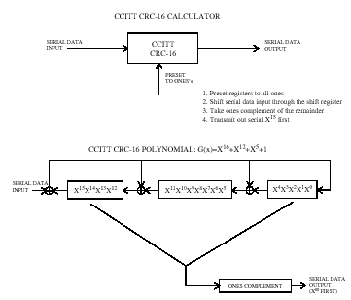

Figure 19 – CCITT CRC-16 Implementation

The CRC-16 described in this subclause is the same one used in the IEEE 802.15.3 draft standard.

Transmitter specifications

Transmit PSD mask

The transmitted spectrum shall have a 0 dBr (dB relative to the maximum spectral density of the signal) bandwidth not exceeding 260 MHz, –12 dBr at 285 MHz frequency offset, and –20 dBr at 330 MHz frequency offset and above. The transmitted spectral density of the transmitted signal mask shall fall within the spectral, as shown in Figure 20.

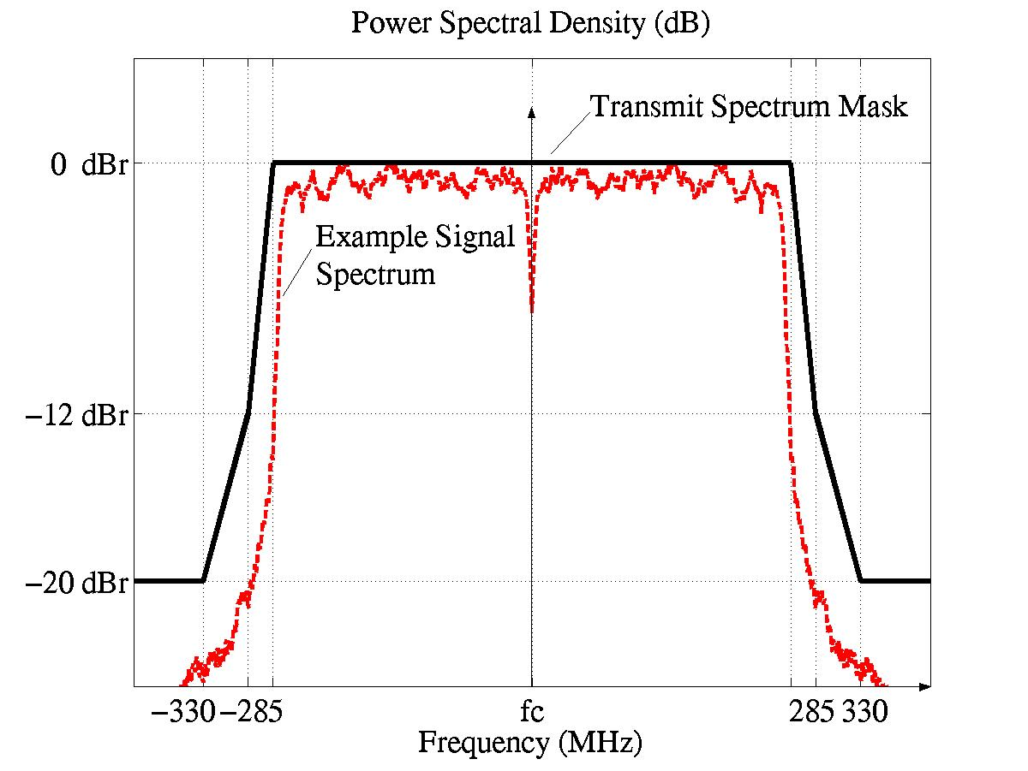

Figure 20 – Transmit Power Spectral Density Mask

Transmit center frequency tolerance

The transmitted center frequency tolerance shall be ±20 ppm maximum.

Symbol clock frequency tolerance

The symbol clock frequency tolerance shall be ±20 ppm maximum.

Clock synchronization

The transmit center frequency and the symbol clock frequency shall be derived from the same reference oscillator.

Receiver specification

Receiver sensitivity

For a packet error rate (PER) of less than 8% with a PSDU of 1024 bytes, the minimum receiver sensitivity numbers for the various rates are listed in Table 15.

Table 15 – Receiver performance requirements
Data rate (Mb/s) | Minimum sensitivity (dBm)
55 | −83.5
80 | −81.7
110 | −80.5
160 | −78.7
200 | −77.2
320 | −75.1
480 | −72.7

Receiver CCA performance

The start of a valid OFDM transmission at a receiver level equal to or greater than the minimum 55 Mb/s sensitivity (−83.5 dBm) shall cause CCA to indicate busy with a probability > 90% within 4.6875 μs. If the preamble portion was missed, the receiver shall hold the carrier sense (CS) signal busy for any signal 20 dB above the minimum 55 Mb/s sensitivity (−63.5 dBm).

Self evaluation matrix

General solution criteria

 | REF. | IMPORTANCE  LEVEL | PROPOSER RESPONSE
Unit Manufacturing Complexity (UMC) | 3.1 | B | +
Signal Robustness
Interference And Susceptibility | 3.2.2 | A | +
Coexistence | 3.2.3 | A | +
Technical Feasibility
Manufacturability | 3.3.1 | A | +
Time To Market | 3.3.2 | A | +
Regulatory Impact | 3.3.3 | A | +
Scalability (i.e. Payload Bit Rate/Data Throughput, Channelization – physical or coded, Complexity, Range, Frequencies of Operation, Bandwidth of Operation, Power Consumption) | 3.4 | A | +
Location Awareness | 3.5 | C | 0

PHY protocol criteria

CRITERIA | REF. | IMPORTANCE  LEVEL | PROPOSER RESPONSE
Size And Form Factor | 5.1 | B | +
PHY-SAP Payload Bit Rate & Data Throughput
Payload Bit Rate | 5.2.1 | A | +
Packet Overhead | 5.2.2 | A | +
PHY-SAP Throughput | 5.2.3 | A | +
Simultaneously Operating Piconets | 5.3 | A | +
Signal Acquisition | 5.4 | A | +
System Performance | 5.5 | A | +
Link Budget | 5.6 | A | +
Sensitivity | 5.7 | A | +
Power Management Modes | 5.8 | B | +
Power Consumption | 5.9 | A | +
Antenna Practicality | 5.10 | B | +

MAC protocol enhancement criteria

CRITERIA | REF. | IMPORTANCE  LEVEL | PROPOSER RESPONSE
MAC Enhancements And Modifications | 4.1. | C | +

Detailed responses to selection criteria and self-evaluation matrix

Unit manufacturing cost

The total die size for the PHY solution is expected to be around 4.6 mm², with 2.7 mm² for the analog/RF portion and 1.9 mm² for the digital portion. These estimates assume a 90 nm CMOS technology node in 2004. If a 130 nm CMOS technology node is assumed, the total die size of the PHY solution is expected to be around 6.8 mm², with 3.0 mm² for the analog/RF portion and 3.8 mm² for the digital potion. The digital portion of the PHY is expected to require 295K gates. The enhancements to the MAC are not expected to affect the die size or gate count of the MAC. The major external components that will be required by the complete solution (RF+PHY+MAC) are a pre-select filter, balun, crystal oscillator, voltage regulator, and SRAM for the MAC.

Signal robustness

Interference and susceptibility

The receiver consists of a front-end pre-select filter to reject out-of band noise and interference. For the three-band TFI-OFDM system presented in this proposal, the pass-band of the pre-select filter is between 3168 MHz to 4752 MHz. The output of the pre-select filter is amplified using an LNA and is followed by down-conversion to the base-band using the appropriate center frequency. The base-band signal is filtered using a 3rd order low-pass filter.

For the interference and susceptibility analysis, the proposed UWB system is assumed to be operating at 6 dB above the receiver sensitivity, namely P_{d} = –74.5 dBm (see Table 28), for an information data rate of 110 Mbps. Based on the link budget table of section 5.6, the average noise power per bit is –87 dBm. Since, a margin of 6 dB is available, the sum of the interferer-and-noise power can be at most –81 dBm to maintain a PER < 8% for a 1024 byte packet. Under the assumption that the impact of the interferer is similar to that of additive noise, this corresponds to a maximum tolerable interferer power of –82.3 dBm at the input of the decoder. The interference and susceptibility analysis for the following types of interferers has been provided in Table 16:

- Microwave oven

- IEEE 802.15.1 (Bluetooth)

- IEEE 802.11b

- IEEE 802.15.3

- IEEE 802.11a

- IEEE 802.15.4

Table 16 – Interference and Susceptibility Analysis

 | Microwave Oven | Bluetooth & IEEE 802.15.1 Interferer | IEEE 802.11b & IEEE 802.15.3 Interferer | IEEE 802.11a Interferer | IEEE 802.15.4 Interferer (2.45 GHz)
Max. tolerable interferer power at the encoder | -82.3 dBm | -82.3 dBm | -82.3 dBm | -82.3 dBm | -82.3 dBm
Processing gain (coding rate of 11/32) | 4.6 dB | 4.6 dB | 4.6 dB | 4.6 dB | 4.6 dB
Minimum base-band filter attenuation | 35.4 dB | 36.9 dB | 36.9 dB | 30.7 dB | 35.6 dB
Front-end pre-select filter attenuation | 35 dB | 35 dB | 35 dB | 30 dB | 35 dB
Max. tolerable interferer power at the antenna | -7.3 dB | -5.8 dB | -5.8 dB | -17 dB | -7.1 dB
Interferer power at 1m separation | -23.2 dBm | -40 dBm | -20 dBm | -31.9 dBm | -40.2 dBm
Minimum margin | 15.9 dB | 34.2 dB | 14.2 dB | 14.1 dB | 33.1 dB
Tolerable separation | ≤ 0.16 m | ≤ 0.02 m | ≤ 0.2 m | ≤ 0.2 m | ≤ 0.02 m

Microwave oven

The microwave oven is an out-of-band interferer and based on the analysis presented in Table 16, the TFI-OFDM system can tolerate this interferer at a minimum separation of 0.16 m.

Bluetooth and IEEE 802.15.1 interferer

This is an out-of-band interferer and based on the analysis presented in Table 16, the TFI-OFDM system can tolerate this interferer at a minimum separation of 0.02 m.

IEEE 802.11b and IEEE 802.15.3 interferer

This is an out-of-band interferer and based on the analysis presented in Table 16, the TFI-OFDM system can tolerate this interferer at a minimum separation of 0.2 m. This interference tolerance is superior to the desired criteria of 0.3 m separation between the IEEE 802.11b interferer and the UWB reference device.

IEEE 802.11a interferer

As the TFI-OFDM system only utilizes the spectrum between 3168 MHz and 4752 MHz, the IEEE 802.11a interferer is an out-of-band interferer. Hence, it is easier to design the front-end pre-select filter to reject the 802.11a interference. Based on the analysis presented in Table 16, the TFI-OFDM system can tolerate this interferer at a minimum separation of at least 0.2 m. This interference tolerance is superior to the desired criteria of 0.3 m separation between the IEEE 802.11a interferer and the UWB reference device.

IEEE 802.15.4 interferer

This is an out-of-band interferer and the TFI-OFDM system can tolerate this interferer at a minimum separation of 0.02 m. The analysis presented in Table 16 is only for the IEEE 802.15.4 interferer centered around 2.45 GHz. Although, the 802.15.4 device centered around 868 MHz and 915 MHz can have a receive power that is approximately 9 dB higher than that of the 802.15.4 device centered around 2.45 GHz, the base-band filter attenuation for these frequencies is significantly higher, and hence the 802.15.4 device with a center frequency of 2.45 GHz is the worst-case interferer.

Generic in-band modulated interferer

The robustness of the TFI-OFDM system to the presence of a generic in-band modulated interferer was evaluated based on AWGN simulations that incorporate losses due to front-end filtering, clipping at the DAC, ADC degradation (4-bits for 110/200 Mbps), packet acquisition, channel estimation, clock frequency mismatch (± 20 ppm at the TX and RX), carrier offset recovery, carrier tracking, etc. The center frequency of the interferer was swept uniformly from 3254 MHz to 4704 MHz in uniform steps of 50 MHz. Since the symbol rate of the modulated interferer is only 5 MHz, it will interfere with only a couple of tones. The affected tones can be erased to combat the narrow-band interferer and erasure of these tones results in some performance degradation. One of the advantages of the TFI-OFDM system is that the sub-band in which the narrow band interferer is present can still be used with minimal impact. When operating at 6 dB above sensitivity for the 110/200 Mbps data rates, it was observed that the TFI-OFDM system can tolerate a generic in-band modulated interferer with a power of P_{I} > P_{d} – 3.6 dB. The packet error rate performance of the TFI-OFDM system in the presence of an in-band modulated interferer is illustrated in Figure 21.

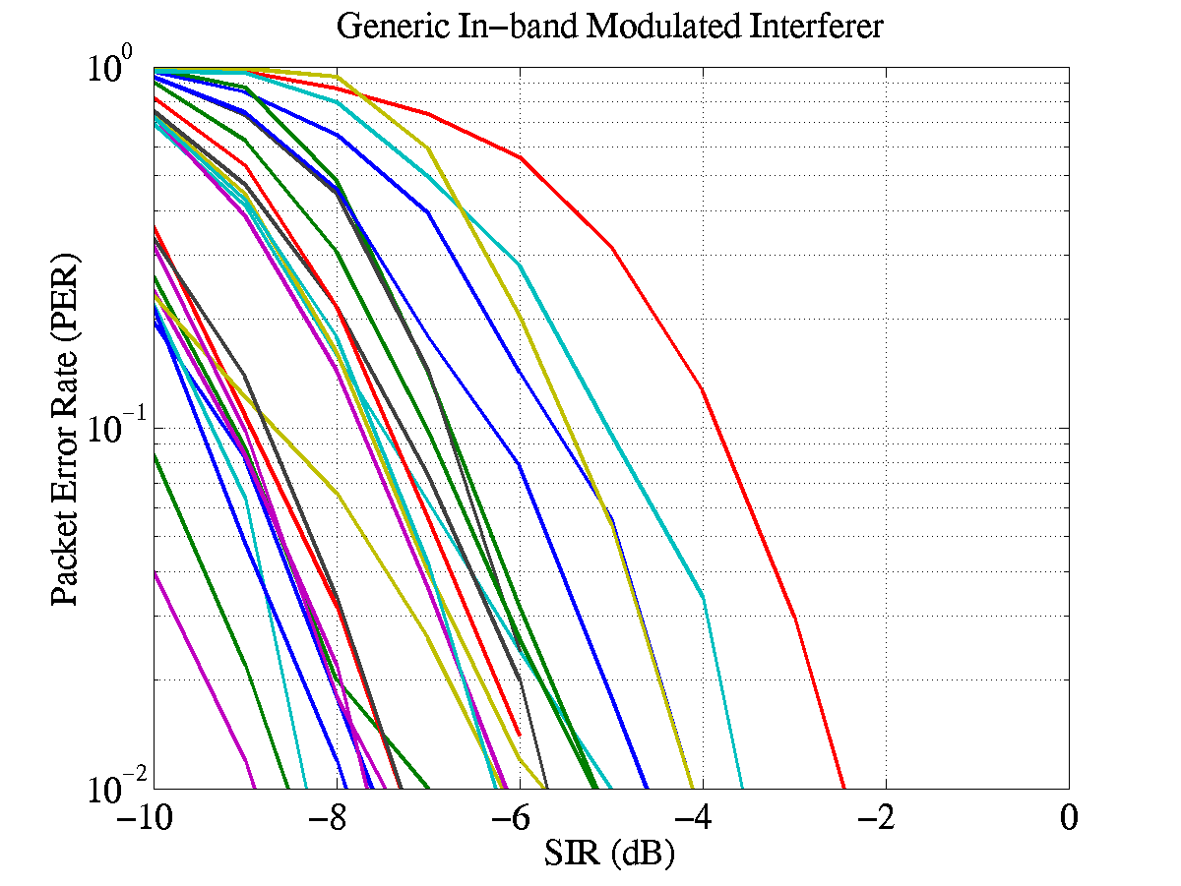
Figure 21: PER performance in the presence of a generic in-band modulated interferer

Generic in-band tone interferer

The robustness of the TFI-OFDM system to the presence of a generic in-band tone interferer was evaluated based on AWGN simulations that incorporate losses due to front-end filtering, clipping at the DAC, ADC degradation (4-bits for 110/200 Mbps), packet acquisition, channel estimation, clock frequency mismatch (± 20 ppm at the TX and RX), carrier offset recovery, carrier tracking, etc. A generic in-band tone interferer will affect at most two tones in any OFDM symbol. The affected tones can be erased to combat the narrow-band interferer and erasure of these tones results in some performance degradation. Hence, the sub-band in which the narrow band interferer is present can still be used with minimal impact. When operating at 6 dB above sensitivity, for the 110/200 Mbps data rates, it was observed that the TFI-OFDM system can tolerate a generic in-band tone interferer with a power of P_{I} > P_{d} –5.6 dB. The packet error rate performance of the TFI-OFDM system in the presence of an in-band modulated interferer is illustrated in Figure 22.
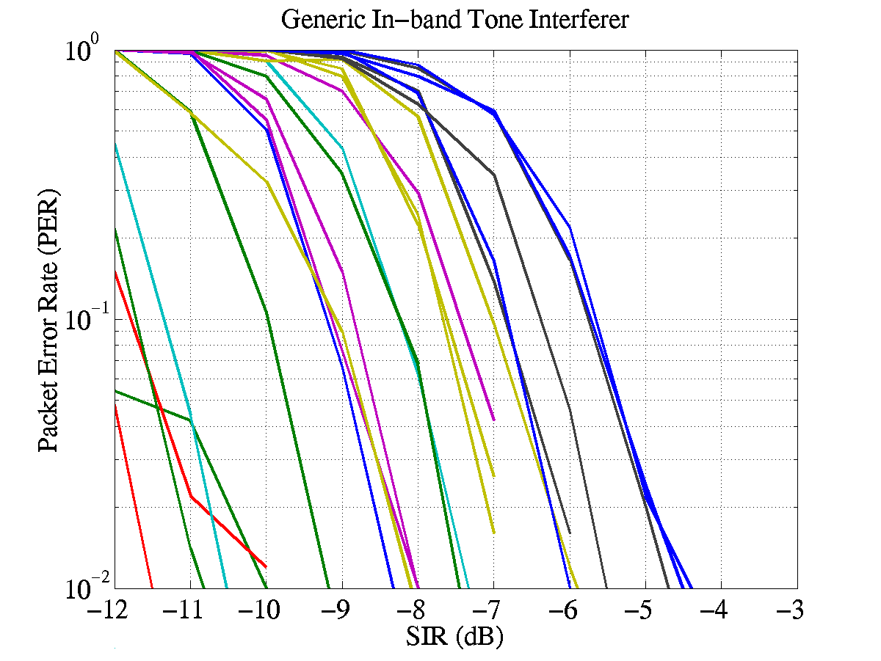
Figure 22: PER performance in the presence of a generic in-band tone interferer

Out-of-band interference from intentional and unintentional radiators

The minimum out-of-band rejection (in dB) provided by the TFI-OFDM is listed in Table 17 for various center frequencies.

Table 17 – Minimum out-of-band rejection for TFI-OFDM
Center Frequency | Pre-select Filter Attenuation | Base-band Filter Attenuation | Total Attenuation
900 MHz | 35 dB | 60 dB | 95 dB
1900 MHz | 35 dB | 47 dB | 82 dB
2450 MHz | 35 dB | 35 dB | 70 dB
5150 MHz | 25 dB | 25 dB | 50 dB
5300 MHz | 30 dB | 30 dB | 60 dB
5850 MHz | 35 dB | 44 dB | 79 dB

Coexistence

The TFI-OFDM system is very coexistence friendly. Firstly, for the proposed system employing three sub-bands, all the victim receivers specified in the selection criteria document are essentially out-of-band. Hence, the impact of the TFI-OFDM system on these devices will be minimal, if any. Secondly, the TFI-OFDM system offers an enhanced level of co-existence with both existing and future narrow-band systems that occupy the same spectrum. Co-existence with in-band systems can be achieved by dynamically turning ON/OFF tones.

In this sub-section, out-of-band mask requirements on the TFI-OFDM system will be computed based on the IEEE 802.11a and IEEE 802.11b victim receivers.

IEEE 802.11a interferer

The IEEE 802.11a receiver has a minimum receiver sensitivity of –82 dBm and a signal bandwidth of 20 MHz. For the average interfering power of the UWB device to be at least 6 dB less than the minimum sensitivity level of the victim receiver, at a distance separation of 0.3 m, the transmit power of the UWB device in the bandwidth of interest should be less than –51.5 dBm or equivalently –64.5 dBm/MHz. This corresponds to an out-of-band rejection mask of at least 23 dB at a frequency of 5.3 GHz. This level of out-of-band rejection can be easily achieved at the transmitter by using the front-end pre-select filter

IEEE 802.11b interferer

The IEEE 802.11b receiver has a minimum receiver sensitivity of –76 dBm and a signal bandwidth of 11 MHz. For the average interfering power of the UWB device to be at least 6 dB less than the minimum sensitivity level of the victim receiver, at a distance separation of 0.3 m, the transmit power of the UWB device in the bandwidth of interest should be less than –52.4 dBm or equivalently –62.8 dBm/MHz. This corresponds to an out-of-band rejection mask of at least 22 dB at a frequency of 2.4 GHz. This level of out-of-band rejection can be easily achieved at the transmitter by using the front-end pre-select filter.

Technical feasibility

Manufacturability

The proposed UWB solution will leverage current standard CMOS technology. Leveraging the standard analog and digital CMOS technology will result in a straightforward development effort. In addition, the digital section of the proposed PHY is similar to that of conventional and mature OFDM solutions, such as 802.11a and 802.11g.

Time to market

Τhe earliest a complete CMOS PHY solution would be ready for integration is 2005.

Regulatory impact

The proposed PHY complies the rules specified in the United States Code of Federal Regulations, Title 47, Section 15, Parts 15.517, 15.519, and 15.521 The proposed scheme will also comply in regions where they adopt the ruling specified by the FCC. Currently, there are no standardized regulations for UWB technologies in Europe, Japan, and Korea. However, regulatory efforts are underway in these regions. Due to the flexibility of the proposed scheme, it will comply with most regulatory standards.

Scalability

The proposed system demonstrates scalability of the following parameters:

- Power Consumption: The power consumption scales monotonically with information data rate. The power consumption values are listed as a function of the information data rates in Table 29.

- Payload Bit Rate and Throughput: Several payload bit rates have been specified for the TFI-OFDM system in Table 3. Additional payload bit rates can be incorporated in the proposed system by defining new spreading/coding rates. New coding rates can be obtained by puncturing the rate 1/3 mother code and defining new puncturing patterns.

- Channelization: Fourteen non-overlapping physical channels have been defined for the TFI-OFDM system in Table 12. In the initial system, three channels will be used and more channels can be added as the RF technology improves.

- Complexity: The system complexity monotonically scales with the information data rate.

- Range: The range of the TFI-OFDM system is a function of the data rate of operation and is tabulated in Table 27 for the information data rates of 110 Mb/s, 200 Mb/s and 480 Mb/s.

- Frequencies of operation: The proposed system can easily scale the frequencies of operation by adding or turning off some of the sub-bands.

- Occupied bandwidth: The occupied bandwidth of the proposed system can be easily modified by dynamically turning on/off tones.

- Technology: The TFI-OFDM system has a comparable complexity between the analog and digital sections. The die size, power consumption and speed of operation of the digital section will scale with technology (Moore’s law).

Location awareness

The TFI-OFDM system has the capability to determine the relative location of one device with respect to another. The relative location information can be obtained by estimating the round trip delay between the devices. As the bandwidth of each sub-band in the TFI-OFDM system is 528 MHz, the minimum resolvability between the multi-path fingers is 1.9 ns. Hence, the minimum level of accuracy that can be obtained for the location awareness is 57 cm.

Alternate PHY required MAC enhancements and modifications

Introduction

This clause specifies the enhancements to the MAC that are needed in support of the proposed PHY.

The PHY specification defines certain interleaving sequences (IS) each of which is a repetition of an ordered group of channel indexes (see Figure 23). Each IS is designated by a unique IS number. Given an IS, the OFDM symbols of a PLCP frame, which starts with a PLCP preamble, are transmitted successively on each of the ordered channels, beginning from the first one, as defined for that HS.

A predetermined IS, as specified by the PHY, is used in transmitting each beacon frame. This facilitates the reception of beacon frames by DEVs, and hence the synchronization of unassociated DEVs, or resynchronization of associated DEVs that have lost the synchronization, with a given PNC.

The PHY further defines certain rotation sequences (RS) each of which is a repetition of an ordered group of IS numbers (see Figure 24). Each RS is designated by a unique RS number. In any piconet, DEVs employ the ordered ISs defined for a specific RS to transmit their non-beacon frames in successive superframes, with a specific IS corresponding to a specific superframe. Different piconets should choose different RSs for the use by their respective DEVs.

The introduction of RSs further randomizes the subchannels used among, and hence reduces the interference from, overlapping piconets. With CSMA/CA used as the access method in the CAP, DEVs in overlapping piconets tend to synchronize the start of their frame transmissions, thereby resulting in repetitive collisions if a fixed IS were used for all transmissions in any piconet.

IS_1 = {Channel_2, Channel_1, Channel_3, Channel_1, Channel_2, Channel_3, Repeats}

IS_2 = {Channel_1, Channel_3, Channel_2, Channel_3, Channel_2, Channel_1, Repeats}

Figure 23 – Example interleaving sequences (IS)

RS_1 = {IS_1, IS_3, IS_2, IS_1, IS_2, IS_3, Repeats}

RS_2 = {IS_2, IS_3, IS_1, IS_3, IS_2, IS_1, Repeats}

Figure 24 – Example rotation sequences (RS)

The MAC enhancements presented in this document specify the mechanisms that enable the MAC entity of any DEV in a given piconet to choose the appropriate interleaving sequence for its non-beacon frame transmissions, and to communicate the chosen interleaving sequence to the PHY entity within the same DEV.

Frame format enhancement for time-frequency interleaving

Time-frequency interleaving information element
The time-frequency interleaving (TFI) IE contains a set of parameters necessary to allow synchronization for DEVs using the proposed PHY. The IE Payload field contains Interleaving Sequence (IS) and Rotation Sequence (RS) parameters (see Figure 25).

Octets: 1 | 1 | 1 | 1
Element ID | Length | Interleaving Sequence | Rotation Sequence

Figure 25 – Time-Frequency Frequency information element (TFI IE) format

The Interleaving Sequence field is 1 octet in length and specifies the current interleaving sequence (PHYPIB_CurrentIS) of channel indexes within a set of interleaving sequences.

The Rotation Sequence field is 1 octet in length and specifies the current rotation sequence (PHYPIB_CurrentRS) of interleaving sequences within a set of rotation sequences.

The PNC shall update the IS field in each beacon according to the RS field, changing one IS Number to the next in the order as defined for that RS. The PNC shall maintain the same RS Number in successive beacons, thus allowing the DEVs missing beacons to determine the interleaving sequences used for the corresponding superframes. The PNC may change the RS parameter by applying the piconet parameter change procedure as defined in the IEEE 802.15.3-2003 Standard. The interleaving sequence shall start with the first IS that appears in the new RS once the piconet parameter change takes effect.

Other fields may be added to this IE Payload in future MAC enhancements.

Piconet parameter change information element

The New Channel Index field in the Piconet Parameter Changer information element is renamed as “New Channel Index / RS Number”. For DEVs using the proposed PHY, when the Change Type field in this information element is set to 4, the Interpretation shall be “RS Number” (instead of “Channel” as currently defined), the Field to Decode shall be “New Channel Index / RS Number”, and the Description of Field Contents shall read “The new RS Number that will take effect after the beacon with the Change Counter field equal to zero is sent.”

Beacon frame

A TFI IE shall be included in each beacon frame of a piconet using the proposed PHY. It shall immediately follow the CTA IE(s) in the beacon.

Management enhancements for time-frequency interleaving

TFI PHY PIB

The following is added to the table for TFI PHY attributes.

Table 1 — FH PHY attributes (new)

Attribute | Length | Definition | Type
PHYPIB_CurrentIS | 1 octet | The interleaving sequence to be used by this DEV for the current superframe | Dynamic
PHYPIB_CurrentRS | 1 octet | The rotation sequence to be used by this DEV in determining interleaving sequences for subsequent superframes | Dynamic

The values of these attributes are updated by means of the PLME-SET.request and PLME-SET.confirm primitives as defined in Clause 6 of IEEE 802.15.3-2003 standard.

The PLME-SET.request contains two parameters, PHYPIB_Attribute and PHYPIB_Value, and is issued by the MLME to the PLME to set PHYPIB_Attribute to PHYPIB_Value. For the above two attributes, this primitive is issued upon receiving a valid beacon or missing an expected beacon.

The PLME-SET.confirm contains two parameters, ResultCode and PHYPIB_Attribute, and is issued by the PLME to the MLME in response to a PLME-SET.request. The ResultCode indicates the result of setting the PHYPIB_Attribute to the requested value.

PHY layer criteria

Size and form factor

Solutions for the PC card, compact flash, memory stick, and SD memory will be available in 2005.

PHY-SAY payload bit rate and data throughput

Payload bit rate

The proposed UWB PHY supports information data rates of 55, 80, 110, 200, 320, and 480 Mb/s. The support of transmitting and receiving data rates of 55, 110, and 200 Mb/s are mandatory. The support for the remaining data rates of 80, 160, 320, and 480 Mb/s are optional.

Packet overhead

The initial preamble is comprised of 30 OFDM symbols, where the duration of each OFDM symbol is 312.5 ns. Thus, the initial preamble has a length of 9.375 μs. Note that this value is independent of information data rate. The PLCP header, MAC header, HCS, and tail bits corresponds to 120 information bits. After encoding and puncturing, this corresponds to exactly 350 coded bits. Since, the PLCP header, MAC header, HCS, and tail bits are sent at an information data rate of 55 Mbps, these coded bits correspond to exactly 7 OFDM symbols. Thus, the PLCP header, MAC header, HCS, and tail bits have a total length of 2.1875 μs. Again, this time is independent of information data rate since it is always encoded at 55 Mbps.

Since the MPDU will be encoded at the information data rate, the length in time for the MPDU will vary according to the data rate. Using the equation defined in Section 1.3.9, we can determine the number of OFDM symbols that will be needed to transmit an MPDU+FCS of 1024 octets. Since the time for each OFDM symbol is 312.5 ns, we can easily determine the time required for 1024 octet data packets.

Table 18 summarizes the length in time for each component of the packet as a function of information data rate.

Table 18 – Time duration of each component of the packet versus data rate
Time | Length at  55 Mb/s | Length at 80 Mb/s | Length at 110 Mb/s | Length at 160 Mb/s | Length at 200 Mb/s | Length at 320 Mb/s | Length at 480 Mb/s
T_PA_INIT | 9.375 μs | 9.375 μs | 9.375 μs | 9.375 μs | 9.375 μs | 9.375 μs | 9.375 μs
T_PHYHDR + T_MACHDR + T_HCS + T_TAILBITS | 2.1875 μs | 2.1875 μs | 2.1875 μs | 2.1875 μs | 2.1875 μs | 2.1875 μs | 2.1875 μs
T_DATA | 149.0625 μs | 102.5 μs | 74.6875 μs | 51.25 μs | 41.25 μs | 25.625 μs | 17.1875 μs
T_MIFS | 2 μs | 2 μs | 2 μs | 2 μs | 2 μs | 2 μs | 2 μs
T_PA_CONT | 4.6875 μs | 4.6875 μs | 4.6875 μs | 4.6875 μs | 4.6875 μs | 4.6875 μs | 4.6875 μs
T_SIFS | 10 μs | 10 μs | 10 μs | 10 μs | 10 μs | 10 μs | 10 μs
T_RIFS | 24.6875 μs | 24.6875 μs | 24.6875 μs | 24.6875 μs | 24.6875 μs | 24.6875 μs | 24.6875 μs
T_BIFS | 14.6875 μs | 14.6875 μs | 14.6875 μs | 14.6875 μs | 14.6875 μs | 14.6875 μs | 14.6875 μs

PHY-SAP throughput

The throughput for a single frame and multiple frame (5 frames) transmission with an MPDU of 1024 bytes as a function of the information data rate is summarized in Table 19.

Table 19 – Throughput for a 1024 byte MPDU versus data rate (single/multiple frames)
# of frames | Throughput at 55 Mb/s | Throughput at 80 Mbps | Throughput at 110 Mbps | Throughput at 160 Mbps | Throughput at 200 Mbps | Throughput at 320 Mbps | Throughput at 480 Mbps
1 | 48.01 Mb/s | 66.03 Mb/s | 85.11 Mb/s | 112.51 Mb/s | 130.42 Mb/s | 173.61 Mb/s | 211.41 Mb/s
5 | 51.05 Mb/s | 71.91 Mb/s | 95.15 Mb/s | 130.73 Mb/s | 155.56 Mb/s | 221.18 Mb/s | 286.43 Mb/s

The throughput for a single frame and multiple frame (5 frames) transmission with an MPDU of 4024 bytes as a function of the information data rate is summarized in Table 20.

Table 20 – Throughput for a 4024 byte MPDU versus data rate (single/multiple frames)
# of frames | Throughput at 55 Mb/s | Throughput at 80 Mbps | Throughput at 110 Mbps | Throughput at 160 Mbps | Throughput at 200 Mbps | Throughput at 320 Mbps | Throughput at 480 Mbps
1 | 52.97 Mb/s | 75.84 Mb/s | 102.30 Mb/s | 144.34 Mb/s | 175.92 Mb/s | 263.20 Mb/s | 362.37 Mb/s
5 | 53.87 Mb/s | 77.70 Mb/s | 105.71 Mb/s | 151.23 Mb/s | 186.26 Mb/s | 287.05 Mb/s | 409.16 Mb/s

Simultaneously operating piconets

The multiple piconet capability of the TFI-OFDM system was evaluated, based on simulations, in the presence of un-coordinated piconets. The performance simulations incorporate losses due to front-end filtering, clipping at the DAC, ADC degradation (4-bits for 110 Mbps), multi-path, packet acquisition, channel estimation, clock frequency mismatch (± 20 ppm at the TX and RX), carrier offset recovery, carrier tracking, etc. As specified in the test, the shadowing component was removed from both the reference and interfering links by normalizing each channel realization to unity multi-path energy. Table 21 lists the channel realizations used for the reference link and the interfering link as a function of the channel environment.

Table 21 – Channel realizations used in the simultaneously operating piconet test
Channel Environment | Reference Link | Interfering Link
CM1 | 1 to 5 | 6 to 10
CM2 | 1 to 5 | 6 to 10
CM3 | 1 to 5 | 6 to 10
CM4 | 1 to 5 | 6 to 10

Different time-frequency interleaving patterns are assigned to the various simultaneously operating piconets. The time-frequency interleaving sequences are designed to have good collision properties for all possible asynchronous shift among the simultaneously operating piconets. The time-frequency interleaving sequences used for this test are tabulated in Table 22.

Table 22 – Time-frequency interleaving sequences for simultaneously operating piconets.
Piconet | Time-Frequency Interleaving Sequence (IS)
PNC_1 | {Channel_1, Channel_2, Channel_3, Channel_1, Channel_2, Channel_3}
PNC_2 | {Channel_1, Channel_3, Channel_2, Channel_1, Channel_3, Channel_2}
PNC_3 | {Channel_1, Channel_1, Channel_2, Channel_2, Channel_3, Channel_3}
PNC_4 | {Channel_1, Channel_1, Channel_3, Channel_3, Channel_2, Channel_2}

For the single piconet separation distance, the test link is established such that the reference link is set at a distance of d_{ref} = 10 m for a data rate of 110 Mbps. The distance separation at which a single interferer can be tolerated is obtained by averaging the performance over all combinations of the reference link channel realizations and 5 interferer link channel realizations for each channel environment. The distance separation is tabulated in Table 23 for a variety of reference multi-path channel environments and interfering channel environments. The average packet error rate curves for the single piconet interference test is illustrated in Figure 26. The single piconet interference separation is not very dependent on the channel environment of the interfering link.

Table 23 – Single piconet interference separation distance.

Interferer Link  Test Link | AWGN | CM1 | CM2 | CM3 | CM4
CM1  (d_{int}/d_{ref}) | 9.5 m (0.95) | 10.5 m  (1.05) | 9.5 m  (0.95) | 10.8 m  (1.08) | 10.4 m  (1.04)
CM2  (d_{int}/d_{ref}) | 8.9 m (0.89) | 9.8 m  (0.98) | 8.9 m  (0.89) | 10.3 m  (1.03) | 9.7 m  (0.97)
CM3  (d_{int}/d_{ref}) | 8.9 m (0.89) | 9.8 m  (0.98) | 9.1 m  (0.91) | 10.3 m  (1.03) | 9.8 m  (0.98)
CM4  (d_{int}/d_{ref}) | 12.5 m (1.25) | 13.3 m  (1.33) | 12.7 m  (1.27) | 14.2 m  (1.42) | 13.4 m  (1.34)

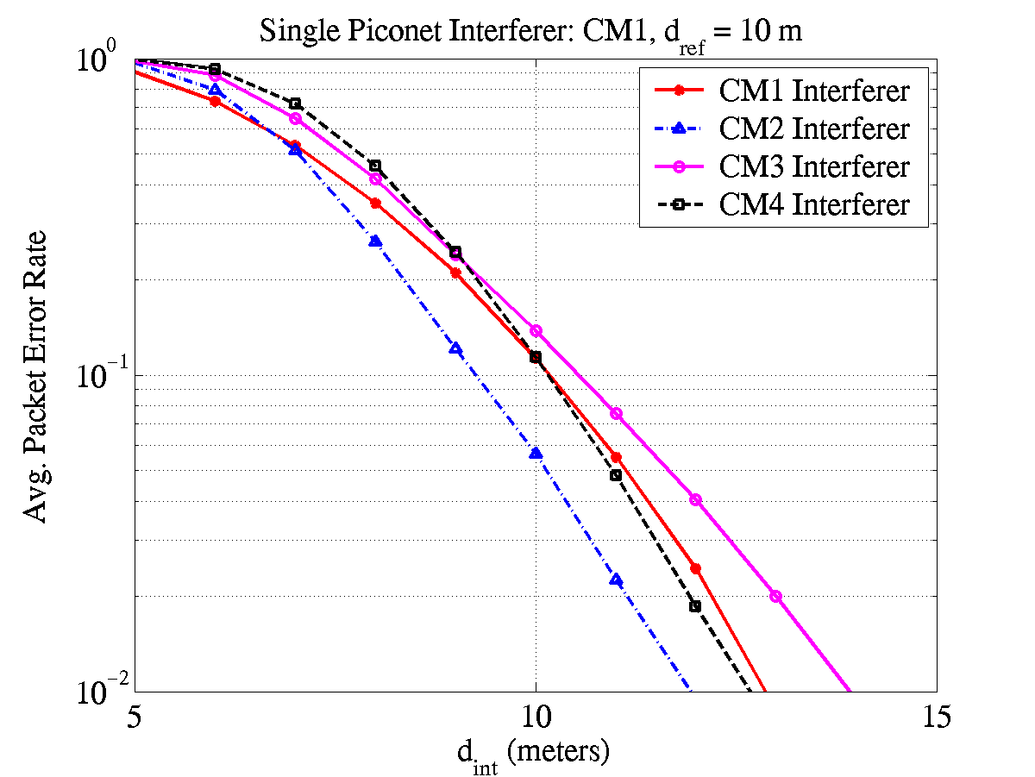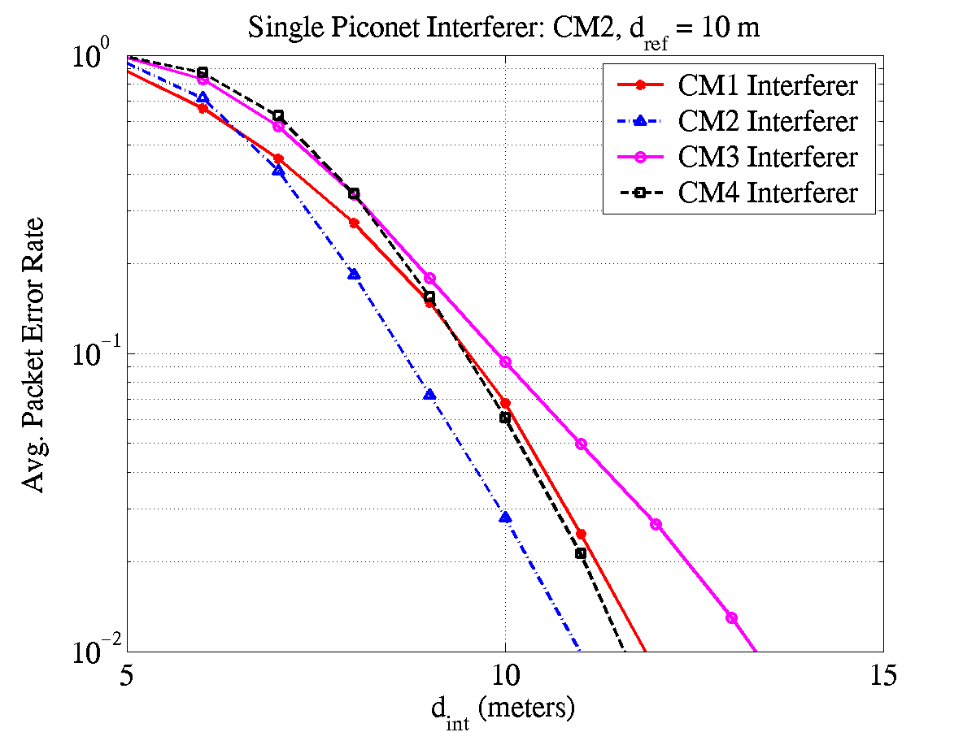
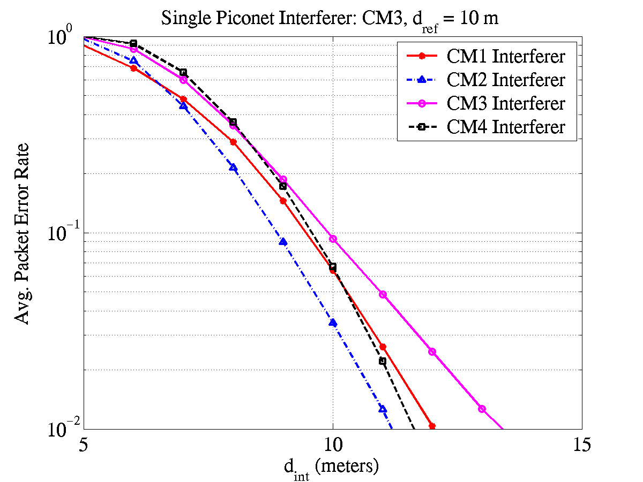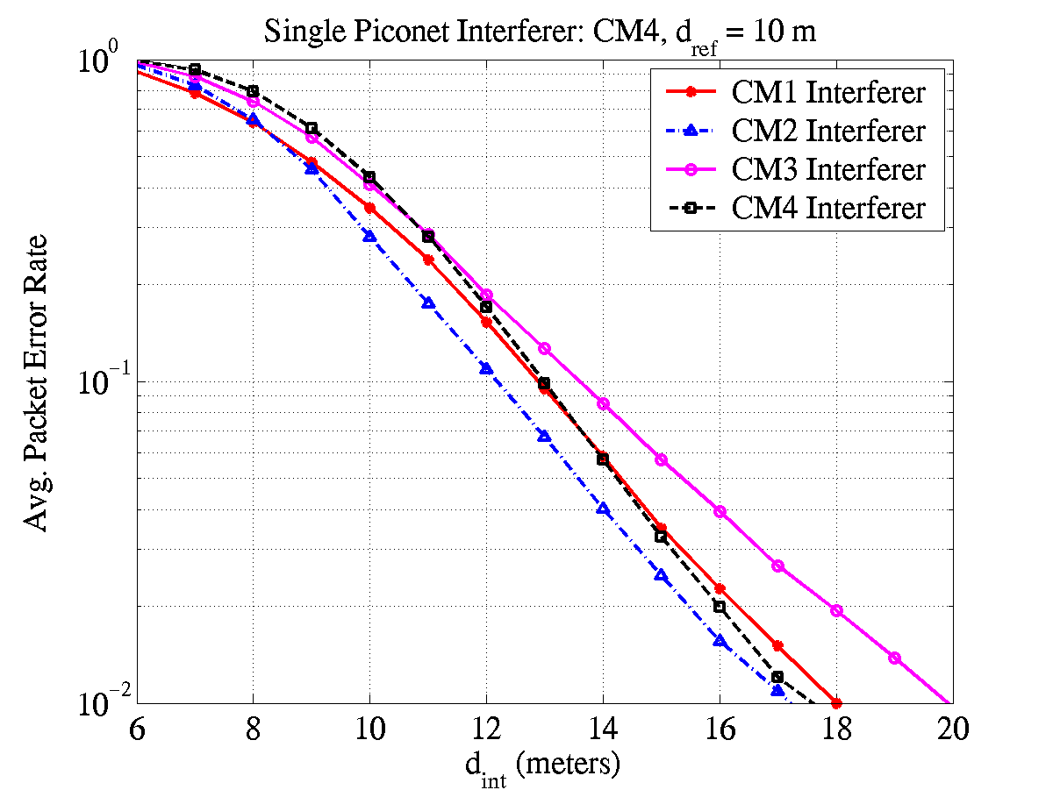
Figure 26 – Packet error rate performance for a single piconet interferer.

The multi-piconet interference separation distance is tabulated in Table 24 for all reference multi-path channel environments and N = 1, 2 and 3 interfering piconets. As specified in the test, the interferer link is assumed to be AWGN and the reference link is set at a distance separation of d_{ref} = 10 m.

Table 24 – Multi-piconet interference separation distance.

Interferer Link  Test Link | AWGN  (N=1) | AWGN  (N=2) | AWGN  (N=3)
CM1  (d_{int}/d_{ref}) | 9.5 m  (0.95) | 13.5 m  (1.35) | 16.5 m  (1.65)
CM2  (d_{int}/d_{ref}) | 8.9 m  (0.89) | 12.5 m  (1.25) | 15.4 m  (1.54)
CM3  (d_{int}/d_{ref}) | 8.9 m  (0.89) | 12.7 m  (1.27) | 15.4 m  (1.54)
CM4  (d_{int}/d_{ref}) | 12.5 m (1.25) | 17.8 m  (1.78) | 21.8 m  (2.18)

FDMA can be used when enhanced multi-piconet capability is required. The FDMA mode can be defined by specifying the appropriate time-frequency interleaving sequence. For example, if the second sub-band is assigned for a piconet, the time-frequency interleaving sequence is specified as IS = {Channel_2, Channel_2, Channel_2, Repeats}. As the TFI-OFDM system proposes the use of 3 sub-bands for the initial deployment, a maximum of three piconets can be supported with the FDMA option. Furthermore, when only a single sub-band is assigned for a piconet the transmit power, and hence the sensitivity, will be 10log₁₀(3) dB less than when a time-frequency interleaving sequence spanning 3 sub-bands is used. Table 25 tabulates the distance at which N = 2 interferers can be tolerated for a data rate of 110 Mbps, when the reference link is set at a distance of d_{ref} = 6 m. In this test, the reference piconet is assigned sub-band 2, while the interfering piconets are assigned the sub-bands 1 and 3, respectively. The baseband channel select filter is designed to providean adjacent channel rejection of approximately 15 dB on average.
Table 25 – Multi-piconet interference separation distance with FDMA.
Test Link  Interferer Link | CM1 | CM2 | CM3
AWGN (N=2)  (d_{int}/d_{ref}) | 2.1 m  (0.35) | 2.0 m  (0.33) | 2.0 m  (0.33)

The performance of signal acquisition in the presence of a single piconet interferer was also examined. Figure 27 shows the probability of miss detection as a function of the separation distance for a test link channel environment of CM3. As specified by the test, the reference distance was fixed at 10 meters. In this simulation, the interferer link was varied across the various channel models. The simulations assume that the reference link uses the first time-frequency interleaving sequence specified in Table 22, while the interfering link uses the second time-frequency interleaving sequence specified in Table 22. The results shown in Figure 27 were averaged over a minimum of 20,000 realizations for each multi-path channel environment. The impairments that were included in the system simulations included an offset of ±20 ppm was also assumed at both the transmitter and receiver clock synthesizer, and a 4-bit ADC at the receiver.

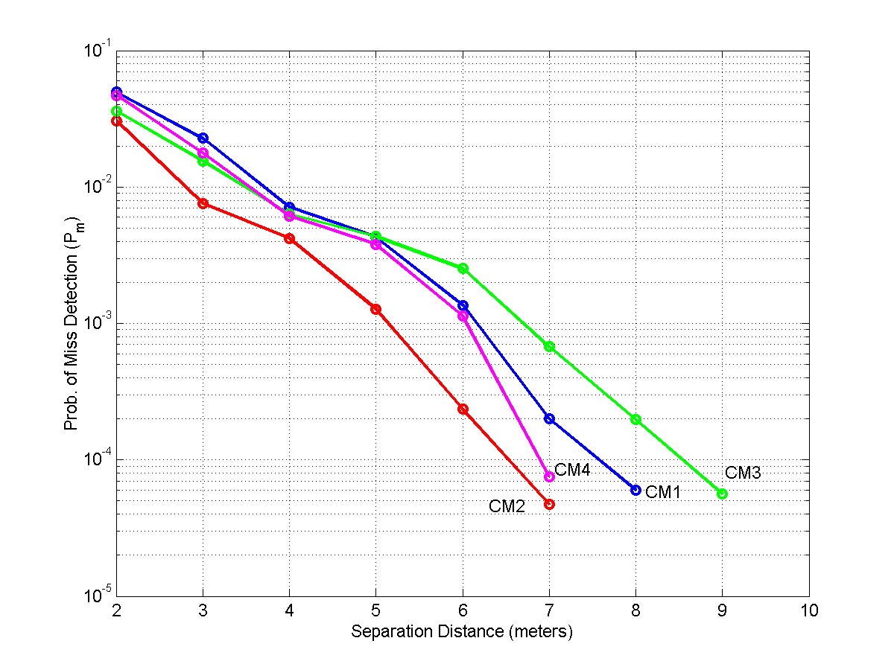
Figure 27 – Probability of miss detection versus separation for a single piconet interferer and a reference link channel environment of CM3.

This figures shows that the packet can be acquired at a separation distance of less than 4 meters without significant impact on the packet error rate.

Signal acquisition

The standard PLCP preamble is designed specifically to be robust in low signal-to-noise environments. In fact, the standard PLCP preamble was designed to operate at 3 dB below sensitivity for an information data rate of 55 Mb/s. Table 26 provides the false alarm and miss detect probabilities for an information data rate of 110 and 200 Mb/s. These probabilities are specified for a single piconet and various channel conditions (AWGN, CM1 through CM4). These results were averaged over 50,000 realizations (500 noise realizations for each of the 100 channel realizations) for a given multi-path channel environment. These results include an offset of ±20 ppm at both the transmitter and receiver clock synthesizer. In addition, a 4-bit ADC was implemented at the receiver.

Table 26 – False detect and miss detect probabilities for a single piconet
Channel Environment | P_{m} at 110 Mb/s | P_{m} at 200 Mb/s | P_{f} | Acquistion Time
AWGN | < 2 × 10⁻⁵ | < 2 × 10⁻⁵ | 6.2 × 10⁻⁴ | < 4.69 μs
CM1 | < 2 × 10⁻⁵ | < 2 × 10⁻⁵ | 6.2 × 10⁻⁴ | < 4.69 μs
CM2 | < 2 × 10⁻⁵ | < 2 × 10⁻⁵ | 6.2 × 10⁻⁴ | < 4.69 μs
CM3 | < 2 × 10⁻⁵ | < 2 × 10⁻⁵ | 6.2 × 10⁻⁴ | < 4.69 μs
CM4 | < 2 × 10⁻⁵ | < 2 × 10⁻⁵ | 6.2 × 10⁻⁴ | < 4.69 μs

The probability of miss detection as a function of distance is plotted in Figure 28. This figure shows that the proposed preamble is robust in all multi-path channel environments, even for large distances. Again, these results were averaged over 50,000 realizations (500 noise realizations for each of the 100 channel realizations) for a given multi-path channel environment.

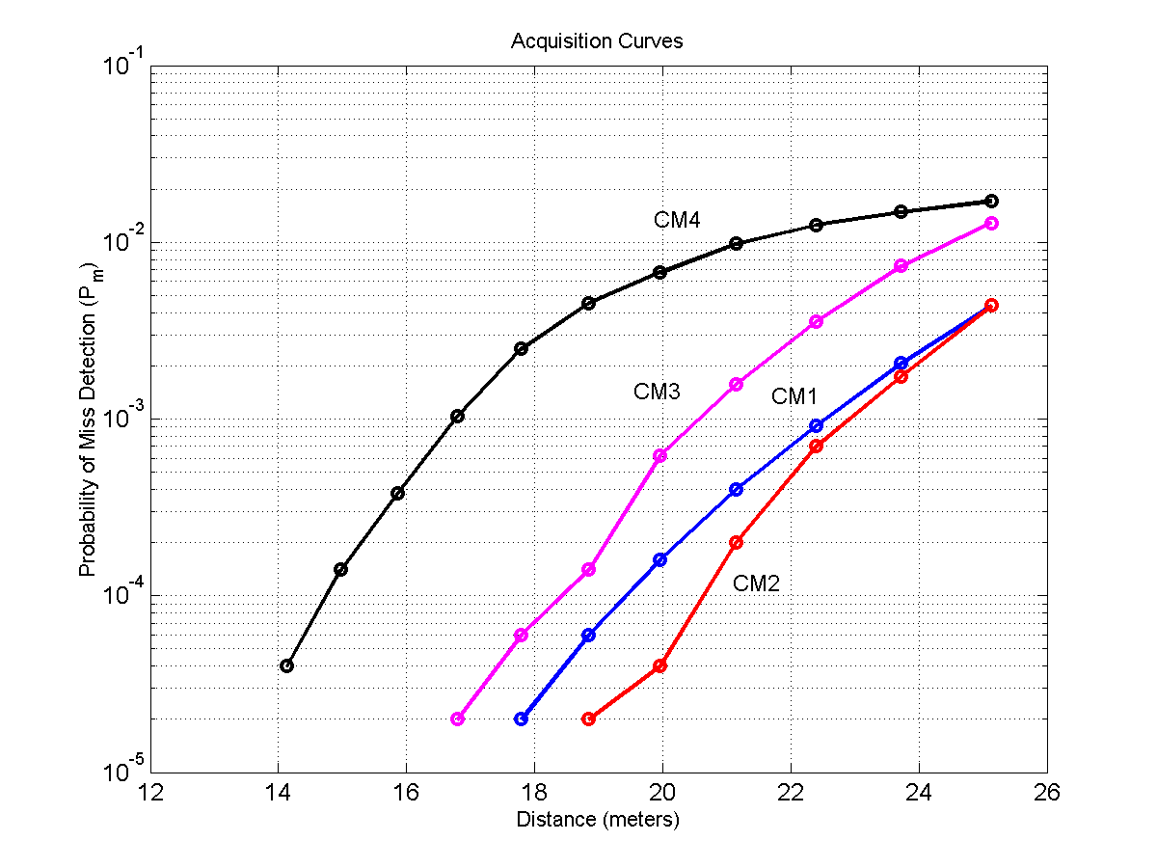
Figure 28 – Probability of miss detection as a function of distance

A timeline showing the overall acquisition process of the standard PLCP preamble is shown in Figure 29. The first 6.5625 μs are used for packet detection and acquisition, coarse frequency estimation, coarse symbol timing estimation, and AGC settling. The next 0.9375 μs are used for synchronization within the preamble, i.e., to determine the location within the preamble, and to indicate the start of the channel estimation sequence. The final 1.875 μs are used for channel estimation, fine frequency estimation, and fine symbol timing estimation.

Figure 29 – Timeline for acquisition of the standard PLCP preamble

System

The performance of the TFI-OFDM system was evaluated in AWGN and multi-path channel environments specified by the 802.15.3a channel modeling sub-committee report. A path loss decay exponent of 2 was assumed for all the four channel environments and the “new” channel realizations from each of the environments have been used for these simulations. All simulations were performed with at least 200 packets (typically 500) with a payload of 1K bytes each. The performance simulations incorporate losses due to front-end filtering, clipping at the DAC, ADC degradation (4-bits for 110/200 Mbps and 5-bits for 480 Mbps), multi-path, shadowing, packet acquisition, channel estimation, clock frequency mismatch (± 20 ppm at the TX and RX), carrier offset recovery, carrier tracking, etc. The PER performance for an AWGN channel is shown in Figure 30 as a function of distance and the information data rate.

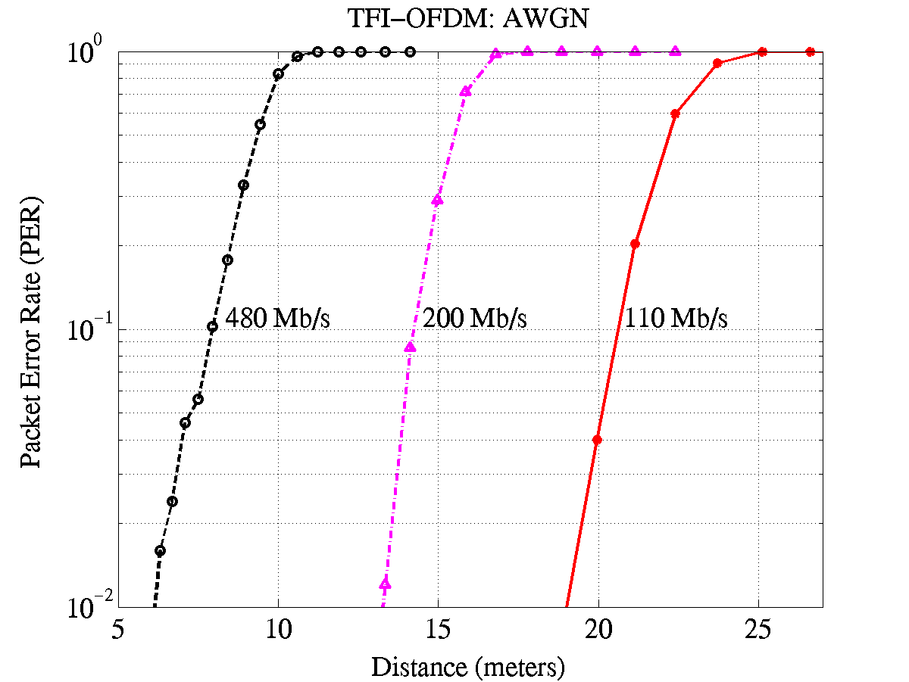
Figure 30 – PER as a function of distance and information data rate in an AWGN environment

The PER performance for the 90th %ile channel realization is illustrated in Figure 31, Figure 32, Figure 33, and Figure 34 as a function of distance for the four channel environments CM1-CM4, respectively. These plots correspond to the performance of the 90th best channel realization, i.e., the worst 10% channels were discarded. This implies that the performance of the TFI-OFDM system is better than what is illustrated in these plots for at least 90% of the channel realizations from each channel environment.

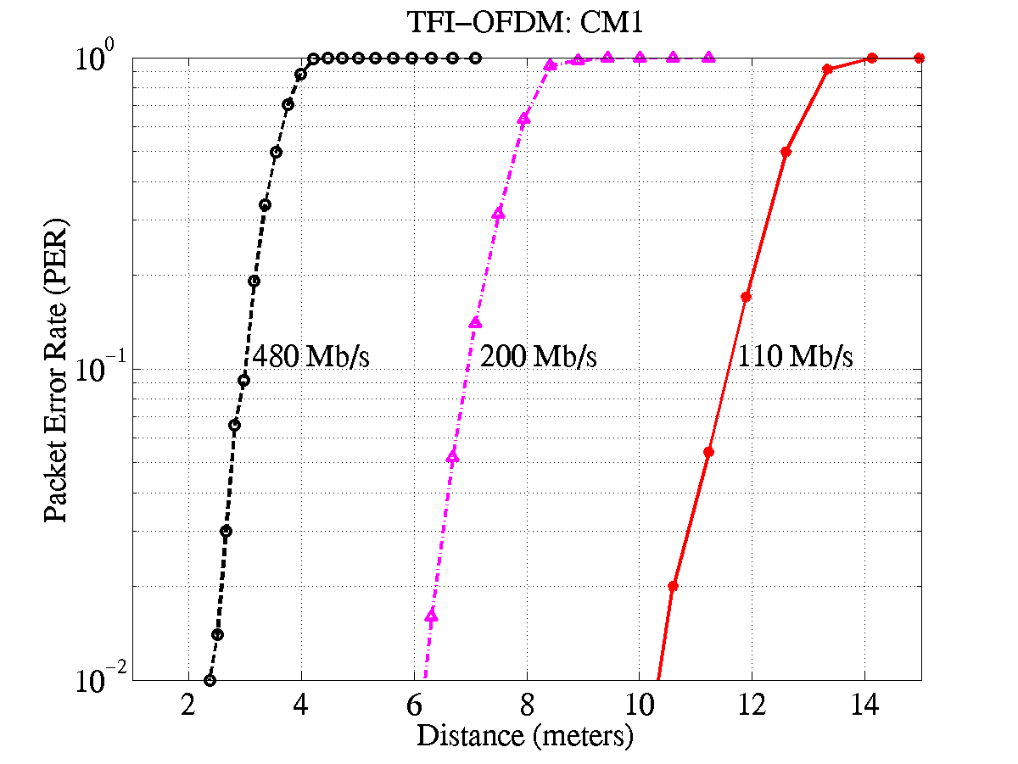
Figure 31 – PER as a function of distance and information data rate in a CM1 channel environment for the 90th %ile channel realization.

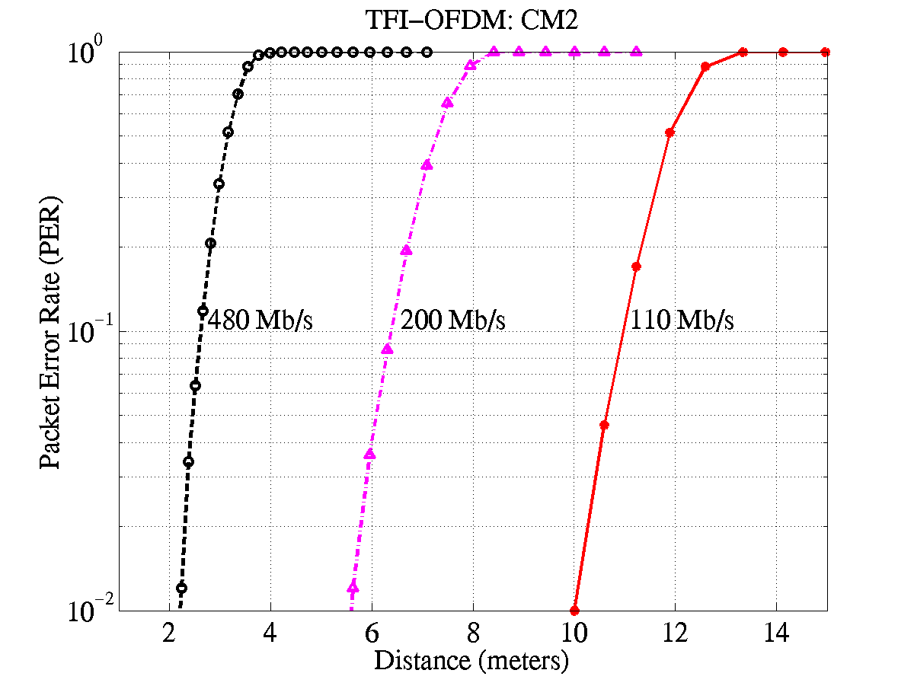
Figure 32 – PER as a function of distance and information data rate in a CM2 channel environment for the 90th %ile channel realization.

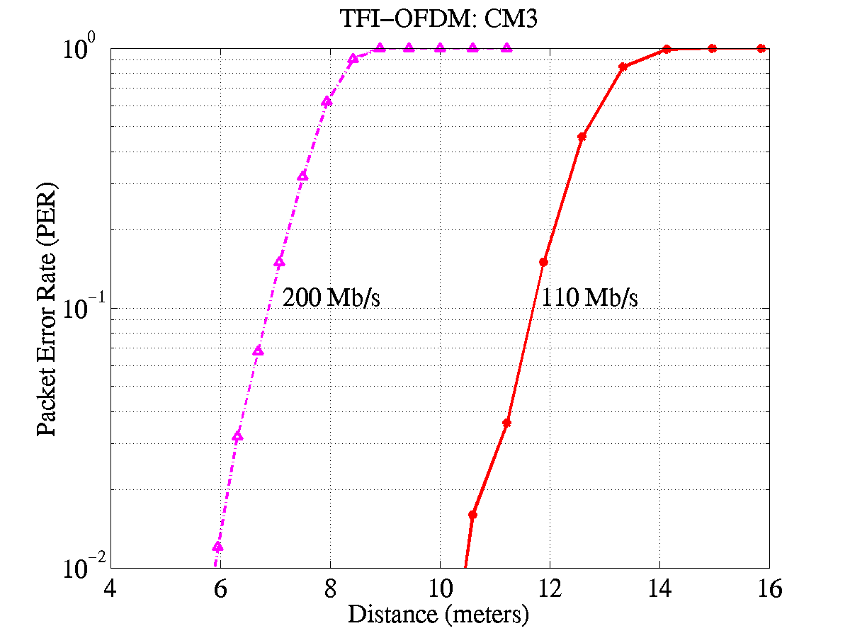
Figure 33 – PER as a function of distance and information data rate in a CM3 channel environment for the 90th %ile channel realization.

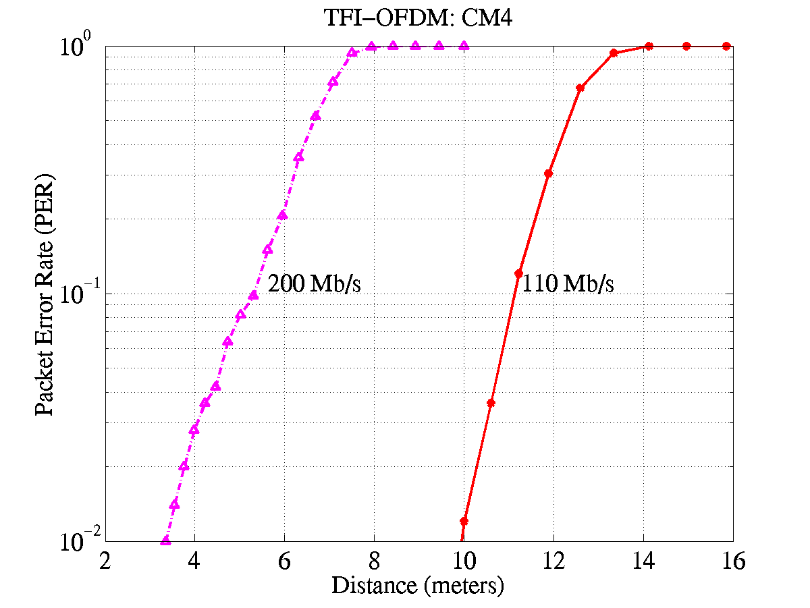
Figure 34 – PER as a function of distance and information data rate in a CM4 channel environment for the 90th %ile channel realization.

The range at which the TFI-OFDM system can achieve a PER of 8% with a link success probability of 90% is listed in Table 27 for AWGN and the multi-path channel environments. As the link success probability is dominated by shadowing and not by signal acquisition (see Table 26), the link success probability in AWGN channel environment, for the distance values listed in Table 27, is close to 100%. In AWGN and all multi-path environments, the TFI-OFDM system easily satisfies the data rate versus range requirement of 110 Mbps at 10 m and 200 Mbps at 4 m. Furthermore, the TFI-OFDM system can support data rates of 110 Mbps, 200 Mbps and 480 Mbps at a distance of 10.9-11.6 m, 5-6.9 m and 2.6-2.9 m, respectively, in various multi-path channel environments for a link success probability of 90%.

Table 27 – Range to achieve a PER of 8% with a 90% link success probability.
Rate | AWGN | CM1 | CM2 | CM3 | CM4
110 Mb/s | 20.5 m | 11.5m | 10.9m | 11.6m | 11m
200 Mb/s | 14.1m | 6.9 m | 6.3 m | 6.8 m | 5 m
480 Mb/s | 7.8 m | 2.9 m | 2.6 m | N/A | N/A

The probability of link success for the four multi-path channel environments is illustrated in Figure 35 as a function of distance for an information data rate of 110 Mbps. As the TFI-OFDM system has been designed to be robust to multi-path and with a sufficiently long cyclic prefix, the performance is similar in the four channel environments. The small variations in performance are primarily due to the effect of shadowing that has been incorporated in the 100 channel realizations corresponding to each of the four channel environments. From Figure 35 we see that the TFI-OFDM system can support a data rate of 110 Mbps at a distance of about 10.9-11.6 m with a link success probability of 90% and a distance of 13.8-14.7 m for a link success probability of 75 %.

Figure 35 – Range as a function of link success probability and channel environment for an information data rate of 110 Mbps.

The plot of the 90% outage PER (defined as the average PER over the 90% best channels) as a function of E_{b}/N₀ is shown in Figure 36, Figure 37, Figure 38, and Figure 39 for the four multi-path channel environments and the AWGN environment for an information data rate of 110 Mbps. For these plots, the value of E_{b} was computed as the average multi-path signal energy, averaged over the 100 channel realizations for each environment.

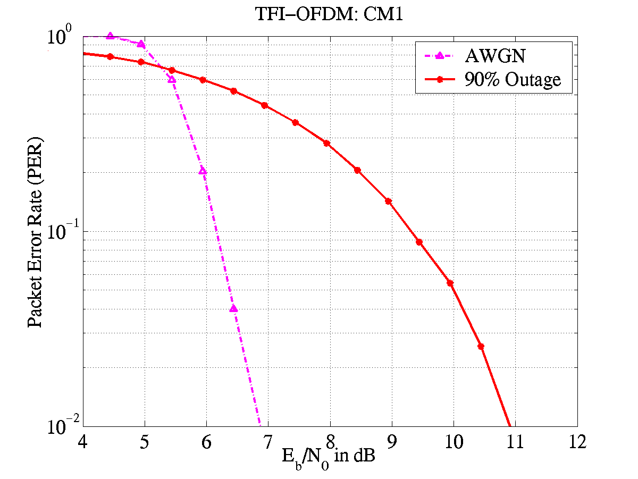
Figure 36 – 90% outage PER as a function of E_{b}/N₀ for a CM1 channel environment and an information data rate of 110 Mbps.

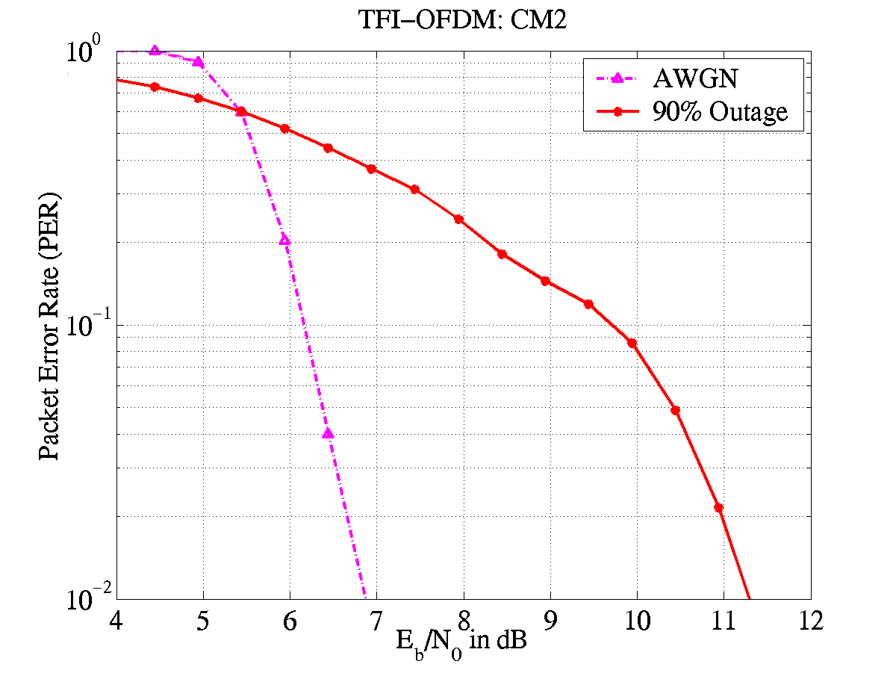
Figure 37 – 90% outage PER as a function of E_{b}/N₀ for a CM2 channel environment and an information data rate of 110 Mbps.

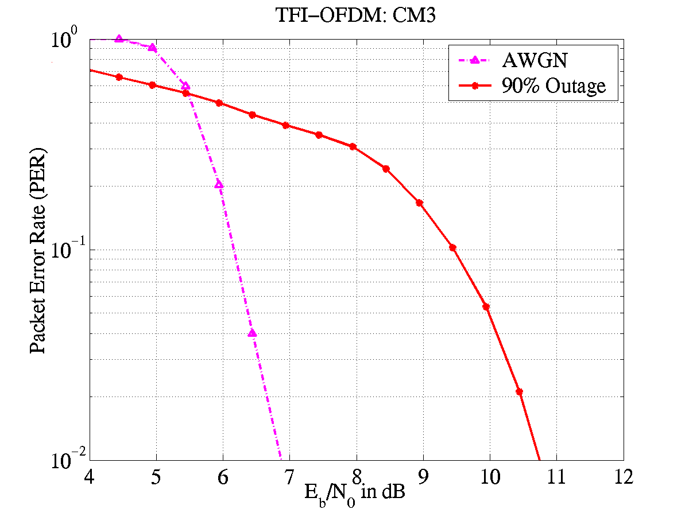
Figure 38 – 90% outage PER as a function of E_{b}/N₀ for a CM3 channel environment and an information data rate of 110 Mbps.

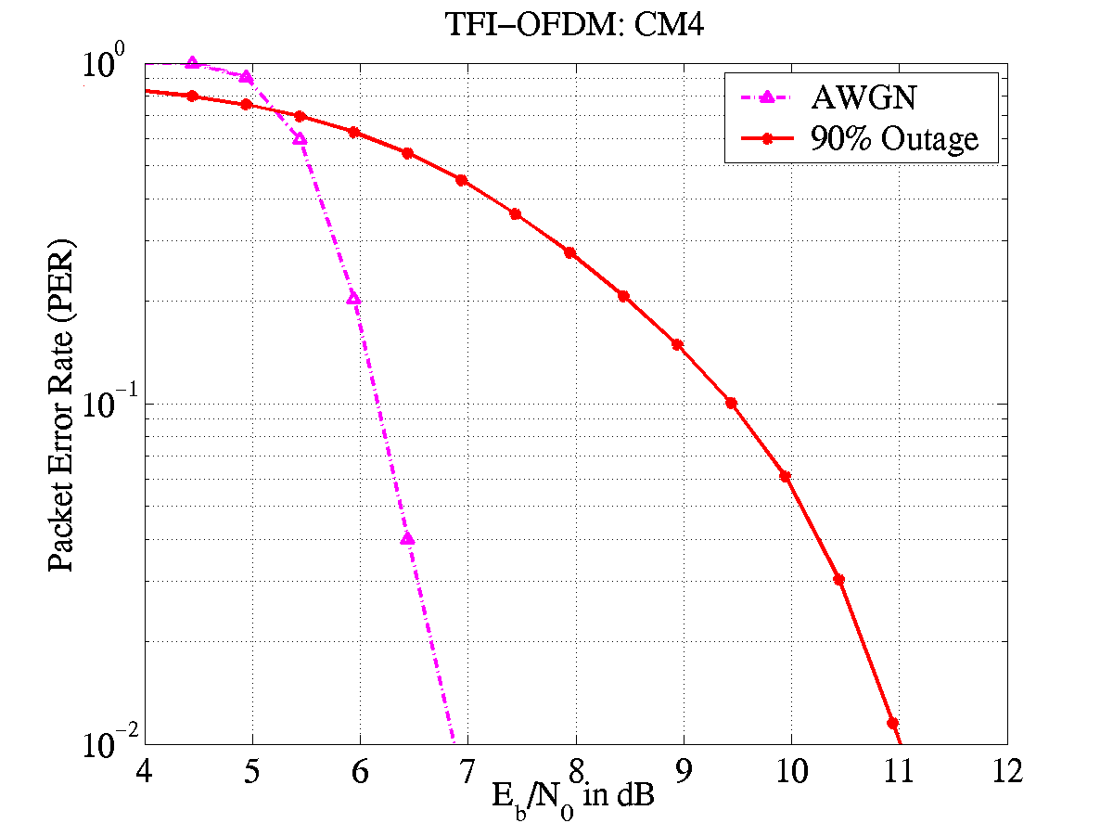
Figure 39 – 90% outage PER as a function of E_{b}/N₀ for a CM4 channel environment and an information data rate of 110 Mbps.

Link budget

Parameter | Value | Value | Value
Information data rate (R_{b}) | 110 Mb/s | 200 Mb/s | 480 Mb/s
Average Tx power (P_{T}) | −10.3 dBm | −10.3 dBm | −10.3dBm
Tx antenna gain (G_{T}) | 0 dBi | 0 dBi | 0 dBi
$f_{c}^{'}=\sqrt{f_{\text{min}}f_{\text{max}}}$: geometric center frequency of waveform ($f_{\text{min}}$ and $f_{\text{max}}$ are the -10 dB edges of the waveform spectrum) | 3882 MHz | 3882 MHz | 3882 MHz
Path loss at 1 meter ($L_{1}=\text{20}{\text{log}}_{\text{10}}(4{{πf}_{c}^{'}}/c)$)  $c=3×{\text{10}}^{8}$ m/s | 44.2 dB | 44.2 dB | 44.2 dB
Path loss at d m ($L_{2}=\text{20}{\text{log}}_{\text{10}}(d)$) | 20 dB  (d = 10 meters) | 12 dB  (d = 4 meters) | 6 dB  (d = 2 meters)
Rx antenna gain ($G_{R}$) | 0 dBi | 0 dBi | 0 dBi
Rx power ($P_{R}=P_{T}+G_{T}+G_{R}−L_{1}−L_{2}$ (dB)) | −74.5 dBm | −66.5 dBm | −60.5 dBm
Average noise power per bit ($N=−\text{174}+\text{10}{\text{*log}}_{\text{10}}(R_{b})$) | −93.6 dBm | −91.0 dBm | −87.2 dBm
Rx Noise Figure Referred to the Antenna Terminal ($N_{F}$)¹ | 6.6 dB | 6.6 dB | 6.6 dB
Average noise power per bit ($P_{N}=N+N_{F}$) | −87.0 dBm | −84.4 dBm | −80.6 dBm
Required E_{b}/N₀ (S) | 4.0 dB | 4.7 dB | 4.9 dB
Implementation Loss² (I) | 2.5 dB | 2.5 dB | 3.0 dB
Link Margin ($M=P_{R}−P_{N}−S−I$) | 6.0 dB | 10.7 dB | 12.2 dB
Proposed Min. Rx Sensitivity Level³ | −80.5 dBm | −77.2 dBm | −72.7 dBm

¹ The primary sources for the noise figure are the LNA and mixer. The voltage gain of the LNA is approximately 15 dB, while the voltage conversion gain of the mixer is approximately 10 dB. The total noise at the output of the LNA is 0.722 × 10^{–16} V²/Hz. This value includes the noise of the LNA and the input of resistor. The total noise at the output of the mixer is 0.722 × 10^{–16} V²/Hz + (8 × 10^{–9})² V²/Hz = 0.786 × 10^{–16} V²/Hz, where the second term in the addition is generated by the noise sources within the mixer. Thus, the overall noise figure for the analog front-end is 10log₁₀(7.86/2.56) = 4.9 dB. Including the losses associated with the pre-select filter (1.0 dB) and the transmit/receive switch (0.7 dB), the overall noise figure is 6.6 dB.
² Includes losses due to cyclic prefix overhead, front-end filtering, clipping at the DAC, ADC degradation, channel estimation, clock frequency mismatch, carrier offset recovery, carrier tracking, etc.

Sensitivity

For a packet error rate (PER) of less than 8% with a PSDU of 1024 bytes, the minimum receiver sensitivity numbers for the various rates are listed in Table 15.

Table 28 – Receiver performance requirements
Data rate (Mb/s) | Minimum sensitivity (dBm)
55 | −83.5
80 | −81.7
110 | −80.5
160 | −78.7
200 | −77.2
320 | −75.1
480 | −72.7

Power management modes

The proposed PHY system shall support all of the power managements modes (ACTIVE, PSPS, SPS, and HIBERNATE) defined the IEEE 802.15.3 draft standard.

Power consumption

The power consumption calculations are provided for both a 90 nm CMOS technology node that will be available in early 2004 and a 130 nm CMOS technology node that is currently available. In addition, for the 90/130 nm process node a supply voltage of 1.5/1.8 V was assumed for the analog section of the PHY, except for the LNA where a 2 V supply was assumed. The digital section of the PHY requires a supply voltage of 1.2/1.3 V (for the 90/130 nm process node) and a clock of 132 MHz. Using these assumptions, the power for transmit, receive, clear channel assessment, and power save were calculated. The resulting power consumption values are listed in Table 29.

Table 29 – Power consumption
Process Node | Rate (Mb/s) | Transmit | Receive | CCA | Power Save (Deep Sleep Mode)
90 nm | 110 | 93 mW | 155 mW | 94 mW | 15 μW
90 nm | 200 | 93 mW | 169 mW | 94 mW | 15 μW
90 nm | 480 | 145 mW | 236 mW | 94 mW | 15 μW
130 nm | 110 | 117 mW | 205 mW | 117 mW | 18 μW
130 nm | 200 | 117 mW | 227 mW | 117 mW | 18 μW
130 nm | 480 | 180mW | 323 mW | 117 mW | 18 μW

Antenna practicality

The antenna is assumed to have the following characteristics across the bandwidth of interest: frequency-independent gain and omni-directional patterns. The remaining requirements for the antenna can be relaxed because OFDM has an inherent robustness against gain, phase, and group delay variation that may be introduced by the antenna. A 16 mm × 13.6 mm x 3 mm antenna with similar characteristics is already commercially available at a low cost and can meet many of the form factors specified in the selection criteria document.

Appendix

In this section we address the design of cyclic prefix length, peak-to-average ratio requirement and FFT/IFFT complexity for the TFI-OFDM system.

Cyclic prefix length

One of the key design parameters in an OFDM system is the duration of the cyclic prefix (CP). This length should be chosen such that the overhead due to CP is small, while still minimizing the performance degradation due to loss in collected multi-path energy and the resulting inter-carrier-interference (ICI). To illustrate the impact of CP length on system performance, the average captured energy for the CM3 channel environment, as well as the inter-carrier interference (ICI) introduced by the multi-path energy outside the cyclic prefix window, is plotted in Figure 40. For a cyclic prefix length of 60 ns, the average loss in collected multi-path is less than 0.1 dB, while the ICI-to-Signal ratio is less than -24 dB. In this figure, the ICI-to-Signal ratio is shown at the input of the decoder and, hence, incorporates the processing gain that is expected for an information data rate of 110 Mbps. From the link budget analysis of section 5.6, the required E_{b}/N₀ (including implementation losses), to achieve a PER of 8 %, is only 6.5 dB. Hence, a choice of 60 ns for the cyclic prefix length is more than sufficient.

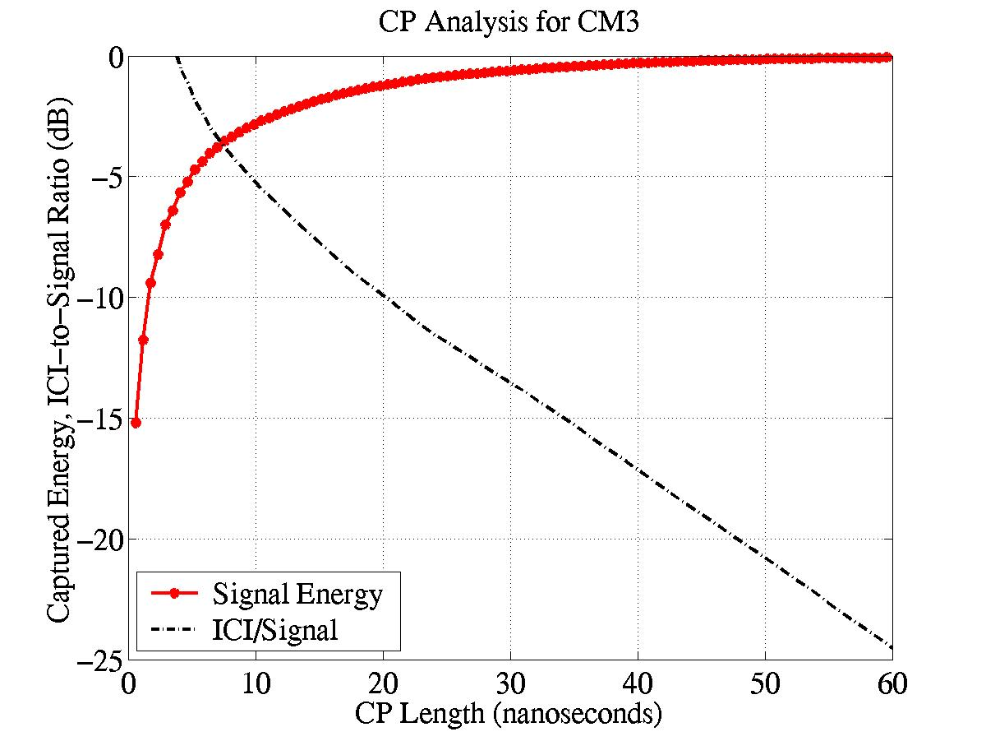
Figure 40 – Captured multi-path energy as a function of cyclic prefix length for a CM3 channel environment

Peak-to-average ratio

The peak-to-average ratio (PAR) requirement of an OFDM system is a critical parameter in assessing whether the system can be implemented in CMOS. A very large PAR requirement would dictate a higher peak transmit power and higher bit precision for the transmit DAC. However, for an OFDM system the PAR can be decreased by allowing a very small percentage of clipping at the transmit DAC. The tradeoff between PAR and clipping percentage at the transmit DAC is illustrated in Figure 41 for an OFDM system with 128 tones. The impact of clipping at the transmit DAC on system performance was investigated for the TFI-OFDM system. For a PAR of 9 dB the clipping percentage at the transmit DAC is negligibly small and the performance degradation is less than 0.1 dB for an AWGN as well as a multi-path (CM3: 4-10 m NLOS) channel environment. For the TFI-OFDM system, the average transmit power in each sub-band (including the pilot tones) is –9.5 dBm. A PAR of 9 dB results in a peak transmit power of less than 0 dBm, which is realizable in CMOS technology.

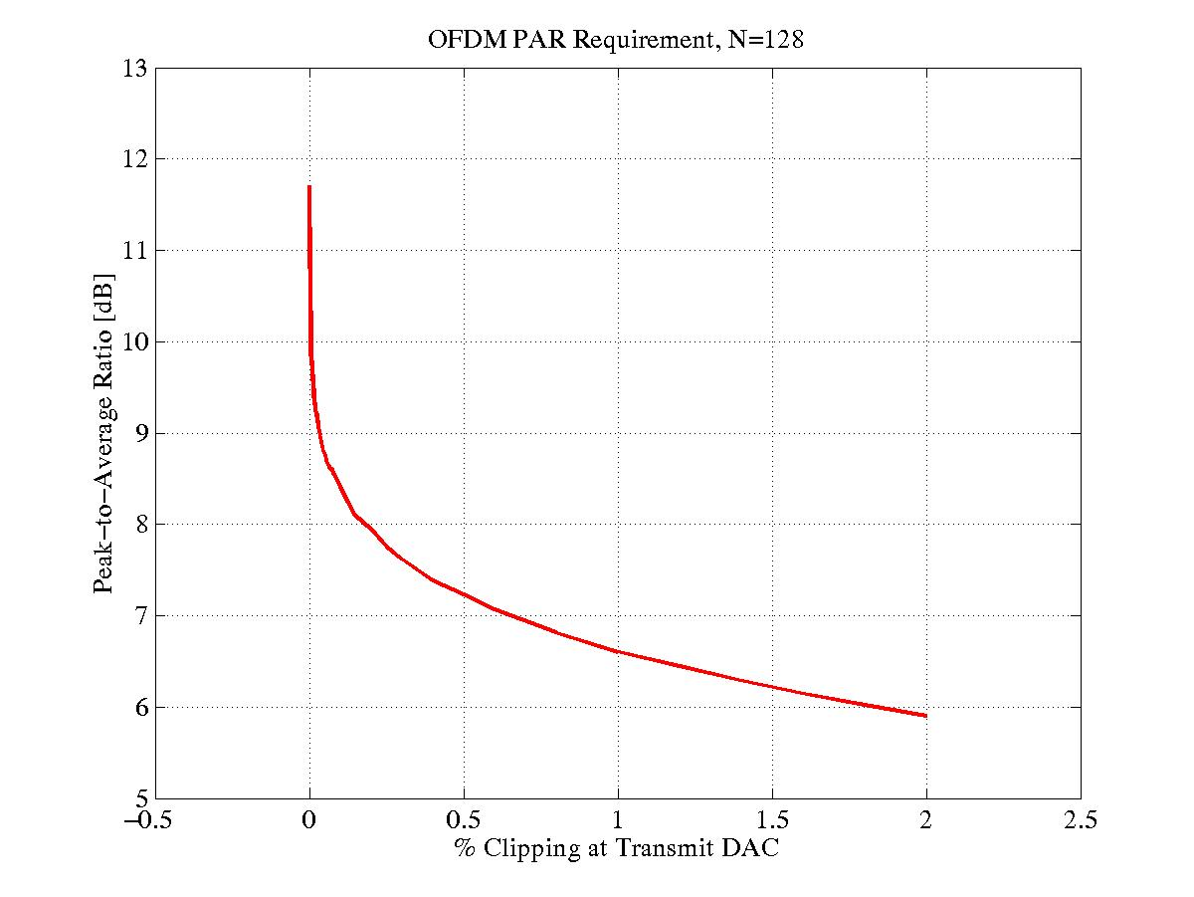
Figure 41 – Peak-to-Average ratio as a function of clipping percentage at the transmit DAC

FFT/IFFT complexity

The FFT/IFFT is one of the digital base-band modules in an OFDM system that could potentially be of high complexity. In this section, we show that the FFT/IFFT block for the TFI-OFDM system has only moderate complexity and can be implemented with current digital technology. In the TFI-OFDM system, during RX/TX mode, a 128-point FFT/IFFT operation has to be performed within a symbol duration of T_{SYMB} = 312.5 ns. Using a radix-2 architecture for the FFT/IFFT implementation requires that 320 complex multiplies and 896 complex additions be performed every 312.5 ns. Table 30 lists the number of complex multiplies/additions operations per clock cycle as a function of the clock frequency. For the sake of comparison, performing 10 complex multiplies at a clock frequency of 102.4 MHz is equivalent to implementing a 2-finger rake receiver operating at a rate of 512 MHz.

Table 30 – Number of multilply/addition operations for a 128-point FFT/IFFT
Clock Frequency (MHz) | Number of complex multiplies/cycle | Number of complex additions/cycle
51.2 | 20 | 56
64 | 16 | 44.8
102.4 | 10 | 28
128 | 8 | 22.4

Component area.
This is a pessimistic analysis performed for the sub-band closest to the interferer and does not include the processing gain of 10log₁₀(3) dB that arises from the use of Time-Frequency Interleaving across 3 sub-bands.

