IEEE P802.15
Wireless Personal Area Networks™
Project | IEEE P802.15 Working Group for Wireless Personal Area Networks™
Title | High Rate Physical Layer Solution for TG3a
Date Submitted | 9 May 2003
Source | Yongsuk Kim  Wonyong Yoon  Samsung Advanced Institute of Technology,  Yongin-si, Kyunggi-do, South Korea 449-712  Seung Hyong Rhee  Dong Won Kwak  Byung Joo Lee  Networking Systems Research Lab.  Kwangwoon University,  Seoul, South Korea 139-701 | yongsuk@samsung.com  wy.yoon@samsung.com  Voice: +82-31-280-9576  Fax: +82-31-280-9587  shrhee@daisy.kw.ac.kr  rednjs@kw.ac.kr  parang@explore.kw.ac.kr  Voice: +82-940-5441  Fax: +82-2-943-7607
Re:
Abstract | This contribution proposes Application-aware Channel Time Allocation  for High Rate WPAN
Purpose | Technical discussions for IEEE802.15.3 alternative PHY down selection
Notice | This document has been prepared to assist the IEEE P802.15. It is offered as a basis for discussion and is not binding on the contributing individual(s) or organization(s). The material in this document is subject to change in form and content after further study. The contributor(s) reserve(s) the right to add, amend or withdraw material contained herein.
Release | The contributor acknowledges and accepts that this contribution becomes the property of IEEE and may be made publicly available by P802.15.

MAC Enhancement Contribution

Application-aware Channel Time Allocation
for High Rate WPAN

i-Networking Lab, Samsung Advanced Institute of Technology

and

Networking Systems Research Lab, KWU

May 9, 2003
Abstract

Decoding of MPEG bit streams depends on successful transmissions of frame data, which require a low JFR (Job Failure rate) and a low delay variance as well as a high throughput. As an MAC enhancement for 802.15.3a, we propose a simple application-aware channel time allocation scheme for high rate WPAN in order to achieve a high-quality video transmission of MPEG stream: A DEV tells PNC the maximum sizes of its frames along with the channel time requests, and the PNC allocates a CTA for the DEV according to the predefined frame sequence. Simulation results show that our scheme achieves significantly lower JFRs, lower delay variances, and higher throughputs than the standard scheduling scheme.

1. Introduction

Among the three methods for communicating data between DEVs in 802.15.3 piconets, if a DEV needs channel time on a regular basis, it asks the PNC for isochronous channel time[1]. The PNC, upon receiving the channel time request command, allocates time in a CTA if the requested channel time is available. As the current draft standard doe not recommend any special mechanism to efficiently allocate the channel time among competing source DEVs, we assume PNC assigns the channel time on the first-come-first-serve basis. If, thus, the requested channel time is not available or the PNC can not support the request for any reason, the DEV’s request shall be rejected or it may choose to use a small channel time.

The isochronous time allocation capability of the 802.15.3 WPAN is expected to be quite useful for the distribution of high-quality and real-time video and audio. Among the future applications, MPEG encoded video (e.g., MPEG-2 HDTV) is anticipated to occupy a large portion of the traffic in wireless mobile networks, including PAN. Decoding of MPEG bit stream depends on successful transmissions of I-frame, P-frame, and B-frame data. Among the frames, a loss or a large delay of an I-frame especially can produce a severe effect on the overall video quality. The frames are arranged in a periodic pattern which is referred to as GOP(Group of Pictures)[2]. When the GOP size is 12, a typical structure is IBBPBBPBBPBB.

In this document, we propose a simple application-aware MAC scheme for 802.15.3 WPAN in order to achieve a high-quality video transmission of MPEG stream. A DEV tells PNC the maximum sizes of its I-frame, P-frame, and B-frame along with the channel time requests before the isochronous stream creation, and the PNC allocates a CTA for the DEV according to the predefined frame sequence. This document is organized as follows: In the next section, we explain the standard scheduling method of isochronous channel time allocation for an MPEG video stream, and describe the three performance measures we adopt in this document. In Section 3, we propose a new MAC scheme that allows for the PNC to dynamically allocate channel times for a source DEV according to the MPEG frame structure. Section 4 describes the simulation model and presents how our approach outperforms the standard method, and finally Section 5 concludes this document.

2. MPEG-4 Frame Transmissions

For the simulations, we use the MPEG traffic generator which gives almost the same stochastic characteristics with a real MPEG traffic. We assume that, for MPEG flows, the frame are generated every 1/30 seconds. The size of each frames are, however, random according to the distributions of the model. A source DEV requests PNC a channel time which is required to send an average size of the frames in its traffic; i.e., if the size of GOP is 12, the requested time is determined as follows.

Figure 1 Fragmentation of an I-frame

Let Imax, Pmax, and Bmax be the maximum sizes in bytes of I-frames, P-frames, and B-frames of a source DEV, respectively. Then, in case of an I-frame, it should be fragmented at the MAC layer as Figure 1, and the total time required to transmit all the fragmented packets, including the defer duration and ACK timeout, is given by

TxTime(Imax) =

(TxTime(1 fragmented frame size) + Defer_Duration + Timeout_ACK)*(n-1)
+ TxTime(Imax_{n}) + Defer_Duration + Timeout_ACK (1)

The transmission time required to send an entire P-frame or B-frame can be calculated in the same way, and the DEV shall request the average time required to send those maximum-size frames as follows:

Channel time requested = (TxTime(Imax)+8*TxTime(Bmax)+3*TxTime(Pmax)) / 12

As the source DEV requests the amount of time above, PNC allocates CTA for the DEV in every superframe as in Figure 2. We assume that the superframes are also generated every 1/30 seconds. In the figure, fixed amount of channel time is repeated every superframe, and the source DEV generates variable sizes of frame sequences according to the GOP structure. It should be noticed that, if the time required to send an entire frame is longer than the CTA, the remaining segments of the frame should be transmitted in the next superframe. It causes a frame delay that is greater than the frame interval of the traffic and may deteriorate the video quality.

Figure 2 Channel time allocations

In this document, we measure the performance of MPEG-4 transmission in 802.15.3 WPAN in three different ways: JFR(Job Failure Rate), throughput, and delay variance. JFR is the rate at which some packets of a frame miss their pre-defined deadline (1/30seconds in this case) and the frame is dropped by the receiving DEV. JFR has been widely adopted as a performance measure in real-time systems, e.g. [3], especially for the measurement of failure rates in hard real-time systems. In case of interactive video and audio applications, both of delay and delay variance are critical parameters that should be bounded to avoid distracting human users. In many other cases, e.g. video-on-demand, however, guaranteeing a delay variance (or jitter) may be a more critical issue as passive receivers can buffer the frames and playback the video.

3. An Application-Aware MAC

If a source DEV requests a fixed amount of channel time that corresponds to the average time required to send the maximum-size (I, B, and P) frames, there may be many chances that the time required to send an entire frame is longer than the CTA and the frame is dropped due to missing the deadline. In order to avoid this, the DEV might request its CTA set to maximum I-frame size. In every superframe, a fixed-size CTA equal to maximum I-frame size is allocated. Every CTA is large enough to accommodate all the frames of the MPEG stream and thus there will be no frame missing the deadline. For P- and B-frames which are typically much smaller than maximum I-frame, significant amount of CTA will remain idle. This will result in poor channel utilization.
In order to achieve both decreased frame-missing rate and better channel utilization, we propose an application-aware MAC scheme in which the PNC dynamically allocates the size of CTA for a source DEV according to the MPEG frame sequence.

Figure 3 Dynamic channel time allocation for MPEG frames

Before requesting the channel time, a source DEV finds the maximum sizes of its I-frames, P-frames, and B-frames in bytes, and computes the amount of time to send those entire frames using equation (1). The DEV send this information along with the channel time request.
For this, additional fields need to be appended to the current channel time request command. The additional fields are shown in the figure below, followed by the meaning of each field.
- Type: application (“1” denotes MPEG-2)
  - By adding a new type value, we can define additional application profiles
- Len: length of subsequent fields (in byte)
- Frame rate
  - Determines period (inter-frame time) of CTAs
  - The PNC might change the superframe size according to this frame rate
- N: the size of GOP
- M: the space between predictive frames
- Itime: time corresponding to the maximum size of I frames (in TU)
- Ptime: time corresponding to the maximum size of P frames
- Btime: time corresponding to the maximum size of B frames

Figure 3 depicts an example where the PNC produces superframes every 1/30 seconds and, in each superframe, different sizes of CTA are allocated according to the GOP structure. Three different amounts of time, which are required to transmit the entire Imax, Pmax, and Bmax frames, are determined by the DEV, and the PNC allows dynamic sizes of CTA based on the GOP structure of size 12, i.e., IBBPBBPBBPBB. One can easily see that, as the time required to send an entire frame is less than or equal to the CTA in every superframe, theoretically the packets can not miss their deadline unless the transmission error rate is not zero and thus packet retransmissions occur. That means we can significantly reduce the frame missing rate, i.e. JFR.

Figure 4 Comparing channel time allocation schemes

Figure 4 compares the two channel time allocation methods. In the above figure, the channel time for a MPEG source DEV is dynamically allocated according to the GOP structure. In the below one, however, the PNC supports the isochronous video stream transmission by periodically allowing fixed size of CTA in every superframe. It is easy to see that, in the method below, it may happen that a long-sized frame miss the deadline due to the short channel time.
Figure 5 compares the two schemes in the same way with figure 4 when 2 flows are connected in the piconet. In our scheme (denoted by AAM), each source DEV enjoys enough channel times to send an entire MPEG frame within a single superframe. In the other scheme (denoted by STD), however, all DEVs receive a fixed size of channel time, and thus sending an MPEG frame involves a possible risk of missing deadline.

Figure 5 Comparing channel time allocation schemes (2 flows)

4. Simulations

4.1 Simulation model

Simulations have been carried out to analyze the effect of our proposed scheme compared to the standard mechanism. In the simulation study we focused our attention on the evaluation and comparison of performance of two schemes in terms of JFR, throughput, and delay variance. We have used ns-2 with the CMU wireless extension[4] and 802.15.3 modules developed by Intel[3]. Simulations are performed in two scenarios: zero error rate and one size of GOP, non-zero error rate and two sizes of GOPs.

Table 1 Simulation parameters
Attribute | Value
Channel bit rate | 250Mbps
Number of flows | 1~4
MPEG4 traffic rate | 8Mbps
Duration | 200 sec
Number of Simulations | 5 times each
GOP size | 9 and 12
Superframe Interval | 1/30 sec
Dead line | 1/30 sec

Table 1 shows the parameters we have used for the simulations. In addition we assume that the nodes do not move during the simulation. We have chosen the channel bit rate as 250 Mbps in order to provide enough length of superframe even in the case of 4 flows in the piconet. Note that, although the maximum channel bit rate of current draft standard of 802.15.3 PHY is 55 Mbps, 802.15 TG3a considers UWB as a strong candidate for the high rate alternative PHY, whose target bit rate is 480 Mbps.

Figure 6 shows the topology of the piconet in our simulations. The MPEG-4 agent at each source DEV generates video frames of random sizes according to the GOP structure, and its MAC fragments the frames into packets and transmits them to the sink (PNC in our simulations) whenever its channel time is available. The PNC receives the packets, assembles into an original MPEG frame, and send it to LossMonitor, the sink agent, only if all the packets of a frame arrive within a deadline; otherwise, the frame is regarded as a missing one and dropped. Starting from a single flow from a DEV to a PNC, we increase the number of MPEG-4 sources up to four DEVs in the simulations, where the sink is always set to the PNC.

Figure 6 Piconet topology for the simulation
Usually we adopt 12 as the size of GOP in the simulations, whose structure is depicted in (a) of Figure 7. In some simulations, however, we used the GOP size of 9, whose typical structure is IBBPBBPBB as shown in (b) of Figure 7, in order to analyze the effect of coexistence of different GOP structures in a piconet.

Figure 7 Different GOP structures

4.2 Results

The effect of dynamic channel time allocations can be clearly verified in Figure 8. In the figures in this chapter, we denote our application-aware MAC scheme and the fixed-size CTA scheme for an isochronous traffic as AAM and STD, respectively. Regardless of the number of MPEG flows in the piconet, the standard scheme shows about 6.7% of failure rates in average. In our scheme, however, the rate is significantly decreased to less than 0.3% in average. The high failure rates in the standard channel time allocation are due to the fact that many big-sized video frames cannot be transmitted in one superframe, whose period corresponds to the frame interval in our simulations. Our scheme, on the other hand, dynamically allocates different sizes of channel times in each of the superframes based on the GOP structure, and thus, any frame can be transmitted within the frame interval, i.e., the deadline.

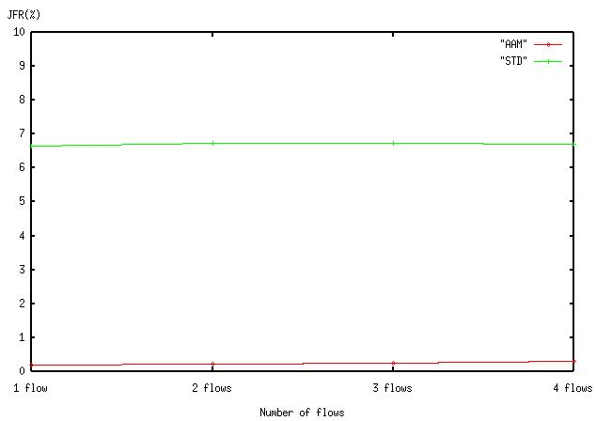
Figure 8 Job failure rate for different number of MPEG flows

Theoretically the failure rate in our scheme should be zero regardless of the number of flows, as the length of CTA in a superframe is always greater than or equal to the maximum time required to send an entire frame of a type that is scheduled to be generated in the superframe based on the GOP structure. However, as it may be hard to identify the maximum sizes of each of the frame types in every MPEG transmissions, we decide to use approximate values of maximum frame sizes in the simulations: that is why the JFR graph of our scheme does not decrease to zero.

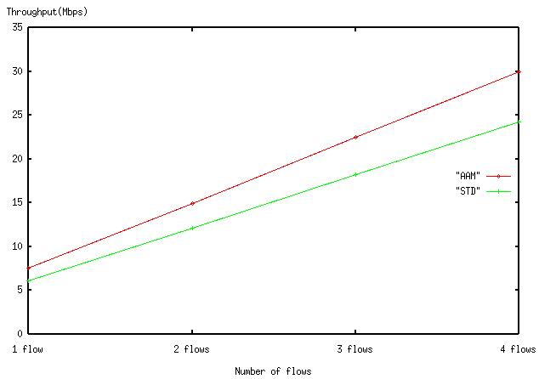
Figure 9 Aggregate throughputs in the two schemes

We measured the aggregate throughput at the application level, not at the MAC level; that is, if some packets of a video frame miss the deadline, then the entire frame is regarded as a missing one and not included in the throughput measurement at the receiving agent. Figure 9 shows that our scheme outperforms the standard scheme in terms of the aggregate throughput also. In the 1 flow case, our scheme achieves more than 7.5 Mbps of throughput, which is just below of the MPEG-4 frame rate, 8 Mbps. The standard scheme, however, shows much less throughput and the difference between the throughputs of the two schemes is getting larger as the number of MPEG flows increases. That is because the fixed channel time allocation is risky for big-sized frame to be transmitted within the frame interval and it causes the application level throughput to be decreased.

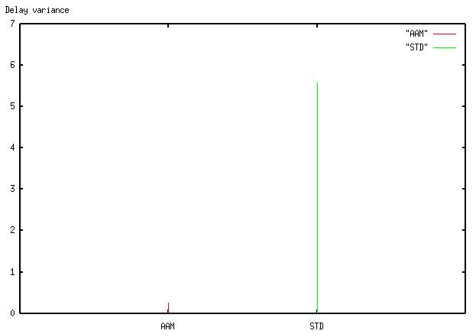
Figure 10 Delay variances of the two schemes

If the MPEG application is not interactive one, e.g. video-on-demand, delay variance may be a more critical issue than transmission delay, as the receiving DEV can buffer the MPEG frames and playbacks them with a fixed amount of delay. The delay variance is defined by
$\frac{\sum_{k=1}^{n}{(d_{\text{avg}}−d_{k})^{2}}}{n}$,
where d_{avg} is the average delay of all MPEG frames including the missing ones. The delay time of a dropped frame was set to the time limit, i.e. 1/30 seconds. Figure 10 depicts the delay variances of the two schemes, where the standard scheme has the value of 5.58 while our scheme shows a very small value of 0.25. Note that, as the delay of a missing frame was set to the deadline, the difference between the two delay variances is actually much higher than the figure since there are much more missing frames in the standard scheme.

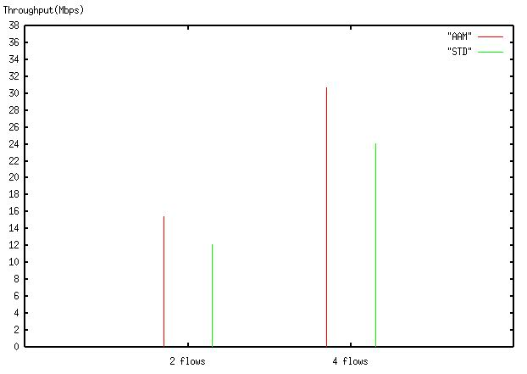
Figure 11 Simulations with different GOPs
Figure 11 depicts the aggregate throughputs of the two schemes where different GOP structures are used. In the two-flow case, GOP sizes of 9 and 12 are used. In the other case, two flows have GOP size of 12 and the other two have size of 9. In the figure we see that in both cases, regardless of the GOP structure, the aggregate throughputs of our scheme are greater than those of the standard scheme.

In the simulations so far we have assumed that the transmission error rate is zero; i.e., a packet sent by a source DEV is not corrupted or lost as long as enough time remains in the CTA. In the next simulations, we have measured the failure rates assuming non-zero error rates. In both schemes two MPEG flows are connected and the packet error rates increase up to 5%. Naturally, the failure rate increases as the number of corrupted or lost packets increases(Figure 12); however, JFR of our scheme is always much below that of the standard scheme at any value of error rate.

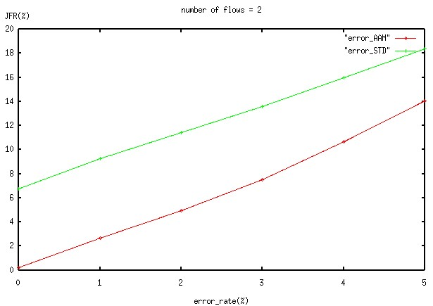
Figure 12 Job failure rates with non-zero error rates
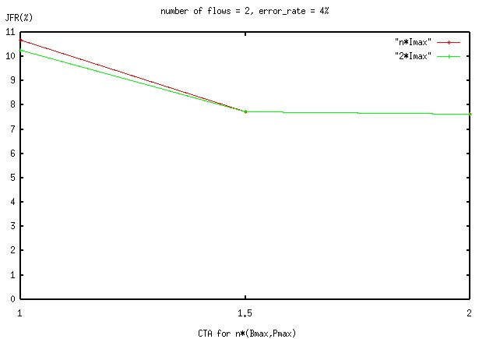
Figure 13 Effects of CTA size for a fixed error rate
Figure 13 shows the effect of increasing the size of CTA in our application-aware MAC scheme when the packet error rate of the link has a fixed value. In the above graph, the channel times allocated for each type of frames are set to 1.5 times and 2 times of the initial amount of channel time. In the graph below, the channel time for I-frames is always set to 2 times of the CTA required to send the entire frame of Imax, and the channel time for P-frames and B-frames is set to 1.5 times and 2 times as the previous case. The figure clearly shows that, as long as the channel time is dynamically allocated according to the GOP structure, the assignment of more channel time does not improve the JFR or throughput of an MPEG connection.

5. Conclusion

In this document, we propose a simple application-aware MAC scheme for 802.15.3 WPAN in order to achieve a high-quality video transmission of MPEG-4 stream. A DEV tells PNC the maximum sizes of its I-frame, P-frame, and B-frame along with the channel time requests before the isochronous stream creation, and the PNC allocates CTA for the DEV dynamically according to the predefined frame sequence. Extensive simulation results show that our scheme achieves significantly lower JFRs, lower delay variances, and higher aggregate throughputs than the standard scheduling scheme.

References

[1] Wireless Medium Access Control (MAC) and Physical Layer (PHY) Specifications for High Rate Wireless personal Area Networks (WPAN), IEEE, Draft P802.15.3/D17, April 2003
[2] F. Fitzek and M. Reisslein, “MPEG-4 and H.263 video traces for network performance evaluation,” IEEE Network, vol.15, no.6, pp. 40-54, Nov/Dec 2001
[3] R. Mangharam and M. Demirhan, “Performance and simulation analysis of 802.15.3 QoS,” IEEE 802.15-02/297r1, Jul. 2002
[4] The CMU Monarch Project, “Wireless and mobile extension to ns”

